PROGRAMMING
Regex Pattern | Meaning | Example Input | Output
[0-9] | Any single digit | "a1b2c3" | "a*b*c*"
[a-z] | Any lowercase letter | "a1B2c3" | "*1B2*3"
[A-Z] | Any uppercase letter | "a1B2C3" | "a12*3"
\\s | Any whitespace | "a b\tc\n" | "a*b*c*"
\\d | Any digit (same as [0-9]) | "abc123" | "abc***"
[^a-zA-Z0-9] | Special characters | "abc@123#" | "abc123"

s.replaceAll(“[^a-z]”,””);
s.replaceAll(“[^0-9]”,””);
s.replaceAll(“[0-9a-zA-Z]”,””] ^ not operator.
s.replaceAll(“[0-9]”,”@”) all numbers @

FOR LOOP TIME COMPLEX=
- ON = SINGLE FOR LOOP 5
- ON²= FOR LOOP INSIDE NESTED FOR LOOP 5*5=25;
- O2N=2 FOR LOOPS 5+5 = 10;

-2 upper to lower lower to upper=
String a="apPLe";

for(int i=0;i<a.length();i++){
char ch=a.charAt(i);
if(ch>='A' && ch<='Z'){ o/p APplE
System.out.print(Character.toLowerCase(ch));
}else{
System.out.print(Character.toUpperCase(ch));
}
}

-1 DUPLICATE CHARACTER REMOVE=
String sentence = "this is java interview";
String result = "";

for (int i = 0; i < sentence.length(); i++) {
char ch = sentence.charAt(i);

// If this character is not already in the result, add it
if (result.indexOf(ch) == -1) { (-1) indicates not found
result += ch;
}
}

System.out.println(result); output = this javanrv
}
String result = "thi";
System.out.println(result.indexOf('t')); // 0 (found at index 0)
System.out.println(result.indexOf('h')); // 1 (found at index 1)
System.out.println(result.indexOf('x')); // -1 (not found)

0 READ THE OUTPUT SKIPPING AFTER V CHARACTER=
0 //input = this is java interview
//output =thsi is jav intervew remove after v

String str="this is java interview";
String s="";
for(int i=0;i<str.length();i++){
s+= str.charAt(i);
if(str.charAt(i)=='v'){
i+=1;
}
}
System.out.println(s);
}
}

1 REVERSE A STRING =
STEPS=
- TAKE A STRING / CREATE A STRING VARIABLE TO STORE THE STRING
- CREATE A VARIABLE CALLED AS REVERSE.
- CONCATINATE THE CHARACTERS FROM THE LAST / REV VARIABLE .
- PRINT THE REVERSE STRING.
public class ReverseString {

public static void main(String [] args) {
String s="Programme";
String rev="";

for(int i=s.length()-1;i>=0;i--) {
char ch=s.charAt(i); //index length
rev=rev+ch;
}
System.out.println(rev); //o/p emmargorP
}

INSTEAD USING EXTRA VARIABLE
/* istead of using extra variable *//* reading from the end*/
String s="programming";
for(int i=s.length()-1;i>=0;i--) {

char ch=s.charAt(i);
System.out.println(s.charAt(i)); // print reverse in vertical
System.out.println(ch); //pring reverse in vertical
System.out.print(ch); // O/P gnimmargorp
}

METHODS USED FROM STRING CLASS=
- LENGTH () = USED TO FIND THE LENGTH OF THE STRING ( START FROM 1 2 3 4 ETC..,)
- CHAR AT() = USED TO READ CHARACTERS FROM A PARTICULAR INDEX.
EMPTY STRING =
- INITIALIZING EMPTY BECOUSE ANY CHARACTER STORED IN REVERSE IF WE CONCATINATE THE VALUES .
- THE VALUE WILL BE CHANGED , BUT AFTER RECIVING I WANT TO HAVE THE SAME CHARACTER . SO WE CREATE A EMPTY STRING.

2 STRING PALINDROM=
- THE STRING WHICH READ SAME FORWARD OR REVERSE VARIABLE VALUE IS SAME.
STEPS=
- CREATE STRING VARIABLE .
- EMPTY STRING TO STORE REVERSE VALUE .
- ITTERATE OVER THE STRING IN REVERSE DIRECTION.
- PRINT STRING WHICH IS REVERSED .
- COMPARE THE STRING TO CHECK IT IS PALINDROME.
public class String_Is_Pallindrom {
public static void main(String [] args) {

String s="Mom";
String rev=""; // to compare the value we require rev ""

for(int i=s.length()-1;i>=0;i--) {
char ch=s.charAt(i);

// rev=rev+ch; //syso hear it will print m , mo , moM (as per the loop)
rev+=ch;
}
System.out.println(rev);
System.out.println(s);
//if(s.equals(rev)) { //o/p Mom is not a pallindrome
if(s.equalsIgnoreCase(rev)) { // op Mom is pllindrome INGNORE CASE

System.out.println(s+" is pllindrome");
}
else
System.out.println(s+"is not a pallindrome");
// CASE SENSITIVE.
}
- EQUALS = COMPARE THE STRING VALUES.
- EQUALS IGNORE CASE = COMPARE THE CHARACTER.
- CASES ARE NOT SAME IT IS NOT A PALINDROME .
- ONLY COMPARE CHARACTER NOT THE CASE.

3 OCCURANCE OF EACH CHASRACTER =
- EXAMPLE= aabbac = 3a , b2 , c1
- OCCURANCE OF THE CHARACTER.
- CASES ARE DIFFERENT THEY ARE TREATED AS 2 DIFFERENT CHARECTERS
- EXAMPLE = India I 1 ,n 1 , d 1 , I 1 , a 1.
STEPS=
- TAKE A STRING .
- CREATE A LINKED HASH MAP .
- ITTERATE OVER THE STRING .
- AXCESS EACH CHARACTER AND CHECK THE CHARACTER IS PRESENT IN THE MAP OR NOT.
- IF MAP CONTAINS KEY INCREMENT THE VALUE USING GET()AND AXCESS BACK TO THE MAP.
- IF MAP DOES NOT CONTAIN KEY ADD CHAR AND 1.
- The LinkedHashMap is like this notebook — it stores pairs like (letter, count).
- You look at each letter one by one:
  - If you have seen the letter before, you add 1 to its count.
  - If it's the first time, you write the letter with count 1.
- At the end, you have a list of letters and how many times they appeared.

Example:
String: "akdfklsaksdskla"
- Look at the first letter: 'a' → not seen before → add 'a' = 1
- Next letter: 'k' → not seen → add 'k' = 1
- Next letter: 'd' → not seen → add 'd' = 1
- Next letter: 'f' → not seen → add 'f' = 1
- Next letter: 'k' → already seen 'k' → increase count from 1 to 2
- And so on...
- O / P {a=3, k=4, d=2, f=1, l=2, s=3}

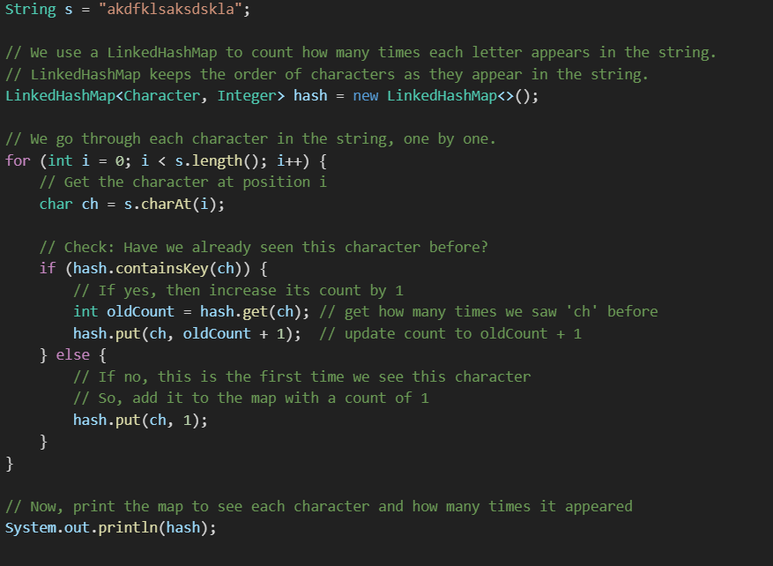

- LINKED HASH MAP = MAINTAIN INSERTION ORDER , DUPLICATE KEYS NOT ALLOWED.
- ELSE = ELSE IS GOING TO ADD 1 TO HASH THEN ITTERATE VALUE WILL BE INCREASED.
- GENERIC MAP = IS CALLED BECOUSE IT CAN ONLY STORE KEY VALUE PAIR.

4 PRINT DUPLICATE IN A STRING=
TO PRINT DUPLICATE =
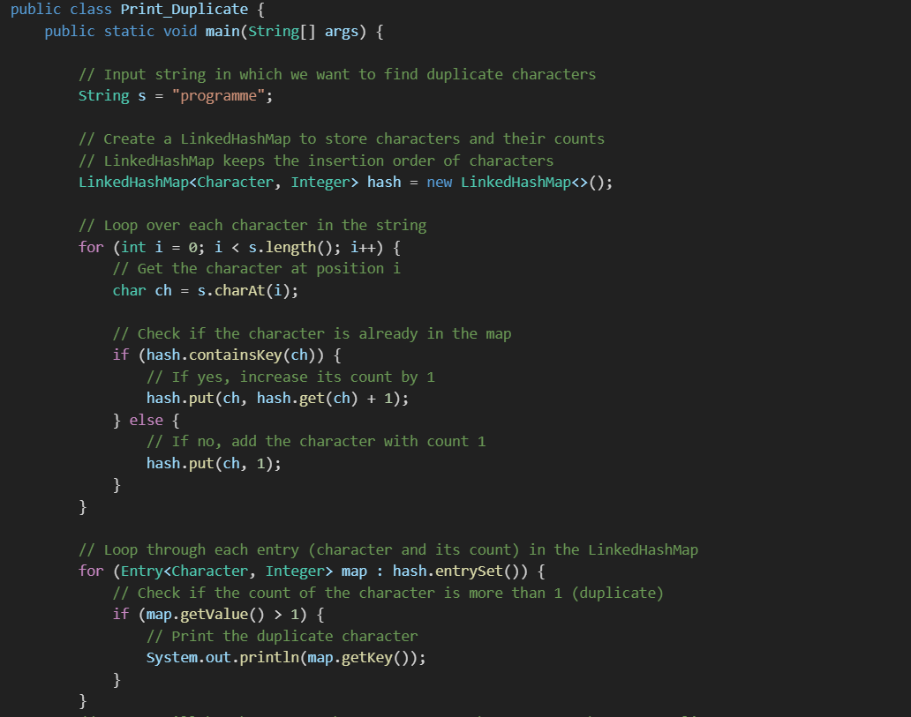 //o/p vertically r , m

TO PRINT UNIQUE=
public class Print_unique {
public static void main(String[] args) {

String s="programme";

LinkedHashMap<Character, Integer> hash=new LinkedHashMap();
for(int i=0;i<s.length();i++) { // for(int i=0;i<=s.length()-1;i++) {
char ch=s.charAt(i);

if(hash.containsKey(ch)) {
hash.put(ch, hash.get(ch)+1);
}else
hash.put(ch, 1);
}
for(Entry<Character, Integer> map:hash.entrySet()) { // for each loop
if(map.getValue()==1) {
System.out.println(map.getKey());
}
}
//o/p vertically p , o , g , a , e

5 REMOVE DUPLICATE=
- TERM = MULTIPLE OCCURANCE OF THE SINGLE CHARACTER.
- LINKED HASH SET = DOES NOT ALLOW DUPLICATE , MAINTAIN INSERTION ORDER.
STEPS=
- CREATE A STRING .
- CREATE A SET AS IT DOES NOT ALLOW DUPLICATES.
- ITTERATOR OVER THE STRING .
- ADD EACH CHARACTER TO THE SET.
- PRINT SET.
public class Remove_Duplicate {
public static void main(String[] args) {

String s="programmin";

LinkedHashSet set=new LinkedHashSet();
for(int i=0;i<s.length();i++) {
set.add(s.charAt(i));
}
System.out.println(set);
}
} // o/p [p, r, o, g, a, m, i, n]

6 FIND SUM OF NUMBERS IN A STRING=
- EXAPMLE= AB1C23 SUM=6
STEPS=
- DECLARE A STRING .
- CREATE A VARIABLE CALLED SUM.
- ITTERATE OVER THE STRING.
- CHECK IF THE CHARACTER IS NUMBER.
- IF SO ADD IT TO SUM.

- SUM+CH =48 //SUBSTRACTING BECOUSE CONVERTING CHAT INTO NUMBER.
- CHAR =’1’ = 49 , SO 48-=1.
- SO CONVERTING CHAR INTO INTEGER VALUE IS DONE BY SUBSTRACTING WITH 48.
public class SumOfNumbers {

public static void main(String[] args) {
String s="guruK7112";
int sum =0;

for(int i=0;i<s.length();i++) {
char ch=s.charAt(i);
if(ch>='0'&&ch<'9') { //if(ch>='0') o/p 297
sum=sum+ch-48;
}
}
System.out.println(sum); // o/p 11
}
}

7 FIND THE NUMBER OF ALPHABETS ,SPECIAL CHARACTER , DIGIESTS NUBMER=
- EXAMPLE = AB12*& ALPHABET =2 , NUMBER=2 , SPECIAL CHAR=2.
STEPS=
1.TAKE A STRING DATA .
- CREATE 3 VARIABLES .
- ITTERATE OVER THE STRING.
- CHECK IF CHAR IS DIGIT THEN INCREASE THE CHAR COUNT.
- CHCEK IF CHAR IS LOWER CASE OR UPPERCASE AND INCREASE THE COUNT.
- OTHERWISE INCREASE THE COUNT OF SPECIAL CHARACTER.
- PRINT ALL TE 3 VALUES.
public class CountOfAlpa_number_specialCharecter {
public static void main(String[] args) {
String s="gk@7112";
int alphabet=0,numeric=0,specialChar=0;
for(int i=0;i<s.length();i++) {
char ch=s.charAt(i);

if(ch>='0' && ch<='9') {
numeric++;
}else if((ch>='a' && ch<='z') || (ch>='A' && ch<='Z')) {
alphabet++;
}else
specialChar++;
}
System.out.println("numeric "+numeric); // O/P 4
System.out.println("alphabet "+alphabet); //O/P 2
System.out.println("specialChar "+specialChar); //O/P 1
}

8 CHECK IF 2 STRINGS ARE ANAGRAMS=
- ANAGRAM= THOSE WORDS HAVING SAME LENGTH OF VALUES.
- HAVING SAME CHARACTER ARRANGED IN DIFFERENT ORDER.
- ALL THE CHARECTERISTIC OF 1ST STRING SHOULD BE ALSO PRESENT IN 2ND STRING.
- EXAPMLE = ABCD == DBCA CORRET
- ABCD == DECA FALSE
STEPS=
- CREATEA STRING 2.
- CHECK IF LENGTH OF 2 STRINGS ARE SAME .
- IF SAME CONVERT THEM TO ARRAY.
- SORT THEM AND COMPARE AFTER SORTING.
- IF EQUALS THEY ARE ANAGRMS ELSE THEY ARE NOT ANAGRAMS.
- USING ARRAY CLASS MEHTOD CALLED AS EQUAL PASS 2 REF A1.EQULAS(A2) IT WILL COMPARE THE ADRESS AND IT WILL NOT COMPARE THE VALUES.
- TO COMPARE THE VALUES USE ARRAYS .EQUALS (A1,A2);
public class Anagrams {
public static void main(String[] args) {
String s1="bird";
String s2="irdb";

if(s1.length()==s2.length()) { // comapre length (may be anagram)
char[] ch1=s1.toLowerCase().toCharArray();
char[] ch2=s2.toLowerCase().toCharArray(); //convert to lower case

Arrays.sort(ch1); //sort then both
Arrays.sort(ch2);

if(Arrays.equals(ch1, ch2)) { // compare using arrays equals
System.out.println(s1+" and "+s2+" are anagrams ");
}else
System.out.println(s1+" and "+s2+" are not anagrams");

}else {
System.out.println(s1+" and "+s2+"are not anagrams"); }

9 SWAP 2 STRINGS WITHOUT USING A 3RD VARIABLE=
S1=APPLE , S2=MANGO SWAP S1 = MANGO S2=APPLE.
STEPS=
- CREATE A STRING .
- CREATE A STRING .
- CONCATE 2 STRINGS .
- USE 2 ARGUMETNS SUBSTRING MEHTODS .
- USE 1 ARGUMETN SUBSTRING METHODS.
public class SwapStrings {
public static void main(String[] args) {

String s1="swap";
String s2="mango";

System.out.println("before swapping ");
System.out.println(s1); //swap
System.out.println(s2); //mango

s1=s1+s2; // concatinate
s2=s1.substring(0,s1.length()-s2.length()); // 0 , 10-5=0 to 4
s1=s1.substring(s2.length()); // remaining 5

System.out.println("after swapping ");
System.out.println(s1); //mango
System.out.println(s2); //swap

}

10 FIND ALL POSSIBLE SUBSTRING .
EXAMPLE SUM = S SU SUM , U UM , M
1 TAKE A STRING
2 TAKE A NESTED LOOP AND CALL THE SUBSTRING MEHTOD AND PRINT THE STRING.
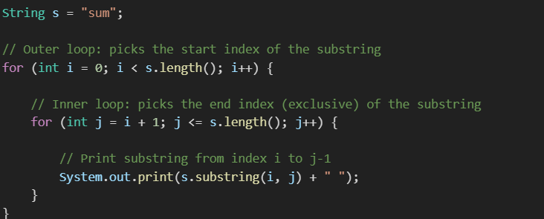

What is happening here?
- You want to print all possible substrings of the string "sum".
- A substring is any sequence of characters inside the string, like "s", "su", "u", etc.
- You use two loops:
  - The outer loop i decides where the substring starts.
  - The inner loop j decides where the substring ends (one past the last character, because substring(i,j) excludes j).

Walkthrough with "sum":
i | j | substring(i,j) | Explanation
0 | 1 | "s" | start at 0, end before 1
0 | 2 | "su" | start at 0, end before 2
0 | 3 | "sum" | start at 0, end before 3
1 | 2 | "u" | start at 1, end before 2
1 | 3 | "um" | start at 1, end before 3
2 | 3 | "m" | start at 2, end before 3

Why j = i + 1 and j <= s.length()?
- j must always be greater than i because substring must have at least one character.
- j goes up to the length of the string because the substring end index can be up to the string’s length (exclusive).

So, the output will be:
bash
CopyEdit
s su sum u um m

11 SUBSTRING LENGTH IS GREATER THAN EQUAL TO 2.
public class subString_lengthis_greater_than_1 {
public static void main(String[] args) {

String s="sum";

for(int i=0;i<s.length();i++) { //i=0
for(int j=i+1;j<=s.length();j++) { //j=i+1
String s1=s.substring(i,j);
if(s1.length()>=2) {
System.out.println(s1);
}
} // o/p su sum um
}

12 SUBSTRING PALLINDROME=user for extract pallindrome
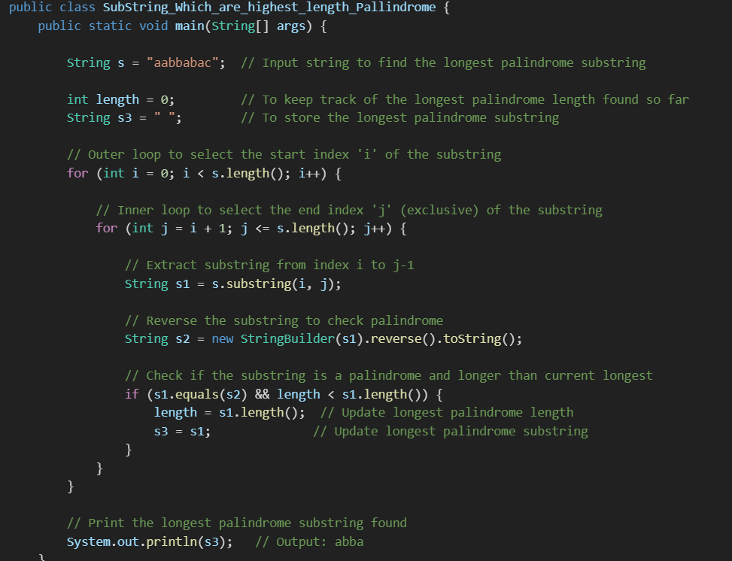

- We want to find the longest palindrome substring inside the given string s.
- Two nested loops generate every possible substring:
  - Outer loop picks the start index.
  - Inner loop picks the end index.
- For each substring:
  - We reverse it.
  - Check if the original substring equals the reversed substring (which means it's a palindrome).
  - If yes, and its length is greater than the previously found palindrome, update the stored longest palindrome and its length.
- Finally, print the longest palindrome substring.

Example for input "aabbabac":
- It checks substrings like "a", "aa", "aab", "abba", etc.
- Finds "abba" is a palindrome and longest so far.
- Prints "abba" at the end.

13 COMPRESS A STRING (AaaaBBaa= a4b2a2) used to compress
EXAMPLE= STRING S=AABBACAB O/P A2B2A1C1A1B1

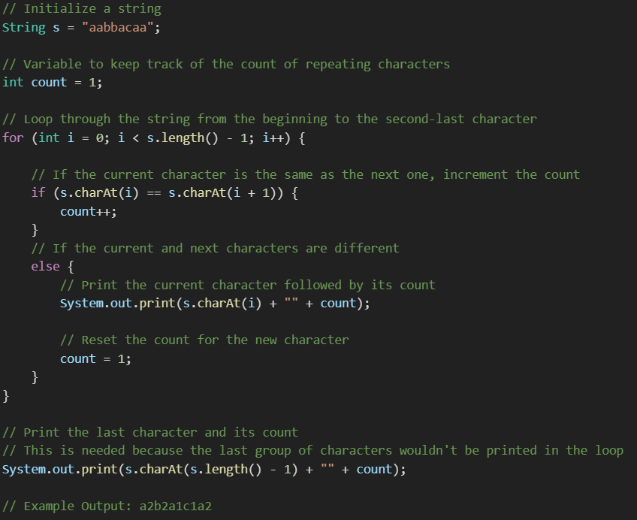the code does: i+1 is used to compare next character in string.
It counts consecutive repeating characters and prints them in the format: character + count.

14 EXPAND A STRING (select even or odd array)
EXAMPLE= A2B2C1B1 O/P AABBCB
How it works (Step-by-step for g3k5k9l8):
Index | Character | Meaning
0 | g | letter
1 | 3 | repeat 'g' 3 times
2 | k | letter
3 | 5 | repeat 'k' 5 times
4 | k | letter
5 | 9 | repeat 'k' 9 times
6 | l | letter
7 | 8 | repeat 'l' 8 times
Output:

gggkkkkkkkkkkllllllll

Why s.charAt(i+1) - 48?
In Java, characters like '3', '5', etc. are characters, not numbers. Their ASCII values are:
- '0' = 48
- '1' = 49
- '2' = 50
- ...
- '9' = 57
So '3' - 48 = 3, converting the character digit to an actual number. Select even array

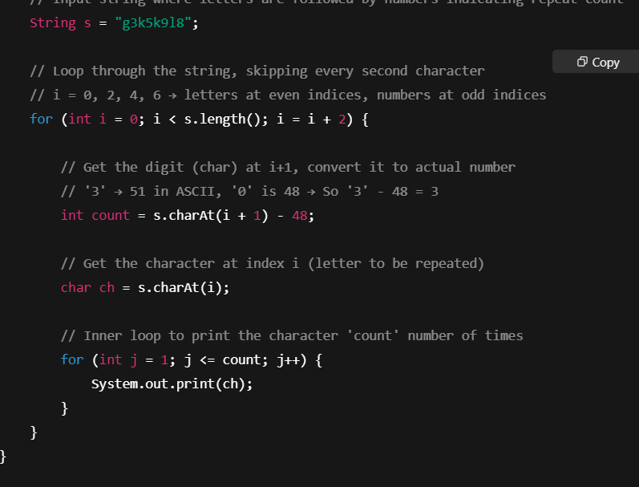

15 BALANCED STRING =
- FOR EVERY OPENING PARATHSIS THERE IS A MATCHING CLOSED PARANTHISHS.
- EXAPMPLE ={} () [] {([])} {([)]}
- NOT A BALANCED STRING = {] (] {) ETC..,
- REMOVE ELEMENT FROM LIST , IF THE LIST IS EMPTY IT IS BALANCED.
- NOT EMPTY NOT BALANCED.
How the Algorithm Works
You're using an ArrayList as a stack, which follows the Last In, First Out (LIFO) principle.
Here's the process:
- Initialize an empty list to hold unmatched brackets.
- Traverse the string one character at a time.
  - If the current character is an opening bracket ([, {, ():
    - Add it to the list.
  - If it's a closing bracket (], }, )):
    - Check if it matches the last item in the list.
    - If it matches → remove the last item (since the pair is closed).
    - If it doesn’t match or the list is empty → add the closing bracket (or leave it for detection of imbalance).
- After the loop:
  - If the list is empty → the string is balanced.
  - If the list has any leftover brackets → the string is not balanced.

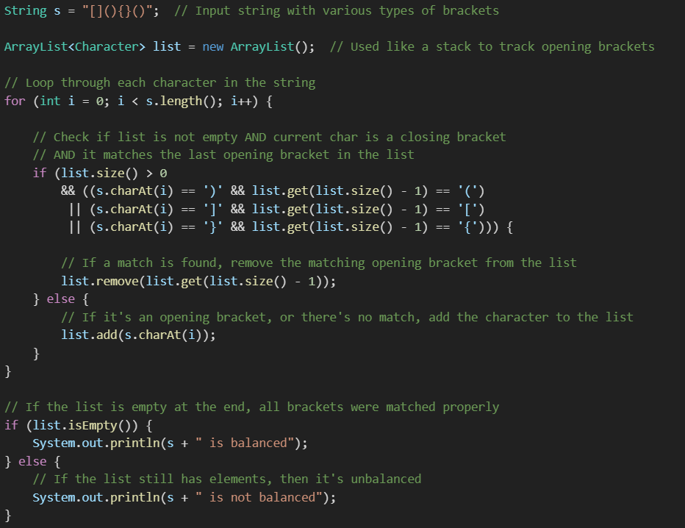

SENTENCES=

16 REVERSE THE SEQUENCE OF EACH WORD IN A STRING=
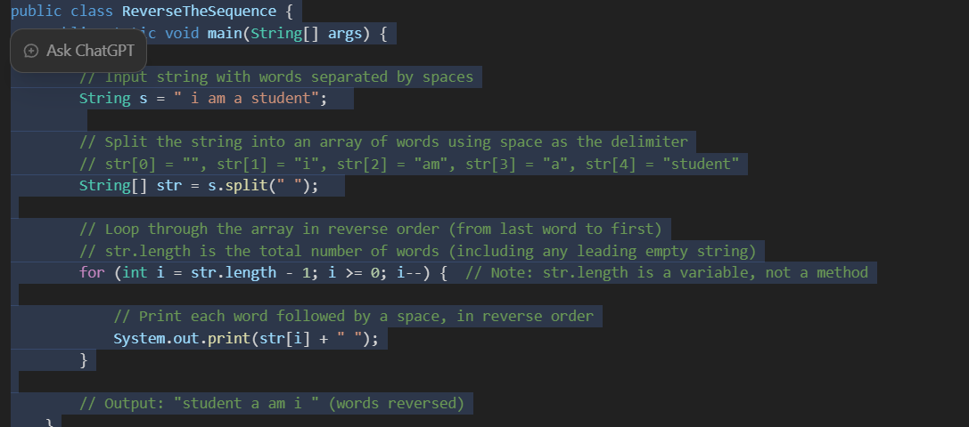
- s.split(" ")
Splits the sentence into an array of words using space as the delimiter. If the string starts with a space, the first element will be an empty string ("").
- str.length - 1
This starts the loop at the last index of the array. Since array indices start from 0, we subtract 1 to start from the end.
- System.out.print(str[i] + " ")
Prints each word in reverse order, separated by a space. No newline is added, so everything prints on the same line.
- Output Analysis:
Input: " i am a student"
Output: "student a am i "
The first space causes an empty string ("") to appear at index 0, so it doesn’t affect the output visually.

💡 Optional Improvements:
If you want to trim leading/trailing spaces and ignore empty strings:
java
CopyEdit
String s = " i am a student".trim(); // Removes leading/trailing spaces
String[] str = s.split("\\s+"); // Splits on one or more spaces

17 CONVERT THE INITIAL LETTER OF EACH WORD TO UPPERCASE=
- DECLARE AN ARRAY .
- SPLIT THE STRING.
- CONVERT THE 1ST LETTER OF EACH WORD TO UPPERCASE.
- CONCATENATE REST OF THE STRING.
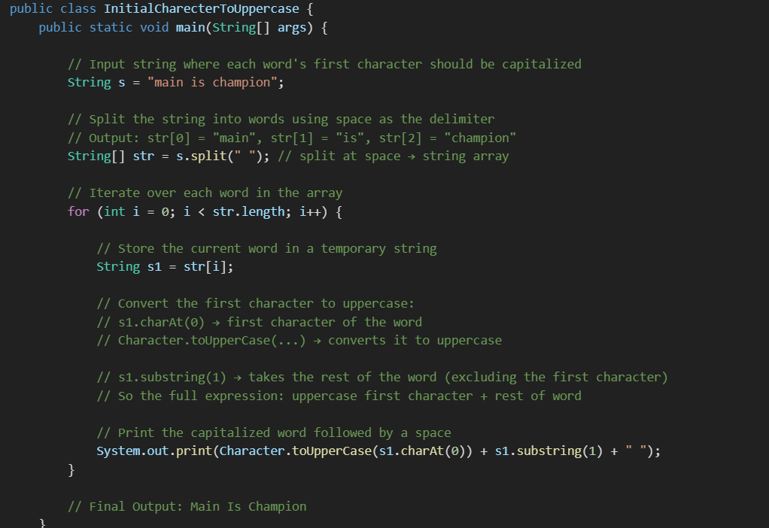
public void first() {
String a="repair return claim";
String[] b=a.split(" ");
for(int i=0;i<b.length;i++) {
String s= b[i].substring(0).toUpperCase();

System.out.print(s+" ");
}
}
} Repair Return Claim

18 SWAP 1ST WORD AND LAST WORD=
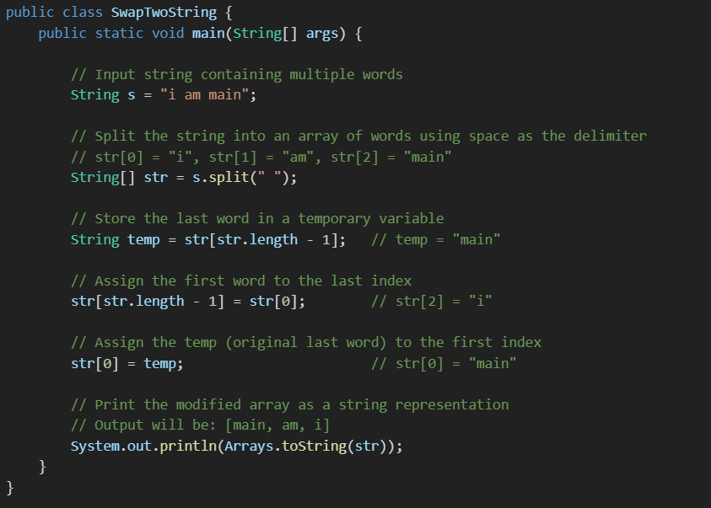

19 REVERSE A STRING WITHOUT REVERSING SPACES=
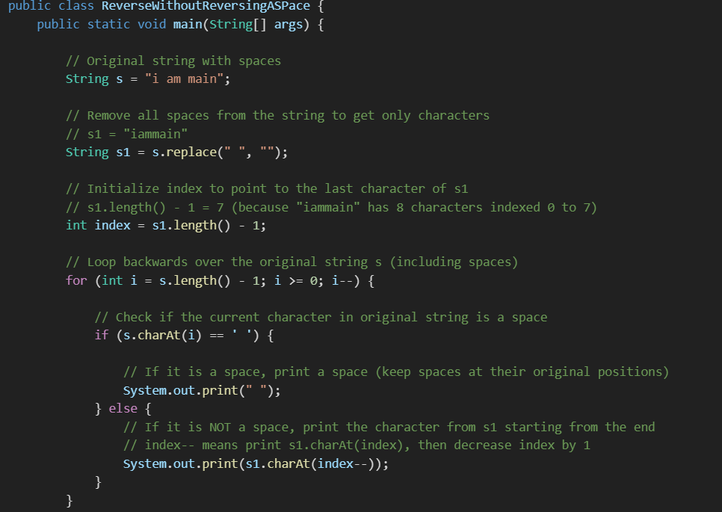
Explanation:
- The goal is to reverse all characters in the string without moving the spaces.
- First, all spaces are removed from the string using replace(" ", "").
- The index starts at the last character of this no-space string.
- Then, the program loops backwards through the original string:
  - When a space is encountered, it prints a space directly.
  - When a non-space character is encountered, it prints the character from the end of s1 and moves the index backwards.
- This way, letters get reversed, but spaces stay in their original places.

20 PANAGRAMS=
- EXAMPLE = THE QUICK BROWN FOX JUMPS OVER THE LAZY DOG.
- PACK MY BOX WITH FIVE DOZEN LIQOR JUGS
- IT HAS ALL THE CHARECTERS BETWEEN A TO Z SO IT IS CALLED AS PANAGRAMS.
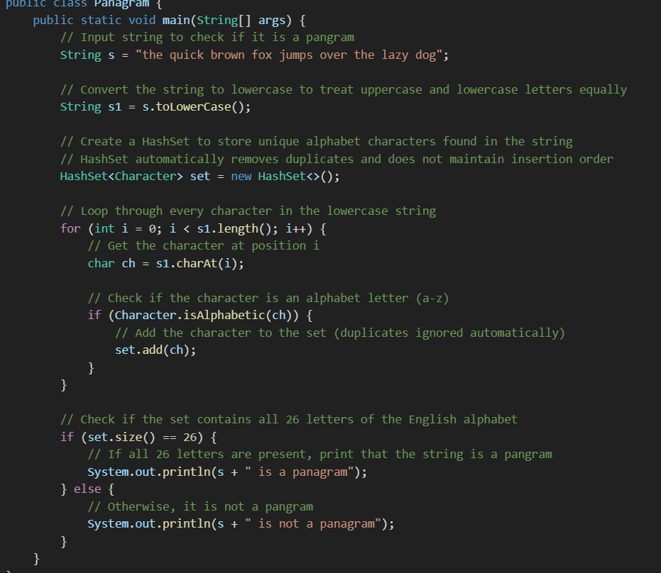
• What is a pangram?
A pangram is a sentence that contains every letter of the alphabet at least once.
• Why convert to lowercase?
To avoid counting uppercase and lowercase letters separately, making the check simpler.
• Why use a HashSet?
HashSet stores only unique characters and ignores duplicates, so you can easily count distinct letters.
• Check the set size:
If the size is 26 (letters 'a' to 'z'), the string is a pangram.

21 REVERSE A SENTENCE PLUS WORD=
String s = "i am automation engineer";
String k = "";

for (int i = s.length() - 1; i >= 0; i--) {
k += s.charAt(i);
}

String[] d = k.split(" ");

for (int i = d.length - 1; i >= 0; i--) {
String word = new StringBuilder(d[i]).reverse().toString();
System.out.print(word + " ");
}
} 0/P reenigne noitamotoua ma i

22.REVERSE ONLY WORDS IN SENTENCE=
YOU CAN USE SPLIT(“ “) AND STRINGBUFFER();
public void first() {
String a="difference between collection and collections";
O/P ecnereffid neewteb noitcelloc dna snoitcelloc
String result="";
int start=0;

for(int i=0;i<=a.length();i++){
if(i==a.length() || a.charAt(i)==' '){

for(int j=i-1;j>=start;j--){
result+=a.charAt(j);
}
if(i!=a.length()){
result+=" ";
}
start=i+1;
}
}
System.out.println(result);
}

OCCURANCE OF CHARACTER WITHOUT COLLECTION=
String c="dieland sequce akfj charcter";
char[] a=c.toCharArray();
boolean[] b=new boolean[a.length];
for(int i=0;i<a.length;i++){
if(b[i]==false){
int count=0;

for(int j=0;j<a.length;j++){
if(a[i]==a[j]){
b[j]=true;
count++; D2
C->2
}
}
if(count==2)
System.out.println(a[i]+" ---> "+count);

b = {false, false, false, false, false, false, false, false, false, false}
First Iteration (i = 0)
- b[0] == false → process a[0] = 3.
- Inner loop compares a[0] with all other a[j]:
  - Match at j = 0 → set b[0] = true.
  - Match at j = 9 → set b[9] = true.

Arrays
descend[i]= sum[sum.length-1-i ]; to reverse a loop

1 MINIMUM AND MAXIMUM ELEMEN+TS IN AN ARRAY=
- CREATE A VARIABLE CALLED MIN AND MAX .
- ITTERATE OVER THE ARRAY
- IF ANY ELEMENT IS GREATER THEN MAX INITIALIZE =MAX NUMBER.
- IF ANY ELEMENT IS LESSER THAN MIN INITIALIZE MIN=NUMBER.
- PRINT MIN AND MAX
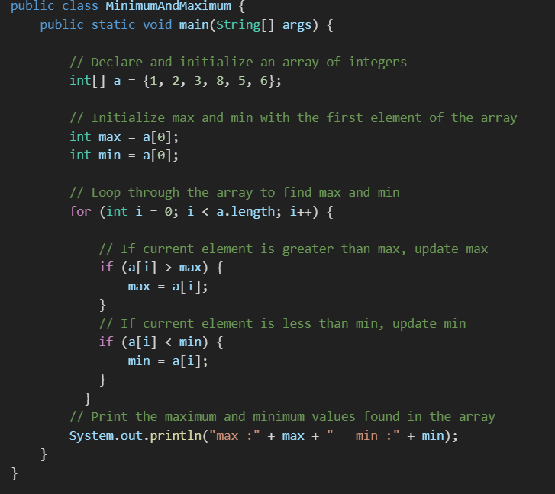

2 FIND SECOND MAXIMUM ELEMENT IN THE ARRAY=
- CREATE A VARIABLE CALLED MAX AND SMAX.
- ITTERATE OVER THE ARRAY.
- FIND THE MAX ELEMENT , EXISTING MAX BECOMES SECOND MAX .
- OTHERWISE IF ANY ELEMENT IS GREATER THAN SECOND MAX AND NOT EQUAL TO MAX.
- THEN IT IS INITIALIZED TO SECOND MAX.
- PRINT THE SECOND MAX.
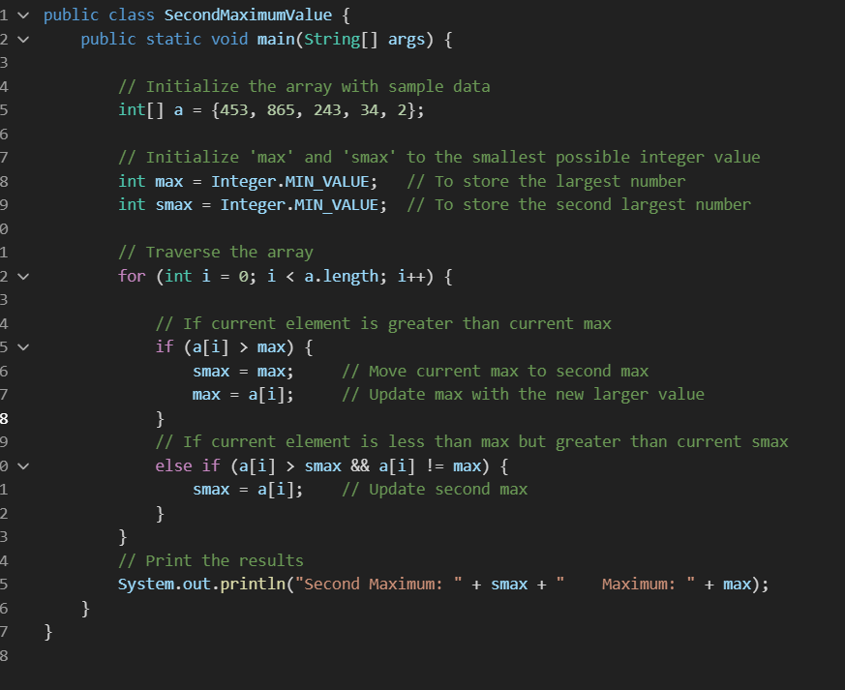

3 LEFT ROTATION OF AN INTEGER ARRAY=
- LENGTH -1 BECOUSE IT CANNOT TAKE LAST INDEX VALUE IT DOESN’T HAVE +1 INDEX 0/P // [2, 3, 4, 5, 1]
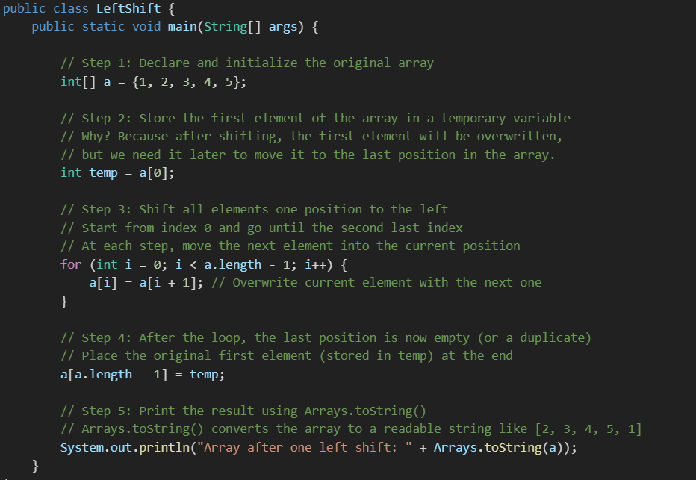
RIGHT SHIFT= [5, 1, 2, 3, 4]
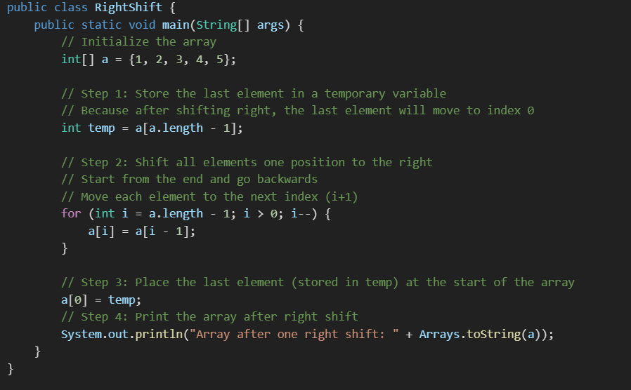
LEFT SHIFT BY TWO=
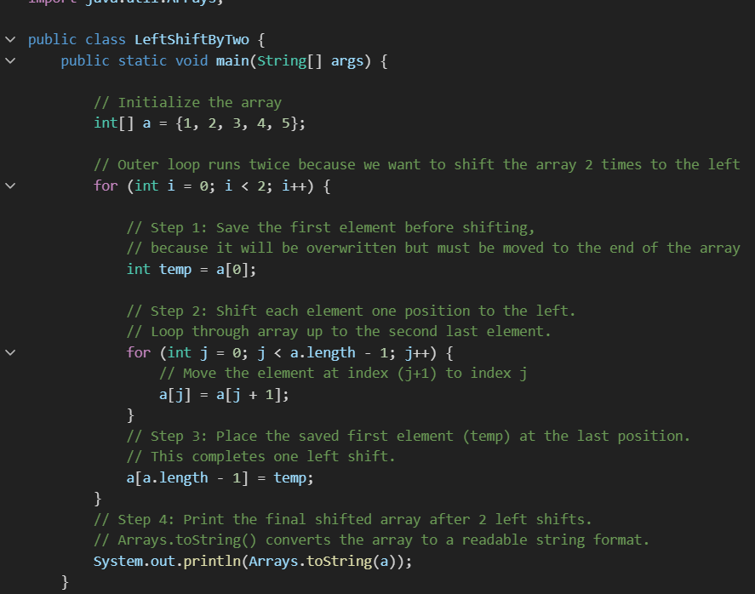
- Outer loop (i from 0 to 1):
This means the entire left shift process is repeated 2 times, shifting the array left by 1 position each time, for a total of 2 positions.

Inside Outer Loop (One Left Shift):
- Save the first element (temp = a[0]):
We keep this safe because after shifting, a[0] will be replaced.
- Shift left by one position (for j loop):
For each index j from 0 to a.length - 2, replace a[j] with a[j+1].
For example, after first iteration inside the inner loop,
  - a[0] = a[1] → a[0] = 2
  - a[1] = a[2] → a[1] = 3
and so on.
- Put temp (old first element) at the end:
a[a.length - 1] = temp puts the original first element at the last index.

Step-by-step for 2 Left Shifts:
- After 1st shift:
{2, 3, 4, 5, 1}
- After 2nd shift:
{3, 4, 5, 1, 2}

Final Output: [3, 4, 5, 1, 2]

4 SHIFT ALL ZEROS TO ONE SIDE IN ARRAY=(we can use Arrays.sort(a) or bubble sort)
- DECLARE AN ARRAY .
- CREATE ANOTHR ARRAY TO COPY THE ELEMENTS FROM ORIGINAL ARRAY .
- IF ANY ELEMENT IN THE ARRAY IS A NON ZERO ELEMENT ADD IT TO THE NEW ARRAY .
- PRINT THE ELEMENT IN THE ARRAY.
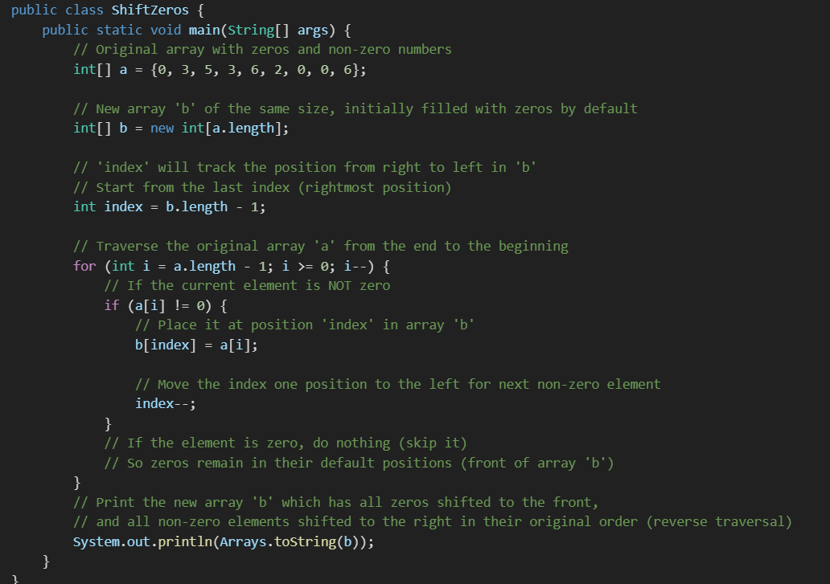
- Original array:
{0, 3, 5, 3, 6, 2, 0, 0, 6}
- New array b:
Initialized as {0, 0, 0, 0, 0, 0, 0, 0, 0} by default.
- Traverse a from right to left:
Starting from last element 6 at index 8 → it’s not zero, so assign b[8] = 6, then index = 7
Next, element 0 at index 7 → skip
Element 0 at index 6 → skip
Element 2 at index 5 → b[7] = 2, index=6
Element 6 at index 4 → b[6] = 6, index=5
Element 3 at index 3 → b[5] = 3, index=4
Element 5 at index 2 → b[4] = 5, index=3
Element 3 at index 1 → b[3] = 3, index=2
Element 0 at index 0 → skip
- Final b after assignment:
{0, 0, 0, 3, 5, 3, 6, 2, 6}
Zeros stay at the front because the new array was initialized with zeros and you never overwrite those leading zero positions.

Summary:
- You copy only non-zero elements into the new array from the end towards the front.
- Remaining positions in b are zeros by default.
- This effectively shifts all zeros to the start, and keeps non-zero elements at the right side in the same relative order they appeared when traversed backward.
- The array length and order of non-zero elements in reverse traversal are preserved.
int[] a={1,0,4,5,0,7,3,2,0};
int index=a.length-1;

for(int i=a.length-1;i>=0;i--){
if(a[i]!=0){
a[index--]=a[i];
}
}
while(index>=0){
a[index--]=0; [0, 0, 0, 1, 4, 5, 7, 3, 2] in same array
}
System.out.println(Arrays.toString(a));
}
}

5 SUM OF 2 ARRAYS=
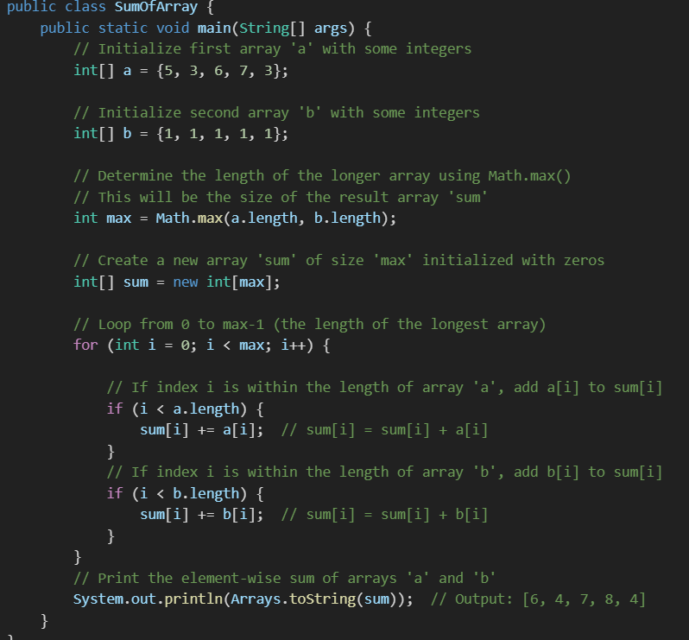
- Input arrays:
  - a = [5, 3, 6, 7, 3]
  - b = [1, 1, 1, 1, 1]
- The program calculates the element-wise sum of a and b.
- Since both arrays have the same length (5), max is 5.
- For each index i from 0 to 4:
  - Add a[i] to sum[i] if i is valid for a.
  - Add b[i] to sum[i] if i is valid for b.
- Resulting sum array is:
[5+1, 3+1, 6+1, 7+1, 3+1] → [6, 4, 7, 8, 4]

Why this approach?
- Using Math.max() and checking the index with if(i < array.length) helps the code to work correctly even if arrays a and b have different lengths.
- It avoids ArrayIndexOutOfBoundsException by making sure to only add elements from the arrays if the current index is valid.

Example if arrays had different lengths:
int[] a = {5, 3, 6};
int[] b = {1, 1, 1, 1, 1};
Output would be:
[6, 4, 7, 1, 1]
OR
for(int i=0;i<max;i++) {
if(i<a.length && i<b.length) {
sum[i]+=a[i]+=b[i]; }

6 PRINT THE POSITION OF DUPLICATED ELEMENTS IN ARRAY=
- IF MAP IS HAVING A[I] ADD INDEX TO THE MAP.
- IF MAP IS NOT HAVING A[I] ADD ARRAYLIST TO THE MAP.
- DECLARE AN ARRAY .
- CREATE A LINKED HASH MAP OF INTEGER AND ARRAYLIST TYPE.
- ADD THE ELEMENTS TO THE HASHMAP IF IT IS REPEATED ADD TO THE LIST.
- OTHERWISE ADD THE ELEMENT TO MAP WITH A ARRAYLIST.
// int[] a= {1,2,3,1,2,3,3,4};
// LinkedHashMap<Integer,ArrayList> hash=new LinkedHashMap();
//
// for(int i=0;i<a.length;i++) {
// if(hash.containsKey(a[i])) {
// hash.get(a[i]).add(i);
// }
// else {
// hash.put(a[i],new ArrayList());
// }
// }
// System.out.println(hash);
//}
//} // o/p {1=[3], 2=[4], 3=[5, 6], 4=[]}

Step-by-step explanation with example array:
a = {1, 2, 3, 1, 2, 3, 3, 4}
- Start with an empty map: {}
Iteration i=0, a[0]=1:
- 1 not in map → add key 1 with list [0]
- Map: {1=[0]}
i=1, a[1]=2:
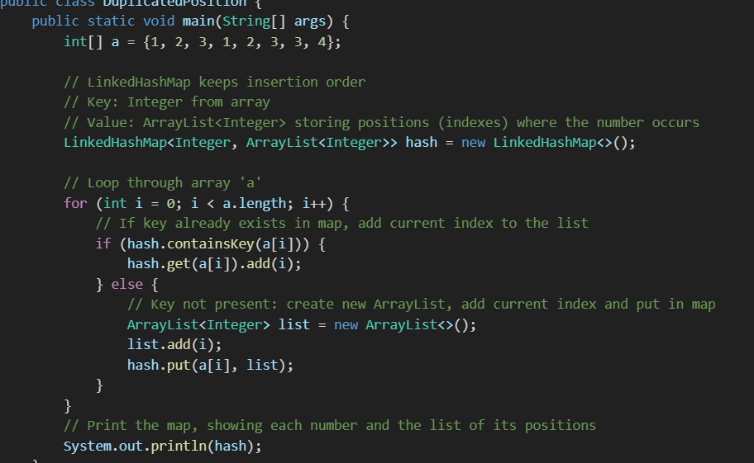
- 2 not in map → add key 2 with [1]
- Map: {1=[0], 2=[1]}
i=2, a[2]=3:
- 3 not in map → add key 3 with [2]
- Map: {1=[0], 2=[1], 3=[2]}
i=3, a[3]=1:
- 1 exists → add index 3 to list for key 1
- Map: {1=[0, 3], 2=[1], 3=[2]}
So the final output printed by System.out.println(hash); is:
{1=[0, 3], 2=[1, 4], 3=[2, 5, 6], 4=[7]}

// to print without empty array
int[] a= {1,2,3,1,2,3,3,4};
LinkedHashMap<Integer,ArrayList> hash=new LinkedHashMap();

for(int i=0;i<a.length;i++) {
if(hash.containsKey(a[i])) {
hash.get(a[i]).add(i);
}
else {
hash.put(a[i],new ArrayList());
}
}
for(Entry<Integer,ArrayList> map:hash.entrySet()) {
if(map.getValue().size()>1);
System.out.print(" ");
System.out.print(map.getKey()+"-"+map.getValue());
}
// 1-[3] 2-[4] 3-[5, 6]
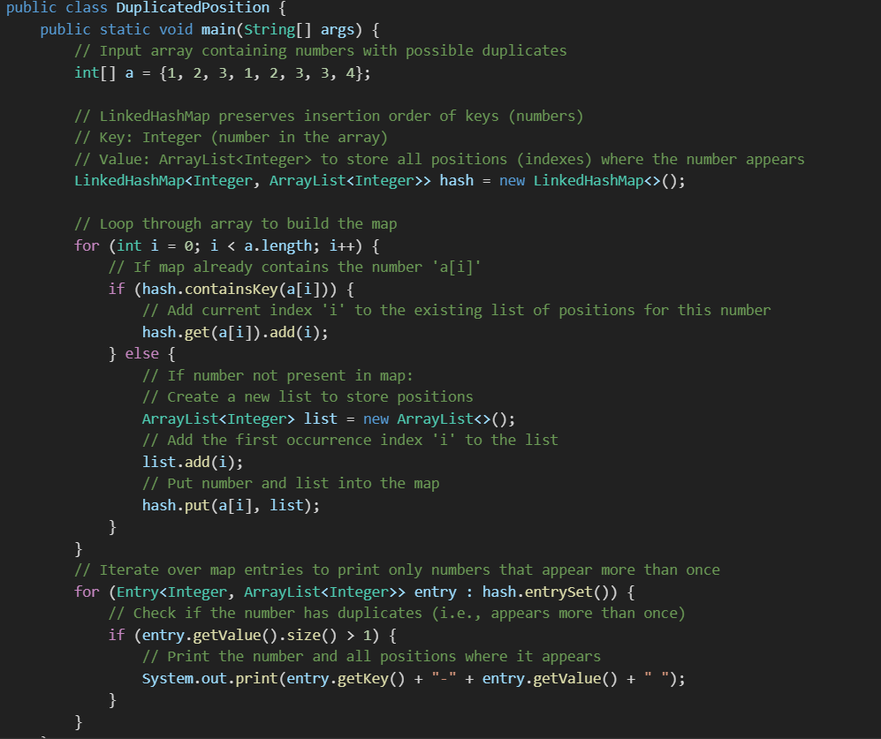
- Why we use LinkedHashMap (to keep the order).
- How the map stores numbers as keys and a list of all their positions as values.
- How the loop builds this map by either creating a new list or appending to an existing one.
- How the print loop only shows numbers with more than one occurrence.
- What the output represents: numbers and all their index positions.

Example output for this code:
1-[0, 3] 2-[1, 4] 3-[2, 5, 6]
This means:
- Number 1 appears at indexes 0 and 3
- Number 2 appears at indexes 1 and 4
- Number 3 appears at indexes 2, 5, and 6
- Number 4 appears only once, so it’s not printed

7 SUM OF ELEMENT EQUAL TO A SPECIFIC OR TARGET NUMBER IF TARGET SUM=9

8 65 to 90 A Z 97 TO 122 az
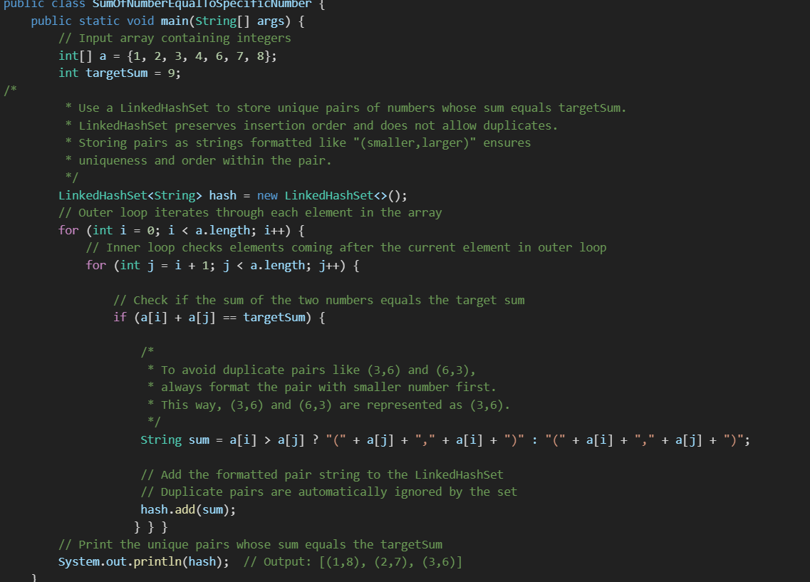
Explanation in depth:
- Input Array a: Holds the numbers to check pairs from.
- targetSum: The sum we want to find pairs for (9 in this case).
- Why LinkedHashSet?
  - Avoids duplicate pairs automatically.
  - Preserves the order pairs are found in.
- Nested Loops:
  - Outer loop picks a number.
  - Inner loop picks numbers coming after the outer loop’s current number to avoid checking the same pairs twice and avoid pairs like (a,b) and (b,a) both.
- Condition a[i] + a[j] == targetSum: Finds pairs whose sum matches the target.
- Pair formatting: Ensures pairs are always ordered smallest first for consistent and unique representation.
- Adding pairs to hash: Avoids duplicates, so only unique pairs remain.
- Output: Displays the unique pairs in insertion order.
- EXAMPLE = TARGET SUM =9

8 OCCRANCE OF A NUMBER AND CHARACTER=
int[] a={3,4,6,5,7,9,1,2,8,3};
boolean[] b=new boolean[a.length];
for(int i=0;i<a.length;i++){ //WITHOUT COLLECTION
if(b[i]==false){
int count=0;

for(int j=0;j<a.length;j++){
if(a[i]==a[j]){
b[j]=true;
count++;
}
}
if(count==2)
System.out.println(a[i]+" ---> "+count);

b = {false, false, false, false, false, false, false, false, false, false}
First Iteration (i = 0)
- b[0] == false → process a[0] = 3.
- Inner loop compares a[0] with all other a[j]:
  - Match at j = 0 → set b[0] = true.
  - Match at j = 9 → set b[9] = true.

TRIANGLE PATTERN=
- WE SHOULD ALWAYS GO FOR THE NESTED LOOP .
- OUTER LOOP USED TO PRINT THE LINES.
- INNER LOOP USED TO PRINT THE STARS.
- ALONG WITH ROWS i VALUE IS SAME .
- ALONG THE COLUMNS J VALUE IS SAME .
- WE ARE GOING TO MAKE USE OF RELATIONAL OPERATOR AND ARITHAMETICAL OPERATOR.
i\j | 1 | 2 | 3 | 4 | 5
1 | (1,1)* | (1,2) | (1,3) | (1,4) | (1,5)
2 | (2,1)* | (2,2)* | (2,3) | (2,4) | (2,5)
3 | (3,1)* | (3,2)* | (3,3)* | (3,4) | (3,5)
4 | (4,1)* | (4,2)* | (4,3)* | (4,4)* | (4,5)
5 | (5,1)* | (5,2)* | (5,3)* | (5,4)* | (5,5)*
j=1 → 1 >= 1 → print " *"  j=2 → 1 < 2 → print " "  j=3 → 1 < 3 → print " "  j=4 → 1 < 4 → print " "  j=5 → 1 < 5 → print " " | j=1 → 2 >= 1 → print " *"  j=2 → 2 >= 2 → print " *"  j=3 → 2 < 3 → print " "  j=4 → 2 < 4 → print " "  j=5 → 2 < 5 → print " "
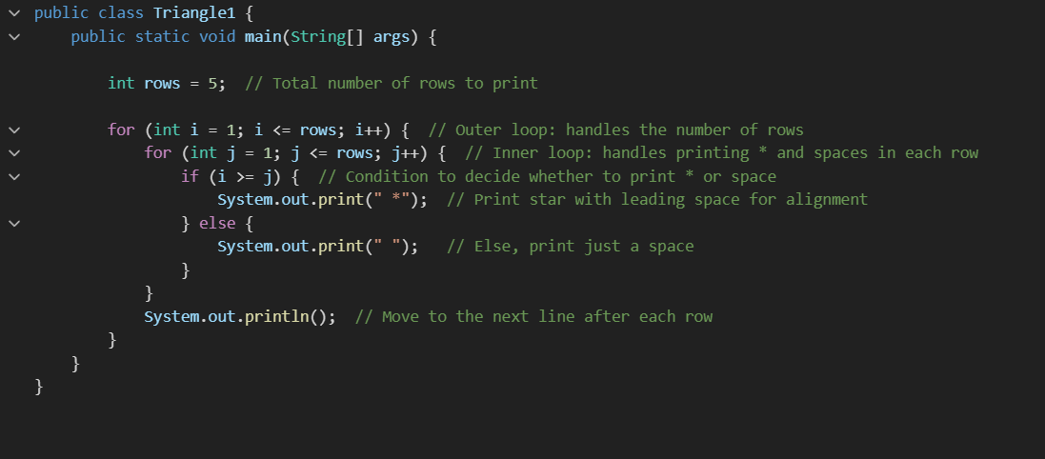
*
* *
* * *
* * * *
* * * * *
IF 1,1 2,2 3,3 = (I=J)
- OUTER LOOP RUNS FOR THE NUMBER OF ROWS .
- INNER LOOP PRINTS ‘*BASED ON THE CONDITION I>=J
- ELSE SPACE.

ABOVE THE DIAGNAL=
- i = current row
- j = current column
- Print "*" only if i <= j
- Else print space

📊 (i,j) Condition Table with Output Symbol
i\j | 1 | 2 | 3 | 4
1 | (1,1)* | (1,2)* | (1,3)* | (1,4)*
2 | (2,1) | (2,2)* | (2,3)* | (2,4)*
3 | (3,1) | (3,2) | (3,3)* | (3,4)*
4 | (4,1) | (4,2) | (4,3) | (4,4)*

🔍 Explanation:
Each cell contains:
- (i,j)* → condition i <= j is true, so "*" is printed
- (i,j) → condition is false, so " " is printed

🧾 Actual Output Pattern:
****
***
**
*
(Each line shifts right with increasing i, due to leading spaces)
public class AboveDiagnal {
public static void main(String[] args) {

int row=4;

for(int i=1;i<=row;i++) { // START 1 TO ADD ROW (IF ZERO LEAVE EMPTY)
for(int j=1;j<=row;j++) {
if(i<=j) {
System.out.print("*"); TRUE PRINT STAR
}
else {
System.out.print(" "); FALSE PRINT SPACE
}
}
System.out.println(); AFTER EVERY LOOP PRINT SHIFT NEXT LINE.
}

Left diagnal=
public class leftDiagnal {
public static void main(String[] args) {
int row=11;

for(int i=1;i<=row;i++) {
for(int j=1;j<=row;j++) {
if(i+j<=row+1) {
System.out.print("*");
}else
System.out.print(" ");
}
System.out.println(); ****
} ***
} **
} *

Below secondry diagnal=
public class DiagnalLast {
public static void main(String[] args) {
int row=4;

for(int i=1;i<=row;i++) {
for(int j=1;j<=row;j++) {
if((i+j)>=(row+1)) {
System.out.print("*"); *
} **
Else ***
System.out.print(" "); ****
}
System.out.println();
}

Number triangle
public class NumberTriangle {
public static void main(String[] args) {
int row=9;

for(int i=1;i<row;i++) {
for(int j=1;j<=row;j++) {
if(i>=j) {
System.out.print(j+" ");
}else
System.out.print(" ");
}
System.out.println();
}
1
1 2
1 2 3
1 2 3 4
1 2 3 4 5
1 2 3 4 5 6
1 2 3 4 5 6 7
1 2 3 4 5 6 7 8
public class BelowDiagnalNumber {
public static void main(String[] args) {
int row=7;

for(int i=1;i<=row;i++) {
int k=1;

for(int j=1;j<=row;j++) {
if(i+j>=row+1) {
System.out.print((k++) +" ");
}else
System.out.print(" ");
}
System.out.println();
}
}
1
1 2 OUTSIDE THE LOOP K WILL BE INCREASED IN OUTER LOOP K WILL BE ALWAYS START FROM 1 WHEN INITIALIZED
1 2 3
1 2 3 4
1 2 3 4 5
1 2 3 4 5 6
1 2 3 4 5 6 7

REVERS STRING AND PRINT THE SUBSTRING =
public class ReverseSubString {
public static void main(String[] args) {
String s = "Hello";
s=new StringBuilder(s).reverse().toString();
for(int i=1;i<=s.length();i++) {
System.out.print(s.substring(0,i)+" ");
}
} //o ol oll olle olleH
}

Pattern=
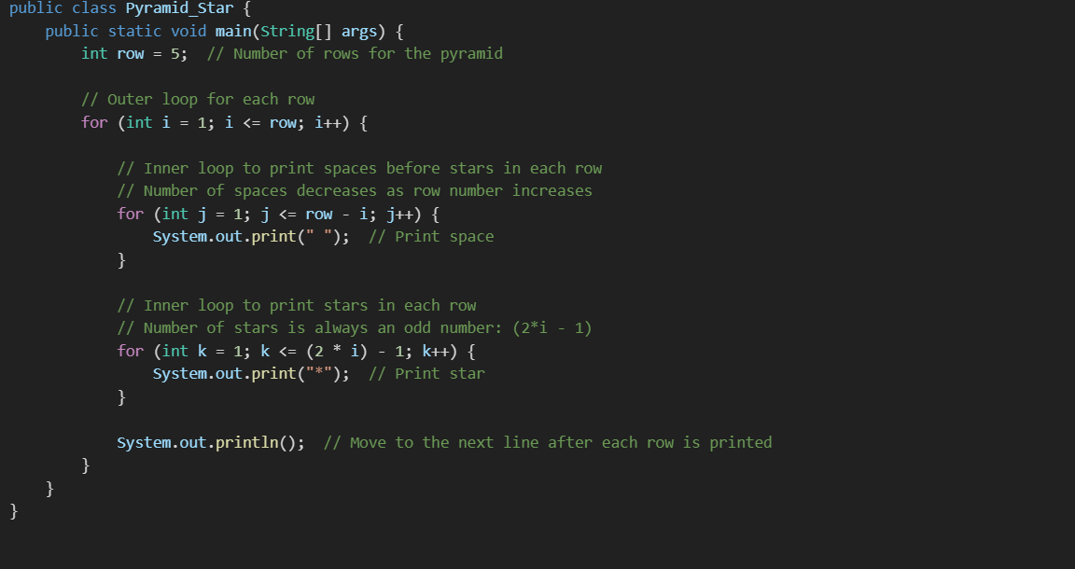
* ← 4 spaces + 1 star
*** ← 3 spaces + 3 stars
***** ← 2 spaces + 5 stars
******* ← 1 space + 7 stars
********* ← 0 spaces + 9 stars

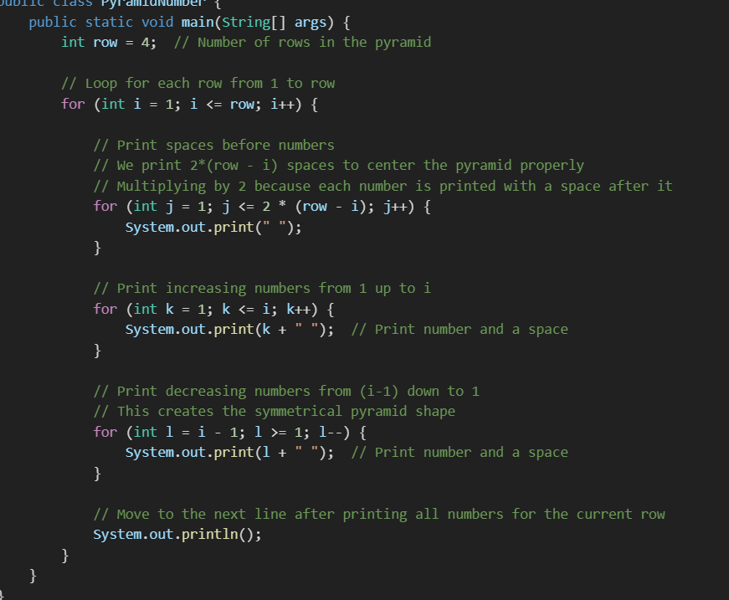
1
1 2 1
1 2 3 2 1
1 2 3 4 3 2 1

NUMBER PROGRAME

If working with numbers for addition use 0 for multiplication use 1.

PRIME NUMBER=
- PRIME NUMBERS ARE 2,3,5,7.
- ONLY 2 IS THE EVEN NUMBER
- PRIME NUMBER WILL BE ALWAYS ODD .
- IF IT IS A ODD NUMBER AND IF IT IS ONLY 2 DEVISERS LIKE 5,3,7 THEN THEY ARE CALLED AS PRIME NUMBER .
- DIVISIBLE BY 1 AND ITSELF IS A PRIME NUMBER .
- SO WE ITTERATE NUMBER BETWEEN 2 TO N-1 (ORIGINAL NUMBER) SO 7 IS A PRIME NUMBER.
- IF ANY NUMBER NOT DIVISIBLE BY 2 AND N-1 IT IS NOT A PRIME NUMBER.
- • 2 → (only divisible by 1 and 2) → ✅ prime
- • 3 → (only divisible by 1 and 3) → ✅ prime
- • 5 → (only divisible by 1 and 5) → ✅ prime
- 1 → Only one divisor (just 1) → ❌ not prime
- 4 → Divisors: 1, 2, 4 → ❌
- 6 → Divisors: 1, 2, 3, 6 → ❌
9 → Divisors: 1, 3, 9 → ❌
public class PrimeNumber { // Declares the PrimeNumber class
public static void main(String[] args) { // Main method, entry point of the program
int num = 4; // Declare and initialize the number to check for primality
boolean flag = true; // Flag to indicate if the number is prime; true means prime by default

// Check if the number is less than or equal to 2
if (num <= 2) {
flag = false; // Set flag to false as numbers <= 2 (except 2) are not prime
} else {
// Loop from 2 to num - 1 to check for factors
for (int i = 2; i <= num - 1; i++) {
if (num % i == 0) { // If num is divisible by any i
flag = false; // It's not a prime number
break; // Exit the loop early
}
}
}
// Output the result based on the flag value
if (flag) {
System.out.print(num + " is primeNumber");
} else {
System.out.println(num + " is not a primeNumber");
}
}

2 FIBANOCI SERIES=
- IT SHOULD START FROM 0.
- The Fibonacci series is a sequence of numbers in which each number is the sum of the two preceding ones, usually starting with 0 and 1.
public class FibannociSeries {
public static void main(String[] args) {

int a = 0; // First number of the Fibonacci series
int b = 1; // Second number of the Fibonacci series

// Loop to print the first 10 Fibonacci numbers
for (int i = 1; i <= 10; i++) {
System.out.print(a + " "); // Print current number

int c = a + b; // Calculate next number in the series
a = b; // Move to next: a becomes b
b = c; // b becomes the new calculated value
}
} 0/P 0 1 1 2 3 5 8 13 21 34

3 FACTORIAL=
- The factorial of a number n (written as n!) is the product of all positive integers from 1 to n.
- Examples:
- 5! = 5 × 4 × 3 × 2 × 1 = 120
- 4! = 4 × 3 × 2 × 1 = 24
- 1! = 1
- 0! = 1 (by definition)
public class FactorialExample {
public static void main(String[] args) {
int num = 5; // Change this to calculate factorial of another number
int fact = 1;

for (int i = 1; i <= num; i++) {
fact = fact * i;
}

System.out.println("Factorial of " + num + " is: " + fact);
}
} O/P 120

4 POWER OF NUMBER=
- In mathematics, when we say "a raised to the power b" (written as a^b), it means multiplying the number a by itself b times.
- • 2^3 = 2 × 2 × 2 = 8
- • 5^0 = 1 (any number to the power of 0 is 1)
- • 3^4 = 3 × 3 × 3 × 3 = 81
public class PowerOfNumber { // Class declaration

public static void main(String[] args) { // Main method

int num = 25; // The base number (number to be raised to a power)
int power = 2; // The exponent (power to raise the base to)
int pro = 1; // Variable to store the final result, initialized to 1

// Loop to multiply the number 'power' times
for (int i = 1; i <= power; i++) {
pro = pro * num; // Multiply 'pro' by 'num' in each iteration
}
// Print the result
System.out.println(pro); // Output: 25^2 = 625 (25*25)
} }
//
// How it works (example for num = 25, power = 2):
//Initially, pro = 1
//
//First iteration: pro = 1 * 25 = 25
//
//Second iteration: pro = 25 * 25 = 625
//
//Final output: 625

5 SWAP 2 NUMBERS WITHOUT USING 3 RD VARIABLE=
public class SwapNumbers {
public static void main(String[] args) {
int a = 10;
int b = 20;

System.out.println("Before swap: a = " + a + ", b = " + b);

// Swapping without using a third variable
a = a + b; // a = 10 + 20 = 30
b = a - b; // b = 30 - 20 = 10
a = a - b; // a = 30 - 10 = 20

System.out.println("After swap: a = " + a + ", b = " + b);
}
} Before swap: a = 10, b = 20 After swap: a = 20, b = 10

6 PALINDROME=
package NumberProgrammes;

public class Pallindrome { // Class definition (Note: correct spelling is "Palindrome")
public static void main(String[] args) { // Main method

int num = 121; // Original number to check
int rev = 0; // Variable to store the reversed number
int temp = num; // Copy of the original number to use later for comparison

// Loop to reverse the number
while(num > 0) {
int d = num % 10; // Extract the last digit
rev = rev * 10 + d; // reversed number
num = num / 10; // Remove the last digit from num
}

// Check if the reversed number is the same as the original
if(temp == rev) {
System.out.println(temp + " is palindrome");
} else {
System.out.println(temp + " is not a palindrome");
}
}
}
// 121 % 10 = 1 → last digit // rev = 0 * 10 + 1 = 1
//
// rev = 0 * 10 + 1 = 1 //rev = 1 * 10 + 2 = 12
//
// num = 121 / 10 = 12 //rev = 12 * 10 + 1 = 121
//
// Repeat until num becomes 0
//
// Final rev = 121, which matches the original → it's a palindrome!

7 DENOMINATION OF THE CURRENCY=
public class DenominationOfTheCurrency {
public static void main(String[] args) {

int amount = 2888; // The total amount to break down into currency notes

// Array of currency notes in descending order (largest to smallest)
int[] notes = {2000, 500, 200, 100, 50, 20, 10, 5, 2, 1};

// Loop through each denomination to find out how many notes are needed
for (int i = 0; i < notes.length; i++) {
int deno = amount / notes[i]; // Calculate number of notes for current denomination

System.out.println(notes[i] + " -- " + deno); // Print denomination and count

amount = amount % notes[i]; // Update amount with the remainder } }
}

8 NUMBER DIVISIBILITY=
package NumberProgrammes;

public class NumberDivisibility {
public static void main(String[] args) {
int num = 21; // Number to check divisibility for

// Check if number is divisible by both 5 and 3
if (num % 5 == 0 && num % 3 == 0) {
System.out.println("hai bye");
}
// Check if number is divisible only by 5
else if (num % 5 == 0) {
System.out.println("hai");
}
// Check if number is divisible only by 3
else if (num % 3 == 0) {
System.out.println("bye");
}
// If not divisible by 3 or 5, no output (you can add an else if you want)
}
}

}

No collection

reverse
@Test
public void reverse() {
String s = "representational state transfer restful";
String[] sa = s.split(" ");
for (int i = 0; i < sa.length; i++) {
if (sa[i].equalsIgnoreCase("state") || sa[i].equalsIgnoreCase("restful")) {

sa[i] = new StringBuffer(sa[i]).reverse().toString();
}
}
System.out.println(Arrays.toString(sa));
} 0/p representational", "etats", "transfer", "lufthser"

reverse
@Test
public void covert() {
String s="who knows how its made"; //reverse 1 how 2 made
String[] k=s.split(" ");
for(int i=0;i<k.length;i++) {
if(k[i].equalsIgnoreCase("how")|| k[i].equalsIgnoreCase("made")){
k[i]=new StringBuffer(k[i]).reverse().toString();
System.out.print(k[i]+" ");
}
else {
System.out.print(k[i]+" ");
}
}
} 0/p who knows woh its edam

Using for each
@Test
public void covert() {
String s = "who knows how its made";
String[] ki = s.split(" ");

for (String k: ki) {
if (k.equalsIgnoreCase("how") || k.equalsIgnoreCase("made")) {
k = new StringBuffer(k).reverse().toString();
System.out.print(k + " ");
} else {
System.out.print(k + " ");
}
}
}

Longest word
@Test
public void longestWord() {

String s = "writable smjhjkart insert";
String[] sep = s.split(" ");
String length = "";

for(String se:sep) {
if(se.length()>length.length()) {
length=se;
}
}
System.out.println(length);
}
} o/p smjhjkart

Remove duplicate without collection=
@Test
public void removeDuplicate() {

String a="hi hello hi hello how ar ehoasfd who";
String[] ab= a.split(" ");
String sa="";
for(int i=0;i<ab.length;i++){
if(!(sa.contains(ab[i]))){
sa=sa.concat(ab[i]+" ");
}
}
System.out.println(sa);
}
}

Triangle 3 skip

class Main {
public static void main(String[] args) {
int row=5;

for(int i=1;i<=row;i++){
int num=i;
for(int j=1;j<=i;j++){
if(i>=j){
System.out.print(num); 1
num+=3; 2 5
} 3 6 9
System.out.print(" "); 4 7 10 13
}
System.out.println();
}

Even odd triangle
class Main {
public static void main(String[] args) {
int row=5;

for(int i=1;i<=row;i++){

int start=(i%2==0)?2:1;
for(int j=1;j<=i;j++){
System.out.print(start+" ");
start+=2; 1
} 2 4
System.out.print("\n"); 1 3 5
} 2 4 6 8
System.out.println();
}
}

Reverse a word from sentence
// without hard coding
class Main {
public static void main(String[] args){
String sa="windows path linux path mac path are different";
String[] ab=sa.split(" ");
for(int i=2;i<ab.length;i++){
ab[i]= new StringBuffer(ab[i]).reverse().toString();
break;
}
System.out.println(Arrays.toString(ab));
}
}

windows path xunil path mac path are different
}

Print till sorted array
@Test
public void printTillSortedIndex() {
int[] a={9,8,7,6,5,1,2};

for(int i=0;i<a.length-1;i++){
if(a[i]>a[i+1]){
continue;
}
else{
System.out.println(i);
}
}
} 0/p 5
}

merge and sort the array=
@Test
public void mergeArraysAndSort() { //2 arrays sort them

int a[]={1,2,3,4,5,6,7,8};
int[] b={9,7,5,7,8,97,9};
int[] res=new int[a.length+b.length];
int ndex=0;
for(int i=0;i<res.length;i++){
if(i<a.length){
res[i]=a[i];
}else{
res[i]=b[ndex++];
}
}
for(int i=0;i<res.length;i++){
for(int j=i+1;j<res.length;j++){
if(res[i]>res[j]){
int temp=res[i];
res[i]=res[j];
res[j]=temp;
}
}}
System.out.println(Arrays.toString(res));
} } [1, 2, 3, 4, 5, 5, 6, 7, 7, 7, 8, 8, 9, 9, 97]

Reverse half word=
public class ReverseFirstWord {
public static void main(String[] args) {
String input = "goodhello";

// Split into two parts
String firstPart = input.substring(0, 4); // "good"
String secondPart = input.substring(4); // "hello"

// Reverse the first part
String reversed = new StringBuilder(firstPart).reverse().toString();

// Concatenate and print
String output = reversed + secondPart;
System.out.println("Output = " + output); // Output = dooghello
}
Or
System.out.print("Enter input string: ");
String input = sc.nextLine();

// Assume first 4 characters are to be reversed
String reversed = "";
for (int i = 3; i >= 0; i--) {
reversed += input.charAt(i);
}

String output = reversed + input.substring(4);
System.out.println("Output = " + output);
}
}

Last half number is decending number
int[] a={1,2,3,4,5,6,7,8,9,1,2};
int half=a.length/2;

for(int i=half;i<a.length;i++){
for(int j=i+1;j<a.length;j++){
if(a[i]>a[j]){
int temp=a[j];
a[j]=a[i];
a[i]=temp;
}
}
}
System.out.println(Arrays.toString(a));

} [1, 2, 3, 4, 5, 1, 2, 6, 7, 8, 9]
}

Happy number total 2 digits (bidirectional) if get mutliple total that digits
class Main {
public static void main(String[] args) {
int n=34912375; 3+4=7+9=16=6+1=7 till all numbers
int sum=0;

while(n>0){
int d=n%10;
sum=sum+d;
n=n/10;

if(sum>9){
int frs=sum%10;
sum=sum/10;
sum=sum+frs;
}
}
System.out.println(sum);
}
}
Or
class Main {
public static void main(String[] args) {
int num=1265;
int sum=0;
while(num>0){
int d=num%10;
num=num/10;
sum+=d;
}
if(sum>9){
int nu=sum%10;
int v=sum/10;
sum=v+nu;
}
System.out.println(sum);
}
}

Reverse only characters in a string
class Main {
public static void main(String[] args) {
String a="kjf35&^%abc354";
String b= a.replaceAll("[^a-z]","");
int index=b.length()-1;
for(int i=0;i<a.length();i++){
char ch =a.charAt(i);
if(!Character.isAlphabetic(ch)){
System.out.print(ch);
}
else{
System.out.print(b.charAt(index--));
}
}

}
} reverse alhabet

UNIQUE OR DUPLICATE=
@Test
public void uniquSingle() {
String s="java";

for(int i=0;i<s.length();i++) {
char ch=s.charAt(i);

if(s.indexOf(ch)==s.lastIndexOf(ch)) { //index does not match
System.out.println(ch);
}
} unique in a string j and v
}

WORD OCCURRED IN A STRING USING SPLIT=
==================================================================================
@Test
public void printOnlyHowMany() {
String input = "javaseleniumjavapython";
String val="java";

int count= input.split(val,-1).length-1;

System.out.println(val+" repeated "+count);
}
Or
System.out.println(input.split(val).length) o/p = 2

Java repeated 2 times
=========================================================================
@Test
public void max$min(){
int[] a= {5,3,6,3,2,1,5,6,8,9};

TreeSet set=new TreeSet();
for(int i=0;i<a.length;i++) {
set.add(a[i]);
}

System.out.println(set.last()); max array
System.out.println(set.first()); min array
}

TRIPLTES =
@Test
public void trippletTest(){
int[] a= {1,2,2,2,3,6,6,6,4,5,6,6,6,7};
int count=0;
for(int i=0;i<a.length-3;i++) {
if(a[i]==a[i+1] && a[i]==a[i+2] && a[i]!=a[i+3]) {
count++;
}
}
System.out.println(count);

}
//triplets (not proper last missing)

TREE SET SECOND MAX AND MIN ARRAY=
int[] a={3,2,4,5,6,7,3,7,8,9,1,3,9};
TreeSet<Integer> set =new TreeSet();

for(int i=0;i<a.length;i++){ array max , array min
set.add(a[i]);
} //outside for loop or arrayindexoutof bounds exception
int d=set.last();
set.remove(d);
System.out.println(set.last()+" second Max array"); =8

int f=set.first();
set.remove(f);
System.out.println(set.first()+" second minimum array"); =2

CHECK IF IT IS SORTED ARRAY=
int[] a = { 1, 2, 3, 4, 5 };

boolean came = true;
for (int i = 0; i < a.length - 1; i++) {
if (a[i] > a[i + 1]) {
came = false;
}
}
if (came) {
System.out.println("it is sorted");
} else {
System.out.println("it is not sorted");
}
}

ARRAYS OF ANAGRAME
String[] str = { "eat", "tea", "tan", "ate", "nat", "bat" };

HashMap<String, List<String>> map = new HashMap();

for (String s : str) {
char[] ch = s.toCharArray();
Arrays.sort(ch);

String sorted = new String(ch);

if (!map.containsKey(sorted)) {
map.put(sorted, new ArrayList());
} does not contain then add
map.get(sorted).add(s);
}
for (List<String> group : map.values()) {
System.out.println(group);
}
[bat] [nat, tan] [eat, tea, ate]

TRIPLETS AND QUADRUPLTES
int[] arr = { 0, 2, 1, 1, 1, 1, 2, 0, 2, 2, 2, 2, 5, 2, 6, 6, 6 };
int triplete = 0;
int quadruplets = 0;

int count=1;

for(
int i = 1;i<arr.length;i++)
{
if (arr[i] == arr[i - 1]) {
count++;
} else {
if (count == 3)
triplete++;
if (count == 4)
quadruplets++;
count = 1;
}
} //to select last integer
if(count==3)triplete++;
if(count==4)quadruplets++;

System.out.println(triplete);
System.out.println(quadruplets);
}}

Functional interface=
package Lamda;

public interface LambdaEx {
void ma();
}
Lambda utilitzation
public class LamdaEx2 {
public static void main(String[] args) {
LambdaEx ref = () -> {

System.out.println("hello");
};
ref.ma();
}
}
public interface LamPara {

public void add(int a,int b);
}
public class LamPEx {
public static void main(String[] args) {
LamPara ref = (a, b) -> {
System.out.println(a + b);
};
ref.add(40, 30);

LamPara f = (a, b) -> {
System.out.println(a - b);
};
f.add(50, 30);

LamPara k = (a, b) -> {
System.out.println(a * b);
};
k.add(64, 2);
}

Stream api java 1.8
- Return type of stream is stream .
- Only used for collection and array.
- Sorted()=sort
- Distict()=remove duplicate
- Parrallel stream executiosn using multiple streams like=
- int[] d=Arrays.stream(a).distinct().sorted().toArray();
- Filter takes 3 expressions
- int b[]=Arrays.stream(a).filter(i->i%2==0).toArray();
- 1 i 2 i%2 3==0
- Even or odd numbers
- int j[]= Arrays.stream(a).distinct().sorted().filter(i->i%2==0).toArray();
public class CollectionStream {
public static void main(String[] args) {
List<String> s = Arrays.asList("java", "selenium", "sql", "restAssured", "pm");

// without using add mehtod

System.out.println(s);

// directly using collection ref
List<String> p = s.stream().map(a -> a.toUpperCase()).collect(Collectors.toList());

System.out.println(p);
}
}
public class MStream {
public static void main(String[] args) {
int[] a = { 5, 4, 3, 7, 8, 9, 6 };

int j[] = Arrays.stream(a).distinct().sorted().filter(i -> i % 2 == 0).toArray();

System.out.println(Arrays.toString(j));

String m = Arrays.stream(j).max().toString();
Or
int m = Arrays.stream(j).max().getAsInt();

System.out.println(m);
}
For string use this
System.out.println(list.stream().max(String::compareTo).get()); (lengthy word)
System.out.println(list.stream().min(String::compareTo).get()); (short word) ==for String
public class StreamApi {

public static void main(String[] args) {
int a[]= {10,20,48,47,92,10,20};

int b[]= Arrays.stream(a).sorted().toArray();
System.out.println(Arrays.toString(b));

//privious object is not modified with the help of stream

int[] c=Arrays.stream(a).distinct().toArray();
System.out.println(Arrays.toString(c));

int[] d=Arrays.stream(a).distinct().sorted().toArray();
System.out.println(Arrays.toString(c));

}
}

FIND THE MISSING NUMBER=
public static void main(String[] args) {
int[] a={9,5,8,6};
Arrays.sort(a);

for(int i=0;i<a.length-1;i++){
if(a[i+1]-a[i]>1){
System.out.println(a[i]+1);
break; }
}
}
}

✅ What is compareTo()?
The compareTo() method is part of the Comparable interface in Java (java.lang.Comparable). It is used to compare two objects of the same type to determine their natural order (e.g., ascending or descending).
- "Cat" vs "Dog":
- 'C' = 67
- 'D' = 68
- So 67 - 68 = -1 → "Cat" comes before "Dog".
- it is used to compare all alphabets from first s1 and s2 c-d , a-o, t-g ,
- 1st if its not zero it will stop at there.
@Test
public void compareToMethdo() {
String[] ch= {"a","b","c","a","c"};
for(int i=0;i<ch.length;++i) {
for(int j=i+1;j<ch.length;++j) {

if(ch[i].compareTo(ch[j])==0) {
System.out.println(ch[j]+" ");
break;//to avoid printing duplicate multiple times
}
}
}

Find duplicat / unique in 2 arrays=
import java.util.Map.Entry;
class Main {
public static void main(String[] args) {
String[]s1={"emma","ella","ravi","nadeen"};
String[]s2={"meera","shali","emma","raveesh","ella"};

LinkedHashMap<String, Integer> hash=new LinkedHashMap<>();

for(String s:s1){
hash.put(s,hash.getOrDefault(s,0)+1);
}
for(String s:s2){
hash.put(s,hash.getOrDefault(s,0)+1);
}
for(Entry<String, Integer> map:hash.entrySet()){
if(map.getValue()==1){
System.out.println(map.getKey());
}
}

@Test //merge import java.util.stream.*;
public void conca() {
int[] a = { 1, 2, 3, 4, 5 };
int[] b = { 1,2,3,6, 10 };
//merge use intStream , doubleStream
//IntStream.concat(Arrays.stream(a), Arrays.stream(b)).forEach(System.out::print);

IntStream.concat(Arrays.stream(a), Arrays.stream(b)).sorted().distinct().forEach(n->System.out.print(n+" "));

- Collections.sort(list); // list = [A, B, D, E, Z]
- Collections.sort(list, reverseComparator); // list = [Z, E, D, B, A]
- String max = Collections.max(list); // max = "E"
- String min = Collections.min(list); // min = "A"
- // Replace All
- Collections.replaceAll(list, "C", "Z"); // list = [A, B, Z, D, E]

- // Reverse
- Collections.reverse(list); // list = [E, D, Z, B, A]

Collection =

1.occurance
public void get() {
String a="Stringhg";
(for multiple words , char ,or int anything occurance use this logic only)
HashMap<Character,Integer> hash=new HashMap();

for(int i=0;i<a.length();i++) { or for(char s:a.toCharArray(){
char ch=a.charAt(i); hash.put(s,hash.getOrDefault(s,0)+1);
hash.put(ch, hash.getOrDefault(ch, 0)+1);
}
System.out.println(hash);

} {r=1, S=1, t=1, g=2, h=1, i=1, n=1}

2.merge array and sort =
public void get() {
int[] a= {1,2,3,4};
int[] b= {6,7,8,9};
ArrayList<Integer> list=new ArrayList();
for(int aa:a) {
list.add(aa);
}
for(int bb:b) {
list.add(bb);
}
Collections.sort(list);
System.out.println(list);
}
} [1, 2, 3, 4, 6, 7, 8, 9]

3.IN DESCENDING ORDER =
int[] a= {1,2,3,4};
int[] b= {6,7,8,9};
ArrayList<Integer> list=new ArrayList();
for(int aa:a) {
list.add(aa);
}
for(int bb:b) {
list.add(bb);
}
Collections.sort(list);
Collections.reverse(list);
System.out.println(list);
}
} [9, 8, 7, 6, 4, 3, 2, 1]

4.maximum and minimum values=
public void get() {
int[] a= {1,2,3,4};
int[] b= {6,7,8,9};
ArrayList<Integer> list=new ArrayList();
for(int aa:a) {
list.add(aa);
}
for(int bb:b) {
list.add(bb);
}
System.out.println(Collections.max(list));
System.out.println(Collections.min(list));
}

5.freqency how many times it occred=
int[] a= {1,2,3,4};
int[] b= {6,7,8,9,1};
ArrayList<Integer> list=new ArrayList();
for(int aa:a) {
list.add(aa);
}
for(int bb:b) {
list.add(bb);
}
System.out.println(Collections.frequency(list,1));
} 2

6.using string frequency=
String a[]= {"mellon","coconut","peach","Apple"};
String b[]= {"coconut","peach","timeger"};
ArrayList<String> list=new ArrayList();
for(String aa:a) {
list.add(aa);
}
for(String bb:b) {
list.add(bb);
}
Collections.sort(list);
System.out.println(list);
System.out.println(Collections.frequency(list,"coconut")); 2
}

Occurance=(consequtive)
int[] a= {1,1,0,1,0,0,1,1,1} ;
int maxCount=1;
int count=1;
for(int i=1;i<a.length;i++){
if(a[i]==a[i-1]){
count++;
}else{
maxCount=Math.max(maxCount,count);
}
}
System.out.println(maxCount);
o/p = 3
}

List<String> s = Arrays.asList("Apple","ant","bat","ball","bannana","cat","apple","",null);

ArrayList<String> list = new ArrayList<>();
for(String sa : s){
if(sa != null && !sa.isEmpty()){
list.add(sa.trim()); // remove trailing spaces like "cat " or "apple "
}
}
Collections.sort(list);

HashMap<String, List<String>> map = new HashMap<>();
for(String li : list){
char ch = li.charAt(0);
String m = String.valueOf(ch).toLowerCase();

// If key doesn't exist, create a new list
map.putIfAbsent(m, new ArrayList<>());
// Always add the element
map.get(m).add(li);
}

System.out.println(map);
}
} {a=[Apple, ant, apple], b=[ball, bannana, bat], c=[cat]}

Remove duplicate using arrayList()
class Main {
public static void main(String[] args) {
List<Integer> list = new ArrayList<>(Arrays.asList(1, 2, 3, 4, 3, 2));

for (int i = 0; i < list.size(); i++) {
for (int j = i + 1; j < list.size(); j++) {
if (list.get(i).equals(list.get(j))) {
list.remove(j);
j--; // adjust index after removal
}
}
}
System.out.println(list);
}
}
upperCase=
String word = "hello";
String result = "";

for (int i = 0; i < word.length(); i++) {
char ch = word.charAt(i);
if (ch >= 'a' && ch <= 'z') {
ch = (char)(ch - 32); // convert to uppercase
}
result += ch;
}

System.out.println(result); HELLO

REMOVE DUPLICATE

String[] a = {"boolean", "int", "char", "string", "int", "boolean"};

// Convert array to list (because indexOf/lastIndexOf are in List, not array)
List<String> list = Arrays.asList(a);

for (int i = 0; i < list.size(); i++) {
String element = list.get(i);
if (list.indexOf(element) == list.lastIndexOf(element)) {
System.out.println(element);
}}
============================================================================ remove duplicate using array
Missing number
public class MissingNumbers {
public static void main(String[] args) {
int[] a = {4, 3, 6, 1, 10};
Arrays.sort(a);

for (int i = 0; i < a.length - 1; i++) {
if (a[i+1] - a[i] > 1) {
for (int j = a[i] + 1; j < a[i+1]; j++) {
System.out.println(j);
}
}
}
}
}

Missing number using collection=
int[] a= {5,4,6,8,1};

HashSet<Integer> set = new HashSet();

for (int aa : a) {
set.add(aa);
}
int num = Collections.max(set);
int min= Collections.min(set);

for (int i = min; i < num; i++) {
if (!set.contains(i)) {
System.out.println(i);
}
}
}

