BEHAVIOUR DRIVEN DEVELOPMENT=

BDD=
it is a software development process that is used in agile process=
bdd is an itterative process which has 3 stpes
stpes are
1 discovery =findeing out what it could do
2.formulation = it defines what it should do
3.automation = where we decide where what it actually does.
bdd focuses on behaviour of the application

PREDECISES TLD AND TDD=
test last development(TLD) (normal selenium script)
which means testing is done at the end of development process (after developing then testing)(after cpding is done)
1 step process

test driven development(TDD)
test creation is done 1st then step coding.(developer create test maching required behaviour of the code then develop code in intention of test as to pass).(after testing , writing the code)
step by step incremental process
[create the tests(no actual code is present so fail) --> test fail --> write the required code for it (if the code is not enough if it is falining again & agian then add --> refractor tests]

--> this process continue until entire application is built ,extremly tedious and incremental helps to get very good qualit software

bdd is a extension of tdd --> similar bud tdd focuses on coding part(tdd focuses on coding part)(only technial member)(incremental process)
butt bdd focus behaviour of the application part(behaviour focuses of application part)(every one stholders,dev & te).(iterative processs)

BDD CUCUMBER=

to implement bdd in process we have multiple tools that are available in market=
1.cucumber , 2 behave , 3 jbehave ,4 specflow

cucumber can be used along with selenium and java
cucumber is a tool/framework --> this helps implement bdd

to work on cucumber we need to know ghekin language=
it provides redable language to understans what is being tested.

gherkin language=
is a parcable language ,it is very simple language to use
it is a combination of given ,when ,then.
helps what is being tested what is the result.

gherking keywords = given , when , and , then
given - works as a precodition
when - action to perform
and - it is used for concatination (like adding more precondition)
then - it is a keyword taht is used to perovide validation.

how to write user storys=
--------------------------

user storys are smaller chunk of entire requirement
feature =login
ex= login as user story

scenario=
1.user should be loged in using valid credentials

consider user story as 1 feature , scerario as scenario
to convert this into test steps we are going to use gharkin language keywords
when we combine everythig feature , scenario , teststep then we will get feature file .
Feature: Login

Scenario:
validate user is able to login using valid crdentials

Given Browser is open and URL is navigated
And Login page is displayed
When user enters valid username and valid password
And user clicks on login button
Then user should be successfully loged in
And browser should closed

cucumber is a tool to use external tools we need to add plugins
1.cucumber eclipse plugin

in ide =1.configure -> convert to cucumber project --> it is going to convert maven project into , cucumber maven project (so feature file is going to change)

should extend with .feature or itll is not a feature file
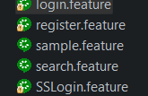

what is glucode
for a statement how to give implementation this implementation is gluCode.(providing implementation)

dependency (io.cucumber)
cucumber jvm : core=
cucumber jvm :java provide api to work with all cucumber and java
cucumber jvm :testNg unit testing tool api so that work with cucumber
dependency>
<groupId>io.cucumber</groupId>
<artifactId>cucumber-core</artifactId>
<version>7.14.0</version>
</dependency>

<!-- https://mvnrepository.com/artifact/io.cucumber/cucumber-java -->
<dependency>
<groupId>io.cucumber</groupId>
<artifactId>cucumber-java</artifactId>//gharking keywords and @before & @after
<version>7.11.2</version>
</dependency>
<dependency>
<groupId>org.seleniumhq.selenium</groupId>
<artifactId>selenium-java</artifactId>
<version>4.31.0</version>
</dependency>

<!-- https://mvnrepository.com/artifact/io.cucumber/cucumber-testng -->
<dependency>
<groupId>io.cucumber</groupId>
<artifactId>cucumber-testng</artifactId>//testng runner class, parallel execution
<version>7.14.0</version>
</dependency>

<dependency>
<groupId>com.aventstack</groupId>
<artifactId>extentreports</artifactId>
<version>5.1.2</version>
</dependency>

<!-- https://mvnrepository.com/artifact/tech.grasshopper/extentreports-cucumber7-adapter -->
<dependency>
<groupId>tech.grasshopper</groupId>
<artifactId>extentreports-cucumber7-adapter</artifactId>
<version>1.10.1</version>
</dependency>

undefined = scenario (implementation for the scenario is missing )
to provide implememtation glucode keyword it is used to provide implementation
also called as step defination.

in feature file statements are in yellow its just telling which is do not have guclode present.

introduction to runner class
runner class
@cucumberOptions annotation
cucumber options attribute

report generation using plugins
html& json reports
extent reports

Runner class
runner is a centralized place to execute feature files
using runner class we can execute all the feature files present in the package
runner class will automatically combine feature file with step defination without any extra code is required
runner class support junit and testng

@CucumberOptions
this annotation responsible to glue together feature file and step defination
also responsible to give you attribute to develop different kind of attributes

attribute=
features = give the location of the feature file (pacagename and feature)
glue = to specify step defination (packagename)

to run a runner class every single runner class must extend AbstractTestNgCucumverTests
@CucumberOptions(features = {"./src/test/java/features.login.feature"},glue = {"stepDefinition"}) package name of step defination , feature name of feature
public class CucumberRunner extends AbstractTestNGCucumberTests{

}

instead of providing name of the feature file we can give location until package name provide stepdefination package it wll execute all the feature and step files
@CucumberOptions(features = {"./src/test/java/features"},glue = {"stepDefinition"}) (only package names of both features and stepDefination)
public class CucumberRunner extends AbstractTestNGCucumberTests{

}

reports=ex
sample regression suite
when we execute regression suite -> get report -> report contains multiple attributes -> 1.how many test cases , 2.passed test cases , 3 failed test cases , 4.exceptions
for cucumber in test-outpit folder it shows index.html report
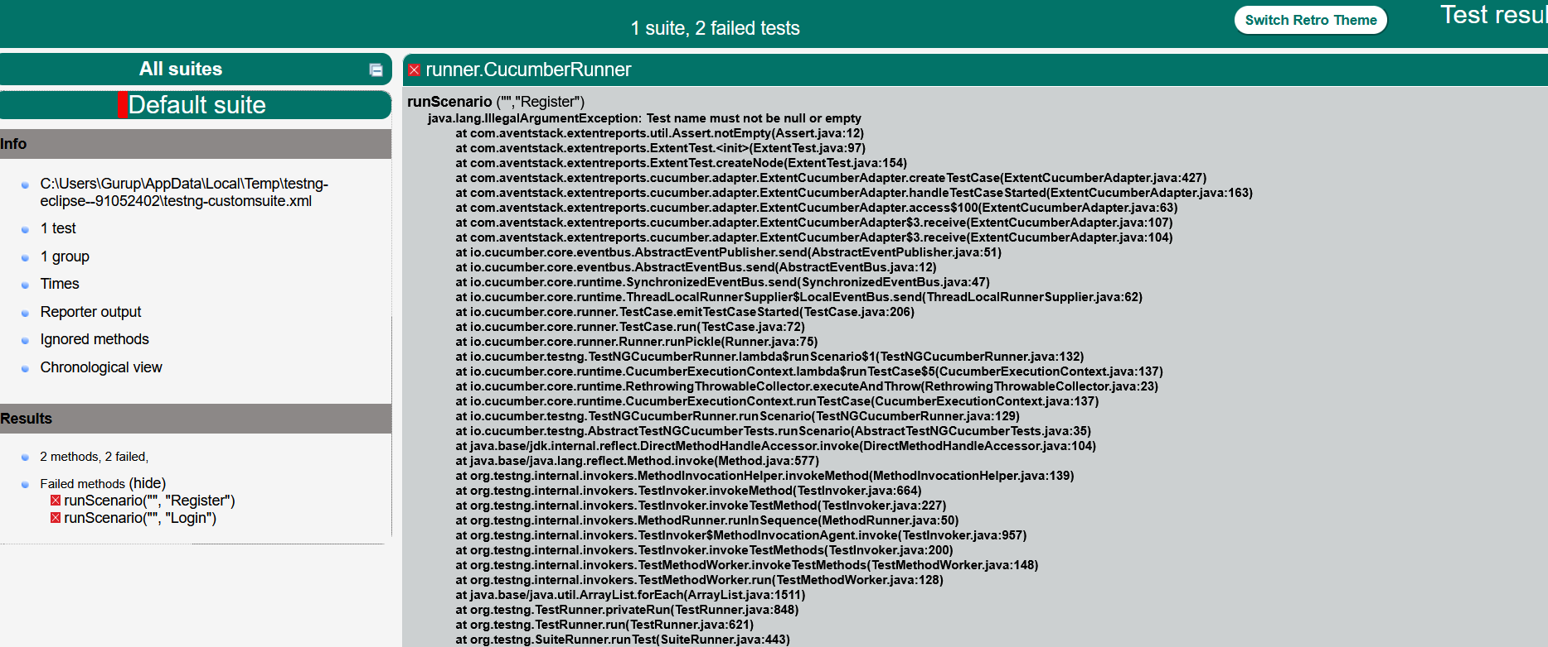
using runner we are going to generate cucumber html & json report using runner
using attribute plugin
plugin = built in plugin available in cucumber
,plugin = {"html:Reports/CucumberReports.html"})
to generate html report give execact Reports Folder name to save html report
@CucumberOptions(features = {"./src/test/java/features"},glue = {"stepDefinition"}
,plugin = {"html:Reports/CucumberReports.html"})
public class CucumberRunner extends AbstractTestNGCucumberTests{

}

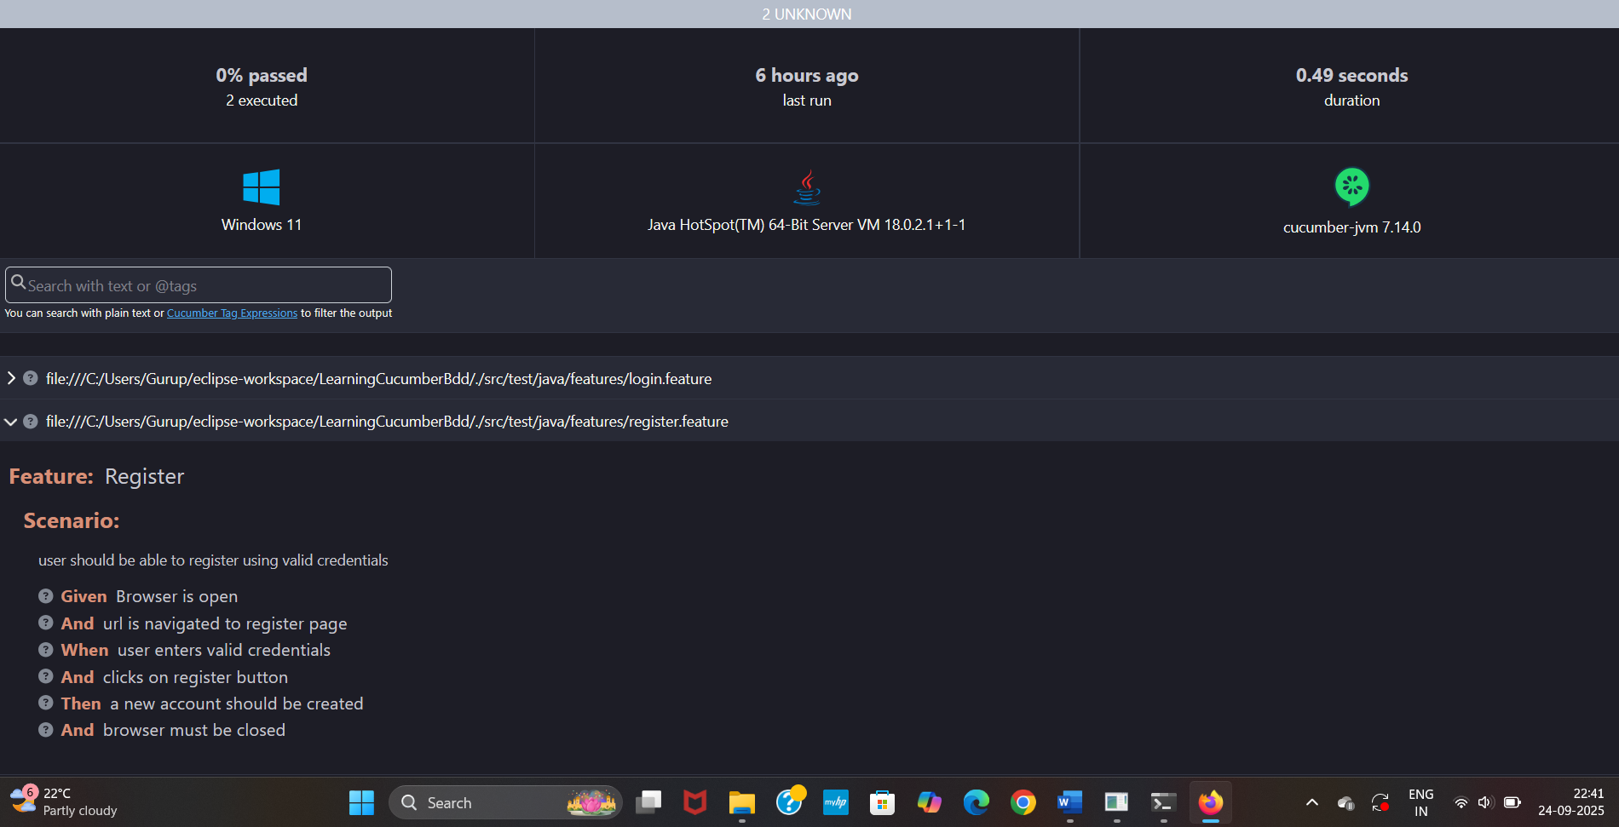
extent Reports not accept feature file formate behavious different then selenium script
we need a intermediate/adapter for cucumber as well as extent reports
grasshopper.extent.cucumber7.adapter (becose every cucumber version is 7);
@CucumberOptions(features = {"./src/test/java/features"},glue = {"stepDefinition"}
,plugin = {"html:Reports/CucumberReports.html","json:Reports/CucumberJSONReport.json"})
public class CucumberRunner extends AbstractTestNGCucumberTests{

}

in plugin becouse extent report not part of we cannot give extent:folder
"com.aventstack.extentreports.cucumber.adapter.ExtentCucumberAdapter"
the code required to generate ex report taken from official documentation.

and we need to create properties file for extent report to start and storing location
extent.reporter.spark.start=true
extent.reporter.spark.out=Reports/ExtentReport.html
extent.reporter.spark.start=true = specifing wheter report should start or not
extent.reporter.spark.out=Reports/ExtentReport.html = location to store the report
https://extentreports.com/docs/versions/4/java/cucumber4.html
@CucumberOptions(features = {"./src/test/java/features"},glue = {"stepDefinition"}
,plugin = {"html:Reports/CucumberReports.html","json:Reports/CucumberJSONReport.json"
,"com.aventstack.extentreports.cucumber.adapter.ExtentCucumberAdapter:"})
public class CucumberRunner extends AbstractTestNGCucumberTests{

}

DATADRIVEN TESTING PART -1
TO WRITE MULTIPLE SCENARIOS IN FEATURE FILE
Feature: ShoppersStackLogin

Scenario: validate shopper can login using valid crdentials

Given Browser is open and URL is navigated
And Login page will be displayed
When user enters valid Shopper credentials
And clicks on Shopper login button
Then Shopper should be successfully logged in
And Browser should close

Scenario: validate merchant can login using valid credentials

Given Browser is open and proper url is navigated
And Login page is displayed
When merchant enters valid credentials
And clicks on merchant login button
Then merchant should be successfully logged in
And browser s close

Scenario:
validate admin can login using valid credentials

Given Browse is open and proper url is navigated
And Login page is displayed
When admin enters valid credentials
And click on login button
Then admin must be successfull logged in
And browser should close

Becouse login page is same
Feature: ShoppersStackLogin

Scenario: validate shopper can login using valid crdentials

Given Browser is open and URL is navigated
And Login page will be displayed
When user enters valid Shopper credentials
And clicks on Shopper login button
Then Shopper should be successfully logged in
And Browser should close

Scenario: validate merchant can login using valid credentials

Given Browser is open and URL is navigated
And Login page will be displayed
When merchant enters valid credentials
And clicks on merchant login button
Then merchant should be successfully logged in
And browser s close

Scenario:
validate admin can login using valid credentials

Given Browse is open and proper url is navigated
And Login page will be displayed
When admin enters valid credentials
And click on login button
Then admin must be successfull logged in
And browser should close

Becouse only email and password are changing=
Feature: ShoppersStackLogin

Scenario: validate shopper can login using valid crdentials

Given Browser is open and URL is navigated
And Login page will be displayed
When user enters "qa_testmerchantdell@gmail.com" and "Password@123"
And clicks on login button
Then Shopper should be successfully logged in
And Browser should closed------------------------------------same for all

Scenario: validate merchant can login using valid credentials

Given Browser is open and URL is navigated
And Login page will be displayed
When merchant enters "qa_merchantlogin@gmail.com" and "password@123"
And clicks on login button
Then merchant should be successfully logged in
And Browser should closed

Scenario:
validate admin can login using valid credentials

Given Browse is open and proper url is navigated
And Login page will be displayed
When admin enters "qa_testadmindell@gmail.com" and "Password@123"
And clicks on login button
Then admin must be successfull logged in
And Browser should closed

(When we run the runner class then we will get snippets and error message)
After executing this feature file
Where ever WE ARE ENTERING THE EMAIL ID PASSWORD AT RUN TIME IT WILL GIVEN IN THE FORM OF {STRING} {STRING}

public class SSLogin {

public WebDriver driver;

@Given("Browser is open and URL navigated")
public void browser_is_open_and_url_navigated() {
driver = new ChromeDriver();
driver.manage().window().maximize();
driver.manage().timeouts().implicitlyWait(Duration.ofSeconds(20));
driver.get("https://www.shoppersstack.com/");

}

@Given("Login page will be displayed")
public void login_page_will_be_displayed() {
driver.findElement(By.xpath("loginBtn")).click();
}

@When("user enters {string} and {string}")
public void user_enters_and(String string,String string2) {
System.out.println("user enter credentials");
}

@When("clicks on shopper login button")
public void clicks_on_shopper_login_button() {
System.out.println("clicks on shopper login button");
}

@Then("shopper should be succesfully logged in")
public void shopper_should_be_succesfully_logged_in() {
System.out.println("shopper succefully logged in");
}

@Then("browser shoulb close")
public void browser_close() {
System.out.println("browser close");
}

}

Feature: ShoppersStackLogin

Scenario: validate shopper can login using valid crdentials

Given Browser is open and URL is navigated
And Login page will be displayed
And shopper login is displayed
When user enters "qa_testmerchantdell@gmail.com" and "Password@123"
And clicks on login button
Then Shopper should be successfully logged in
And Browser should closed

Scenario: validate merchant can login using valid credentials

Given Browser is open and URL is navigated
And Login page will be displayed
And merchant login is diplayed
When merchant enters "qa_merchantlogin@gmail.com" and "password@123"
And clicks on login button
Then merchant should be successfully logged in
And Browser should closed

Scenario:
validate admin can login using valid credentials

Given Browse is open and proper url is navigated
And Login page will be displayed
And admin login is displayed
When admin enters "qa_testadmindell@gmail.com" and "Password@123"
And clicks on login button
Then admin must be successfull logged in
And Browser should closed

After executing itll display 3 methods which does not have implementation.
package stepDefinitions;

import java.time.Duration;

import org.openqa.selenium.By;
import org.openqa.selenium.WebDriver;
import org.openqa.selenium.chrome.ChromeDriver;
import org.testng.Assert;

import io.cucumber.java.en.Given;
import io.cucumber.java.en.Then;
import io.cucumber.java.en.When;

public class SSLogin {

public WebDriver driver;

@Given("Browser is open and URL is navigated")
public void browser_is_open_and_url_is_navigated() {
driver = new ChromeDriver();
driver.manage().window().maximize();
driver.manage().timeouts().implicitlyWait(Duration.ofSeconds(20));
driver.get("https://www.shoppersstack.com/");
}

@Given("Login page will be displayed")
public void login_page_will_be_displayed() {
driver.findElement(By.id("loginBtn")).click(); // <-- Update locator
}

@Given("shopper login is displayed")
public void shopper_login_is_displayed() {
Assert.assertTrue(driver.findElement(By.xpath("//strong[contains(text(),'Shopper')]")).isDisplayed());
}

@When("user enters {string} and {string}")
public void user_enters_and(String userName, String password) {
driver.findElement(By.id("Email")).sendKeys(userName);
driver.findElement(By.id("Password")).sendKeys(password);
}

@When("merchant enters {string} and {string}")
public void merchant_enters_and(String userName, String password) {
driver.findElement(By.id("Email")).sendKeys(userName);
driver.findElement(By.id("Password")).sendKeys(password);
}

@When("admin enters {string} and {string}")
public void admin_enters_and(String userName, String password) {
driver.findElement(By.id("Email")).sendKeys(userName);
driver.findElement(By.id("Password")).sendKeys(password);
}

@When("clicks on login button")
public void clicks_on_login_button() {
driver.findElement(By.id("LoginBtn")).click(); // <-- Update locator
}

@Then("shopper should be successfully logged in")
public void shopper_should_be_successfully_logged_in() {
Assert.assertTrue(driver.findElement(By.xpath("//span[contains(text(),'hello')]")).isDisplayed());
}

@Then("merchant should be successfully logged in")
public void merchant_should_be_successfully_logged_in() {
Assert.assertTrue(driver.findElement(By.xpath("//span[contains(text(),'approved merchant')]")).isDisplayed());
}

@Then("admin must be successfully logged in")
public void admin_must_be_successfully_logged_in() {
Assert.assertTrue(driver.findElement(By.xpath("//span[contains(text(),'Admin')]")).isDisplayed());
}

@Then("Browser should be closed")
public void browser_should_be_closed() {
driver.quit();
}
}

DATA DRIVEN TESTING PART -2
------------------------------------------------------
SCEANARIO OUTLINE , DATA TABLES
In feature file we have to use anguler braces “<Computer>” this is telling data for this passed by feature file,AND IT IS A CONTAINER FOR <COMPUTER> WE ARE PASSING BOOKES
Using keyword EXAMPLES WE CAN CREATE OWN TABULAR FORMATE
WHEN WE ARE USING EXAMPLES WE NEED TO USE SCENARIO OUTLINE NOT SCENARIO
Feature: Search

Scenario Outline:
:
: validate when user enters text in search text field then the search result must be displyed

Given welcome page is displyed
When user enters "<search>" in serach text field
Then serach results must be displyed

Examples:
| search | 2 data (so 2 scenrios and 6 steps)
|computers|
| Books |
After execution
@when(“user enters {String} in search text filed )
What ever method has {string} the method is also parameterized,so whatever value pass throw feature file will be landzon on parameter variable can be used throw out the method

package stepDefination;

import java.time.Duration;

import org.openqa.selenium.By;
import org.openqa.selenium.WebDriver;
import org.openqa.selenium.chrome.ChromeDriver;
import org.testng.Assert;

import io.cucumber.java.en.Given;
import io.cucumber.java.en.Then;
import io.cucumber.java.en.When;

public class Search {

public WebDriver driver;
public String serachItem;

@Given("welcome page is displayed")
public void welcome_page_is_displayed() {
driver = new ChromeDriver();
driver.manage().window().maximize();
driver.manage().timeouts().implicitlyWait(Duration.ofSeconds(20));
driver.get("https://demowebshop.tricentis.com/");
}

@When("user enters {string} in search text field")
public void user_enters_in_search_text_field(String serachItem) {
driver.findElement(By.id("small-serachterms")).sendKeys(serachItem);
driver.findElement(By.xpath("//input[@value='Search']")).click();

}

@Then("search results must be displayed")
public void search_results_must_be_displayed() {
Assert.assertTrue(driver.findElement(By.id("Q")).getDomAttribute("value").contains(serachItem));
}

}
After execution it shows
2 scenarios and 6 steps (since feature file having only 3 steps)
Becouse steps are repeated as many as test data similar to data provider
Feature: Search

Scenario Outline:
:
: validate when user enters text in search text field then the search result must be displyed

Given welcome page is displyed
When user enters "<search>" in serach text field
Then serach results must be displyed

Examples:
| search |
|computers|
| Books |
|10 | if we pass other then string we need to add regular expression

@When("^user enters \"([^\"]*)\" in search text field$") public void user_enters_in_search_text_field(String serachItem) {
Using this regex we can pass any kind of data
if no error we will get other half string so we use slash(\);
we need to give ^ and $ at the end to denote this method accepte regular expression

DATA TABLES=
DATA TABLE IS APPLICABLE ONLY FOR PARTICULER STEP
EXAMPLES ; APPLICABLE FOR ENTIRE SCENARIO
Feature:Register

Scenario:
user should be able to register using valid credentials

Given Browser is open
And url is navigated to register page
When user enters valid credentials
| m | Test | manualtest | qs_manueltest3@gmail.com | Password@123|
And clicks on register button
Then a new account should be created
And browser must be closed

Datatable can be worked on of this ways
// in order to handle data table
//List<E> ,LIst<List<E>>, List<Map<k,v>>,Map<k,v> or Map<k, List<v>>
1st get of 0 is row next is index
driver.findElement(By.xpath("//input[@value='"+data.get(0).get(0)+"']"));
@When("user enters valid credentials")
public void user_enters_valid_credentials(DataTable dataTable) {
List<List<String>> data=dataTable.asLists();
driver.findElement(By.xpath("//input[@value='"+data.get(0).get(0)+"']"));
driver.findElement(By.id("FirstName")).sendKeys(data.get(0).get(1));
driver.findElement(By.id("LastName")).sendKeys(data.get(0).get(2));
driver.findElement(By.id("Email")).sendKeys(data.get(0).get(3));
driver.findElement(By.id("Password")).sendKeys(data.get(0).get(4));
driver.findElement(By.id("ConfirmPassword")).sendKeys(data.get(0).get(5));
}

Feature:Register

Scenario:
user should be able to register using valid credentials

Given Browser is open
And url is navigated to register page
When user enters valid credentials
| M | Test | manualtest | qs_manueltest3@gmail.com | Password@123|
| F | Test | manITest | qs_lsdfjksTest@gmail.com | Passwoerd@413 |
And clicks on register button
Then a new account should be created
And browser must be closed

@When("user enters valid credentials")
public void user_enters_valid_credentials(DataTable dataTable) {
List<List<String>> data=dataTable.asLists();
driver.findElement(By.xpath("//input[@value='"+data.get(1).get(0)+"']"));
driver.findElement(By.id("FirstName")).sendKeys(data.get(1).get(1));
driver.findElement(By.id("LastName")).sendKeys(data.get(1).get(2));
driver.findElement(By.id("Email")).sendKeys(data.get(1).get(3));
driver.findElement(By.id("Password")).sendKeys(data.get(1).get(4));
driver.findElement(By.id("ConfirmPassword")).sendKeys(data.get(1).get(5));
}

Cucumber tags and backgroud keywords
if have lot of scenarios but if we need to execute particular tag
for that we need to denote the tag before scenario or scenario outline(what ever tag we need to we can provide)

Feature: ShoppersStackLogin

@Smoke
Scenario: validate shopper can login using valid crdentials

Given Browser is open and URL is navigated
And Login page will be displayed
When user enters "qa_testmerchantdell@gmail.com" and "Password@123"
And clicks on login button
Then Shopper should be successfully logged in
And Browser should closed

@Smoke
Scenario: validate merchant can login using valid credentials

Given Browser is open and URL is navigated
And Login page will be displayed
When merchant enters "qa_merchantlogin@gmail.com" and "password@123"
And clicks on login button
Then merchant should be successfully logged in
And Browser should closed

@Regression
Scenario:
validate admin can login using valid credentials

Given Browse is open and proper url is navigated
And Login page will be displayed
When admin enters "qa_testadmindell@gmail.com" and "Password@123"
And clicks on login button
Then admin must be successfull logged in
And Browser should closed

in runner class we need to provide attribute tags ="tag name ",

@CucumberOptions(features = { "./src/test/java/features" }, glue = { "stepDefinition" },
tags ="@Smoke",
plugin = {
"html:Reports/CucumberReports.html", "json:Reports/CucumberJSONReport.json",
"com.aventstack.extentreports.cucumber.adapter.ExtentCucumberAdapter:" })
public class CucumberRunner extends AbstractTestNGCucumberTests {

} all the smoke scnarios will be executed

Feature: ShoppersStackLogin

@Smoke @Regression
Scenario: validate shopper can login using valid crdentials

Given Browser is open and URL is navigated
And Login page will be displayed
When user enters "qa_testmerchantdell@gmail.com" and "Password@123"
And clicks on login button
Then Shopper should be successfully logged in
And Browser should closed

@Smoke @Regression
Scenario: validate merchant can login using valid credentials

Given Browser is open and URL is navigated
And Login page will be displayed
When merchant enters "qa_merchantlogin@gmail.com" and "password@123"
And clicks on login button
Then merchant should be successfully logged in
And Browser should closed

@Regression @Somke
Scenario:
validate admin can login using valid credentials

Given Browse is open and proper url is navigated
And Login page will be displayed
When admin enters "qa_testadmindell@gmail.com" and "Password@123"
And clicks on login button
Then admin must be successfull logged in
And Browser should closed

TO EXECUTE BOTH SOMKE AND REGRESSION USE (and) for any one use or
@CucumberOptions(features = { "./src/test/java/features" }, glue = { "stepDefinition" },
tags ="@Smoke and @Regression",
plugin = {
"html:Reports/CucumberReports.html", "json:Reports/CucumberJSONReport.json",
"com.aventstack.extentreports.cucumber.adapter.ExtentCucumberAdapter:" })
public class CucumberRunner extends AbstractTestNGCucumberTests {

}

we can use not operator to ignore that tag and execute all the tags
@CucumberOptions(features = { "./src/test/java/features" }, glue = { "stepDefinition" },
tags ="not @Smoke",
plugin = {
"html:Reports/CucumberReports.html", "json:Reports/CucumberJSONReport.json",
"com.aventstack.extentreports.cucumber.adapter.ExtentCucumberAdapter:" })
public class CucumberRunner extends AbstractTestNGCucumberTests {

}

BACKGROUD KEYWORD=
using background keyword ,using this we can give all the preconditions
ALL THE PRECONDITION FOR THAT PARTICULAR FEATURE

ONLY APPLICABLE FOR ALL THE SCENARIOS FOR THAT FEATURE
Before=
Feature: Books

using background keyword ,using this we can give all the preconditions

Scenario: validate user can sort the page alphabetically
Given browser is open to welcome page
When user is loged in
And user clicks on book page
And books page is displayed
And user chooses A-Z in sort by drop down
Then page should be sorted alphabetically

Scenario: validate user can add Computing and internet book to cart
Given browser is open to welcome page
When user is loged in
And user clicks on book page
And books page is displayed
And user clicks on add to cart button for computing and internet book
Then book should be added to cart

Scenario: validate user can add health book to cart
Given browser is open to welcome page
When user is loged in
And user clicks on book page
And books page is displayed
And user clicks on add to cart button for Health book
Then book should be added to cart

After=
Feature: Books

Background:
Given browser is open to welcome page
When user is loged in
And user clicks on book page
And books page is displayed

Scenario: validate user can sort the page alphabetically
And user chooses A-Z in sort by drop down
Then page should be sorted alphabetically

Scenario: validate user can add Computing and internet book to cart
And user clicks on add to cart button for computing and internet book
Then book should be added to cart

Scenario: validate user can add health book to cart
And user clicks on add to cart button for Health book
Then book should be added to cart

( | ) this is a pipeline operator
Feature: Books

Background:
Given browser is open to welcome page
When user is loged in
| qa_testuser823@gmail.com | Password@324 |
And user clicks on book page
And books page is displayed

Scenario: validate user can sort the page alphabetically
And user chooses A-Z in sort by drop down
Then page should be sorted alphabetically

Scenario: validate user can add Computing and internet book to cart
And user clicks on add to cart button for computing and internet book
Then book should be added to cart

Scenario: validate user can add health book to cart
And user clicks on add to cart button for Health book
Then book should be added to cart

public class Books {

public WebDriver driver;

@Given("browser is open to welcome page")
public void browser_is_open_to_welcome_page() {
driver = new ChromeDriver();
driver.manage().timeouts().implicitlyWait(Duration.ofSeconds(10));
driver.manage().window().maximize();
driver.get("https://demowebshop.tricentis.com/");
}

@When("user is logged in")
public void user_is_logged_in(DataTable datatable) {
List<List<String>> data = datatable.asLists();
String userName = data.get(0).get(0);
String password = data.get(0).get(1);
driver.findElement(By.partialLinkText("Log in")).click();
driver.findElement(By.id("Email")).sendKeys(userName);
driver.findElement(By.id("Password")).sendKeys(password);
driver.findElement(By.xpath("//input[@value='Log in']")).click();

}

@And("user clicks on book page")
public void user_clicks_on_book_page() {
driver.findElement(By.partialLinkText("Books")).click();
}

@And("books page is displayed")
public void books_page_is_displayed() {
//click on books link either title or url contains books so we can validate any of the books
Assert.assertTrue(driver.getCurrentUrl().contains("books"));

}

@And("user chooses A-Z in sort by drop down")
public void user_chooses_a_z_in_sort_by_drop_down() {

WebElement drop = driver.findElement(By.id("products-orderby"));
Select select = new Select(drop);
select.selectByVisibleText("Name: A to Z");
}

@Then("page should be sorted alphabetically")
public void page_should_be_sorted_alphabetically() {
System.out.println("page is sorted");
}

@And("user clicks on add to cart button for computing and internet book")
public void user_clicks_on_add_to_cart_button_for_computing_and_internet_book() {
driver.findElement(
By.xpath("//a[text()='Computing and Internet']/ancestor::div[@class='details']/descendant::input"))
.click();

}

@Then("book should be added to cart")
public void book_should_be_added_to_cart() {
String data = driver.findElement(By.xpath("//p[text()='The product has been added to your ']")).getText();
Assert.assertEquals(data, "The product has been added to the cart");
driver.quit();
}

@And("user clicks on add to cart button for Health book")
public void user_clicks_on_add_to_cart_button_for_health_book() {
driver.findElement(By.xpath("//a[text()='Health Book']/./..//input")).click();
}
}

HOOKS=
public class Hook {
@Before //we should have either method declaration / class declaration
public void before() {
System.out.println("*********************");
System.out.println("Before Method execution / for precodition");
}
@After
public void after() {
System.out.println("**************");
System.out.println("After method execution / for postCondition");
}

}

BEFORE MEHTOD EXECUTES EVERYTIME BEFORE EVERY SCENARIO
IT ILL EXECUTES HOW MANY TIMES SCNARIO IS PRESENT IN FEATURE FILE THOSE MANY TIME ITLL EXECUTE
Execution flow=
//@Before --> Background --> Scenario--> @After

//background applicable for feature file and those sceanrios
//in the hook class annotation present in hook class are applicable to all the scenarios and all feature files present in the package.

@CucumberOptions(features = { "./src/test/java/features" }, glue = { "stepDefinition","hook" },
tags ="not @Smoke", //pakage name of hook
plugin = {
"html:Reports/CucumberReports.html", "json:Reports/CucumberJSONReport.json",
"com.aventstack.extentreports.cucumber.adapter.ExtentCucumberAdapter:" })
public class CucumberRunner extends AbstractTestNGCucumberTests {

}

To provide precondition for specific scenario we need to give=
Feature: Search

@Regression @Search
Scenario Outline:
:
: validate when user enters text in search text field then the search result must be displyed

Given welcome page is displyed
When user enters "<search>" in serach text field
Then serach results must be displyed

Examples:
| search |
|computers|
| Books |
|10 |
| 6.0 |

package hook;

import io.cucumber.java.After;
import io.cucumber.java.Before;

public class Hook {
@Before
public void before() {

}

@Before("@Search")
public void beforeSearch() {
System.out.println("login code");
}
@After
public void after() {
System.out.println("**************");
System.out.println("After method execution / for postCondition");
}

}

@CucumberOptions(features = { "./src/test/java/features" }, glue = { "stepDefinition","hook" },
tags ="@Search",
plugin = {
"html:Reports/CucumberReports.html", "json:Reports/CucumberJSONReport.json",
"com.aventstack.extentreports.cucumber.adapter.ExtentCucumberAdapter:" })
public class CucumberRunner extends AbstractTestNGCucumberTests {

}
All will be executed

Dry run=
It is a helper attribute=
//dry accept boolen values
//when working in a project there are chances of multiple features been executed or being created and those features files may not all needed step definition present to want to know which has step defintion and which not has step defination that is where we use step definition

Feature: Subscribe

Scenario: user shoul be able to subscribe to new letter using valid email id

Given Browser is open and URL is navigated #if we use same statement it already has the glue code so we can achive code reusability
When user enters valid email id and clicks on subscribe button
Then user should be able to succcessfully subscribe

Feature: Community Poll

Scenario: User should be able to poll after log in

Given Browser is open and URL is navigated #if we use same statement it already has the glue code so we can achive code reusability
And user is logged in
When user selects an option in community poll
Then the option must be recorded

in this around 2 to 3 steps not have glucode present
if there are feature files that not implemented
in dry we can give true
dry compare feature file steps with step definition if steps are implmented it will run it as usual (itll not execute browser)

in runner class

undefinedStepException =
not implemented

@CucumberOptions(features = { "./src/test/java/features" }, glue = { "stepDefinition","hook" },
tags ="@Search",
dryRun = true,
plugin = {
"html:Reports/CucumberReports.html", "json:Reports/CucumberJSONReport.json",
"com.aventstack.extentreports.cucumber.adapter.ExtentCucumberAdapter:" })
public class CucumberRunner extends AbstractTestNGCucumberTests {

}

public class CommunityPoll {

@When("user selects an option in community poll")
public void user_selects_an_option_in_community_poll() {

}
@Then("the option must be recorded")
public void the_option_must_be_recorded() {

}
}
dryrun to check all the features steps have been implemented
if we give dry run as falls it executes all feature file normally
it its true then does matches your feature file steps with step definition method
it'll check if this steps are implemented and give the output .

Exceptions =
1.undefinedStepException
2.pending Exception -> step is not defined
3.cucumber excpetion -> issue in feature file
4.cucumberDatatableException -> Header Name Mismatch, Using asMaps() Without Header
5. DuplicateStepDefinitionException -> duplicate stepDefinition

FRAMEWORK=

MAVEN PROJECT STRUCTURE=
Str/Main/java -> Java util,webdriver util, file util, Db util, excel utility, object repositery, Driver manager
Src/main/resource -> envioronment config data
Src/test/java ->Hooks , Runner, StepDefinition
Src/test/resource -> Feature files.
Pom.xml -> selenium java, cucumber core, cucumber testng, cucumber java, mysql
Reports -> html , json, xml , failed.txt
Target -> testfailed.xml, emailable report.
Driver/suite.xml files
1.Generic utility=
- Generic utility it is common for all the projects it can be used for any application it contains sub utilitys such as
JavaUtility -> in order to get the random number, simpleDateFormate, getting the future date we use java utility.
WebDriver utility -> it includes selenium utility such as maximize, select class, actions class, frame alerts, javscript executor utility it contains.
File utility -> in order to read the data from properties file we have file utilty which is used to read common data.
Db utility -> in order to connect to the database , disconnect db, get the data from db, verify expected data in db we use db utility.
Excel utilty -> in order to read the data from excel , get the last rownum , verify the excel data we go for excel utiltiy.
DriverManager -> inorder to use driver for all the elements
public class DriverManage {

public static ThreadLocal<WebDriver> driver=new ThreadLocal<WebDriver>();

public static ThreadLocal<WebDriverWait> wait=new ThreadLocal<WebDriverWait>();

public static WebDriver getDriver() {
return driver.get();

}

public static WebDriverWait getWait() {
return wait.get();
}

public static void setDriver(WebDriver actDriver) {
driver.set(actDriver);
}

public static void setWebDriverWait(WebDriverWait actWait) {
wait.set(actWait);
}
}

2.Object reposiitery =
where all the elements are stored and business utility is stored inside the Object repositery, for every pom page we have different classes.
public class HomePage {

WebDriver driver;
public HomePage(WebDriver driver) {
this.driver=driver;
PageFactory.initElements(driver, this);
}

@FindBy(xpath="//a[text()='Get started']") private WebElement getStartedBtn;

@FindBy(xpath="//span[text()='Create']") private WebElement createBtn;

@FindBy(xpath="//span[text()='(RFQ)']") private WebElement rfqBtn;

public WebElement getGetStartedBtn() {
return getStartedBtn;
}
public WebElement getCreateBtn() {
return createBtn;
}
public WebElement getRfqBtn() {
return rfqBtn;
}

}

3.Resources ->
we have a physicall files such as properties file which is used to store environment configuration data, such as enviroment, browser, un, pwd, bd credentials.
4.Hooks ->
in this class we have @Before and @After annotation where @Before is used to execute before executing each scnairo and @After will execute after executing each scnario.
@Before we have launching the browser, implicitly wait maximizing the browser and connecting to Db.
@After we have closing the browser, clossing the connection to Db.

FileUtility fu=new FileUtility();
WebDriver driver;
@Before()

public void configBf() throws IOException {

WebDriver driver=new ChromeDriver();
driver.manage().window().maximize();
driver.manage().timeouts().implicitlyWait(Duration.ofSeconds(20));

DriverManage.setDriver(driver);
DriverManage.getDriver().get("http://demo.procurehere.com");

LoginPage login=new LoginPage(DriverManage.getDriver());
login.loginToApp(fu.getTheDataFromPropertiesFile("un"), fu.getTheDataFromPropertiesFile("pwd"));
login.getLoginBtn().click();
}
@After ()
public void configAf(Scenario scenario) {

if(scenario.isFailed()) {
TakesScreenshot ts=(TakesScreenshot)driver;
byte[] screen= ts.getScreenshotAs(OutputType.BYTES);
scenario.attach(screen, "image/png", scenario.getName());
}
driver.quit();
}
}

5.Runner class ->
it is extends to AbstractCucumber testng class were we are going to run the scripts using @CucumberOptions annotation were we set the feature file path and glue for step definition and hooks.
- In order to generate the reports such as html, xml, json reports.
- In order to use dryrun where we can execute to check only implementation is present or not.
- Tags in order to execute specific tags.
- Monochrome for console.
- In order to do parallel exeuction we use runner class.
- @CucumberOptions(features= {"classpath:Features"},
- glue= {"StepDefinition", "Priv_Proc_Hooks"}, // include hooks package so @Before runs
- plugin= {"pretty","html:target/cucumber-reports.html",
- "json:target/cucumber.json",
- "junit:target/cucumber.xml",
- "rerun:target/failed.txt"},
- tags="@eventDetails",
- dryRun=false,
- monochrome=true)
- public class Runner extends AbstractTestNGCucumberTests{

- @DataProvider
- public Object[][] scenario() {
- return super.scenarios();
- }
- }

6.Step definition ->
- At hear we have the step definition reading the hardcoded data from the feature file .
- Using regex reading the data, and by using dataTables getting the data from the feature file.
- By using all the utilitys such as generic utility object repositery. We are going to implemetn in step definition.
public class EventDetailsRFQ {

WebDriver driver;
HomePage home;
EventCreationPage event;
EventDetailsPage details;
WebDriverUtility web = new WebDriverUtility();

String buyer;

@Given("Buyer successfully loggedin")
public void buyer_successfully_loggedin() {
driver = DriverManage.getDriver();
home = new HomePage(driver);
home.getGetStartedBtn().click();

}

@Given("clicks on CreateButton")
public void clicks_on_create_button() {
home.getCreateBtn().click();
}

@Given("select the rfq from the options")
public void select_the_rfq_from_the_options() {
home.getRfqBtn().click();
}

@When("buyer clicks on create from blank")
public void buyer_clicks_on_create_from_blank() {
event = new EventCreationPage(driver);
event.getCreateFromBlankLink().click();
}

@Then("the event details section should be displayed")
public void the_event_details_section_should_be_displayed() {
details = new EventDetailsPage(driver);
boolean section = details.getEventDetailsSection().isDisplayed();
Assert.assertTrue(section);
}

@Given("when the buyer scroll to event settings section")
public void when_the_buyer_scroll_to_event_settings_section() {
web.actionScrollToAmount(driver, 0, 200);
}

@When("buyer clicks on urgent event checkbox")
public void buyer_clicks_on_urgent_event_checkbox() {
details = new EventDetailsPage(driver);
details.getUrgentEventCheckbox().click();
}

@Then("the urgen event should be checked")
public void the_urgen_event_should_be_checked() {
WebElement checkbox = details.getUrgentEventCheckbox();
boolean checked = checkbox.isSelected();
Assert.assertTrue(checked);
}

@Then("uncheck the urgent event checkbox")
public void the_urgent_event_should_be_unchecked() {
WebElement checkbox = details.getUrgentEventCheckbox();
checkbox.click();
}

@Then("the urgent event should be unchecked")
public void the_event_details_section_should_be_closed() {
boolean unchek = details.getUrgentEventCheckbox().isSelected();
Assert.assertFalse(unchek);
}

@When("buyer clicks on unmasking owner checkbox")
public void buyer_clicks_on_unmasking_owner_checkbox() {
details.getViewSupplierNameCheckbox().click();
}

@Then("the unmasking owner should be checked")
public void the_unmasking_owner_should_be_checked() {
WebElement checkbox = details.getViewSupplierNameCheckbox();
boolean checked = checkbox.isSelected();
Assert.assertTrue(checked);
}

@Then("input field should be enabled")
public void input_field_should_be_enabled() {
boolean inputFiled = details.getUnmaskOwnersInputField().isEnabled();
Assert.assertTrue(inputFiled);

}

@Then("buyer can enter the unmasking owner name {string}")
public void buyer_can_enter_the_unmasking_owner_name(String buyerName) {
details.getUnmaskOwnersInputField().sendKeys(buyerName);
buyer=buyerName;

}

@Then("select the option from the dropdown")
public void select_the_option_from_the_dropdown() {
details.getUnmaskOwnersFirstOption().click();

}

@Then("the unmasking owner should be displayed in the input field")
public void the_unmasking_owner_should_be_displayed_in_the_input_field() {

details.getUnmaskOwnersInputField().getText();
Assert.assertEquals(details.getUnmaskOwnersInputField().getText(),buyer.trim());

}

public class LoginSc {

WebDriver driver; // don't fetch driver at class-load time
LoginPage login;

@Given("i am on the login page")
public void i_am_on_the_login_page() {
driver = DriverManage.getDriver();

login = new LoginPage(driver);
boolean username = login.getUsername().isDisplayed();
Assert.assertTrue(username);
}

@When("i enter valid username and password")
public void i_enter_valid_username_and_password(DataTable dataTable) {
String un = dataTable.cell(0, 0); //to read the row and cell from pipeline inline step
String pwd = dataTable.cell(0, 1);

login.loginToApp(un, pwd);
}

@When("clicking on the login button")
public void clicking_on_the_login_button() {
login.getLoginBtn().click();
}

@Then("user should be successfully logged in")
public void user_should_be_successfully_logged_in() {
boolean text = login.getWelcomeText().isDisplayed();
Assert.assertTrue(text);
}
}

7.Feature file =
- In feature files we have all the background, scenarios and scenario outline exampls are stored in feature file having the tag names .
- @login
- Feature: login to the application

- Scenario: buyer login to the application successfully
- Given i am on the login page
- When i enter valid username and password
- | 1CLOUDHUB@PH.COM | 1Cloud@1233 |
- And clicking on the login button
- Then user should be successfully logged in
8.pom xml =
- In order to work with the 3rd party librarys we need to add dependncy such as seleniujm java, cucumber java, cucumber core, cucumber testng, postgress sql dependency are presnet in pom.xml file.
- Sure fire plugin build is present where we can configre and execut using the id.
- And we have properties to maintain the version of the dependencys.

<dependencies>

<dependency>
<groupId>io.cucumber</groupId>
<artifactId>cucumber-testng</artifactId>
<version>7.14.0</version>
</dependency>

<dependency>
<groupId>io.cucumber</groupId>
<artifactId>cucumber-java</artifactId>
<version>7.14.0</version>
</dependency>

<dependency>
<groupId>org.seleniumhq.selenium</groupId>
<artifactId>selenium-java</artifactId>
<version>4.31.0</version>
</dependency>

<dependency>
<groupId>io.cucumber</groupId>
<artifactId>cucumber-core</artifactId>
<version>7.28.2</version>
</dependency>

</dependencies>

<build>
<plugins>
<plugin>
<groupId>org.apache.maven.plugins</groupId>
<artifactId>maven-surefire-plugin</artifactId>
<version>3.0.0-M9</version>
<configuration>
<suiteXmlFiles>
<suiteXmlFile>testng.xml</suiteXmlFile>
</suiteXmlFiles>
</configuration>
</plugin>
</plugins>
</build>

</project>

9.Reports=
- In this reports we have cucumber html report where we can check which scnerio is failed , pass and what the excpetion which step is failed and on which data it is exeucted how many pass and fail will be present in this folder
- And we have json report and rerun faild report it includes only the failed scneraios where we can see and execute.
Using json editor : json report
[
{
"line": 1,
"uri": "classpath:Features/EventDetails.feature",
"id": "rfq-event-details-section",
"keyword": "Feature",
"name": "RFQ event details section",
"description": "",
"elements": [
{
"line": 3,
"type": "background",
"keyword": "Background",
"name": "",
"description": "",
"steps": [
{
"keyword": "Given ",
"line": 4,
"match": {
"location": "StepDefinition.EventDetailsRFQ.buyer_successfully_loggedin()"
},
"name": "Buyer successfully loggedin",
"result": {
"duration": 7719097700,
"status": "passed"
}
},
{
"keyword": "And ",
"line": 5,
"match": {
"location": "StepDefinition.EventDetailsRFQ.clicks_on_create_button()"
},
"name": "clicks on CreateButton",
"result": {
"duration": 280830500,
"status": "passed"
}
},

Using cucumber html report:
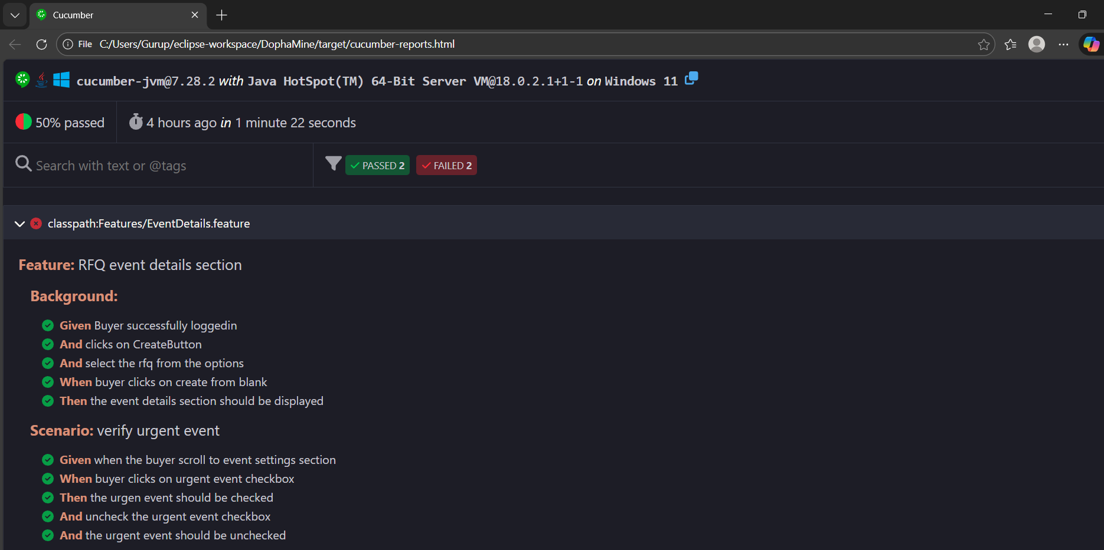
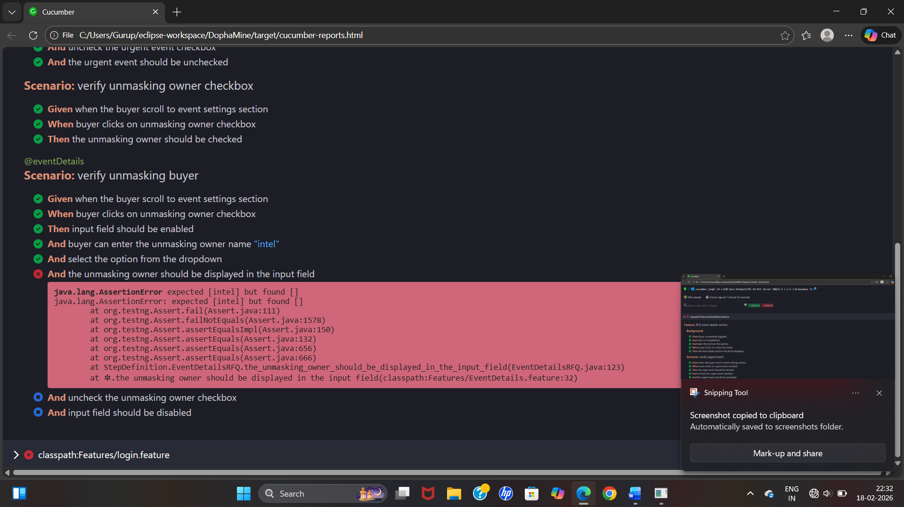
Rerun: falied txt folder
classpath:Features/EventDetails.feature:26
classpath:Features/login.feature:4

Testng reports:
Index.html
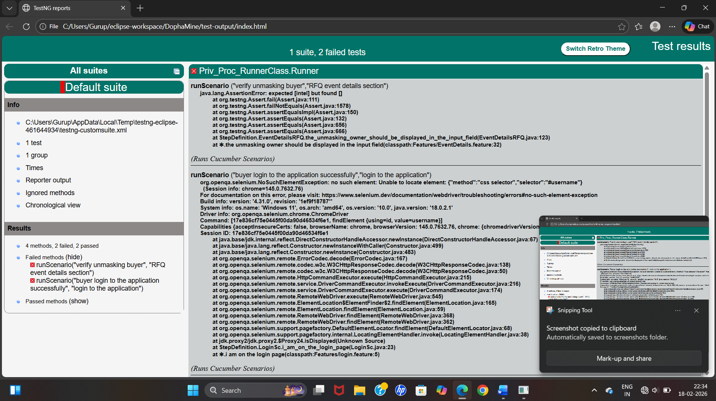
Testng report emailable-report.html
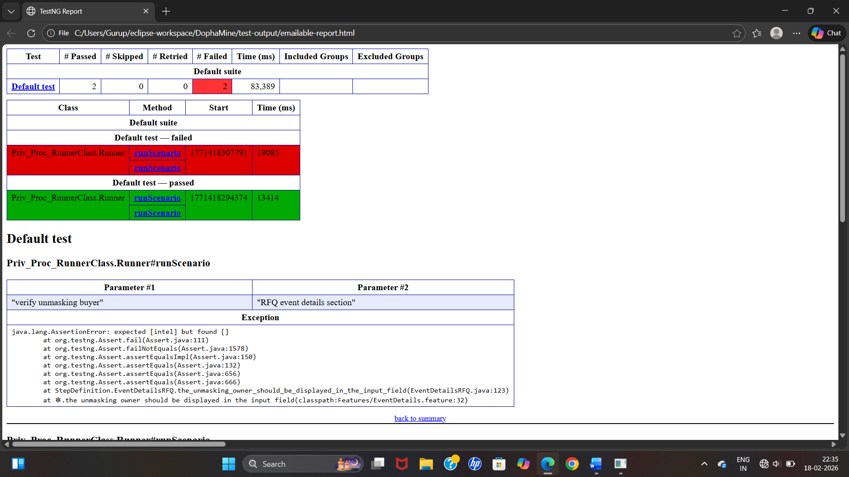
Data Type | Feature Usage | Step Definition | Quotes?
int | <count> | {int} | ❌
long | <number> | {long} | ❌
float | <amount> | {float} | ❌
double | <price> | {double} | ❌
bigdecimal | <tax> | {bigdecimal} | ❌
boolean | <flag> | {boolean} | ❌
string | "<text>" | {string} | ✅
word | <status> | {word} | ❌ (single word only)

To run cucumber feature file=
mvn test -Dcucumber.features="src/test/resources/features/login.feature"

Line 12 scenario will run=(run specific scenario)
mvn test -Dcucumber.features="src/test/resources/features/login.feature:12"
Run by tag=
mvn test -Dcucumber.filter.tags="@smoke and @regression"
mvn test -Dcucumber.filter.tags="@smoke"
Run with specific environment=
mvn test -Dbrowser=chrome -Denv=qa
Generate reports=
mvn test -Dcucumber.plugin="html:target/cucumber-report.html"
Dry run =
mvn test -Dcucumber.execution.dry-run=true
Debug Mode=
mvn test -X

