**Common Wealth of AUS**

----------------------------------------------------------------------------------------

Q1 : Tell the O/P of this Programme;

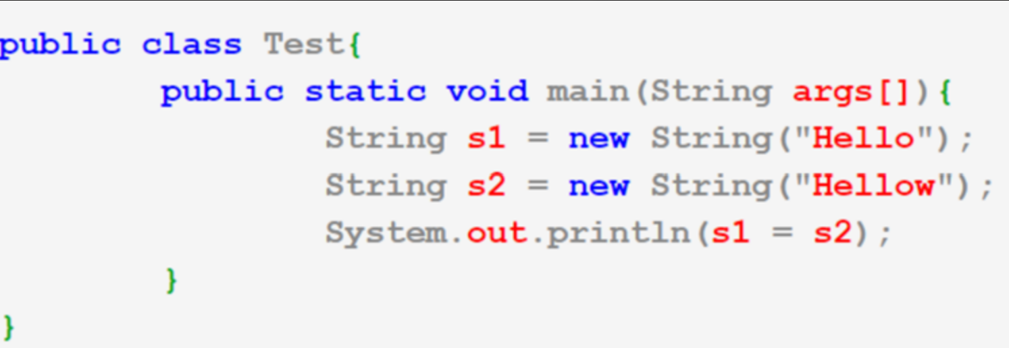

ANS: O/P will be “Hellow”

Q2: Tell the O/P of the Programme:

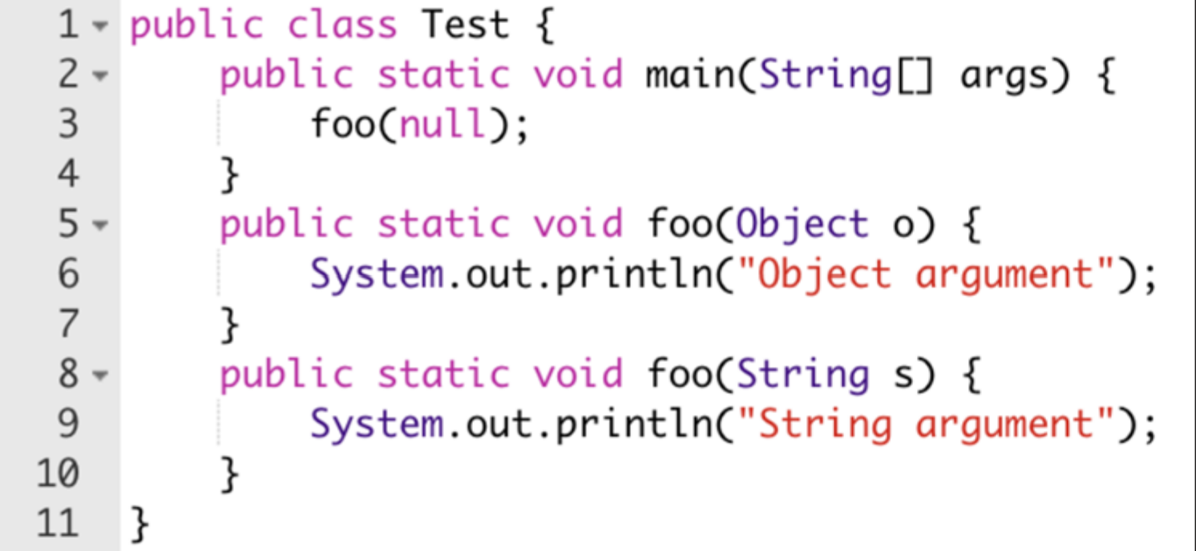

ANS : O/P will be String Argument.

Q3 : Check is a String is Alphanumeric if Yes do a sum of no in it and print the sum    
 Input - “Gaurav12345”

Output- 1+2+3+4+5 = 15

Q4: tell the O/P of this Programme:

public class JavaAssess

{

int x=9;

public static void main(String args[])

{

System.out.println(“printing..”);

System.out.println(x++);

}

}

ANS : will through the Error.