CprE 308 Homework 3
Department of Electrical and Computer Engineering
Iowa State University

Student Name: Gurumanie Singh Dhiman

University-ID: 911192340

Problem 1. (5 points)

Applications can be roughly classified into two types based on I/O pattern: sequential and random. Which type of applications tend to have better I/O performance on hard disk drives? Why?

Sequential I/O applications tend to have better I/O performance on Hard Disk Drives (HDD). This is mainly due to the fact that sequential accesses minimize on the overhead it takes from the disk head movement and also allows for data to be read in a contiguous order. Whereas, in random accesses there is more requests, overhead and data-seeking time.

However, the above is only true as a general statement because which type has “better” performance depends on the task at hand. For example, random I/O is better when it comes to accessing scattered data points such as database indexing.

Problem 2. (5 points)
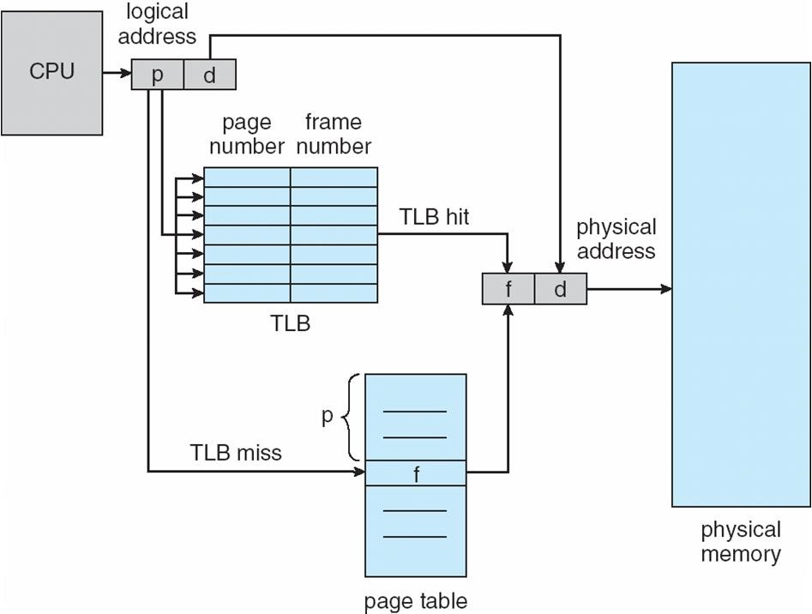

The figure above shows the basic workflow of paging with TLB. Assume the TLB hit ratio is R, which means the percentage of times that a page reference is found in the TLB. Also, assume the latency of memory access is L. Calculate the Effective Access Time (EAT) using R and L.

EAT = R * L + (1 - R) * 2 L

Assuming that R and L are converted from percentage to decimal (Ex: 80% → 0.8).

Problem 3. (10 points)
We can evaluate a page-replacement algorithm by running it on a particular string of memory references (reference string) and computing the number of page faults on that string. Each number in the reference string represents a page number. Assume there is a reference string as follows:

8,0,1,2,0,3,0,4,2,3,0,3,0,3,2,1,2,0,1,8

Assume the system only has three physical memory frames, and the content of the frames corresponding to the reference string above is as follows:

8 0 1 2 0 3 0 4 2 3 0 3 0 3 2 1 2 0 1 8
8 | 8 | 8 | 2 | 2 | 2 | 2 | 4 | 4 | 4 | 0 | 0 | 0 | 0 | 0 | 0 | 0 | 0 | 0 | 8
 | 0 | 0 | 0 | 0 | 3 | 3 | 3 | 2 | 2 | 2 | 2 | 2 | 2 | 2 | 1 | 1 | 1 | 1 | 1
 |  | 1 | 1 | 1 | 1 | 0 | 0 | 0 | 3 | 3 | 3 | 3 | 3 | 3 | 3 | 2 | 2 | 2 | 2

- Based on the memory content above, how many page faults are there for the given reference string?

13

- Which page-replacement algorithm is used in the system?

First In First Out (FIFO)

- Assume we extend the physical memory by adding one more frame, i.e., there are four frames in the main memory in total now. Assume the system uses Least Recently Used (LRU) page replacement algorithm. Fill in the following table to show the content of the memory frames for the given reference string.

8 0 1 2 0 3 0 4 2 3 0 3 0 3 2 1 2 0 1 8
8 | 8 | 8 | 8 | 8 | 3 | 3 | 3 | 3 | 3 | 3 | 3 | 3 | 3 | 3 | 3 | 3 | 3 | 3 | 8
 | 0 | 0 | 0 | 0 | 0 | 0 | 0 | 0 | 0 | 0 | 0 | 0 | 0 | 0 | 1 | 1 | 1 | 1 | 1
 |  | 1 | 1 | 1 | 1 | 1 | 4 | 4 | 4 | 4 | 4 | 4 | 4 | 4 | 4 | 4 | 4 | 4 | 4
 |  |  | 2 | 2 | 2 | 2 | 2 | 2 | 2 | 2 | 2 | 2 | 2 | 2 | 2 | 2 | 0 | 0 | 0

