CPRE/CYBSC-5360_FALL-2025 PROJECT-3

Scenario
A woman (Betty) has been murdered. The murder was called in by Betty’s husband (Simon), who claims to have been at home at the time. Your job is to analyze these artifacts for forensically interesting information. Time Zone: UTC+9
Case Details

Introduction

15:31 on 2017-07-17
Chuncheon Emergency Services received a phone call from a local apartment building manager. A man that lived in the apartment building claimed that his wife was attacked inside their apartment.

15:40 2017-07-17
Police arrive on-scene and find the husband (Simon HALLYM) and apartment manager (KIM Kil Whan) outside of the apartment.

The apartment is secured, and a woman is found lying on the ground in the living room. She is not breathing and has no pulse. From an initial assessment it appears as though she was stabbed multiple times. Medical services arrive and confirm she is deceased.

15:50 2017-07-17
Investigator 1 interrogates the building manager (Mr. KIM) and husband (Mr. HALLYM). The building manager claims the Mr. Hallym ran down the stairs screaming for the police.
Full transcripts of the interrogation of Mr. Hallym can be found in Appendix A.

A search of the apartment revealed the following digital devices:

- Door sensors at the main door
- Motion sensor on the shelf
- Wristband on the floor where the victims’ (Betty Hallym) body was found
- Mobile Phone on the floor where the victims’ (Betty Hallym) body was found 5. Amazon Echo device
- Google OnHub wifi router connected to SmartThings Hub and IPTime switch
- Samsung Smart things hub
- IPTime Switch OnHub (6) and Modem (ISP)
- Raspberry Pi connected via HDMI to TV
- Bluetooth headphone
- Door sensor at the bedroom door

Data Acquisition（Images are available on this location C:\CPRE 536 Project Images）
- Acquired image of Betty Hallym’s Samsung Note II (Black)
- 002-BettyNote2Black
- Acquired image of Raspberry Pi (SmartTV)
- 001-SmartTV-RaspberryPi.zip
- Acquired diagnostic report from Google OnHub
- 004-Onhub-diagnostic-report
- Acquired data from Amazon Echo / Alexa Cloud UI
- 003-Amazon-Echo-Alexa-Web-Scrape
- Acquired SmartHome network traffic logs from Acme, Inc. - 005-IoT_Net_Traffic

Appendix A
15:49 2017-07-17 Interrogation of Simon
1. What is your full name?
– Simon Hallym
2. What do you do?
– I am a computer programmer.
3. Are you living in this Home?
– Yes, I am living with Betty. She is my wife, Betty Hallym.
4. Could you please describe what happened?
– I was watching a movie. After finishing the movie, I came into the living room and found her on the ground.
5. Do you know someone who would want to hurt your wife?
- No. No one.
6. Did she have friends in the area?
- I don't think so. We just moved here.
7. Where did you watch the video?
– I was in our bedroom.
8. Could you remember what time?
– Almost 3? I don’t know exactly. Maybe around 3pm. I think that's when we got home.
9. When you were watching video, didn’t you hear anything?
– She listens to music, so I used headphones. I didn't hear anything.
10. Can you remember what you were watching?
– It was a drama from YouTube.
11. We found SmartThings sensors around your home. Do you have access to this data?
– Yes, I get it on my phone.
12. May we have permission to access your phone?
- Yes, ok.
13. May we have permission to access your SmartThings data?
- Alright.
14. Can you identify this black Samsung Note II, and Mi step monitor?
– Those are Betty's.
15. Do you know any passwords for the phone?
- No.
16. What are the passwords to your WIFI?
- Home is iot14306, but the guest network is iot14305

Questions
- (1 point) Please find all the apps installed and recently used on Betty’s phone.

When opening up the USERDATA for BettyNote2Black in Encase, I was able to find the folders app-lib and app. When I looked into these I found all the apps on Betty’s phone.

There are 34 apps in the app-list folder:
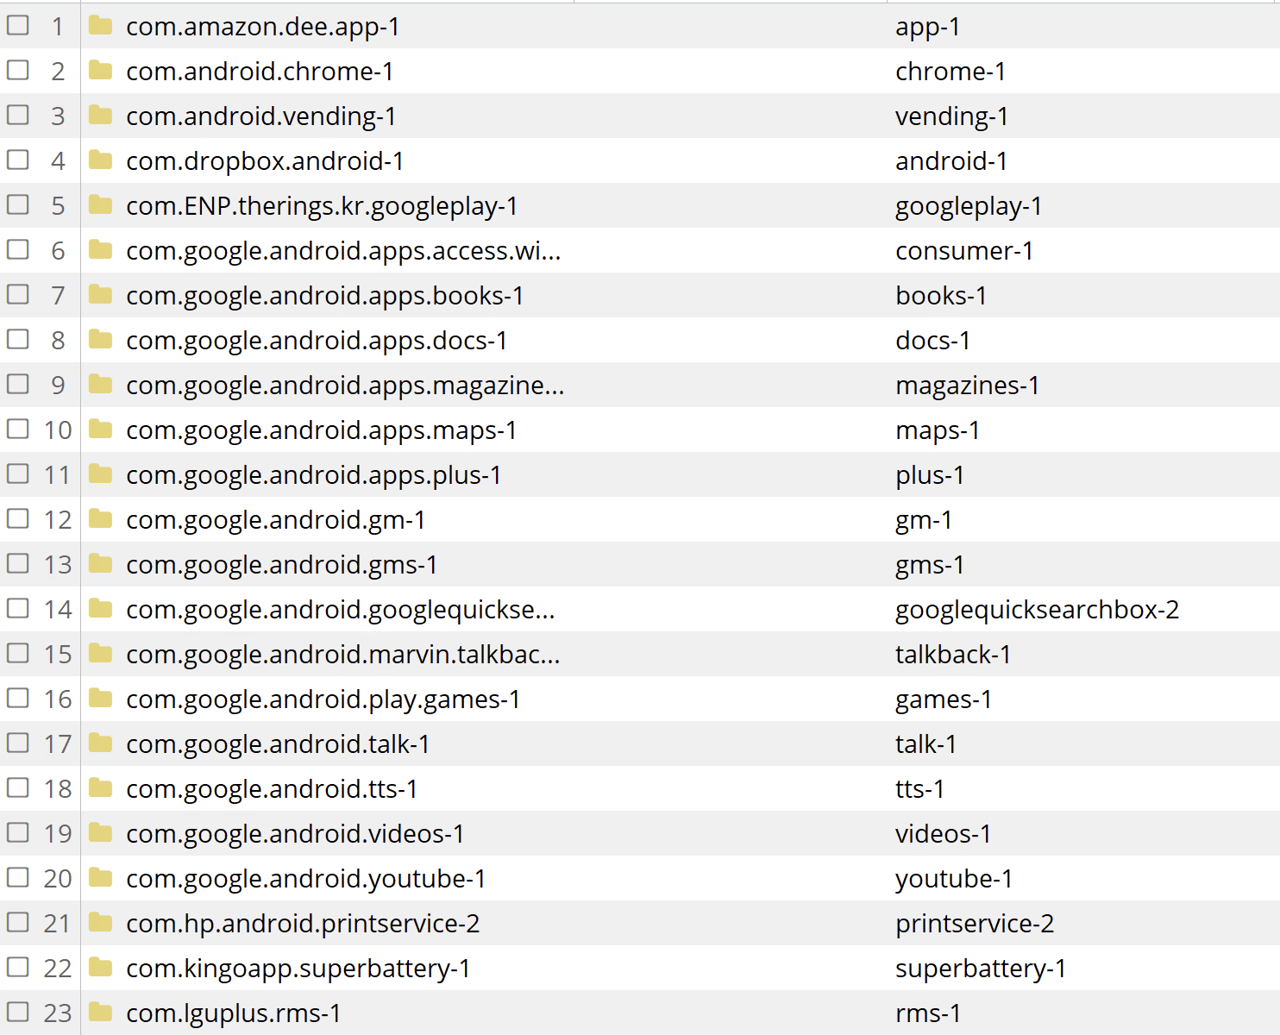
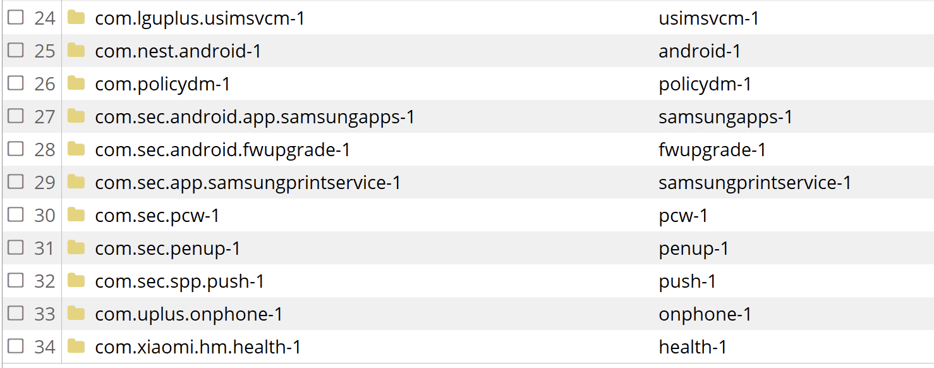

And there are 36 apps in the app folder:
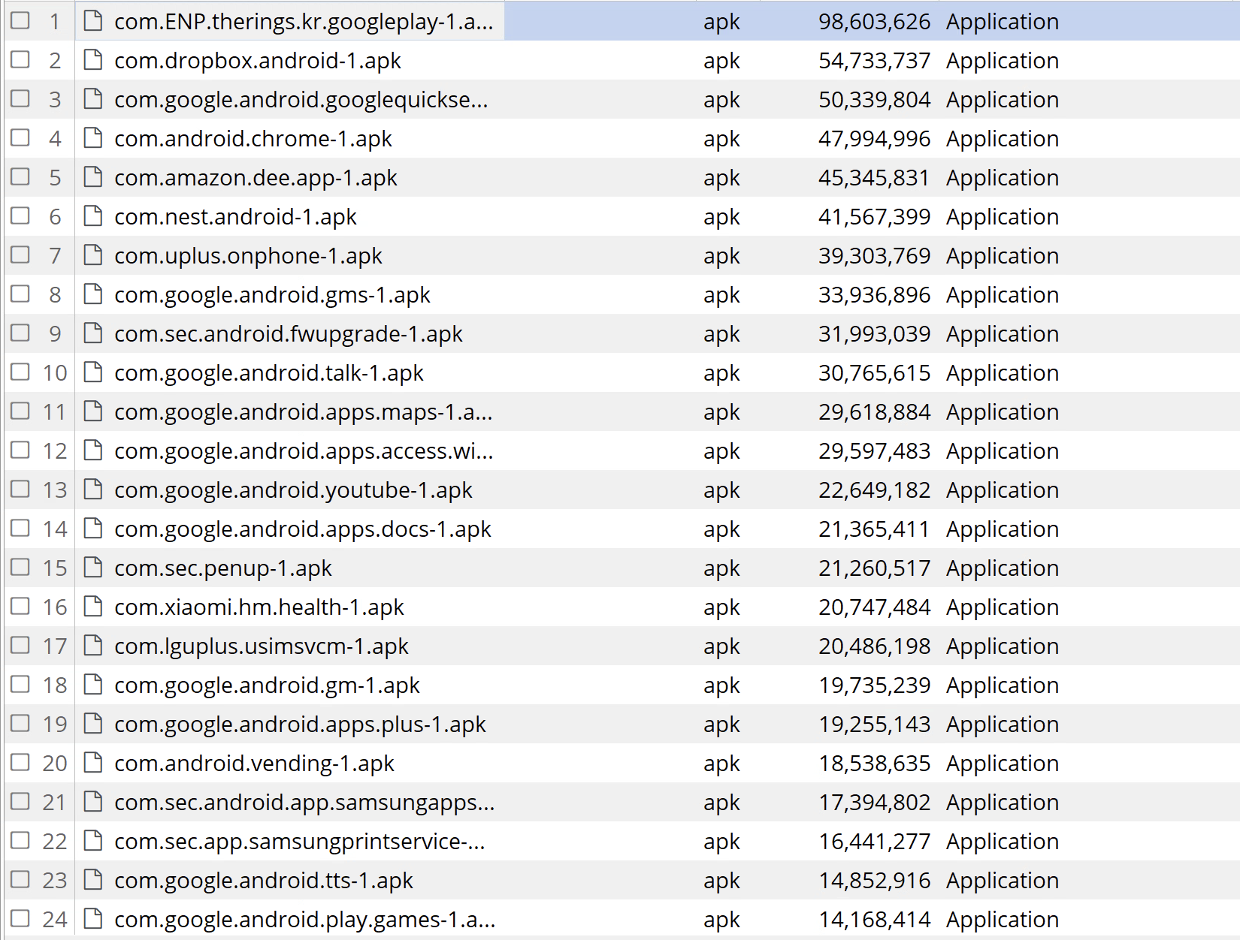
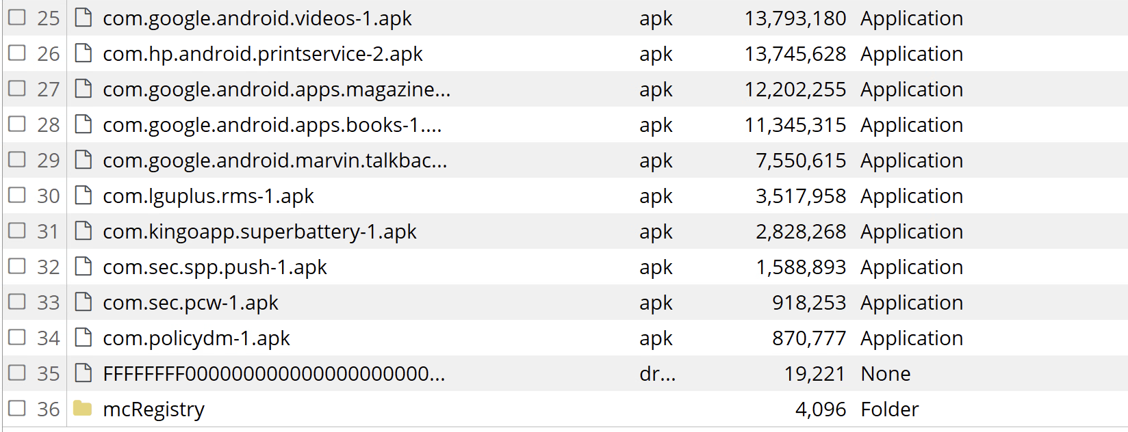

- (1 point) Please find the browsing history of websites and videos.

Based on Q1, Betty’s phone mainly used the Chrome browser.

- (2 points) Please find the chat history and emails.

- (1 point) Please find the history of usage between smartphone and wearable device.

- (1 point) Please find the timestamp when Amazon Echo is called by voice command “Wake up”.

After unzipping the 005-Amazon-Echo-Alexa-Web-Scrape file, I was able to go inside and look at all the files one at a time. Towards the end of the folder I found a file called “history second page.png” which contained the following details:
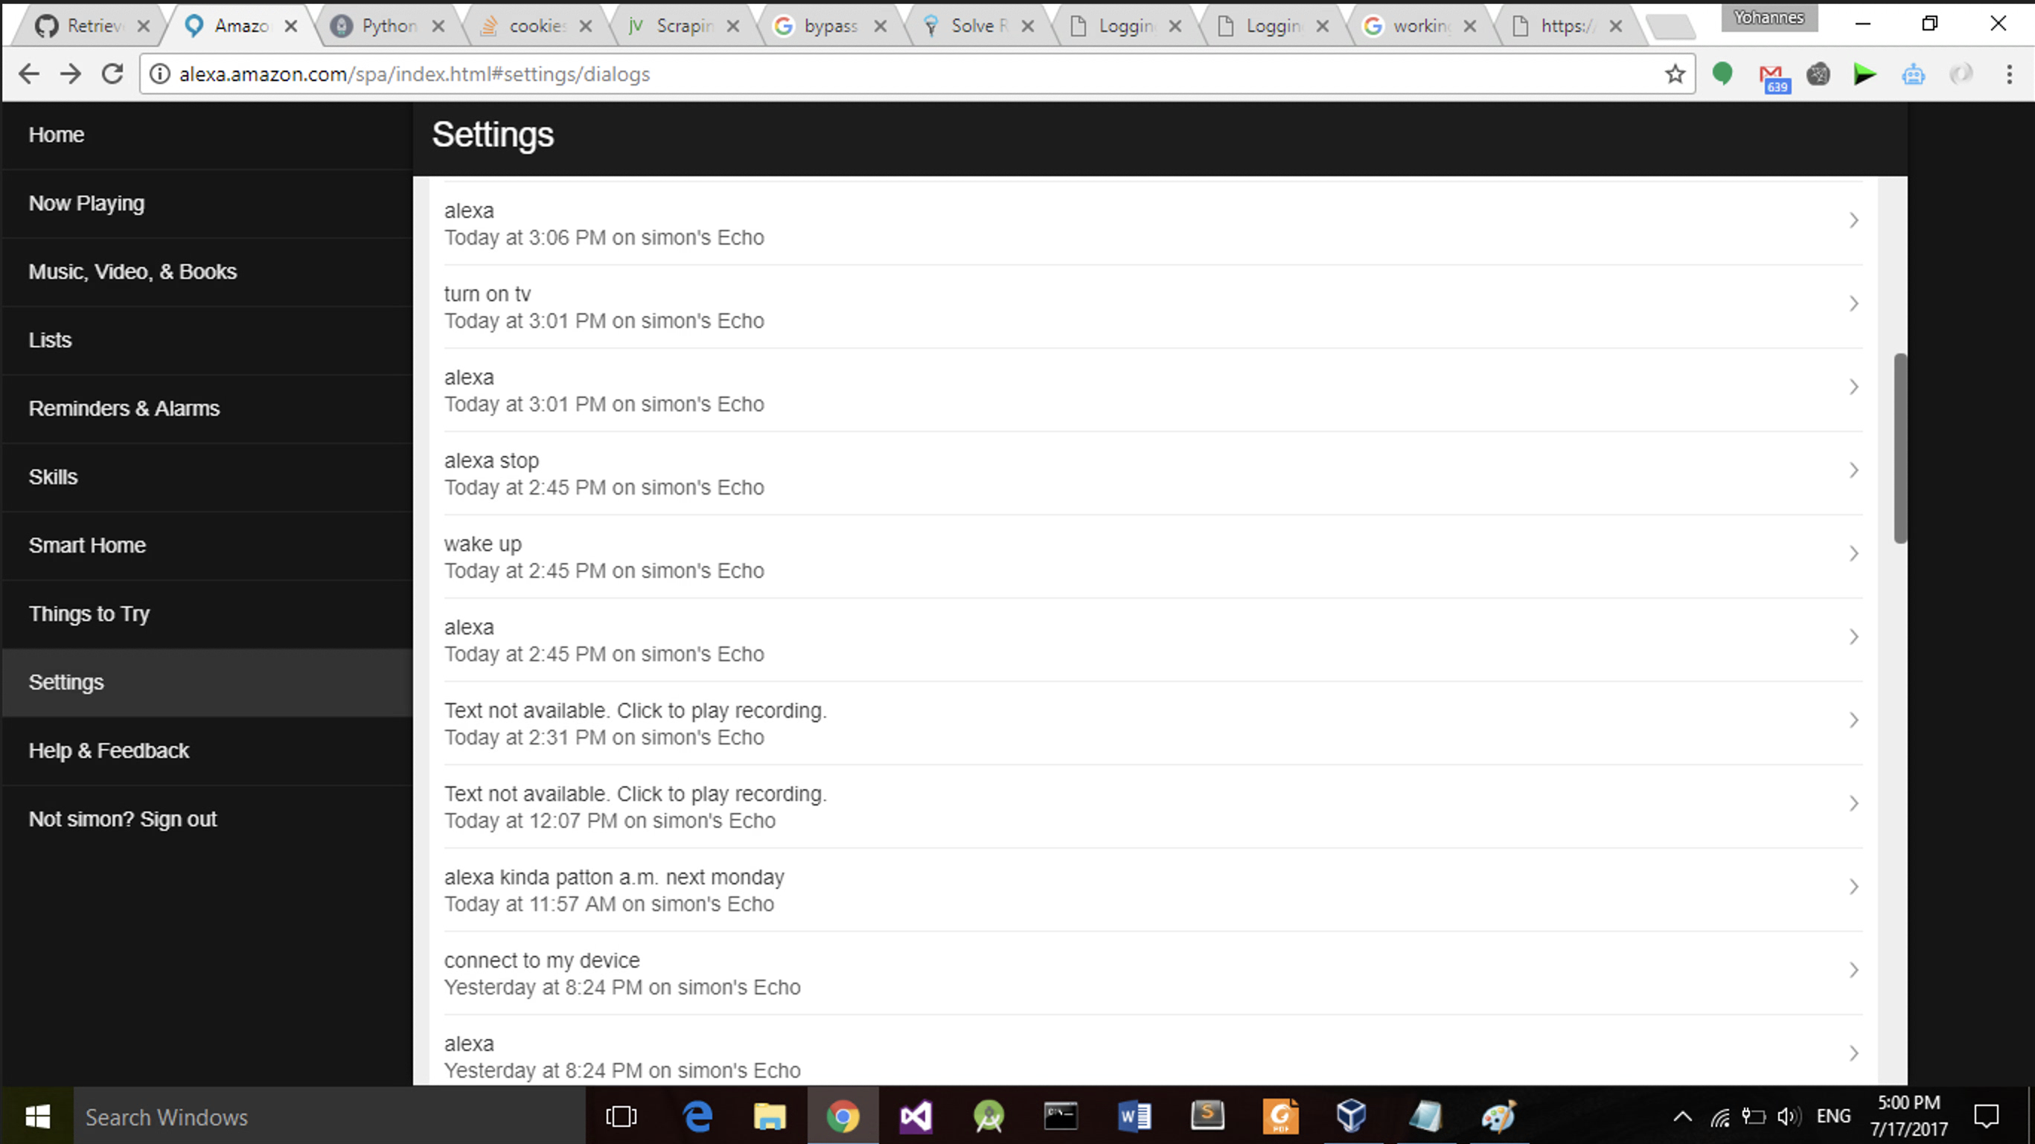

As we can see from the above entries, the Amazon Echo is called by voice command “Wake up” at exactly 2:45 PM.

- (1 point) Please find the IP address from Google OnHub diagnostic-report.

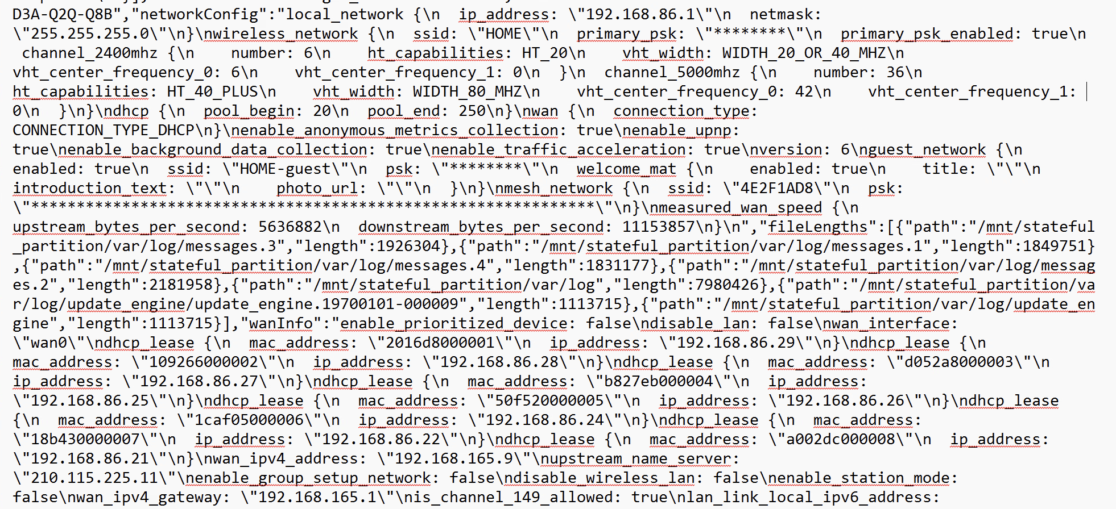
After cleaning up the above onhubdump report, I got the following details:

Clean Interface IP Addresses
127.0.0.1
192.168.86.1
192.168.87.1
192.168.165.9

Clean Active Device IPs
192.168.86.21
192.168.86.22
192.168.86.24
192.168.86.25
192.168.86.26
192.168.86.27
192.168.86.28
192.168.86.29

- (1 point) Please build up Betty’s activity from these devices.

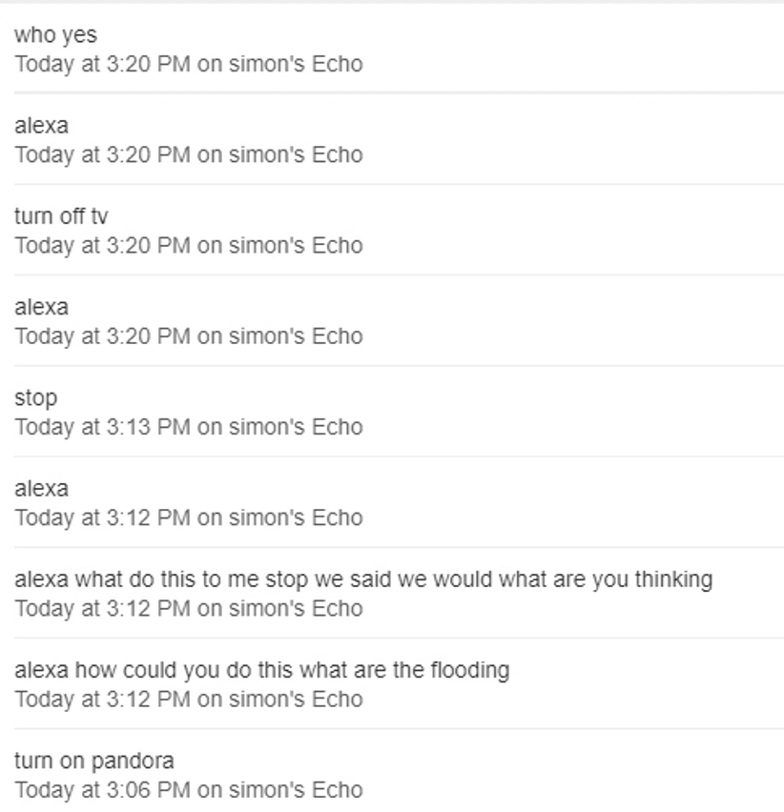

- (2 points) Simon claimed he arrived home at around 3 pm on 7th July 2017 and used a Bluetooth headset to watch TV, after which he found her on the ground when he entered the living room. Please verify his statement. Did he lie or not?

Toolkits Recommended
Encase(002-BettyNote2Black)
Onhubdump(004-Onhub-diagnostic-report)
https://github.com/benmanns/onhub/tree/master/cmd/onhubdump

To install Onhubdump, please following the instructions below:

1. If go is not installed, install it from https://go.dev/doc/install 2. Verify your go installation:
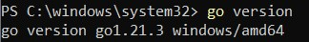
- Open terminal, and type in command:
go install github.com/benmanns/onhub/cmd/onhubdump@latest
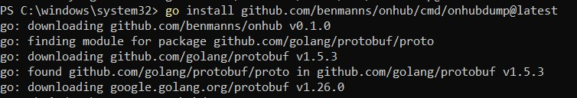
- Navigate to the directory where you downloaded and saved the diagnostic report 5. Use command:
onhubdump 004-Onhub-diagnostic-report
6. Refer to the link below to learn how to use this tool:
https://github.com/benmanns/onhub/tree/master/cmd/onhubdump

