Lab 8 Report:
3.1.1
5. The output is coming from the remote machine. Once we are successfully connected using the command “ssh dhiman@class-linux1.ece.iastate.edu,” my shell on the macOS interacts with the remote server at Iowa State.
3.1.2
3. The scp command reads the source file and writes it to our destination. It is like copy/paste feature on most computers. Whereas the rsync command employs a delta transfer algorithm and some other optimizations which make the operation much more faster. Furthermore, a key difference is that rsync only copies over the differences being made to the file instead of the entire file again.
4. The first time I ran the command it sent the full size (3,587 bytes) of the file since it does not exist on my local computer. The second time it was only 101 bytes sent when the command was run (file size was much smaller since it already exists).
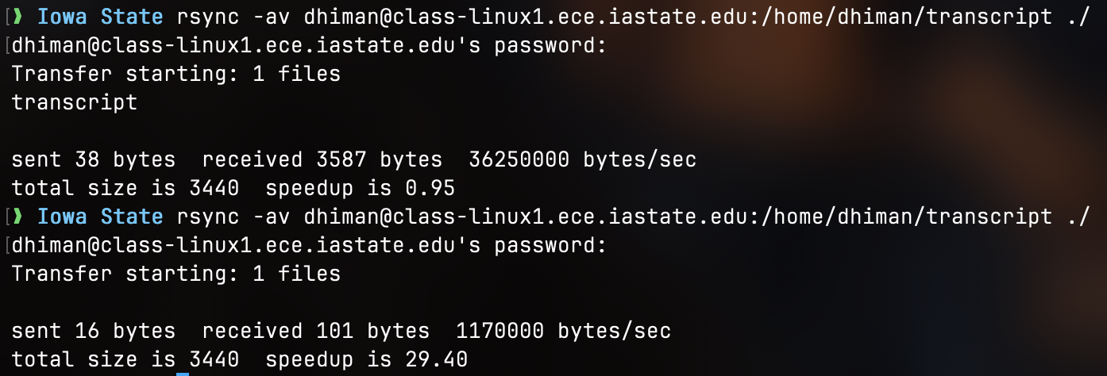
3.1.4
The system (known hosts) is to ensure that you always reach the intended server which helps protect against “Man-in-the-Middle” attacks. Yes, I get a warning when I try to remove the entry and ssh back into the machine. This warning is mainly because the remote machine treats my connection as a new connection.
3.1.5
1. After running “ssh-keygen -t dsa,” the private key is in the id_dsa and the public key is in the id_dsa.pub file. Basically if there is a .pub extension it means public key and without the .pub extension means private key.
2. The difference between a passphrase and a password is that the passphrase is specifically for the private key itself (to encrypt and decrypt it). Whereas a password allows you to log into the account and is used for authentication. If you end up forgetting your passphrase, you will be unable to decrypt your private key that you created. You will need to generate another pair.
3. Your passphrase is used to encrypt the private key file. The public key file is not encrypted because it is not secret and is supposed to be shared with servers and other clients to identify the machine you are on.
3.1.6
From a security standpoint, key-based authentication is much more secure since an attacker would need to have both the private key file and the passphrase to log in, rather than just knowing the password. Furthermore, when we decrypt the key locally, this means that the passphrase is never really sent over the network or online, whereas a password is.

