Name: Gurumanie Singh Dhiman
Section: A
University ID: 911192340

Lab 3 Report
Summary:
10pts
In this lab, I learned the basics of threading using the pthread library in C. It showed me how threads work concurrently and how they are called and used by the main function. Within the first few sections itself, it was clear how important using pthread_join( ) is to make sure that the main thread that is running waits for the other threads to finish first. Without using pthread_join( ) there are some threads that are unable to finish on time, especially if there is a sleep( ) somewhere within those threads. This really changes the output of the threads and I even learnt that thread scheduling is not based solely on the way the code is written but also depending on the OS that we are using.

Furthermore, working with mutex and condition variables showed me how synchronization is handled in between threads which is especially handy in the producer-consumer problem. When we got rid of the mutex in one of the exercies, it resulted in different results that were incorrect due to race conditions which further explains just how challenging threads are. I was definitely taken aback when I saw that the decrement thread got to execute first again and again resulting in -990 as my output. This was also because the code clearly showed the increment thread being declared and also created first, yet somehow due to the way my specific OS scheduled tasks, it would still execute the decrement thread first.
Lab Questions:
3.1:
6pts To make sure the main terminates before the threads finish,
add a sleep(5) statement in the beginning of the thread functions.
Can you see the threads' output? Why?

Before sleep(5) statement was added:
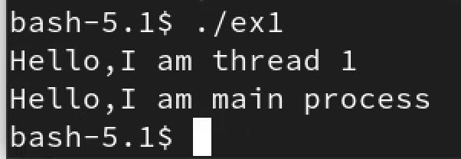

After sleep(5) statement was added:
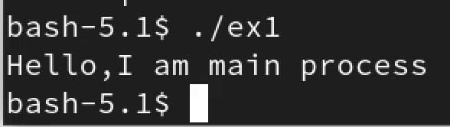
I was able to see the threads’ output and the main print statement before the sleep statements were added but only the main print statement after the sleep statements were added. This is because after adding the sleep(5) statement, the main no longer waits for the other two threads to finish and simply exits once it is done. That is why we only see the main print statement and none of the threads’ print statements because they were not done waiting (5 seconds) yet. Before our sleep(5) was added we saw at least one thread print statement which was likely due to the fact that the first thread finished running before main, but the second thread did not have enough time to run before main could finish and exit.

2pts Add the two pthread_join statements just before the printf statement in
main. Pass a value of NULL for the second argument. Recompile and rerun the program. What is the output? Why?
I am now able to see all the print statements (both threads and main). This is because after adding the pthread_join statements, main waits patiently for both the threads to finish running before it exits. Only once both threads are done with their task of waiting and printing their messages does main finally exit.
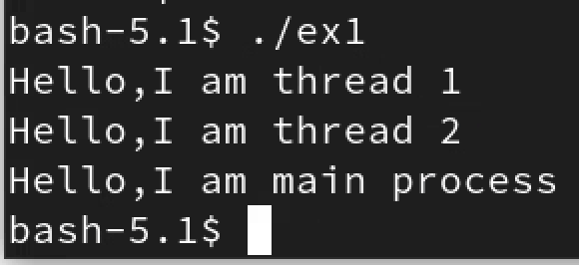

2pts Include your commented code.
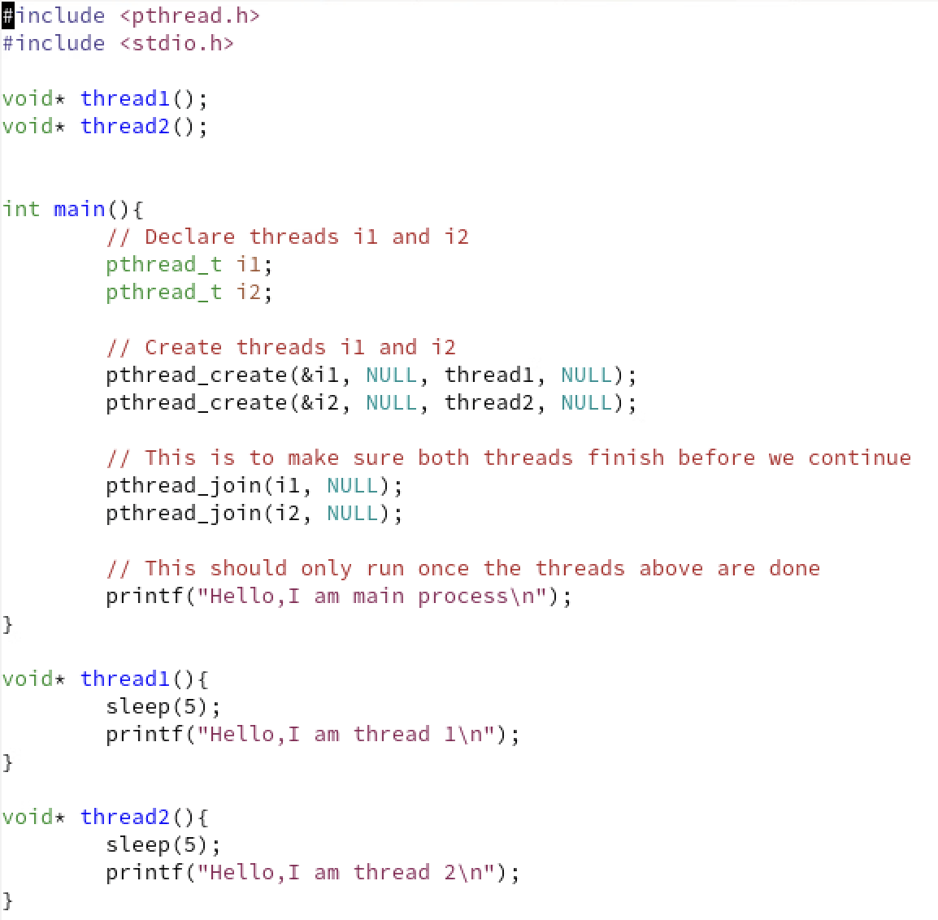
3.2:
3.2.1:
2pts Compile and run t1.c, what is the output value of v?
The output value of v is 0.
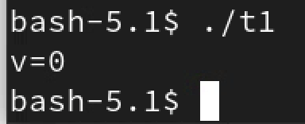

8pts Delete the pthread_mutex_lock and pthread_mutex_unlock statement in both increment and decrement threads. Recompile and rerun t1.c, what is the output value of v? Explain why the output is the same, or different.
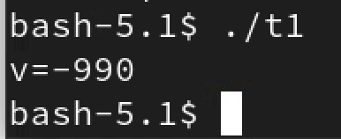
After deleting the pthread_mutex_lock and pthread_mutex_unlock statements from boht increment and decrement threads the output value drops to -990. Before we got rid of the lock and unlock statements from the increment and decrement threads, we got 0 because the increment thread added 10 till it hit v (99 times) and the decrement thread subtracted 10 till it hit v (99 times). This made our output value of v even out to end up being 0. Whereas, when we got rid of our lock and unlock statements, our output value of v is -990 because the increment thread gets delayed from execution every time. It is fascinating because we know increment is created first and even called first yet it never gets to go, but this is mainly because we spoke about this in class and it is because pthread_create doesn’t decide which thread gets to go first. While the program is non-deterministic by design, the specific OS I am running constantly gives me -990 because of how it is possibly set up or how my specific OS thread ordering works.

3.2.2:
10pts Include your modified code with your lab submission and comment
on what you added or changed.
In init and main(), I added an additional routine in line 3 (void again () ), an extra pthread_cond_t called done_world, a new thread id called tid_again, a pthread_create for the thread again, and a pthread_join for the thread again. In world(), I set done = 1, and updated signal for world to let again() know world() is done. In again( ), I set it up similar to the way world() is set up, but did not need to include an update to done = 1 or update a signal for again because there is no thread after it.
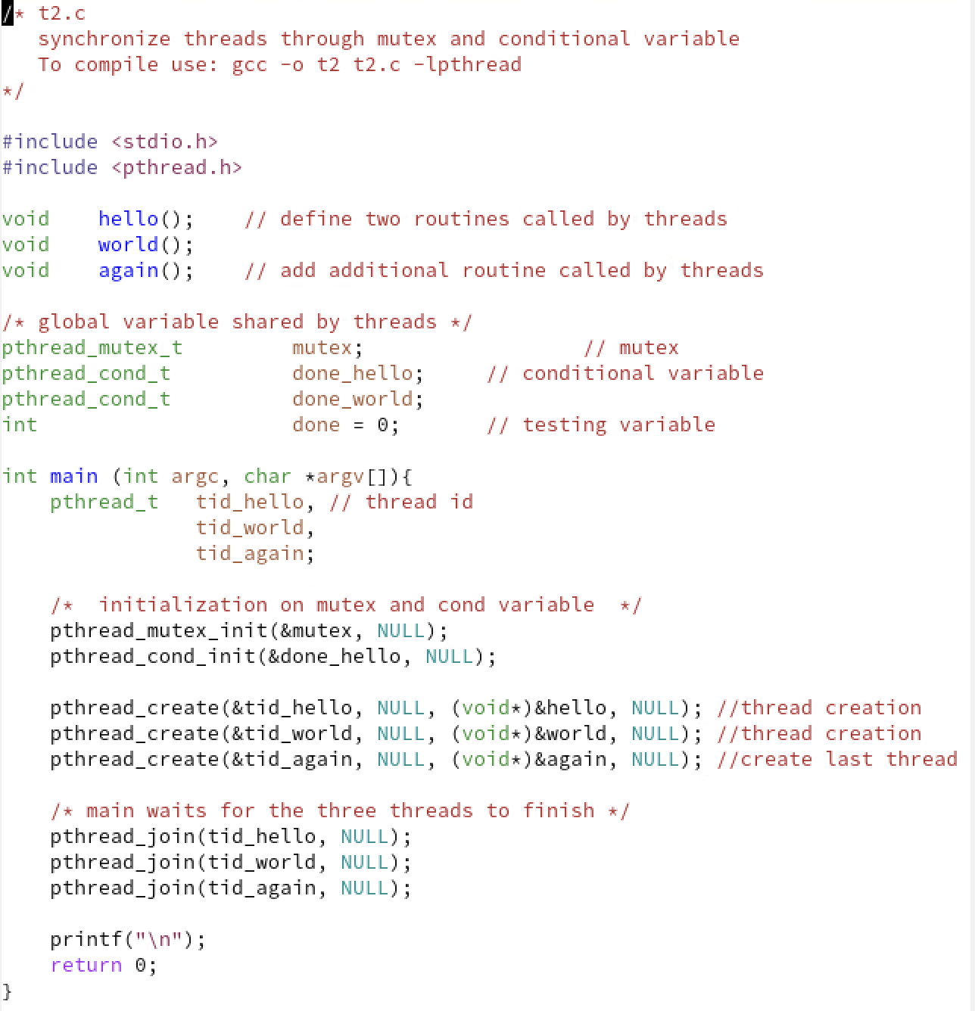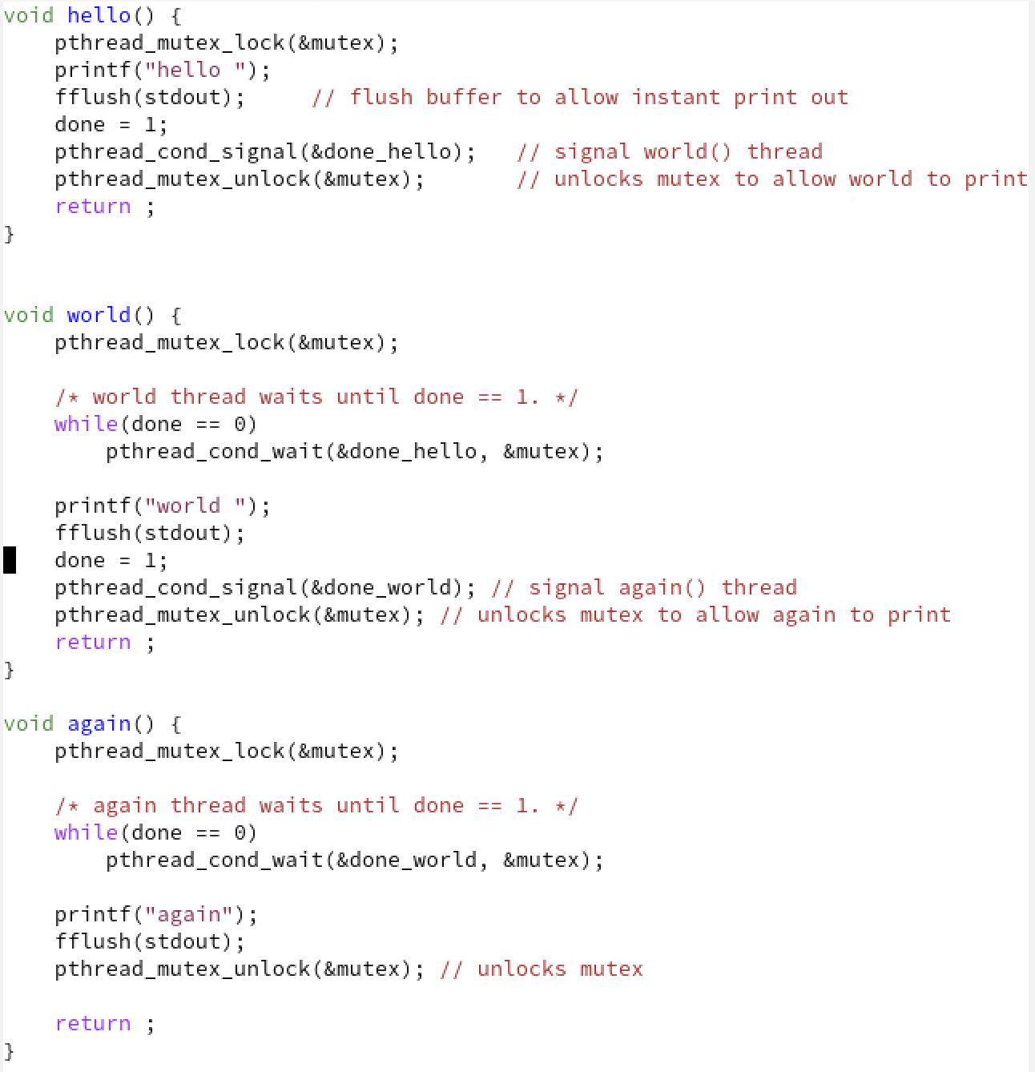
3.3:
20pts Include your modified code with your lab submission and comment on what you added or changed.
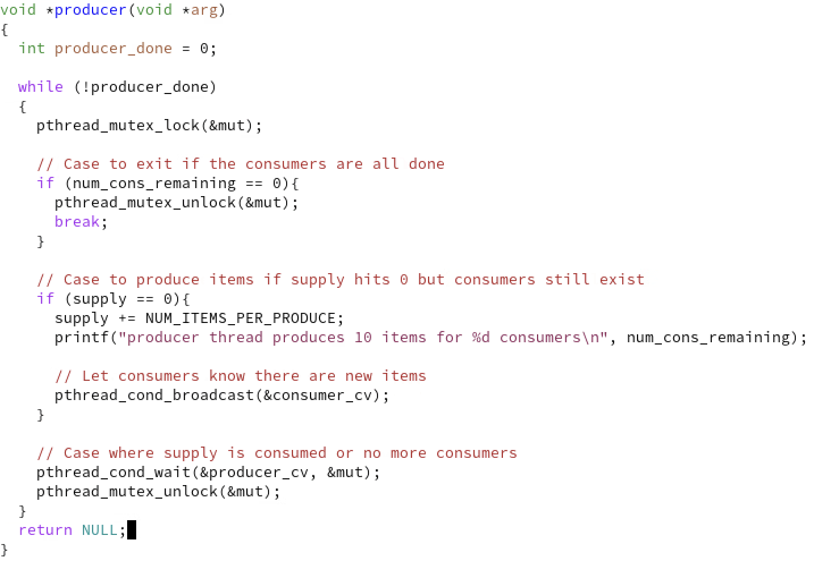
The producer thread I modified runs in a basic while loop which produces 10 items at a time when the supply is 0 and there are still consumers that exist. It starts by first locking the shared mutex variable, which is unlocked once all the consumer threads are done and then exits. Otherwise when the supply is 0 and there are still consumers, it adds 10 more items and lets the consumers know (broadcasts) that it has done so, after which it just waits until the consumers notify the producer that the supply has run out again. This process continues until all the consumers are done.

