MITRE ATT&CK
In this homework, I will be going over:
- A group and all their techniques
  - Whitefly, Group G0107
- A software package and how it is used
  - Daserf, Software S0187
- A campaign and how it is used
  - Operation Honeybee, Campaign C0006

Whitefly: This is a cyber espionage group that has been operating since at least 2017. This group has targeted organizations based mostly in Singapore across multiple sectors and has a primary motive to steal large amounts of sensitive info. This group was mainly linked to the attack against SingHealth which is the largest public health organization in Singapore.
Daserf: This is a backdoor that has been used to spy on and steal info from Japanese, South Korean, Russian, Singaporean and Chinese victims. It is written in Visual C and Delphi.
Operation Honeybee: This was a campaign that targeted humanitarian aid and inter-Korean affair organizations from at least late 2017 to early 2018 (quite a small timeframe). It initially only targeted South Korea but expanded to eventually include Vietnam, Singapore, Japan, Indonesia, Argentina, and Canada. The security researchers that looked into this campaign found that the threat actors were likely Korean speakers based on the metadata in the documents and executable files. They also named this campaign Honeybee after seeing the author name in multiple malicious word documents.

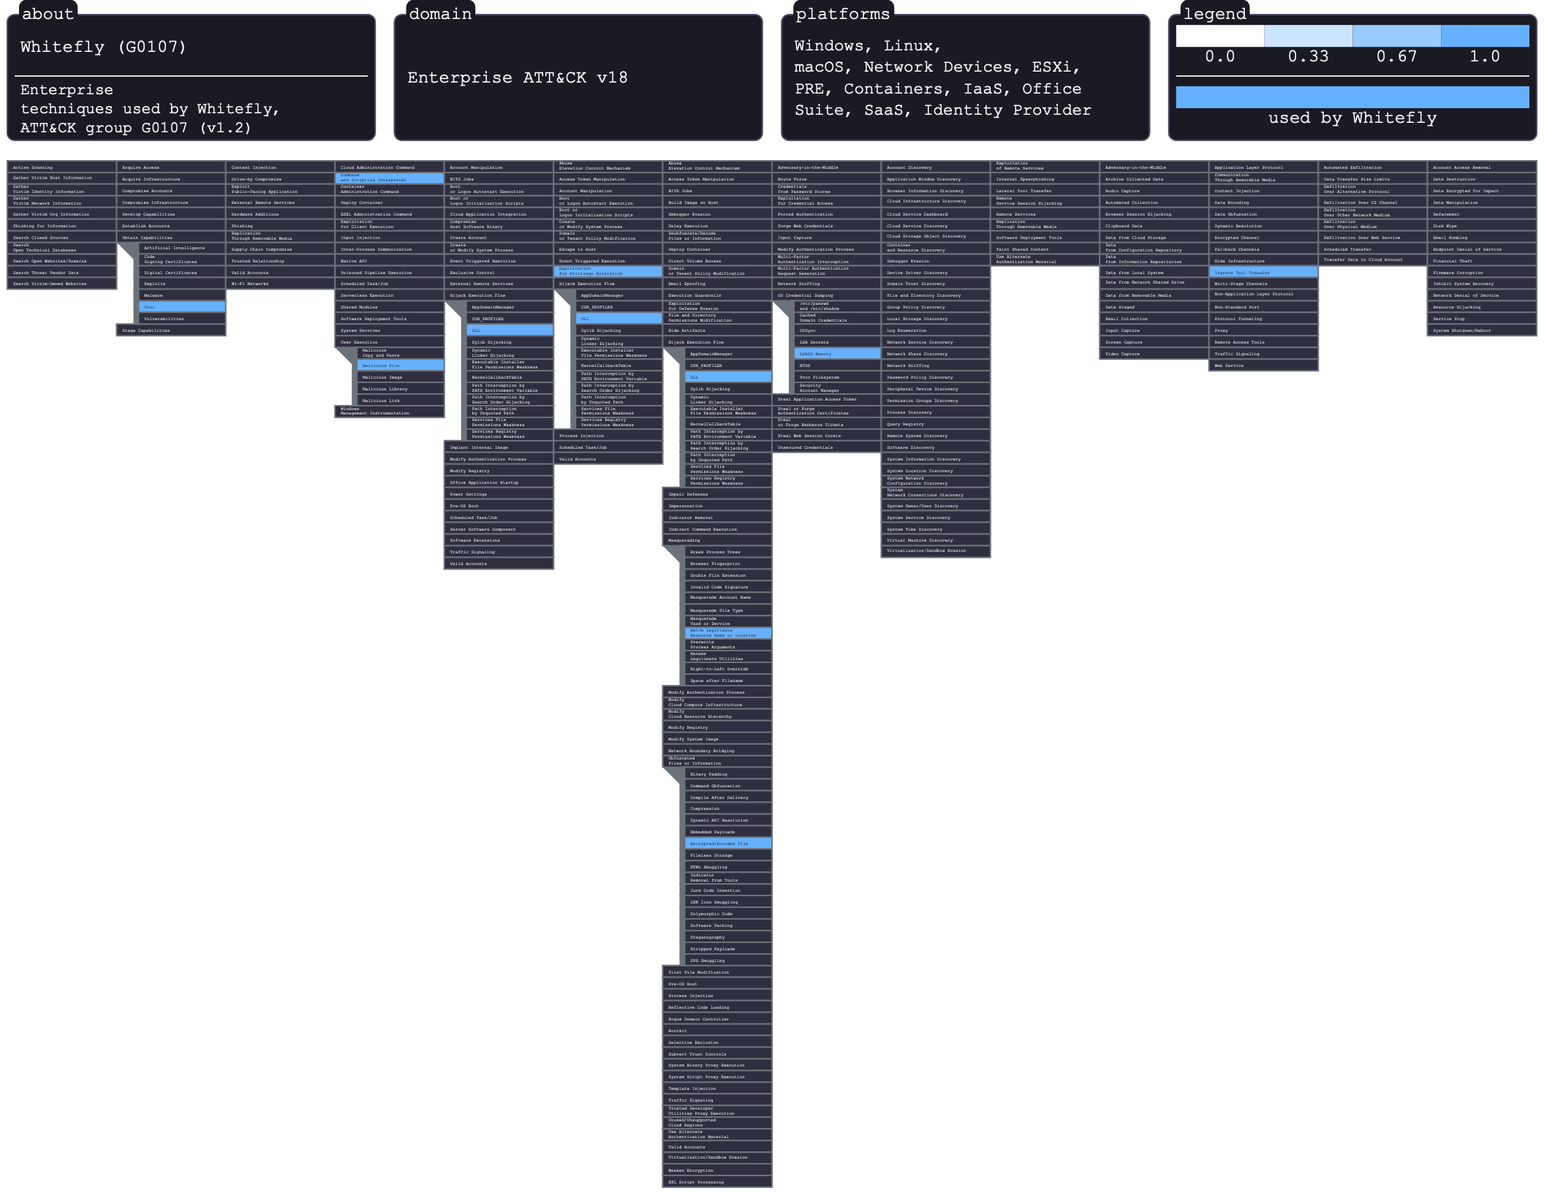
During the attack on SingHealth, the Whitefly threat group basically executed a multiple stage breach that combined social engineering with some technical evasion. This operation was most likely initiated by first delivering malicious executables and DLLs which were disguised as harmless documents or images to deceive employees and gain initial access. Once these files were inside, the attackers utilized DLL search order hijacking to execute the “Vcrodat” loader, which put a remote shell in the systems and communicated with their Command and Control (C2) server using encrypted payloads. To maintain persistence and avoid being detected by SingHealth’s defenses, the attackers masqueraded their malicious files by using names that were the same as the legit security vendor software that SingHealth was using. Then, attackers escalated their access by exploiting a known Windows privilege escalation vulnerability (CVE-2016-0051) on unpatched systems and deployed credential harvesting tools like Mimikatz. These set of tools allowed them to move laterally through the infra, downloading more malicious utilities from their C2 server as needed and then identifying and exfiltrating the sensitive medical records of 1.5 million patients.

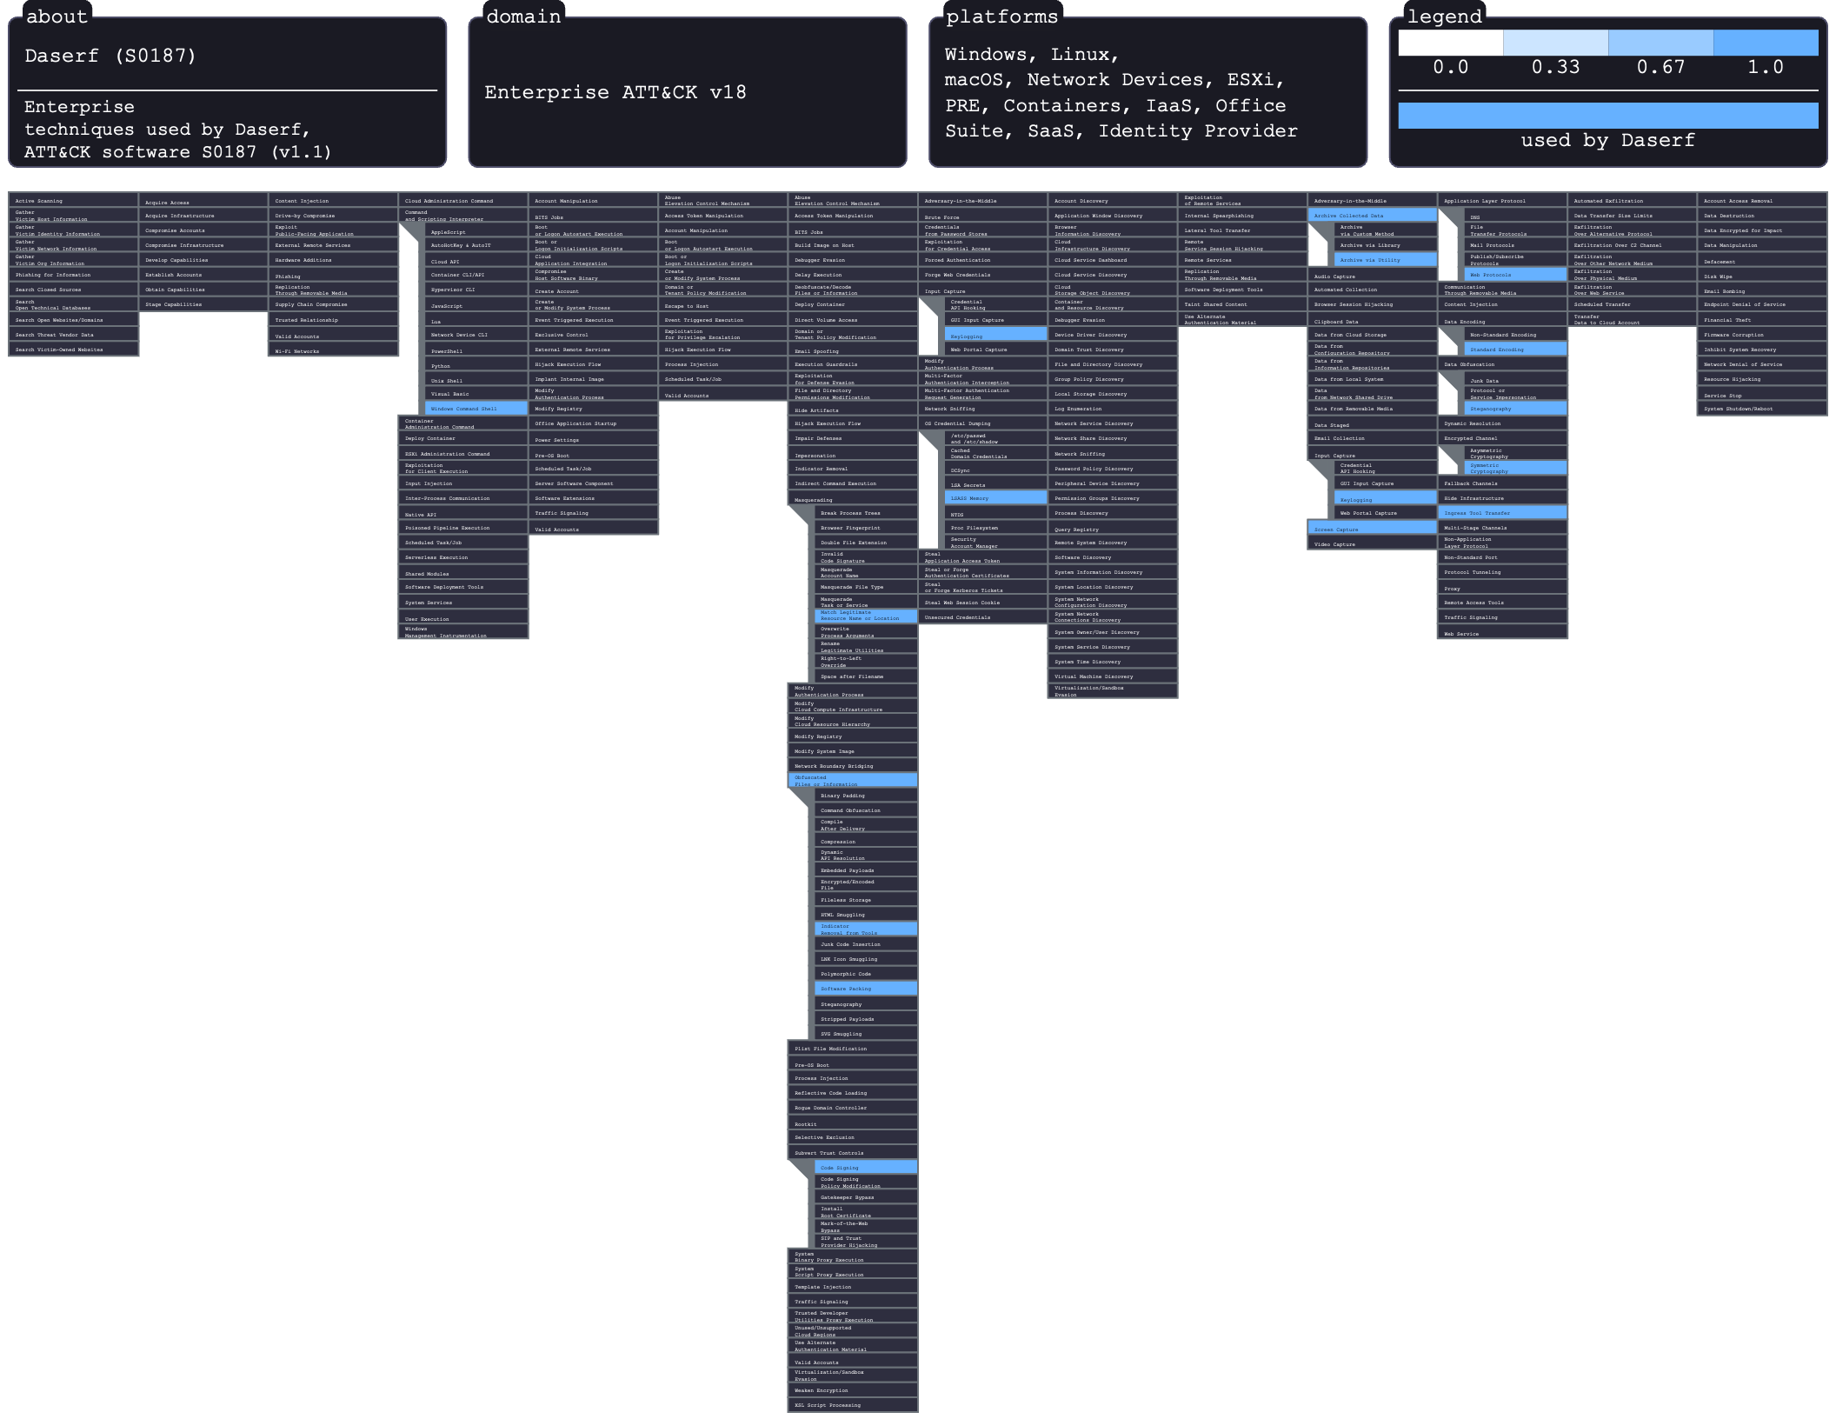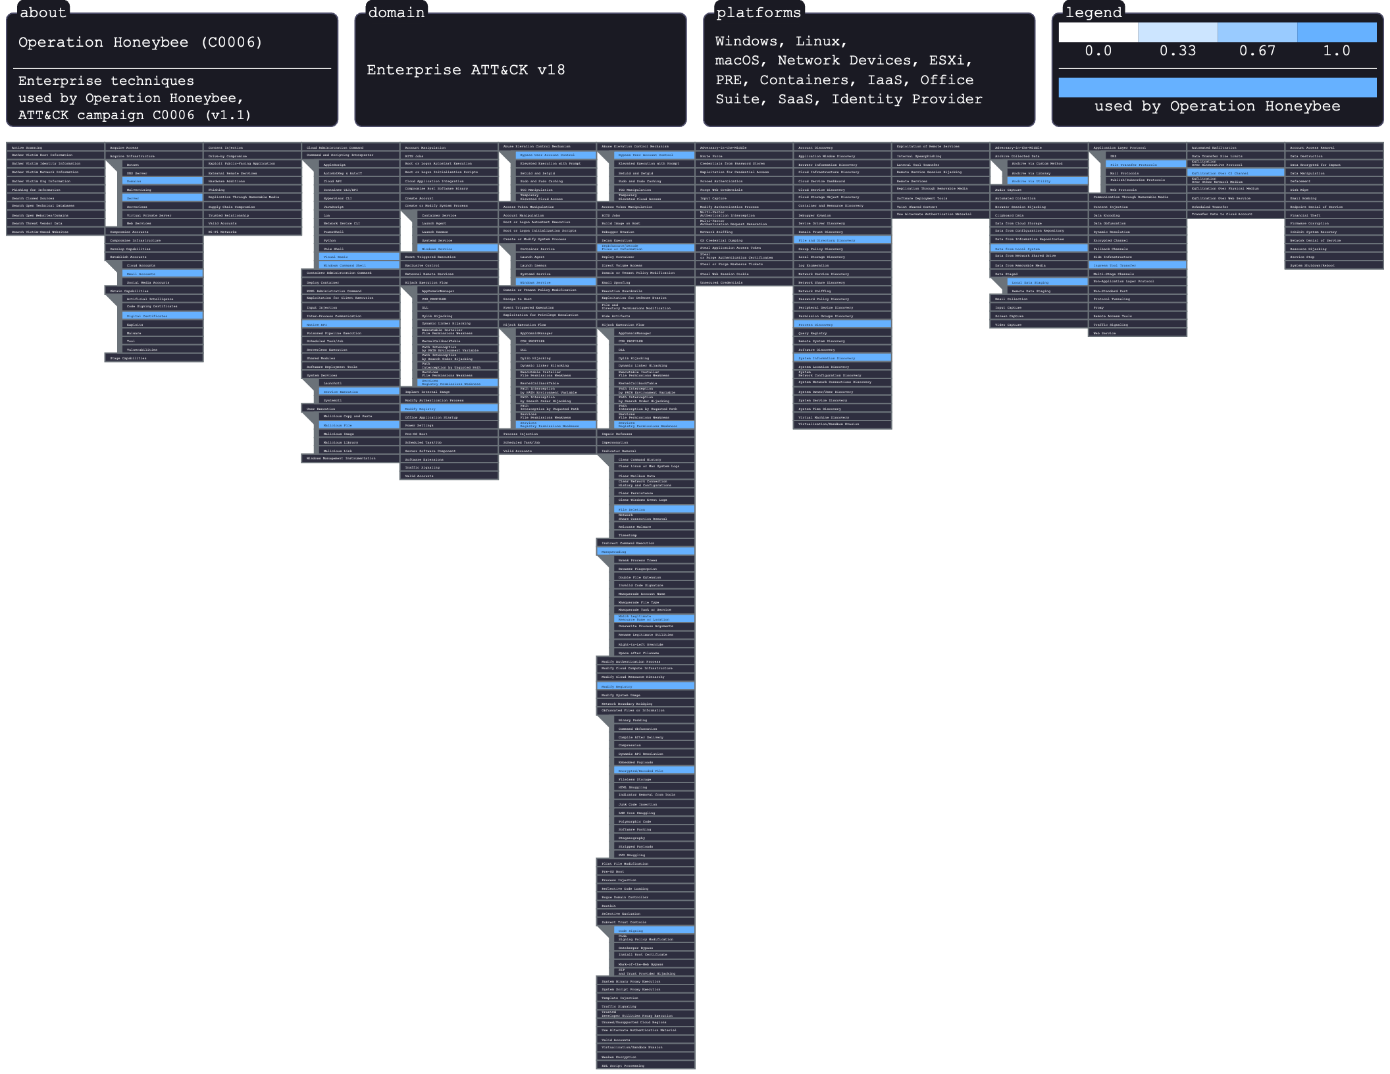
This malware displays significant flexibility through Ingress Tool Transfers, which allow it to download additional payloads or execute instructions using the Windows Command Shell. In the reconnaissance phase, Daserf conducts data harvesting, such as Input Capture through keylogging, Screen Captures, and OS Credential Dumping using utilities like Mimikatz to scrape secrets from the LSASS memory. To further hide its activities, it sometimes uses Steganography to hide incoming malicious code in harmless looking files. Finally, the stolen intelligence is secured using Archive Collected Data techniques, which are specifically password-protected .rar files that ensure that exfiltrated sensitive information remains hidden from network security monitors when it is on the way to the adversary.
Daserf is a sophisticated espionage tool designed for stealthy data extraction and maintaining persistent network access. To evade initial detection, this malware employs Masquerading, which uses legitimate folder names like “Intel” or “Adobe.” It can be validated through Code Signing with stolen digital certificates or concealed using the MPRESS software packer. Once it is inside a system, it secures its Command and Control (C2) communication by utilizing Web Protocols (using HTTP) obfuscated with RC4 symmetric encryption and custom Base64 encoding.
Once the initial access was established, the threat actors used Abuse of Elevation Control Mechanisms and Service Hijacking to bypass User Account Control (UAC) and install persistent backdoors as “Windows services.” Throughout this compromise, the actors performed extensive Discovery, using the Windows Command Shell (cmd) to catalog system info, active processes, and specific keywords within local files. To facilitate data theft, they used Local Data Staging, in which sensitive information was moved into text files, Archived via zip utilities, and then Obfuscated using custom Base64 encoding before being sent by Exfiltration over C2 channels like FTP. To maintain a low profile, the operation frequently used Indicator Removal, which employed batch files to delete malicious artifacts and revert registry modifications, basically minimizing their forensic footprint on the compromised host.
Operation Honeybee was a coordinated cyber campaign that used a mix of social engineering and system manipulation. The whole point of the attack chain mainly began with User Execution, where the victims were enticed to enable macros in a malicious Word document, which then triggered a Visual Basic script to download an implant. To bypass security alerts, the MaoCheng dropper used Masquerading which showed up as a standard document icon and then Subverted Trust Controls by using a stolen Adobe digital signature.

