Mobile Asset Theft: CherryBlos Malware Campaign
1. Introduction
The rapid growth of Decentralized Finance has massively changed the power of financial structure, with the key responsibility for asset protection being handed to the end users. The main entry point for this new and recent system is using the mobile cryptocurrency wallet, which allows users to access their digital assets. However, this has also led to the development of many structural weaknesses that most banking systems are protected against. These weaknesses include things such as institutional safety nets and transaction reversal, which Decentralized Finance lacks (MITRE ATT&CK, n.d.).
The malware CherryBlos first showed up in 2023 and was a complex malware attack that specifically targeted Android devices. It was designed to exploit the structural weaknesses discussed earlier. By combining social engineering, service abuse, and data-extraction methodologies, CherryBlos was able to successfully target the fundamental private seed phrase which is critical for users to keep their accounts secure.
This malware attack revealed critical weaknesses in the trust-based models of mobile application ecosystems and decentralized security (28 et al., 2023), which then eventually prompted an evolution towards hardware-based security measures and more rigorous automated screening processes on Android.
2. Mobile DeFi
The technology which was involved in this attack is related to the Non-Custodial Mobile Cryptocurrency Wallet. Basically non-custodial wallets are different from custodial wallets because they use a traditional bank or a centralized exchange on the Play Store like Coinbase and give users sole control over their private keys.
Three key elements need to be addressed to dive into this problem deeper:
- Seed Phrases: Most wallets use a “mnemonic seed phrase,” which is basically a combination of 12 to 24 random words. This phrase is the master key to their wallet, and anyone who has the phrase has complete control over the assets.
- Android App Distribution: Even though the Google Play Store is the primary source of app downloads, the Android operating system allows for “sideloading” (basically a way to install apps from third-party websites or Telegram channels), which then creates this loophole that is able to evade official security scans and allows users to download “pirated” versions of apps from third-party sources (Google. (n.d.).).
- The Structural Weakness: In the DeFi system, there is no way for you to simply “Forget Password” or go to some form of fraud department to go back on your account or assist (especially if the downloaded version is “Pirated”). Once your seed phrase is lost and the transaction is confirmed on the blockchain, it is irreversible. CherryBlos exploited this exact weakness to ensure that this was a high-impact financial theft.
3. CherryBlos Attack Analysis
CherryBlos was first discovered by the Trend Micro team in mid-2023. The complexity of CherryBlos is in its multi-stage execution and Optical Character Recognition (OCR) which searches for embedded seed phrases in images (The Hacker News).
MITRE ATT&CK® Navigator Layers
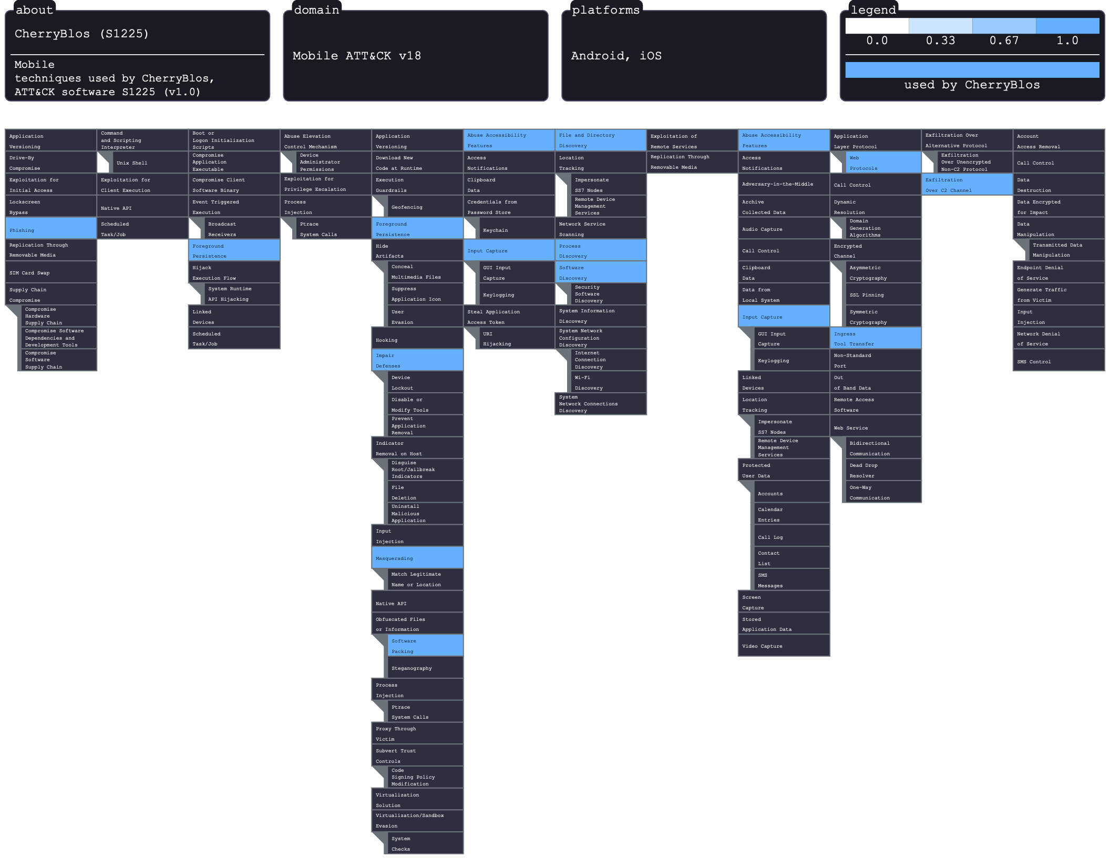
The following table shows the specific adversarial tactics and techniques used by CherryBlos (Software ID: S1225):

Adversary Goal and Weakness Exploited
The primary objective of this malware was direct financial theft. CherryBlos was not interested in typical data like emails, but rather in the “key” to the cryptocurrency market (which was the seed phrases).
- OCR Innovation: The most malicious aspect of this malware was its ability to scan a user’s photo gallery for screenshots of seed phrases. Users tend to take screenshots of their recovery phrases during the setup process despite warnings, and CherryBlos automated the search for these “digital master keys.”
- Accessibility Abuse: The malware also used a form of social engineering where it tricked users into turning on “Accessibility Services” (which was meant for disabled users) so that it could automatically approve more permissions, and then it went ahead and projected fake screens over real banking apps to steal passwords.

4. Evolution of Technology and Defenses
The effects of CherryBlos and other forms of malware have hardened the mobile security landscape. In essence, the state of mobile security before the 2023 wave was that it was entirely dependent on Google Play Protect and signature-based detections. However, CherryBlos used commercial software packers (such as Jiagubao) to conceal its code from static analysis.
The Evolution of Mobile Application Security:
The main evolution began with the implementation and adoptation of Hardware-Backed Keystores, in which the latest Android wallets started using the Hardware Security Modules (HSM) to ensure that the user’s private keys never stayed in the main OS memory, where the malware could access them.
This was also followed by the implementation of Screenshot Blocking, where new finance apps began to leverage the FLAG_SECURE window attribute to prevent the OS (and malware such as CherryBlos) from taking screenshots or recording the screen.
Furthermore, there was also a change in the policies during 2025. This is where Google introduced a more rigid Cryptocurrency Exchanges and Software Wallets Policy. This change in policy made it compulsory for developers in certain regions to submit proof of government licensing which made it difficult for “scam” apps to remain in the store.

5. Future Issues
Of course, as the tactics of adversaries evolve from simple code to social engineering using AI in today’s day and age, I think that the “Worst-Case Scenario” for information warfare is the erosion of digital trust. Some future threats that are devastating could include things such as:
- Deepfake Support Scams: The use of AI voices to trick users into “verifying” their wallets over the phone is a threat that is becoming more and more inevitable.
- Supply Chain Injection: Open-source libraries (such as SDKs on mobile devices) that the wallet’s software uses could potentially infect millions of users at the source if not handled with care and precaution.
All in all, CherryBlos was quite the turning point at least in terms of mobile security. It showed the world that in the realm of DeFi, an attacker no longer needs to crack the blockchain's encryption or even try to, instead, they only need to compromise user behavior and device visibility.

References
Cherryblos. CherryBlos, Software S1225 | MITRE ATT&CK®. (n.d.). https://attack.mitre.org/software/S1225/
28, B. T. M. Research Jul, Authors, Micro, T. M. Research Trend, Research, T. M., Trend Micro, & Us, C. (2023, July 28). Related cherryblos and Faketrade Android malware involved in scam campaigns. Trend Micro. https://www.trendmicro.com/en_us/research/23/g/cherryblos-and-faketrade-android-malware-involved-in-scam-campai.html
The Hacker News. (2023, July 31). New android malware cherryblos utilizing OCR to steal sensitive data. https://thehackernews.com/2023/07/new-android-malware-cherryblos.html
Google. (n.d.). Understanding google play’s cryptocurrency exchanges and software wallets policy - play console help. Google. https://support.google.com/googleplay/android-developer/answer/16329703?hl=en

