Lab Assignment #3
Used commands:
john --wordlist=/usr/share/wordlists/rockyou.txt --rules passwd1 && john --incremental passwd1
john --wordlist=/usr/share/wordlists/rockyou.txt --rules passwd2 && john --incremental passwd2
ophcrack

Passwords found (from passwd1):
Username | Password
setup | NO PASSWORD
comments | guest
dmd | dmd5620
cacavas | jeanne1
murni | murni1
venkat | sairam.
georgiou | 5465
carr | invalid
coldiron | tuxboy
iqbal | rashid
aqeel | sarwar
demkowsk | mike1
mina | mani
cpre489 | 489

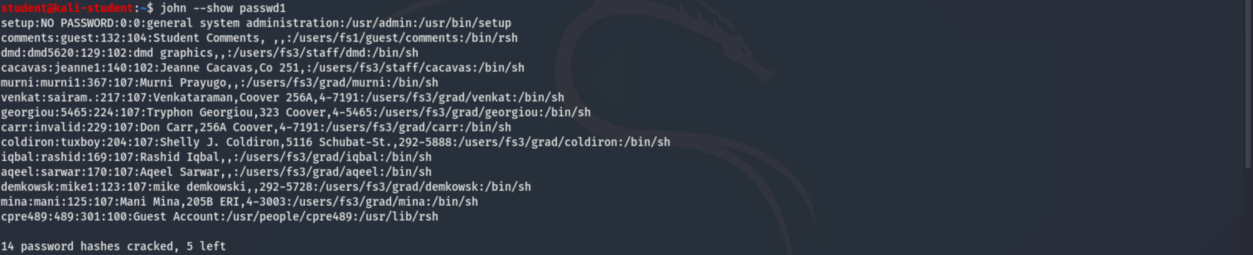
Total 14 passwords cracked out of 19.

Passwords found (from passwd2):
In the below screenshots, username is the before the first semicolon, i.e. First username and password is fanp and password is ffffff. Username:Password
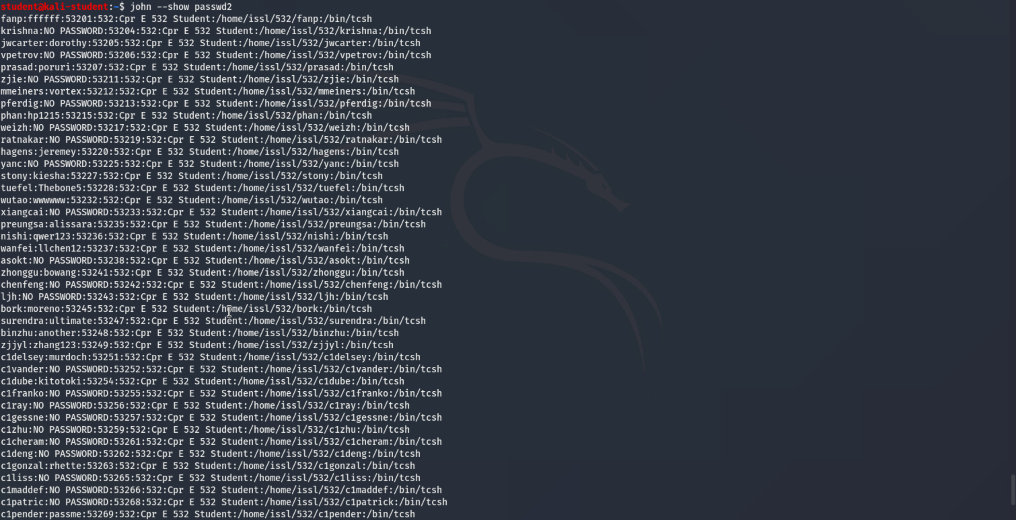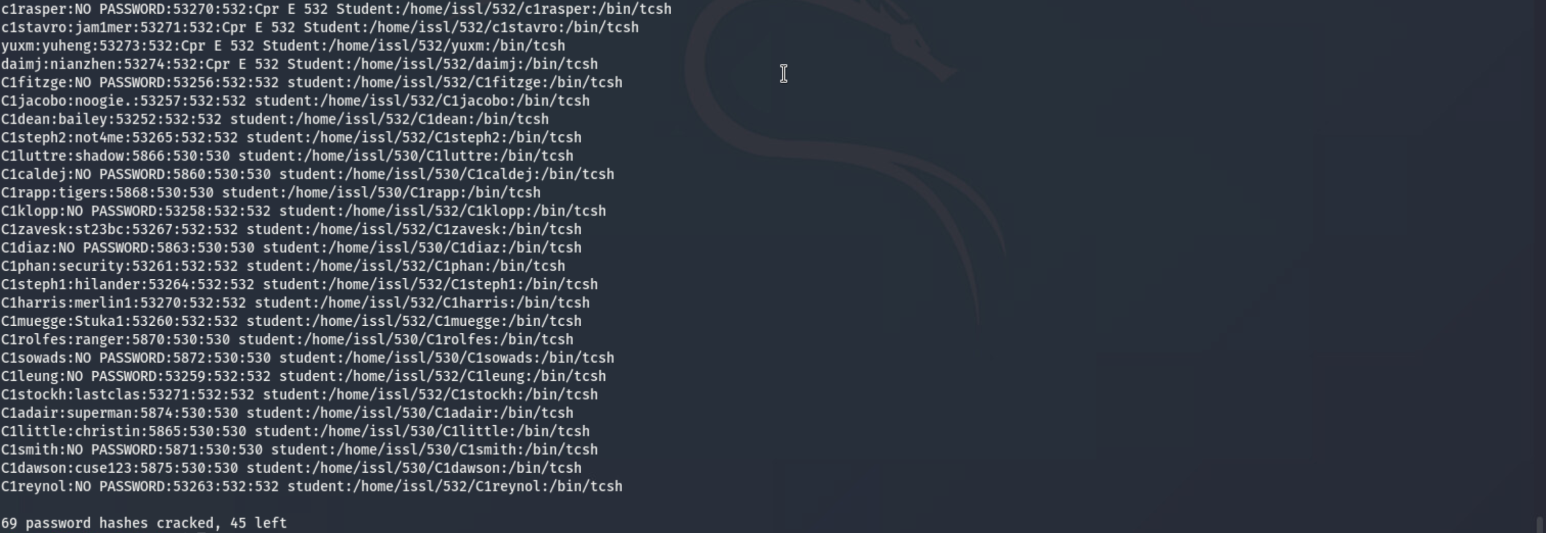
The above were not put in a table since there were so many. Total 69 passwords cracked.
Windows XP Passwords found (using ophcrack):
Username | Password
Administrator | 00Smurfz
student | mmll573
William Adama | laura
Laura Roslin | xab3347lm
Kara Thrace | frakthls
Lee Adama | starbuck
Gaius Baltar | six
sharon | almzmxx44
Saul Tigh | 447759abc
Galen Tyrol | frakcylons
Ellen Tigh | imacylon
Felix Gaeta | x1y2z3
*disabled* Guest | empty

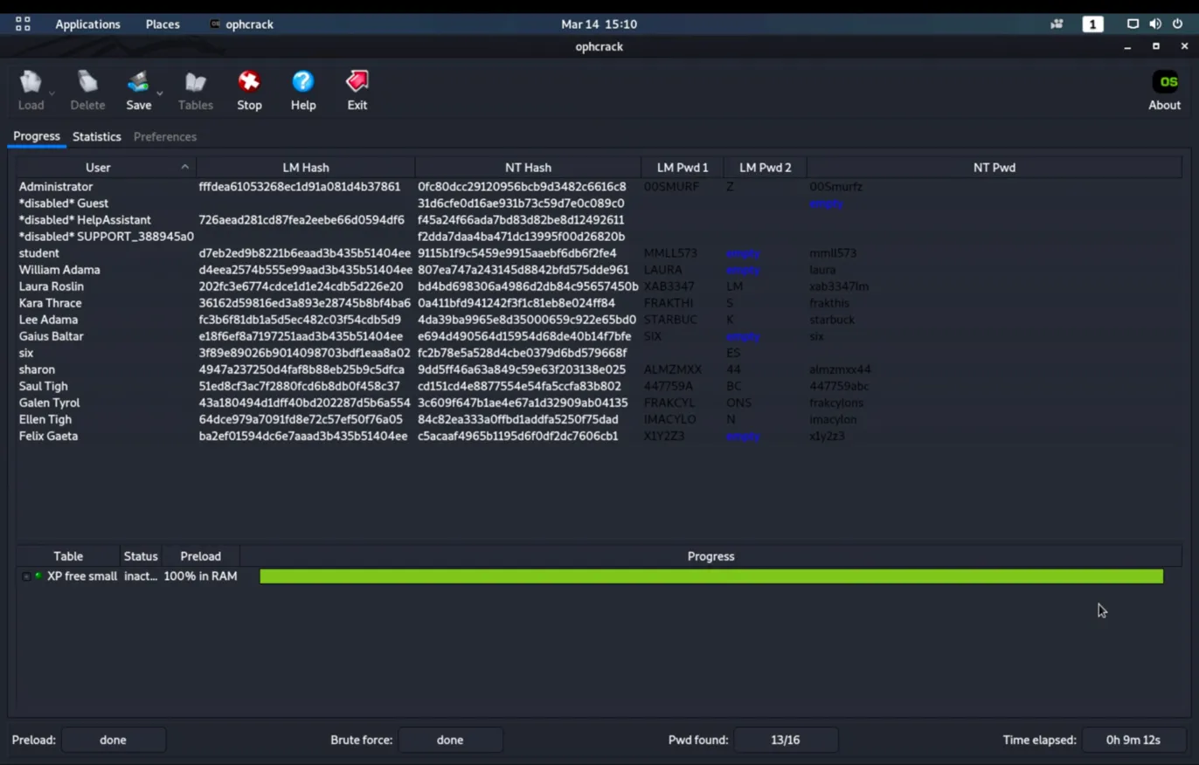
Total 13 passwords cracked out of 16.

