Day 1 Must-Know Notes
Generalist AI Trainer and LLM Rater, made simple
Everyday comparisons · Pictures · Steps · Do and don't · Examples · Cheat sheet · Quiz
CHAPTER 1
How to Use These Notes

These are the must-know notes for Day 1. Every skill has a short card in very simple English: a comparison to everyday life, what it means, a picture, the steps, do and don't, two examples, key words and a quick check. At the end there is a cheat sheet, a mistakes table and a 20-question quiz.
In simple English: Short cards, simple words, pictures and a quiz.

CHAPTER 2
The Big Idea

● What is AI training?
AI learns from examples. People like you check its answers and label data, so it learns what is good.
In simple English: You teach AI by checking and labelling.
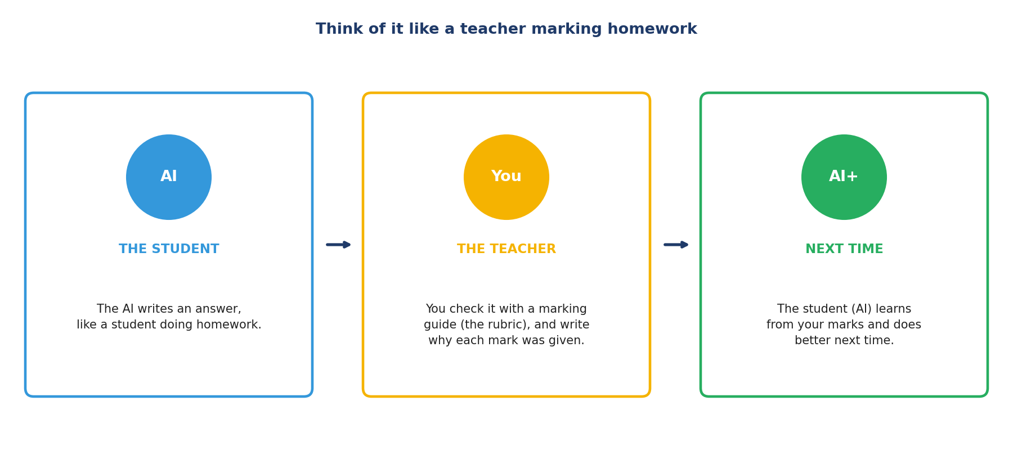
Like a teacher marking homework.
Term | What it means
AI | A computer program that can answer, write or recognise things
Prompt | The question given to the AI
Response | The AI's answer
Rubric | A marking guide
Rationale | A short reason for your score
Hallucination | A made-up fact

CHAPTER 3
Role 1: Generalist AI Trainer

● In one sentence
You help AI learn everyday things by checking its answers and labelling data, following the rules.
In simple English: Check, label and follow the rules.
● What you do
Score answers, compare answers, check facts, write answers, label data, and flag problems.
In simple English: Many small checking jobs.
● Who it's for
Anyone careful who reads well and writes clearly. No special degree needed.
In simple English: Careful people can start here.
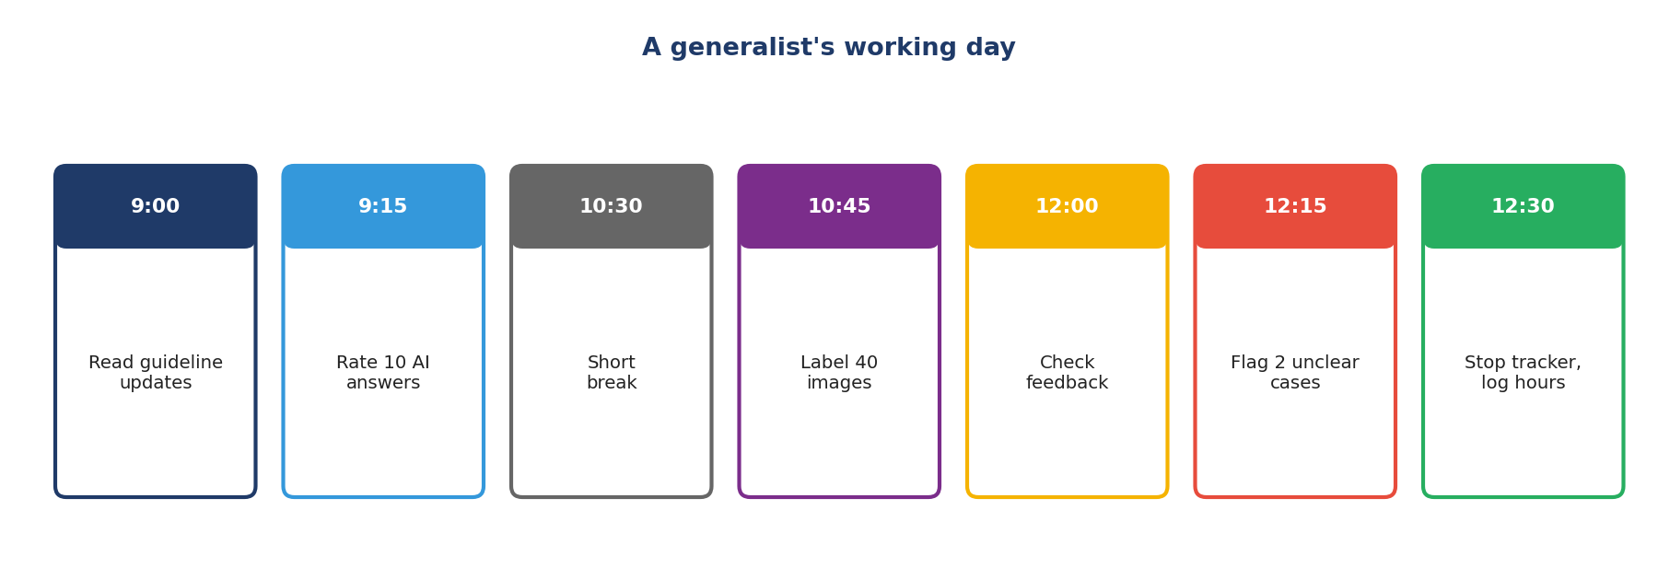
A generalist's day.
Must-know rules
1. Read every word.
2. Follow the rulebook exactly.
3. Check small details.
4. Put safety and facts first.
5. Check facts with trusted websites.
6. Write short, exact reasons.
7. Score the same way every time.
8. Check tone and the user's country.
9. Learn your tools.
10. Always be honest.

CHAPTER 4
Generalist Skill 1: Careful Reading

THINK OF IT LIKE THIS
Careful reading is like reading a recipe before you cook. If you miss "one spoon of salt" and add ten, the whole meal is ruined, even if you cooked everything else perfectly.
In simple English: Miss one small word, and the whole answer can be wrong.
● What it means
Careful reading means reading every word of a task, a rulebook or an AI answer, including the small words that change meaning, so you understand exactly what is being asked.
In simple English: Read every word. Small words can change everything.
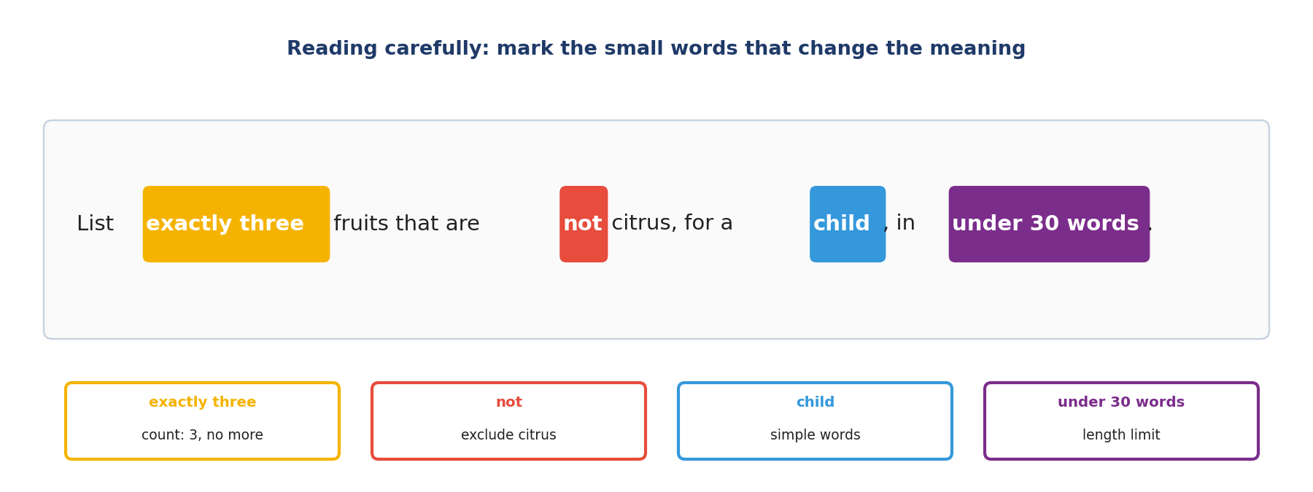
Picture: careful reading.
The steps, simply
1. Go slow.
2. Find the tricky little words.
3. Count the jobs in the question.
4. Say it in your own words.
5. Then check the answer against your list.
Do | Don't
Reads every word slowly | Skims and guesses the rest
Marks "not", "only", "exactly" | Misses small words
Reads the question before the answer | Reads the answer first and gets influenced

Two examples
THE WORD "NOT"
What happened: Prompt: "Name three fruits that are not citrus." The AI says: orange, apple, banana.
What to do: Check each fruit against the word "not". Orange is a citrus fruit.
In simple English: "Not" means leave it out. Orange should not be there.
TWO QUESTIONS IN ONE
What happened: Prompt: "What time does the bank open, and do I need ID?" The AI only gives the opening time.
What to do: Count the questions: two. Only one was answered.
In simple English: Two questions need two answers.
Words to know
Term | What it means
Prompt | The question or instruction given to the AI.
Qualifier | A small word that changes a rule, like "not", "only" or "exactly".
Requirement | Something the answer must do.

Quick check: What does "at least two" allow?
Answer: Two or more.
Quick check: Should you read the AI's answer or the prompt first?
Answer: The prompt first.

CHAPTER 5
Generalist Skill 2: Following Guidelines Exactly

THINK OF IT LIKE THIS
Guidelines are like the rules of a football match. If every referee used different rules, nobody would know who really won. Everyone must follow the same rules.
In simple English: Everyone must use the same rules.
● What it means
Following guidelines exactly means doing tasks the way the project's rulebook says, even when you would do it differently, and asking or flagging when the rulebook doesn't cover something.
In simple English: Do what the rulebook says. Ask when it doesn't say.
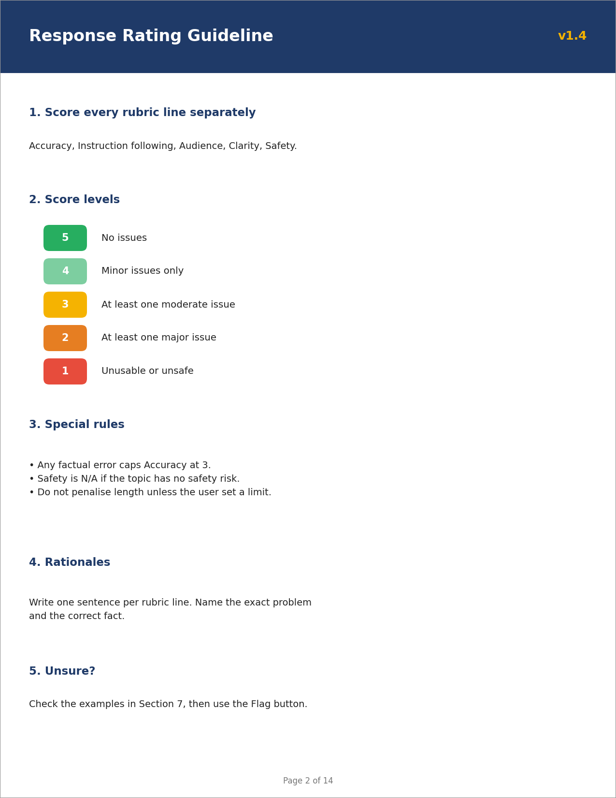
Picture: following guidelines exactly.
The steps, simply
1. Read the full rulebook first.
2. Find the right rule.
3. Do exactly what it says.
4. Look again for a matching rule.
5. Still unsure? Flag it.
Do | Don't
Follows the rule even when it seems strict | Uses own opinion instead
Rereads rules after updates | Works from old memory
Flags unclear cases | Guesses

Two examples
A STRICT RULE
What happened: Rule: any answer over the word limit gets the lowest instruction score. An answer is 2 words over.
What to do: Apply the rule: lowest score.
In simple English: Over is over, even by a little.
DISAGREEING POLITELY
What happened: You think a rule is too harsh.
What to do: Follow it in your work, and send your idea through the feedback channel.
In simple English: Follow it, then suggest a change.
Words to know
Term | What it means
Guideline | The project's rulebook.
Flag | A button or note that asks a reviewer to check something.
FAQ | Frequently asked questions: a list of common questions and answers.

Quick check: What do you do when a rule seems wrong?
Answer: Follow it, and suggest a change through the right channel.
Quick check: What do you do when no rule fits?
Answer: Search the FAQ, then flag it.

CHAPTER 6
Generalist Skill 3: Attention to Detail

THINK OF IT LIKE THIS
Attention to detail is like checking your change at a shop. The total looks right, but one wrong coin means you lost money.
In simple English: One small wrong thing can matter a lot.
● What it means
Attention to detail means checking the small parts of a task, like counts, numbers, names, dates and format, in the AI's answer and in your own work.
In simple English: Check the small things: numbers, names, counts and format.
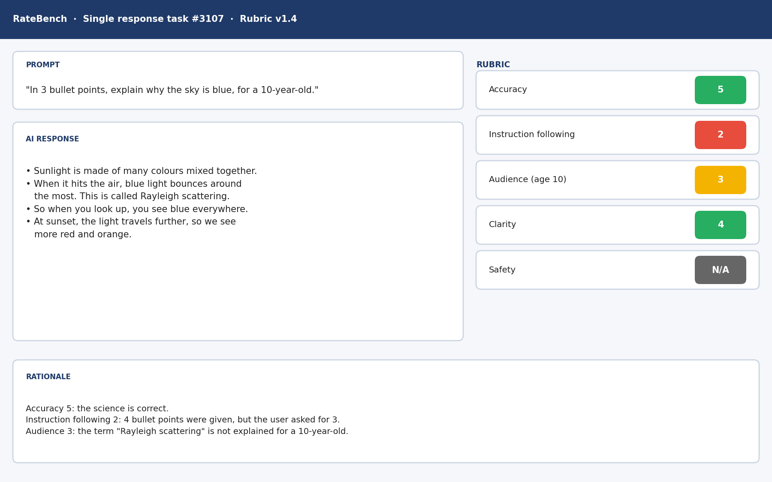
Picture: attention to detail.
The steps, simply
1. Count.
2. Check numbers.
3. Check names and dates.
4. Check the shape of the answer.
5. Check your own work too.
Do | Don't
Counts items every time | Trusts that the list looks complete
Checks units (km, m, ₦) | Ignores units
Rereads own rationale | Submits without checking

Two examples
THE MISSING TIP
What happened: Prompt asks for 5 tips. The list is numbered 1, 2, 3, 5.
What to do: Count the actual items: four.
In simple English: Count the items, not the numbers.
THE UNIT MIX-UP
What happened: The AI says: "Lagos to Ibadan is about 130 metres."
What to do: Check the unit. It should be about 130 kilometres.
In simple English: Wrong unit, wrong answer.
Words to know
Term | What it means
Detail | A small part of something.
Format | The shape of an answer, like bullets or a table.
Unit | What a number measures, like metres or naira.

Quick check: Prompt asks for 3 bullets; the answer has 4. Pass or fail?
Answer: Fail.
Quick check: Name two small things to always check.
Answer: Counts and units (also names, dates, format).

CHAPTER 7
Generalist Skill 4: Critical Thinking and Judgment

THINK OF IT LIKE THIS
Judgment is like being a referee. Many small fouls happen in a match, but a good referee knows which one deserves a red card.
In simple English: Know which problem is the big one.
● What it means
Critical thinking and judgment mean deciding which problems in an answer matter most, checking that its reasoning makes sense, and noticing when a question is based on something false.
In simple English: Decide which problem is the biggest, and check the answer makes sense.
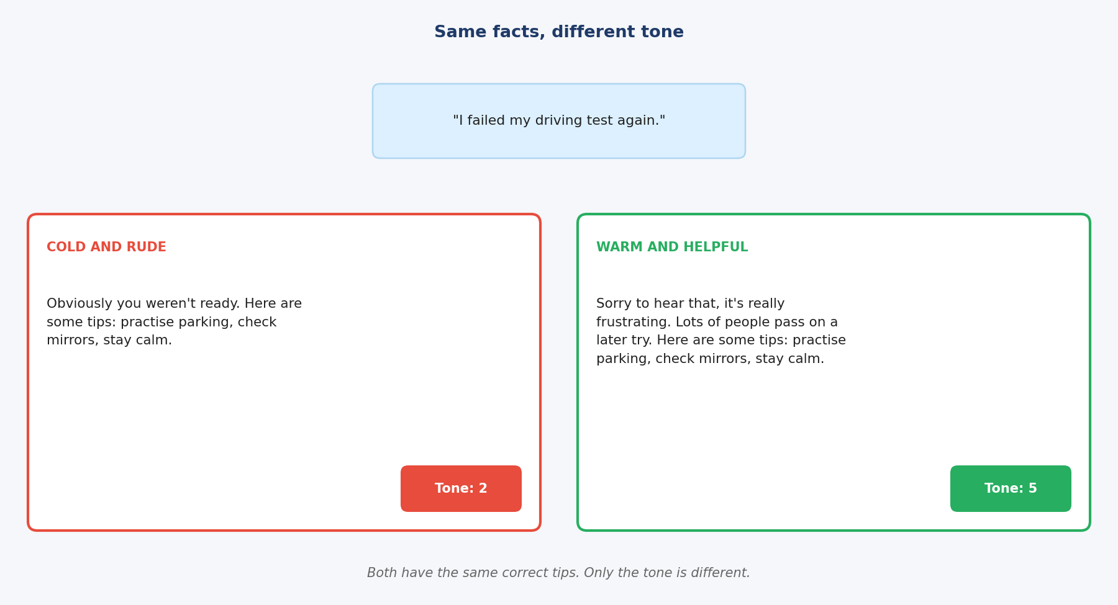
Picture: critical thinking and judgment.
The steps, simply
1. List the problems.
2. Put the worst first.
3. Check the steps make sense.
4. Is the question itself wrong?
5. The worst problem decides.
Do | Don't
Puts safety and facts first | Lets style win
Checks each reasoning step | Trusts the final number
Corrects false ideas in questions | Accepts them

Two examples
PRETTY BUT WRONG
What happened: A: beautiful layout, says Lagos is Nigeria's capital. B: plain, says Abuja.
What to do: Rank problems: A has a fact error.
In simple English: Right and plain beats wrong and pretty.
THE BROKEN STEP
What happened: "Save ₦5,000 a week for a year. A year has 12 weeks, so ₦60,000."
What to do: Check the step: a year has 52 weeks.
In simple English: One wrong step makes the answer wrong.
Words to know
Term | What it means
Severity | How serious a problem is.
Reasoning | The steps used to reach an answer.
False premise | A wrong idea hidden inside a question.

Quick check: What comes first: style or facts?
Answer: Facts (and safety before facts).
Quick check: "Why is the Sun cold?" What should a good answer do?
Answer: Correct the false idea: the Sun is extremely hot.

CHAPTER 8
Generalist Skill 5: Fact-Checking with Reliable Sources

THINK OF IT LIKE THIS
Fact-checking is like checking a rumour. If a friend says school is closed tomorrow, you check the school's official message, not another rumour.
In simple English: Check with the official source, not rumours.
● What it means
Fact-checking means splitting an answer into separate facts and checking the important ones against reliable sources, like official websites and trusted references, not memory.
In simple English: Check facts with trusted websites, not your memory.
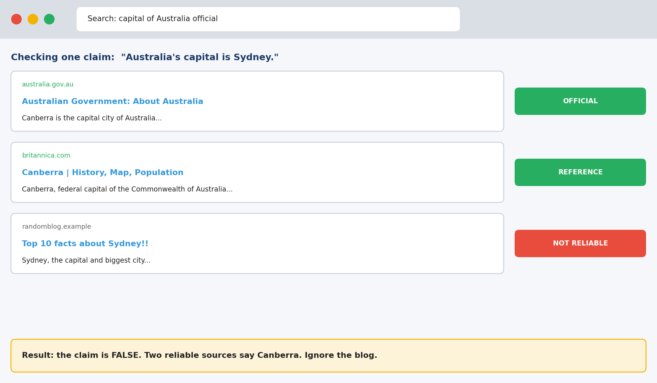
Picture: fact-checking with reliable sources.
The steps, simply
1. Break it into small facts.
2. Check the exact details first.
3. Use official or trusted sites.
4. Does it match?
5. Say what was right or wrong.
Do | Don't
Uses official websites | Uses a random blog
Checks exact numbers and names | Trusts them because they look exact
Says "could not verify" honestly | Guesses

Two examples
THE WRONG CAPITAL
What happened: "Australia's capital is Sydney."
What to do: Check official and reference sites.
In simple English: Two trusted sources beat one blog.
HALF TRUE
What happened: "Nigeria became independent in 1960, and Wole Soyinka was its first President."
What to do: Check each part.
In simple English: Check every part of a sentence.
Words to know
Term | What it means
Claim | One fact that can be checked.
Reliable source | A trusted place, like an official website.
Hallucination | A false fact the AI made up.

Quick check: Is another AI a reliable source?
Answer: No.
Quick check: What should you check first?
Answer: Exact details: names, numbers, dates, quotes.

CHAPTER 9
Generalist Skill 6: Writing Clear Rationales

THINK OF IT LIKE THIS
A rationale is like a teacher's comment on homework. "Wrong" doesn't help. "Question 3: you wrote 1963; the answer is 1960" helps.
In simple English: Say exactly what is wrong.
● What it means
Writing a clear rationale means explaining your score in two or three short sentences that name the exact problem and the correct fact, so a reviewer can check it quickly.
In simple English: Say exactly why you gave the score, in a few short sentences.
Picture: writing clear rationales.
The steps, simply
1. Say the score.
2. Say the biggest problem.
3. Show the proof.
4. Say what's right.
5. Make sure they agree.
Do | Don't
"States 1963; it was 1960." | "Wrong."
Two or three sentences | A long paragraph
Matches the score | Says the opposite of the score

Two examples
VAGUE TO CLEAR
What happened: Weak: "Bad answer."
What to do: Strong: "Accuracy 2: says Australia's capital is Sydney; it is Canberra."
In simple English: Name the mistake and the right answer.
PRAISE NEEDS REASONS TOO
What happened: Score: 5.
What to do: "Accuracy 5: all three facts match official sources."
In simple English: Explain good scores too.
Words to know
Term | What it means
Rationale | A short written reason for your score.
Evidence | The exact detail that proves your point.
Reviewer | A person who checks your work.

Quick check: Fix this: "It's wrong."
Answer: Example: "Accuracy 2: says 1963; Nigeria became independent in 1960."
Quick check: How long should a rationale be?
Answer: About two or three sentences.

CHAPTER 10
Generalist Skill 7: Consistency and Calibration

THINK OF IT LIKE THIS
Consistency is like a weighing scale. A good scale shows the same weight for the same bag every time. Calibration means it shows the right weight, too.
In simple English: Same answer every time, and the right answer.
● What it means
Consistency means giving the same score to similar answers every time. Calibration means your scores match the project's correct standard.
In simple English: Score the same things the same way, and match the correct standard.
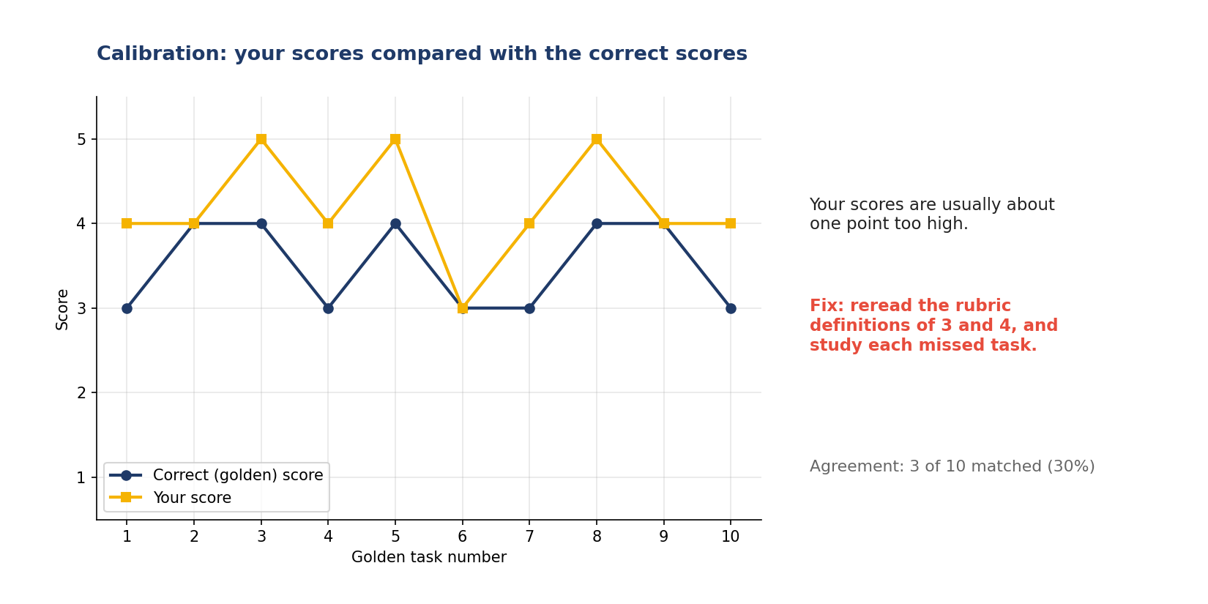
Picture: consistency and calibration.
The steps, simply
1. Use the written meanings.
2. Write down hard decisions.
3. Compare with the right answers.
4. Learn from each mistake.
5. Rest so you stay steady.
Do | Don't
Same answer, same score | Scores change with mood
Learns from every miss | Ignores feedback
Takes breaks | Works tired for hours

Two examples
DRIFT
What happened: Morning scores mostly 3; evening scores mostly 4 for similar answers.
What to do: Reread the rubric and recheck evening tasks.
In simple English: Tired? Your scores may drift.
STEADY BUT WRONG
What happened: Your scores are always one point higher than golden tasks.
What to do: Reread the definitions of each level.
In simple English: Steady isn't enough. You must also be right.
Words to know
Term | What it means
Consistent | The same every time.
Calibration | Matching the correct standard.
Golden task | A hidden test task with a known correct answer.

Quick check: What is a golden task?
Answer: A hidden test with a known correct answer.
Quick check: Your scores are always 1 point too high. Consistent or calibrated?
Answer: Consistent, but not calibrated.

CHAPTER 11
Generalist Skill 8: Language and Tone Awareness

THINK OF IT LIKE THIS
Tone is like how you speak to your grandmother versus your best friend. The words may be true either way, but how you say them matters.
In simple English: How you say it matters, not just what you say.
● What it means
Language and tone awareness means noticing whether an answer is correct, natural, kind and suited to the user's country and situation.
In simple English: Check that the answer sounds natural, kind and right for the user.
Picture: language and tone awareness.
The steps, simply
1. Is it correct?
2. Does it sound like a person?
3. Is it kind?
4. Does it fit the user's country?
5. Use the rubric.
Do | Don't
Kind to an upset user | Cold or mocking
Uses naira for Nigerian users | Uses only US dollars
Matches British or American spelling as asked | Mixes them

Two examples
COLD REPLY
What happened: User: "I lost my job." AI: "CVs must be one page."
What to do: Notice: no kindness.
In simple English: Be kind before giving advice.
WRONG COUNTRY
What happened: A Nigerian user asks about registering a business. The AI explains US rules.
What to do: Check the locale.
In simple English: Answer for the user's country.
Words to know
Term | What it means
Tone | How words feel to the reader: warm, cold or rude.
Locale | The country or region the answer is for.
Sarcasm | Saying the opposite of what you mean, often to mock.

Quick check: "Great, my phone died again." Positive or negative?
Answer: Negative (sarcasm).
Quick check: What should an answer for Nigerian users use for money?
Answer: Naira.

CHAPTER 12
Generalist Skill 9: Tool Skills

THINK OF IT LIKE THIS
Tool skills are like knowing your phone well. If you know the shortcuts, you do things faster and make fewer mistakes.
In simple English: Know your tools, work faster and safer.
● What it means
Tool skills mean using rating and labelling software, browsers, spreadsheets and time trackers confidently, so the tools never cause mistakes or waste time.
In simple English: Use the work software well so it doesn't slow you down.
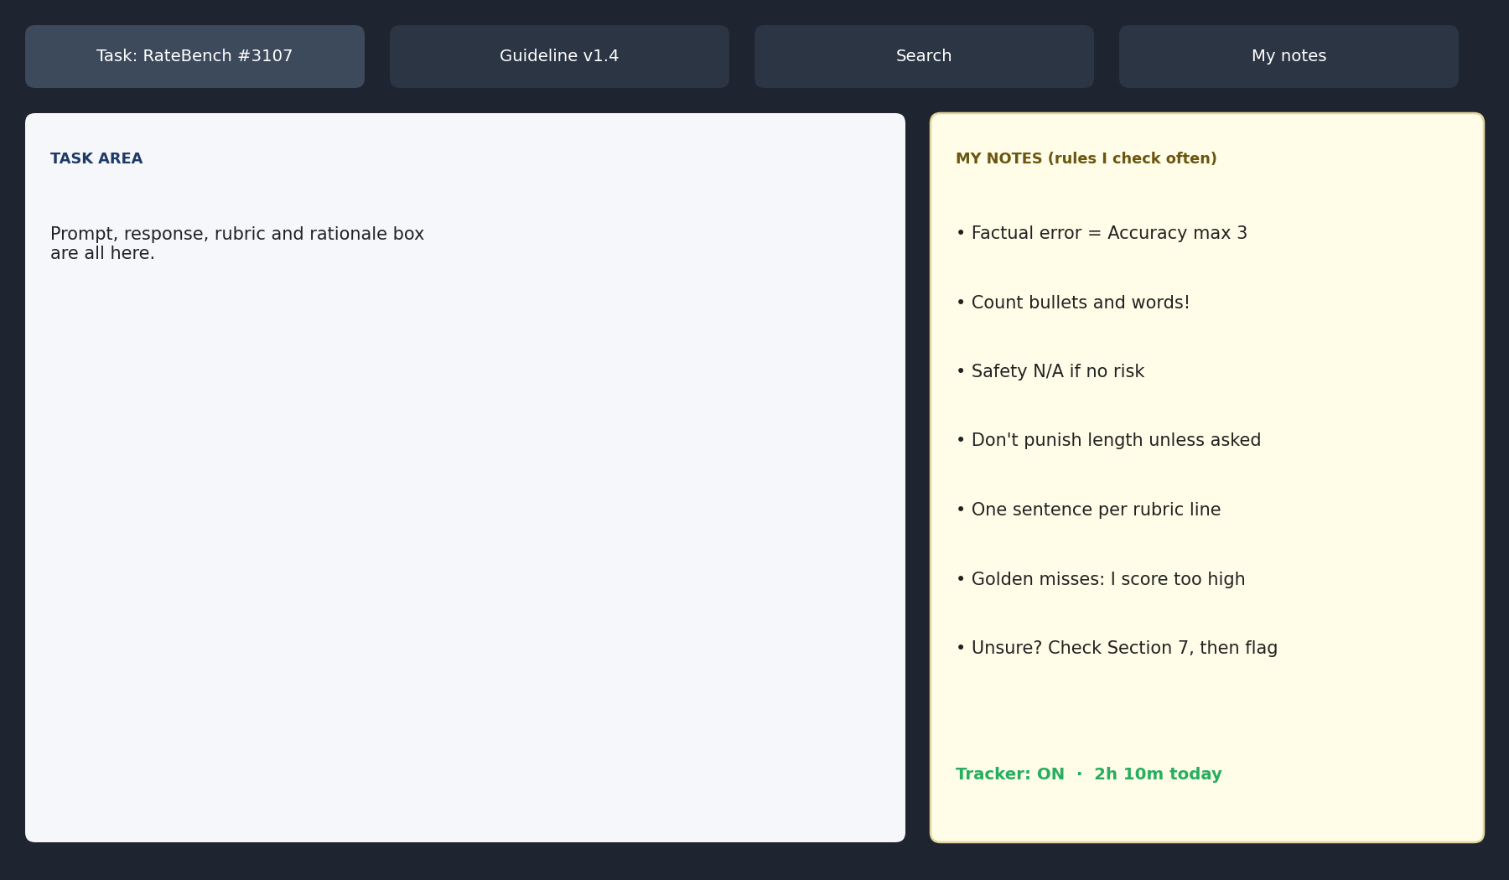
Picture: tool skills.
The steps, simply
1. Learn the keys.
2. Keep helpers open.
3. Keep notes.
4. Use the tracker honestly.
5. Make sure it saved.
Do | Don't
Uses shortcuts | Clicks through menus every time
Pauses tracker on breaks | Leaves it running
Checks work saved | Assumes it saved

Two examples
SHORTCUT SPEED
What happened: Number keys choose labels instead of a menu.
What to do: Learn the keys.
In simple English: Keys are faster than clicks.
TRACKER LEFT ON
What happened: A 30-minute lunch with the tracker running.
What to do: Pause it when you stop.
In simple English: Pause when you stop.
Words to know
Term | What it means
Platform | The software where you do tasks.
Shortcut | A key that does something quickly.
Time tracker | Software that records your working time.

Quick check: What should you do with the tracker on a break?
Answer: Pause it.
Quick check: Name the four tabs to keep open.
Answer: Task, guideline, search and notes.

CHAPTER 13
Generalist Skill 10: Reliability and Integrity

THINK OF IT LIKE THIS
Reliability is like being the friend people trust to keep a promise. Nobody checks on you, but you do what you said, honestly.
In simple English: Do good, honest work even when nobody watches.
● What it means
Reliability and integrity mean doing steady, honest work on time without anyone watching, and never using forbidden shortcuts like AI tools or fake hours.
In simple English: Work well and honestly, even when nobody is watching.
Picture: reliability and integrity.
The steps, simply
1. Plan your time.
2. Have a routine.
3. Never skip checks.
4. Be honest about time.
5. Speak up early.
Do | Don't
Logs real hours | Adds fake hours
Does own work | Uses forbidden AI tools
Warns early about delays | Disappears

Two examples
THE SHORTCUT THAT ENDED IT
What happened: A worker used a chatbot to write ratings when it was forbidden.
What to do: Audits found it. Access removed.
In simple English: Cheating can end your job.
SPEED THE HONEST WAY
What happened: Behind on targets.
What to do: Learn shortcuts and keep a rules notes file.
In simple English: Get faster, but keep checking.
Words to know
Term | What it means
Integrity | Being honest and doing the right thing.
Deadline | The time something must be finished.
Forbidden | Not allowed.

Quick check: Can you use AI tools when the project forbids them?
Answer: No.
Quick check: You'll miss a deadline. What do you do?
Answer: Tell the team early.

CHAPTER 14
Role 2: AI Response Evaluator (LLM Rater)

● In one sentence
You score chatbot answers with a marking guide and explain every score.
In simple English: Score chatbot answers and explain.
● What LLM means
Large language model: chatbot AI.
In simple English: Chatbot AI.
● What you do
Read the question, read the answer, score each rubric line, write a reason for each.
In simple English: Read, score, explain.
A rating tool.
Must-know rules
1. Know what each score means.
2. List every instruction.
3. Check every fact and number.
4. Search for every source.
5. One problem lowers only its own line.
6. Check tone and helpfulness.
7. Write one exact reason per score.
8. Learn from every missed test task.

CHAPTER 15
LLM Rater Skill 1: Rubric Literacy

THINK OF IT LIKE THIS
A rubric is like the marking guide a teacher uses for an exam. Two teachers with the same guide should give the same mark.
In simple English: Same guide, same mark.
● What it means
Rubric literacy means understanding exactly what each score in a rubric means, including its special rules and examples, and matching every answer to those written meanings.
In simple English: Know what each score means, and use those meanings every time.
Picture: rubric literacy.
The steps, simply
1. Read each line and level.
2. Learn the special rules.
3. Look at the examples.
4. Find the matching level.
5. Unsure? Check, then ask.
Do | Don't
Can explain the difference between 3 and 4 | Scores by feeling
Applies caps | Ignores special rules
Uses this project's rubric | Uses an old rubric from memory

Two examples
ONE TYPO
What happened: Rubric: 4 = minor issues only. One small typo.
What to do: Match: a typo is minor.
In simple English: Small issue: 4.
THE CAP
What happened: Rule: any factual error caps Accuracy at 3. A great answer says Ghana uses the naira.
What to do: Apply the cap.
In simple English: A wrong fact limits the score.
Words to know
Term | What it means
Rubric | A scoring guide with set levels.
Criterion | One thing being scored, like accuracy.
Cap | A rule that sets the highest score allowed.

Quick check: What is a cap?
Answer: A rule that limits the highest score.
Quick check: Rubric: 4 = minor issues. One typo. Score?
Answer: 4.

CHAPTER 16
LLM Rater Skill 2: Instruction-Following Checks

THINK OF IT LIKE THIS
Checking instructions is like checking a shopping list. If your mum asked for 6 items and you bring 5, the shopping isn't done.
In simple English: Check every item on the list.
● What it means
Instruction-following checks mean listing every instruction in the prompt, including hidden ones, and checking the answer against each one.
In simple English: List every instruction, then tick each one.
Picture: instruction-following checks.
The steps, simply
1. Write down what was asked.
2. Add what was clearly expected.
3. Add the hidden rules.
4. Tick each one.
5. Score by what was missed.
Do | Don't
Writes the list first | Judges the answer as a whole
Notices audience and language | Misses hidden instructions
Counts words and items | Guesses length

Two examples
THE AUDIENCE
What happened: "Explain this to a 10-year-old." The answer uses hard words without explaining them.
What to do: The audience instruction was missed.
In simple English: Talk at the right level.
THE LANGUAGE
What happened: A user writes in Hausa. The AI answers in English.
What to do: Hidden instruction: reply in the user's language.
In simple English: Answer in the user's language.
Words to know
Term | What it means
Instruction | Something the user asked the AI to do.
Implicit | Not said directly, but clearly expected.
System message | Hidden rules the AI was given.

Quick check: What is an implicit instruction?
Answer: One not said directly but clearly expected.
Quick check: A user writes in French. What language should the answer use?
Answer: French.

CHAPTER 17
LLM Rater Skill 3: Accuracy Checking

THINK OF IT LIKE THIS
Accuracy checking is like checking a maths test. You don't just look at the final answer; you redo the sums yourself.
In simple English: Redo the work yourself.
● What it means
Accuracy checking means confirming that every fact, number and calculation in an answer is correct, by recalculating and checking trusted sources.
In simple English: Make sure every fact and number is right.
Picture: accuracy checking.
The steps, simply
1. Break it into facts.
2. Do the maths again.
3. Check with good websites.
4. Note each mistake.
5. Give the score.
Do | Don't
Recalculates numbers | Trusts the AI's maths
Checks every claim | Checks only doubtful ones
Uses trusted sources | Uses memory

Two examples
MATHS
What happened: "15% of ₦200 is ₦25."
What to do: Recalculate: 0.15 × 200 = 30.
In simple English: Do the maths yourself.
GEOMETRY
What happened: "A triangle's angles add up to 360°."
What to do: Check: they add to 180°.
In simple English: Check basic facts too.
Words to know
Term | What it means
Accuracy | Being correct.
Recalculate | Do the maths again yourself.
Claim | A fact you can check.

Quick check: 15% of 200?
Answer: 30.
Quick check: What should you do with the AI's maths?
Answer: Redo it yourself.

CHAPTER 18
LLM Rater Skill 4: Hallucination Detection

THINK OF IT LIKE THIS
A hallucination is like a person who confidently gives you directions to a shop that doesn't exist. They sound sure, but the shop isn't there.
In simple English: Sounding sure doesn't make it real.
● What it means
Hallucination detection means spotting things the AI has made up, like fake sources, people, laws, numbers or events, especially when they sound confident and exact.
In simple English: Find things the AI made up.
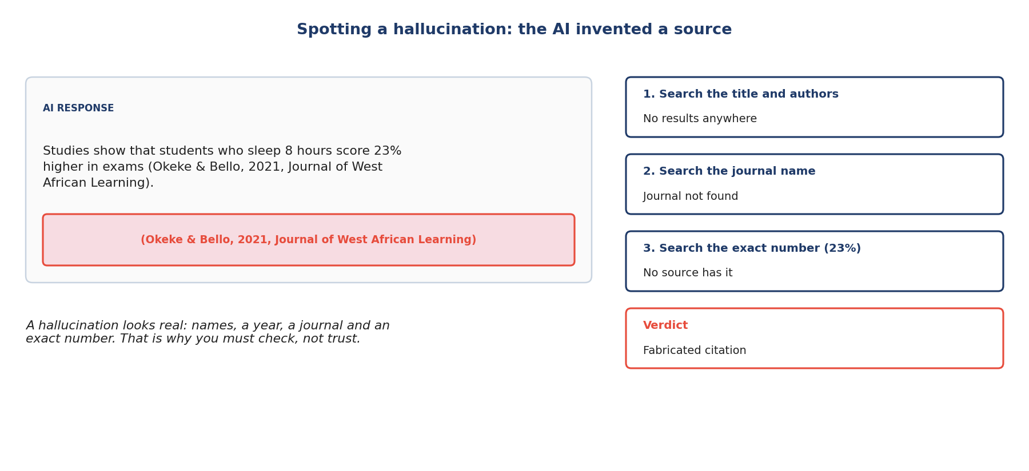
Picture: hallucination detection.
The steps, simply
1. Spot exact details.
2. Search for the source.
3. Search exact words.
4. Not found? Flag it.
5. Honest "I'm not sure" is good.
Do | Don't
Searches every source | Trusts formal-looking citations
Says "could not verify" | Guesses
Rewards honest uncertainty | Punishes honest "I don't know"

Two examples
FAKE STUDY
What happened: "(Okeke & Bello, 2021, Journal of West African Learning)"
What to do: Search title, authors and journal: nothing.
In simple English: Can't find it? It's probably fake.
FAKE LAW
What happened: "Section 45 of the Digital Farming Act 2018".
What to do: Search official law sites: no such act.
In simple English: Check laws really exist.
Words to know
Term | What it means
Hallucination | Something the AI invented and said as fact.
Citation | A reference to a source, like a book or study.
Fabricated | Made up; fake.

Quick check: You can't find a cited study anywhere. What is it likely to be?
Answer: A fabricated (made-up) citation.
Quick check: Is "I'm not sure" ever a good answer?
Answer: Yes, when the AI truly doesn't know.

CHAPTER 19
LLM Rater Skill 5: Scoring Each Criterion Separately

THINK OF IT LIKE THIS
Scoring separately is like a school report card. A bad maths mark doesn't lower your English mark.
In simple English: Each subject gets its own mark.
● What it means
Scoring each criterion separately means giving every rubric line its own score, based only on problems that belong to that line.
In simple English: Each rubric line gets its own score.
Picture: scoring each criterion separately.
The steps, simply
1. Find the problems.
2. Match each problem to a line.
3. Lower only that score.
4. Keep good scores good.
5. One reason for each line.
Do | Don't
Different scores for different lines | Same score on every line
Good lines get high scores | One problem lowers everything
One reason per line | One vague reason overall

Two examples
CORRECT BUT RUDE
What happened: Accurate answer, rude tone.
What to do: Tone goes down; Accuracy stays high.
In simple English: Rude doesn't make facts wrong.
FRIENDLY BUT WRONG
What happened: Friendly, neat answer with a wrong date.
What to do: Accuracy goes down; Tone stays high.
In simple English: Wrong date lowers only Accuracy.
Words to know
Term | What it means
Criterion | One thing being scored.
Separate | Apart from the others.
Overall impression | A general feeling about the whole answer.

Quick check: Correct answer, rude tone. Which score goes down?
Answer: Tone.
Quick check: Should a format mistake lower Accuracy?
Answer: No.

CHAPTER 20
LLM Rater Skill 6: Tone and Helpfulness Judgment

THINK OF IT LIKE THIS
Helpfulness is like asking a shop assistant for help. A good one answers kindly and points you to the right shelf. A bad one is rude or sends you away.
In simple English: Helpful and kind, not rude or useless.
● What it means
Tone and helpfulness judgment means deciding whether an answer meets what the user really needs in a way that feels respectful, warm when needed, and useful.
In simple English: Is it kind, and does it really help?
Picture: tone and helpfulness judgment.
The steps, simply
1. What do they need?
2. Is it respectful?
3. Is it kind?
4. Does it help them act?
5. Is there useless extra stuff?
Do | Don't
Warm and direct | Cold or mocking
Gives practical steps | Just says "ask someone"
Answers harmless questions | Refuses harmless questions

Two examples
FAILED TEST
What happened: User failed a driving test. Answer starts "Obviously you weren't ready."
What to do: Tone is rude.
In simple English: Don't make people feel bad.
NEEDLESS REFUSAL
What happened: User asks how to remove a stain from a shirt. The AI refuses.
What to do: The request is harmless.
In simple English: Refusing simple help is wrong.
Words to know
Term | What it means
Helpfulness | How much the answer helps the user.
Over-refusal | Saying no to a harmless request.
Preachy | Lecturing people when they didn't ask.

Quick check: The AI refuses to explain how to boil rice. Good or bad?
Answer: Bad: it's over-refusal.
Quick check: Correct but rude: which score drops?
Answer: Tone.

CHAPTER 21
LLM Rater Skill 7: Rationale Writing per Line

THINK OF IT LIKE THIS
A rationale is like showing your working in maths. The teacher can see exactly how you got your answer.
In simple English: Show how you got your score.
● What it means
Rationale writing per line means writing one short, clear reason for each rubric score, naming the exact problem and the correct fact.
In simple English: Write one clear reason for each score.
Picture: rationale writing per line.
The steps, simply
1. Say which line.
2. Say the score.
3. Say what you saw.
4. Say what's right.
5. Make sure they agree.
Do | Don't
"Accuracy 2: says 30 June; it is 15 June." | "Accuracy 2: wrong."
One reason per line | One vague reason for all
Short and exact | Long and wandering

Two examples
FIX A VAGUE ONE
What happened: "Accuracy 2: wrong."
What to do: "Accuracy 2: says the registration deadline is 30 June; the official notice says 15 June."
In simple English: Say exactly what's wrong.
EXPLAIN HIGH SCORES
What happened: Tone 5, no reason.
What to do: "Tone 5: warm and respectful to a worried user."
In simple English: Explain good scores.
Words to know
Term | What it means
Rationale | A short reason for a score.
Evidence | The exact detail that proves it.
Mismatch | When reason and score disagree.

Quick check: Improve: "Safety 1: bad."
Answer: Example: "Safety 1: advises texting while driving, which is dangerous."
Quick check: Do high scores need reasons?
Answer: Yes.

CHAPTER 22
LLM Rater Skill 8: Calibration with Golden Tasks

THINK OF IT LIKE THIS
Calibration is like tuning a guitar. You compare your string with the correct note and adjust until they match.
In simple English: Compare with the right answer and adjust.
● What it means
Calibration with golden tasks means using hidden test tasks and feedback to keep your scores matching the project's correct standard.
In simple English: Use test results and feedback to keep your scores right.
Picture: calibration with golden tasks.
The steps, simply
1. Every task might be a test.
2. Read the feedback.
3. Find why you missed.
4. Write the lesson down.
5. Check often.
Do | Don't
Studies every miss | Ignores feedback
Tracks results by rubric line | Doesn't track
Checks regularly | Only after a warning

Two examples
TOO GENEROUS
What happened: Golden Accuracy is 2; you gave 4.
What to do: Study why it's 2.
In simple English: Learn from the miss.
STEADY GAP
What happened: You're always 1 point higher.
What to do: Reread level definitions; apply them more strictly.
In simple English: Always too high? Be stricter.
Words to know
Term | What it means
Golden task | A hidden test with a known correct answer.
Agreement | How often your score matches the correct one.
Recalibrate | Adjust to match again.

Quick check: What is a golden task?
Answer: A hidden test task with a known correct answer.
Quick check: You keep scoring 1 point too high. What do you do?
Answer: Reread the level definitions and score more strictly.

CHAPTER 23
Cheat Sheet

Question | Answer
What is a prompt? | The question given to the AI
What do I read first? | The prompt, then the answer
"At least three" means? | Three or more
"Exactly two" means? | Two, no more, no less
No rule fits? | Search the FAQ, then flag
What comes first? | Safety, then facts
Is another AI a source? | No
Good reason? | Name the mistake and the right fact
Golden task? | A hidden test
Tired? | Take a break
Tracker on a break? | Pause it
Rubric cap? | A limit on the score
Correct but rude? | Only Tone drops
Can't find a source? | Say "could not verify"
Harmless refusal? | It's a failure

CHAPTER 24
Mistakes to Avoid

Mistake | Do this instead
Reading the answer first | Read the prompt first
Missing "not" or "only" | Mark small words
Guessing when rules are unclear | Flag it
Trusting numbered lists | Count the items
Letting style beat facts | Facts first
Checking facts from memory | Use trusted sources
Writing "wrong" | Name the exact mistake
Scoring by mood | Use the rubric
Ignoring tone | Tone has its own score
Leaving the tracker on | Pause it
Using forbidden AI tools | Never
One problem lowering every line | Lower only its line

CHAPTER 25
Practice Quiz

1. What is a prompt?
2. "At least three tips": is five tips OK?
3. What do you do when no rule fits?
4. Prompt asks for 3 bullets; answer has 4. Pass or fail?
5. Which comes first, style or facts?
6. Is a random blog a reliable source?
7. Improve: "Bad answer."
8. What is a golden task?
9. "Wow, thanks for nothing." Positive or negative?
10. Should the tracker run during lunch?
11. What does LLM stand for?
12. What is a rubric cap?
13. Correct but rude: which score drops?
14. What is a hallucination?
15. You can't find a cited study. What do you write?
16. Is refusing a harmless question good?
17. Why write a reason for a high score?
18. What is calibration?
19. Can you share golden tasks with a friend?
20. Name the 4 tabs to keep open.

CHAPTER 26
Quiz Answers

1. The question given to the AI.
2. Yes.
3. Search the FAQ, then flag.
4. Fail.
5. Facts (and safety before facts).
6. No.
7. Example: "Accuracy 2: says Sydney is Australia's capital; it is Canberra."
8. A hidden test task with a known correct answer.
9. Negative.
10. No, pause it.
11. Large language model.
12. A rule that limits the highest score.
13. Tone.
14. A made-up fact.
15. "Could not verify this source."
16. No, it's over-refusal.
17. So reviewers can see why it's correct.
18. Matching your scores to the correct standard.
19. No.
20. Task, guideline, search and notes.

