Day 2 Comprehensive Lecture Notes
LLM Evaluation Specialist (Pairwise Ranking) and AI QA Reviewer
Deep and wide · 16 skills · Step-by-step methods · 64 worked examples · Pictures explained · Very simple English
CHAPTER 1
Welcome to Day 2

Yesterday you learned to score one AI answer. Today you learn two next-step jobs: comparing two answers and choosing the better one (LLM Evaluation Specialist), and checking other people's work (AI QA Reviewer).
In simple English: Day 1: score one answer. Day 2: compare two answers, and check other people's work.
Time | What we do | What you learn
9:00 to 9:10 | Recap and poll | Five Day 1 questions in the chat
9:10 to 9:45 | Role 1 | LLM Evaluation Specialist and its 8 skills
9:45 to 10:20 | Role 2 | AI QA Reviewer and its 8 skills
10:20 to 10:30 | Compare and assignment | Which job suits you, and your homework

In simple English: Online class: Tuesday 9:00 to 10:30 pm, for Set 1 and Set 2.
● How to read these notes
Every idea has a very simple line. Pictures are explained step by step. Read the simple line first if a sentence feels hard.
In simple English: Read the easy line first if you get stuck.

CHAPTER 2
Words You Need for Day 2

Term | What it means
Pairwise | Comparing two things side by side.
Preference | Your choice of the better answer.
Strength | How much better: slightly or much.
Tie | When two answers are equally good.
Severity | How serious a problem is.
Bias | A habit that pushes your judgment the wrong way.
QA | Quality assurance: checking work is good enough.
Sample | A small part that shows what the whole is like.
Error log | A spreadsheet that records mistakes.
Feedback | Advice that helps someone improve.
Agreement | How often raters give the same answer.
Metric | A number that measures something.

In simple English: Learn these 12 words first.

CHAPTER 3
Role 1: LLM Evaluation Specialist (Pairwise Ranking)

DEFINITION
An LLM Evaluation Specialist compares two AI answers to the same question, decides which is better and by how much, and explains why with evidence.

In simple English: You compare two AI answers, pick the better one, say how much better, and explain why.
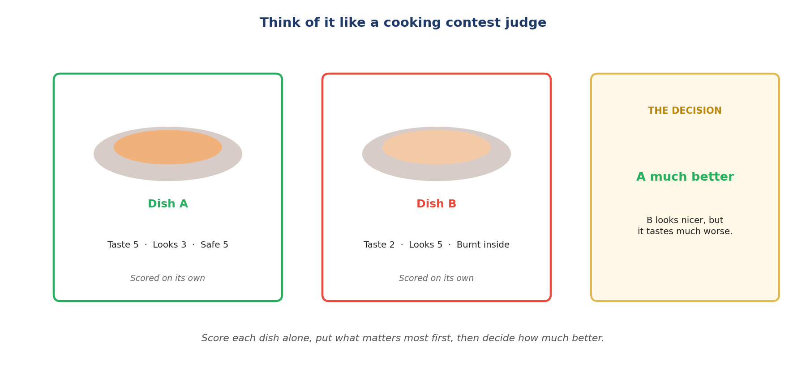
Like a cooking contest judge.
Let's read this picture together
Step 1 Each dish is scored on its own first.
Simply: Score each one alone.
Step 2 Dish B looks nicer, but it tastes much worse.
Simply: Looks can trick you.
Step 3 The judge decides A is much better, and says why.
Simply: Decide, say how much, explain.
The words explained
● What "pairwise" means
"Pair" means two. You compare two answers side by side.
In simple English: Comparing two.
● What "LLM evaluation" means
Judging how good a chatbot's answers are.
In simple English: Judging chatbot answers.
What a comparison task looks like
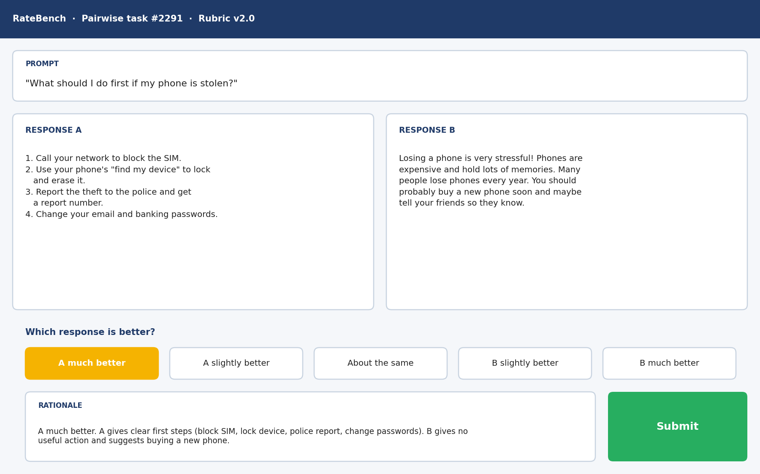
A real-style pairwise rating tool.
Let's read this tool together
Step 1 The prompt at the top: "What should I do first if my phone is stolen?"
Simply: The question.
Step 2 Response A gives four clear steps: block the SIM, lock the phone, report it, change passwords.
Simply: A gives real help.
Step 3 Response B talks about how stressful it is and says to buy a new phone.
Simply: B gives no real help.
Step 4 The five buttons: A much better is selected.
Simply: The choice and how much.
Step 5 The rationale box explains why, with evidence from both.
Simply: The reason.
Option | When to use it | Simply
A much better / B much better | A serious difference: safety, a key fact, or the main question missed | Big gap
A slightly better / B slightly better | A small difference: clarity, a small extra, a small miss | Small gap
About the same | No real difference | No gap

In simple English: Five buttons, chosen by how much the difference matters.
Why companies pay for this
● Teaching the AI what people prefer
Your choices train a "reward model": a program that learns which answers people prefer. It then guides the AI towards better answers. This is called RLHF (reinforcement learning from human feedback).
In simple English: Your choices teach the AI what people like.
The rulebook for comparing
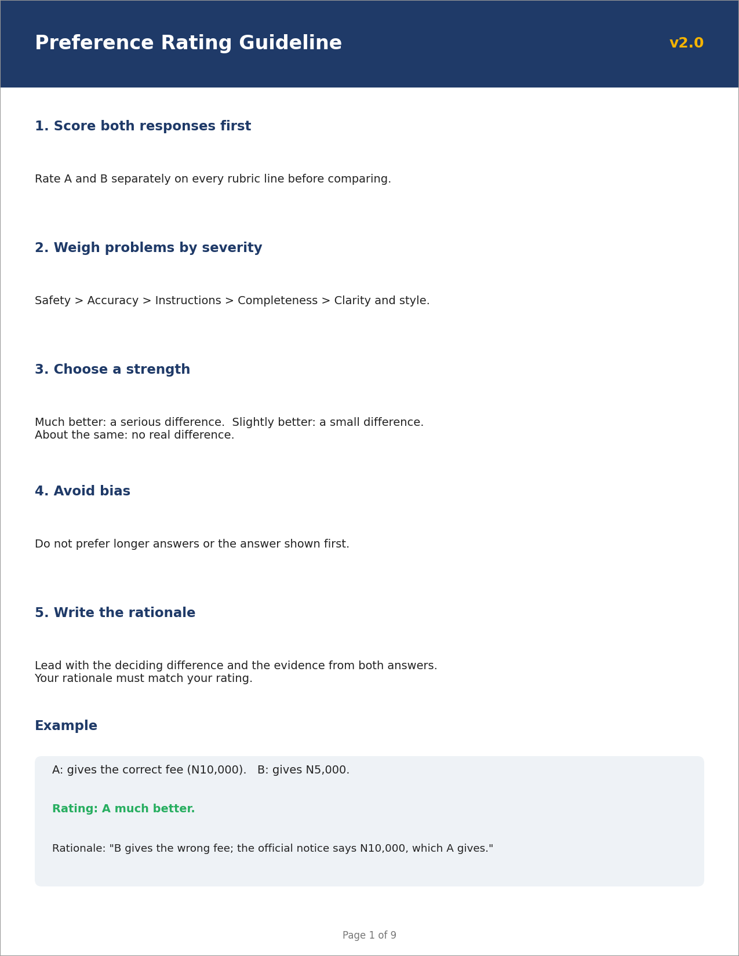
A page from a preference rating guideline.
Let's read this page together
Step 1 Score both answers first.
Simply: Score both.
Step 2 Weigh problems: safety, then accuracy, then instructions, then completeness, then style.
Simply: Biggest problems first.
Step 3 Choose a strength: much, slightly, or about the same.
Simply: How much better.
Step 4 Avoid bias: longer and first are not better.
Simply: Don't be tricked.
Step 5 Write a reason that matches your choice.
Simply: Explain it.
More about the job
● Common job titles
Pairwise Evaluator, Preference Rater, RLHF Rater, Response Ranker, LLM Evaluation Specialist.
In simple English: Many names, same work.
● How people get this job
Usually after doing well at rating single answers (Day 1).
In simple English: Day 1 skills come first.
● What it is NOT
It's not choosing the answer you like. Every choice must follow the rules and be explained.
In simple English: Evidence, not taste.
● Where it leads
QA reviewing (Role 2 today), rubric design, and special projects.
In simple English: It can lead to reviewing.

CHAPTER 4
How the 8 Pairwise Skills Work Together

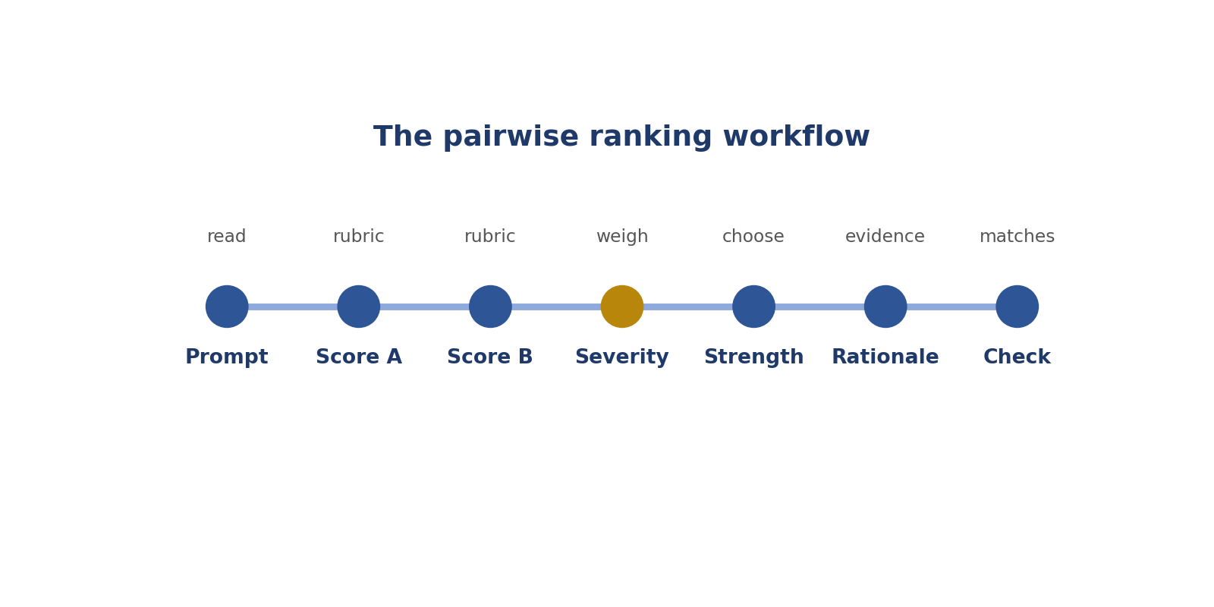
The pairwise steps.
Step | Skill | Simply
Score each answer alone | 1. Scoring before comparing | Score A, score B
Find the biggest problems | 2. Severity ranking | Worst first
Decide how much better | 3. Preference strength | How big is the gap?
Notice when they're equal | 4. True ties | Equal? Say so
Don't be tricked by length or order | 5. Avoiding bias | Longer isn't better
Let danger decide | 6. Safety first | Unsafe loses
Explain with proof | 7. Evidence-based rationales | Show proof
Check reason and choice agree | 8. Matching | They must match

CHAPTER 5
Pairwise Skill 1: Scoring Each Answer Before Comparing

THINK OF IT LIKE THIS
Imagine judging a cooking contest. A good judge tastes and marks each dish on its own first, before deciding which one wins. If you taste the first dish and fall in love with it, you might be unfair to the second.
In simple English: Mark each one on its own first, then compare.
DEFINITION
Scoring each answer before comparing means rating Answer A and Answer B separately with the rubric first, and only then deciding which is better.

In simple English: Score A. Score B. Then compare.
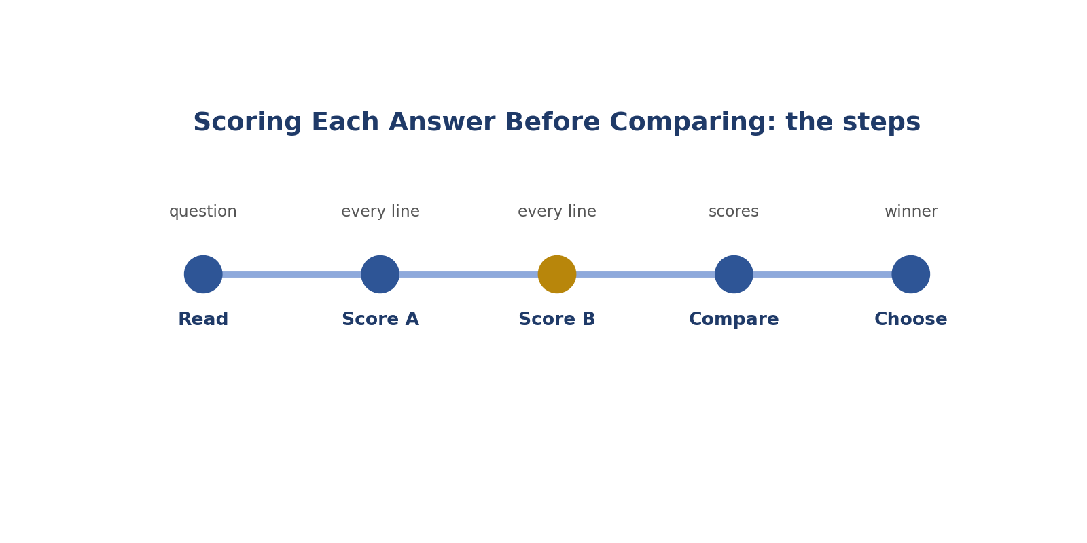
Scoring Each Answer Before Comparing: the steps.
Real-style picture for scoring each answer before comparing.
Words to know
Term | What it means
Pairwise | Comparing two things side by side.
Independent | On its own, without looking at the other.
Rubric | The scoring guide.

● Where it fits in the job
Every comparison task ends with a choice. Scoring first makes that choice fair and easy to explain.
In simple English: Your choice must come from scores.
● Why it matters
Reading one answer changes how you see the other. Scoring each on its own protects you from being unfair.
In simple English: One answer can trick you about the other.
How to do it, step by step
Step 1 Read the question and list what it asks.
Simply: Know what was asked.
Step 2 Score Answer A on every rubric line.
Simply: Score A fully.
Step 3 Score Answer B on every rubric line.
Simply: Score B fully.
Step 4 Compare the two sets of scores.
Simply: Look at the differences.
Step 5 Choose the winner from the scores.
Simply: Let the scores decide.
Good versus bad
What good looks like | What bad looks like
Scores both before choosing | Chooses first, then finds reasons
Writes notes for both answers | Compares at a quick glance
Judges each against the rubric | Judges B against A

Worked examples
THE PRETTY LOSER
The situation: A is beautifully laid out but says Kenya's capital is Mombasa. B is plain and says Nairobi.
What to do: Score both: A Accuracy 1 or 2, B Accuracy 5.
Why: The scores show B is much better, even though A looks nicer.
In simple English: Nice-looking isn't the same as right.
TWO DIFFERENT PROBLEMS
The situation: A misses an example the user asked for. B gives a wrong date.
What to do: Score both on Completeness and Accuracy.
Why: A loses on Completeness; B loses on Accuracy. A wrong date is usually worse, so A wins.
In simple English: Score both, then weigh the problems.
EQUAL SCORES
The situation: Both answers score 5 on every line.
What to do: Compare: no difference.
Why: The scores point to "about the same".
In simple English: Same scores mean a tie.
READING ORDER
The situation: You read A first and loved it; B seems worse.
What to do: Score B on its own against the rubric.
Why: B might be just as good. Your first impression isn't proof.
In simple English: Don't let the first answer trick you.
Common mistakes
Mistake | Why it's a problem
Choosing first, scoring later | Your reasons will just defend a guess.
Comparing at a glance | Hidden errors get missed.
Judging B against A | Use the rubric, not the other answer.
Skipping rubric lines | Problems on those lines get missed.

● How it's tested
Tests use pairs where the better-looking answer has a hidden error.
In simple English: Tests hide mistakes in pretty answers.
How to practise
1. For 10 pairs, write both sets of scores before choosing.
2. Sometimes read B first.
3. Check your choice matches your scores.
Skill levels
Level | What it looks like
Beginner | Chooses by first impression.
Developing | Scores both, sometimes skips lines.
Strong | Always scores both fully before choosing.

● What it looks like on your CV
"Evaluated paired AI responses independently against multi-criteria rubrics before determining preferences."
In simple English: This shows a fair method.
Quick check
Online poll: Why score both answers before choosing?
Answer: So your choice comes from evidence, not first impressions.
Online poll: A looks nicer but has a wrong fact. What do the scores show?
Answer: B is better, because A's accuracy score is lower.
Practise this skill: Day 2 Task Bank, Chapter 1.

CHAPTER 6
Pairwise Skill 2: Severity Ranking

THINK OF IT LIKE THIS
Severity is like a mechanic checking a car. A scratch on the paint and broken brakes are both problems, but only one makes the car dangerous to drive.
In simple English: Some problems are much bigger than others.
DEFINITION
Severity ranking means putting problems in order of how much they could harm or mislead the user: safety first, then accuracy, then instructions, then completeness, then style.

In simple English: Put the most serious problems first.
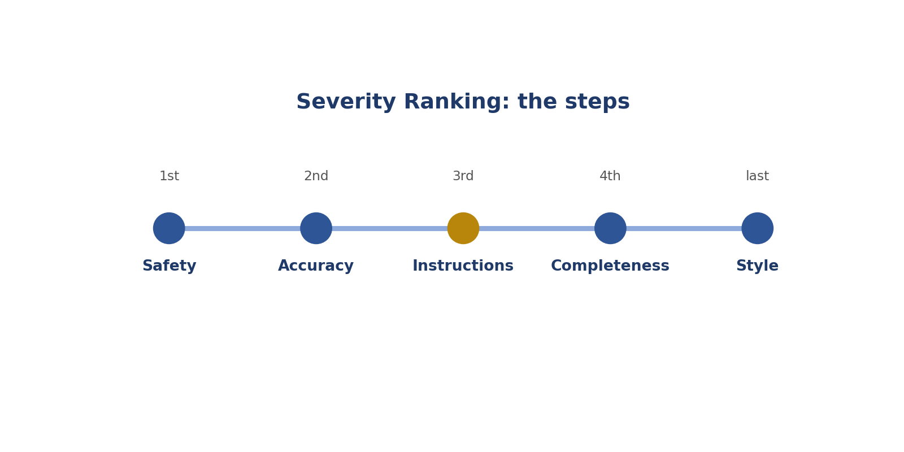
Severity Ranking: the steps.
Real-style picture for severity ranking.
Words to know
Term | What it means
Severity | How serious a problem is.
Ladder | An order from most to least important.
Mislead | Make someone believe something false.

● Where it fits in the job
In comparisons, both answers usually have some problem. Severity decides which problem matters most.
In simple English: Severity decides the winner.
● Why it matters
Without severity, raters count problems. Then a pretty but unsafe answer can win.
In simple English: Weigh problems, don't count them.
How to do it, step by step
Step 1 List each answer's problems.
Simply: Write the problems down.
Step 2 Mark each one: safety, accuracy, instructions, completeness or style.
Simply: Name the kind of problem.
Step 3 Find each answer's worst problem.
Simply: Find the biggest one.
Step 4 Compare the worst problems first.
Simply: Compare the big ones.
Step 5 Choose the answer with the less serious worst problem.
Simply: Less serious problems win.
Good versus bad
What good looks like | What bad looks like
Weighs problems by harm | Counts problems
Safety and facts first | Lets style win
Explains why one problem is worse | Says "A had more issues"

Worked examples
TYPOS VERSUS A WRONG NUMBER
The situation: A has three typos. B gives the wrong emergency number.
What to do: B's problem is a safety and accuracy problem.
Why: A wins much better, even though it has more problems.
In simple English: One big problem beats many small ones.
FORMAT VERSUS PRICE
The situation: A uses bullets instead of a table. B gives a wrong price.
What to do: Accuracy outranks format.
Why: A is better.
In simple English: A wrong price is worse than wrong format.
MISSING VERSUS AWKWARD
The situation: A misses one of three tips. B has one awkward sentence.
What to do: Completeness outranks style.
Why: B is better.
In simple English: Missing content is worse than awkward words.
UNSAFE VERSUS LONG
The situation: A gives unsafe electrical advice. B is 50 words over the limit.
What to do: Safety comes first.
Why: B is better.
In simple English: Unsafe always loses.
Common mistakes
Mistake | Why it's a problem
Counting problems | Weigh them instead.
Letting style beat facts | Facts come first.
Ignoring safety in a friendly answer | Safety comes first, always.
Forgetting completeness | Missing parts matter.

● How it's tested
Tests pair a style problem with a factual or safety problem.
In simple English: Tests mix big and small problems.
How to practise
1. Rank the problems in 5 pairs before choosing.
2. Learn the ladder by heart.
3. Explain each choice using the ladder.
Skill levels
Level | What it looks like
Beginner | Counts problems.
Developing | Knows the ladder; sometimes lets style win.
Strong | Always decides by the most serious problem.

● What it looks like on your CV
"Prioritised safety and factual accuracy when ranking model outputs."
In simple English: This shows good judgment.
Quick check
Online poll: What is the order of the severity ladder?
Answer: Safety, accuracy, instructions, completeness, style.
Online poll: Three typos or one wrong emergency number: which is worse?
Answer: The wrong emergency number.
Practise this skill: Day 2 Task Bank, Chapter 2.

CHAPTER 7
Pairwise Skill 3: Choosing Preference Strength

THINK OF IT LIKE THIS
Strength is like a football score. Winning 1-0 and winning 5-0 are both wins, but one is much bigger. Your choice should show how big the win is.
In simple English: Say how big the difference is.
DEFINITION
Choosing preference strength means picking how much better one answer is (slightly or much), or saying they are about the same, based on how much the difference would affect the user.

In simple English: Pick how much better, not just which.
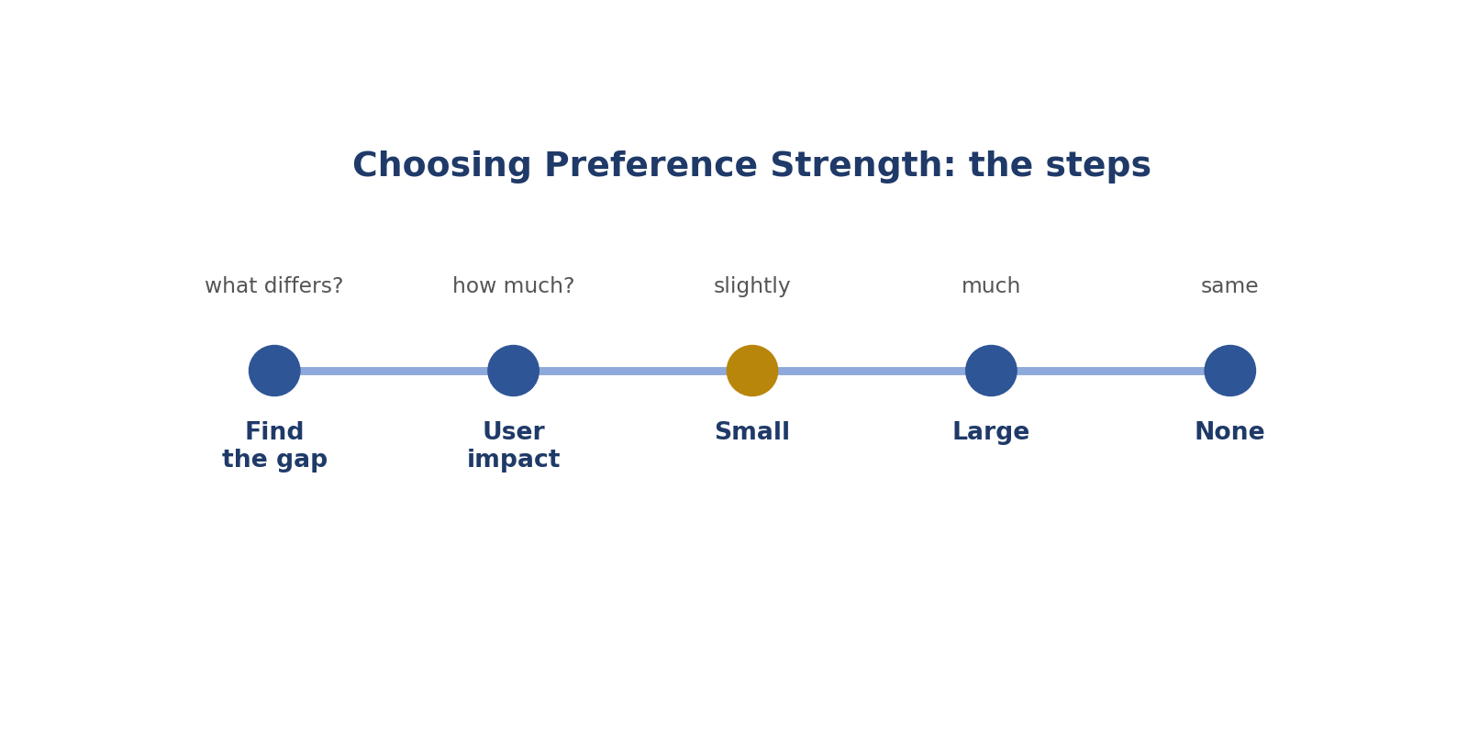
Choosing Preference Strength: the steps.
Real-style picture for choosing preference strength.
Words to know
Term | What it means
Preference | Your choice of the better answer.
Strength | How much better: slightly or much.
Impact | How much something affects someone.

● Where it fits in the job
The strength is part of what the AI learns. "Much better" tells it the gap really matters.
In simple English: Strength teaches the AI how big the gap is.
● Why it matters
Saying "much" for a tiny difference, or "slightly" for a big one, teaches the AI the wrong lesson.
In simple English: Wrong strength teaches wrong lessons.
How to do it, step by step
Step 1 Find the main difference.
Simply: What's different?
Step 2 Ask: how much would this change the user's result?
Simply: Does it matter to the user?
Step 3 Big effect: much better.
Simply: Big gap, much better.
Step 4 Small effect: slightly better.
Simply: Small gap, slightly better.
Step 5 No effect: about the same.
Simply: No gap, a tie.
Good versus bad
What good looks like | What bad looks like
Uses the whole scale | Always picks "much better"
Explains why the gap is big or small | Picks strength by feeling
Small style gaps get "slightly" | Small gaps get "much"

Worked examples
AN EXTRA USEFUL TIP
The situation: Both correct; A adds one useful tip.
What to do: Small benefit.
Why: A slightly better.
In simple English: A small extra is a small win.
HALF THE ANSWER MISSING
The situation: A answers fully; B answers half.
What to do: Big effect on the user.
Why: A much better.
In simple English: Half missing is a big gap.
UNSAFE ADVICE
The situation: B gives unsafe advice; A is safe.
What to do: Very big effect.
Why: A much better. Choosing "slightly" would be too weak.
In simple English: Danger means "much better".
A GREETING
The situation: A says "Hello"; B doesn't. Everything else equal.
What to do: No real effect.
Why: About the same.
In simple English: A greeting doesn't matter.
Common mistakes
Mistake | Why it's a problem
Always choosing "much better" | Use slightly for small gaps.
Never choosing a tie | Ties are real.
"Slightly better" for unsafe answers | Danger is a big gap.
Choosing by feeling | Ask about the user's result.

● How it's tested
Tests include both small-gap and big-gap pairs.
In simple English: Tests check both kinds of gap.
How to practise
1. For each pair, write one sentence on why the gap is small or big.
2. Practise all five options.
3. Compare your strengths with the answer key.
Skill levels
Level | What it looks like
Beginner | Uses one or two options.
Developing | Uses the scale but not always correctly.
Strong | Strength always matches the real effect.

● What it looks like on your CV
"Assigned calibrated preference strengths reflecting impact on users."
In simple English: This shows careful judgment.
Quick check
Online poll: What question helps choose strength?
Answer: How much would this difference change the user's result?
Online poll: Both correct; A has one extra helpful tip. Which option?
Answer: A slightly better.
Practise this skill: Day 2 Task Bank, Chapter 3.

CHAPTER 8
Pairwise Skill 4: Recognising True Ties

THINK OF IT LIKE THIS
A tie is like two runners crossing the finish line at the same moment. Pretending one won would be unfair.
In simple English: If they're equal, say so.
DEFINITION
Recognising a true tie means choosing "about the same" when two answers are equally good, instead of inventing a winner.

In simple English: If they're equally good, call it a tie.
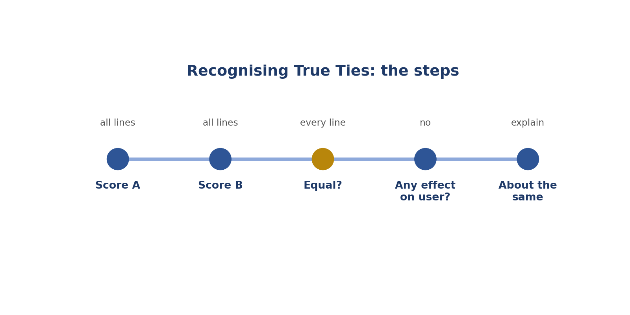
Recognising True Ties: the steps.
Words to know
Term | What it means
Tie | When two answers are equally good.
Noise | Confusing, useless data.
Equivalent | Equal in value.

● Where it fits in the job
Ties are real answers. A fake winner adds confusion to what the AI learns.
In simple English: Ties are allowed and useful.
● Why it matters
Inventing differences teaches the AI something that isn't true.
In simple English: Fake winners confuse the AI.
How to do it, step by step
Step 1 Score A on every line.
Simply: Score A.
Step 2 Score B on every line.
Simply: Score B.
Step 3 Check every line is equal.
Simply: All lines the same?
Step 4 Ask if any difference would matter to the user.
Simply: Would the user care?
Step 5 If not, choose "about the same" and explain.
Simply: Call it a tie and say why.
Good versus bad
What good looks like | What bad looks like
Calls ties when answers are equal | Always invents a winner
Explains the tie | Writes "same" and nothing else
Checks every line first | Calls a tie to avoid thinking

Worked examples
SAME FACT, DIFFERENT WORDS
The situation: Both say water boils at 100°C at sea level, in different words.
What to do: No real difference.
Why: About the same.
In simple English: Different words, same quality.
NUMBERS VERSUS BULLETS
The situation: No format was asked. A uses numbers, B uses bullets.
What to do: No effect on the user.
Why: About the same.
In simple English: If no format was asked, it doesn't matter.
TWO GOOD REFUSALS
The situation: Both politely refuse a harmful request.
What to do: Both correct.
Why: About the same.
In simple English: Two right answers tie.
CAN'T NAME A REASON
The situation: You feel B is better but can't say why.
What to do: No rubric reason.
Why: About the same, until you find a real reason.
In simple English: No reason, no winner.
Common mistakes
Mistake | Why it's a problem
Never using ties | Ties are real.
Using ties to avoid hard choices | Check every line first.
Writing only "same" | Explain why.
Calling a tie when one is unsafe | Safety breaks ties.

● How it's tested
Tests include pairs that differ only in wording.
In simple English: Tests include real ties.
How to practise
1. Find 5 pairs that differ only in style and explain the tie.
2. Practise writing tie rationales.
3. Check for hidden differences before calling a tie.
Skill levels
Level | What it looks like
Beginner | Never picks ties.
Developing | Picks ties but can't explain them.
Strong | Uses ties correctly, with clear reasons.

● What it looks like on your CV
"Identified equivalent outputs to avoid introducing noise into preference data."
In simple English: This shows careful thinking.
Quick check
Online poll: When is "about the same" right?
Answer: When both answers are equal on every line and no difference matters to the user.
Online poll: Improve the rationale "Same."
Answer: "About the same: both correct and within the limit; only the wording differs."
Practise this skill: Day 2 Task Bank, Chapter 4.

CHAPTER 9
Pairwise Skill 5: Avoiding Length and Order Bias

THINK OF IT LIKE THIS
Bias is like choosing a book because it's the thickest one on the shelf. Thicker doesn't mean better. And the first book you see isn't always the best one.
In simple English: Bigger or first isn't better.
DEFINITION
Avoiding length and order bias means not preferring an answer just because it is longer or because you read it first.

In simple English: Don't pick an answer for being longer or first.
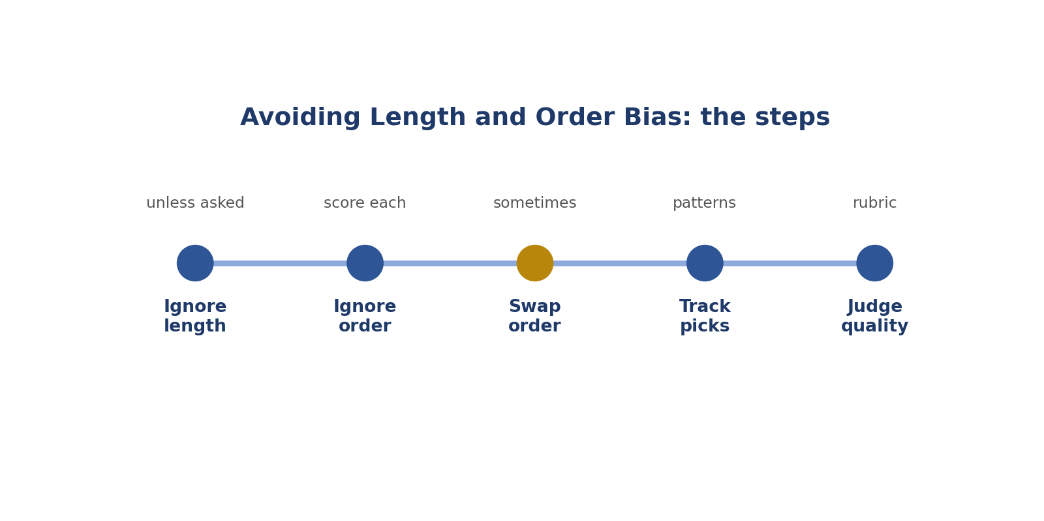
Avoiding Length and Order Bias: the steps.
Real-style picture for avoiding length and order bias.
Words to know
Term | What it means
Bias | A habit that pushes your judgment the wrong way.
Length bias | Preferring longer answers.
Order bias | Preferring the answer you read first.

● Where it fits in the job
Raters are often pulled towards longer answers. Avoiding this keeps the AI's lessons honest.
In simple English: Length can trick raters.
● Why it matters
If raters reward length, the AI learns to waffle.
In simple English: Rewarding length teaches the AI to waffle.
How to do it, step by step
Step 1 Ask what length the user needed.
Simply: How long should it be?
Step 2 Score each answer on its own.
Simply: Score each alone.
Step 3 Sometimes read B first.
Simply: Change your reading order.
Step 4 Track how often you pick A or the longer one.
Simply: Watch your habits.
Step 5 Judge only on quality.
Simply: Quality decides.
Good versus bad
What good looks like | What bad looks like
Matches length to the user's need | Picks the longest answer
Swaps reading order sometimes | Always prefers A
Notices padding | Rewards waffle

Worked examples
THE PADDED ANSWER
The situation: A: 350 words of history before answering a yes/no question. B: 40 words, answers first.
What to do: Check what the user needed: a quick answer.
Why: B is better.
In simple English: Long isn't better for a quick question.
ASKED FOR DETAIL
The situation: The user asked for a detailed explanation. A is long and accurate.
What to do: Length matches the request.
Why: Length is good here.
In simple English: Long is fine when they ask for detail.
ALWAYS A
The situation: You picked A in 9 of 10 tasks.
What to do: Check for order bias.
Why: Review some choices.
In simple English: Watch for the habit of picking A.
EXTRA WORDS, EXTRA MISTAKE
The situation: A is longer and adds one wrong fact; B is short and correct.
What to do: The extra words added an error.
Why: B is better.
In simple English: More words can mean more mistakes.
Common mistakes
Mistake | Why it's a problem
Picking the longest answer | Judge quality.
Always preferring A | Score each alone.
Rewarding repetition | Repeating isn't helpful.
Ignoring a length request | Follow it.

● How it's tested
Tests pair long padded answers with short correct ones.
In simple English: Tests use waffly answers.
How to practise
1. Swap reading order every few tasks.
2. Count how often you pick the longer answer.
3. Rewrite a long answer into a short one.
Skill levels
Level | What it looks like
Beginner | Often picks longer answers.
Developing | Knows the bias; sometimes slips.
Strong | Judges only on quality, every time.

● What it looks like on your CV
"Applied bias-aware evaluation, including checks for length and order bias."
In simple English: This shows fair judging.
Quick check
Online poll: Name two biases.
Answer: Length bias and order bias.
Online poll: The user asked "short answer only". A is 3 sentences, B is 1. Which is better?
Answer: B.
Practise this skill: Day 2 Task Bank, Chapter 5.

CHAPTER 10
Pairwise Skill 6: Safety-First Judgment

THINK OF IT LIKE THIS
Safety-first is like a lifeguard at a pool. Before anything else, they check nobody is in danger.
In simple English: Check for danger first.
DEFINITION
Safety-first judgment means letting any real danger in an answer decide the comparison, while remembering that refusing harmless requests is also a failure.

In simple English: Unsafe answers lose. Refusing harmless questions also loses.
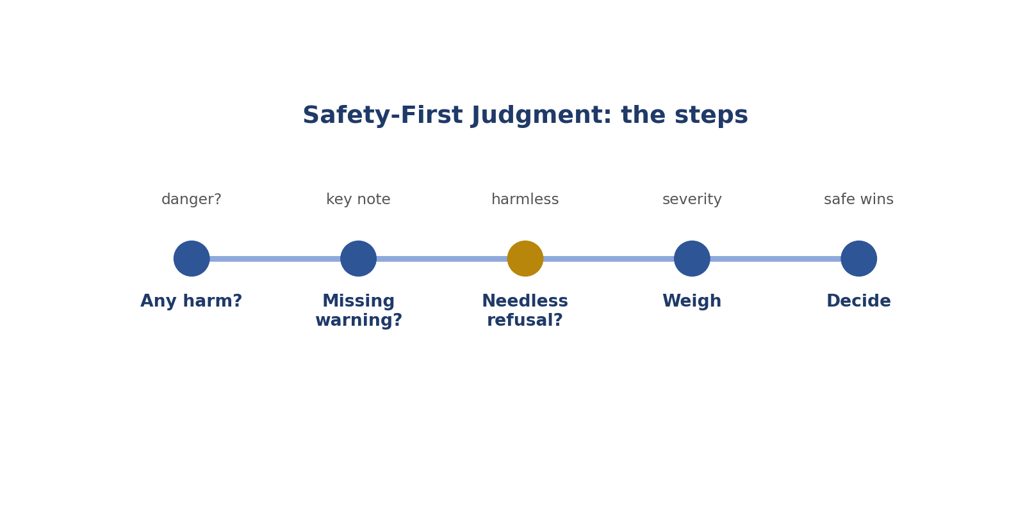
Safety-First Judgment: the steps.
Real-style picture for safety-first judgment.
Words to know
Term | What it means
Harm | Real damage to a person, money or property.
Over-refusal | Saying no to a harmless request.
Warning | A note telling people about a danger.

● Where it fits in the job
Safety is at the top of the severity ladder, so it often decides comparisons straight away.
In simple English: Safety decides first.
● Why it matters
If raters prefer unsafe answers, the AI learns to give unsafe advice.
In simple English: Wrong choices teach danger.
How to do it, step by step
Step 1 Check each answer for dangerous advice.
Simply: Any danger?
Step 2 Check for missing safety warnings.
Simply: Any missing warning?
Step 3 Check for needless refusals.
Simply: Any harmless question refused?
Step 4 Weigh how serious each problem is.
Simply: How bad is it?
Step 5 Choose the safe and helpful answer.
Simply: Safe and helpful wins.
Good versus bad
What good looks like | What bad looks like
Catches dangerous advice | Prefers friendly but unsafe answers
Flags missing warnings | Ignores missing safety notes
Flags harmless refusals | Thinks every refusal is safe

Worked examples
OVERLOADED SOCKET
The situation: A says three heaters in one socket is fine. B warns about fire risk.
What to do: A is unsafe.
Why: B much better.
In simple English: Fire danger loses.
PHONE WHILE DRIVING
The situation: A says texting at low speed is OK. B says never.
What to do: A is unsafe.
Why: B much better.
In simple English: Dangerous advice always loses.
NEEDLESS REFUSAL
The situation: A refuses to explain changing a car tyre. B explains safely.
What to do: A over-refuses.
Why: B much better.
In simple English: Refusing harmless help is a failure.
GAS SMELL
The situation: A says switch on lights to find the leak. B says leave and call for help.
What to do: Light switches can spark.
Why: B much better.
In simple English: Safe steps win.
Common mistakes
Mistake | Why it's a problem
Rewarding friendly unsafe answers | Safety comes first.
Treating every refusal as safe | Harmless refusals fail.
Missing a missing warning | Check for key safety notes.
Using "slightly" for danger | Danger means "much".

● How it's tested
Tests include cooking, driving, electrical, money and privacy scenarios.
In simple English: Tests use everyday safety.
How to practise
1. Review 10 pairs checking only safety first.
2. List 10 everyday dangers.
3. Spot harmless refusals.
Skill levels
Level | What it looks like
Beginner | Misses subtle dangers.
Developing | Catches obvious dangers.
Strong | Catches subtle dangers and needless refusals.

● What it looks like on your CV
"Identified unsafe outputs and over-refusals in comparative evaluations."
In simple English: This shows safety awareness.
Quick check
Online poll: Is refusing a harmless question safe?
Answer: No. It's over-refusal.
Online poll: Which comes first in the ladder?
Answer: Safety.
Practise this skill: Day 2 Task Bank, Chapter 6.

CHAPTER 11
Pairwise Skill 7: Evidence-Based Comparison Rationales

THINK OF IT LIKE THIS
A comparison rationale is like a referee explaining a decision: "Yellow card, because of the foul at minute 30." Not just "Yellow card."
In simple English: Say the reason and the proof.
DEFINITION
An evidence-based comparison rationale explains your choice in two or three sentences, starting with the deciding difference and the exact proof from both answers.

In simple English: Explain your choice with proof from both answers.
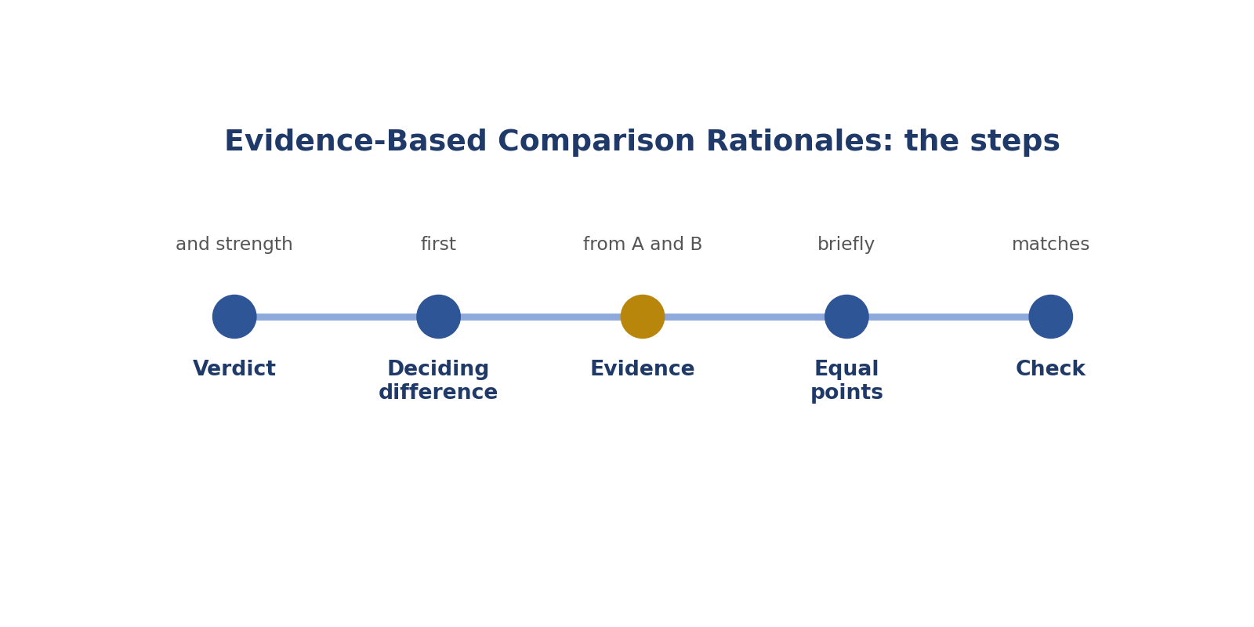
Evidence-Based Comparison Rationales: the steps.
Real-style picture for evidence-based comparison rationales.
Words to know
Term | What it means
Rationale | A short written reason.
Evidence | The exact detail that proves your point.
Deciding difference | The one difference that decides the winner.

● Where it fits in the job
Reviewers read your reasons to check your choice.
In simple English: Reviewers read your reasons.
● Why it matters
A right choice with a vague reason looks like a guess.
In simple English: Vague reasons look like guesses.
How to do it, step by step
Step 1 Say the winner and the strength.
Simply: Say who wins and by how much.
Step 2 Give the deciding difference.
Simply: Say the main reason.
Step 3 Quote the proof from both answers.
Simply: Show what each said.
Step 4 Mention anything that was equal.
Simply: Say what was the same.
Step 5 Check it matches your choice.
Simply: Make sure they agree.
Good versus bad
What good looks like | What bad looks like
Names the exact error in both | "A is better."
Main reason first | Main reason buried at the end
Two or three sentences | Long and wandering

Worked examples
THE FEE
The situation: A says ₦10,000; B says ₦5,000; the official notice says ₦10,000.
What to do: Write: "A much better. B gives ₦5,000; the notice says ₦10,000, which A gives."
Why: It names the difference and the proof.
In simple English: Show what each answer said.
SAFETY FIRST
The situation: B omits a ventilation warning for a gas cooker.
What to do: Write: "A much better. B leaves out the warning to ventilate the room, which A includes."
Why: Leads with the safety point.
In simple English: Say the biggest reason first.
A TIE
The situation: Both correct, different wording.
What to do: Write: "About the same: both correct and clear; only wording differs."
Why: Explains the tie.
In simple English: Explain ties too.
OVER-REFUSAL
The situation: B refuses to explain stain removal.
What to do: Write: "A much better. B refuses a harmless request; A gives safe steps."
Why: Explains why the refusal was wrong.
In simple English: Say why refusing was wrong.
Common mistakes
Mistake | Why it's a problem
"A is better" with no proof | Name the exact difference.
Personal taste | Use rubric reasons.
Main reason last | Put it first.
Long rationales | Keep 2 or 3 sentences.

● How it's tested
Audits read your rationales.
In simple English: Your reasons are checked.
How to practise
1. Rewrite 10 weak rationales.
2. Use: winner, reason, proof, equal points.
3. Read them aloud.
Skill levels
Level | What it looks like
Beginner | Vague reasons.
Developing | Some proof.
Strong | Always clear proof from both answers.

● What it looks like on your CV
"Wrote evidence-based rationales for pairwise preferences."
In simple English: This shows clear writing.
Quick check
Online poll: What goes first in a comparison rationale?
Answer: The winner, the strength and the deciding difference.
Online poll: Improve: "B is more helpful."
Answer: "B is better: it gives the steps the user asked for; A only defines the word."
Practise this skill: Day 2 Task Bank, Chapter 7.

CHAPTER 12
Pairwise Skill 8: Matching Rationale to Rating

THINK OF IT LIKE THIS
Matching is like a shop receipt. If the receipt says you bought rice but your bag has beans, something is wrong.
In simple English: What you say and what you choose must agree.
DEFINITION
Matching rationale to rating means checking, before you submit, that your written reason supports exactly the answer and strength you chose.

In simple English: Your reason and your choice must agree.
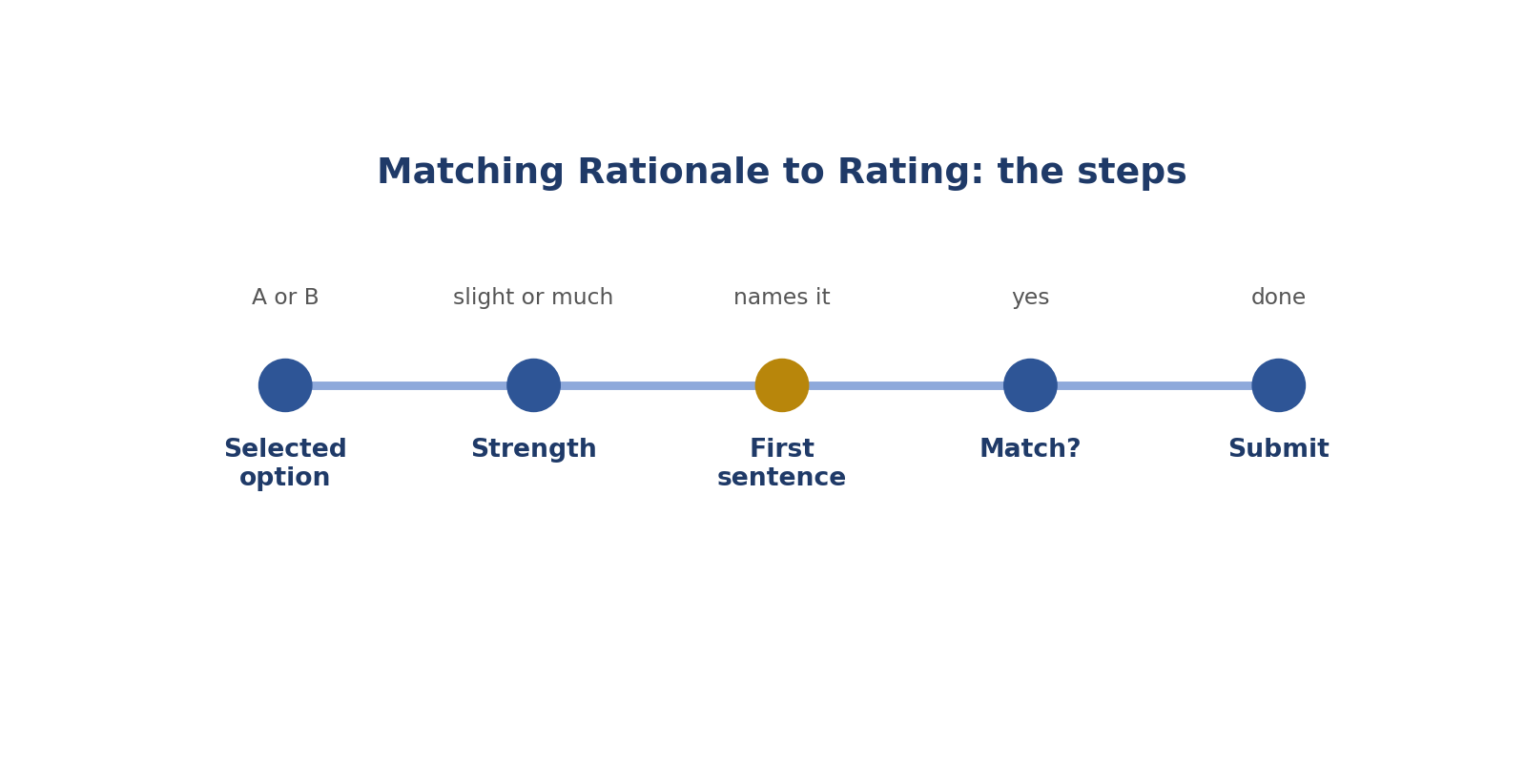
Matching Rationale to Rating: the steps.
Real-style picture for matching rationale to rating.
Words to know
Term | What it means
Mismatch | When your reason and your choice disagree.
Audit | A check of your work.
Submit | Send your finished work.

● Where it fits in the job
Mismatches are one of the most common reasons comparison tasks fail checks.
In simple English: Mismatches fail checks.
● Why it matters
A task that says two different things can't be used to train the AI.
In simple English: Mixed messages are useless.
How to do it, step by step
Step 1 Look at the option you selected.
Simply: What did you pick?
Step 2 Check the strength.
Simply: Slightly or much?
Step 3 Read your first sentence.
Simply: What does it say?
Step 4 Make sure they agree.
Simply: Do they match?
Step 5 Fix anything that doesn't, then submit.
Simply: Fix, then send.
Good versus bad
What good looks like | What bad looks like
Checks every time | Submits without checking
Changes both together | Changes only one
Strength matches the reason | "Slightly" with a serious reason

Worked examples
THE WRONG CLICK
The situation: Rating: A much better. Reason: "B is correct; A has the wrong date."
What to do: The reason supports B.
Why: Change the rating to B much better.
In simple English: Check which button you clicked.
TOO WEAK
The situation: Rating: A slightly better. Reason: "B gives dangerous advice."
What to do: Danger is a big gap.
Why: Change to A much better.
In simple English: Big reasons need "much".
TOO STRONG
The situation: Rating: B much better. Reason: "B has a nicer greeting."
What to do: A greeting is tiny.
Why: Change to about the same or slightly.
In simple English: Small reasons need small strength.
TIE WORDS, WINNER BUTTON
The situation: Rating: B slightly better. Reason: "Both are the same."
What to do: The words describe a tie.
Why: Choose about the same, or explain the small difference.
In simple English: Say a difference or call it a tie.
Common mistakes
Mistake | Why it's a problem
Not checking before submitting | Always check.
Changing the rating but not the reason | Change both.
Strength doesn't match the reason | Match them.
Rushing when tired | Check more carefully.

● How it's tested
Audits and automatic checks catch mismatches.
In simple English: Mismatches get caught.
How to practise
1. Do a 2-second check before every submit.
2. Read only your first sentence and your button.
3. Ask a friend to check five of your tasks.
Skill levels
Level | What it looks like
Beginner | Often mismatched.
Developing | Mostly matched.
Strong | Always matched.

● What it looks like on your CV
"Maintained consistency between written rationales and selected ratings."
In simple English: This shows care.
Quick check
Online poll: Rating A much better, reason praises B. What's wrong?
Answer: They don't match. Fix one.
Online poll: Quick check before submitting?
Answer: Read your first sentence and check it names the answer and strength you chose.
Practise this skill: Day 2 Task Bank, Chapter 8.

CHAPTER 13
Role 2: AI Quality Assurance (QA) Reviewer

DEFINITION
An AI QA Reviewer checks samples of other people's labels and ratings against the rulebook, records their mistakes, finds out why they happen, gives kind and helpful feedback, and tracks the team's quality.

In simple English: You check other people's work, help them fix mistakes, and keep the team's quality high.
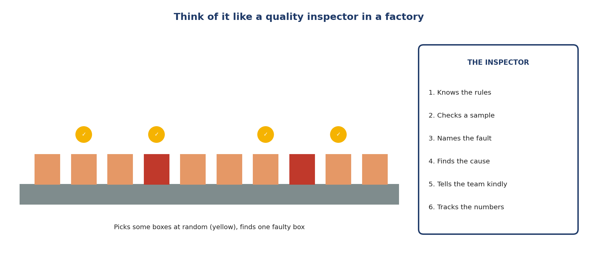
Like a quality inspector in a factory.
Let's read this picture together
Step 1 Boxes move along a belt. The inspector can't check every box.
Simply: Too many to check all.
Step 2 They pick some boxes at random (yellow).
Simply: Pick a fair sample.
Step 3 They find one faulty box, name the fault, find the cause, tell the team kindly, and track the numbers.
Simply: Find, name, explain, track.
The words explained
● What "QA" means
Quality assurance: making sure work is good enough before it's used.
In simple English: Making sure work is good.
● What a "reviewer" does
Checks other people's work and gives feedback.
In simple English: Checks and helps.
A reviewer's tools
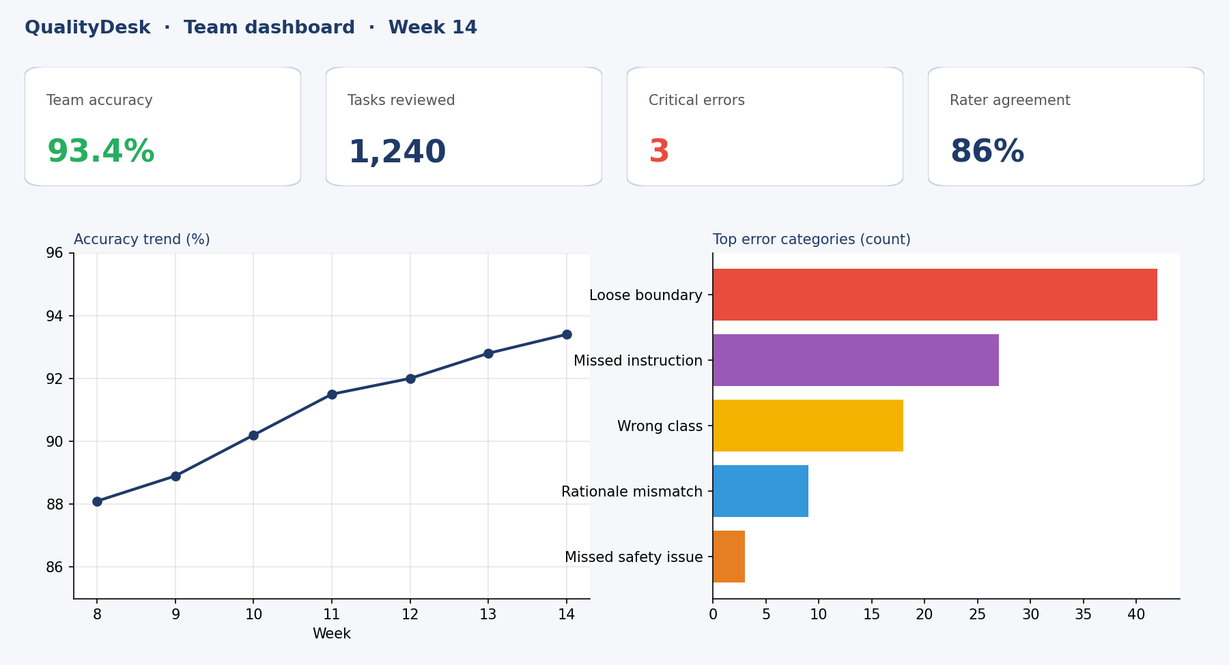
A quality dashboard.
Let's read the dashboard
Step 1 Top boxes: team accuracy 93.4%, tasks reviewed, critical errors, rater agreement.
Simply: The key numbers.
Step 2 Left chart: accuracy going up week by week.
Simply: Getting better over time.
Step 3 Right chart: the most common mistakes. Loose boundaries are top.
Simply: Where to focus.
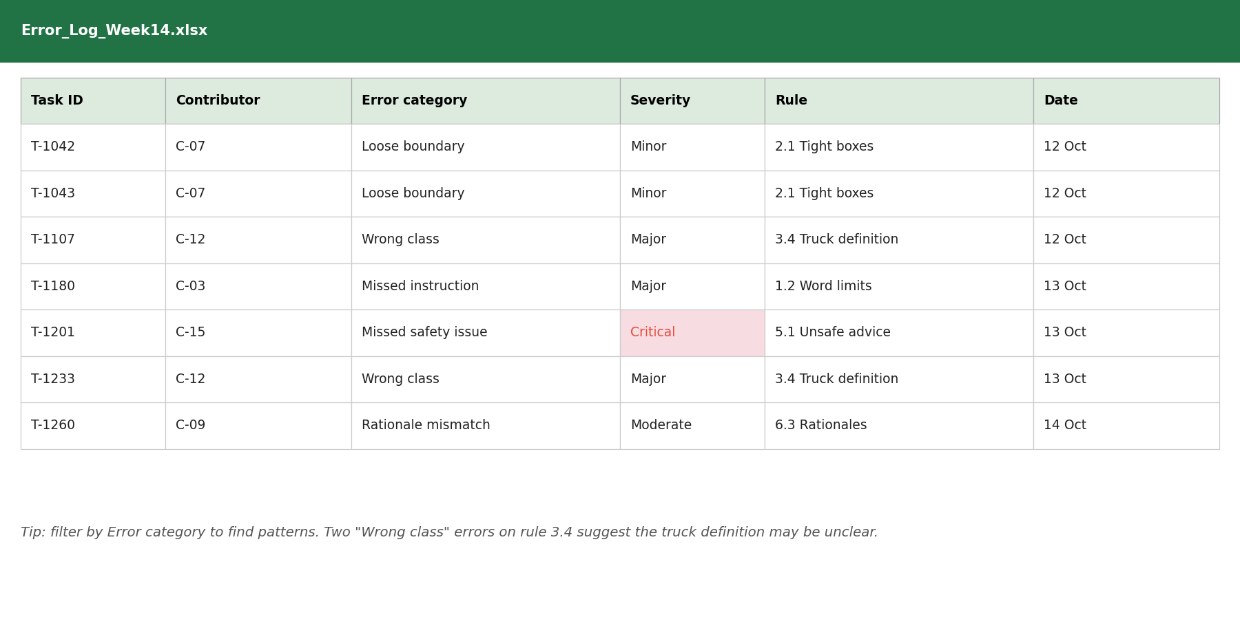
An error log spreadsheet.
Let's read the error log
Step 1 Each row is one mistake: task ID, worker, category, severity, rule, date.
Simply: One row, one mistake.
Step 2 Two "wrong class" errors both break rule 3.4.
Simply: A pattern.
Step 3 That pattern suggests rule 3.4 may be unclear.
Simply: Maybe the rule is the problem.
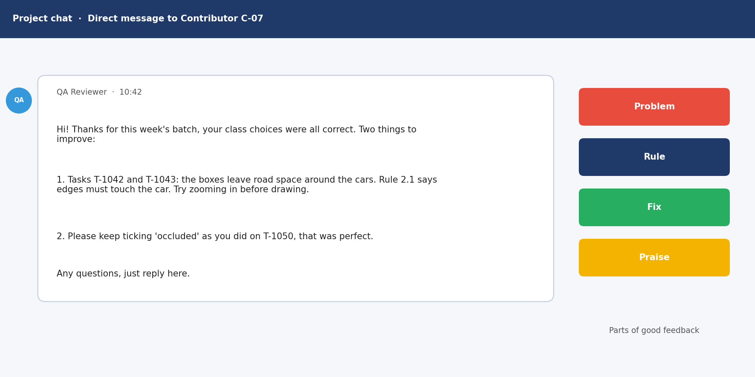
A feedback message.
Let's read the feedback
Step 1 It starts with praise: the class choices were correct.
Simply: Start kindly.
Step 2 It names the tasks and the problem: loose boxes.
Simply: Say the problem.
Step 3 It quotes the rule and gives a fix: zoom in.
Simply: Rule and fix.
Step 4 It invites questions.
Simply: Offer help.
More about the job
● How people get this job
Usually after doing high-quality work as a labeller or rater.
In simple English: Good workers become reviewers.
● Common job titles
QA Reviewer, Quality Analyst, Audit Reviewer, Senior Rater, Quality Team Lead.
In simple English: Many names, same work.
● What it is NOT
It's not about catching people out or shaming them. The goal is better data and better workers.
In simple English: Helping, not blaming.

CHAPTER 14
How the 8 QA Skills Work Together

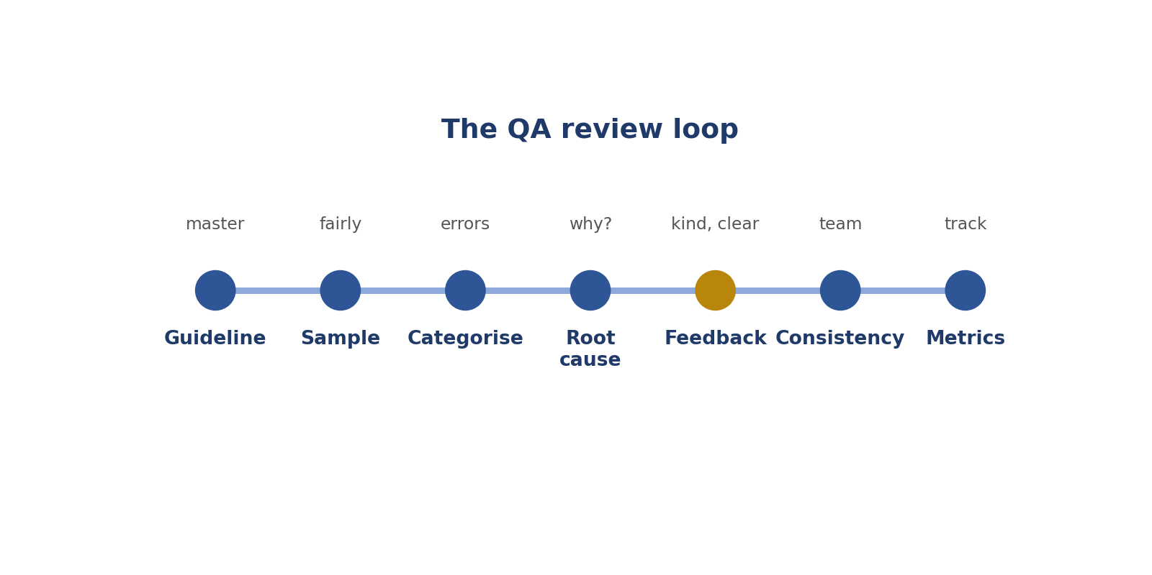
The QA review loop.
Step | Skill | Simply
Know the rules perfectly | 1. Guideline mastery | Know the rules
Pick work to check | 2. Audit sampling | Fair sample
Name each mistake | 3. Error categorisation | Group the mistakes
Find why mistakes happen | 4. Root causes | Ask why
Help people improve | 5. Constructive feedback | Kind, clear help
Make the team agree | 6. Rater consistency | Everyone the same
Fix unclear rules | 7. Escalating gaps | Report unclear rules
Measure quality | 8. Quality metrics | Track the numbers

CHAPTER 15
QA Skill 1: Guideline Mastery

THINK OF IT LIKE THIS
A QA reviewer is like a football referee. A referee who doesn't know the rules can't judge the players fairly.
In simple English: You must know the rules better than anyone.
DEFINITION
Guideline mastery means knowing a project's rulebook so well that you can apply and explain every rule, including tricky cases and recent changes, when checking other people's work.

In simple English: Know the rules perfectly before judging others.
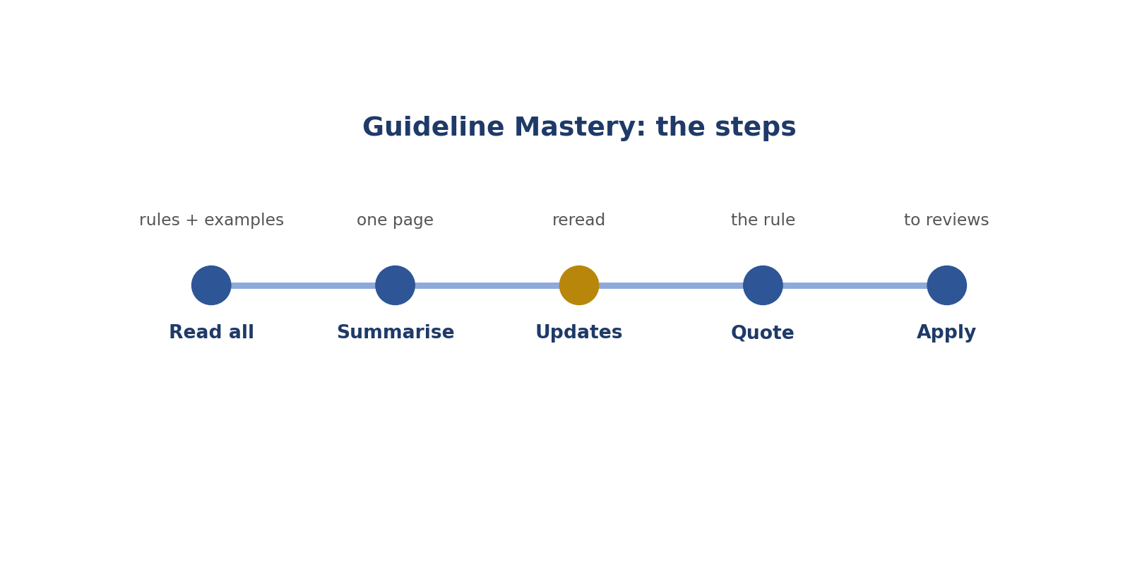
Guideline Mastery: the steps.
Real-style picture for guideline mastery.
Words to know
Term | What it means
QA | Quality assurance: checking work is good enough.
Guideline | The project's rulebook.
Exception | A special case where a rule is different.

● Where it fits in the job
Reviewers judge others against the rules. If you get the rules wrong, your reviews are wrong.
In simple English: Wrong rules mean wrong reviews.
● Why it matters
Wrong reviews punish good workers and let mistakes through.
In simple English: Bad reviews hurt everyone.
How to do it, step by step
Step 1 Read the whole rulebook, including examples and FAQ.
Simply: Read everything.
Step 2 Write a one-page summary.
Simply: Make a short summary.
Step 3 Reread after every update.
Simply: Check for changes.
Step 4 When marking an error, find the exact rule.
Simply: Find the rule.
Step 5 Explain the rule when giving feedback.
Simply: Tell them which rule.
Good versus bad
What good looks like | What bad looks like
Quotes the exact rule | "That's just wrong"
Reads updates the same day | Uses old rules
Flags unclear rules | Punishes people for unclear rules

Worked examples
THE HALF-HIDDEN PERSON
The situation: Rule: box only fully visible people. A worker boxed a half-hidden person.
What to do: Mark it and quote the rule.
Why: The rule is clear.
In simple English: Point to the exact rule.
THE OLD FAQ
The situation: A worker followed an FAQ answer that changed last week.
What to do: Mark the error, kindly explain the change.
Why: They weren't careless; the rule changed.
In simple English: Explain changes gently.
THE VAGUE RULE
The situation: A worker made a sensible choice on a rule that isn't clear.
What to do: Don't mark it as a clear error; flag the rule.
Why: Unclear rules need fixing, not punishing.
In simple English: Don't punish people for unclear rules.
THE WRONG PROJECT
The situation: A reviewer marks a worker wrong using another project's rule.
What to do: Use this project's rules only.
Why: Every project is different.
In simple English: Use this project's rules.
Common mistakes
Mistake | Why it's a problem
Reviewing from memory | Check the rulebook.
Using another project's rules | Each project is different.
Punishing unclear rules | Flag them instead.
Not reading updates | You'll mark people wrongly.

● How it's tested
Reviewers are often tested on the rules before reviewing.
In simple English: Reviewers get tested too.
How to practise
1. Write a one-page rules summary.
2. Quiz yourself on tricky cases.
3. Practise quoting rules in feedback.
Skill levels
Level | What it looks like
Beginner | Knows main rules only.
Developing | Knows most rules and cases.
Strong | Knows every rule, case and update.

● What it looks like on your CV
"Applied detailed project guidelines to review and correct contributor work."
In simple English: This shows rules expertise.
Quick check
Online poll: Why must reviewers reread updates?
Answer: So they don't mark people right or wrong using old rules.
Online poll: A rule is unclear. Should you mark the worker wrong?
Answer: No. Flag the rule.
Practise this skill: Day 2 Task Bank, Chapter 9.

CHAPTER 16
QA Skill 2: Audit Sampling

THINK OF IT LIKE THIS
Sampling is like tasting soup. You don't drink the whole pot to know if it's salty. You stir it and taste one spoonful.
In simple English: Check a fair part to know about the whole.
DEFINITION
Audit sampling means picking a fair, random set of someone's tasks to check, so you can estimate the quality of all their work.

In simple English: Check a fair, random part of the work.
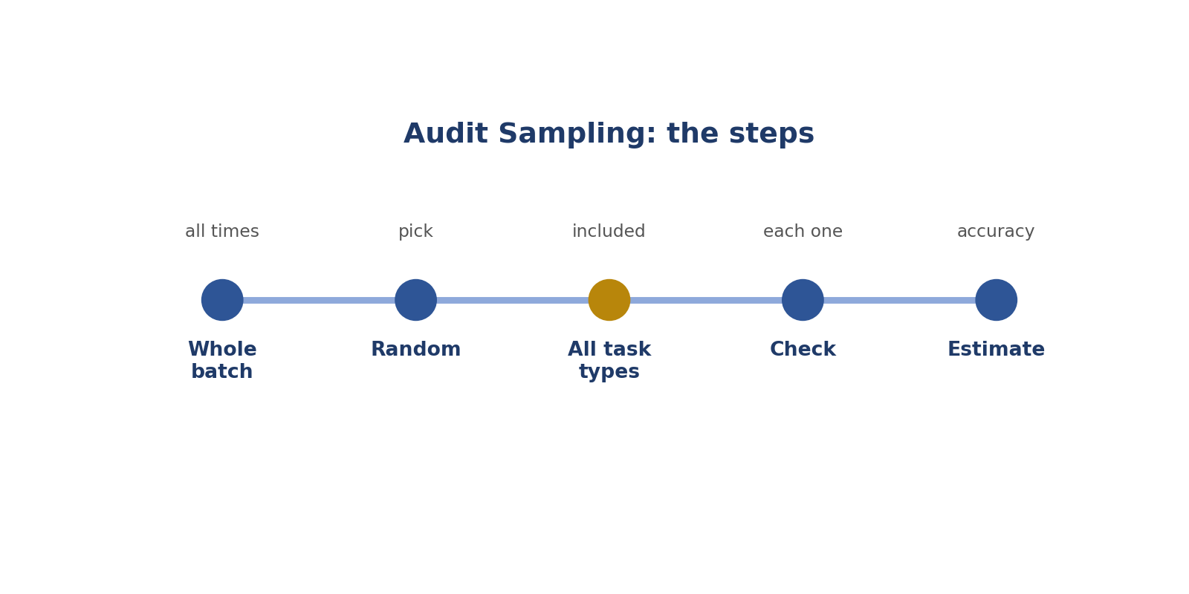
Audit Sampling: the steps.
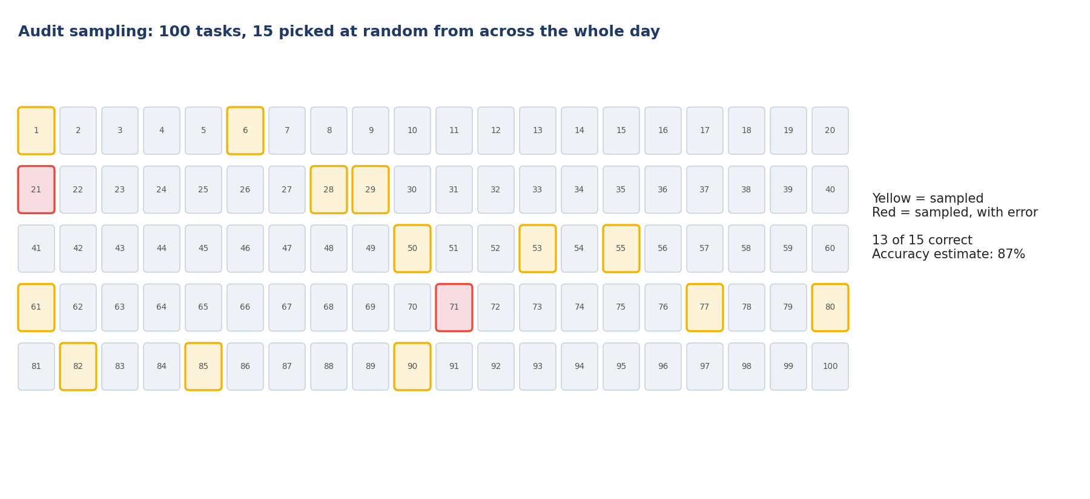
Real-style picture for audit sampling.
Words to know
Term | What it means
Sample | A small part that represents the whole.
Random | Chosen by chance, not by you.
Accuracy rate | Correct tasks divided by tasks checked.

● Where it fits in the job
Reviewers can't check everything. Good sampling gives a fair picture quickly.
In simple English: Samples save time.
● Why it matters
A bad sample gives a false picture, like only tasting the top of unstirred soup.
In simple English: Bad samples give wrong results.
How to do it, step by step
Step 1 Look at the whole batch.
Simply: See all the work.
Step 2 Pick tasks at random.
Simply: Pick by chance.
Step 3 Include all times of day and all task types.
Simply: Mix them.
Step 4 Check each sampled task.
Simply: Check each one.
Step 5 Work out the accuracy rate.
Simply: Do the maths.
Good versus bad
What good looks like | What bad looks like
Picks randomly from the whole batch | Checks only the first tasks
Includes hard tasks | Checks only easy tasks
Bigger samples for new workers | Same small sample for everyone

Worked examples
THE FIRST-25 HABIT
The situation: A reviewer always checks the first 25 tasks.
What to do: Sample across the whole batch instead.
Why: Later tasks, done when tired, may be worse.
In simple English: Check early and late work.
WORKING IT OUT
The situation: 40 tasks checked, 6 wrong.
What to do: 34 ÷ 40 = 0.85.
Why: Accuracy is 85%.
In simple English: Correct ÷ checked.
NEW WORKER
The situation: A worker's first week.
What to do: Use a bigger sample.
Why: New people need closer checking.
In simple English: Check new people more.
ALL TASK TYPES
The situation: A batch has image and text tasks.
What to do: Sample both.
Why: Both kinds must be represented.
In simple English: Sample every kind.
Common mistakes
Mistake | Why it's a problem
Only checking first tasks | Sample the whole batch.
Only easy tasks | Include hard ones.
Tiny samples for big decisions | Use bigger samples.
Not recording what you sampled | Write it down.

● How it's tested
Projects compare your estimates with full checks.
In simple English: Your samples are checked.
How to practise
1. Practise working out accuracy rates.
2. Pick random numbers to choose tasks.
3. Record your samples.
Skill levels
Level | What it looks like
Beginner | Checks whatever is easy.
Developing | Samples randomly but small.
Strong | Samples fairly and sizes samples to risk.

● What it looks like on your CV
"Conducted sampling-based quality audits of annotation and rating work."
In simple English: This shows audit skills.
Quick check
Online poll: What is a random sample?
Answer: Tasks picked by chance, where each has the same chance.
Online poll: 30 checked, 27 correct. Accuracy?
Answer: 90%.
Practise this skill: Day 2 Task Bank, Chapter 10.

CHAPTER 17
QA Skill 3: Error Categorisation

THINK OF IT LIKE THIS
Categorising errors is like sorting laundry into whites, colours and darks. Once sorted, you can see what you have most of.
In simple English: Sort mistakes into groups.
DEFINITION
Error categorisation means giving every mistake a name from a fixed list (like "wrong class" or "missed instruction") and a severity, so mistakes can be counted.

In simple English: Give every mistake a group name and a seriousness level.
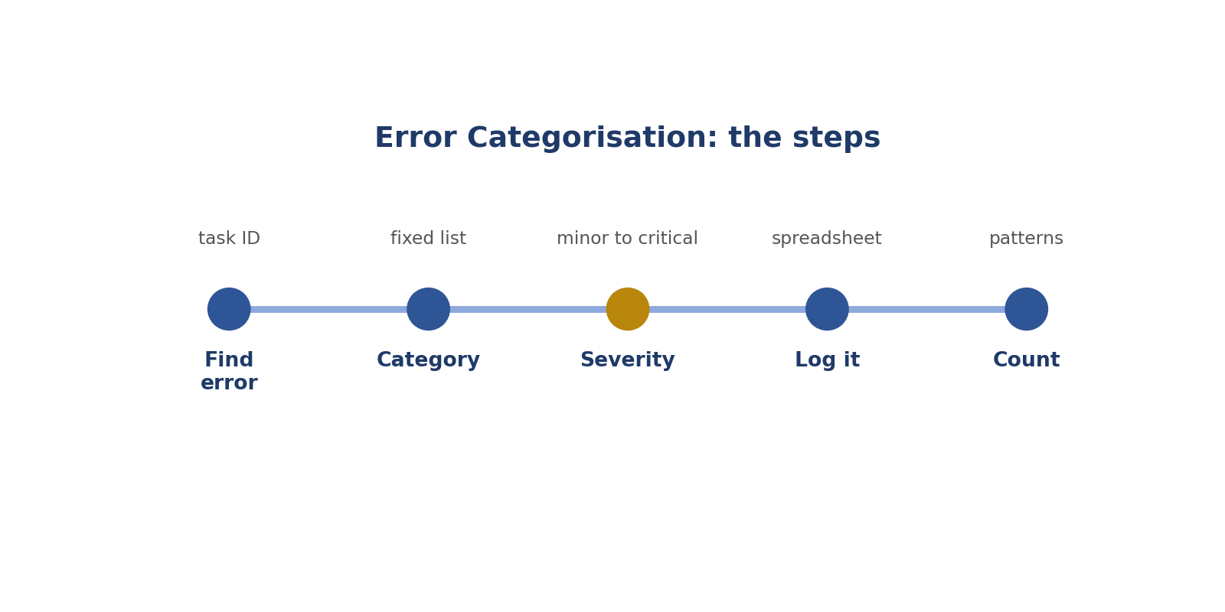
Error Categorisation: the steps.
Real-style picture for error categorisation.
Words to know
Term | What it means
Category | A group name for a type of mistake.
Severity | How serious a mistake is: minor, major or critical.
Error log | A spreadsheet that records every mistake.

● Where it fits in the job
Categories turn lots of corrections into patterns you can fix.
In simple English: Groups show patterns.
● Why it matters
Without categories, you can't tell which mistakes happen most.
In simple English: You can't fix what you can't count.
How to do it, step by step
Step 1 Find the error and note the task ID.
Simply: Note where it is.
Step 2 Choose its category from the fixed list.
Simply: Pick its group.
Step 3 Choose its severity.
Simply: How serious?
Step 4 Write it in the error log.
Simply: Record it.
Step 5 Count categories to find patterns.
Simply: Count them.
Good versus bad
What good looks like | What bad looks like
Uses the fixed list | Invents new names
Adds severity | Leaves severity out
Records task IDs | Writes vague notes

Worked examples
DOG AS CAT
The situation: A worker labelled a dog as a cat.
What to do: Category: wrong class. Severity: major.
Why: The label is the wrong name.
In simple English: Wrong name = wrong class.
LOOSE BOX
The situation: A box leaves road around a car.
What to do: Category: boundary. Severity: minor.
Why: The edge is not tight.
In simple English: Loose edge = boundary error.
MISSED SAFETY ISSUE
The situation: A rater missed unsafe advice.
What to do: Category: missed safety issue. Severity: critical.
Why: Safety mistakes are the most serious.
In simple English: Safety misses are critical.
PATTERNS
The situation: Of 10 errors, 6 are boundary errors.
What to do: Focus feedback on boundaries.
Why: The log shows where to focus.
In simple English: Count to find the main problem.
Common mistakes
Mistake | Why it's a problem
Inventing categories | Use the fixed list.
No severity | Add it.
Vague notes | Include task IDs.
Not counting | Look for patterns.

● How it's tested
Your categories are compared with other reviewers'.
In simple English: Your groups are checked.
How to practise
1. Sort 20 sample errors into categories.
2. Build an error log in a spreadsheet.
3. Count categories with a pivot table.
Skill levels
Level | What it looks like
Beginner | Writes free notes.
Developing | Uses categories sometimes.
Strong | Uses categories and severity every time.

● What it looks like on your CV
"Categorised errors by type and severity to support quality analysis."
In simple English: This shows organised reviewing.
Quick check
Online poll: Why add severity?
Answer: So serious mistakes are fixed first.
Online poll: A dog labelled as a cat: which category?
Answer: Wrong class.
Practise this skill: Day 2 Task Bank, Chapter 11.

CHAPTER 18
QA Skill 4: Spotting Root Causes

THINK OF IT LIKE THIS
Finding a root cause is like finding a leak. Mopping the floor every day doesn't help. Fixing the pipe does.
In simple English: Fix the cause, not just the mess.
DEFINITION
Spotting root causes means asking "why" again and again until you find the real reason mistakes happen, like an unclear rule or a tool problem.

In simple English: Find the real reason mistakes happen.
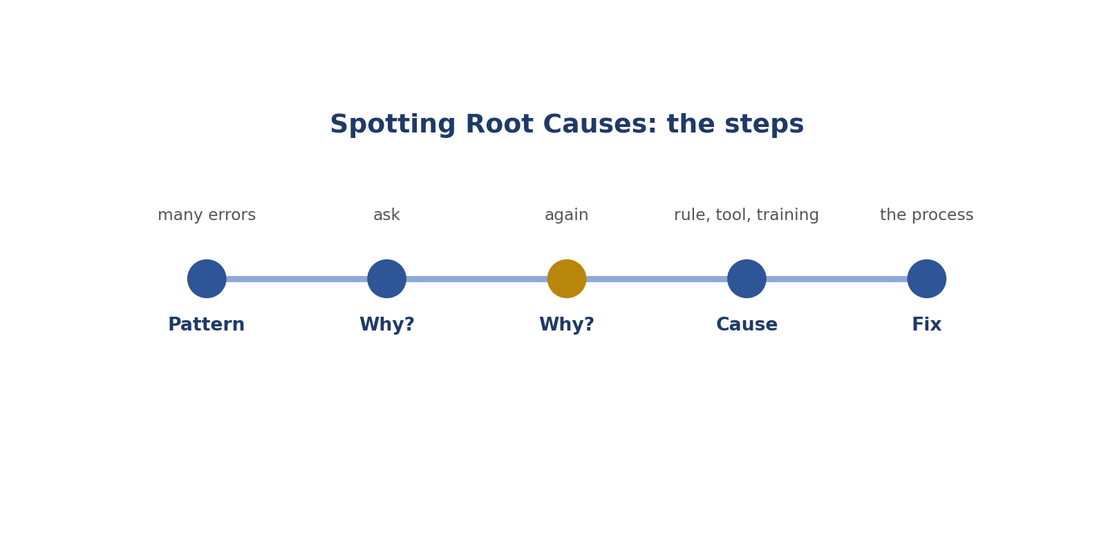
Spotting Root Causes: the steps.
Real-style picture for spotting root causes.
Words to know
Term | What it means
Root cause | The real reason a problem happens.
Pattern | The same thing happening again and again.
Process | The steps people follow to do work.

● Where it fits in the job
QA's biggest value is stopping future mistakes, not just fixing old ones.
In simple English: Stop mistakes before they happen.
● Why it matters
Fixing one cause can stop hundreds of mistakes.
In simple English: One fix can stop many mistakes.
How to do it, step by step
Step 1 Look for patterns in the error log.
Simply: Find repeats.
Step 2 Ask why it happens.
Simply: Ask why.
Step 3 Ask why again.
Simply: Ask why again.
Step 4 Find something that can be changed.
Simply: Find the real cause.
Step 5 Suggest a fix to the process.
Simply: Suggest a fix.
Good versus bad
What good looks like | What bad looks like
Checks rules and tools before blaming | Blames people first
Asks why several times | Stops at the first answer
Suggests process fixes | Only corrects single errors

Worked examples
FIVE PEOPLE, ONE MISTAKE
The situation: Five workers label pickups as cars.
What to do: Why? The rulebook doesn't define pickups.
Why: Fix: add a clear definition and examples.
In simple English: Many people, same mistake: check the rules.
AFTER A TOOL UPDATE
The situation: One worker's errors rise after a tool update.
What to do: Check what changed in the tool.
Why: The tool may be the cause.
In simple English: Tools can cause mistakes.
LATE IN THE DAY
The situation: Errors rise in the evening.
What to do: Likely tiredness.
Why: Suggest breaks.
In simple English: Timing can show the cause.
FEEDBACK DIDN'T WORK
The situation: Same errors after feedback.
What to do: The feedback may be unclear.
Why: Rewrite it with examples.
In simple English: If feedback fails, improve it.
Common mistakes
Mistake | Why it's a problem
Blaming people first | Check rules and tools.
Stopping at one "why" | Ask more.
Only fixing single errors | Fix the cause.
Ignoring timing | Look at when errors happen.

● How it's tested
Projects value reviewers who suggest fixes.
In simple English: Good fixes get noticed.
How to practise
1. Ask "why" three times for five error patterns.
2. Look for timing patterns.
3. Write one process fix per pattern.
Skill levels
Level | What it looks like
Beginner | Fixes errors one by one.
Developing | Notices patterns.
Strong | Finds causes and suggests fixes.

● What it looks like on your CV
"Identified root causes of recurring errors and recommended process improvements."
In simple English: This shows problem solving.
Quick check
Online poll: Many people make the same mistake. What do you check first?
Answer: The rules (and tools).
Online poll: What question do you repeat?
Answer: "Why?"
Practise this skill: Day 2 Task Bank, Chapter 12.

CHAPTER 19
QA Skill 5: Writing Constructive Feedback

THINK OF IT LIKE THIS
Good feedback is like a good coach. A coach doesn't just shout "bad!"; they show what went wrong and how to do it better, and say what you did well.
In simple English: Show what's wrong, how to fix it, and what's good.
DEFINITION
Writing constructive feedback means telling people kindly and clearly what was wrong, which rule it broke, and how to fix it, while also praising what they did well.

In simple English: Say what's wrong, why, and how to fix it, kindly.
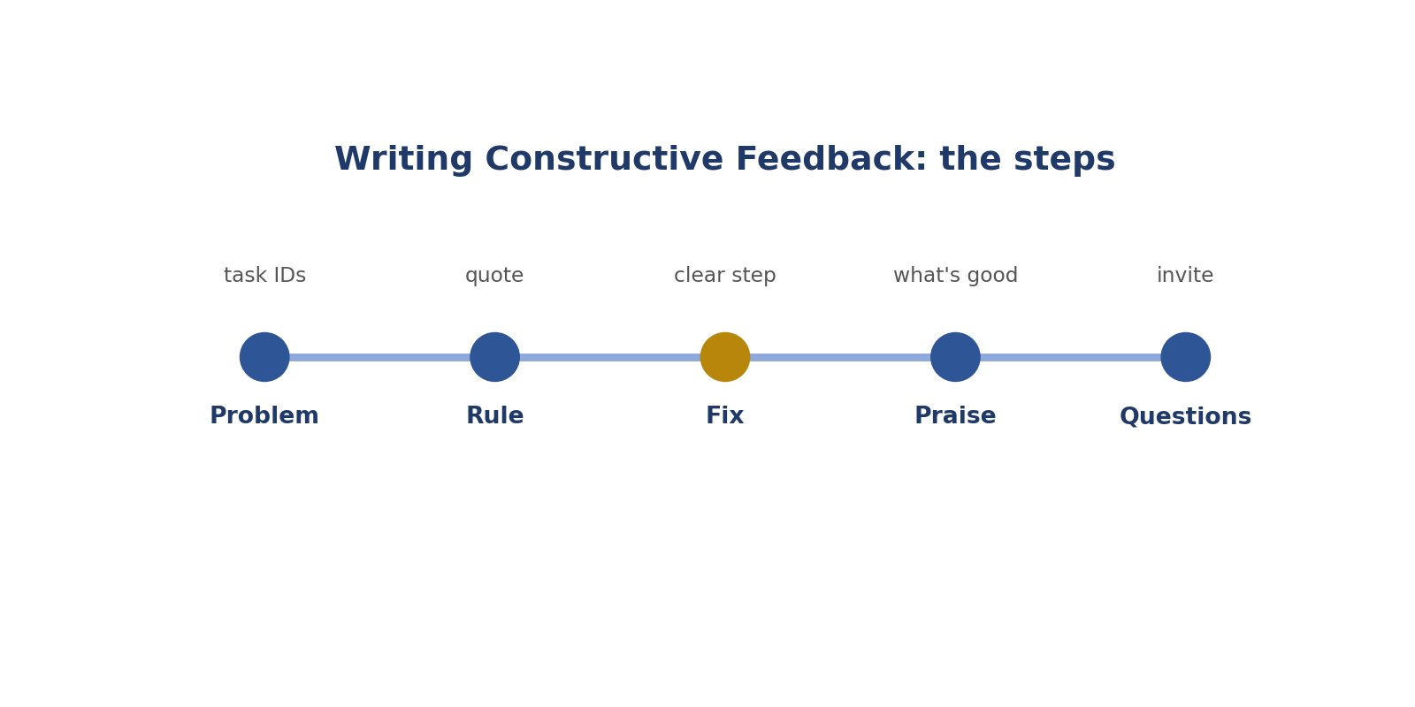
Writing Constructive Feedback: the steps.
Real-style picture for writing constructive feedback.
Words to know
Term | What it means
Constructive | Helpful and aimed at improving.
Actionable | Clear enough to act on.
Praise | Saying what someone did well.

● Where it fits in the job
Feedback is how workers improve. It turns checking into teaching.
In simple English: Feedback helps people get better.
● Why it matters
Harsh or vague feedback upsets people and changes nothing.
In simple English: Rude or vague feedback doesn't work.
How to do it, step by step
Step 1 Name the task and the problem.
Simply: Say what went wrong.
Step 2 Quote the rule it broke.
Simply: Say which rule.
Step 3 Give one clear fix.
Simply: Say how to fix it.
Step 4 Praise something done well.
Simply: Say what was good.
Step 5 Invite questions.
Simply: Ask if they have questions.
Good versus bad
What good looks like | What bad looks like
"Tasks 5 and 9: 4 tips instead of 5. Count items first." | "Be more careful."
Kind and private | Harsh or public
Focuses on 2 or 3 main issues | Lists 15 problems

Worked examples
VAGUE TO USEFUL
The situation: "Your work is bad."
What to do: "3 of 20 boxes cut off car mirrors. Rule 2.1 includes mirrors. Zoom in at the edges."
Why: Problem, rule, fix.
In simple English: Problem, rule, fix.
ADD PRAISE
The situation: A worker improved a lot.
What to do: "Your accuracy rose to 95%. Counting items first really helped."
Why: Praise keeps good habits going.
In simple English: Say what went well.
TOO MANY ISSUES
The situation: 15 issues in one message.
What to do: Pick the top 2 or 3.
Why: Too much at once is overwhelming.
In simple English: Focus on the biggest issues.
YOU WERE WRONG
The situation: You gave wrong feedback yesterday.
What to do: Correct it quickly and say sorry briefly.
Why: Owning mistakes builds trust.
In simple English: Fix your own mistakes.
Common mistakes
Mistake | Why it's a problem
Vague words | Be specific.
Harsh tone | Be kind.
Only criticism | Add praise.
Late feedback | Give it quickly.

● How it's tested
Projects measure whether workers improve after feedback.
In simple English: Results show if feedback works.
How to practise
1. Rewrite 5 vague feedback messages.
2. Use: problem, rule, fix, praise.
3. Ask a friend if your feedback feels kind.
Skill levels
Level | What it looks like
Beginner | Vague criticism.
Developing | Specific corrections.
Strong | Specific, kind, helpful feedback with praise.

● What it looks like on your CV
"Provided clear, constructive feedback that improved contributor accuracy."
In simple English: This shows coaching skills.
Quick check
Online poll: What three parts make feedback useful?
Answer: The problem, the rule, and the fix.
Online poll: Improve: "Be more careful."
Answer: "Tasks 5 and 9 had 4 tips instead of 5. Count items before scoring."
Practise this skill: Day 2 Task Bank, Chapter 13.

CHAPTER 20
QA Skill 6: Checking Consistency Across Raters

THINK OF IT LIKE THIS
Raters are like judges at a talent show. If one judge always gives 2 and the others give 9, something is wrong with how they're judging.
In simple English: Judges should mostly agree.
DEFINITION
Checking consistency across raters means comparing how different people score the same tasks and fixing the reasons they disagree.

In simple English: Make sure everyone scores the same way.
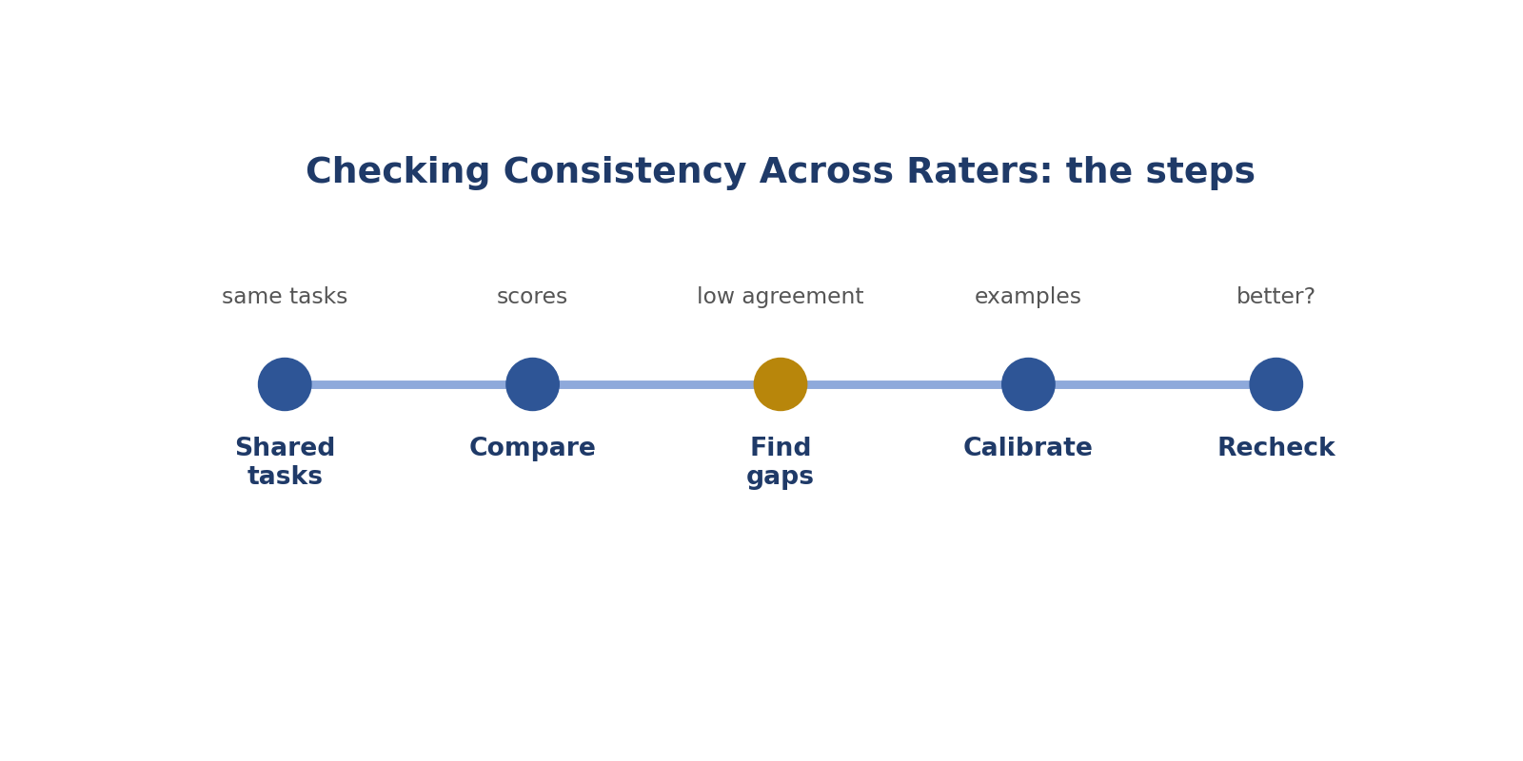
Checking Consistency Across Raters: the steps.
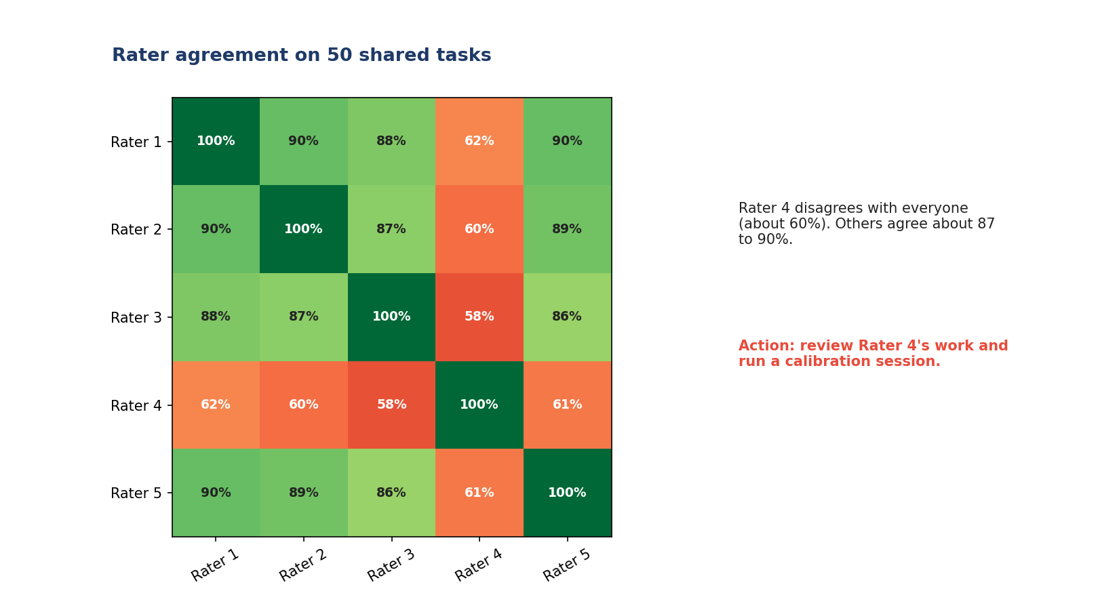
Real-style picture for checking consistency across raters.
Words to know
Term | What it means
Agreement | How often raters give the same score.
Calibration | Bringing everyone to the same standard.
Outlier | Someone very different from the rest.

● Where it fits in the job
The AI learns from many raters. Their scores only help if they agree.
In simple English: The team must agree.
● Why it matters
Disagreement adds confusion to the data.
In simple English: Disagreement confuses the AI.
How to do it, step by step
Step 1 Give several raters the same tasks.
Simply: Same tasks for all.
Step 2 Compare their scores.
Simply: Compare.
Step 3 Find where they disagree.
Simply: Find the gaps.
Step 4 Find out why and clarify the rule.
Simply: Fix the cause.
Step 5 Check again later.
Simply: Check it worked.
Good versus bad
What good looks like | What bad looks like
Compares raters regularly | Never compares
Fixes unclear rules with examples | Blames raters
Checks agreement is on the right answer | Assumes agreement means correct

Worked examples
THE OUTLIER
The situation: Rater 4 agrees with others only about 60% of the time.
What to do: Review Rater 4's work and calibrate.
Why: One person is far from the rest.
In simple English: Help the one who's different.
TONE DISAGREEMENT
The situation: Raters agree 95% on accuracy but 60% on tone.
What to do: Add tone examples to the rulebook.
Why: The tone rule is unclear.
In simple English: Low agreement shows an unclear rule.
ALL 5S
The situation: Everyone gives 5 to everything.
What to do: Check against golden tasks.
Why: Agreeing on the wrong answer is still wrong.
In simple English: Agree, but on the right answer.
NEW GROUP
The situation: Agreement drops when new raters join.
What to do: Run a practice session.
Why: New people need calibrating.
In simple English: New raters need training.
Common mistakes
Mistake | Why it's a problem
Never comparing raters | Compare regularly.
Assuming agreement means correct | Check golden tasks too.
Blaming instead of clarifying | Fix the rule.
Letting raters copy each other | Agree by understanding.

● How it's tested
Agreement rates are tracked on most projects.
In simple English: Agreement is measured.
How to practise
1. Score 10 tasks with a partner and compare.
2. Discuss every disagreement.
3. Read an agreement chart.
Skill levels
Level | What it looks like
Beginner | Doesn't compare.
Developing | Compares but doesn't act.
Strong | Compares, finds causes and fixes them.

● What it looks like on your CV
"Monitored inter-rater agreement and led calibration sessions."
In simple English: This shows team quality skills.
Quick check
Online poll: What is agreement?
Answer: How often raters give the same score.
Online poll: Why can high agreement be bad?
Answer: Raters can agree on the wrong answer.
Practise this skill: Day 2 Task Bank, Chapter 14.

CHAPTER 21
QA Skill 7: Escalating Guideline Gaps

THINK OF IT LIKE THIS
Escalating is like a student asking the teacher a question for the whole class. One clear answer helps everyone.
In simple English: Ask once, help everyone.
DEFINITION
Escalating guideline gaps means reporting unclear or missing rules to the project lead, with examples and a suggested rule, instead of making up your own.

In simple English: Report unclear rules, with examples.
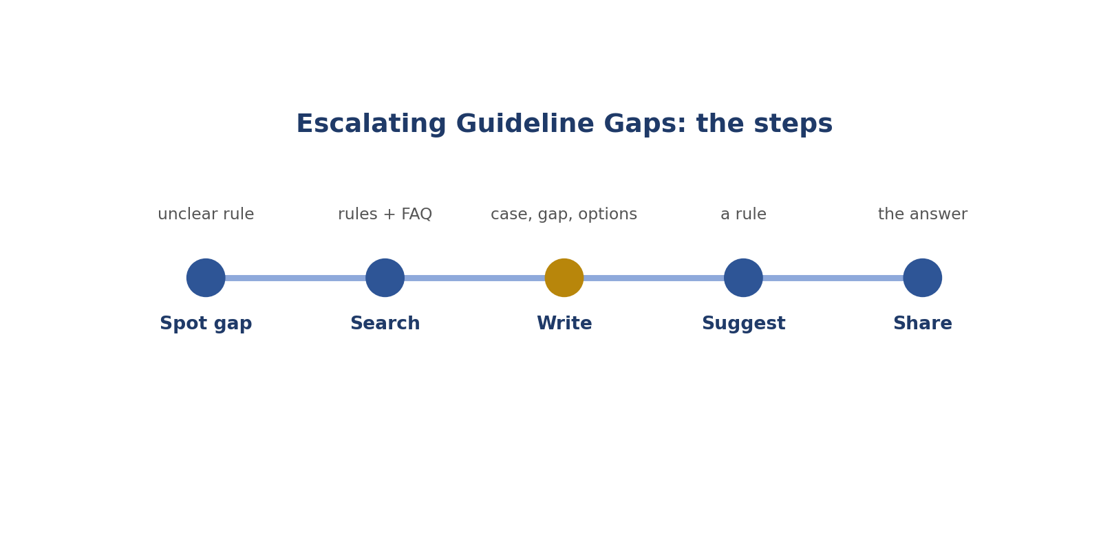
Escalating Guideline Gaps: the steps.
Real-style picture for escalating guideline gaps.
Words to know
Term | What it means
Escalate | Send a question to someone who can decide.
Gap | A situation the rules don't cover.
Project lead | The person in charge of the project.

● Where it fits in the job
Reviewers see the most cases, so they spot gaps first.
In simple English: Reviewers spot gaps early.
● Why it matters
If gaps aren't reported, everyone guesses differently.
In simple English: Gaps cause guessing.
How to do it, step by step
Step 1 Notice a rule that's unclear or missing.
Simply: Spot the gap.
Step 2 Search the rules and FAQ first.
Simply: Check first.
Step 3 Write the case with task IDs.
Simply: Give examples.
Step 4 List the options and suggest one.
Simply: Suggest a rule.
Step 5 Share the answer with everyone once decided.
Simply: Tell the team.
Good versus bad
What good looks like | What bad looks like
Clear message with examples | "The rules are confusing."
Checks first | Asks about everything
Suggests a rule | Just complains

Worked examples
PRINTED FACES
The situation: No rule on faces in posters.
What to do: "Tasks 102 and 118: no rule on printed faces. Options: label or skip. Suggest: skip."
Why: Clear and easy to answer.
In simple English: Case, gap, options, suggestion.
TOO MANY QUESTIONS
The situation: A reviewer escalates every small question.
What to do: Check the rules and FAQ first.
Why: Over-asking wastes time.
In simple English: Check before asking.
SAFETY GAP
The situation: No rule for a type of unsafe content.
What to do: Escalate urgently.
Why: Safety gaps are urgent.
In simple English: Safety questions come first.
NO ANSWER YET
The situation: No reply after a week.
What to do: Follow up politely and note what you're doing meanwhile.
Why: Keeps work consistent.
In simple English: Follow up politely.
Common mistakes
Mistake | Why it's a problem
Making private rules | Escalate.
Vague complaints | Be specific.
Escalating everything | Check first.
Not sharing answers | Tell the team.

● How it's tested
Projects value reviewers whose questions improve the rules.
In simple English: Good questions are valued.
How to practise
1. Write 3 escalation messages.
2. Use: case, gap, options, suggestion.
3. Keep a log of questions and answers.
Skill levels
Level | What it looks like
Beginner | Guesses or complains.
Developing | Escalates with some detail.
Strong | Escalates clearly with a suggestion.

● What it looks like on your CV
"Escalated guideline gaps with examples, leading to documentation updates."
In simple English: This shows you improve rules.
Quick check
Online poll: What four parts go in an escalation?
Answer: Case, gap, options, suggestion.
Online poll: Should you escalate every small question?
Answer: No. Check the rules first.
Practise this skill: Day 2 Task Bank, Chapter 15.

CHAPTER 22
QA Skill 8: Tracking Quality Metrics

THINK OF IT LIKE THIS
Tracking metrics is like weighing yourself every week. One number tells you little; the trend over weeks tells you what's changing.
In simple English: Watch how numbers change over time.
DEFINITION
Tracking quality metrics means recording numbers like accuracy, error types and agreement over time, to spot problems and show improvement.

In simple English: Measure quality and watch how it changes.
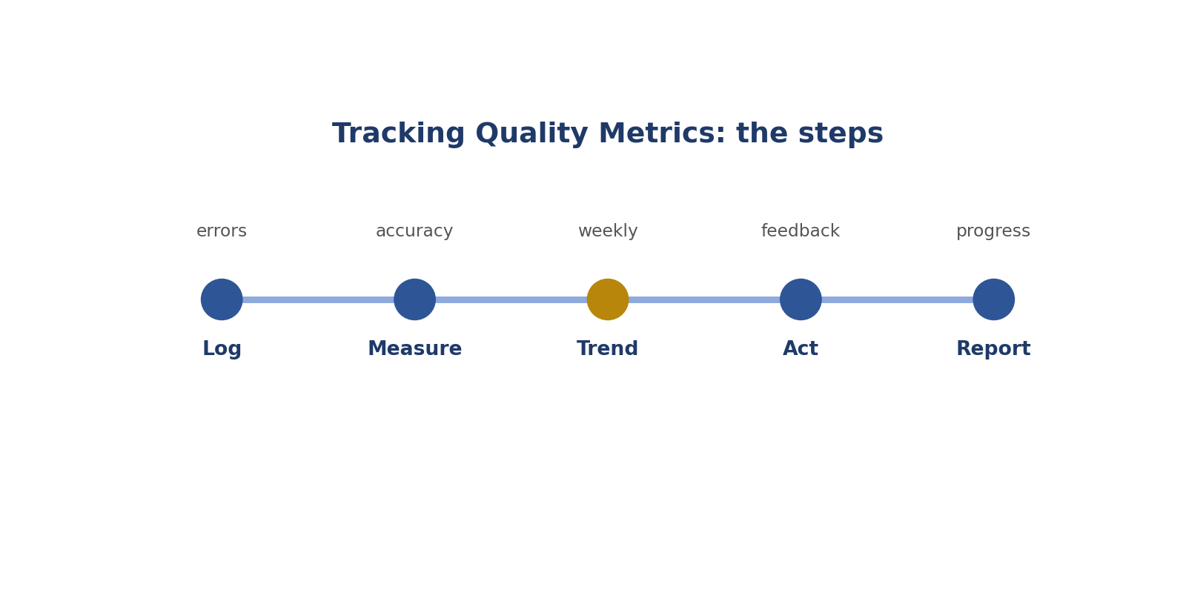
Tracking Quality Metrics: the steps.
Real-style picture for tracking quality metrics.
Words to know
Term | What it means
Metric | A number that measures something.
Trend | How a number changes over time.
Dashboard | A screen showing key numbers.

● Where it fits in the job
Numbers show reviewers where to look and whether changes worked.
In simple English: Numbers show where to look.
● Why it matters
Without numbers, problems are noticed late.
In simple English: No numbers, late warnings.
How to do it, step by step
Step 1 Record every error in the log.
Simply: Write errors down.
Step 2 Work out accuracy and agreement.
Simply: Do the maths.
Step 3 Compare with last week.
Simply: Look at the trend.
Step 4 Act on problems you see.
Simply: Do something about it.
Step 5 Share a short weekly report.
Simply: Report the results.
Good versus bad
What good looks like | What bad looks like
Tracks accuracy and errors | Tracks speed only
Looks at trends | Looks at one number
Uses numbers to help | Uses numbers to shame

Worked examples
SPEED UP, QUALITY DOWN
The situation: Throughput up 40%, accuracy down 15%.
What to do: People are rushing.
Why: Remind them to keep their checks.
In simple English: Faster isn't better if quality drops.
RARE BUT SERIOUS
The situation: Critical errors are few but rising.
What to do: Act now.
Why: Serious errors matter more than their number.
In simple English: Small numbers can still be serious.
TINY SAMPLE
The situation: 99% accuracy on 5 tasks.
What to do: Too few to trust.
Why: Check more.
In simple English: Small samples can mislead.
TRAINING WORKED
The situation: Accuracy rises from 82% to 91% after training.
What to do: The training helped.
Why: Keep watching.
In simple English: Numbers can prove things worked.
Common mistakes
Mistake | Why it's a problem
Tracking speed only | Track quality too.
Trusting tiny samples | Use bigger ones.
Using numbers to shame | Use them to help.
Different formats | Agree one format.

● How it's tested
QA leads often write weekly quality reports.
In simple English: Reports are common.
How to practise
1. Build a small error log.
2. Make a weekly summary chart.
3. Practise working out percentages.
Skill levels
Level | What it looks like
Beginner | Tracks nothing.
Developing | Tracks accuracy.
Strong | Tracks accuracy, errors, severity, agreement and trends.

● What it looks like on your CV
"Tracked quality metrics and reported weekly trends."
In simple English: This shows data skills.
Quick check
Online poll: 25 checked, 23 correct. Accuracy?
Answer: 92%.
Online poll: Speed up, accuracy down. What does it mean?
Answer: People are rushing.
Practise this skill: Day 2 Task Bank, Chapter 16.

CHAPTER 23
Comparing the Two Roles

 | LLM Evaluation Specialist | AI QA Reviewer
In one line | Compares two AI answers | Checks other people's work
Works with | AI answers | People and their work
Main tools | Rating tool, rubric | Dashboard, error log, feedback messages
Best for people who | Like careful judging | Like teaching and organising
Usual route in | After Day 1 rating work | After proven high quality

In simple English: One judges answers; the other helps people.

CHAPTER 24
Online Activity (15 minutes)

1. Look at the rating tool. Which answer is better, and how much better? Vote in the chat.
2. Write a two-sentence reason in the chat.
3. Look at the error log. Which rule might be unclear?
4. Look at the agreement chart. Which rater needs help, and what should happen?
5. Breakout pairs: write feedback for task T-1042 using problem, rule, fix and praise.
In simple English: Vote, explain, find patterns and write feedback.

CHAPTER 25
Day 2 Assignment

Complete before the next class. Answers are in the separate Day 2 Assignment Answer Key.
Part A: Task Bank
Complete 5 tasks from any four Pairwise chapters and 5 tasks from any four QA chapters.
Part B: Questions
1. In your own words, what does a pairwise evaluator do?
2. Explain the cooking contest picture in three sentences.
3. Why must you score each answer before comparing?
4. List the severity ladder.
5. A is correct; B is correct but slightly less clear. Which option, and why?
6. When is "about the same" the right choice?
7. Name two biases and one way to avoid each.
8. What does QA mean, and what does a QA reviewer do?
9. 40 tasks checked, 6 wrong. What is the accuracy rate?
10. Five workers make the same mistake. What should you check first?
11. Rewrite this feedback: "Be more careful."
12. Why can high agreement between raters still be bad?
Part C: Reflection
Which Day 2 job suits you better, and which two skills will you practise first?

CHAPTER 26
Glossary

Term | What it means
Pairwise | Comparing two things.
Preference | Your choice.
Strength | How much better.
Tie | Equally good.
Severity | How serious a problem is.
Bias | A habit that pushes judgment the wrong way.
Length bias | Preferring longer answers.
Order bias | Preferring the first answer.
Over-refusal | Saying no to something harmless.
Rationale | A short reason.
Evidence | Proof.
Reward model | A program that learns what people prefer.
QA | Quality assurance.
Sample | A part that shows the whole.
Random | Chosen by chance.
Error category | A group name for a mistake.
Root cause | The real reason for a problem.
Feedback | Advice to help improve.
Agreement | How often raters match.
Escalate | Send a question to someone who decides.
Metric | A number that measures something.
Trend | How a number changes over time.

CHAPTER 27
Day 2 Recap

☐ I know the 12 Day 2 words
☐ I can explain both Day 2 jobs
☐ I can score two answers and choose the right strength
☐ I know when to choose a tie
☐ I can read an error log and a dashboard
☐ I can write feedback with problem, rule and fix
☐ I have started the Task Bank and assignment

