Day 2 Must-Know Notes
Pairwise Evaluator and AI QA Reviewer, made simple
Everyday comparisons · Pictures · Steps · Do and don't · Examples · Cheat sheet · Quiz
CHAPTER 1
How to Use These Notes

These are the must-know notes for Day 2. Every skill has a short card in very simple English: an everyday comparison, what it means, a picture, the steps, do and don't, two examples, key words and a quick check. At the end there is a cheat sheet, a mistakes table and a 20-question quiz.
In simple English: Short cards, simple words, pictures and a quiz.

CHAPTER 2
The Big Idea

● Two new jobs
Job 1 compares two AI answers and picks the better one. Job 2 checks other people's work and helps them improve.
In simple English: Compare answers, or check people's work.
Term | What it means
Pairwise | Comparing two answers
Strength | How much better
Tie | Equally good
QA | Checking work is good enough
Sample | A fair part of the work
Feedback | Helpful advice

CHAPTER 3
Role 1: LLM Evaluation Specialist

● In one sentence
You compare two AI answers, pick the better one, say how much better, and explain why.
In simple English: Pick the better answer and explain.
● What you do
Read the question, score both answers, choose, explain.
In simple English: Read, score, choose, explain.
● Why it matters
Your choices teach the AI what people prefer.
In simple English: You teach the AI.
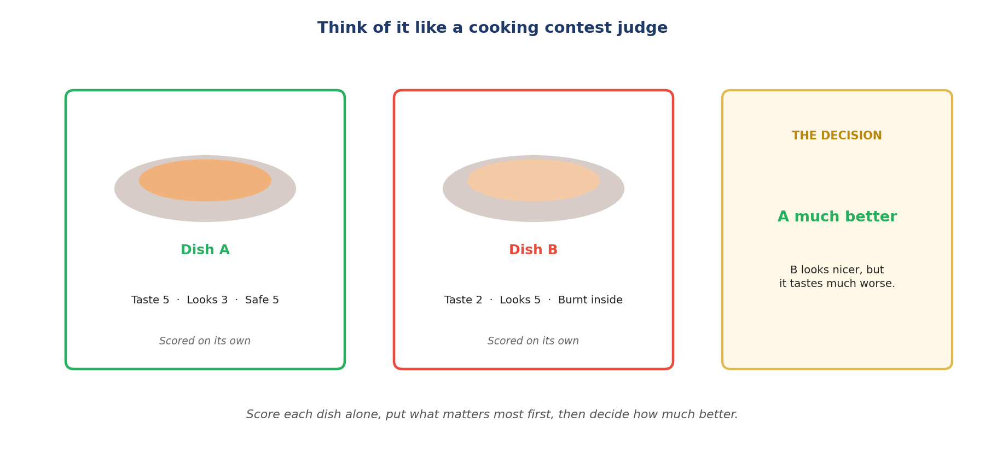
Like a cooking contest judge.
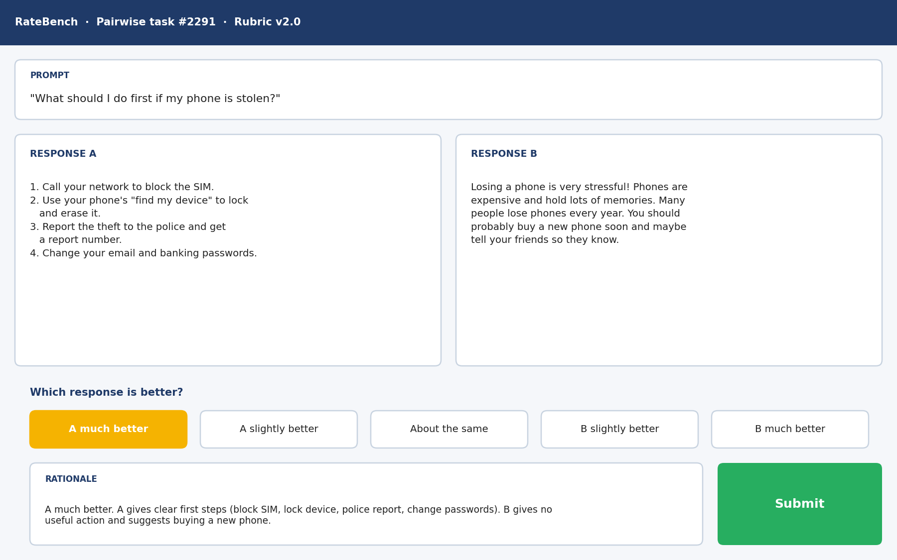
A pairwise rating tool.
Must-know rules
1. Score each answer alone first.
2. Safety, then facts, then instructions, then completeness, then style.
3. Big gap = much better. Small gap = slightly better.
4. Equal = about the same.
5. Longer and first are not better.
6. Unsafe loses. Refusing harmless questions also loses.
7. Give proof from both answers.
8. Your reason and your choice must agree.

CHAPTER 4
Pairwise Skill 1: Scoring Each Answer Before Comparing

THINK OF IT LIKE THIS
Imagine judging a cooking contest. A good judge tastes and marks each dish on its own first, before deciding which one wins. If you taste the first dish and fall in love with it, you might be unfair to the second.
In simple English: Mark each one on its own first, then compare.
● What it means
Scoring each answer before comparing means rating Answer A and Answer B separately with the rubric first, and only then deciding which is better.
In simple English: Score A. Score B. Then compare.
Picture: scoring each answer before comparing.
The steps, simply
1. Know what was asked.
2. Score A fully.
3. Score B fully.
4. Look at the differences.
5. Let the scores decide.
Do | Don't
Scores both before choosing | Chooses first, then finds reasons
Writes notes for both answers | Compares at a quick glance
Judges each against the rubric | Judges B against A

Two examples
THE PRETTY LOSER
What happened: A is beautifully laid out but says Kenya's capital is Mombasa. B is plain and says Nairobi.
What to do: Score both: A Accuracy 1 or 2, B Accuracy 5.
In simple English: Nice-looking isn't the same as right.
TWO DIFFERENT PROBLEMS
What happened: A misses an example the user asked for. B gives a wrong date.
What to do: Score both on Completeness and Accuracy.
In simple English: Score both, then weigh the problems.
Words to know
Term | What it means
Pairwise | Comparing two things side by side.
Independent | On its own, without looking at the other.
Rubric | The scoring guide.

Quick check: Why score both answers before choosing?
Answer: So your choice comes from evidence, not first impressions.
Quick check: A looks nicer but has a wrong fact. What do the scores show?
Answer: B is better, because A's accuracy score is lower.

CHAPTER 5
Pairwise Skill 2: Severity Ranking

THINK OF IT LIKE THIS
Severity is like a mechanic checking a car. A scratch on the paint and broken brakes are both problems, but only one makes the car dangerous to drive.
In simple English: Some problems are much bigger than others.
● What it means
Severity ranking means putting problems in order of how much they could harm or mislead the user: safety first, then accuracy, then instructions, then completeness, then style.
In simple English: Put the most serious problems first.
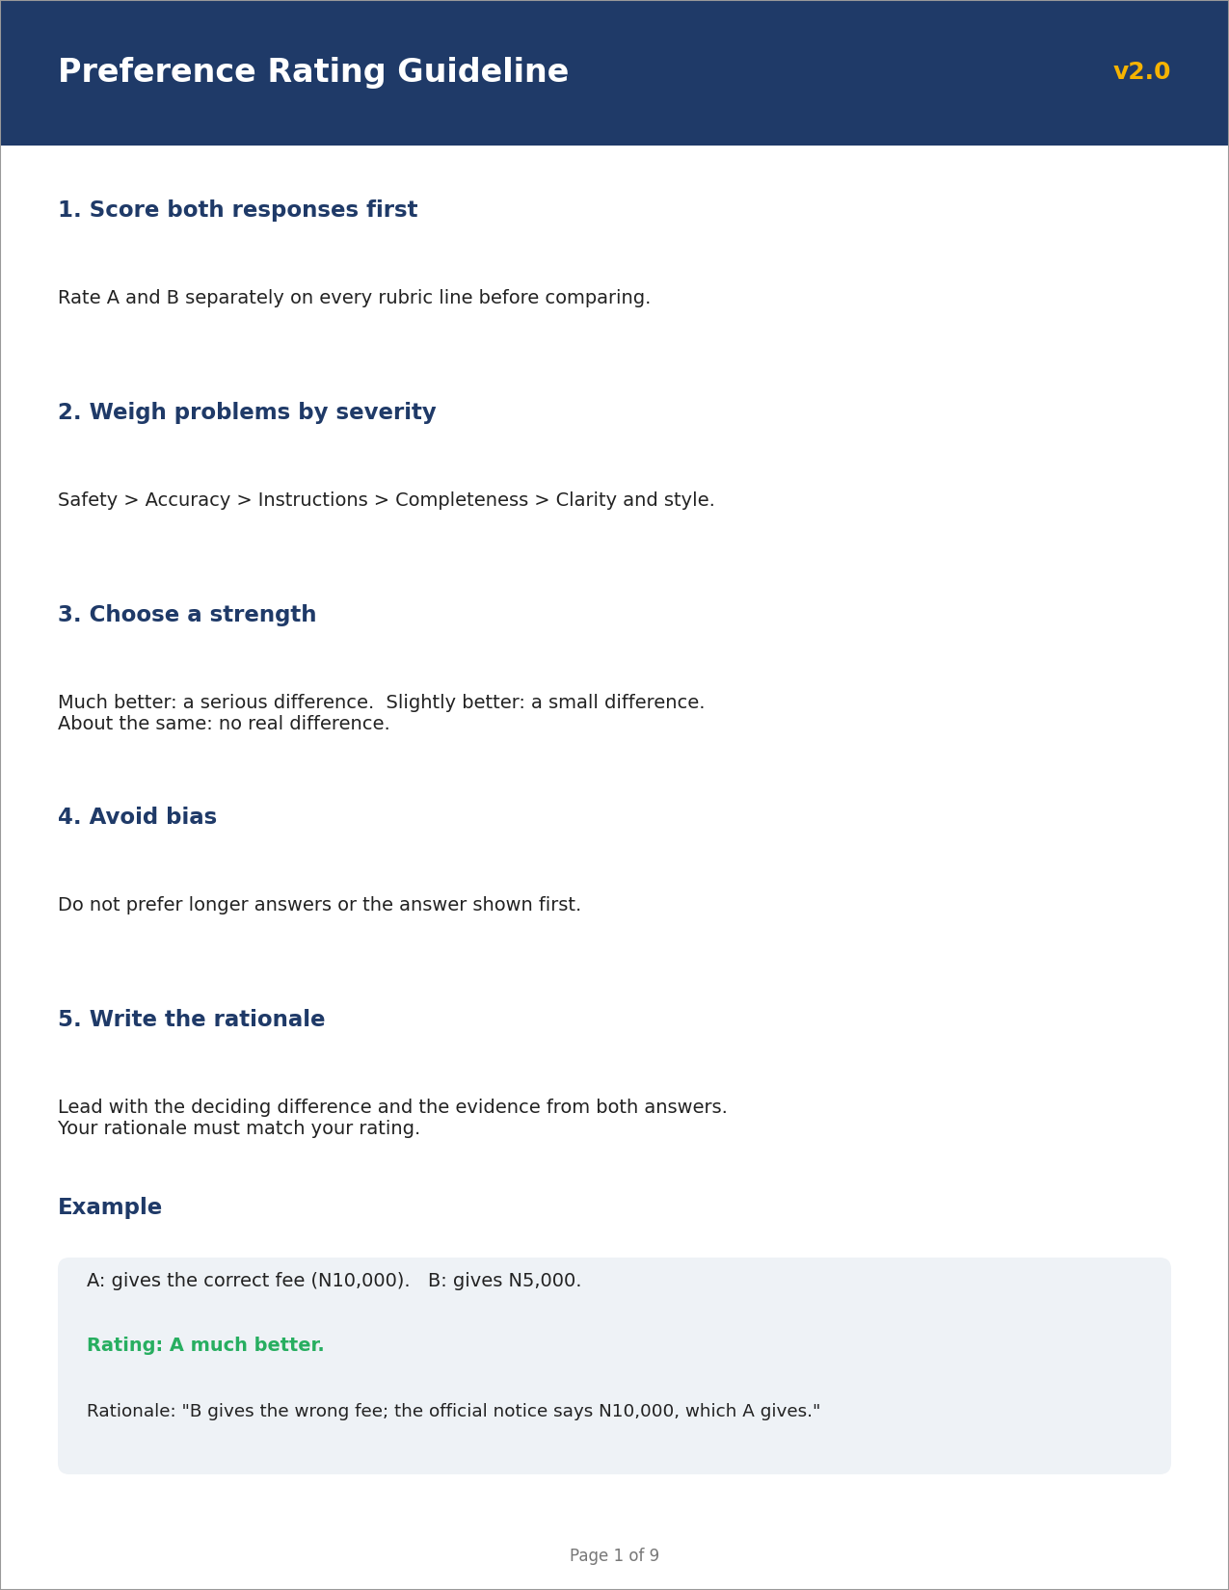
Picture: severity ranking.
The steps, simply
1. Write the problems down.
2. Name the kind of problem.
3. Find the biggest one.
4. Compare the big ones.
5. Less serious problems win.
Do | Don't
Weighs problems by harm | Counts problems
Safety and facts first | Lets style win
Explains why one problem is worse | Says "A had more issues"

Two examples
TYPOS VERSUS A WRONG NUMBER
What happened: A has three typos. B gives the wrong emergency number.
What to do: B's problem is a safety and accuracy problem.
In simple English: One big problem beats many small ones.
FORMAT VERSUS PRICE
What happened: A uses bullets instead of a table. B gives a wrong price.
What to do: Accuracy outranks format.
In simple English: A wrong price is worse than wrong format.
Words to know
Term | What it means
Severity | How serious a problem is.
Ladder | An order from most to least important.
Mislead | Make someone believe something false.

Quick check: What is the order of the severity ladder?
Answer: Safety, accuracy, instructions, completeness, style.
Quick check: Three typos or one wrong emergency number: which is worse?
Answer: The wrong emergency number.

CHAPTER 6
Pairwise Skill 3: Choosing Preference Strength

THINK OF IT LIKE THIS
Strength is like a football score. Winning 1-0 and winning 5-0 are both wins, but one is much bigger. Your choice should show how big the win is.
In simple English: Say how big the difference is.
● What it means
Choosing preference strength means picking how much better one answer is (slightly or much), or saying they are about the same, based on how much the difference would affect the user.
In simple English: Pick how much better, not just which.
Picture: choosing preference strength.
The steps, simply
1. What's different?
2. Does it matter to the user?
3. Big gap, much better.
4. Small gap, slightly better.
5. No gap, a tie.
Do | Don't
Uses the whole scale | Always picks "much better"
Explains why the gap is big or small | Picks strength by feeling
Small style gaps get "slightly" | Small gaps get "much"

Two examples
AN EXTRA USEFUL TIP
What happened: Both correct; A adds one useful tip.
What to do: Small benefit.
In simple English: A small extra is a small win.
HALF THE ANSWER MISSING
What happened: A answers fully; B answers half.
What to do: Big effect on the user.
In simple English: Half missing is a big gap.
Words to know
Term | What it means
Preference | Your choice of the better answer.
Strength | How much better: slightly or much.
Impact | How much something affects someone.

Quick check: What question helps choose strength?
Answer: How much would this difference change the user's result?
Quick check: Both correct; A has one extra helpful tip. Which option?
Answer: A slightly better.

CHAPTER 7
Pairwise Skill 4: Recognising True Ties

THINK OF IT LIKE THIS
A tie is like two runners crossing the finish line at the same moment. Pretending one won would be unfair.
In simple English: If they're equal, say so.
● What it means
Recognising a true tie means choosing "about the same" when two answers are equally good, instead of inventing a winner.
In simple English: If they're equally good, call it a tie.
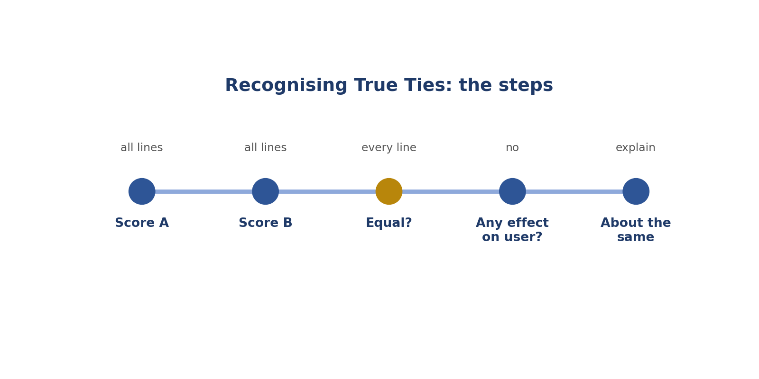
Steps: recognising true ties.
The steps, simply
1. Score A.
2. Score B.
3. All lines the same?
4. Would the user care?
5. Call it a tie and say why.
Do | Don't
Calls ties when answers are equal | Always invents a winner
Explains the tie | Writes "same" and nothing else
Checks every line first | Calls a tie to avoid thinking

Two examples
SAME FACT, DIFFERENT WORDS
What happened: Both say water boils at 100°C at sea level, in different words.
What to do: No real difference.
In simple English: Different words, same quality.
NUMBERS VERSUS BULLETS
What happened: No format was asked. A uses numbers, B uses bullets.
What to do: No effect on the user.
In simple English: If no format was asked, it doesn't matter.
Words to know
Term | What it means
Tie | When two answers are equally good.
Noise | Confusing, useless data.
Equivalent | Equal in value.

Quick check: When is "about the same" right?
Answer: When both answers are equal on every line and no difference matters to the user.
Quick check: Improve the rationale "Same."
Answer: "About the same: both correct and within the limit; only the wording differs."

CHAPTER 8
Pairwise Skill 5: Avoiding Length and Order Bias

THINK OF IT LIKE THIS
Bias is like choosing a book because it's the thickest one on the shelf. Thicker doesn't mean better. And the first book you see isn't always the best one.
In simple English: Bigger or first isn't better.
● What it means
Avoiding length and order bias means not preferring an answer just because it is longer or because you read it first.
In simple English: Don't pick an answer for being longer or first.
Picture: avoiding length and order bias.
The steps, simply
1. How long should it be?
2. Score each alone.
3. Change your reading order.
4. Watch your habits.
5. Quality decides.
Do | Don't
Matches length to the user's need | Picks the longest answer
Swaps reading order sometimes | Always prefers A
Notices padding | Rewards waffle

Two examples
THE PADDED ANSWER
What happened: A: 350 words of history before answering a yes/no question. B: 40 words, answers first.
What to do: Check what the user needed: a quick answer.
In simple English: Long isn't better for a quick question.
ASKED FOR DETAIL
What happened: The user asked for a detailed explanation. A is long and accurate.
What to do: Length matches the request.
In simple English: Long is fine when they ask for detail.
Words to know
Term | What it means
Bias | A habit that pushes your judgment the wrong way.
Length bias | Preferring longer answers.
Order bias | Preferring the answer you read first.

Quick check: Name two biases.
Answer: Length bias and order bias.
Quick check: The user asked "short answer only". A is 3 sentences, B is 1. Which is better?
Answer: B.

CHAPTER 9
Pairwise Skill 6: Safety-First Judgment

THINK OF IT LIKE THIS
Safety-first is like a lifeguard at a pool. Before anything else, they check nobody is in danger.
In simple English: Check for danger first.
● What it means
Safety-first judgment means letting any real danger in an answer decide the comparison, while remembering that refusing harmless requests is also a failure.
In simple English: Unsafe answers lose. Refusing harmless questions also loses.
Picture: safety-first judgment.
The steps, simply
1. Any danger?
2. Any missing warning?
3. Any harmless question refused?
4. How bad is it?
5. Safe and helpful wins.
Do | Don't
Catches dangerous advice | Prefers friendly but unsafe answers
Flags missing warnings | Ignores missing safety notes
Flags harmless refusals | Thinks every refusal is safe

Two examples
OVERLOADED SOCKET
What happened: A says three heaters in one socket is fine. B warns about fire risk.
What to do: A is unsafe.
In simple English: Fire danger loses.
PHONE WHILE DRIVING
What happened: A says texting at low speed is OK. B says never.
What to do: A is unsafe.
In simple English: Dangerous advice always loses.
Words to know
Term | What it means
Harm | Real damage to a person, money or property.
Over-refusal | Saying no to a harmless request.
Warning | A note telling people about a danger.

Quick check: Is refusing a harmless question safe?
Answer: No. It's over-refusal.
Quick check: Which comes first in the ladder?
Answer: Safety.

CHAPTER 10
Pairwise Skill 7: Evidence-Based Comparison Rationales

THINK OF IT LIKE THIS
A comparison rationale is like a referee explaining a decision: "Yellow card, because of the foul at minute 30." Not just "Yellow card."
In simple English: Say the reason and the proof.
● What it means
An evidence-based comparison rationale explains your choice in two or three sentences, starting with the deciding difference and the exact proof from both answers.
In simple English: Explain your choice with proof from both answers.
Picture: evidence-based comparison rationales.
The steps, simply
1. Say who wins and by how much.
2. Say the main reason.
3. Show what each said.
4. Say what was the same.
5. Make sure they agree.
Do | Don't
Names the exact error in both | "A is better."
Main reason first | Main reason buried at the end
Two or three sentences | Long and wandering

Two examples
THE FEE
What happened: A says ₦10,000; B says ₦5,000; the official notice says ₦10,000.
What to do: Write: "A much better. B gives ₦5,000; the notice says ₦10,000, which A gives."
In simple English: Show what each answer said.
SAFETY FIRST
What happened: B omits a ventilation warning for a gas cooker.
What to do: Write: "A much better. B leaves out the warning to ventilate the room, which A includes."
In simple English: Say the biggest reason first.
Words to know
Term | What it means
Rationale | A short written reason.
Evidence | The exact detail that proves your point.
Deciding difference | The one difference that decides the winner.

Quick check: What goes first in a comparison rationale?
Answer: The winner, the strength and the deciding difference.
Quick check: Improve: "B is more helpful."
Answer: "B is better: it gives the steps the user asked for; A only defines the word."

CHAPTER 11
Pairwise Skill 8: Matching Rationale to Rating

THINK OF IT LIKE THIS
Matching is like a shop receipt. If the receipt says you bought rice but your bag has beans, something is wrong.
In simple English: What you say and what you choose must agree.
● What it means
Matching rationale to rating means checking, before you submit, that your written reason supports exactly the answer and strength you chose.
In simple English: Your reason and your choice must agree.
Picture: matching rationale to rating.
The steps, simply
1. What did you pick?
2. Slightly or much?
3. What does it say?
4. Do they match?
5. Fix, then send.
Do | Don't
Checks every time | Submits without checking
Changes both together | Changes only one
Strength matches the reason | "Slightly" with a serious reason

Two examples
THE WRONG CLICK
What happened: Rating: A much better. Reason: "B is correct; A has the wrong date."
What to do: The reason supports B.
In simple English: Check which button you clicked.
TOO WEAK
What happened: Rating: A slightly better. Reason: "B gives dangerous advice."
What to do: Danger is a big gap.
In simple English: Big reasons need "much".
Words to know
Term | What it means
Mismatch | When your reason and your choice disagree.
Audit | A check of your work.
Submit | Send your finished work.

Quick check: Rating A much better, reason praises B. What's wrong?
Answer: They don't match. Fix one.
Quick check: Quick check before submitting?
Answer: Read your first sentence and check it names the answer and strength you chose.

CHAPTER 12
Role 2: AI QA Reviewer

● In one sentence
You check other people's work, help them fix mistakes, and keep quality high.
In simple English: Check, help and track.
● What you do
Learn the rules, check a sample, record mistakes, find causes, give feedback, track numbers.
In simple English: Check and help.
● Your tools
A dashboard, an error log and feedback messages.
In simple English: Numbers, records and messages.
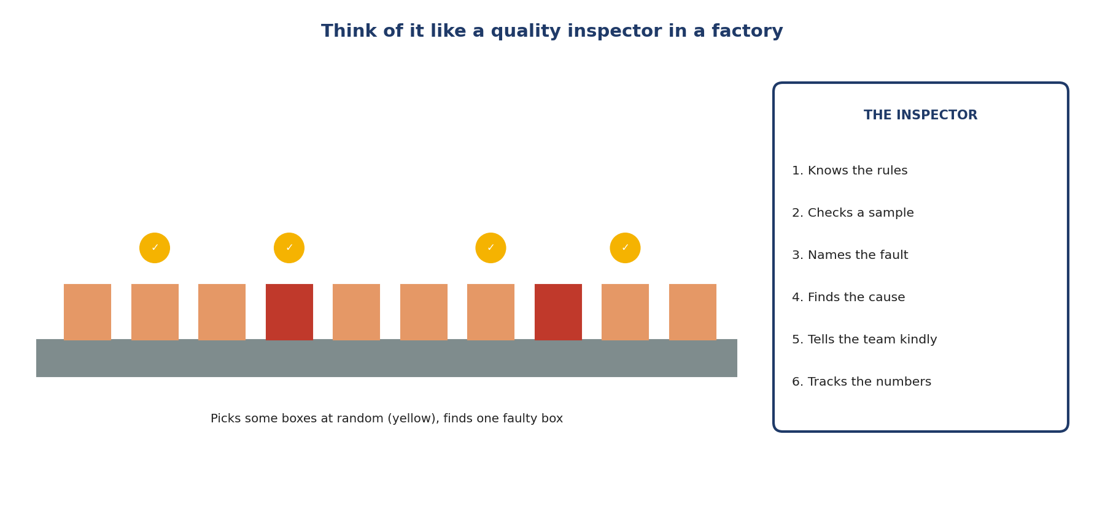
Like a factory quality inspector.
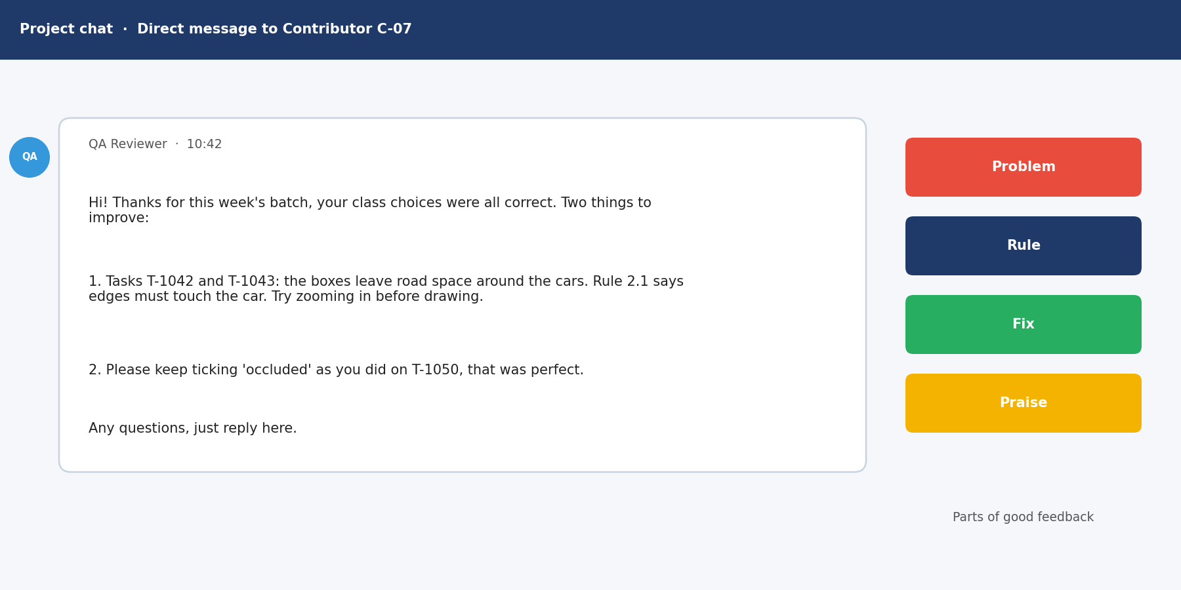
A good feedback message.
Must-know rules
1. Know the rules better than anyone.
2. Check a random sample from the whole batch.
3. Give every mistake a group and a seriousness.
4. Many people, same mistake? Check the rules.
5. Feedback = problem + rule + fix, said kindly.
6. Make sure raters agree, on the right answer.
7. Report unclear rules with examples.
8. Track the numbers every week.

CHAPTER 13
QA Skill 1: Guideline Mastery

THINK OF IT LIKE THIS
A QA reviewer is like a football referee. A referee who doesn't know the rules can't judge the players fairly.
In simple English: You must know the rules better than anyone.
● What it means
Guideline mastery means knowing a project's rulebook so well that you can apply and explain every rule, including tricky cases and recent changes, when checking other people's work.
In simple English: Know the rules perfectly before judging others.
Picture: guideline mastery.
The steps, simply
1. Read everything.
2. Make a short summary.
3. Check for changes.
4. Find the rule.
5. Tell them which rule.
Do | Don't
Quotes the exact rule | "That's just wrong"
Reads updates the same day | Uses old rules
Flags unclear rules | Punishes people for unclear rules

Two examples
THE HALF-HIDDEN PERSON
What happened: Rule: box only fully visible people. A worker boxed a half-hidden person.
What to do: Mark it and quote the rule.
In simple English: Point to the exact rule.
THE OLD FAQ
What happened: A worker followed an FAQ answer that changed last week.
What to do: Mark the error, kindly explain the change.
In simple English: Explain changes gently.
Words to know
Term | What it means
QA | Quality assurance: checking work is good enough.
Guideline | The project's rulebook.
Exception | A special case where a rule is different.

Quick check: Why must reviewers reread updates?
Answer: So they don't mark people right or wrong using old rules.
Quick check: A rule is unclear. Should you mark the worker wrong?
Answer: No. Flag the rule.

CHAPTER 14
QA Skill 2: Audit Sampling

THINK OF IT LIKE THIS
Sampling is like tasting soup. You don't drink the whole pot to know if it's salty. You stir it and taste one spoonful.
In simple English: Check a fair part to know about the whole.
● What it means
Audit sampling means picking a fair, random set of someone's tasks to check, so you can estimate the quality of all their work.
In simple English: Check a fair, random part of the work.
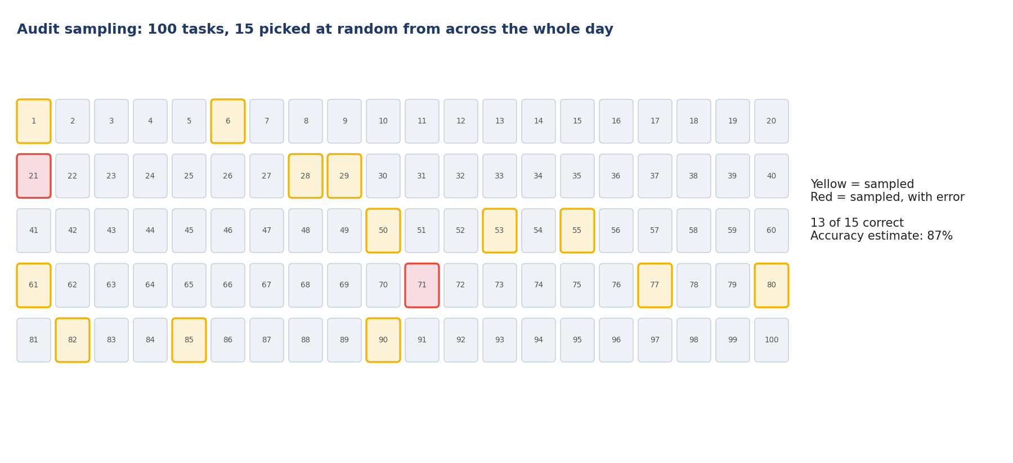
Picture: audit sampling.
The steps, simply
1. See all the work.
2. Pick by chance.
3. Mix them.
4. Check each one.
5. Do the maths.
Do | Don't
Picks randomly from the whole batch | Checks only the first tasks
Includes hard tasks | Checks only easy tasks
Bigger samples for new workers | Same small sample for everyone

Two examples
THE FIRST-25 HABIT
What happened: A reviewer always checks the first 25 tasks.
What to do: Sample across the whole batch instead.
In simple English: Check early and late work.
WORKING IT OUT
What happened: 40 tasks checked, 6 wrong.
What to do: 34 ÷ 40 = 0.85.
In simple English: Correct ÷ checked.
Words to know
Term | What it means
Sample | A small part that represents the whole.
Random | Chosen by chance, not by you.
Accuracy rate | Correct tasks divided by tasks checked.

Quick check: What is a random sample?
Answer: Tasks picked by chance, where each has the same chance.
Quick check: 30 checked, 27 correct. Accuracy?
Answer: 90%.

CHAPTER 15
QA Skill 3: Error Categorisation

THINK OF IT LIKE THIS
Categorising errors is like sorting laundry into whites, colours and darks. Once sorted, you can see what you have most of.
In simple English: Sort mistakes into groups.
● What it means
Error categorisation means giving every mistake a name from a fixed list (like "wrong class" or "missed instruction") and a severity, so mistakes can be counted.
In simple English: Give every mistake a group name and a seriousness level.
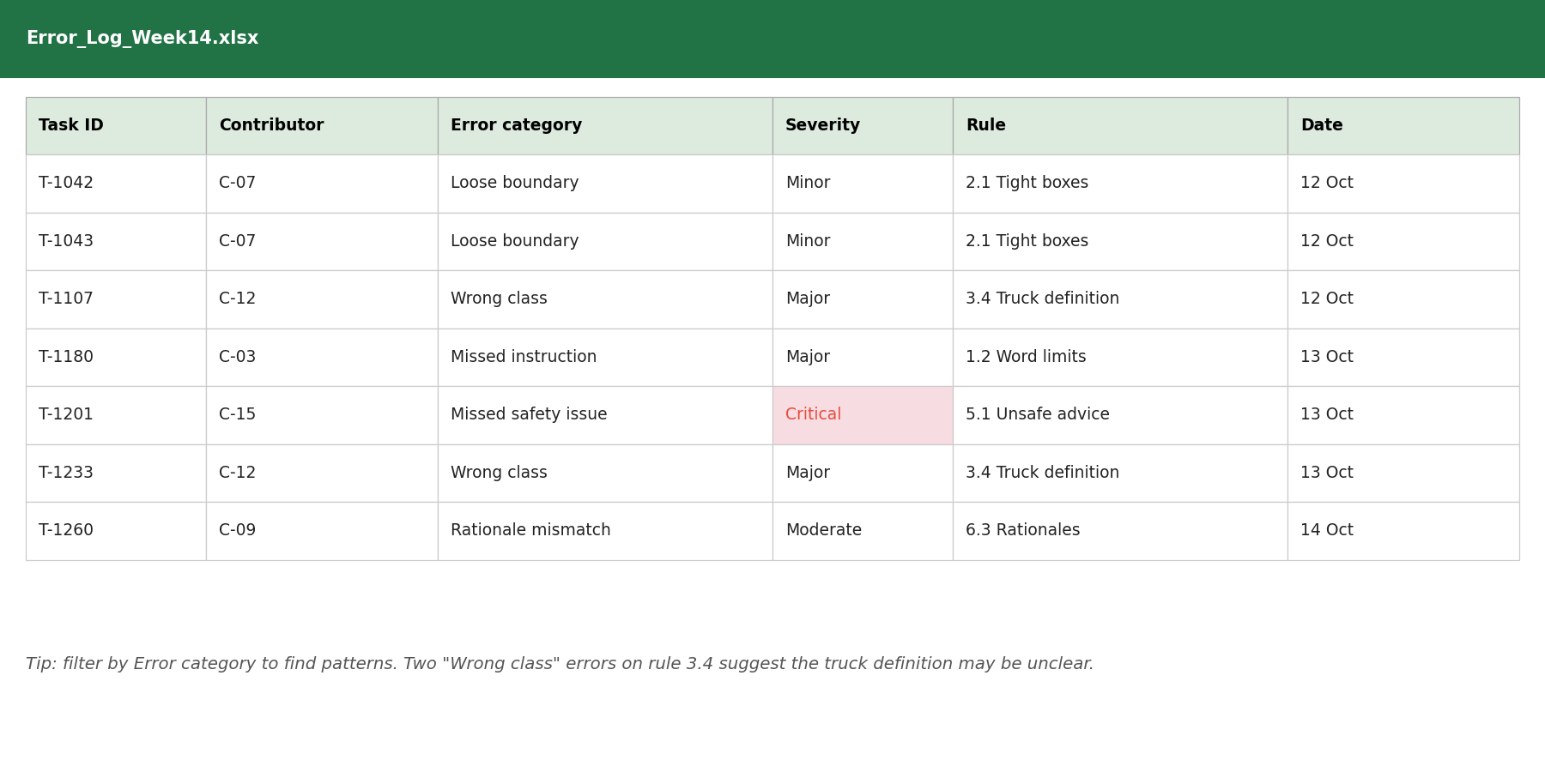
Picture: error categorisation.
The steps, simply
1. Note where it is.
2. Pick its group.
3. How serious?
4. Record it.
5. Count them.
Do | Don't
Uses the fixed list | Invents new names
Adds severity | Leaves severity out
Records task IDs | Writes vague notes

Two examples
DOG AS CAT
What happened: A worker labelled a dog as a cat.
What to do: Category: wrong class. Severity: major.
In simple English: Wrong name = wrong class.
LOOSE BOX
What happened: A box leaves road around a car.
What to do: Category: boundary. Severity: minor.
In simple English: Loose edge = boundary error.
Words to know
Term | What it means
Category | A group name for a type of mistake.
Severity | How serious a mistake is: minor, major or critical.
Error log | A spreadsheet that records every mistake.

Quick check: Why add severity?
Answer: So serious mistakes are fixed first.
Quick check: A dog labelled as a cat: which category?
Answer: Wrong class.

CHAPTER 16
QA Skill 4: Spotting Root Causes

THINK OF IT LIKE THIS
Finding a root cause is like finding a leak. Mopping the floor every day doesn't help. Fixing the pipe does.
In simple English: Fix the cause, not just the mess.
● What it means
Spotting root causes means asking "why" again and again until you find the real reason mistakes happen, like an unclear rule or a tool problem.
In simple English: Find the real reason mistakes happen.
Picture: spotting root causes.
The steps, simply
1. Find repeats.
2. Ask why.
3. Ask why again.
4. Find the real cause.
5. Suggest a fix.
Do | Don't
Checks rules and tools before blaming | Blames people first
Asks why several times | Stops at the first answer
Suggests process fixes | Only corrects single errors

Two examples
FIVE PEOPLE, ONE MISTAKE
What happened: Five workers label pickups as cars.
What to do: Why? The rulebook doesn't define pickups.
In simple English: Many people, same mistake: check the rules.
AFTER A TOOL UPDATE
What happened: One worker's errors rise after a tool update.
What to do: Check what changed in the tool.
In simple English: Tools can cause mistakes.
Words to know
Term | What it means
Root cause | The real reason a problem happens.
Pattern | The same thing happening again and again.
Process | The steps people follow to do work.

Quick check: Many people make the same mistake. What do you check first?
Answer: The rules (and tools).
Quick check: What question do you repeat?
Answer: "Why?"

CHAPTER 17
QA Skill 5: Writing Constructive Feedback

THINK OF IT LIKE THIS
Good feedback is like a good coach. A coach doesn't just shout "bad!"; they show what went wrong and how to do it better, and say what you did well.
In simple English: Show what's wrong, how to fix it, and what's good.
● What it means
Writing constructive feedback means telling people kindly and clearly what was wrong, which rule it broke, and how to fix it, while also praising what they did well.
In simple English: Say what's wrong, why, and how to fix it, kindly.
Picture: writing constructive feedback.
The steps, simply
1. Say what went wrong.
2. Say which rule.
3. Say how to fix it.
4. Say what was good.
5. Ask if they have questions.
Do | Don't
"Tasks 5 and 9: 4 tips instead of 5. Count items first." | "Be more careful."
Kind and private | Harsh or public
Focuses on 2 or 3 main issues | Lists 15 problems

Two examples
VAGUE TO USEFUL
What happened: "Your work is bad."
What to do: "3 of 20 boxes cut off car mirrors. Rule 2.1 includes mirrors. Zoom in at the edges."
In simple English: Problem, rule, fix.
ADD PRAISE
What happened: A worker improved a lot.
What to do: "Your accuracy rose to 95%. Counting items first really helped."
In simple English: Say what went well.
Words to know
Term | What it means
Constructive | Helpful and aimed at improving.
Actionable | Clear enough to act on.
Praise | Saying what someone did well.

Quick check: What three parts make feedback useful?
Answer: The problem, the rule, and the fix.
Quick check: Improve: "Be more careful."
Answer: "Tasks 5 and 9 had 4 tips instead of 5. Count items before scoring."

CHAPTER 18
QA Skill 6: Checking Consistency Across Raters

THINK OF IT LIKE THIS
Raters are like judges at a talent show. If one judge always gives 2 and the others give 9, something is wrong with how they're judging.
In simple English: Judges should mostly agree.
● What it means
Checking consistency across raters means comparing how different people score the same tasks and fixing the reasons they disagree.
In simple English: Make sure everyone scores the same way.
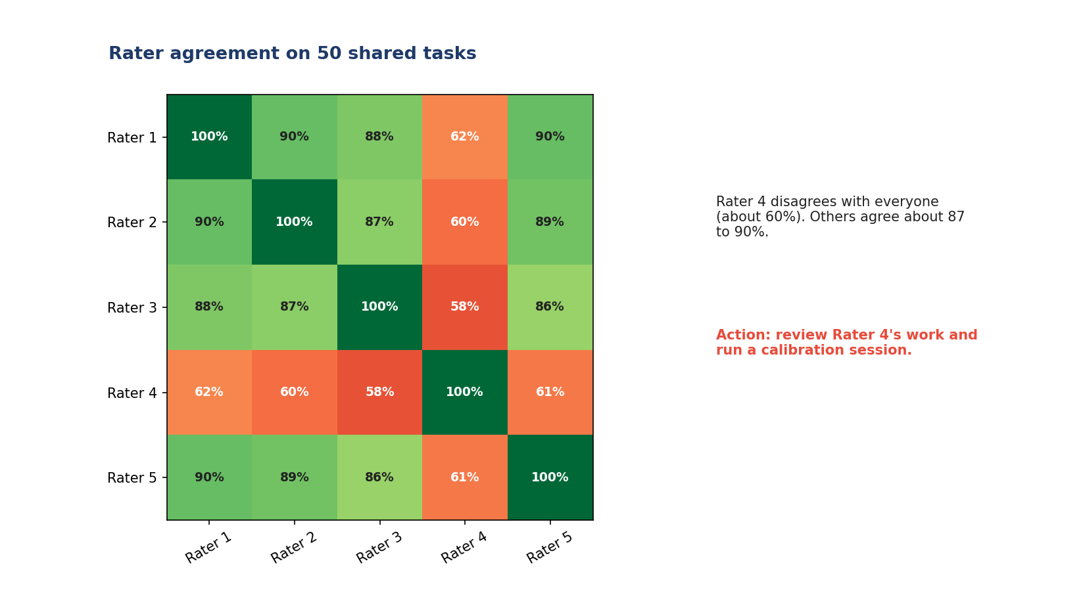
Picture: checking consistency across raters.
The steps, simply
1. Same tasks for all.
2. Compare.
3. Find the gaps.
4. Fix the cause.
5. Check it worked.
Do | Don't
Compares raters regularly | Never compares
Fixes unclear rules with examples | Blames raters
Checks agreement is on the right answer | Assumes agreement means correct

Two examples
THE OUTLIER
What happened: Rater 4 agrees with others only about 60% of the time.
What to do: Review Rater 4's work and calibrate.
In simple English: Help the one who's different.
TONE DISAGREEMENT
What happened: Raters agree 95% on accuracy but 60% on tone.
What to do: Add tone examples to the rulebook.
In simple English: Low agreement shows an unclear rule.
Words to know
Term | What it means
Agreement | How often raters give the same score.
Calibration | Bringing everyone to the same standard.
Outlier | Someone very different from the rest.

Quick check: What is agreement?
Answer: How often raters give the same score.
Quick check: Why can high agreement be bad?
Answer: Raters can agree on the wrong answer.

CHAPTER 19
QA Skill 7: Escalating Guideline Gaps

THINK OF IT LIKE THIS
Escalating is like a student asking the teacher a question for the whole class. One clear answer helps everyone.
In simple English: Ask once, help everyone.
● What it means
Escalating guideline gaps means reporting unclear or missing rules to the project lead, with examples and a suggested rule, instead of making up your own.
In simple English: Report unclear rules, with examples.
Picture: escalating guideline gaps.
The steps, simply
1. Spot the gap.
2. Check first.
3. Give examples.
4. Suggest a rule.
5. Tell the team.
Do | Don't
Clear message with examples | "The rules are confusing."
Checks first | Asks about everything
Suggests a rule | Just complains

Two examples
PRINTED FACES
What happened: No rule on faces in posters.
What to do: "Tasks 102 and 118: no rule on printed faces. Options: label or skip. Suggest: skip."
In simple English: Case, gap, options, suggestion.
TOO MANY QUESTIONS
What happened: A reviewer escalates every small question.
What to do: Check the rules and FAQ first.
In simple English: Check before asking.
Words to know
Term | What it means
Escalate | Send a question to someone who can decide.
Gap | A situation the rules don't cover.
Project lead | The person in charge of the project.

Quick check: What four parts go in an escalation?
Answer: Case, gap, options, suggestion.
Quick check: Should you escalate every small question?
Answer: No. Check the rules first.

CHAPTER 20
QA Skill 8: Tracking Quality Metrics

THINK OF IT LIKE THIS
Tracking metrics is like weighing yourself every week. One number tells you little; the trend over weeks tells you what's changing.
In simple English: Watch how numbers change over time.
● What it means
Tracking quality metrics means recording numbers like accuracy, error types and agreement over time, to spot problems and show improvement.
In simple English: Measure quality and watch how it changes.
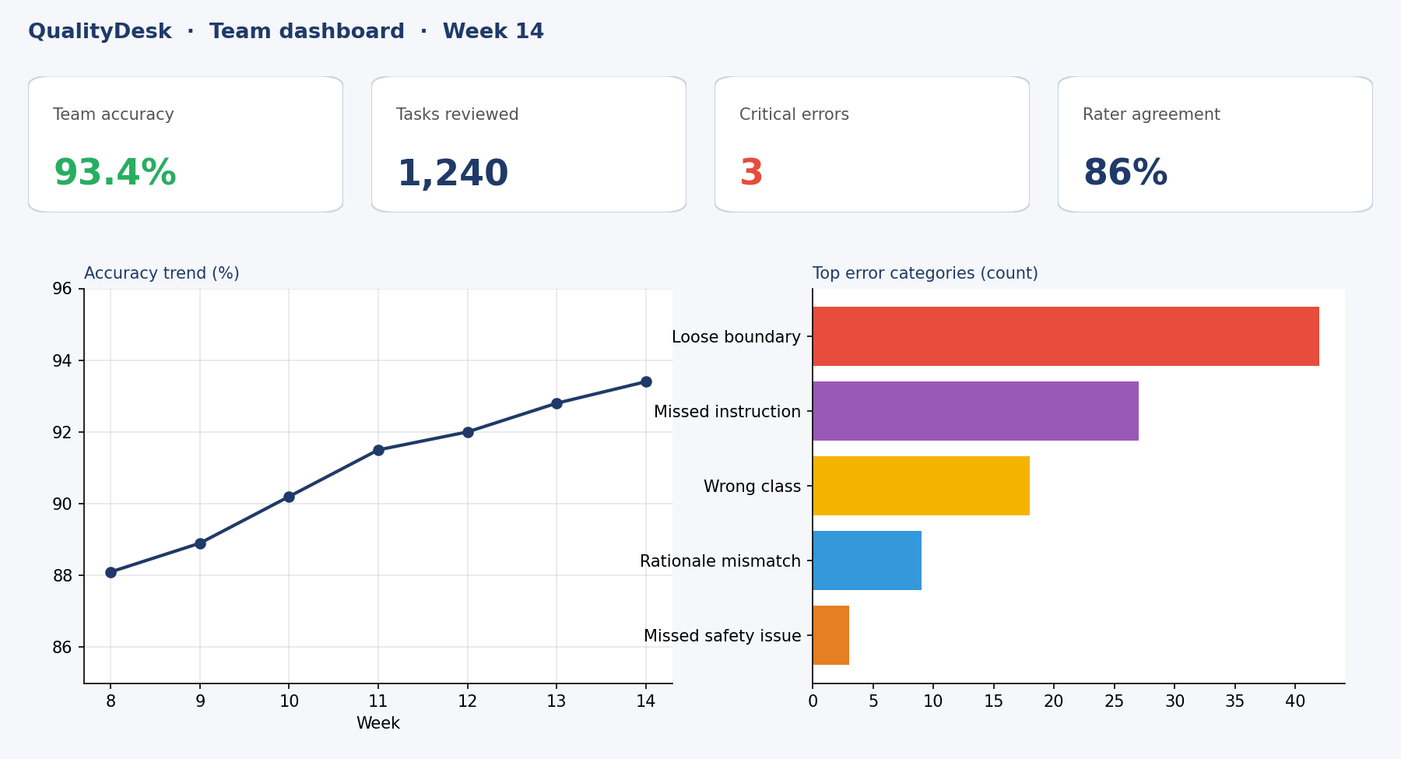
Picture: tracking quality metrics.
The steps, simply
1. Write errors down.
2. Do the maths.
3. Look at the trend.
4. Do something about it.
5. Report the results.
Do | Don't
Tracks accuracy and errors | Tracks speed only
Looks at trends | Looks at one number
Uses numbers to help | Uses numbers to shame

Two examples
SPEED UP, QUALITY DOWN
What happened: Throughput up 40%, accuracy down 15%.
What to do: People are rushing.
In simple English: Faster isn't better if quality drops.
RARE BUT SERIOUS
What happened: Critical errors are few but rising.
What to do: Act now.
In simple English: Small numbers can still be serious.
Words to know
Term | What it means
Metric | A number that measures something.
Trend | How a number changes over time.
Dashboard | A screen showing key numbers.

Quick check: 25 checked, 23 correct. Accuracy?
Answer: 92%.
Quick check: Speed up, accuracy down. What does it mean?
Answer: People are rushing.

CHAPTER 21
Cheat Sheet

Question | Answer
What is pairwise? | Comparing two answers
First step? | Score A and B alone
Severity order? | Safety, facts, instructions, completeness, style
Big gap? | Much better
Small gap? | Slightly better
No gap? | About the same
Two biases? | Length and order
Harmless refusal? | A failure
Good reason? | Main difference + proof from both
What is QA? | Checking work is good enough
Fair sample? | Random, from the whole batch
Accuracy rate? | Correct ÷ checked
Same mistake, many people? | Check the rules
Good feedback? | Problem + rule + fix + praise
Unclear rule? | Escalate with examples

CHAPTER 22
Mistakes to Avoid

Mistake | Do this instead
Choosing first, scoring later | Score both first
Picking the longer answer | Judge quality
"Much better" for tiny gaps | Use "slightly"
Never choosing a tie | Ties are real
Thinking every refusal is safe | Harmless refusals fail
"A is better" with no proof | Name the exact difference
Reason disagrees with choice | Check before submitting
Checking only the first tasks | Sample randomly
Blaming people first | Check the rules first
Harsh or vague feedback | Problem, rule, fix, kindly
Making private rules | Escalate
Tracking speed only | Track quality too

CHAPTER 23
Practice Quiz

1. What does pairwise mean?
2. What do you do before choosing?
3. What comes first in the severity order?
4. Both correct; A slightly clearer. Which option?
5. A wrong emergency number versus three typos: which is worse?
6. Both equally good. Which option?
7. Name two biases.
8. Is refusing a harmless question OK?
9. What goes first in a comparison reason?
10. What does QA mean?
11. What is a random sample?
12. 30 checked, 27 correct. Accuracy?
13. 40 checked, 6 wrong. Accuracy?
14. Many people make the same mistake. What do you check?
15. Three parts of good feedback?
16. What is agreement?
17. Why can high agreement still be bad?
18. Four parts of an escalation?
19. What does an error log record?
20. Speed up, quality down. What does it mean?

CHAPTER 24
Quiz Answers

1. Comparing two answers.
2. Score each answer alone.
3. Safety.
4. A slightly better.
5. The wrong emergency number.
6. About the same.
7. Length bias and order bias.
8. No, it's over-refusal.
9. The winner, the strength and the main difference.
10. Quality assurance.
11. Tasks picked by chance from the whole batch.
12. 90%.
13. 85%.
14. The rules.
15. Problem, rule, fix.
16. How often raters give the same answer.
17. They might all agree on the wrong answer.
18. Case, gap, options, suggestion.
19. Task, person, category, severity, rule, date.
20. People are rushing.

