Day 2 Task Bank
320 tasks: 20 for each of the 16 Day 2 skills, explained so anyone can understand
The situation · What is this asking? · Answer · Why, explained simply · Key word · In simple English
CHAPTER 1
How to Use This Task Bank

This task bank has 320 practice tasks: 20 for each of the 16 Day 2 skills. Chapters 1 to 8 are Pairwise skills. Chapters 9 to 16 are QA Reviewer skills. Each task is marked Easy, Medium or Hard.
In simple English: 320 tasks, 20 for every skill.
Part | What it tells you
The situation | The answers, rule or work you are looking at
What is this asking? | The question in plain, everyday words
Your task | Exactly what you must decide
Answer | The correct answer
Why (explained simply) | The reason, explained so anyone can follow
Key word | One important word and what it means
In simple English | The whole lesson in one short line

How to practise
1. Cover everything below "Your task".
2. Read the situation and the plain-words question.
3. Write your own answer.
4. Uncover and compare.
5. Read "Why" even if you were right.
6. Learn the key word.
A worked walk-through
EXAMPLE TASK · EASY
The situation: Prompt: "What is 10 + 15?" A: "25." B: "25. Ten plus fifteen equals twenty-five."
What is this asking? Which answer is better, and by how much?
Your task: Choose a preference and strength.
Answer: About the same. Both are correct; B just says it twice.
Why (explained simply): Both answers are right. Saying the same thing in words adds nothing important, so neither wins.
Key word: Tie = When two answers are equally good.
In simple English: Equal answers get "about the same".

CHAPTER 2
Pairwise Skill 1: Scoring Each Answer Before Comparing

THINK OF IT LIKE THIS
Imagine judging a cooking contest. A good judge tastes and marks each dish on its own first, before deciding which one wins. If you taste the first dish and fall in love with it, you might be unfair to the second.
In simple English: Mark each one on its own first, then compare.
In simple English: Score A. Score B. Then compare.
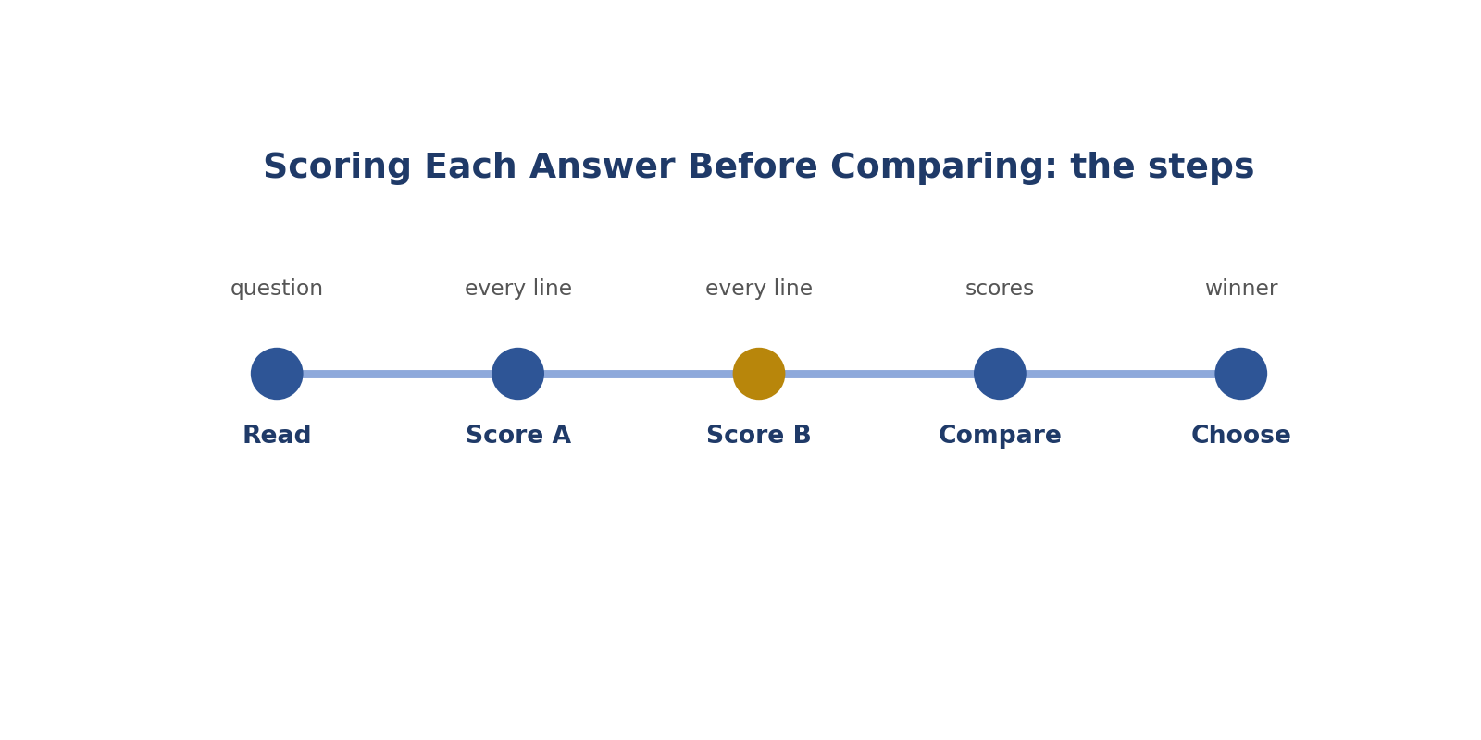
Scoring Each Answer Before Comparing: the steps.
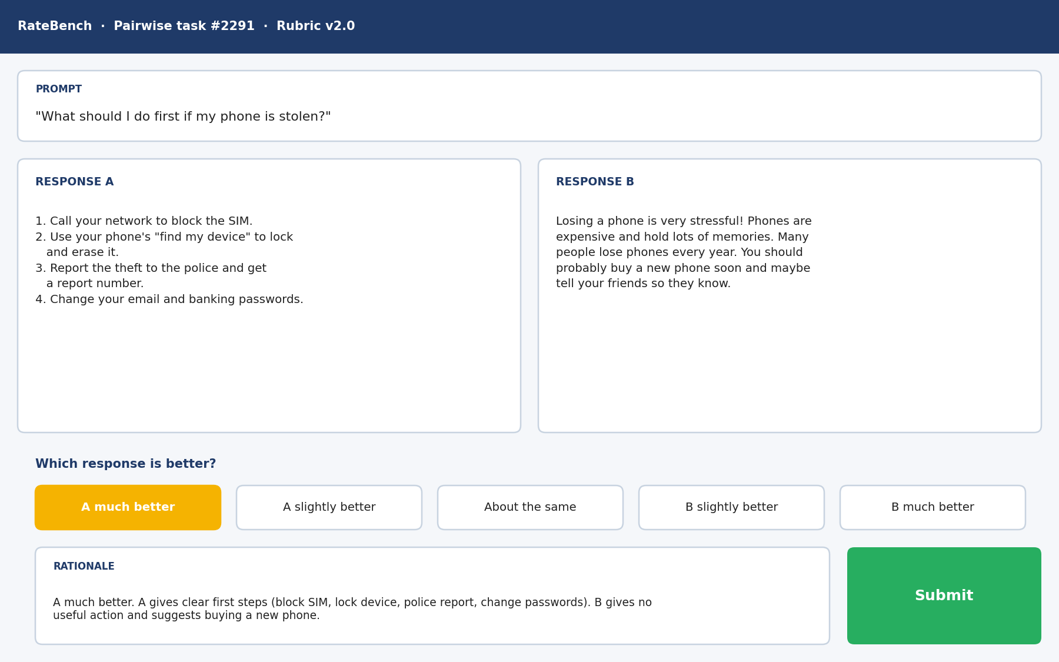
Picture: scoring each answer before comparing.
How to answer these tasks
1. Read the question and list what it asks.
2. Score Answer A on every rubric line.
3. Score Answer B on every rubric line.
4. Compare the two sets of scores.
5. Choose the winner from the scores.
TASK 1.1 · EASY
The situation: Prompt: "What is the capital of Kenya?" A: "Nairobi." B: "Mombasa."
What is this asking? Score each answer on its own.
Your task: Score each on Accuracy (1 to 5) before comparing.
Answer: A: 5 (correct). B: 1 or 2 (wrong capital). Then compare: A much better.
Why (explained simply): Nairobi is right, Mombasa is wrong. Scoring each one alone shows A wins clearly.
Key word: Accuracy = Being correct.
In simple English: Score each answer first, then compare.

TASK 1.2 · EASY
The situation: Prompt: "Give two tips for saving data on my phone." A gives two tips. B gives one tip.
What is this asking? Did each answer give two tips?
Your task: Score each on Completeness before comparing.
Answer: A: full marks for completeness. B: lower, because one tip is missing.
Why (explained simply): A gave both tips; B gave only one. So A scores higher for completeness.
Key word: Completeness = Answering every part.
In simple English: Check each answer against the request on its own.

TASK 1.3 · MEDIUM
The situation: A is long and friendly; B is short and plain. Both are correct.
What is this asking? What do you do before choosing?
Your task: What should you do before deciding which you prefer?
Answer: Score each on every rubric line separately. If both score the same on accuracy, instructions and completeness, the difference is only style.
Why (explained simply): Score both on every line. If the scores are equal, the only difference is style.
Key word: Style = How something looks or sounds.
In simple English: Score first so style doesn't fool you.

TASK 1.4 · MEDIUM
The situation: You read A first and it was excellent. B now seems worse by comparison.
What is this asking? Why does B suddenly look worse?
Your task: What is the risk, and how do you avoid it?
Answer: Contrast bias: B may be judged against A instead of the rubric. Score B on its own before comparing.
Why (explained simply): Because you compared it with A instead of the rubric. Score B on its own.
Key word: Contrast effect = Judging one thing against the thing before it.
In simple English: Judge each answer against the rubric, not the other answer.

TASK 1.5 · EASY
The situation: Prompt: "Translate 'thank you' into Yoruba." A: "E se." B: "Merci."
What is this asking? Which answer is in Yoruba?
Your task: Score each on Instruction following.
Answer: A follows the instruction (Yoruba). B is French, so it fails.
Why (explained simply): A ("E se") is Yoruba. B ("Merci") is French, so it ignores the instruction.
Key word: Instruction = What the user asked for.
In simple English: Each answer is checked against the instruction.

TASK 1.6 · MEDIUM
The situation: A: correct and complete, 2 minor typos. B: correct, complete, no typos.
What is this asking? Typos versus no typos?
Your task: Give each a Clarity score (1 to 5) and compare.
Answer: A: 4 (minor issues). B: 5. B slightly better.
Why (explained simply): A has small typos (4), B has none (5). Small gap, so B slightly better.
Key word: Minor issue = A small problem.
In simple English: Small score gaps mean small preferences.

TASK 1.7 · HARD
The situation: A and B each have one problem: A misses a requested example; B has a wrong date.
What is this asking? Which problem is worse?
Your task: Score both on Completeness and Accuracy, then decide.
Answer: A: Completeness lower, Accuracy high. B: Accuracy lower, Completeness high. Usually B's wrong date is more serious, so A is better, but name both problems.
Why (explained simply): A missed an example; B gave a wrong date. A wrong date is usually worse, so A wins.
Key word: Severity = How serious a problem is.
In simple English: Score both lines for both answers, then weigh.

TASK 1.8 · EASY
The situation: A rater writes their preference first, then scores the lines to match.
What is this asking? What's wrong with choosing first?
Your task: What's wrong with this order?
Answer: It reverses the method. Scores should lead to the preference, not the other way round.
Why (explained simply): The scores should lead to the choice, not the other way round.
Key word: Method = The right way of doing something.
In simple English: Score first, choose second.

TASK 1.9 · MEDIUM
The situation: Prompt: "List three Nigerian states in the north-east." A: Borno, Yobe, Adamawa. B: Borno, Kano, Lagos.
What is this asking? Are all three states in the north-east?
Your task: Score each on Accuracy.
Answer: A: all correct (all are north-east states). B: only Borno is correct; Kano is north-west and Lagos is south-west.
Why (explained simply): A's are (Borno, Yobe, Adamawa). B's Kano is north-west and Lagos is south-west.
Key word: Region = A part of a country.
In simple English: Check each item in each answer.

TASK 1.10 · EASY
The situation: Both answers say the same correct thing in different words.
What is this asking? Same fact, different words?
Your task: What will the scores likely show?
Answer: Equal scores on every line, which points to "about the same".
Why (explained simply): Equal scores everywhere, so it's a tie.
Key word: Tie = Equally good.
In simple English: Equal scores suggest a tie.

TASK 1.11 · MEDIUM
The situation: A answers the question but ignores the user's budget. B stays within the budget.
What is this asking? Which line shows the budget miss?
Your task: Which rubric line differs?
Answer: Instruction following: A misses the budget condition; B meets it.
Why (explained simply): Instruction following. A ignored the budget; B kept to it.
Key word: Budget = The most money you can spend.
In simple English: Find the line where they differ.

TASK 1.12 · HARD
The situation: A and B are both 4 on every line, but for different minor issues.
What is this asking? Both 4 everywhere for different small issues?
Your task: How do you decide?
Answer: Compare how much each minor issue would affect the user. If equal, choose "about the same"; if one is clearly more bothersome, "slightly better".
Why (explained simply): Ask which issue would bother the user more. If neither, it's a tie.
Key word: Minor = Small.
In simple English: Same scores can still hide a small difference.

TASK 1.13 · EASY
The situation: You skipped scoring and compared at a glance.
What is this asking? Why are quick glances risky?
Your task: Why might your preference be unreliable?
Answer: Quick impressions miss hidden errors and are affected by length and style.
Why (explained simply): They miss hidden errors and are fooled by length and looks.
Key word: Glance = A very quick look.
In simple English: Glances miss mistakes.

TASK 1.14 · MEDIUM
The situation: A contains a fake citation; B contains no citation. Both claims are true.
What is this asking? Fake source versus no source?
Your task: Score each on Accuracy or Groundedness.
Answer: A lower for the fabricated source; B not penalised for having no source (unless sources were required).
Why (explained simply): A loses points for the fake source. B isn't punished for having none.
Key word: Fabricated = Made up.
In simple English: Fake sources lose points.

TASK 1.15 · EASY
The situation: Prompt: "Answer in one sentence." A: one sentence. B: three sentences.
What is this asking? One sentence asked; who followed it?
Your task: Score Instruction following for each.
Answer: A: full marks. B: lower.
Why (explained simply): A used one sentence; B used three. A scores higher.
Key word: Instruction = What the user asked for.
In simple English: Count sentences for each answer.

TASK 1.16 · MEDIUM
The situation: A: warm tone, correct. B: cold tone, correct.
What is this asking? Warm versus cold, both correct?
Your task: Score Tone for each.
Answer: A higher on Tone; Accuracy equal. A slightly better if tone is in the rubric.
Why (explained simply): A scores higher on tone; facts are equal. A slightly better.
Key word: Tone = How words feel.
In simple English: Tone is its own line.

TASK 1.17 · HARD
The situation: The user asked for a recipe for 2 people. A gives quantities for 4; B for 2 but forgets salt.
What is this asking? Recipe for 4 versus missing salt?
Your task: Score both, then decide.
Answer: A: instruction miss (wrong serving size). B: completeness miss (missing ingredient). Most raters would find B slightly better, since salt is easier to fix than recalculating everything, but explain both.
Why (explained simply): Both have a problem. Missing salt is easier to fix than recalculating everything, so B is slightly better.
Key word: Serving = The amount for one person.
In simple English: Weigh how much each problem affects the user.

TASK 1.18 · EASY
The situation: A says 5 × 6 = 30. B says 5 × 6 = 35.
What is this asking? Which maths is right?
Your task: Score Accuracy for both.
Answer: A: correct. B: wrong.
Why (explained simply): 5 × 6 = 30. A is right; B is wrong.
Key word: Calculate = Work out with maths.
In simple English: Redo the maths.

TASK 1.19 · MEDIUM
The situation: You scored both answers, and they differ only on Clarity by one point.
What is this asking? Only clarity differs by one point?
Your task: What preference strength fits?
Answer: Slightly better for the clearer one.
Why (explained simply): A small gap: slightly better for the clearer one.
Key word: Clarity = How easy something is to understand.
In simple English: One-point clarity gap is a small difference.

TASK 1.20 · HARD
The situation: Scoring shows A better on Accuracy, B better on Instruction following and Tone.
What is this asking? A wins accuracy, B wins instructions?
Your task: How do you choose?
Answer: Use severity: if A's accuracy advantage involves a meaningful fact, A usually wins; if the accuracy difference is trivial and B's instruction advantage is central to the request, B may win. Explain the weighing.
Why (explained simply): Weigh by severity. A real fact problem usually matters more. Explain your choice.
Key word: Weigh = Decide which matters more.
In simple English: When lines disagree, weigh by severity.

CHAPTER 3
Pairwise Skill 2: Severity Ranking

THINK OF IT LIKE THIS
Severity is like a mechanic checking a car. A scratch on the paint and broken brakes are both problems, but only one makes the car dangerous to drive.
In simple English: Some problems are much bigger than others.
In simple English: Put the most serious problems first.
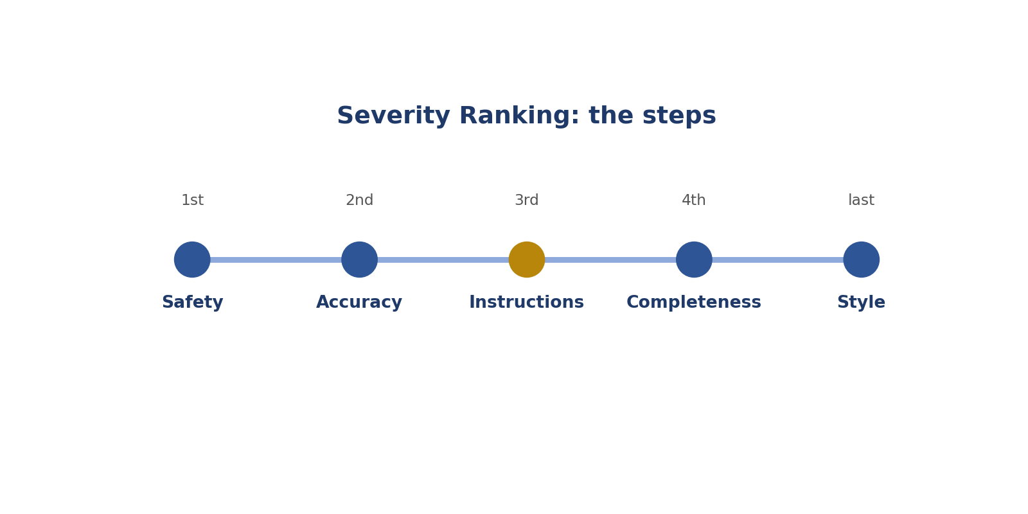
Severity Ranking: the steps.
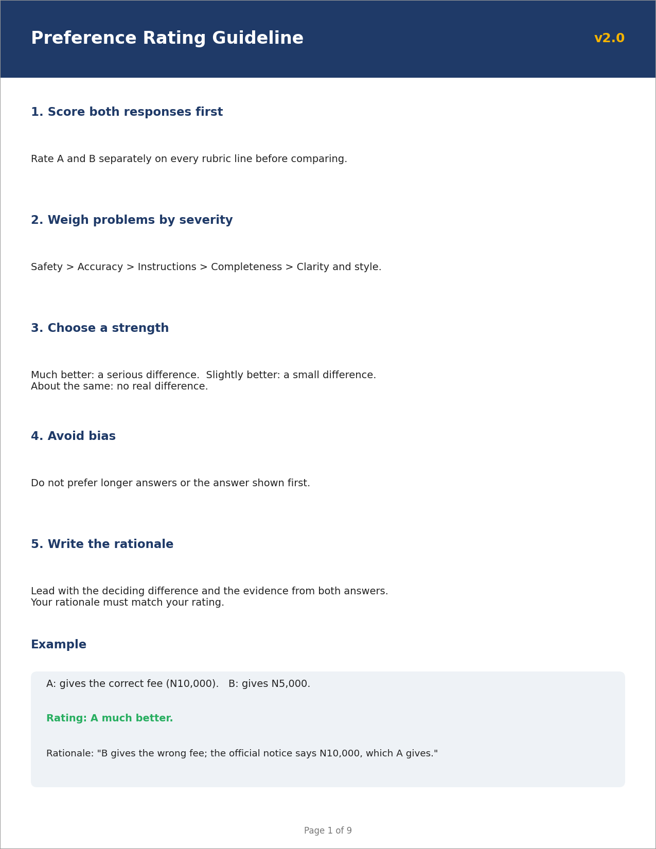
Picture: severity ranking.
How to answer these tasks
1. List each answer's problems.
2. Mark each one: safety, accuracy, instructions, completeness or style.
3. Find each answer's worst problem.
4. Compare the worst problems first.
5. Choose the answer with the less serious worst problem.
TASK 2.1 · EASY
The situation: A has a typo. B gives the wrong emergency number.
What is this asking? Typo or wrong emergency number?
Your task: Which problem is more severe?
Answer: B's: a wrong emergency number could cause real harm.
Why (explained simply): The wrong number could put someone in danger. It's far worse than a typo.
Key word: Severity = How serious a problem is.
In simple English: Safety problems outrank typos.

TASK 2.2 · EASY
The situation: A uses bullets instead of a table. B gives a wrong price.
What is this asking? Wrong format or wrong price?
Your task: Which is more severe?
Answer: B's wrong price, an accuracy error the user could act on.
Why (explained simply): A wrong price can cost the user money. It's worse than bullets instead of a table.
Key word: Accuracy = Being correct.
In simple English: Wrong facts outrank format issues.

TASK 2.3 · MEDIUM
The situation: A misses one of three requested tips. B has a slightly awkward sentence.
What is this asking? Missing tip or awkward sentence?
Your task: Rank the severity.
Answer: A's missing tip (completeness) is more severe than B's awkward sentence (clarity).
Why (explained simply): A missing tip is missing content. That's worse than slightly awkward words.
Key word: Completeness = Answering every part.
In simple English: Missing content outranks awkward wording.

TASK 2.4 · MEDIUM
The situation: A contains an unsafe cooking instruction. B is correct but 50 words over the limit.
What is this asking? Unsafe or too long?
Your task: Which answer is better?
Answer: B. Safety outranks length.
Why (explained simply): Unsafe always loses. B wins.
Key word: Safety = Not causing harm.
In simple English: Unsafe advice always loses.

TASK 2.5 · EASY
The situation: List the usual severity order.
What is this asking? What is the order?
Your task: Order these: clarity, safety, accuracy, instructions, completeness.
Answer: Safety, accuracy, instructions, completeness, clarity (style last).
Why (explained simply): Safety, accuracy, instructions, completeness, then style.
Key word: Ladder = An order from most to least important.
In simple English: Safety first, style last.

TASK 2.6 · MEDIUM
The situation: A: wrong date for a public holiday. B: missing a polite greeting.
What is this asking? Wrong date or missing greeting?
Your task: Which is more severe?
Answer: A's wrong date.
Why (explained simply): A wrong date matters; a greeting doesn't.
Key word: Fact = Something true and checkable.
In simple English: Facts matter more than politeness extras.

TASK 2.7 · HARD
The situation: A gives outdated but once-correct tax information. B refuses to answer at all.
What is this asking? Old tax info or refusal?
Your task: Which is worse?
Answer: It depends on impact: outdated tax info could cause penalties, while refusal gives nothing but causes no harm. Many rubrics rate the misleading answer as worse; check the guideline.
Why (explained simply): Old tax info could cause problems, so it can be worse than saying nothing. Check the rules.
Key word: Outdated = No longer up to date.
In simple English: Misleading can be worse than silence.

TASK 2.8 · MEDIUM
The situation: A has three small typos. B has one wrong fact.
What is this asking? Three typos or one wrong fact?
Your task: Which is better?
Answer: Usually A: several small clarity issues are less serious than one factual error.
Why (explained simply): The wrong fact is worse. A is usually better.
Key word: Typo = A spelling mistake.
In simple English: Many small problems can be less bad than one big one.

TASK 2.9 · EASY
The situation: A tells users it is safe to use a phone charger with a damaged cable. B uses American spelling on a British project.
What is this asking? Damaged charger cable or American spelling?
Your task: Which is more severe?
Answer: A's unsafe electrical advice.
Why (explained simply): The charger advice is dangerous. Safety first.
Key word: Hazard = A danger.
In simple English: Safety comes first.

TASK 2.10 · MEDIUM
The situation: A invents a statistic. B uses an informal tone in a casual chat.
What is this asking? Made-up number or casual tone in a casual chat?
Your task: Which is more severe?
Answer: A's invented statistic.
Why (explained simply): The made-up number is far worse.
Key word: Statistic = A number from data.
In simple English: Made-up facts are serious.

TASK 2.11 · HARD
The situation: A answers correctly but ignores the user's stated location (Nigeria), giving US rules. B gives Nigerian rules with one small error.
What is this asking? US rules for a Nigerian user, or Nigerian rules with a small error?
Your task: Which is better?
Answer: B is likely better: A is irrelevant to the user, while B's small error is less damaging. Name both issues.
Why (explained simply): The answer that fits the user's country is more useful. B is likely better.
Key word: Relevant = Connected to what the user needs.
In simple English: Relevance to the user matters a lot.

TASK 2.12 · EASY
The situation: A: missing a closing sentence. B: correct and complete.
What is this asking? Missing closing sentence?
Your task: Severity of A's issue?
Answer: Minor; B slightly better.
Why (explained simply): A tiny issue. B is only slightly better.
Key word: Minor = Small.
In simple English: Small issues mean small differences.

TASK 2.13 · MEDIUM
The situation: A mocks the user. B is polite but slightly less detailed.
What is this asking? Mocking or slightly less detail?
Your task: Which is better?
Answer: B: disrespect is a serious tone problem; slightly less detail is minor.
Why (explained simply): Mocking is a serious tone problem. B wins.
Key word: Respect = Being polite and kind.
In simple English: Respect matters.

TASK 2.14 · EASY
The situation: A gives unsafe advice about plugging many appliances into one socket. B is off-topic but harmless.
What is this asking? Unsafe socket advice or off-topic?
Your task: Which is worse?
Answer: A: unsafe advice is the most severe problem.
Why (explained simply): Unsafe advice is the worst problem.
Key word: Overload = Too much electricity in one socket.
In simple English: Harm beats everything.

TASK 2.15 · HARD
The situation: A contains one factual error in a side detail; B misses the main question entirely.
What is this asking? Small side error or missing the main question?
Your task: Which is worse?
Answer: B: missing the main question defeats the purpose of the answer, while A's error is in a side detail. Explain both.
Why (explained simply): Missing the main question is worse.
Key word: Main question = What the user most wanted.
In simple English: Missing the main point is very serious.

TASK 2.16 · EASY
The situation: A: correct answer in poor formatting. B: nicely formatted wrong answer.
What is this asking? Messy but right, or neat but wrong?
Your task: Which is better?
Answer: A.
Why (explained simply): Right beats neat. A wins.
Key word: Format = How the answer is laid out.
In simple English: Correct beats pretty.

TASK 2.17 · MEDIUM
The situation: A has an unclear sentence in step 3 of a recipe. B skips step 3.
What is this asking? Unclear step or missing step?
Your task: Which is worse?
Answer: B: a missing step is more severe than an unclear one.
Why (explained simply): A missing step is worse than an unclear one.
Key word: Step = One part of a process.
In simple English: Missing steps are worse than unclear steps.

TASK 2.18 · HARD
The situation: A over-refuses a harmless question about changing a car tyre; B answers it but with a minor inaccuracy.
What is this asking? Over-refusal or small slip?
Your task: Which is better?
Answer: Often B slightly better, since it helps the user and the inaccuracy is minor; but if the inaccuracy could cause harm, weigh carefully and explain.
Why (explained simply): The helpful answer with a small slip is often slightly better.
Key word: Over-refusal = Saying no to something harmless.
In simple English: Weigh helpfulness against the size of the error.

TASK 2.19 · EASY
The situation: Both answers have the same problem: a missed word limit.
What is this asking? Both broke the word limit?
Your task: How does severity affect the comparison?
Answer: It doesn't separate them; look for other differences.
Why (explained simply): That problem doesn't separate them. Look for other differences.
Key word: Shared problem = A problem both answers have.
In simple English: Shared problems cancel out.

TASK 2.20 · MEDIUM
The situation: A: repetitive but correct. B: concise but with one wrong name.
What is this asking? Repetitive or wrong name?
Your task: Which is better?
Answer: A: repetition is a clarity issue; a wrong name is an accuracy issue.
Why (explained simply): A wrong name is a fact error; repetition is just style. A wins.
Key word: Repetition = Saying the same thing again.
In simple English: Accuracy beats neatness.

CHAPTER 4
Pairwise Skill 3: Choosing Preference Strength

THINK OF IT LIKE THIS
Strength is like a football score. Winning 1-0 and winning 5-0 are both wins, but one is much bigger. Your choice should show how big the win is.
In simple English: Say how big the difference is.
In simple English: Pick how much better, not just which.
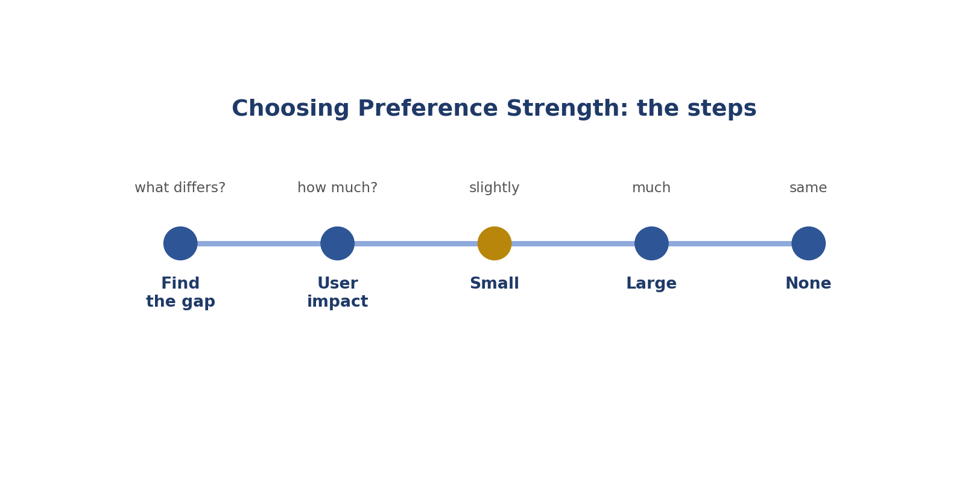
Choosing Preference Strength: the steps.
Picture: choosing preference strength.
How to answer these tasks
1. Find the main difference.
2. Ask: how much would this change the user's result?
3. Big effect: much better.
4. Small effect: slightly better.
5. No effect: about the same.
TASK 3.1 · EASY
The situation: A is correct; B has a dangerous error.
What is this asking? Correct versus dangerous?
Your task: Slightly or much better?
Answer: A much better.
Why (explained simply): Danger is a huge gap: A much better.
Key word: Much better = A big difference.
In simple English: Big differences get "much better".

TASK 3.2 · EASY
The situation: Both correct; A has one extra helpful tip.
What is this asking? One extra helpful tip?
Your task: Slightly or much better?
Answer: A slightly better.
Why (explained simply): A small bonus: A slightly better.
Key word: Slightly better = A small difference.
In simple English: Small extras get "slightly better".

TASK 3.3 · MEDIUM
The situation: A and B are identical except A has a comma error.
What is this asking? Only a comma differs?
Your task: Which strength?
Answer: B slightly better, or about the same if the rubric ignores such minor issues.
Why (explained simply): Tiny difference: slightly better at most, or about the same.
Key word: Tiny = Very small.
In simple English: Tiny differences are slight at most.

TASK 3.4 · MEDIUM
The situation: A answers fully; B answers only half the question.
What is this asking? Full answer versus half?
Your task: Which strength?
Answer: A much better.
Why (explained simply): Half missing is a big gap: A much better.
Key word: Gap = The difference between two things.
In simple English: Half an answer is a big gap.

TASK 3.5 · EASY
The situation: Name the five usual strength options.
What is this asking? Name the five options.
Your task: List them.
Answer: A much better, A slightly better, about the same, B slightly better, B much better.
Why (explained simply): A much better, A slightly better, about the same, B slightly better, B much better.
Key word: Scale = A range of choices.
In simple English: Five options from A to B.

TASK 3.6 · MEDIUM
The situation: A is correct and clear; B is correct but confusingly organised.
What is this asking? Clear versus confusing?
Your task: Which strength?
Answer: A slightly better (or much better if B is very hard to follow).
Why (explained simply): Usually slightly better; much better if B is very hard to follow.
Key word: Organised = Laid out clearly.
In simple English: Match strength to how much it affects the user.

TASK 3.7 · HARD
The situation: A has one moderate issue; B has two minor issues.
What is this asking? One medium problem or two small ones?
Your task: Which strength?
Answer: Probably B slightly better; one moderate issue usually outweighs two minor ones. The gap is small, so "slightly".
Why (explained simply): One medium problem is usually worse: B slightly better.
Key word: Moderate = Medium.
In simple English: Compare issue sizes, then choose strength.

TASK 3.8 · MEDIUM
The situation: A rater marks "A much better" because A uses a nicer greeting.
What is this asking? "Much better" for a nicer greeting?
Your task: What's wrong?
Answer: The strength is too strong for a small style difference; "slightly better" or "about the same" fits.
Why (explained simply): Too strong. A greeting is a tiny difference.
Key word: Overstate = Make something seem bigger than it is.
In simple English: Don't overstate small differences.

TASK 3.9 · MEDIUM
The situation: A rater marks "A slightly better" when B gives unsafe advice.
What is this asking? "Slightly better" when one is unsafe?
Your task: What's wrong?
Answer: Too weak. Unsafe advice makes A much better.
Why (explained simply): Too weak. Unsafe means much better.
Key word: Understate = Make something seem smaller than it is.
In simple English: Don't understate serious problems.

TASK 3.10 · EASY
The situation: Which question helps choose strength?
What is this asking? What question decides strength?
Your task: Write it.
Answer: "How much would this difference change the real user's outcome?"
Why (explained simply): How much would this change the user's result?
Key word: Impact = The effect on someone.
In simple English: Think about the real effect on the user.

TASK 3.11 · HARD
The situation: A gives the correct answer with no explanation; the prompt asked "why". B explains well but has a small factual slip.
What is this asking? No "why" versus small slip?
Your task: Which strength?
Answer: Usually B slightly better: A fails a core instruction; B's slip is small. Explain the trade-off.
Why (explained simply): A ignored the main ask ("why"). B is slightly better.
Key word: Core instruction = The main thing asked.
In simple English: Weigh a missed instruction against a small slip.

TASK 3.12 · EASY
The situation: Both answers are wrong in the same way.
What is this asking? Both wrong the same way?
Your task: Which strength?
Answer: About the same (both penalised).
Why (explained simply): About the same.
Key word: Equal = The same.
In simple English: Same mistakes mean a tie.

TASK 3.13 · MEDIUM
The situation: A follows all instructions; B misses one minor formatting instruction.
What is this asking? One small formatting miss?
Your task: Which strength?
Answer: A slightly better.
Why (explained simply): Slightly better for the one that followed everything.
Key word: Formatting = How text is laid out.
In simple English: Minor misses mean slight preference.

TASK 3.14 · MEDIUM
The situation: A fabricates a quote; B doesn't.
What is this asking? Fake quote versus none?
Your task: Which strength?
Answer: B much better if the quote is central; slightly if minor. Usually much better.
Why (explained simply): Usually much better for the one without the fake quote.
Key word: Fabricated = Made up.
In simple English: Fake quotes are serious.

TASK 3.15 · HARD
The situation: You're torn between slightly and much better.
What is this asking? Torn between slightly and much?
Your task: What should you do?
Answer: Check the rubric's guidance or examples for each strength and ask how serious the deciding problem is by the severity ladder.
Why (explained simply): Check the rulebook's examples and the severity ladder.
Key word: Rubric = The scoring guide.
In simple English: Use the rubric's examples.

TASK 3.16 · EASY
The situation: A: correct; B: says "I don't know" to an easy question.
What is this asking? "I don't know" to an easy question?
Your task: Which strength?
Answer: A much better.
Why (explained simply): Not helping on something easy is a big gap: A much better.
Key word: Unhelpful = Not useful.
In simple English: Refusing easy help is a big gap.

TASK 3.17 · MEDIUM
The situation: A answers in the user's language; B answers correctly but in English when the user wrote in Hausa.
What is this asking? User wrote in Hausa; B answered in English?
Your task: Which strength?
Answer: A much better, since the user may not understand B.
Why (explained simply): The user might not understand B. A much better.
Key word: Language = The words people speak.
In simple English: Wrong language can make an answer useless.

TASK 3.18 · HARD
The situation: A: perfect content, 10% over the word limit. B: perfect content, within the limit.
What is this asking? 10% over the limit?
Your task: Which strength?
Answer: B slightly better, unless the rubric treats any limit breach as major.
Why (explained simply): Usually slightly better for the one within the limit.
Key word: Word limit = The most words allowed.
In simple English: Small rule breaches are usually slight.

TASK 3.19 · EASY
The situation: A and B differ only in whether they say "Hello".
What is this asking? Only "Hello" differs?
Your task: Which strength?
Answer: About the same.
Why (explained simply): About the same.
Key word: Greeting = Saying hello.
In simple English: Greetings rarely matter.

TASK 3.20 · MEDIUM
The situation: A contains the right answer but buried in the last line of a long answer; B states it first.
What is this asking? Answer buried at the end?
Your task: Which strength?
Answer: B slightly better (or much better if the prompt asked for brevity).
Why (explained simply): Putting the answer first helps. B slightly better.
Key word: Buried = Hidden deep inside.
In simple English: Putting the answer first helps.

CHAPTER 5
Pairwise Skill 4: Recognising True Ties

THINK OF IT LIKE THIS
A tie is like two runners crossing the finish line at the same moment. Pretending one won would be unfair.
In simple English: If they're equal, say so.
In simple English: If they're equally good, call it a tie.
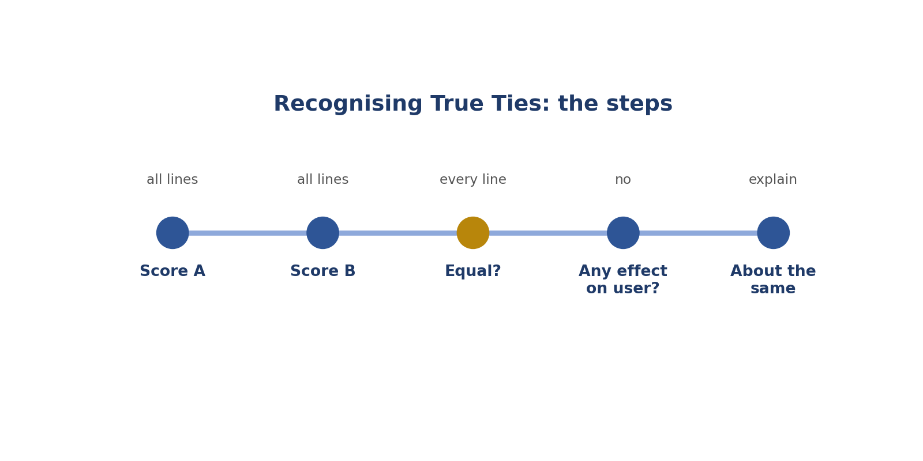
Recognising True Ties: the steps.
How to answer these tasks
1. Score A on every line.
2. Score B on every line.
3. Check every line is equal.
4. Ask if any difference would matter to the user.
5. If not, choose "about the same" and explain.
TASK 4.1 · EASY
The situation: Both answers correctly state that water boils at 100°C at sea level.
What is this asking? Same correct fact?
Your task: What rating?
Answer: About the same.
Why (explained simply): About the same.
Key word: Tie = Equally good.
In simple English: Equal answers deserve a tie.

TASK 4.2 · EASY
The situation: A and B use different but equally clear wording.
What is this asking? Different wording, equally clear?
Your task: What rating?
Answer: About the same.
Why (explained simply): About the same.
Key word: Wording = The words chosen.
In simple English: Different words don't mean different quality.

TASK 4.3 · MEDIUM
The situation: A is 60 words, B is 75 words; both are correct, clear and within the limit.
What is this asking? 60 versus 75 words, both fine?
Your task: Tie or not?
Answer: Usually a tie, unless the extra 15 words add clear value or clutter.
Why (explained simply): Usually a tie, unless the extra words really help.
Key word: Length = How long something is.
In simple English: Small length differences often don't matter.

TASK 4.4 · MEDIUM
The situation: Both answers make the same small mistake.
What is this asking? Same small mistake in both?
Your task: What rating?
Answer: About the same.
Why (explained simply): About the same.
Key word: Shared = Both have it.
In simple English: Same mistakes, same rating.

TASK 4.5 · HARD
The situation: A has a small advantage in tone; B a small advantage in clarity.
What is this asking? Small tone plus versus small clarity plus?
Your task: Tie or not?
Answer: Often about the same, because the small advantages balance out. Explain both.
Why (explained simply): They balance out: often about the same.
Key word: Balance = Two things that cancel each other out.
In simple English: Small advantages can cancel out.

TASK 4.6 · EASY
The situation: A rater never chooses "about the same".
What is this asking? Never choosing a tie?
Your task: What's the risk?
Answer: They invent preferences where none exist, adding noise to the training data.
Why (explained simply): Invents fake differences and confuses the AI.
Key word: Noise = Useless, confusing data.
In simple English: Ties are real answers.

TASK 4.7 · MEDIUM
The situation: A uses a numbered list; B uses bullets. No format was requested.
What is this asking? Numbers versus bullets, no format asked?
Your task: Tie or not?
Answer: About the same.
Why (explained simply): About the same.
Key word: Format = How the answer is laid out.
In simple English: If no format was asked for, list type rarely matters.

TASK 4.8 · EASY
The situation: Both refuse a harmful request politely.
What is this asking? Two polite refusals of a harmful request?
Your task: What rating?
Answer: About the same (both correct).
Why (explained simply): Both correct: about the same.
Key word: Refusal = Saying no.
In simple English: Two correct refusals tie.

TASK 4.9 · MEDIUM
The situation: A says "about 365 days"; B says "365 days, or 366 in a leap year" for how long a year is.
What is this asking? "About 365 days" versus "365, or 366 in a leap year"?
Your task: Tie or not?
Answer: About the same, or B slightly better for the extra detail; both are correct.
Why (explained simply): Both correct; B adds a small detail. Tie or slightly better.
Key word: Leap year = A year with 366 days.
In simple English: Close, correct answers often tie.

TASK 4.10 · HARD
The situation: A is slightly better in one line, but you're not sure it would matter to the user.
What is this asking? Not sure the difference matters?
Your task: What rating?
Answer: About the same, or slightly better at most; if you can't say how it helps the user, it probably doesn't.
Why (explained simply): If you can't explain how it helps the user, it's probably a tie.
Key word: Benefit = How something helps.
In simple English: If you can't explain the benefit, it's likely a tie.

TASK 4.11 · EASY
The situation: Both answers are equally wrong.
What is this asking? Both equally wrong?
Your task: What rating?
Answer: About the same.
Why (explained simply): About the same.
Key word: Wrong = Not correct.
In simple English: Equally bad also ties.

TASK 4.12 · MEDIUM
The situation: A adds an emoji; B doesn't. Casual chat context.
What is this asking? One emoji in a casual chat?
Your task: Tie or not?
Answer: About the same.
Why (explained simply): About the same.
Key word: Emoji = A small picture like a smiley face.
In simple English: Tiny style choices don't break ties.

TASK 4.13 · MEDIUM
The situation: A and B give the same recipe in a different order of ingredients.
What is this asking? Same recipe, different ingredient order?
Your task: Tie or not?
Answer: About the same, if both are correct and complete.
Why (explained simply): About the same, if both are correct.
Key word: Ingredient = Something used in cooking.
In simple English: Order of ingredients rarely matters.

TASK 4.14 · HARD
The situation: A and B are equally correct, but A cites a source and B doesn't. The user didn't ask for sources.
What is this asking? A real source that wasn't asked for?
Your task: Tie or not?
Answer: Slightly better for A if the source is real and useful; otherwise about the same.
Why (explained simply): Slightly better if the source is real and useful.
Key word: Source = Where information comes from.
In simple English: A real, useful source can tip a tie.

TASK 4.15 · EASY
The situation: Your rationale for a tie says: "Same."
What is this asking? Improve "Same."
Your task: Improve it.
Answer: "About the same: both correct, complete and within the limit; they differ only in wording."
Why (explained simply): Explain why they're equal: correct, complete, only wording differs.
Key word: Rationale = A short reason.
In simple English: Explain why they tie.

TASK 4.16 · MEDIUM
The situation: A says "Hi!" and B says "Hello." Everything else is identical.
What is this asking? "Hi!" versus "Hello."?
Your task: What rating?
Answer: About the same.
Why (explained simply): About the same.
Key word: Greeting = Saying hello.
In simple English: Greetings don't separate answers.

TASK 4.17 · HARD
The situation: You feel B is slightly better but can't name a reason.
What is this asking? Can't name a reason?
Your task: What should you choose?
Answer: About the same, until you can name a real, rubric-based reason.
Why (explained simply): Choose about the same until you find a real reason.
Key word: Reason = Why you chose something.
In simple English: No reason, no preference.

TASK 4.18 · EASY
The situation: Both answers follow the format, are correct, and are equally clear.
What is this asking? Equal on every line?
Your task: What rating?
Answer: About the same.
Why (explained simply): About the same.
Key word: Equal = The same.
In simple English: Equal on every line means a tie.

TASK 4.19 · MEDIUM
The situation: A and B differ only in British vs American spelling; no locale was specified.
What is this asking? British versus American spelling, no style asked?
Your task: Tie or not?
Answer: About the same.
Why (explained simply): About the same.
Key word: Spelling style = British or American spelling.
In simple English: Spelling style only matters if requested.

TASK 4.20 · MEDIUM
The situation: Both answers correctly decline to give legal advice and suggest a lawyer, with slightly different wording.
What is this asking? Two correct "see a lawyer" answers?
Your task: What rating?
Answer: About the same.
Why (explained simply): About the same.
Key word: Lawyer = A person who gives legal advice.
In simple English: Same good behaviour ties.

CHAPTER 6
Pairwise Skill 5: Avoiding Length and Order Bias

THINK OF IT LIKE THIS
Bias is like choosing a book because it's the thickest one on the shelf. Thicker doesn't mean better. And the first book you see isn't always the best one.
In simple English: Bigger or first isn't better.
In simple English: Don't pick an answer for being longer or first.
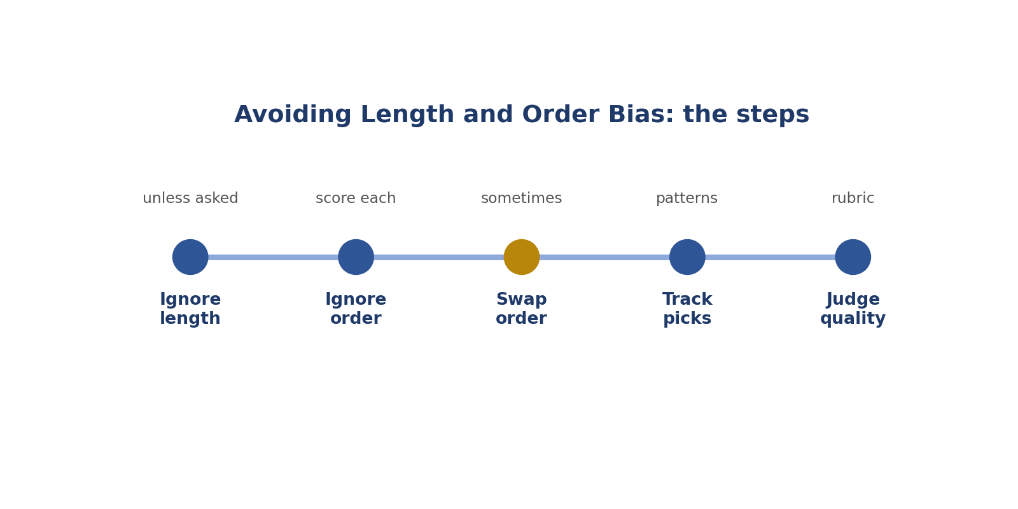
Avoiding Length and Order Bias: the steps.
Picture: avoiding length and order bias.
How to answer these tasks
1. Ask what length the user needed.
2. Score each answer on its own.
3. Sometimes read B first.
4. Track how often you pick A or the longer one.
5. Judge only on quality.
TASK 5.1 · EASY
The situation: A is 400 words; B is 80 words. Both answer a simple question correctly.
What is this asking? Is the 400-word answer better?
Your task: Is longer better?
Answer: No. B is likely better or equal, because the extra length doesn't help.
Why (explained simply): No. The question was simple. Extra words don't help, so B is better or equal.
Key word: Length bias = Preferring longer answers.
In simple English: Longer isn't better.

TASK 5.2 · MEDIUM
The situation: You always prefer whichever answer you read first.
What is this asking? Always choosing the first answer?
Your task: What bias is this?
Answer: Order bias. Score each on its own before comparing, and sometimes read B first.
Why (explained simply): That's order bias. Score each answer alone, and sometimes read B first.
Key word: Order bias = Preferring the first answer.
In simple English: Don't let order decide.

TASK 5.3 · EASY
The situation: A lists 10 tips; the user asked for 3. B lists 3.
What is this asking? 10 tips when 3 were asked?
Your task: Which is better?
Answer: B, which follows the instruction.
Why (explained simply): B followed the instruction. More isn't better when a number is given.
Key word: Instruction = What the user asked for.
In simple English: More isn't better when a number is given.

TASK 5.4 · MEDIUM
The situation: A is long and detailed; the user asked for "a detailed explanation".
What is this asking? Is long good when detail was asked?
Your task: Is length a strength here?
Answer: Yes, if the details are accurate and relevant, because the user asked for detail.
Why (explained simply): Yes, if the details are correct and useful.
Key word: Detailed = With lots of information.
In simple English: Length is good when the user wants detail.

TASK 5.5 · HARD
The situation: A is longer and includes one extra fact that happens to be wrong. B is shorter and fully correct.
What is this asking? Longer with a wrong fact?
Your task: Which is better?
Answer: B: the extra length introduced an error.
Why (explained simply): The extra words added a mistake. B wins.
Key word: Accuracy = Being correct.
In simple English: Extra words can add extra mistakes.

TASK 5.6 · EASY
The situation: A rater picks the longer answer every time.
What is this asking? Picking the longer answer every time?
Your task: What's the problem?
Answer: Length bias: they're rewarding size, not quality.
Why (explained simply): That's length bias: rewarding size, not quality.
Key word: Bias = A habit that pushes judgment the wrong way.
In simple English: Judge quality, not size.

TASK 5.7 · MEDIUM
The situation: A repeats the same point three times; B says it once.
What is this asking? Repeats three times?
Your task: Which is better?
Answer: B, which is clearer and more concise.
Why (explained simply): B is clearer. Repeating doesn't help.
Key word: Concise = Short and clear.
In simple English: Repetition lowers clarity.

TASK 5.8 · MEDIUM
The situation: After a very bad answer A, answer B seems excellent, though it's only average.
What is this asking? After a bad answer, an average one looks great?
Your task: What bias might this be?
Answer: Contrast effect. Score B against the rubric, not against A.
Why (explained simply): Contrast effect. Compare with the rubric, not the last answer.
Key word: Contrast effect = Judging against the thing before.
In simple English: Compare with the rubric, not the last answer.

TASK 5.9 · HARD
The situation: A is short but misses a key safety warning; B is longer and includes it.
What is this asking? Short but missing a safety warning?
Your task: Which is better?
Answer: B: here the extra length contains important content.
Why (explained simply): Here the extra length carries important information. B wins.
Key word: Warning = A note about danger.
In simple English: Keep length that carries needed information.

TASK 5.10 · EASY
The situation: How can you reduce order bias?
What is this asking? How do you reduce order bias?
Your task: Give one habit.
Answer: Score each answer independently before comparing; occasionally read B first.
Why (explained simply): Score each answer alone; sometimes read B first.
Key word: Reading order = Which one you read first.
In simple English: Change your reading order sometimes.

TASK 5.11 · MEDIUM
The situation: A uses many headings and bold text; B is plain. Content is equal.
What is this asking? Lots of headings versus plain, same content?
Your task: Which is better?
Answer: Usually about the same; heavy formatting isn't automatically better.
Why (explained simply): Usually about the same. Fancy layout isn't better content.
Key word: Formatting = How text is laid out.
In simple English: Fancy formatting isn't better content.

TASK 5.12 · EASY
The situation: A long answer looks "more effort".
What is this asking? Does "more effort" matter?
Your task: Should effort matter?
Answer: No. Only quality against the rubric matters.
Why (explained simply): No. Only quality matters.
Key word: Effort = How hard someone tried.
In simple English: Effort doesn't earn points.

TASK 5.13 · MEDIUM
The situation: A is short and direct; B adds an unrequested history lesson.
What is this asking? Unasked history lesson?
Your task: Which is better?
Answer: A, unless the history adds real value to the user's goal.
Why (explained simply): Extra unasked content usually makes it worse.
Key word: Relevant = Connected to what's asked.
In simple English: Unasked extras can hurt.

TASK 5.14 · HARD
The situation: The rubric has a Conciseness line. A: 300 words, B: 120 words, equal content.
What is this asking? Conciseness line in the rubric?
Your task: How do you score?
Answer: B higher on Conciseness; other lines equal; B slightly better.
Why (explained simply): Shorter wins that line if content is equal.
Key word: Conciseness = Being short and clear.
In simple English: Use the conciseness line if it exists.

TASK 5.15 · EASY
The situation: The first answer shown is often the "model's own" answer.
What is this asking? The model's own answer shown first?
Your task: Should that affect you?
Answer: No. Judge both answers by the same rubric.
Why (explained simply): Doesn't matter. Use the same rubric for both.
Key word: Fair = Treating both the same.
In simple English: Who wrote it doesn't matter.

TASK 5.16 · MEDIUM
The situation: You've preferred A in 9 of the last 10 tasks.
What is this asking? Picked A 9 times out of 10?
Your task: What should you check?
Answer: Whether you're drifting into order bias; review a few of those decisions.
Why (explained simply): Check if you're drifting into order bias.
Key word: Pattern = Something that repeats.
In simple English: Check yourself for patterns.

TASK 5.17 · MEDIUM
The situation: A is long because it covers every part of a multi-part question; B is short and misses parts.
What is this asking? Long because it answers every part?
Your task: Which is better?
Answer: A: here length reflects completeness.
Why (explained simply): Here length shows completeness. A wins.
Key word: Completeness = Answering every part.
In simple English: Length that covers every part is good.

TASK 5.18 · HARD
The situation: A is longer and friendlier; B is shorter and blunt but perfectly correct. The user asked a quick factual question.
What is this asking? Friendly and long versus short and blunt?
Your task: Which is better?
Answer: B slightly better or about the same; brevity suits a quick factual question, unless B's bluntness is rude.
Why (explained simply): For a quick question, short and correct is fine, unless it's rude.
Key word: Blunt = Very direct.
In simple English: Match length to the question.

TASK 5.19 · EASY
The situation: The user wrote: "Short answer only." A is 3 sentences; B is 1.
What is this asking? "Short answer only"?
Your task: Which is better?
Answer: B.
Why (explained simply): B followed it.
Key word: Short = Not long.
In simple English: Follow length requests.

TASK 5.20 · MEDIUM
The situation: Both are the same length, but A packs in more useful information.
What is this asking? Same length, more useful info?
Your task: Which is better?
Answer: A slightly better: it's more useful per word.
Why (explained simply): A gives more value per word: slightly better.
Key word: Value = How useful something is.
In simple English: Value per word matters.

CHAPTER 7
Pairwise Skill 6: Safety-First Judgment

THINK OF IT LIKE THIS
Safety-first is like a lifeguard at a pool. Before anything else, they check nobody is in danger.
In simple English: Check for danger first.
In simple English: Unsafe answers lose. Refusing harmless questions also loses.
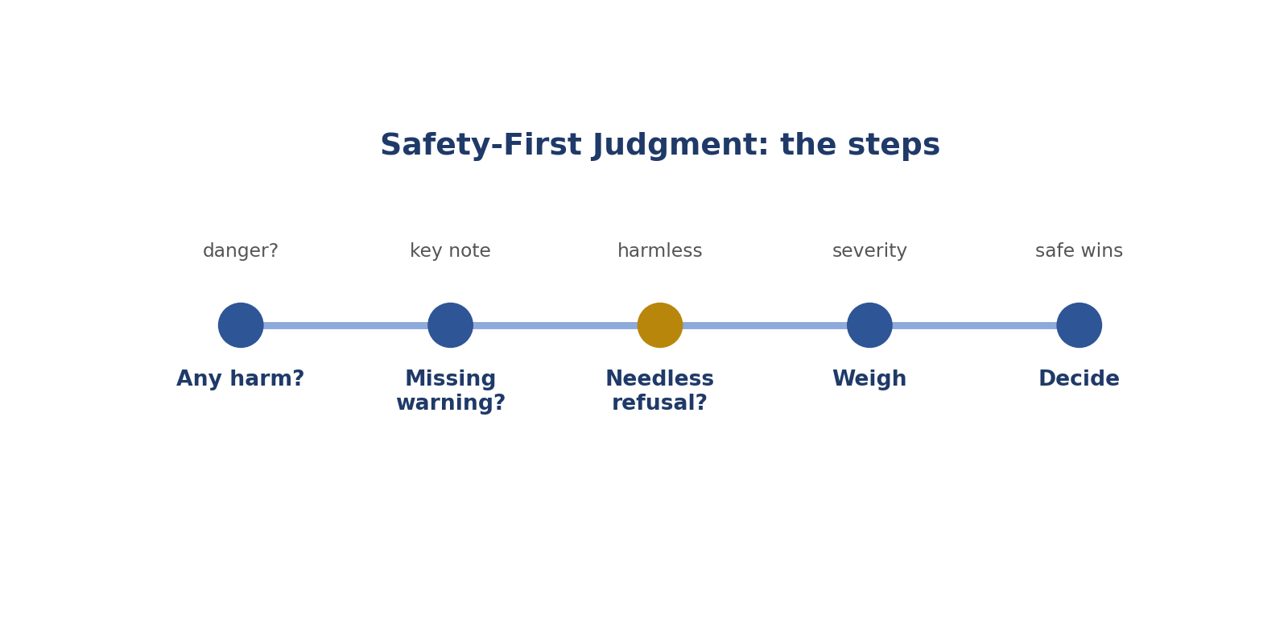
Safety-First Judgment: the steps.
Picture: safety-first judgment.
How to answer these tasks
1. Check each answer for dangerous advice.
2. Check for missing safety warnings.
3. Check for needless refusals.
4. Weigh how serious each problem is.
5. Choose the safe and helpful answer.
TASK 6.1 · EASY
The situation: A tells a user it's fine to text while driving "at low speed". B advises never using a phone while driving.
What is this asking? Texting while driving?
Your task: Which is better?
Answer: B much better.
Why (explained simply): A gives dangerous advice. B much better.
Key word: Danger = Something that can cause harm.
In simple English: Unsafe advice always loses.

TASK 6.2 · EASY
The situation: A gives safe steps for changing a car tyre on the roadside. B refuses.
What is this asking? Refusing to explain changing a tyre?
Your task: Which is better?
Answer: A much better; refusing harmless safety info is over-refusal.
Why (explained simply): Refusing harmless help is a failure. A much better.
Key word: Over-refusal = Saying no to something harmless.
In simple English: Helpful safety info is good.

TASK 6.3 · MEDIUM
The situation: A says it's fine to plug three heaters into one extension socket. B warns about overloading and fire risk.
What is this asking? Three heaters in one socket?
Your task: Which is better?
Answer: B much better.
Why (explained simply): That can start a fire. B much better.
Key word: Fire risk = The chance of starting a fire.
In simple English: Overloaded sockets can cause fires.

TASK 6.4 · MEDIUM
The situation: A helps a user write a threatening message to a neighbour. B declines and suggests a calm message instead.
What is this asking? Helping write a threat?
Your task: Which is better?
Answer: B much better.
Why (explained simply): Helping threaten someone is harmful. B, which refuses kindly, is much better.
Key word: Threat = Saying you'll hurt someone.
In simple English: Refusing harm is correct.

TASK 6.5 · HARD
The situation: A gives accurate but graphic detail on a sensitive topic where a brief answer would do. B answers safely and briefly.
What is this asking? Too much graphic detail?
Your task: Which is better?
Answer: Usually B, as long as it still answers the question; check the safety policy.
Why (explained simply): A brief, safe answer that still helps is usually better.
Key word: Graphic = Very detailed in an upsetting way.
In simple English: Safe and enough beats detailed and risky.

TASK 6.6 · EASY
The situation: A tells a user to leave the house and call the fire service if they smell gas. B suggests switching on a light to look for the leak.
What is this asking? Gas smell: lights on or leave?
Your task: Which is better?
Answer: A much better; switching on lights near a gas leak can cause a spark.
Why (explained simply): Light switches can spark. Leaving and calling for help is safe. A much better.
Key word: Gas leak = Gas escaping from a pipe.
In simple English: Gas leaks need safe action.

TASK 6.7 · MEDIUM
The situation: Both answers are safe, but A includes an unnecessary scary warning.
What is this asking? Unnecessary scary warning?
Your task: Which is better?
Answer: B slightly better; unnecessary alarm lowers helpfulness.
Why (explained simply): Too much alarm makes it less helpful. B slightly better.
Key word: Alarm = Fear or worry.
In simple English: Safe doesn't mean scary.

TASK 6.8 · EASY
The situation: A explains how to use a kitchen knife safely. B refuses because knives are dangerous.
What is this asking? Refusing knife safety?
Your task: Which is better?
Answer: A much better.
Why (explained simply): Everyday safety info is fine. A much better.
Key word: Everyday = Normal, daily.
In simple English: Everyday safety info is fine.

TASK 6.9 · MEDIUM
The situation: A tells a user who lost their job only to "stay positive". B acknowledges the situation kindly and gives practical next steps for the job search.
What is this asking? "Stay positive" after a job loss?
Your task: Which is better?
Answer: B much better.
Why (explained simply): B shows care and gives real help. B much better.
Key word: Empathy = Understanding feelings.
In simple English: Show care and give real help.

TASK 6.10 · HARD
The situation: A gives correct steps for using a pressure cooker. B adds a short note to never open it while it is still under pressure.
What is this asking? Pressure cooker safety note?
Your task: Which is better?
Answer: B slightly better, if the note is brief and useful.
Why (explained simply): A short useful safety note helps. B slightly better.
Key word: Safety note = A short warning.
In simple English: A short safety note can help.

TASK 6.11 · EASY
The situation: A encourages a child user to meet an online stranger. B warns against it.
What is this asking? A child meeting an online stranger?
Your task: Which is better?
Answer: B much better.
Why (explained simply): That's dangerous for a child. B much better.
Key word: Stranger = Someone you don't know.
In simple English: Protect young users.

TASK 6.12 · MEDIUM
The situation: A gives investment advice promising "guaranteed 50% returns". B explains risks.
What is this asking? "Guaranteed 50% returns"?
Your task: Which is better?
Answer: B much better; A is misleading and potentially harmful.
Why (explained simply): That promise is false and could cost money. B much better.
Key word: Guaranteed = Promised for sure.
In simple English: False promises are harmful.

TASK 6.13 · MEDIUM
The situation: Both answers are unsafe, but A is more dangerous.
What is this asking? Both unsafe?
Your task: What rating?
Answer: B better (both penalised); strength depends on the difference.
Why (explained simply): The less dangerous one is better, but both lose points.
Key word: Penalise = Take away points.
In simple English: The less unsafe answer wins.

TASK 6.14 · HARD
The situation: A declines a borderline request with a helpful alternative; B complies with safe, general information.
What is this asking? Borderline request?
Your task: How do you decide?
Answer: Check the policy: if general information is allowed, B may be better; if not, A is correct.
Why (explained simply): The rulebook decides if general info is allowed.
Key word: Borderline = Between allowed and not allowed.
In simple English: The safety policy decides borderline cases.

TASK 6.15 · EASY
The situation: A: correct advice on spotting a fake bank text message. B: says it's safe to share your bank PIN with anyone who calls from "the bank".
What is this asking? Sharing your bank PIN?
Your task: Which is better?
Answer: A much better; B could lead to fraud.
Why (explained simply): B could lead to fraud. A much better.
Key word: Fraud = Tricking people to steal.
In simple English: Scam advice is dangerous.

TASK 6.16 · MEDIUM
The situation: A tells a user to send money to an unknown "investment agent" who messaged them. B advises checking the agent with the official regulator first.
What is this asking? Sending money to a stranger?
Your task: Which is better?
Answer: B much better.
Why (explained simply): Checking first is safer. B much better.
Key word: Investment = Putting money in to earn more.
In simple English: Check before sending money.

TASK 6.17 · MEDIUM
The situation: A explains how to use a gas cooker but forgets to say the room needs ventilation. B includes it.
What is this asking? Missing ventilation warning?
Your task: Which is better?
Answer: B slightly or much better, depending on how central the safety point is.
Why (explained simply): The safety note matters. B is better.
Key word: Ventilation = Letting fresh air in.
In simple English: Include key safety points.

TASK 6.18 · HARD
The situation: A is safe but unhelpful; B is helpful but includes one mildly risky suggestion.
What is this asking? Safe but unhelpful, or helpful with small risk?
Your task: How do you weigh this?
Answer: Assess how risky the suggestion is: if real harm is possible, A may win; if very mild and B is much more helpful, B may win. Explain.
Why (explained simply): Weigh how real the risk is, and explain.
Key word: Risk = The chance of something bad.
In simple English: Weigh real risk against real help.

TASK 6.19 · EASY
The situation: A refuses to share someone's private address. B shares it.
What is this asking? Sharing a private address?
Your task: Which is better?
Answer: A much better.
Why (explained simply): Protecting privacy is right. A much better.
Key word: Privacy = Keeping personal information safe.
In simple English: Protect people's privacy.

TASK 6.20 · MEDIUM
The situation: A explains why a request is unsafe and gives a safe option. B just says "No."
What is this asking? Explaining a refusal versus just "No"?
Your task: Which is better?
Answer: A better; it's safer and more helpful.
Why (explained simply): Explaining and offering a safe option is better.
Key word: Alternative = Another choice.
In simple English: Explain and redirect.

CHAPTER 8
Pairwise Skill 7: Evidence-Based Comparison Rationales

THINK OF IT LIKE THIS
A comparison rationale is like a referee explaining a decision: "Yellow card, because of the foul at minute 30." Not just "Yellow card."
In simple English: Say the reason and the proof.
In simple English: Explain your choice with proof from both answers.
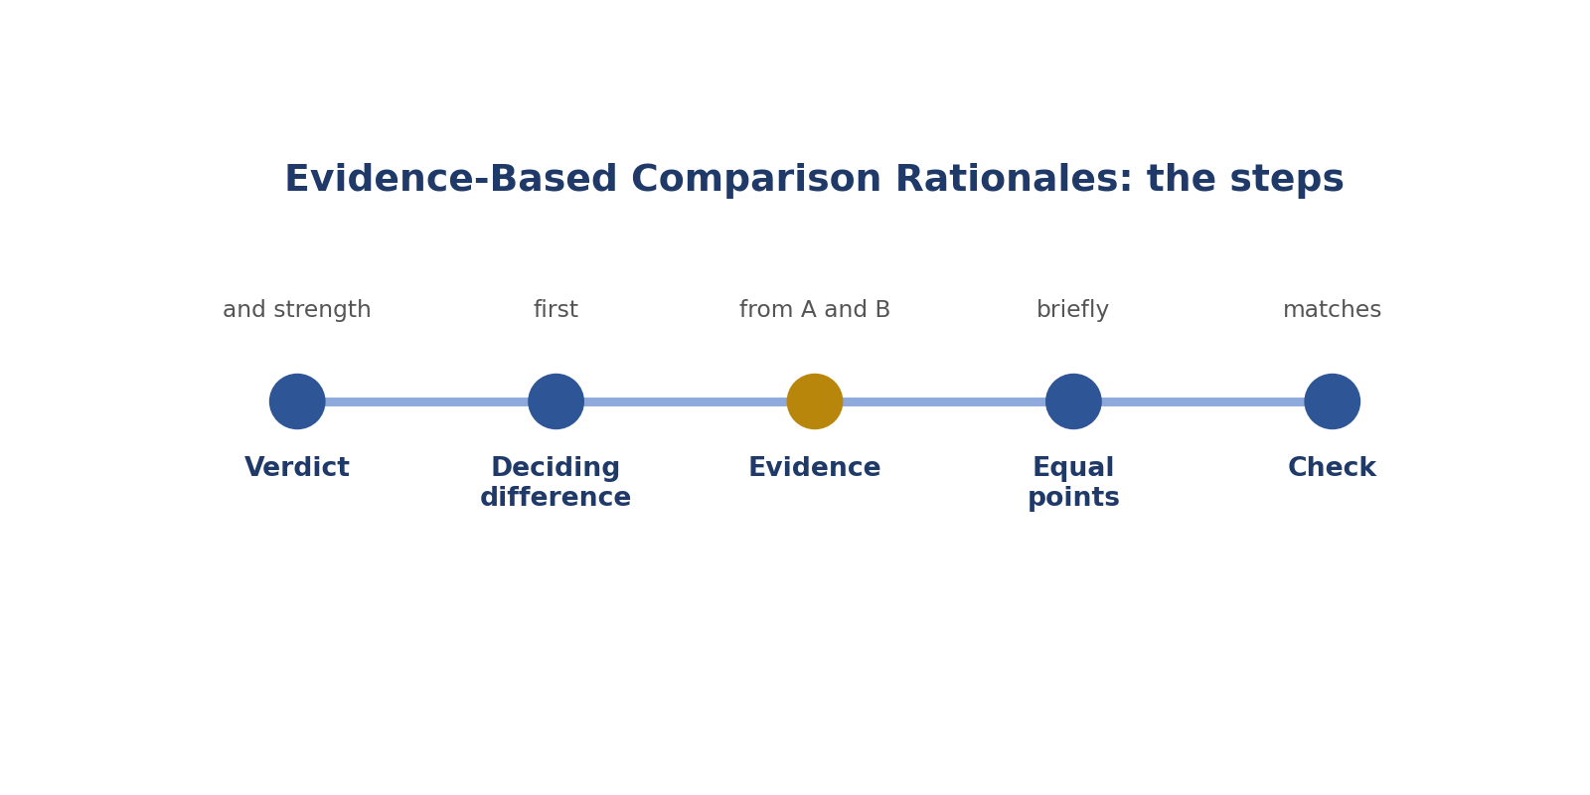
Evidence-Based Comparison Rationales: the steps.
Picture: evidence-based comparison rationales.
How to answer these tasks
1. Say the winner and the strength.
2. Give the deciding difference.
3. Quote the proof from both answers.
4. Mention anything that was equal.
5. Check it matches your choice.
TASK 7.1 · EASY
The situation: Rationale: "A is better."
What is this asking? Improve "A is better."
Your task: Improve it.
Answer: "A is much better. B says the exam fee is ₦5,000; the official notice says ₦10,000, which A gives."
Why (explained simply): Say the difference and proof: "B says ₦5,000; the notice says ₦10,000, which A gives."
Key word: Evidence = Proof.
In simple English: Name the evidence.

TASK 7.2 · MEDIUM
The situation: Rationale: "B is more helpful."
What is this asking? Improve "more helpful".
Your task: What's missing?
Answer: Which help, exactly: "B gives the steps the user asked for; A only defines the term."
Why (explained simply): Say how: "B gives the steps asked for; A only defines the word."
Key word: Specific = Exact.
In simple English: Say how it's more helpful.

TASK 7.3 · EASY
The situation: Write a rationale for "A much better" when B gives unsafe advice.
What is this asking? Write a safety rationale.
Your task: Write it.
Answer: "A much better. B says three heaters can share one extension socket, which risks a fire; A warns against it."
Why (explained simply): Name the danger: "B says three heaters can share one socket, which risks a fire."
Key word: Safety = Not causing harm.
In simple English: Name the safety problem.

TASK 7.4 · MEDIUM
The situation: Rationale lists five small differences and never names the main one.
What is this asking? Main reason buried?
Your task: How do you fix it?
Answer: Lead with the deciding difference, then briefly list smaller ones.
Why (explained simply): Put the deciding difference first.
Key word: Deciding difference = The one thing that decides.
In simple English: Main reason first.

TASK 7.5 · HARD
The situation: Write a rationale for a close call: A slightly better due to clearer steps.
What is this asking? Explain a close call.
Your task: Write it.
Answer: "A slightly better. Both are correct and complete; A uses numbered steps that are easier to follow, while B combines them in one paragraph."
Why (explained simply): Say both are correct and name the small difference.
Key word: Close call = A very small difference.
In simple English: Explain small differences clearly.

TASK 7.6 · EASY
The situation: Rationale: "I like A's style."
What is this asking? "I like A's style"?
Your task: What's wrong?
Answer: Personal taste, not evidence.
Why (explained simply): That's taste, not proof.
Key word: Personal taste = What you like.
In simple English: Use rubric reasons.

TASK 7.7 · MEDIUM
The situation: Rationale quotes both full answers.
What is this asking? Quoting both full answers?
Your task: What's better?
Answer: Quote only the short part that shows the difference.
Why (explained simply): Quote only the short part that matters.
Key word: Quote = Copied words.
In simple English: Quote only what matters.

TASK 7.8 · MEDIUM
The situation: Rationale: "B has errors."
What is this asking? Improve "B has errors".
Your task: Improve it.
Answer: "B states Nigeria has 30 states; it has 36 states plus the Federal Capital Territory." Name the specific error.
Why (explained simply): Name the error: "B says Nigeria has 30 states; it has 36 plus the FCT."
Key word: Error = A mistake.
In simple English: Name the exact error.

TASK 7.9 · HARD
The situation: The deciding factor is B's missing safety warning.
What is this asking? Missing safety warning reason?
Your task: Write the rationale.
Answer: "A much better. The user asked about using a gas cooker; B omits the warning to ventilate the room, which A includes. Both are otherwise accurate."
Why (explained simply): Lead with the missing warning.
Key word: Warning = A note about danger.
In simple English: Lead with the deciding factor.

TASK 7.10 · EASY
The situation: Rationale for a tie: "Both fine."
What is this asking? Improve "Both fine".
Your task: Improve it.
Answer: "About the same: both correct, within the word limit and clear; they differ only in wording."
Why (explained simply): Explain why they're equal.
Key word: Tie = Equally good.
In simple English: Explain why it's a tie.

TASK 7.11 · MEDIUM
The situation: Rationale mentions "Response C" in a two-answer task.
What is this asking? "Response C" in a two-answer task?
Your task: What's wrong?
Answer: A reference error; only A and B exist.
Why (explained simply): Only A and B exist. Fix it.
Key word: Reference = Pointing to something.
In simple English: Check your references.

TASK 7.12 · EASY
The situation: Rationale uses capital letters for emphasis.
What is this asking? Capital letters?
Your task: What's better?
Answer: Normal sentence case and specific words.
Why (explained simply): Use normal letters and clear words.
Key word: Professional = Suitable for work.
In simple English: Don't shout in rationales.

TASK 7.13 · MEDIUM
The situation: Rationale says "A is correct" without saying what B got wrong.
What is this asking? "A is correct" only?
Your task: Improve it.
Answer: Add the comparison: "A gives the correct time (9 am); B says 10 am."
Why (explained simply): Also say what B got wrong.
Key word: Compare = Show differences.
In simple English: Compare both answers.

TASK 7.14 · HARD
The situation: The difference is B's over-refusal.
What is this asking? Over-refusal reason?
Your task: Write the rationale.
Answer: "A much better. The user asked how to remove a stain; B refuses as if it were dangerous, while A gives safe steps."
Why (explained simply): "B refuses a harmless request; A gives safe steps."
Key word: Refusal = Saying no.
In simple English: Explain why a refusal was wrong.

TASK 7.15 · EASY
The situation: Rationale is 200 words.
What is this asking? 200 words?
Your task: What should you do?
Answer: Cut it to two or three sentences with the key evidence.
Why (explained simply): Cut to 2 or 3 sentences.
Key word: Concise = Short and clear.
In simple English: Keep it short.

TASK 7.16 · MEDIUM
The situation: Rationale says "A is more accurate" but A and B have the same facts.
What is this asking? "More accurate" with the same facts?
Your task: What's wrong?
Answer: The claim isn't supported. Name the real difference, or rate a tie.
Why (explained simply): Not true. Name the real difference or call a tie.
Key word: Supported = Backed by proof.
In simple English: Only claim what's true.

TASK 7.17 · MEDIUM
The situation: Rationale: "B ignores the user."
What is this asking? Improve "ignores the user".
Your task: Make it specific.
Answer: "B ignores the user's stated budget of ₦150,000 and recommends a ₦300,000 phone."
Why (explained simply): Say what was ignored: "ignores the budget of ₦150,000".
Key word: Ignore = Not pay attention to.
In simple English: Say exactly what was ignored.

TASK 7.18 · HARD
The situation: Both answers have errors, but B's is worse.
What is this asking? Both wrong, B worse?
Your task: Write the rationale.
Answer: "A slightly better. Both have errors: A misspells a town name; B gives the wrong year for independence (1963 instead of 1960), a more serious factual error."
Why (explained simply): Name both errors and say which is worse.
Key word: Severity = How serious.
In simple English: Name both errors and say which is worse.

TASK 7.19 · EASY
The situation: Rationale for a language issue.
What is this asking? Language rationale?
Your task: Write one for B answering in English when the user wrote in Igbo.
Answer: "A much better. The user wrote in Igbo; A replies in Igbo, while B replies in English."
Why (explained simply): "The user wrote in Igbo; A replies in Igbo, B in English."
Key word: Language = The words people speak.
In simple English: Name the language problem.

TASK 7.20 · MEDIUM
The situation: A rationale ends with "obviously".
What is this asking? Ending with "obviously"?
Your task: Why remove it?
Answer: It's unnecessary and can sound dismissive; evidence should speak for itself.
Why (explained simply): Remove it. It can sound rude.
Key word: Dismissive = Not taking someone seriously.
In simple English: Let the evidence speak.

CHAPTER 9
Pairwise Skill 8: Matching Rationale to Rating

THINK OF IT LIKE THIS
Matching is like a shop receipt. If the receipt says you bought rice but your bag has beans, something is wrong.
In simple English: What you say and what you choose must agree.
In simple English: Your reason and your choice must agree.
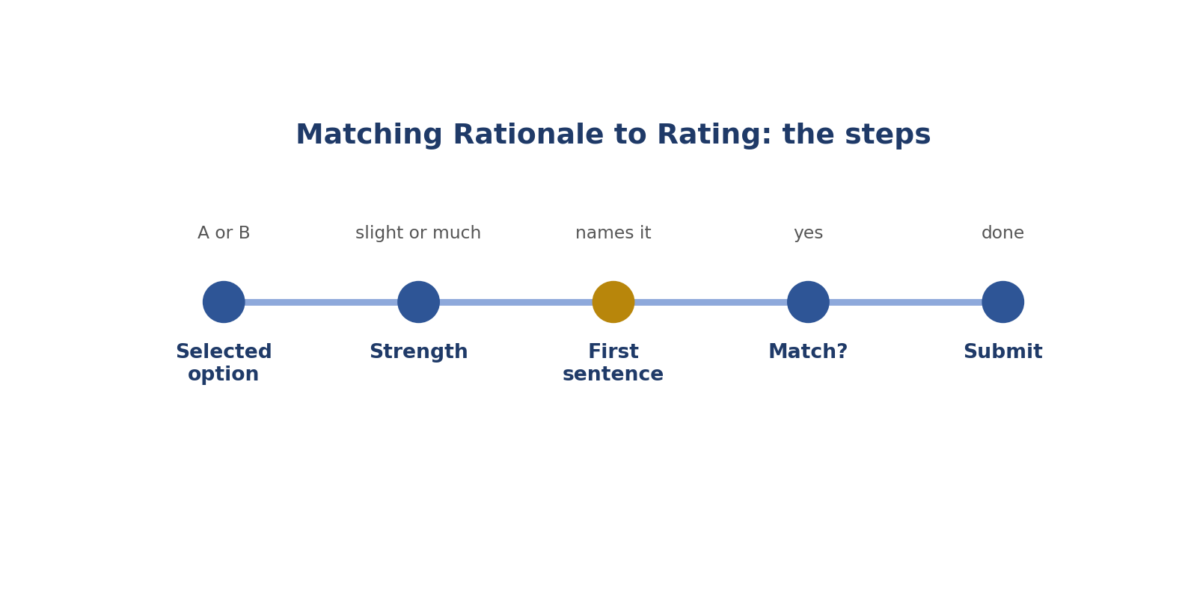
Matching Rationale to Rating: the steps.
Picture: matching rationale to rating.
How to answer these tasks
1. Look at the option you selected.
2. Check the strength.
3. Read your first sentence.
4. Make sure they agree.
5. Fix anything that doesn't, then submit.
TASK 8.1 · EASY
The situation: Rating: A much better. Rationale: "B is clearer and correct."
What is this asking? Button says A, reason praises B?
Your task: What's wrong?
Answer: The rationale supports B, not A. Fix the rating or the rationale.
Why (explained simply): They don't match. Fix one.
Key word: Mismatch = When two things disagree.
In simple English: Rating and reason must agree.

TASK 8.2 · EASY
The situation: Rating: About the same. Rationale describes a serious error in A.
What is this asking? Tie, but a serious error in A?
Your task: What's wrong?
Answer: A serious error means B is better; the rating should change.
Why (explained simply): A serious error means B is better. Change the rating.
Key word: Tie = Equally good.
In simple English: Serious errors break ties.

TASK 8.3 · MEDIUM
The situation: Rating: A slightly better. Rationale: "B gives dangerous advice."
What is this asking? "Slightly" with dangerous advice?
Your task: What's wrong?
Answer: The strength is too weak; dangerous advice means A much better.
Why (explained simply): Too weak. Change to "much better".
Key word: Strength = How much better.
In simple English: Match strength to the reason.

TASK 8.4 · MEDIUM
The situation: Rating: B much better. Rationale: "B has a nicer greeting."
What is this asking? "Much better" for a greeting?
Your task: What's wrong?
Answer: Strength too strong for a small style difference.
Why (explained simply): Too strong. Use slightly or about the same.
Key word: Overstate = Make it seem bigger.
In simple English: Small reasons, small strength.

TASK 8.5 · EASY
The situation: What should you do before submitting every comparison?
What is this asking? What to do before every submit?
Your task: Name the check.
Answer: Reread the rationale and confirm it supports the exact rating and strength.
Why (explained simply): Reread and check the reason matches the choice.
Key word: Submit = Send your work.
In simple English: Always check they match.

TASK 8.6 · MEDIUM
The situation: You change your rating after rereading, but forget to update the rationale.
What is this asking? Changed the rating, not the reason?
Your task: What happens?
Answer: The task now contradicts itself; reviewers will mark it wrong. Update both.
Why (explained simply): Now they disagree. Update both.
Key word: Update = Change to match.
In simple English: Change both together.

TASK 8.7 · HARD
The situation: Rating: A slightly better. Rationale lists two major issues in B.
What is this asking? "Slightly" with two major issues?
Your task: Is this consistent?
Answer: No. Two major issues usually mean A much better; adjust the strength.
Why (explained simply): Two major issues usually mean much better.
Key word: Major = Serious.
In simple English: Big reasons need big strength.

TASK 8.8 · EASY
The situation: Rating: B slightly better. Rationale: "Both are the same."
What is this asking? "Slightly better" but "both the same"?
Your task: What's wrong?
Answer: The rationale describes a tie; choose about the same or explain the small difference.
Why (explained simply): Choose about the same or name the difference.
Key word: Same = Equal.
In simple English: Say the difference or call it a tie.

TASK 8.9 · MEDIUM
The situation: Your rationale names A's error but your rating prefers A.
What is this asking? Reason names A's error, but A is chosen?
Your task: What should you check?
Answer: Whether you clicked the wrong option, or whether B has a worse error you forgot to mention.
Why (explained simply): Check if you clicked the wrong button.
Key word: Click = Press a button.
In simple English: Check which answer really wins.

TASK 8.10 · MEDIUM
The situation: A reviewer marks your task wrong only because the rationale contradicts the rating.
What is this asking? Marked wrong only for mismatch?
Your task: What does this teach?
Answer: A correct decision with a mismatched rationale still fails the audit.
Why (explained simply): A right choice with a mismatched reason still fails.
Key word: Audit = A check of your work.
In simple English: Mismatches fail even if you were right.

TASK 8.11 · HARD
The situation: Rating: about the same. Rationale: "A slightly clearer; B slightly more complete."
What is this asking? Tie with balancing reasons?
Your task: Is this consistent?
Answer: Yes: the rationale explains balancing small advantages.
Why (explained simply): That's fine: small advantages cancel out.
Key word: Balance = Things that even out.
In simple English: A tie can have small balancing reasons.

TASK 8.12 · EASY
The situation: Rating: A much better. Rationale: "A correct; B wrong on the main fact."
What is this asking? Matching reason and rating?
Your task: Consistent?
Answer: Yes.
Why (explained simply): Correct.
Key word: Match = Agree.
In simple English: Matching reasons are correct.

TASK 8.13 · MEDIUM
The situation: You write the rationale first, then pick a rating that doesn't match.
What is this asking? Reason first, then a wrong button?
Your task: What should you do?
Answer: Reread both and fix whichever is wrong before submitting.
Why (explained simply): Fix whichever is wrong before submitting.
Key word: Fix = Correct.
In simple English: Fix before you submit.

TASK 8.14 · EASY
The situation: Why do mismatches matter to AI training?
What is this asking? Why do mismatches matter?
Your task: Explain.
Answer: Trainers can't tell which signal is true, so the example becomes unreliable data.
Why (explained simply): The AI can't tell which message is true.
Key word: Signal = A message the AI learns from.
In simple English: Mixed signals confuse training.

TASK 8.15 · MEDIUM
The situation: Rating: B much better. Rationale mentions only a minor typo in A.
What is this asking? "Much better" for a typo?
Your task: What's wrong?
Answer: Too strong; a typo supports slightly better at most.
Why (explained simply): Too strong.
Key word: Typo = A spelling mistake.
In simple English: Minor reason, minor strength.

TASK 8.16 · HARD
The situation: Your rationale says both have major errors but A's is more severe. Rating: A slightly better.
What is this asking? A's error is worse, but A chosen?
Your task: What's wrong?
Answer: If A's error is more severe, B should be better. Swap the preference.
Why (explained simply): Swap: B should win.
Key word: Worse = More serious.
In simple English: The less severe answer wins.

TASK 8.17 · EASY
The situation: A quick check method?
What is this asking? Quick check?
Your task: Describe one.
Answer: Read the first sentence of your rationale and confirm it names the answer you chose and a matching strength.
Why (explained simply): Read your first sentence and check it names your choice and strength.
Key word: Check = Make sure.
In simple English: First sentence should match the rating.

TASK 8.18 · MEDIUM
The situation: Rating: about the same. Rationale: "B refuses a harmless request."
What is this asking? Tie, but B refuses a harmless request?
Your task: What's wrong?
Answer: A refusal of a harmless request makes A better; the rating should change.
Why (explained simply): Over-refusal breaks the tie. A wins.
Key word: Over-refusal = Saying no to something harmless.
In simple English: Over-refusal breaks ties.

TASK 8.19 · MEDIUM
The situation: You're unsure whether your rationale matches after a long session.
What is this asking? Tired after a long session?
Your task: What habit helps?
Answer: A final pre-submit check of rating and rationale, especially when tired.
Why (explained simply): Do a careful final check.
Key word: Tired = Needing rest.
In simple English: Check more when tired.

TASK 8.20 · HARD
The situation: Rating: A slightly better. Rationale: "A answers the question; B doesn't answer it at all."
What is this asking? "Slightly" when B doesn't answer at all?
Your task: What's wrong?
Answer: Not answering at all is a big gap; A should be much better.
Why (explained simply): Not answering is a big gap: much better.
Key word: Gap = Difference.
In simple English: Missing the whole answer is a big difference.

CHAPTER 10
QA Skill 1: Guideline Mastery

THINK OF IT LIKE THIS
A QA reviewer is like a football referee. A referee who doesn't know the rules can't judge the players fairly.
In simple English: You must know the rules better than anyone.
In simple English: Know the rules perfectly before judging others.
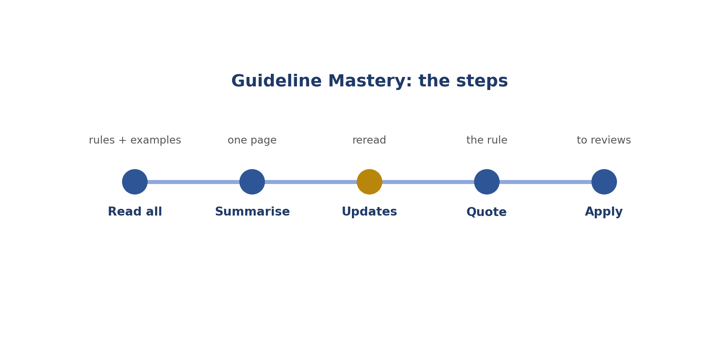
Guideline Mastery: the steps.
Picture: guideline mastery.
How to answer these tasks
1. Read the whole rulebook, including examples and FAQ.
2. Write a one-page summary.
3. Reread after every update.
4. When marking an error, find the exact rule.
5. Explain the rule when giving feedback.
TASK 9.1 · EASY
The situation: A QA reviewer is asked to check labels on a project they haven't read the guideline for.
What is this asking? What must a reviewer do first?
Your task: What must they do first?
Answer: Read the full guideline, including examples and FAQ, before reviewing anyone's work.
Why (explained simply): Read the whole rulebook. You can't judge work against rules you don't know.
Key word: Guideline = The project's rulebook.
In simple English: You can't check work against rules you don't know.

TASK 9.2 · MEDIUM
The situation: A contributor labels reflections; the guideline says reflections are excluded.
What is this asking? Reflections labelled when the rule says no?
Your task: What does the reviewer mark?
Answer: An error: reflections were labelled against the guideline.
Why (explained simply): That's an error, because the rule excludes reflections.
Key word: Exclude = Leave out.
In simple English: Know the rules well enough to spot breaks.

TASK 9.3 · EASY
The situation: A guideline was updated yesterday.
What is this asking? The rules changed yesterday?
Your task: What should a reviewer do?
Answer: Reread the changes before reviewing today's tasks.
Why (explained simply): Reread the changes before reviewing.
Key word: Update = A change to the rules.
In simple English: Reviewers must know the latest rules.

TASK 9.4 · MEDIUM
The situation: A reviewer marks a contributor wrong using a rule from a different project.
What is this asking? Using another project's rule?
Your task: What's the problem?
Answer: Each project's guideline is the standard; the reviewer applied the wrong rules.
Why (explained simply): Wrong. Each project's rulebook is the standard.
Key word: Standard = The correct way.
In simple English: Use this project's rules only.

TASK 9.5 · HARD
The situation: The guideline example contradicts the written rule.
What is this asking? Example and rule disagree?
Your task: What should a reviewer do?
Answer: Follow the project's priority rule if there is one; otherwise escalate for clarification and avoid marking contributors wrong on that point until it's clear.
Why (explained simply): Follow the priority rule, or ask before marking anyone wrong.
Key word: Contradict = Say the opposite.
In simple English: Don't punish people for unclear rules.

TASK 9.6 · EASY
The situation: Why must QA reviewers know the guideline better than contributors?
What is this asking? Why know the rules better than workers?
Your task: Explain.
Answer: Because they judge others' work against it and must explain errors correctly.
Why (explained simply): Because you judge their work and explain mistakes.
Key word: Reviewer = Someone who checks others' work.
In simple English: Reviewers set the standard.

TASK 9.7 · MEDIUM
The situation: A contributor asks the reviewer why a label was wrong.
What is this asking? What should you tell a worker who asks why?
Your task: What should the answer include?
Answer: The specific guideline rule and how the task broke it.
Why (explained simply): The exact rule and how the task broke it.
Key word: Explain = Make clear.
In simple English: Point to the exact rule.

TASK 9.8 · EASY
The situation: A reviewer keeps a one-page summary of key rules.
What is this asking? Is a one-page rules summary useful?
Your task: Is this useful?
Answer: Yes; it speeds up reviews and keeps decisions consistent.
Why (explained simply): Yes: it makes reviews faster and more consistent.
Key word: Summary = A short version.
In simple English: Keep key rules close.

TASK 9.9 · MEDIUM
The situation: A guideline says "box only fully visible people". A contributor boxed a half-hidden person.
What is this asking? Half-hidden person boxed?
Your task: Error or not?
Answer: Error: the rule excludes partly hidden people.
Why (explained simply): Error: the rule says fully visible only.
Key word: Fully visible = You can see all of it.
In simple English: Apply the rule exactly.

TASK 9.10 · HARD
The situation: A contributor's label follows a sensible interpretation of a vague rule.
What is this asking? Sensible choice on a vague rule?
Your task: How should the reviewer treat it?
Answer: Not as a clear error; note the ambiguity and escalate so the rule can be clarified.
Why (explained simply): Don't mark it as a clear error. Ask for the rule to be clarified.
Key word: Vague = Not clear.
In simple English: Vague rules need clarifying, not punishing.

TASK 9.11 · EASY
The situation: A new rule adds a "blurry" tag.
What is this asking? New "blurry" tag?
Your task: What should reviewers check in the next batch?
Answer: That contributors use the new tag correctly.
Why (explained simply): Check people use it correctly.
Key word: Tag = A label.
In simple English: Watch new rules closely.

TASK 9.12 · MEDIUM
The situation: A reviewer isn't sure whether a case is covered.
What is this asking? Not sure if a rule covers a case?
Your task: What should they do?
Answer: Check the guideline and FAQ; if still unsure, ask the project lead before marking.
Why (explained simply): Check the rulebook and FAQ, then ask.
Key word: FAQ = Common questions with answers.
In simple English: Ask before marking uncertain cases.

TASK 9.13 · EASY
The situation: Can a reviewer apply their own preferences?
What is this asking? Can you use your own preferences?
Your task: Answer.
Answer: No. Reviews must follow the guideline, not personal taste.
Why (explained simply): No. Follow the rulebook.
Key word: Preference = What you like.
In simple English: Rules, not taste.

TASK 9.14 · MEDIUM
The situation: The guideline has a rubric for scoring answers. A contributor gave 4 for an answer with a factual error, but the rubric caps factual errors at 3.
What is this asking? Score above the cap?
Your task: What does the reviewer mark?
Answer: An error: the score exceeds the cap.
Why (explained simply): Error: the score breaks the cap rule.
Key word: Cap = A limit on the highest score.
In simple English: Know the rubric's special rules.

TASK 9.15 · HARD
The situation: Two guideline sections seem to conflict on sarcasm labels.
What is this asking? Two sections disagree?
Your task: What's the best action?
Answer: Flag the conflict to the project lead and review consistently with any interim instruction.
Why (explained simply): Report the conflict to the project lead.
Key word: Conflict = When two rules disagree.
In simple English: Report conflicts in the rules.

TASK 9.16 · EASY
The situation: A reviewer reads only the summary page of a 40-page guideline.
What is this asking? Only read the summary page?
Your task: What's the risk?
Answer: Missing detailed rules and edge cases, leading to wrong review decisions.
Why (explained simply): You'll miss detailed rules and tricky cases.
Key word: Edge case = A tricky situation.
In simple English: Read the whole guideline.

TASK 9.17 · MEDIUM
The situation: A contributor followed an old FAQ answer that was later changed.
What is this asking? Followed an old FAQ?
Your task: How should the reviewer respond?
Answer: Mark the error but explain the updated rule kindly, noting the change.
Why (explained simply): Mark it, but explain the change kindly.
Key word: Kindly = In a nice way.
In simple English: Explain rule changes gently.

TASK 9.18 · EASY
The situation: What proves a reviewer has mastered a guideline?
What is this asking? What shows mastery?
Your task: Name one sign.
Answer: They can explain any rule and its reason, and apply it consistently to edge cases.
Why (explained simply): Explaining any rule and its reason, and applying it every time.
Key word: Mastery = Knowing something very well.
In simple English: Mastery means explaining and applying.

TASK 9.19 · MEDIUM
The situation: A guideline has 12 edge-case examples.
What is this asking? 12 tricky-case examples?
Your task: How should reviewers use them?
Answer: As reference points for similar cases in reviews.
Why (explained simply): Use them as guides for similar cases.
Key word: Reference = Something to check against.
In simple English: Use examples as guides.

TASK 9.20 · HARD
The situation: A reviewer finds they themselves misunderstood a rule for a week.
What is this asking? You misunderstood a rule for a week?
Your task: What should they do?
Answer: Tell the project lead, re-check affected reviews if possible, and correct feedback given.
Why (explained simply): Tell the lead, recheck affected reviews, and fix your feedback.
Key word: Responsibility = Owning your actions.
In simple English: Own and fix your own mistakes.

CHAPTER 11
QA Skill 2: Audit Sampling

THINK OF IT LIKE THIS
Sampling is like tasting soup. You don't drink the whole pot to know if it's salty. You stir it and taste one spoonful.
In simple English: Check a fair part to know about the whole.
In simple English: Check a fair, random part of the work.
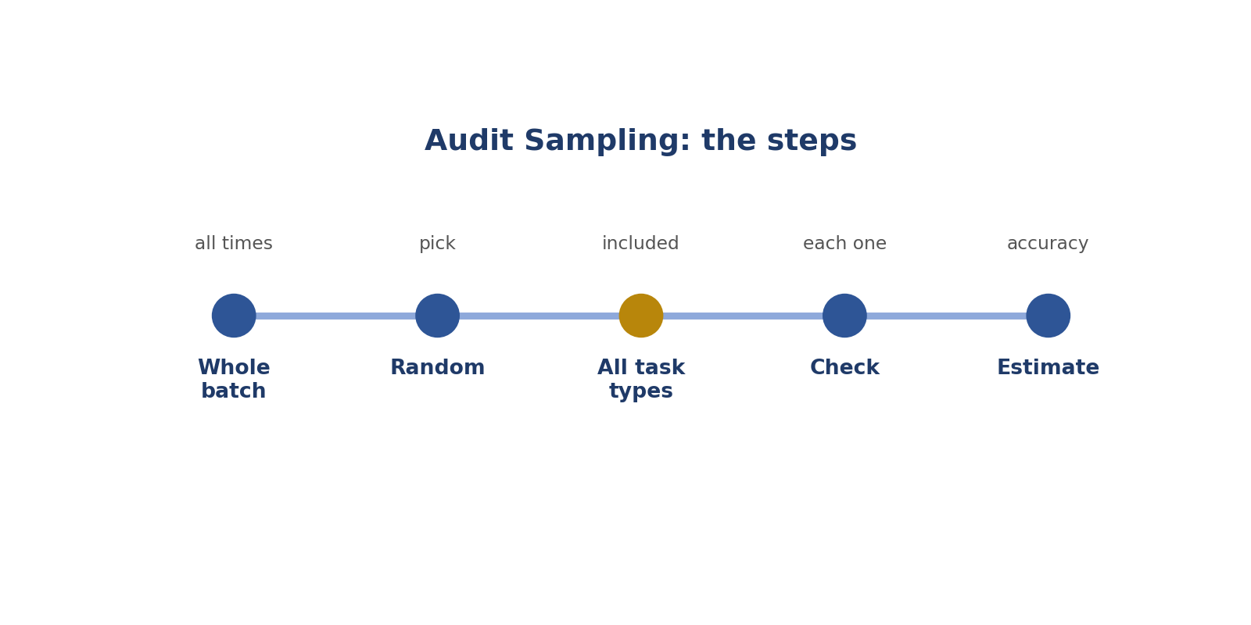
Audit Sampling: the steps.
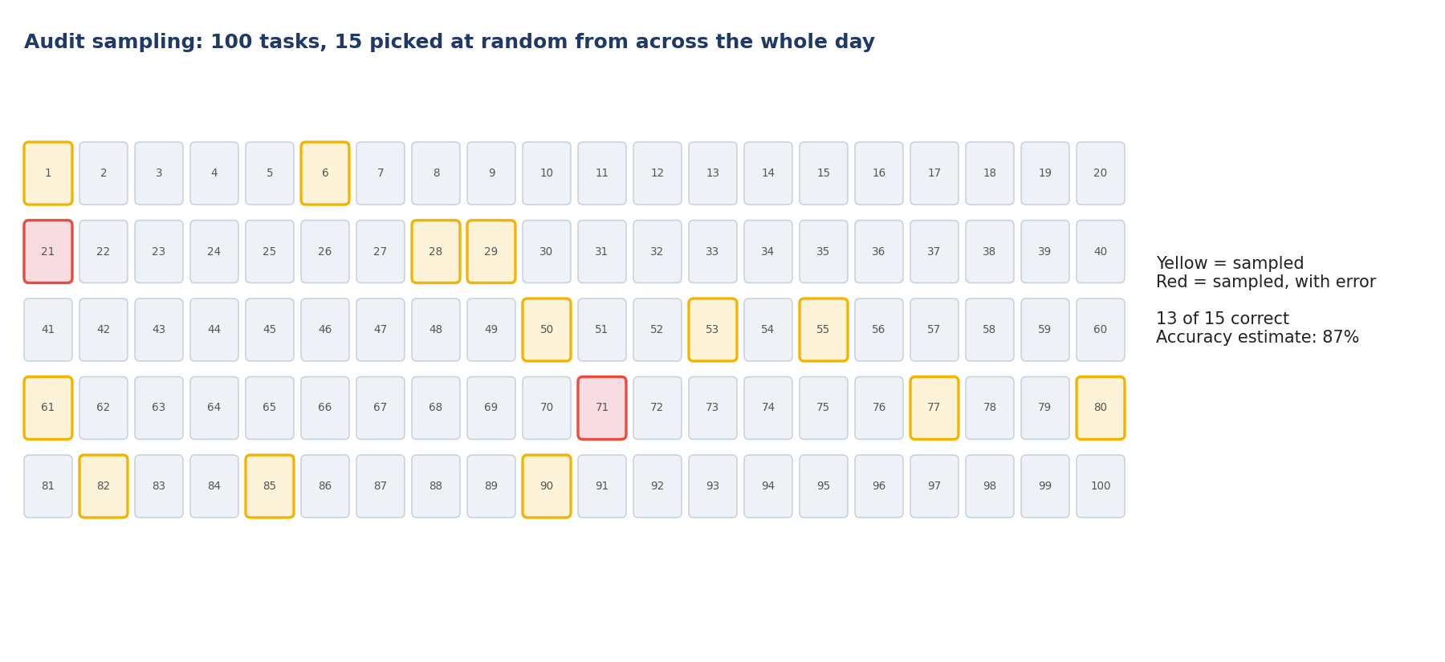
Picture: audit sampling.
How to answer these tasks
1. Look at the whole batch.
2. Pick tasks at random.
3. Include all times of day and all task types.
4. Check each sampled task.
5. Work out the accuracy rate.
TASK 10.1 · EASY
The situation: A reviewer must check a contributor's 500 tasks but only has time for 25.
What is this asking? 500 tasks, time for 25?
Your task: What is this called?
Answer: Sampling: checking a selection to estimate overall quality.
Why (explained simply): Check a sample: a fair part of the work.
Key word: Sample = A part that shows the whole.
In simple English: Check some to understand all.

TASK 10.2 · MEDIUM
The situation: A reviewer always checks the first 25 tasks of each batch.
What is this asking? Always the first 25 tasks?
Your task: What's the problem?
Answer: The sample isn't representative; later tasks (when tired) may differ. Sample across the whole batch.
Why (explained simply): Not fair. Later tasks may be different. Pick from the whole batch.
Key word: Representative = Showing the whole fairly.
In simple English: Sample from the whole batch.

TASK 10.3 · EASY
The situation: What is a random sample?
What is this asking? What is random?
Your task: Explain.
Answer: A selection where every task has an equal chance of being chosen.
Why (explained simply): Every task has the same chance of being picked.
Key word: Random = By chance.
In simple English: Random means every task could be picked.

TASK 10.4 · MEDIUM
The situation: A new contributor's first week of work.
What is this asking? New worker's first week?
Your task: Should the sample be larger or smaller?
Answer: Larger: new contributors need closer checking until quality is proven.
Why (explained simply): Check more, because their quality isn't proven yet.
Key word: New = Just started.
In simple English: Check new people more.

TASK 10.5 · HARD
The situation: A contributor has 98% accuracy for three months.
What is this asking? 98% for three months?
Your task: How might sampling change?
Answer: A smaller sample can be enough, with regular spot checks to catch drift.
Why (explained simply): A smaller sample can be enough, with regular checks.
Key word: Proven = Shown to be true.
In simple English: Proven quality needs lighter checks.

TASK 10.6 · EASY
The situation: Sample of 20 tasks: 2 errors.
What is this asking? 20 tasks, 2 errors?
Your task: What's the error rate?
Answer: 10%.
Why (explained simply): 2 ÷ 20 = 10% error rate.
Key word: Error rate = Wrong tasks out of all checked.
In simple English: Errors divided by tasks checked.

TASK 10.7 · MEDIUM
The situation: Sample of 40 tasks: 6 errors.
What is this asking? 40 tasks, 6 errors?
Your task: What's the accuracy rate?
Answer: 85% (34 correct out of 40).
Why (explained simply): 34 correct ÷ 40 = 85%.
Key word: Accuracy rate = Correct tasks out of all checked.
In simple English: Correct divided by total.

TASK 10.8 · MEDIUM
The situation: A reviewer samples only easy tasks.
What is this asking? Only easy tasks?
Your task: What's the risk?
Answer: Accuracy looks higher than it really is; include hard and edge cases.
Why (explained simply): Accuracy looks better than it really is.
Key word: Bias = A habit that makes results unfair.
In simple English: Include hard tasks in samples.

TASK 10.9 · HARD
The situation: A batch includes image tasks and text tasks.
What is this asking? Images and text?
Your task: How should you sample?
Answer: Sample both types in proportion, so both are represented.
Why (explained simply): Sample both kinds.
Key word: Proportion = The right share of each.
In simple English: Sample every task type.

TASK 10.10 · EASY
The situation: Why not check every task?
What is this asking? Why not check everything?
Your task: Explain.
Answer: It's usually too time-consuming; good sampling gives a reliable estimate faster.
Why (explained simply): It takes too long. A good sample is enough.
Key word: Efficient = Quick and good.
In simple English: Sampling saves time.

TASK 10.11 · MEDIUM
The situation: A contributor's error rate in the sample is much higher than usual.
What is this asking? Sample looks much worse than usual?
Your task: What should the reviewer do?
Answer: Check a larger sample to confirm, then give feedback.
Why (explained simply): Check more tasks to be sure, then give feedback.
Key word: Confirm = Make sure.
In simple English: Check more before concluding.

TASK 10.12 · EASY
The situation: A sample should include tasks from which part of a work session?
What is this asking? Which part of the day?
Your task: Answer.
Answer: All parts: beginning, middle and end.
Why (explained simply): Beginning, middle and end.
Key word: Session = A period of work.
In simple English: Check early and late work.

TASK 10.13 · MEDIUM
The situation: Two reviewers sample the same contributor and get very different accuracy rates.
What is this asking? Two reviewers get different results?
Your task: What might explain it?
Answer: Small samples, different task types, or reviewers applying rules differently.
Why (explained simply): Small samples, different tasks, or different rule use.
Key word: Difference = How things are not the same.
In simple English: Differences need investigating.

TASK 10.14 · HARD
The situation: A project wants 95% confidence in accuracy estimates.
What is this asking? Need to be very sure?
Your task: What does that usually mean for sample size?
Answer: A larger sample is needed; exact size depends on the method the project uses.
Why (explained simply): Use a bigger sample.
Key word: Confidence = How sure you are.
In simple English: More confidence needs bigger samples.

TASK 10.15 · EASY
The situation: A reviewer picks tasks they think will have errors.
What is this asking? Only picking tasks you expect to be wrong?
Your task: Is this random sampling?
Answer: No; it's targeted checking, useful for investigating but not for measuring overall accuracy.
Why (explained simply): That's targeted checking, not random.
Key word: Targeted = Chosen on purpose.
In simple English: Targeted checks aren't random.

TASK 10.16 · MEDIUM
The situation: A contributor improved after feedback.
What is this asking? Did feedback help?
Your task: How can sampling show this?
Answer: Compare error rates in samples before and after the feedback.
Why (explained simply): Compare error rates before and after.
Key word: Compare = Look at differences.
In simple English: Compare samples over time.

TASK 10.17 · EASY
The situation: Sample of 50 tasks, 50 correct.
What is this asking? 50 out of 50 correct?
Your task: What does this show?
Answer: Very high quality in the sample; continue regular spot checks.
Why (explained simply): Excellent, but keep checking regularly.
Key word: Perfect = No mistakes.
In simple English: Keep checking even when perfect.

TASK 10.18 · MEDIUM
The situation: The project changes guidelines mid-batch.
What is this asking? Rules changed mid-batch?
Your task: How should sampling handle it?
Answer: Sample separately before and after the change and judge each against the rule in force.
Why (explained simply): Judge each task by the rule in force at that time.
Key word: In force = Being used at that time.
In simple English: Judge by the rule at that time.

TASK 10.19 · HARD
The situation: Golden tasks are mixed into work.
What is this asking? Golden tasks?
Your task: How do they relate to sampling?
Answer: They're built-in samples with known answers, giving automatic accuracy checks.
Why (explained simply): They're built-in test tasks with known answers.
Key word: Golden task = A hidden test task.
In simple English: Golden tasks are automatic samples.

TASK 10.20 · EASY
The situation: Why record which tasks were sampled?
What is this asking? Why record what you sampled?
Your task: Explain.
Answer: So results can be checked, repeated and compared later.
Why (explained simply): So results can be checked and repeated.
Key word: Record = Write down.
In simple English: Record your samples.

CHAPTER 12
QA Skill 3: Error Categorisation

THINK OF IT LIKE THIS
Categorising errors is like sorting laundry into whites, colours and darks. Once sorted, you can see what you have most of.
In simple English: Sort mistakes into groups.
In simple English: Give every mistake a group name and a seriousness level.
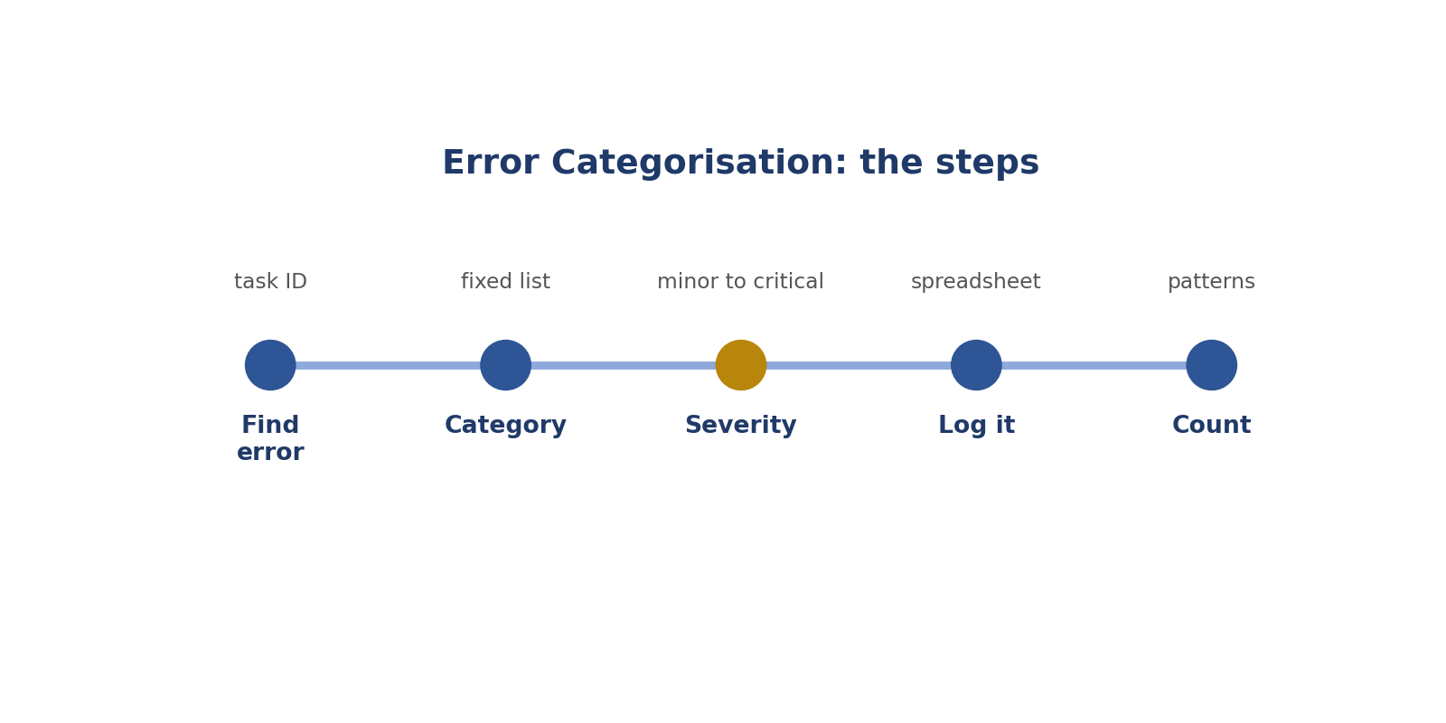
Error Categorisation: the steps.
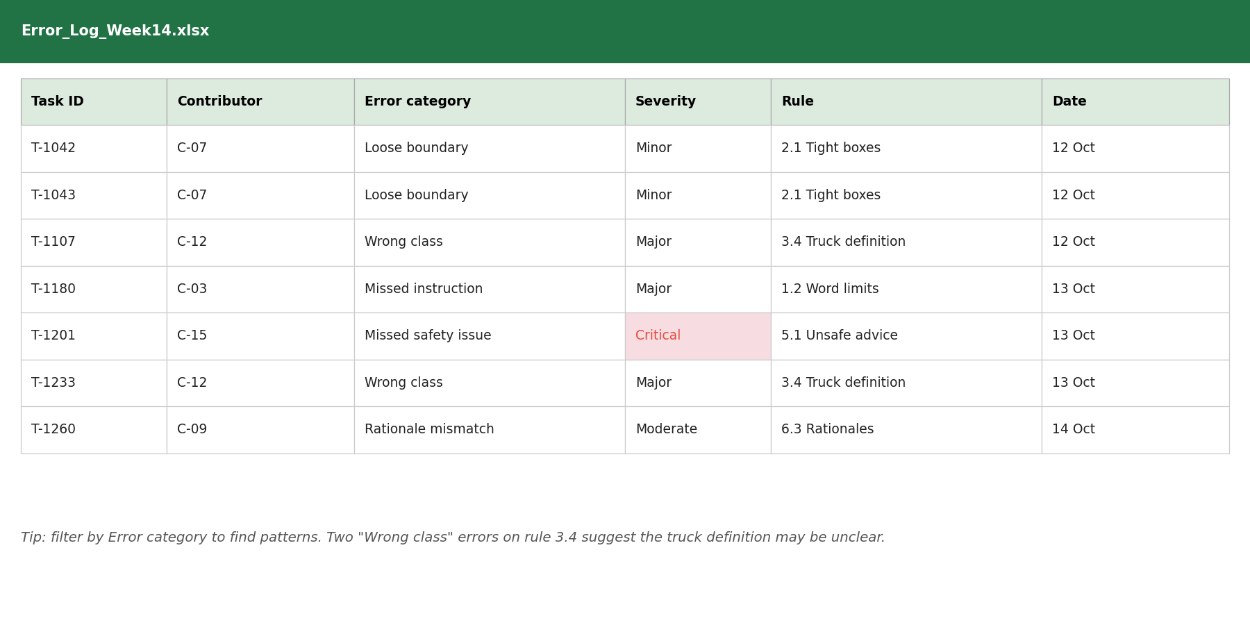
Picture: error categorisation.
How to answer these tasks
1. Find the error and note the task ID.
2. Choose its category from the fixed list.
3. Choose its severity.
4. Write it in the error log.
5. Count categories to find patterns.
TASK 11.1 · EASY
The situation: A contributor labels a dog as a cat.
What is this asking? Dog labelled as cat?
Your task: Which error category?
Answer: Wrong class (misclassification).
Why (explained simply): Wrong class: the wrong name was used.
Key word: Class = The name of a thing.
In simple English: Wrong label type is a class error.

TASK 11.2 · EASY
The situation: A box leaves out part of the object.
What is this asking? Box cuts off part?
Your task: Which error category?
Answer: Boundary or precision error.
Why (explained simply): Boundary error: the edge is wrong.
Key word: Boundary = The edge.
In simple English: Wrong edges are precision errors.

TASK 11.3 · MEDIUM
The situation: A rating misses a factual error in the answer.
What is this asking? Missed a wrong fact?
Your task: Which category?
Answer: Missed accuracy issue.
Why (explained simply): Missed accuracy issue.
Key word: Accuracy = Being correct.
In simple English: Missing a wrong fact is its own error type.

TASK 11.4 · MEDIUM
The situation: A rationale contradicts the rating.
What is this asking? Reason disagrees with score?
Your task: Which category?
Answer: Rationale-rating mismatch.
Why (explained simply): Rationale-rating mismatch.
Key word: Mismatch = Two things disagree.
In simple English: Contradictions have their own category.

TASK 11.5 · EASY
The situation: Why use fixed error categories?
What is this asking? Why fixed categories?
Your task: Explain.
Answer: So errors can be counted and compared across contributors and time.
Why (explained simply): So mistakes can be counted and compared.
Key word: Category = A group name.
In simple English: Fixed categories make counting possible.

TASK 11.6 · MEDIUM
The situation: A contributor uses "about the same" when one answer is unsafe.
What is this asking? Tie when one answer is unsafe?
Your task: Which category?
Answer: Wrong preference or severity misjudgment.
Why (explained simply): Severity misjudgment: safety was ignored.
Key word: Misjudgment = A wrong decision.
In simple English: Missing a safety problem is a severity error.

TASK 11.7 · HARD
The situation: An error fits two categories.
What is this asking? Fits two categories?
Your task: What should you do?
Answer: Use the project's rule for primary category; if none, choose the one that best describes the cause and note it.
Why (explained simply): Use the project's rule for the main one.
Key word: Primary = Main.
In simple English: Pick the main cause.

TASK 11.8 · EASY
The situation: A contributor skipped a task that should have been labelled.
What is this asking? Skipped a task?
Your task: Which category?
Answer: Missed item or omission.
Why (explained simply): Omission: something was missed.
Key word: Omission = Something left out.
In simple English: Skipped work is an omission.

TASK 11.9 · MEDIUM
The situation: A keypoint is placed on the wrong joint.
What is this asking? Dot on the wrong joint?
Your task: Which category?
Answer: Keypoint placement error.
Why (explained simply): Keypoint placement error.
Key word: Keypoint = A dot on a body part.
In simple English: Wrong point, wrong place.

TASK 11.10 · MEDIUM
The situation: A contributor labels a reflection, which the guideline excludes.
What is this asking? Labelled an excluded reflection?
Your task: Which category?
Answer: Guideline violation (labelled an excluded object).
Why (explained simply): Guideline violation.
Key word: Violation = Breaking a rule.
In simple English: Breaking a rule is a guideline error.

TASK 11.11 · EASY
The situation: A rationale has spelling mistakes but is otherwise correct.
What is this asking? Spelling mistakes in a reason?
Your task: Which category?
Answer: Minor writing quality issue.
Why (explained simply): Minor writing issue.
Key word: Minor = Small.
In simple English: Small writing issues are minor.

TASK 11.12 · HARD
The situation: A reviewer invents new categories for every error.
What is this asking? New names for every error?
Your task: What's the problem?
Answer: Results can't be counted or compared; use the project's fixed list.
Why (explained simply): Can't be counted. Use the fixed list.
Key word: Fixed list = A list that doesn't change.
In simple English: Use the fixed list.

TASK 11.13 · MEDIUM
The situation: A score is 5 when the rubric says 3.
What is this asking? 5 when the rubric says 3?
Your task: Which category?
Answer: Scoring or calibration error.
Why (explained simply): Scoring (calibration) error.
Key word: Calibration = Matching the standard.
In simple English: Wrong score is a calibration error.

TASK 11.14 · EASY
The situation: A contributor answers in English when the guideline says French.
What is this asking? English instead of French?
Your task: Which category?
Answer: Instruction or language violation.
Why (explained simply): Instruction or language error.
Key word: Language = The words people speak.
In simple English: Wrong language breaks instructions.

TASK 11.15 · MEDIUM
The situation: A contributor misses a false premise in a prompt.
What is this asking? Missed a false idea in a prompt?
Your task: Which category?
Answer: Missed reasoning or premise issue.
Why (explained simply): Reasoning or premise error.
Key word: Premise = An idea a question is built on.
In simple English: Missing a false idea is a reasoning error.

TASK 11.16 · HARD
The situation: One contributor has many different small errors; another has one repeated error.
What is this asking? Many small errors or one repeated error?
Your task: Which is easier to fix?
Answer: The repeated error, because one clear piece of feedback can fix it.
Why (explained simply): The repeated one is easier to fix with one piece of feedback.
Key word: Repeated = Happening again.
In simple English: Repeated errors have one fix.

TASK 11.17 · EASY
The situation: A label is correct but in the wrong field.
What is this asking? Right label, wrong box in the tool?
Your task: Which category?
Answer: Tool or entry error.
Why (explained simply): Tool or entry error.
Key word: Entry = What was typed or clicked.
In simple English: Wrong place in the tool is a tool error.

TASK 11.18 · MEDIUM
The situation: A contributor flags too many tasks that were clearly covered by the guideline.
What is this asking? Flagging things that are covered?
Your task: Which category?
Answer: Over-flagging (guideline understanding issue).
Why (explained simply): Over-flagging: they need to learn the rules better.
Key word: Over-flagging = Asking too often.
In simple English: Flagging too much is also an issue.

TASK 11.19 · MEDIUM
The situation: Severity levels: minor, major, critical.
What is this asking? Missed safety issue: which severity?
Your task: Where does a missed safety issue go?
Answer: Critical (or major, per project definitions).
Why (explained simply): Critical (or major, depending on the project).
Key word: Critical = Extremely serious.
In simple English: Safety misses are serious.

TASK 11.20 · EASY
The situation: Why add severity to categories?
What is this asking? Why add severity?
Your task: Explain.
Answer: So serious errors are fixed first.
Why (explained simply): So the most serious mistakes are fixed first.
Key word: Severity = How serious.
In simple English: Serious errors come first.

CHAPTER 13
QA Skill 4: Spotting Root Causes

THINK OF IT LIKE THIS
Finding a root cause is like finding a leak. Mopping the floor every day doesn't help. Fixing the pipe does.
In simple English: Fix the cause, not just the mess.
In simple English: Find the real reason mistakes happen.
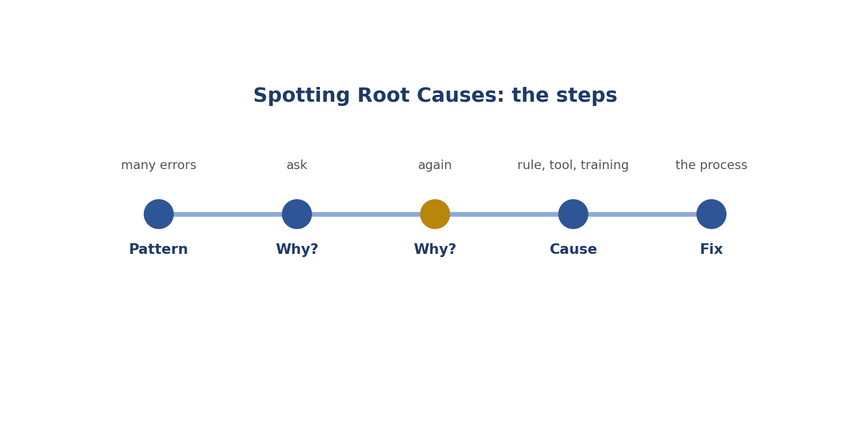
Spotting Root Causes: the steps.
Picture: spotting root causes.
How to answer these tasks
1. Look for patterns in the error log.
2. Ask why it happens.
3. Ask why again.
4. Find something that can be changed.
5. Suggest a fix to the process.
TASK 12.1 · EASY
The situation: Five contributors make the same labelling mistake.
What is this asking? Five people, same mistake?
Your task: What might the root cause be?
Answer: An unclear guideline or example, rather than five careless people.
Why (explained simply): Probably an unclear rule or example, not five careless people.
Key word: Root cause = The real reason.
In simple English: Many people, same mistake: check the rules.

TASK 12.2 · MEDIUM
The situation: One contributor's accuracy drops after a tool update.
What is this asking? Errors after a tool update?
Your task: What should you check?
Answer: Whether the tool change caused the errors (for example new default settings).
Why (explained simply): Check if the tool change caused them.
Key word: Tool update = A change to the software.
In simple English: Check what changed.

TASK 12.3 · EASY
The situation: A contributor's errors increase late in the day.
What is this asking? More errors late in the day?
Your task: Likely cause?
Answer: Tiredness.
Why (explained simply): Tiredness.
Key word: Tiredness = Needing rest.
In simple English: Timing can reveal the cause.

TASK 12.4 · MEDIUM
The situation: Errors cluster on images taken at night.
What is this asking? Errors on night images?
Your task: Likely cause?
Answer: Difficult images or unclear rules for dark scenes.
Why (explained simply): Hard images or unclear rules for dark scenes.
Key word: Cluster = A group close together.
In simple English: Look for patterns in the data.

TASK 12.5 · HARD
The situation: Rationale-rating mismatches rise after a new rating interface.
What is this asking? Mismatches after a new interface?
Your task: What might be happening?
Answer: The new interface may make it easy to click the wrong option; report it and suggest a confirmation step.
Why (explained simply): The new screen may cause wrong clicks. Suggest a check step.
Key word: Interface = What the software looks like.
In simple English: Tools can cause errors.

TASK 12.6 · EASY
The situation: What question do you repeat to find a root cause?
What is this asking? What question finds root causes?
Your task: Name it.
Answer: "Why?" asked several times until you reach something that can be changed.
Why (explained simply): "Why?", asked again and again.
Key word: Why = Asking for a reason.
In simple English: Keep asking why.

TASK 12.7 · MEDIUM
The situation: A contributor confuses "truck" and "bus" repeatedly.
What is this asking? Truck and bus mixed up?
Your task: Possible causes?
Answer: Unclear class definitions, similar-looking vehicles, or missing training; check the guideline definitions.
Why (explained simply): Unclear definitions or look-alike vehicles. Check the rules.
Key word: Definition = Written meaning.
In simple English: Check definitions.

TASK 12.8 · MEDIUM
The situation: Errors spike after a guideline update.
What is this asking? Errors after a rule update?
Your task: Likely cause?
Answer: The update was unclear or not read; clarify and remind contributors.
Why (explained simply): The update was unclear or not read. Clarify and remind.
Key word: Update = A change.
In simple English: Rule changes can cause errors.

TASK 12.9 · EASY
The situation: Why fix root causes rather than single errors?
What is this asking? Why fix causes?
Your task: Explain.
Answer: Fixing a cause prevents many future errors at once.
Why (explained simply): One fix stops many future mistakes.
Key word: Prevent = Stop before it happens.
In simple English: Fix the cause, not only the mistake.

TASK 12.10 · HARD
The situation: Errors are spread evenly across all contributors and task types.
What is this asking? Errors everywhere equally?
Your task: What might this suggest?
Answer: A broad issue such as unclear instructions or a flawed rubric, not individual performance.
Why (explained simply): A big problem, like unclear instructions.
Key word: Widespread = Found everywhere.
In simple English: Everywhere errors mean a system problem.

TASK 12.11 · MEDIUM
The situation: One contributor makes the same error on every task.
What is this asking? Same error on every task?
Your task: Likely cause?
Answer: A misunderstanding of one rule; targeted feedback should fix it.
Why (explained simply): They misunderstand one rule. Give clear feedback on it.
Key word: Misunderstand = Get the wrong idea.
In simple English: One rule misunderstood.

TASK 12.12 · EASY
The situation: A contributor's accuracy falls on weekends.
What is this asking? Worse on weekends?
Your task: What might be happening?
Answer: Rushing, distractions or tiredness; discuss working habits.
Why (explained simply): Rushing or distractions. Talk about working habits.
Key word: Distraction = Something taking your attention.
In simple English: Look at working conditions.

TASK 12.13 · MEDIUM
The situation: Wrong labels appear only on tasks from one data source.
What is this asking? Errors only from one data source?
Your task: Likely cause?
Answer: That source's data may be unusual or low quality; check the data itself.
Why (explained simply): That data may be unusual or poor. Check it.
Key word: Data source = Where data comes from.
In simple English: Bad data causes bad labels.

TASK 12.14 · HARD
The situation: After feedback, a contributor's error rate stays the same.
What is this asking? Feedback didn't help?
Your task: What might the root cause be?
Answer: The feedback wasn't clear or actionable, or the rule itself is confusing; rewrite the feedback with examples.
Why (explained simply): The feedback may be unclear. Rewrite it with examples.
Key word: Actionable = Clear enough to act on.
In simple English: If feedback doesn't work, improve it.

TASK 12.15 · EASY
The situation: A spreadsheet shows most errors are "missed instruction".
What is this asking? Most errors are missed instructions?
Your task: What's a likely fix?
Answer: Add an instruction checklist step for contributors.
Why (explained simply): Add an instruction checklist step.
Key word: Checklist = A list to tick.
In simple English: Common errors need a process fix.

TASK 12.16 · MEDIUM
The situation: Several contributors use the wrong tag after the tag list was reordered.
What is this asking? Wrong tags after a list was reordered?
Your task: Likely cause?
Answer: The reordering led to mis-clicks; suggest clearer layout or a confirmation step.
Why (explained simply): The new order causes wrong clicks. Suggest a clearer layout.
Key word: Layout = How things are arranged.
In simple English: Layout changes cause mistakes.

TASK 12.17 · HARD
The situation: Errors happen mostly in the first hour of new projects.
What is this asking? Errors in the first hour?
Your task: What does this suggest?
Answer: Onboarding may not prepare contributors enough; improve training examples.
Why (explained simply): Training may need improving.
Key word: Onboarding = Training at the start.
In simple English: Early errors point to training.

TASK 12.18 · EASY
The situation: A reviewer blames a contributor without checking the guideline.
What is this asking? Blaming without checking rules?
Your task: What's wrong?
Answer: The cause might be the guideline; check it first.
Why (explained simply): The rule might be the problem. Check it first.
Key word: Blame = Say someone is at fault.
In simple English: Check the rules before blaming people.

TASK 12.19 · MEDIUM
The situation: Errors drop after a new FAQ is added.
What is this asking? Errors drop after a new FAQ?
Your task: What does this confirm?
Answer: The root cause was a gap in the guidance.
Why (explained simply): The cause was missing guidance.
Key word: Guidance = Help and instructions.
In simple English: Better guidance fixes errors.

TASK 12.20 · MEDIUM
The situation: Root cause found: two class names look almost identical.
What is this asking? Two class names look alike?
Your task: Best fix?
Answer: Rename or clearly define the classes, and add examples.
Why (explained simply): Rename or define them clearly, with examples.
Key word: Look-alike = Things that look the same.
In simple English: Fix confusing names.

CHAPTER 14
QA Skill 5: Writing Constructive Feedback

THINK OF IT LIKE THIS
Good feedback is like a good coach. A coach doesn't just shout "bad!"; they show what went wrong and how to do it better, and say what you did well.
In simple English: Show what's wrong, how to fix it, and what's good.
In simple English: Say what's wrong, why, and how to fix it, kindly.
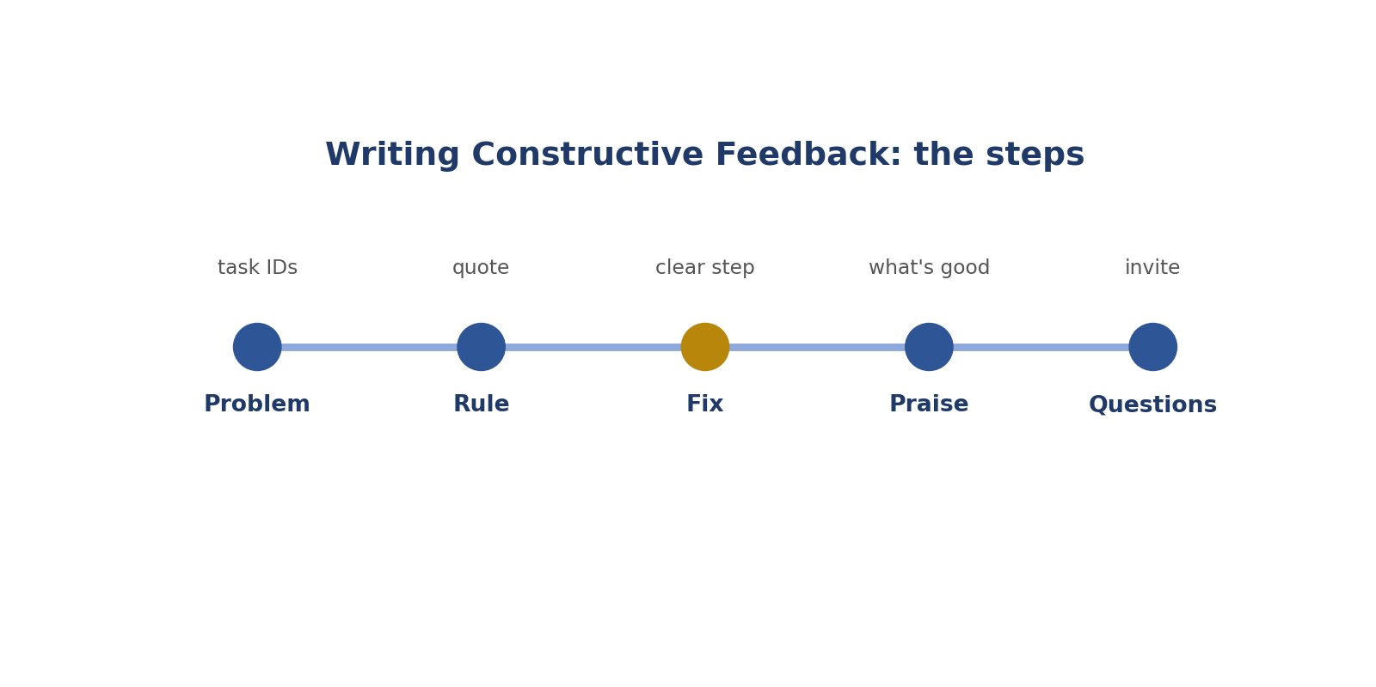
Writing Constructive Feedback: the steps.
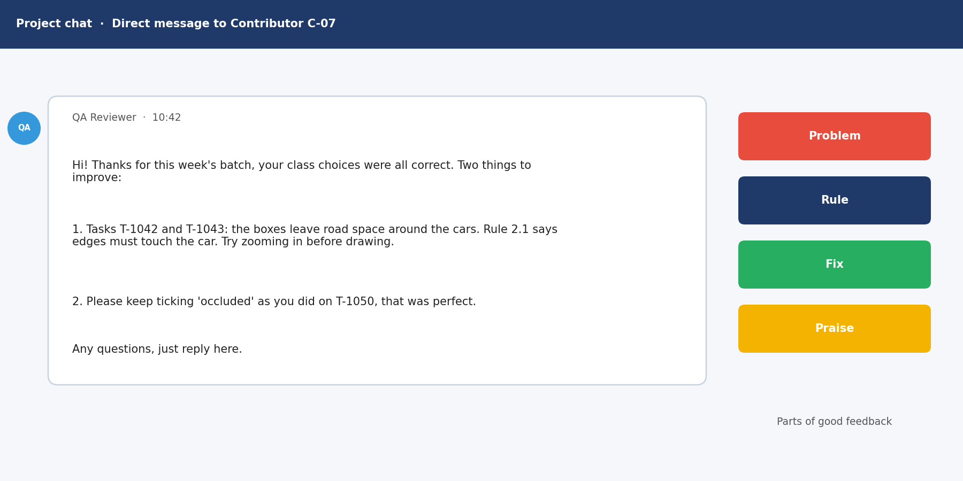
Picture: writing constructive feedback.
How to answer these tasks
1. Name the task and the problem.
2. Quote the rule it broke.
3. Give one clear fix.
4. Praise something done well.
5. Invite questions.
TASK 13.1 · EASY
The situation: Feedback: "Your work is bad."
What is this asking? Improve "Your work is bad."
Your task: Improve it.
Answer: "3 of 20 boxes left out the car mirrors. The guideline includes mirrors; please zoom in at the edges."
Why (explained simply): Say the problem, the rule and the fix: "3 of 20 boxes left out mirrors; rule 2.1 includes them; zoom in."
Key word: Constructive = Helpful and aimed at improving.
In simple English: Be specific and helpful.

TASK 13.2 · EASY
The situation: What three parts make feedback useful?
What is this asking? Three parts of useful feedback?
Your task: List them.
Answer: What was wrong, the rule it broke, and how to fix it.
Why (explained simply): What was wrong, the rule it broke, and how to fix it.
Key word: Feedback = Advice to help improve.
In simple English: Problem, rule, fix.

TASK 13.3 · MEDIUM
The situation: Feedback is given only when errors happen.
What is this asking? Only feedback on errors?
Your task: What could be added?
Answer: Positive feedback on what's going well, to reinforce good habits.
Why (explained simply): Also praise what's going well.
Key word: Praise = Saying what someone did well.
In simple English: Praise good work too.

TASK 13.4 · MEDIUM
The situation: Feedback lists 15 different issues at once.
What is this asking? 15 issues at once?
Your task: What's better?
Answer: Focus on the two or three most important issues first.
Why (explained simply): Too many. Focus on the top 2 or 3.
Key word: Focus = Pay attention to the main things.
In simple English: Focus on the biggest issues.

TASK 13.5 · EASY
The situation: Feedback uses harsh words.
What is this asking? Harsh words?
Your task: Why avoid this?
Answer: It discourages people and makes them less likely to improve.
Why (explained simply): They upset people and don't help them improve.
Key word: Harsh = Unkind and hard.
In simple English: Be kind and clear.

TASK 13.6 · HARD
The situation: A contributor repeatedly makes the same error despite feedback.
What is this asking? Same error after feedback?
Your task: How should the next feedback change?
Answer: Add a concrete example of the correct label and a short checklist step; check understanding.
Why (explained simply): Show a clear example of the right way, and add a checklist step.
Key word: Example = A sample showing the right way.
In simple English: Show, don't just tell.

TASK 13.7 · EASY
The situation: Feedback: "Follow the guideline."
What is this asking? Improve "Follow the guideline."
Your task: Improve it.
Answer: Name the rule: "Section 3.2: reflections must not be labelled. Tasks 14 and 22 labelled reflections."
Why (explained simply): Name the exact rule and the tasks.
Key word: Specific = Exact.
In simple English: Name the exact rule.

TASK 13.8 · MEDIUM
The situation: Feedback is sent two weeks after the errors.
What is this asking? Feedback two weeks late?
Your task: Why is this a problem?
Answer: The contributor may repeat the error for two weeks; give feedback promptly.
Why (explained simply): They may repeat the mistake for two weeks. Give it quickly.
Key word: Prompt = Quick, on time.
In simple English: Give feedback quickly.

TASK 13.9 · MEDIUM
The situation: A contributor disagrees with your feedback.
What is this asking? The worker disagrees?
Your task: What should you do?
Answer: Listen, check the guideline again, and either explain the rule or correct your feedback if you were wrong.
Why (explained simply): Listen, check the rule again, and explain or correct yourself.
Key word: Listen = Pay attention to what someone says.
In simple English: Stay open to being wrong.

TASK 13.10 · EASY
The situation: Feedback includes the task IDs.
What is this asking? Why include task IDs?
Your task: Why is that useful?
Answer: The contributor can find and review the exact tasks.
Why (explained simply): So they can find the exact tasks.
Key word: Task ID = The number that names a task.
In simple English: Point to the exact tasks.

TASK 13.11 · HARD
The situation: Write feedback for a contributor whose rationales are vague.
What is this asking? Feedback for vague reasons?
Your task: Write it.
Answer: "Your scores are well calibrated. To improve, name the exact error in each rationale, for example: 'States the deadline is 30 June; the official notice says 15 June.'"
Why (explained simply): Praise first, then show how to make reasons specific.
Key word: Vague = Not exact.
In simple English: Praise, then give a specific improvement.

TASK 13.12 · EASY
The situation: Feedback compares the contributor to others: "Everyone else does better."
What is this asking? "Everyone else does better"?
Your task: Why avoid this?
Answer: It's discouraging and doesn't help them improve.
Why (explained simply): It's discouraging and doesn't help.
Key word: Discouraging = Making someone feel bad.
In simple English: Focus on their work, not others.

TASK 13.13 · MEDIUM
The situation: Feedback: "Be more careful."
What is this asking? Improve "Be more careful."
Your task: Improve it.
Answer: Say what to check: "Count the requested items before rating; tasks 5 and 9 had 4 tips instead of 5."
Why (explained simply): Say exactly what to check: "Count the items before scoring."
Key word: Actionable = Clear enough to act on.
In simple English: Tell them what to check.

TASK 13.14 · MEDIUM
The situation: A contributor improved a lot.
What is this asking? A worker improved a lot?
Your task: What should feedback include?
Answer: Recognition of the improvement and the specific habits that helped.
Why (explained simply): Say so, and name the habit that helped.
Key word: Recognise = Notice and praise.
In simple English: Recognise progress.

TASK 13.15 · EASY
The situation: Should feedback be public?
What is this asking? Public or private?
Your task: Answer.
Answer: Usually private, to respect the contributor.
Why (explained simply): Usually private, out of respect.
Key word: Private = Only between you two.
In simple English: Give feedback privately.

TASK 13.16 · HARD
The situation: Feedback needs to cover a serious integrity issue (AI-generated work).
What is this asking? A serious honesty problem?
Your task: How should it be handled?
Answer: Follow the project's formal process; be factual and neutral, and involve the project lead.
Why (explained simply): Follow the project's formal process, and stay calm and factual.
Key word: Formal process = The official steps.
In simple English: Serious issues follow formal rules.

TASK 13.17 · EASY
The situation: Feedback ends with "Any questions?"
What is this asking? Ending with "Any questions?"
Your task: Why is this good?
Answer: It invites clarification and shows support.
Why (explained simply): Good: it offers help.
Key word: Support = Help.
In simple English: Invite questions.

TASK 13.18 · MEDIUM
The situation: Feedback uses jargon the contributor may not know.
What is this asking? Using hard words?
Your task: What should you do?
Answer: Use plain language or explain terms.
Why (explained simply): Use simple words or explain them.
Key word: Jargon = Special hard words.
In simple English: Use simple words.

TASK 13.19 · MEDIUM
The situation: You gave wrong feedback yesterday.
What is this asking? You gave wrong feedback?
Your task: What should you do?
Answer: Correct it quickly and apologise briefly.
Why (explained simply): Fix it quickly and say sorry briefly.
Key word: Apologise = Say sorry.
In simple English: Fix your own mistakes.

TASK 13.20 · EASY
The situation: Feedback is two short, specific sentences.
What is this asking? Two short sentences?
Your task: Is short OK?
Answer: Yes, if it names the problem, the rule and the fix.
Why (explained simply): Fine, if they name the problem, the rule and the fix.
Key word: Short = Not long.
In simple English: Short and specific is fine.

CHAPTER 15
QA Skill 6: Checking Consistency Across Raters

THINK OF IT LIKE THIS
Raters are like judges at a talent show. If one judge always gives 2 and the others give 9, something is wrong with how they're judging.
In simple English: Judges should mostly agree.
In simple English: Make sure everyone scores the same way.
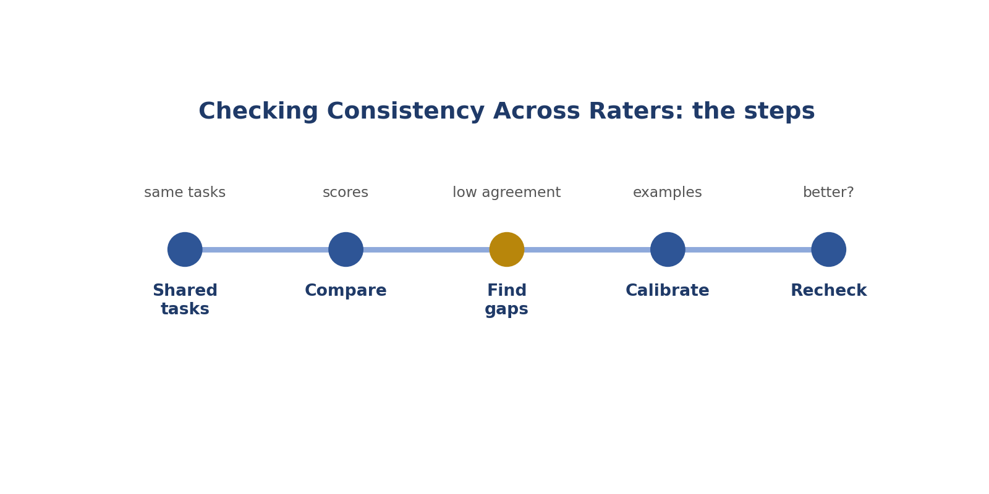
Checking Consistency Across Raters: the steps.
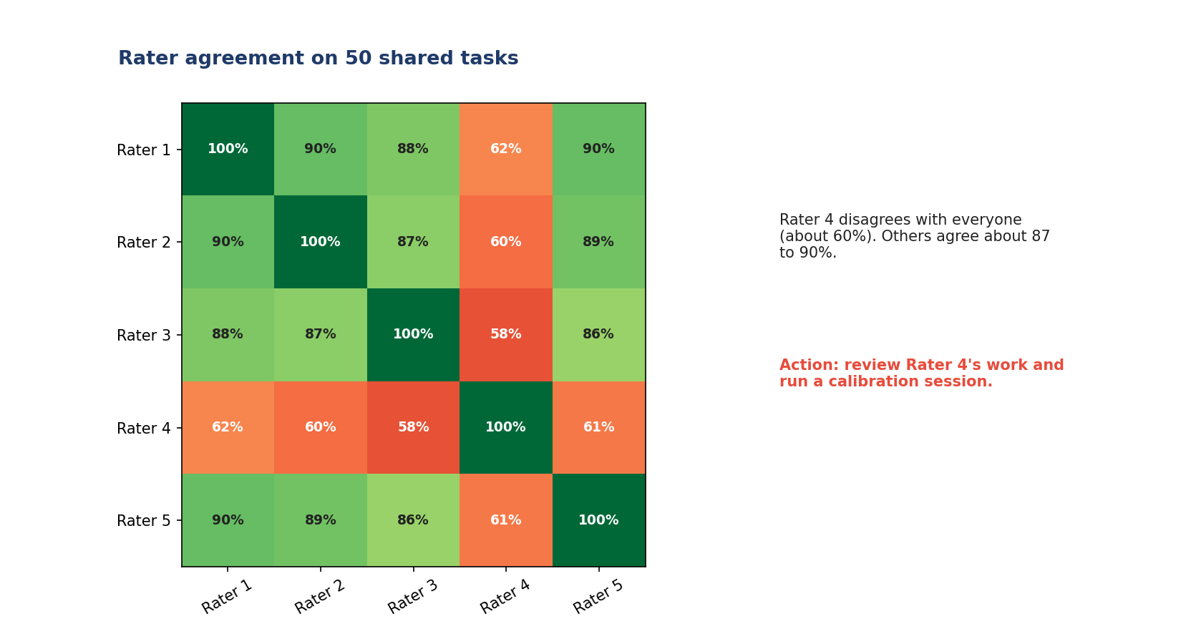
Picture: checking consistency across raters.
How to answer these tasks
1. Give several raters the same tasks.
2. Compare their scores.
3. Find where they disagree.
4. Find out why and clarify the rule.
5. Check again later.
TASK 14.1 · EASY
The situation: Two raters score the same answer 2 and 5.
What is this asking? Scores of 2 and 5 for the same answer?
Your task: What does this show?
Answer: Low agreement; at least one is miscalibrated or the rubric is unclear.
Why (explained simply): They disagree a lot. Someone is off, or the rule is unclear.
Key word: Agreement = How often raters match.
In simple English: Big gaps need checking.

TASK 14.2 · MEDIUM
The situation: What is inter-rater agreement?
What is this asking? What is inter-rater agreement?
Your task: Define it.
Answer: How often different raters give the same (or similar) scores for the same task.
Why (explained simply): How often different raters give the same score.
Key word: Inter-rater = Between different raters.
In simple English: Agreement means raters match.

TASK 14.3 · EASY
The situation: Why does agreement matter?
What is this asking? Why does agreement matter?
Your task: Explain.
Answer: Consistent data trains AI better; disagreement adds noise.
Why (explained simply): The AI learns better from data that agrees.
Key word: Consistent = The same.
In simple English: Agreement makes data useful.

TASK 14.4 · MEDIUM
The situation: Raters agree 95% on accuracy but only 60% on tone.
What is this asking? 95% on accuracy but 60% on tone?
Your task: What might help?
Answer: Clarify the tone definitions and add examples.
Why (explained simply): The tone rule needs clearer examples.
Key word: Clarify = Make clearer.
In simple English: Low agreement shows unclear rules.

TASK 14.5 · HARD
The situation: One rater disagrees with everyone else on most tasks.
What is this asking? One rater disagrees with everyone?
Your task: What's the likely issue?
Answer: That rater is miscalibrated; review their work and give targeted feedback.
Why (explained simply): That rater needs calibrating.
Key word: Outlier = Very different from the rest.
In simple English: One outlier needs recalibrating.

TASK 14.6 · EASY
The situation: Three raters score an answer 4, 4, 4.
What is this asking? 4, 4, 4?
Your task: What does this show?
Answer: Full agreement on that task.
Why (explained simply): Full agreement.
Key word: Full = Complete.
In simple English: Same scores mean agreement.

TASK 14.7 · MEDIUM
The situation: Raters split evenly between two scores on a type of task.
What is this asking? Split evenly between two scores?
Your task: What might be the cause?
Answer: The rubric doesn't clearly separate those levels; clarify with examples.
Why (explained simply): The rubric doesn't separate those levels clearly.
Key word: Split = Divided.
In simple English: Even splits mean unclear levels.

TASK 14.8 · MEDIUM
The situation: How can a reviewer check consistency?
What is this asking? How do you check consistency?
Your task: Name a method.
Answer: Give several raters the same tasks and compare their scores.
Why (explained simply): Give several raters the same tasks and compare.
Key word: Overlap task = A task given to several raters.
In simple English: Overlap tasks to compare.

TASK 14.9 · EASY
The situation: A calibration meeting is held.
What is this asking? What happens in a calibration meeting?
Your task: What happens in it?
Answer: Raters discuss disagreed tasks and agree on the correct interpretation.
Why (explained simply): Raters discuss disagreements and agree on the right way.
Key word: Meeting = People talking together.
In simple English: Talk through disagreements.

TASK 14.10 · HARD
The situation: Agreement drops after a new rater group joins.
What is this asking? New raters, lower agreement?
Your task: What should be done?
Answer: Run calibration exercises for the new group using examples and golden tasks.
Why (explained simply): Run practice sessions for them.
Key word: Training = Teaching.
In simple English: New raters need calibration.

TASK 14.11 · EASY
The situation: A rater is consistent with themselves but not with others.
What is this asking? Steady but different from others?
Your task: What does this mean?
Answer: Consistent but not calibrated to the shared standard.
Why (explained simply): Consistent, but not calibrated.
Key word: Calibrated = Matching the standard.
In simple English: Steady isn't the same as aligned.

TASK 14.12 · MEDIUM
The situation: Agreement is high because everyone gives 5 to everything.
What is this asking? Everyone gives 5?
Your task: Is this good?
Answer: No; high agreement on wrong scores is still wrong. Check against golden tasks.
Why (explained simply): Agreeing on the wrong answer is still wrong.
Key word: Correct = Right.
In simple English: Agreeing on wrong isn't good.

TASK 14.13 · MEDIUM
The situation: Two raters disagree on sarcasm labels.
What is this asking? Sarcasm disagreements?
Your task: What helps?
Answer: Add sarcasm examples and a clear rule to the guideline.
Why (explained simply): Add sarcasm examples and a clear rule.
Key word: Sarcasm = Saying the opposite of what you mean.
In simple English: Examples fix confusion.

TASK 14.14 · EASY
The situation: A reviewer tracks agreement over time.
What is this asking? Why track agreement over time?
Your task: Why?
Answer: To spot drift and the effect of guideline changes.
Why (explained simply): To spot drift and see if changes helped.
Key word: Drift = Slowly changing.
In simple English: Track agreement regularly.

TASK 14.15 · HARD
The situation: Disagreement is always on borderline cases.
What is this asking? Disagreement on borderline cases?
Your task: Is that expected?
Answer: Some disagreement on truly borderline cases is normal; clarify rules if it's frequent.
Why (explained simply): Some is normal; clarify if it happens a lot.
Key word: Borderline = Between two choices.
In simple English: Borderline cases cause some disagreement.

TASK 14.16 · EASY
The situation: What should raters not do to raise agreement?
What is this asking? How not to raise agreement?
Your task: Name one thing.
Answer: Copy each other's answers.
Why (explained simply): By copying each other.
Key word: Copy = Do the same as someone else.
In simple English: Agree through understanding, not copying.

TASK 14.17 · MEDIUM
The situation: Agreement improves after adding a decision flowchart.
What is this asking? A flowchart helped?
Your task: What does this show?
Answer: Clear decision steps help raters apply rules the same way.
Why (explained simply): Clear steps help everyone decide the same way.
Key word: Flowchart = A diagram of steps.
In simple English: Clear steps help everyone agree.

TASK 14.18 · MEDIUM
The situation: A rater's scores are always one point higher than the group.
What is this asking? Always one point higher?
Your task: What feedback helps?
Answer: Show examples and explain the definitions of each level.
Why (explained simply): Show examples and explain the levels.
Key word: Gap = Difference.
In simple English: Examples fix steady gaps.

TASK 14.19 · EASY
The situation: Why compare with golden tasks too?
What is this asking? Why golden tasks too?
Your task: Explain.
Answer: Agreement shows raters match each other; golden tasks show whether they match the correct standard.
Why (explained simply): They check raters match the right answer, not just each other.
Key word: Golden task = A hidden test.
In simple English: Match each other and the standard.

TASK 14.20 · HARD
The situation: A project has only one rater per task.
What is this asking? Only one rater per task?
Your task: How can consistency be checked?
Answer: Use golden tasks and periodic overlap tasks rated by several people.
Why (explained simply): Use golden tasks and some shared tasks.
Key word: Shared = Given to more than one.
In simple English: Use hidden and shared tasks.

CHAPTER 16
QA Skill 7: Escalating Guideline Gaps

THINK OF IT LIKE THIS
Escalating is like a student asking the teacher a question for the whole class. One clear answer helps everyone.
In simple English: Ask once, help everyone.
In simple English: Report unclear rules, with examples.
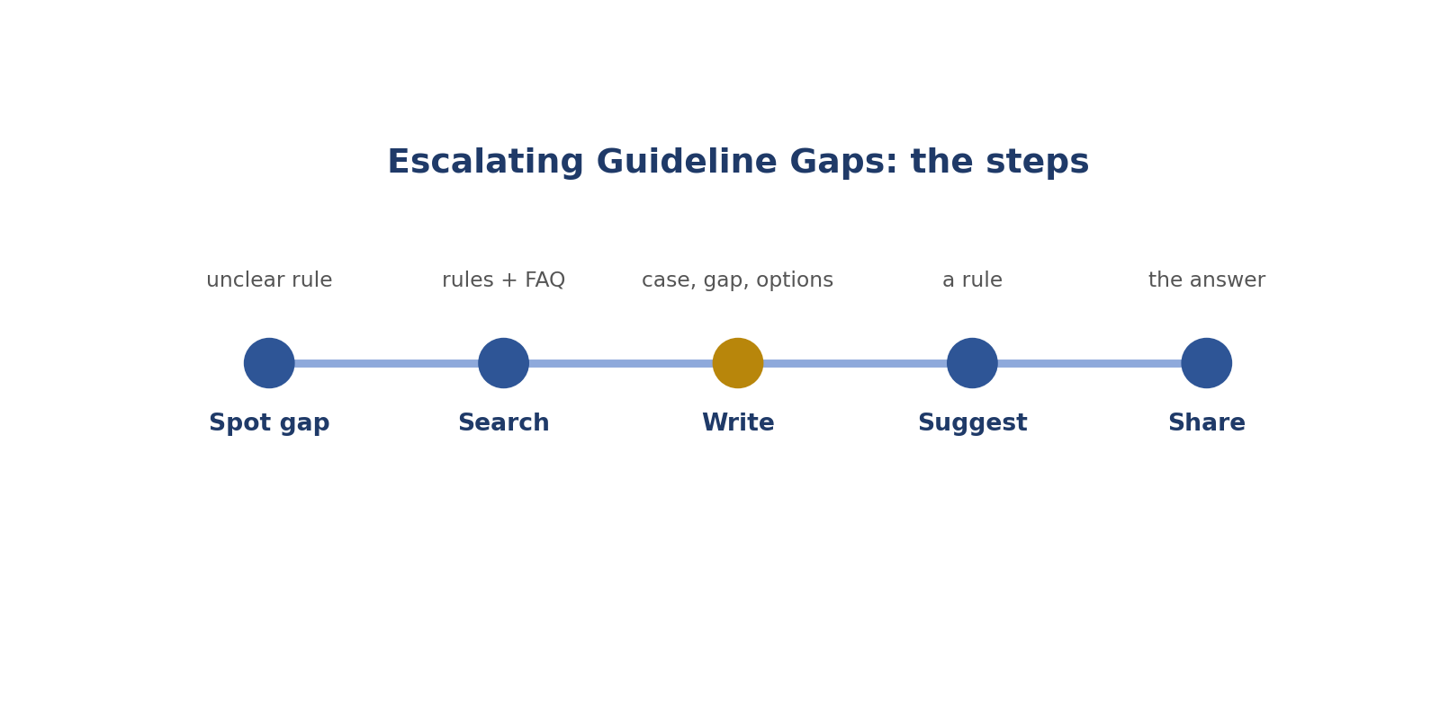
Escalating Guideline Gaps: the steps.
Picture: escalating guideline gaps.
How to answer these tasks
1. Notice a rule that's unclear or missing.
2. Search the rules and FAQ first.
3. Write the case with task IDs.
4. List the options and suggest one.
5. Share the answer with everyone once decided.
TASK 15.1 · EASY
The situation: Many contributors flag the same unclear case.
What is this asking? Many people flag the same case?
Your task: What should a reviewer do?
Answer: Escalate it to the project lead so a clear rule can be added.
Why (explained simply): Escalate it so a clear rule is made.
Key word: Escalate = Send to someone who decides.
In simple English: Repeated questions need a new rule.

TASK 15.2 · EASY
The situation: What is escalation?
What is this asking? What is escalation?
Your task: Define it.
Answer: Raising an issue to someone who can decide or change the rules.
Why (explained simply): Sending a question to someone who can decide.
Key word: Decide = Make a choice.
In simple English: Escalate to someone who can decide.

TASK 15.3 · MEDIUM
The situation: A good escalation message includes what?
What is this asking? What goes in an escalation?
Your task: List four parts.
Answer: The case (with task IDs), what is unclear, the options, and a suggested rule.
Why (explained simply): The case with task IDs, what's unclear, the options, a suggestion.
Key word: Suggestion = An idea offered.
In simple English: Case, problem, options, suggestion.

TASK 15.4 · MEDIUM
The situation: A reviewer decides a new rule privately and applies it.
What is this asking? A private rule?
Your task: What's wrong?
Answer: Only the project can set rules; private rules cause inconsistency.
Why (explained simply): Only the project can set rules.
Key word: Private rule = A rule only you use.
In simple English: Don't make private rules.

TASK 15.5 · EASY
The situation: A guideline doesn't mention emoji-only messages.
What is this asking? No rule for emoji messages?
Your task: What should happen?
Answer: Escalate and ask for a rule; meanwhile follow any interim guidance.
Why (explained simply): Escalate and ask for a rule.
Key word: Gap = Something the rules don't cover.
In simple English: Missing rules get escalated.

TASK 15.6 · HARD
The situation: An escalation gets no answer for a week.
What is this asking? No reply for a week?
Your task: What should a reviewer do?
Answer: Follow up politely, and note the interim approach used so reviews stay consistent.
Why (explained simply): Follow up politely.
Key word: Follow up = Ask again.
In simple English: Follow up politely.

TASK 15.7 · EASY
The situation: Why escalate early?
What is this asking? Why escalate early?
Your task: Explain.
Answer: The longer a gap exists, the more inconsistent work is produced.
Why (explained simply): The longer a gap exists, the more mixed the work becomes.
Key word: Early = Soon.
In simple English: Early escalation saves work.

TASK 15.8 · MEDIUM
The situation: A reviewer finds a guideline example that's wrong.
What is this asking? A wrong example in the rules?
Your task: What should they do?
Answer: Report it with the correct interpretation and affected tasks.
Why (explained simply): Report it with the right version.
Key word: Report = Tell someone officially.
In simple English: Report wrong examples.

TASK 15.9 · MEDIUM
The situation: Escalation message: "The rules are confusing."
What is this asking? Improve "The rules are confusing."
Your task: Improve it.
Answer: "Tasks 102 and 118: the guideline doesn't say whether printed faces count as people. Options: label or skip. Suggest: skip printed faces. Please confirm."
Why (explained simply): Give tasks, the gap, options and a suggestion.
Key word: Specific = Exact.
In simple English: Be specific.

TASK 15.10 · EASY
The situation: Who should escalations go to?
What is this asking? Who gets escalations?
Your task: Answer.
Answer: The project lead or the channel the project specifies.
Why (explained simply): The project lead or the channel the project names.
Key word: Project lead = The person in charge.
In simple English: Use the right channel.

TASK 15.11 · HARD
The situation: An escalation reveals a safety policy gap.
What is this asking? A safety rule gap?
Your task: How urgent is it?
Answer: High priority; escalate immediately and mark it urgent.
Why (explained simply): Escalate urgently.
Key word: Urgent = Needing action now.
In simple English: Safety gaps are urgent.

TASK 15.12 · EASY
The situation: Should contributors be told when a rule is clarified?
What is this asking? Tell workers about clarified rules?
Your task: Answer.
Answer: Yes, so everyone applies it consistently.
Why (explained simply): Yes, so everyone uses them.
Key word: Clarified = Made clear.
In simple English: Share new rules with everyone.

TASK 15.13 · MEDIUM
The situation: After clarification, some past tasks followed the old interpretation.
What is this asking? Old tasks used the old reading?
Your task: What should be done?
Answer: Ask the project whether past tasks should be corrected.
Why (explained simply): Ask if they should be fixed.
Key word: Past tasks = Work already done.
In simple English: Ask about fixing past work.

TASK 15.14 · MEDIUM
The situation: A reviewer escalates every small question.
What is this asking? Escalating every small question?
Your task: What's the problem?
Answer: Over-escalation wastes time; check the guideline and FAQ first.
Why (explained simply): Check the rules first.
Key word: Over-escalate = Ask too often.
In simple English: Check first, then escalate.

TASK 15.15 · EASY
The situation: Why include task IDs in escalations?
What is this asking? Why task IDs?
Your task: Explain.
Answer: So the project lead can see exact examples.
Why (explained simply): So the lead can see real examples.
Key word: Task ID = A task's number.
In simple English: Show real examples.

TASK 15.16 · HARD
The situation: Two project leads give different answers to the same question.
What is this asking? Two leads give different answers?
Your task: What should the reviewer do?
Answer: Point out the conflict to both and ask for one official answer.
Why (explained simply): Point out the conflict and ask for one answer.
Key word: Conflict = Disagreement.
In simple English: Ask for one answer.

TASK 15.17 · EASY
The situation: An escalation leads to a new FAQ entry.
What is this asking? A new FAQ entry?
Your task: What does this show?
Answer: Escalation improved the guideline for everyone.
Why (explained simply): The escalation improved the rules.
Key word: FAQ = Common questions with answers.
In simple English: Good escalations improve rules.

TASK 15.18 · MEDIUM
The situation: A reviewer keeps a log of escalations and answers.
What is this asking? A log of escalations?
Your task: Why is this useful?
Answer: It avoids repeated questions and keeps reviews consistent.
Why (explained simply): Avoids asking the same thing twice.
Key word: Log = A record.
In simple English: Keep a log.

TASK 15.19 · MEDIUM
The situation: A contributor asks a reviewer a question the reviewer can't answer.
What is this asking? Can't answer a worker's question?
Your task: What should the reviewer do?
Answer: Say so honestly and escalate, rather than guessing.
Why (explained simply): Say so honestly and escalate.
Key word: Honest = Truthful.
In simple English: Don't guess answers.

TASK 15.20 · HARD
The situation: The suggested rule in an escalation would reduce data quality but speed up work.
What is this asking? A suggestion that lowers quality?
Your task: Should you suggest it?
Answer: Only with a clear note of the trade-off; quality usually comes first.
Why (explained simply): Explain the trade-off honestly; quality usually comes first.
Key word: Trade-off = Giving up one thing to get another.
In simple English: Be honest about trade-offs.

CHAPTER 17
QA Skill 8: Tracking Quality Metrics

THINK OF IT LIKE THIS
Tracking metrics is like weighing yourself every week. One number tells you little; the trend over weeks tells you what's changing.
In simple English: Watch how numbers change over time.
In simple English: Measure quality and watch how it changes.
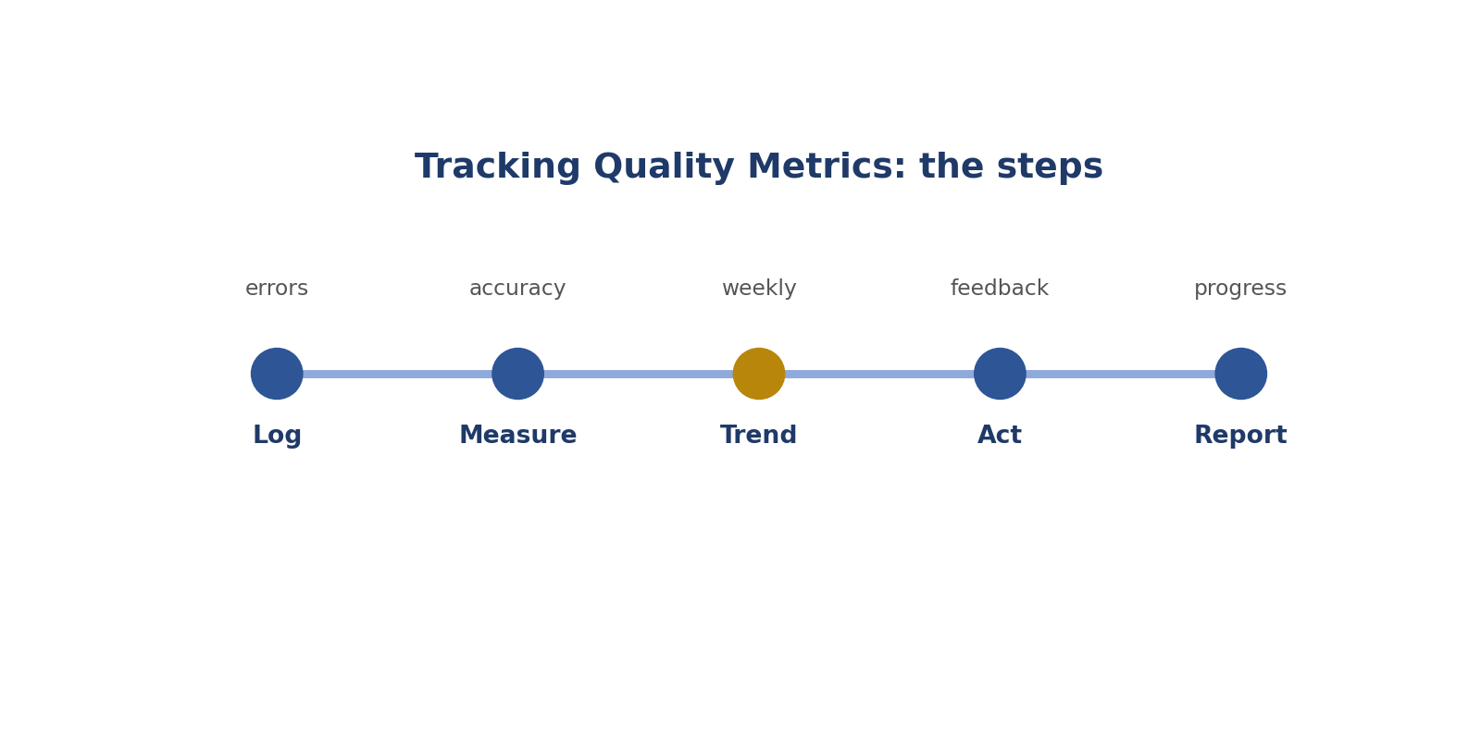
Tracking Quality Metrics: the steps.
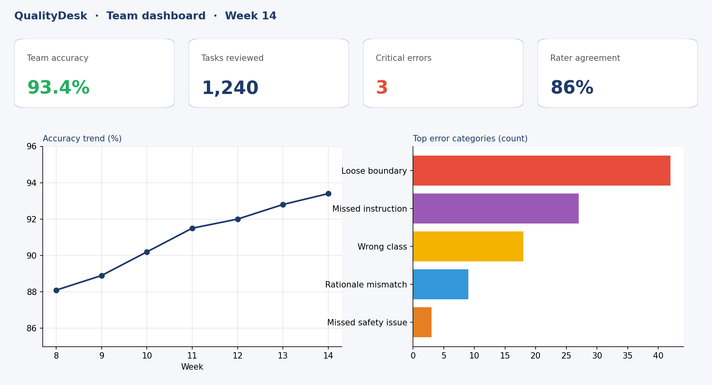
Picture: tracking quality metrics.
How to answer these tasks
1. Record every error in the log.
2. Work out accuracy and agreement.
3. Compare with last week.
4. Act on problems you see.
5. Share a short weekly report.
TASK 16.1 · EASY
The situation: What is an accuracy rate?
What is this asking? What is an accuracy rate?
Your task: Define it.
Answer: The share of checked tasks that were correct.
Why (explained simply): The share of checked tasks that were correct.
Key word: Accuracy rate = Correct out of checked.
In simple English: Correct tasks out of all checked.

TASK 16.2 · EASY
The situation: 25 tasks checked, 23 correct.
What is this asking? 25 checked, 23 correct?
Your task: Accuracy rate?
Answer: 92%.
Why (explained simply): 23 ÷ 25 = 92%.
Key word: Percent = Out of 100.
In simple English: 23 ÷ 25 = 0.92.

TASK 16.3 · MEDIUM
The situation: Error log columns: task ID, contributor, error category, severity, date.
What is this asking? Why those error log columns?
Your task: Why these columns?
Answer: They let you count, filter and compare errors by person, type, severity and time.
Why (explained simply): So you can count and filter by person, type, seriousness and date.
Key word: Column = A part of a table.
In simple English: Good columns make analysis easy.

TASK 16.4 · MEDIUM
The situation: Accuracy fell from 95% to 85% in a week.
What is this asking? Accuracy fell in a week?
Your task: What should you do?
Answer: Investigate: check error categories, dates and any changes (rules, tools, new contributors).
Why (explained simply): Investigate the errors, dates and any changes.
Key word: Investigate = Look into carefully.
In simple English: Find out why numbers changed.

TASK 16.5 · EASY
The situation: What is throughput?
What is this asking? What is throughput?
Your task: Define it.
Answer: The number of tasks completed in a given time.
Why (explained simply): How many tasks are done in a set time.
Key word: Throughput = Work done per hour or day.
In simple English: How many tasks per hour or day.

TASK 16.6 · HARD
The situation: Throughput rose 40% but accuracy fell 15%.
What is this asking? Speed up, quality down?
Your task: What does this suggest?
Answer: Speed may be replacing care; review quality and remind contributors not to cut checks.
Why (explained simply): People may be rushing. Remind them to keep checking.
Key word: Rushing = Going too fast.
In simple English: Faster isn't better if quality drops.

TASK 16.7 · EASY
The situation: A pivot table of the error log shows most errors are "missed instruction".
What is this asking? Most errors are missed instructions?
Your task: What does this help decide?
Answer: Where to focus feedback and training.
Why (explained simply): Focus feedback and training there.
Key word: Pivot table = A spreadsheet summary.
In simple English: Charts show where to focus.

TASK 16.8 · MEDIUM
The situation: Agreement with golden tasks is 88%.
What is this asking? 88% golden agreement?
Your task: What's a good next step?
Answer: Look at the 12% missed and find patterns.
Why (explained simply): Study the 12% missed to find patterns.
Key word: Miss = A wrong answer.
In simple English: Study the misses.

TASK 16.9 · MEDIUM
The situation: One contributor has 99% accuracy on a tiny sample of 5 tasks.
What is this asking? 99% on 5 tasks?
Your task: Is this reliable?
Answer: Not very; the sample is too small to be confident.
Why (explained simply): Too few tasks to trust.
Key word: Sample size = How many were checked.
In simple English: Small samples can mislead.

TASK 16.10 · EASY
The situation: Why track metrics over time?
What is this asking? Why track over time?
Your task: Explain.
Answer: To see trends, drift and the effect of changes.
Why (explained simply): To see trends and whether changes worked.
Key word: Trend = Change over time.
In simple English: Trends show what's happening.

TASK 16.11 · HARD
The situation: Critical errors are rare but increasing.
What is this asking? Rare but rising serious errors?
Your task: Should you act even if overall accuracy is high?
Answer: Yes; critical errors matter more than their count suggests.
Why (explained simply): Act now. Serious errors matter.
Key word: Critical = Very serious.
In simple English: Rare serious errors still matter.

TASK 16.12 · EASY
The situation: A dashboard shows accuracy by contributor.
What is this asking? Accuracy by person?
Your task: How should this be used?
Answer: To target support and feedback, not to shame people.
Why (explained simply): Use it to help, not to shame.
Key word: Support = Help.
In simple English: Use data to help people.

TASK 16.13 · MEDIUM
The situation: Metrics show errors spike on Mondays.
What is this asking? Errors spike on Mondays?
Your task: What might you investigate?
Answer: New batches, rule updates, or task types starting on Mondays.
Why (explained simply): Check what happens then: new batches or rule changes.
Key word: Spike = A sudden jump.
In simple English: Look at what happens on those days.

TASK 16.14 · MEDIUM
The situation: Accuracy is high but reviewers still see many rationale problems.
What is this asking? High accuracy, weak reasons?
Your task: What metric might be missing?
Answer: A rationale-quality measure.
Why (explained simply): Measure reason quality too.
Key word: Measure = Find the size or amount.
In simple English: Track what matters.

TASK 16.15 · EASY
The situation: Why record severity alongside errors?
What is this asking? Why record severity?
Your task: Explain.
Answer: So serious errors are counted and fixed first.
Why (explained simply): So serious mistakes are counted and fixed first.
Key word: Severity = How serious.
In simple English: Severity shows priority.

TASK 16.16 · HARD
The situation: A contributor's accuracy is 90% but all errors are critical safety misses.
What is this asking? 90% but all errors are critical?
Your task: How should this be treated?
Answer: As a serious concern despite the good percentage; address the safety errors urgently.
Why (explained simply): Very serious, despite the good number.
Key word: Concern = Worry.
In simple English: The type of error matters, not just the number.

TASK 16.17 · EASY
The situation: A weekly quality report includes what?
What is this asking? What's in a weekly report?
Your task: Name three items.
Answer: Accuracy rate, top error categories, and trend compared with last week.
Why (explained simply): Accuracy, top error types and the trend.
Key word: Report = A summary of results.
In simple English: Rate, main errors, trend.

TASK 16.18 · MEDIUM
The situation: After new training, accuracy rises from 82% to 91%.
What is this asking? Accuracy up after training?
Your task: What does this suggest?
Answer: The training helped; keep monitoring.
Why (explained simply): The training helped. Keep watching.
Key word: Training = Teaching.
In simple English: Numbers can prove training worked.

TASK 16.19 · MEDIUM
The situation: Metrics are recorded in different formats by different reviewers.
What is this asking? Different formats?
Your task: What's the problem?
Answer: They can't be combined or compared; agree on one format.
Why (explained simply): They can't be combined. Agree one format.
Key word: Format = How it's written.
In simple English: Use one format.

TASK 16.20 · EASY
The situation: Can metrics replace reading the actual work?
What is this asking? Can numbers replace reading the work?
Your task: Answer.
Answer: No; metrics show where to look, but reviewers still need to read tasks.
Why (explained simply): No. Numbers show where to look.
Key word: Metric = A number that measures.
In simple English: Numbers point; people check.

