Day 3 Comprehensive Lecture Notes
Data Annotator (Multimodal) and Computer Vision Annotation Specialist
Deep and wide · 16 skills · Step-by-step methods · 64 worked examples · Pictures explained · Very simple English
CHAPTER 1
Welcome to Day 3

Days 1 and 2 were about judging AI answers. Today is about making the data AI learns from. You will learn two labelling jobs: the Data Annotator, who labels pictures, videos, sounds and text, and the Computer Vision Annotation Specialist, who draws exact labels on pictures.
In simple English: Today you learn to label the data that teaches AI to see, hear and read.
Time | What we do | What you learn
4:00 to 4:10 | Recap quiz | Five Day 2 questions
4:10 to 4:45 | Role 1 | Data Annotator and its 8 skills
4:45 to 5:20 | Role 2 | Computer Vision Annotation Specialist and its 8 skills
5:20 to 5:30 | Compare and assignment | Which job suits you, and your homework

In simple English: Physical class: Wednesday 4:00 to 5:30 pm, Set 1. Set 2 covers this on Sunday.
● How to read these notes
Every idea has a very simple line. Pictures are explained step by step. Read the simple line first if a sentence feels hard.
In simple English: Read the easy line first if you get stuck.

CHAPTER 2
Words You Need for Day 3

Term | What it means
Annotation | Adding labels to data.
Label | A tag or mark, like "car" or a box.
Data | Information, like pictures, sounds and text.
Multimodal | Many kinds of data.
Computer vision | AI that understands pictures.
Class | The name of what something is.
Bounding box | A tight rectangle around an object.
Polygon | A shape traced around the exact edge.
Keypoint | A dot on a body part.
Occluded | Hidden behind something.
Truncated | Cut off by the edge.
Timestamp | A start or end time in sound or video.

In simple English: Learn these 12 words first.

CHAPTER 3
Role 1: Data Annotator (Multimodal)

DEFINITION
A Data Annotator adds labels to different kinds of data (pictures, videos, sounds and text) following the project's rulebook exactly, so AI can learn to recognise what's in the data.

In simple English: A data annotator labels pictures, videos, sounds and words so AI can learn.
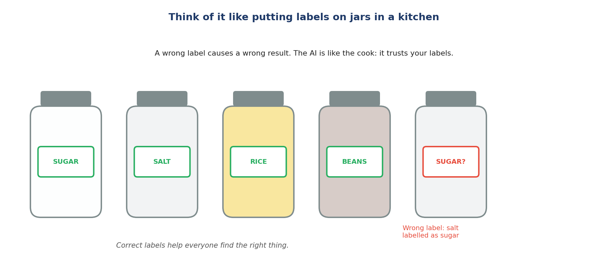
Like putting labels on jars in a kitchen.
Let's read this picture together
Step 1 Each jar has a label: sugar, salt, rice, beans.
Simply: Every jar gets a name.
Step 2 One jar of salt is wrongly labelled "sugar".
Simply: One label is wrong.
Step 3 A cook who trusts the labels would put salt in a cake. The AI trusts your labels in the same way.
Simply: Wrong labels cause wrong results.
The words explained
● What "multimodal" means
"Multi" means many. "Modal" means kind of data. You work with images, video, audio and text.
In simple English: Many kinds of data.
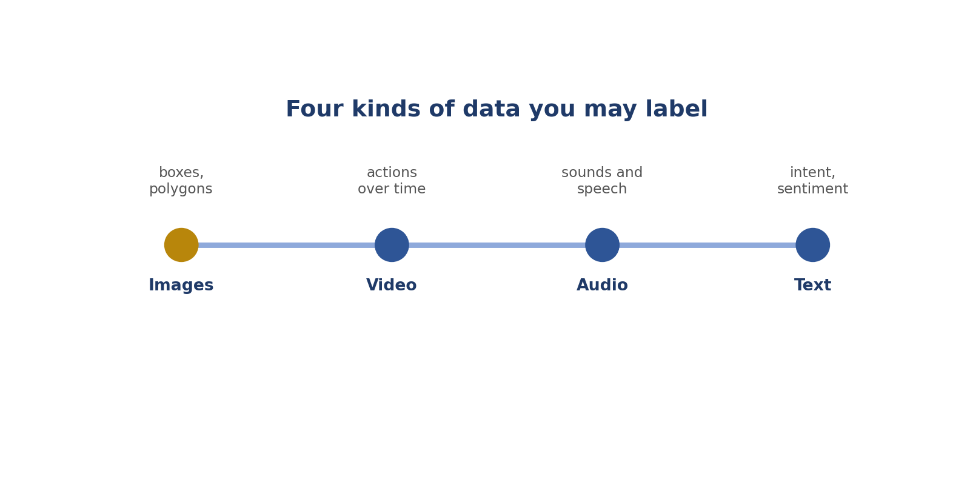
The four kinds of data.
What the work looks like
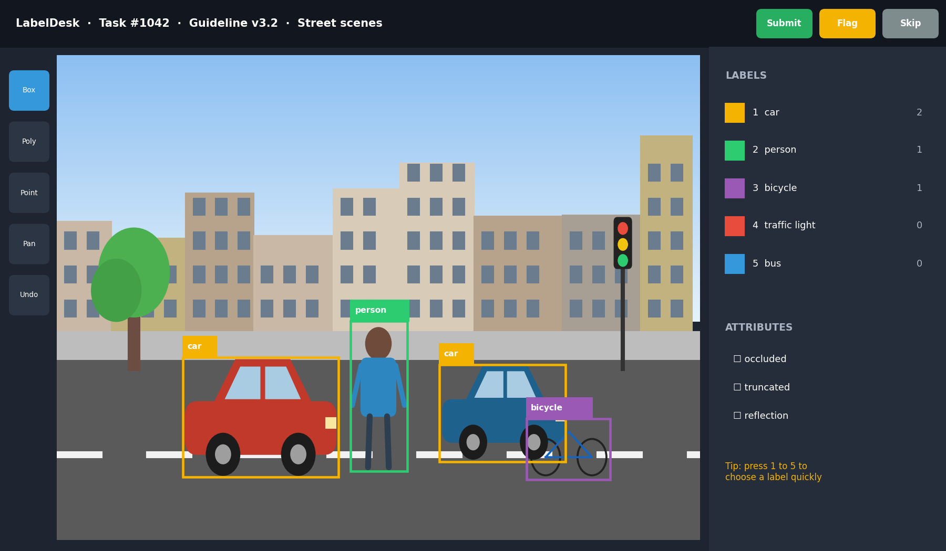
A real-style labelling tool.
Let's read this tool together
Step 1 Top bar: the task number, the rulebook version (v3.2), and the Submit, Flag and Skip buttons.
Simply: Task info and buttons.
Step 2 Left: the tools (box, polygon, point, pan, undo).
Simply: Your drawing tools.
Step 3 Middle: the street picture with boxes around two cars, a person and a bicycle.
Simply: The labelled picture.
Step 4 Right: the label list with colours and counts, plus flags like occluded and truncated.
Simply: Labels and flags.
Step 5 Bottom right: a tip that number keys choose labels quickly.
Simply: A shortcut.
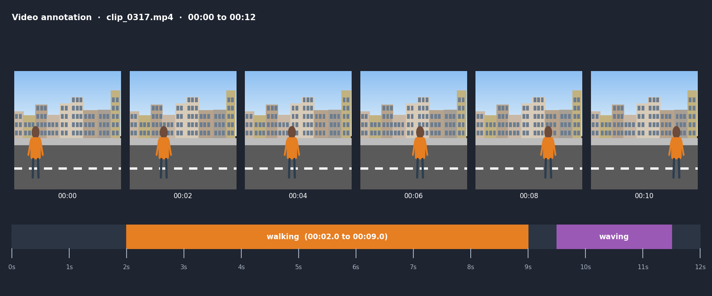
Labelling a video.
Let's read the video picture
Step 1 Six frames show a person walking along a street.
Simply: Pictures over time.
Step 2 The orange bar marks "walking" from 2 to 9 seconds.
Simply: When the action happens.
Step 3 The purple bar marks "waving" near the end.
Simply: Another action.
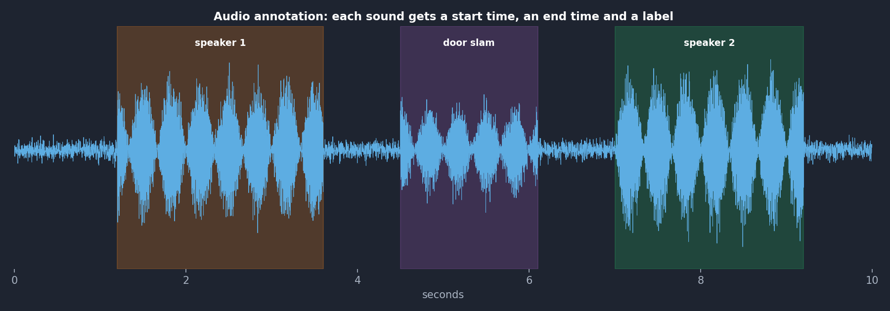
Labelling sound.
Let's read the sound picture
Step 1 The blue wavy line is the sound.
Simply: The sound wave.
Step 2 Coloured areas mark speaker 1, a door slam, and speaker 2.
Simply: Each sound is marked.
Step 3 Each has a start time, an end time and a label.
Simply: Start, end, name.
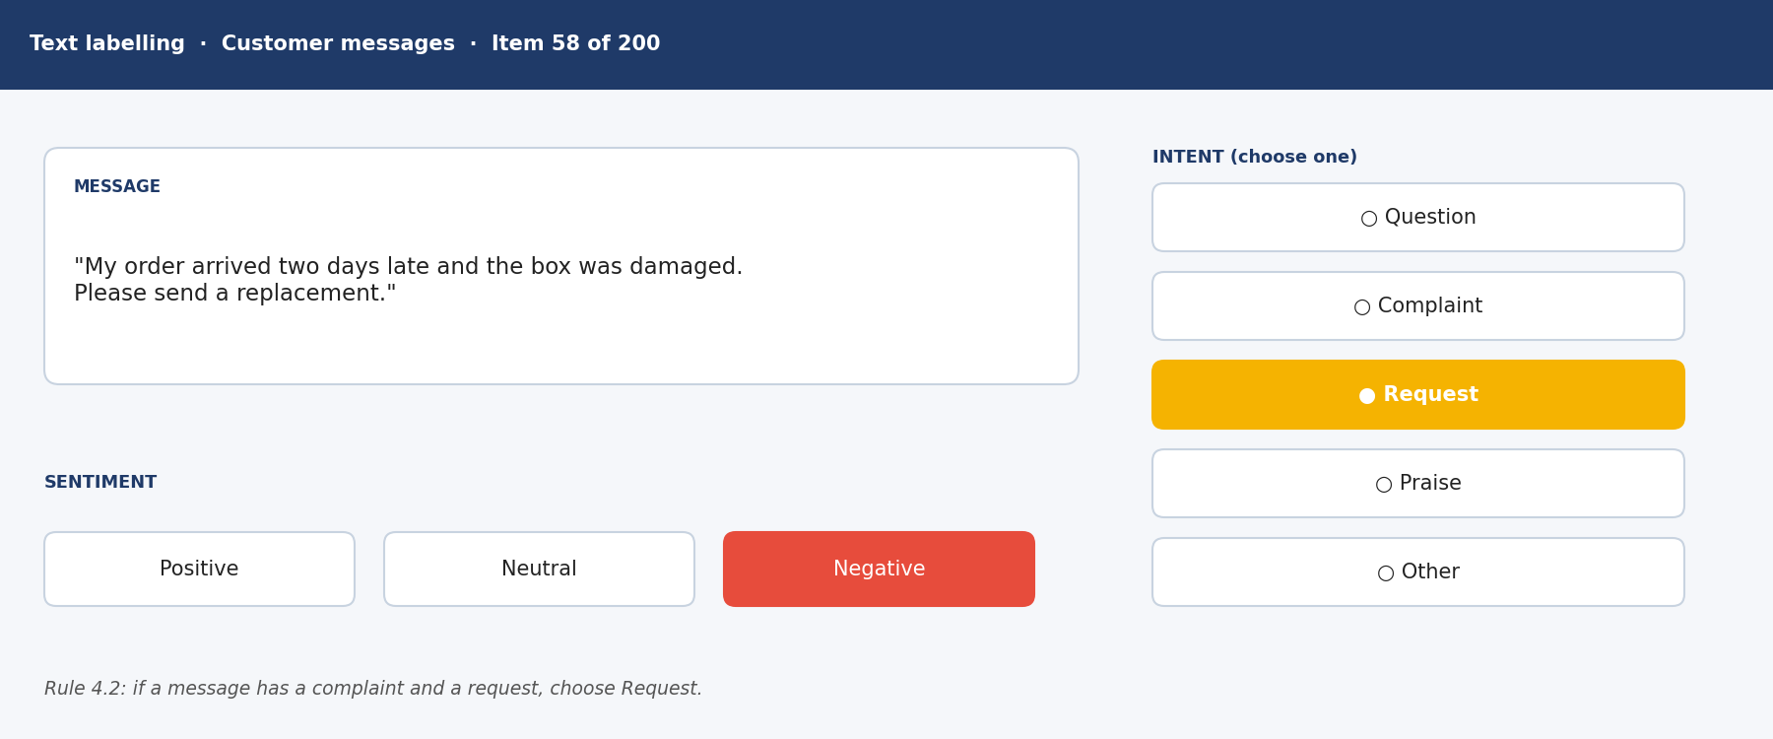
Labelling text.
Let's read the text picture
Step 1 A customer message about a late, damaged order that asks for a replacement.
Simply: The message.
Step 2 Intent: "Request" is chosen, because rule 4.2 says request beats complaint.
Simply: What they want.
Step 3 Sentiment: "Negative", because the customer is unhappy.
Simply: How they feel.
Who uses your work
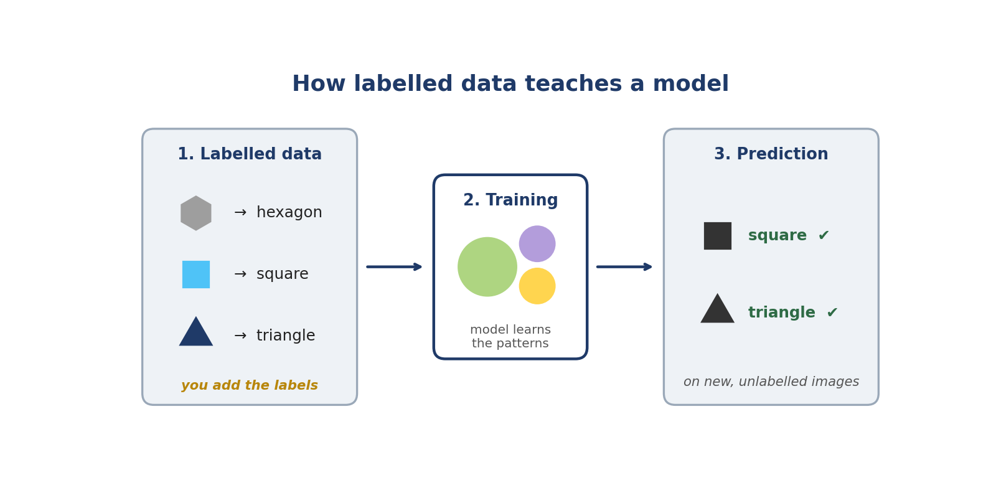
Labelled data teaches the AI.
● How it works
Your labels become examples. The AI studies thousands of them and learns to recognise new things by itself.
In simple English: The AI learns from your examples.
More about the job
● Common job titles
Data Annotator, Data Labeller, Annotation Specialist, AI Data Specialist, Multimodal Annotator.
In simple English: Many names, same work.
● What it is NOT
It's not guessing and not just speed. Every label is checked.
In simple English: Careful work, not fast guessing.
● Where it leads
QA reviewing, computer vision specialist work, or team lead roles.
In simple English: Good work leads to better jobs.

CHAPTER 4
How the 8 Annotation Skills Work Together

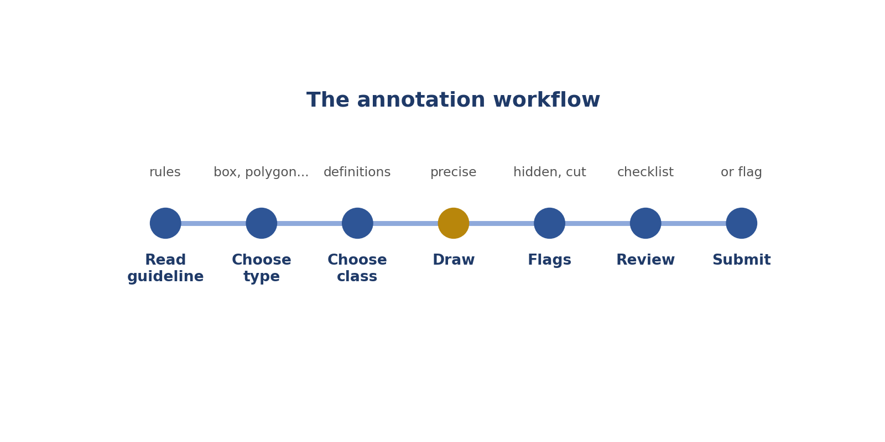
The labelling steps.
Step | Skill | Simply
Know the rules | 1. Reading guidelines | Read the rulebook
Pick the kind of label | 2. Label type | Right tool
Pick the right name | 3. Class definitions | Right name
Handle hidden or cut-off items | 4. Occlusion and truncation | Hidden or cut off?
Handle unclear cases | 5. Flagging edge cases | Ask, don't guess
Place edges exactly | 6. Precision | Exact edges
Stay the same | 7. Consistency | Same every time
Use the tool well | 8. Shortcuts | Fast keys

CHAPTER 5
Annotation Skill 1: Reading Annotation Guidelines

THINK OF IT LIKE THIS
Reading the guideline is like reading the rules of a board game before playing. If you skip the rules, you might move pieces the wrong way the whole game.
In simple English: Read the rules before you play.
DEFINITION
Reading annotation guidelines means studying the project's rulebook from start to finish, including its rules, examples and "do not label" list, before you label anything.

In simple English: Read the whole rulebook before you start.
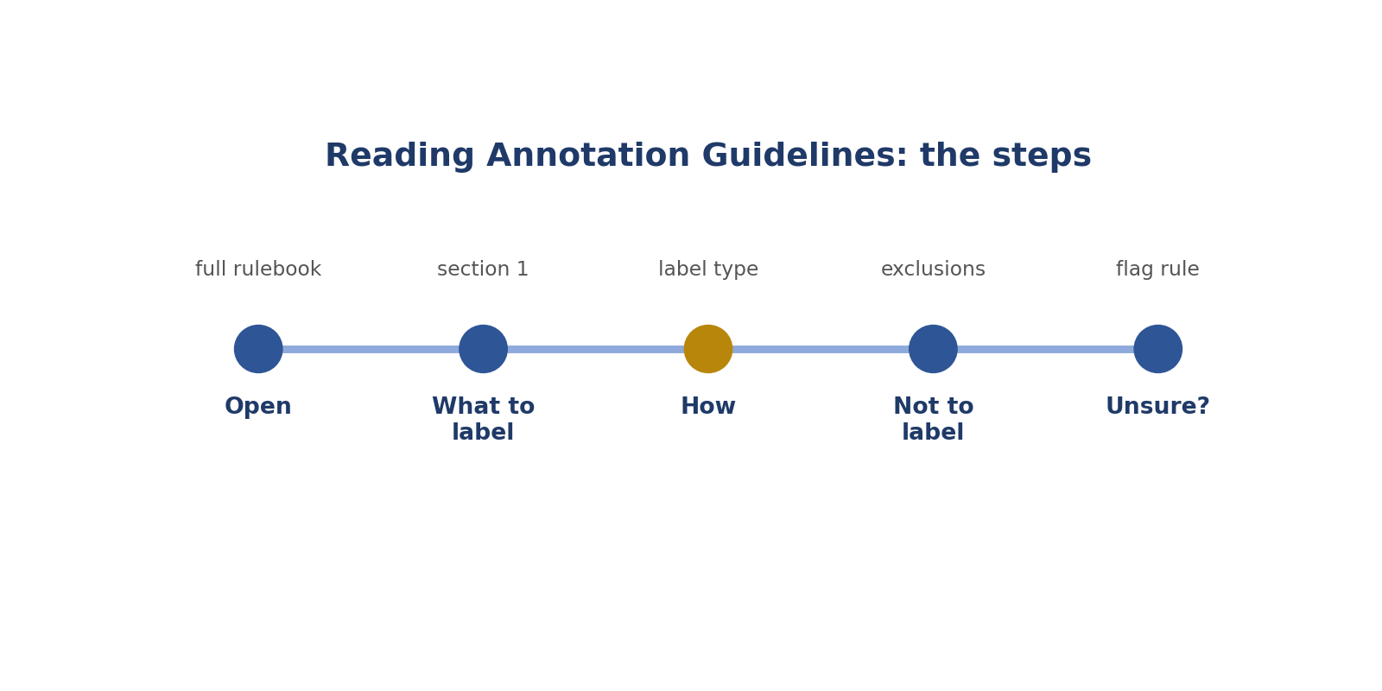
Reading Annotation Guidelines: the steps.
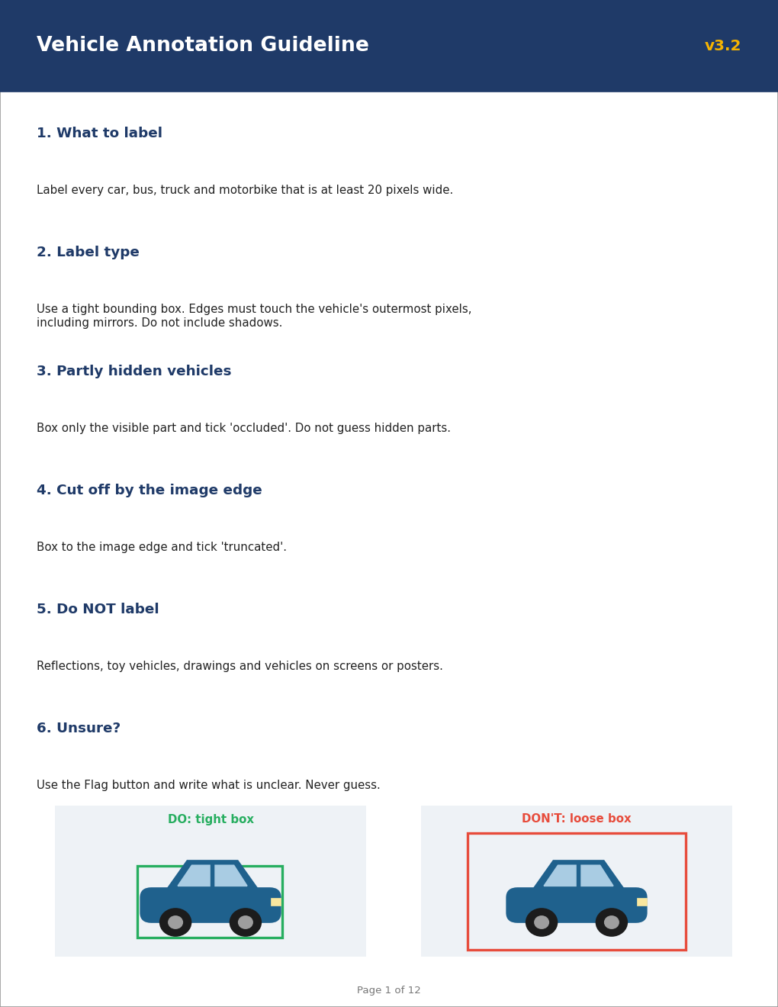
Real-style picture for reading annotation guidelines.
Words to know
Term | What it means
Guideline | The project's rulebook.
Exclusion | Something you must NOT label.
Version | Which update of the rules you're using, like v3.2.

● Where it fits in the job
Every label depends on the rulebook. It's the first thing you open on any project.
In simple English: Every label follows the rules.
● Why it matters
Most rejected labels break a rule that was written in the guideline.
In simple English: Most mistakes break a written rule.
How to do it, step by step
Step 1 Read the whole guideline, page by page.
Simply: Read every page.
Step 2 Find what to label and what NOT to label.
Simply: Know what's in and what's out.
Step 3 Find which label type to use.
Simply: Know the kind of label.
Step 4 Look at every example picture.
Simply: Study the examples.
Step 5 Find what to do when you're unsure.
Simply: Know when to flag.
Good versus bad
What good looks like | What bad looks like
Reads every section | Reads only page 1
Checks updates | Uses old rules
Studies the examples | Skips the pictures

Worked examples
THE "DO NOT LABEL" LIST
The situation: The rule says don't label reflections. A car shows in a shop window.
What to do: Don't label it.
Why: It's on the "do not label" list.
In simple English: If the rules say no, don't label it.
MIRRORS COUNT
The situation: An example picture shows car boxes including side mirrors.
What to do: Include mirrors in your boxes.
Why: Examples show how rules work.
In simple English: Follow the examples too.
SIZE RULE
The situation: The rule says label vehicles at least 20 pixels wide. A motorbike is 25 pixels.
What to do: Label it.
Why: 25 is bigger than 20.
In simple English: Check the number in the rule.
VERSION UPDATE
The situation: The rules changed from v3.1 to v3.2.
What to do: Read the changes first.
Why: Old rules cause mistakes.
In simple English: New rules? Read them first.
Common mistakes
Mistake | Why it's a problem
Starting before reading | You'll break rules you didn't know.
Reading only page 1 | Important rules are later.
Skipping examples | Examples explain tricky cases.
Forgetting updates | Old rules cause errors.

● How it's tested
Onboarding quizzes ask about rules and exceptions.
In simple English: Quizzes test the rules.
How to practise
1. Read a guideline and write a one-page summary.
2. List every "do not label" item.
3. Quiz a friend on the rules.
Skill levels
Level | What it looks like
Beginner | Skims the guideline.
Developing | Knows the main rules.
Strong | Knows every rule, example and update.

● What it looks like on your CV
"Studied and applied detailed annotation guidelines across image, text, audio and video projects."
In simple English: Shows you follow rulebooks.
Quick check
Question: What four things should you know after reading?
Answer: What to label, how, what not to label, and what to do when unsure.
Question: The rule says don't label reflections. Do you label a car in a mirror?
Answer: No.
Practise this skill: Day 3 Task Bank, Chapter 1.

CHAPTER 6
Annotation Skill 2: Choosing the Right Label Type

THINK OF IT LIKE THIS
Label types are like tools in a toolbox. A hammer is great for nails, but useless for screws. Each job needs the right tool.
In simple English: Use the right tool for the job.
DEFINITION
Choosing the right label type means using exactly the kind of mark the rules ask for: a class, a box, a polygon, keypoints, a timestamp or a text tag.

In simple English: Use the kind of label the rules ask for.
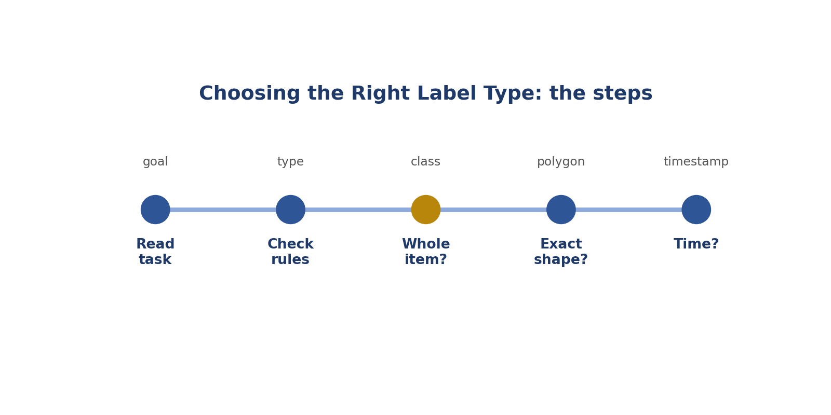
Choosing the Right Label Type: the steps.
Real-style picture for choosing the right label type.
Words to know
Term | What it means
Label type | The kind of mark: class, box, polygon, keypoint, timestamp, tag.
Class | The name of what something is.
Timestamp | A start or end time in audio or video.

● Where it fits in the job
Different AI models need different labels. The wrong type makes the work useless.
In simple English: Wrong type, useless work.
● Why it matters
A box where a polygon was needed means the whole task must be redone.
In simple English: The wrong type wastes the work.
How to do it, step by step
Step 1 Read what the task wants the AI to learn.
Simply: What's the goal?
Step 2 Check the rulebook for the label type.
Simply: What type do the rules say?
Step 3 Whole picture or message? Use a class.
Simply: Whole thing: class.
Step 4 Exact shape? Use a polygon. Position? Use a box.
Simply: Shape or position.
Step 5 Sound or action over time? Use timestamps.
Simply: Time: timestamps.
Good versus bad
What good looks like | What bad looks like
Checks the type every time | Uses boxes for everything
Matches type to the goal | Picks the fastest type
Asks if unsure | Guesses

Worked examples
ROAD OUTLINE
The situation: "Draw the exact outline of each road."
What to do: Use a polygon.
Why: A box would include pavements and cars.
In simple English: Exact shapes need polygons.
ELBOWS AND KNEES
The situation: "Mark each person's elbows and knees."
What to do: Use keypoints.
Why: Body parts need dots.
In simple English: Body parts need keypoints.
INDOOR OR OUTDOOR
The situation: "Is this photo indoor or outdoor?"
What to do: Use a class.
Why: One label for the whole picture.
In simple English: Whole picture: class.
WHO IS SPEAKING
The situation: "Mark when each person speaks."
What to do: Use timestamps with speaker labels.
Why: Sounds happen over time.
In simple English: Time needs timestamps.
Common mistakes
Mistake | Why it's a problem
Using boxes because they're faster | Use what the rules say.
Mixing types | Stick to the required type.
Forgetting extra details | Some tasks need attributes too.
Changing the type yourself | Ask instead.

● How it's tested
Trial tasks check the label type first.
In simple English: The first check is the type.
How to practise
1. Match 10 tasks to their label types.
2. Try each type in a free tool.
3. Explain why each type fits.
Skill levels
Level | What it looks like
Beginner | Uses one type for everything.
Developing | Usually picks the right type.
Strong | Always uses the exact type required.

● What it looks like on your CV
"Produced class labels, bounding boxes, polygons, keypoints and timestamp segments to project specifications."
In simple English: Lists the types you used.
Quick check
Question: Which type traces an exact outline?
Answer: Polygon.
Question: Which type marks when someone speaks?
Answer: Timestamps.
Practise this skill: Day 3 Task Bank, Chapter 2.

CHAPTER 7
Annotation Skill 3: Applying Class Definitions

THINK OF IT LIKE THIS
Class definitions are like a dictionary. People might call a minibus a "bus" or a "van", but the project's dictionary decides which word is correct.
In simple English: The rulebook's meaning decides.
DEFINITION
Applying class definitions means choosing each label by matching the item to the rulebook's written meaning of each class, not by everyday names or guesses.

In simple English: Choose labels by the written meaning.
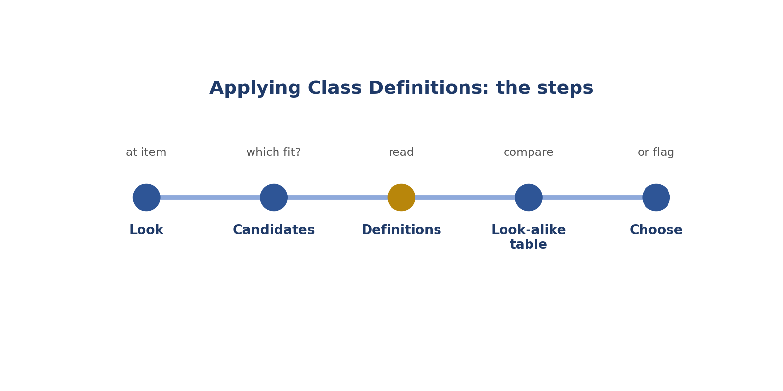
Applying Class Definitions: the steps.
Words to know
Term | What it means
Definition | The written meaning of a class.
Taxonomy | The full list of classes.
Look-alike | Things that look very similar.

● Where it fits in the job
Classes are the names the AI learns. If people use them differently, the AI gets confused.
In simple English: The AI learns your class names.
● Why it matters
Everyday words vary from person to person. Definitions keep everyone the same.
In simple English: Definitions stop confusion.
How to do it, step by step
Step 1 Look at the item carefully.
Simply: Look closely.
Step 2 List the classes it might be.
Simply: Which could it be?
Step 3 Read each definition.
Simply: Read the meanings.
Step 4 Compare look-alikes using a table.
Simply: Compare similar ones.
Step 5 Choose, or flag if none fits.
Simply: Choose or ask.
Good versus bad
What good looks like | What bad looks like
Uses written definitions | Uses everyday names
Compares look-alikes | Guesses between them
Uses "other" or flags when nothing fits | Forces a wrong class

Worked examples
PICKUP TRUCK
The situation: Definition: a truck has a separate cargo area. A pickup has an open cargo bed.
What to do: Label it truck.
Why: The definition decides, not everyday speech.
In simple English: The rulebook's meaning wins.
MINIBUS
The situation: Definition: bus = 15 or more passengers. A 12-seat minibus.
What to do: Not a bus; check if "van" fits.
Why: 12 is fewer than 15.
In simple English: Use the numbers in the definition.
MANNEQUIN
The situation: Class person = any real human. A shop mannequin.
What to do: Not a person.
Why: A mannequin isn't a real human.
In simple English: Read what the class includes.
GOAT
The situation: Classes: cat, dog, other. A goat.
What to do: Label other.
Why: Nothing else fits.
In simple English: Nothing fits? Use other.
Common mistakes
Mistake | Why it's a problem
Using everyday names | Use definitions.
Guessing between look-alikes | Compare carefully.
Forcing a class that doesn't fit | Use other or flag.
Inventing classes | Use only the list.

● How it's tested
Tests include look-alikes like pickups, minibuses and vans.
In simple English: Tests use look-alikes.
How to practise
1. Make a table of look-alike classes.
2. Label 20 tricky photos using definitions.
3. Explain each choice with the definition.
Skill levels
Level | What it looks like
Beginner | Labels by instinct.
Developing | Uses definitions mostly.
Strong | Uses definitions every time, even for look-alikes.

● What it looks like on your CV
"Applied class taxonomies consistently, including look-alike categories."
In simple English: Shows careful labelling.
Quick check
Question: What decides the class: everyday name or definition?
Answer: The definition.
Question: Nothing fits. What do you do?
Answer: Use "other" or flag it.
Practise this skill: Day 3 Task Bank, Chapter 3.

CHAPTER 8
Annotation Skill 4: Occlusion and Truncation Rules

THINK OF IT LIKE THIS
Imagine a friend standing behind a car: you can only see their head. That's occluded (hidden behind something). Now imagine a photo that cuts your friend in half at the edge: that's truncated (cut off).
In simple English: Hidden behind = occluded. Cut by the edge = truncated.
DEFINITION
Occlusion and truncation rules tell you how to label objects that are partly hidden behind something (occluded) or cut off by the edge of the picture or clip (truncated).

In simple English: Know what to do with hidden and cut-off objects.
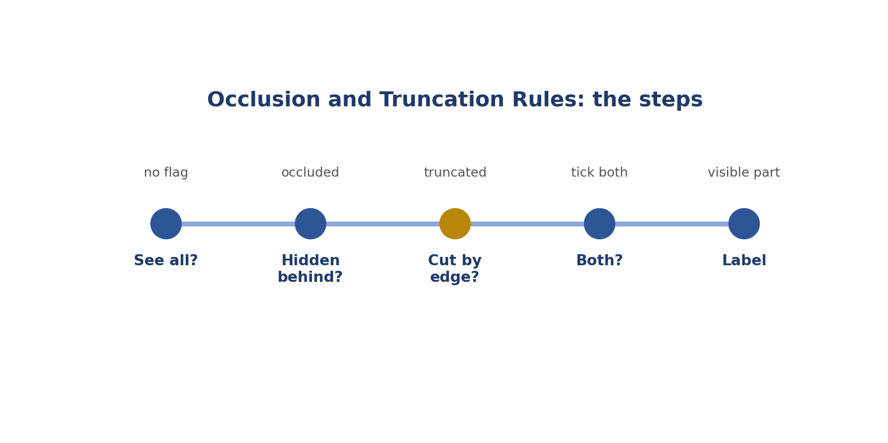
Occlusion and Truncation Rules: the steps.
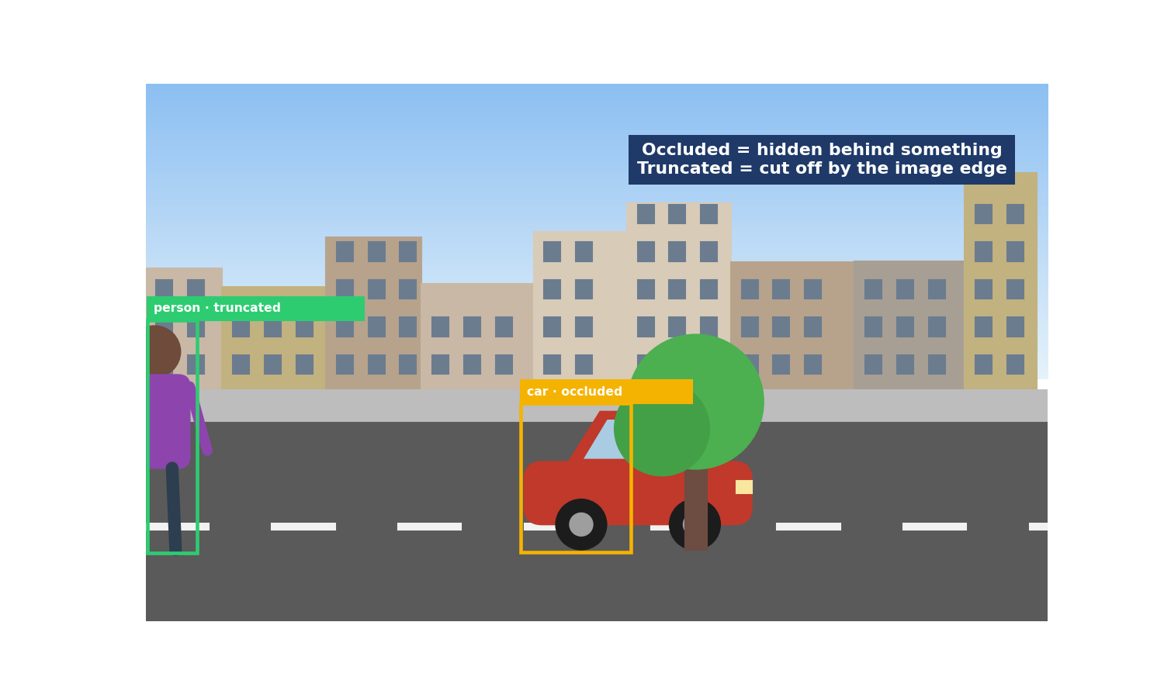
Real-style picture for occlusion and truncation rules.
Words to know
Term | What it means
Occluded | Partly hidden behind something.
Truncated | Cut off by the edge of the picture.
Visible part | The part you can actually see.

● Where it fits in the job
Real pictures are messy. Many objects are hidden or cut off, so these rules are used all the time.
In simple English: These rules are used constantly.
● Why it matters
Guessing the hidden part adds made-up information to the data.
In simple English: Guessing adds fake information.
How to do it, step by step
Step 1 Ask: can I see all of it?
Simply: See all? No flag.
Step 2 Is part hidden behind something? Tick occluded.
Simply: Hidden behind: occluded.
Step 3 Is part cut off by the edge? Tick truncated.
Simply: Cut by edge: truncated.
Step 4 Both? Tick both.
Simply: Both can happen.
Step 5 Label only the visible part, unless told otherwise.
Simply: Label what you see.
Good versus bad
What good looks like | What bad looks like
Labels the visible part | Draws the hidden part
Uses the right flag | Mixes up the flags
Checks every object | Ticks flags by habit

Worked examples
CAR BEHIND A TREE
The situation: A car is half hidden by a tree.
What to do: Box the visible part, tick occluded.
Why: The tree hides part of the car.
In simple English: Behind something: occluded.
PERSON AT THE EDGE
The situation: A person is cut off by the left edge.
What to do: Box to the edge, tick truncated.
Why: The picture's edge cuts them.
In simple English: Edge: truncated.
BOTH
The situation: A car is behind a pole and cut off by the edge.
What to do: Tick both.
Why: Both things happen.
In simple English: It can be both.
VOICES OVERLAPPING
The situation: Two people talk at once in audio.
What to do: Label both segments, if allowed.
Why: One voice partly hides the other.
In simple English: Sounds can overlap too.
Common mistakes
Mistake | Why it's a problem
Drawing hidden parts | Label only what you see.
Mixing up the flags | Behind vs edge.
Ticking flags by habit | Check each object.
Forgetting both can apply | Tick both when needed.

● How it's tested
Test pictures include both on purpose.
In simple English: Tests include both.
How to practise
1. Find 10 photos and decide: occluded, truncated, both or neither.
2. Explain the difference to a friend.
3. Practise in a free labelling tool.
Skill levels
Level | What it looks like
Beginner | Confuses the flags.
Developing | Mostly right.
Strong | Always right, with correct edges.

● What it looks like on your CV
"Applied occlusion and truncation rules accurately in image and video annotation."
In simple English: Shows you handle hard cases.
Quick check
Question: Hidden behind a tree: which flag?
Answer: Occluded.
Question: Cut off by the picture's edge: which flag?
Answer: Truncated.
Practise this skill: Day 3 Task Bank, Chapter 4.

CHAPTER 9
Annotation Skill 5: Flagging Edge Cases

THINK OF IT LIKE THIS
Flagging is like putting up your hand in class when you don't understand. One question helps the whole class get the same answer.
In simple English: Ask, don't guess.
DEFINITION
Flagging edge cases means marking tasks the rules don't clearly cover, with a short note saying what's unclear, instead of guessing.

In simple English: If the rules don't cover it, flag it.
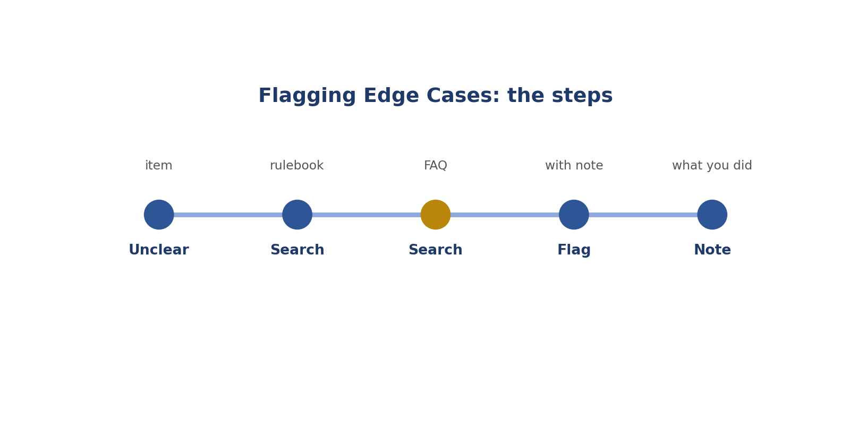
Flagging Edge Cases: the steps.
Real-style picture for flagging edge cases.
Words to know
Term | What it means
Edge case | A situation the rules don't clearly cover.
Flag | A button that asks a reviewer to look.
Note | A short message explaining why.

● Where it fits in the job
No rulebook covers everything. Flags turn uncertainty into clear rules for everyone.
In simple English: Flags help make new rules.
● Why it matters
Guesses create hidden differences across thousands of labels.
In simple English: Guesses make data messy.
How to do it, step by step
Step 1 Notice when you're unsure.
Simply: Feel unsure? Stop.
Step 2 Search the rulebook.
Simply: Look in the rules.
Step 3 Search the FAQ.
Simply: Look in the FAQ.
Step 4 If still unclear, press Flag and write a note.
Simply: Flag with a note.
Step 5 Say what you did meanwhile.
Simply: Say what you did.
Good versus bad
What good looks like | What bad looks like
Flags with a clear note | Guesses
Searches first | Flags everything
Says what was done | Writes "weird"

Worked examples
CAR ON A TV
The situation: A car appears on a TV screen. No rule mentions screens.
What to do: Flag: "Car on a TV screen; no rule for screens; left unlabelled."
Why: The rules don't cover it.
In simple English: Not covered? Flag it.
COVERED CASE
The situation: The rule clearly says to skip reflections.
What to do: Don't flag; follow the rule.
Why: It's already covered.
In simple English: Covered? Just follow the rule.
EMOJI MESSAGE
The situation: A message is only emojis.
What to do: Check the rules; if not covered, flag.
Why: It's unclear.
In simple English: Check, then flag.
BLACK PHOTO
The situation: A photo is completely black.
What to do: Use "unusable" or flag.
Why: Nothing can be labelled.
In simple English: Can't see anything? Flag it.
Common mistakes
Mistake | Why it's a problem
Guessing | Flag instead.
Flagging covered cases | Check the rules first.
Vague notes | Say exactly what's unclear.
Not saying what you did | Say it.

● How it's tested
Reviewers check whether you flag the right cases.
In simple English: Your flags are checked.
How to practise
1. Write 5 flag notes for unclear cases.
2. Find the flag button in a free tool.
3. Keep a list of your flags and answers.
Skill levels
Level | What it looks like
Beginner | Guesses.
Developing | Flags but with vague notes.
Strong | Flags the right cases with clear notes.

● What it looks like on your CV
"Identified and flagged edge cases, contributing to guideline improvements."
In simple English: Shows you improve rules.
Quick check
Question: What do you do before flagging?
Answer: Search the rulebook and FAQ.
Question: What two things go in a flag note?
Answer: What's unclear and what you did.
Practise this skill: Day 3 Task Bank, Chapter 5.

CHAPTER 10
Annotation Skill 6: Precision at Boundaries

THINK OF IT LIKE THIS
Precision is like colouring inside the lines. Going over the lines or leaving gaps makes the picture wrong.
In simple English: Stay exactly on the edges.
DEFINITION
Precision at boundaries means placing edges exactly where the rules say: tight boxes, accurate shape points, and exact start and end times in audio and video.

In simple English: Put edges and times in exactly the right place.
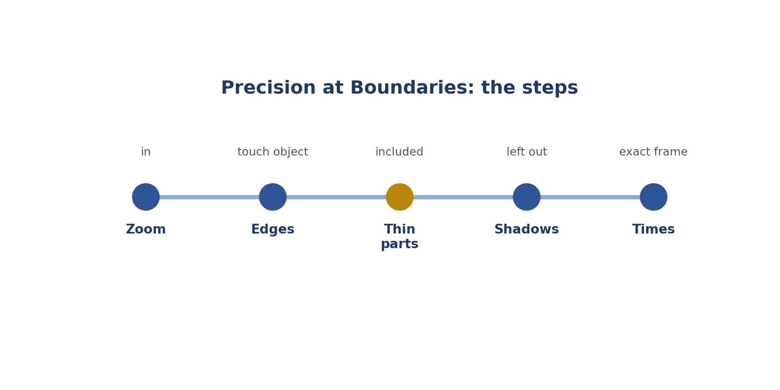
Precision at Boundaries: the steps.
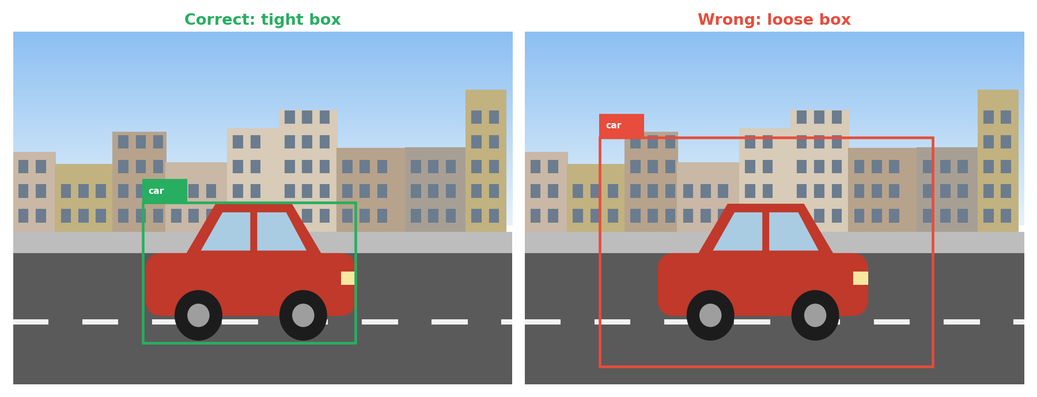
Real-style picture for precision at boundaries.
Words to know
Term | What it means
Boundary | The edge of an object, or the start and end of a sound.
Tight | Touching the edges, with no extra space.
Pixel | One tiny dot in a picture.

● Where it fits in the job
The AI learns exactly where your edges are.
In simple English: The AI copies your edges.
● Why it matters
Loose edges are the most common reason labels are sent back.
In simple English: Loose edges are the most common mistake.
How to do it, step by step
Step 1 Zoom in on the object.
Simply: Zoom in.
Step 2 Make every edge touch the object.
Simply: Touch the edges.
Step 3 Include thin parts like mirrors.
Simply: Include thin parts.
Step 4 Leave out shadows, unless told otherwise.
Simply: Leave out shadows.
Step 5 For audio and video, step frame by frame at the start and end.
Simply: Find the exact time.
Good versus bad
What good looks like | What bad looks like
Tight boxes | Boxes full of background
Includes mirrors and handles | Cuts off thin parts
Exact start and end times | Late or early times

Worked examples
LOOSE BOX
The situation: A box has road all around the car.
What to do: Pull every edge in to touch the car.
Why: Extra road teaches the AI wrong sizes.
In simple English: Touch the edges.
CUT-OFF MIRROR
The situation: A box cuts off the side mirror.
What to do: Move that edge out to include it.
Why: The mirror is part of the car.
In simple English: Include every part.
LATE AUDIO START
The situation: An audio clip starts 0.5 seconds after the speech.
What to do: Move the start earlier.
Why: The start of the speech is missing.
In simple English: Start exactly when it starts.
SHADOW INCLUDED
The situation: A box includes the car's shadow.
What to do: Move the edge to the car body.
Why: Shadows aren't the car.
In simple English: Leave out shadows.
Common mistakes
Mistake | Why it's a problem
Not zooming | Edges get loose.
Including shadows | Usually not allowed.
Cutting thin parts | Include them.
Late or early times | Step frame by frame.

● How it's tested
Audits compare your edges with correct ones.
In simple English: Your edges are measured.
How to practise
1. Draw 10 boxes, then zoom in and fix them.
2. Compare loose and tight boxes.
3. Practise finding exact start times in a video.
Skill levels
Level | What it looks like
Beginner | Loose edges.
Developing | Mostly tight.
Strong | Always tight and exact.

● What it looks like on your CV
"Delivered precise boxes, polygons and timestamps to strict quality standards."
In simple English: Shows precision.
Quick check
Question: What should a tight box touch?
Answer: The object's outer edges on every side.
Question: Should shadows be inside the box?
Answer: Usually no.
Practise this skill: Day 3 Task Bank, Chapter 6.

CHAPTER 11
Annotation Skill 7: Consistency Across Batches

THINK OF IT LIKE THIS
Consistency is like a baker making bread every day. Customers expect the same taste every time, not great on Monday and different on Friday.
In simple English: Same quality every time.
DEFINITION
Consistency across batches means labelling the same kind of item the same way every time, from the first task to the last, even when tired.

In simple English: Label the same things the same way, every time.
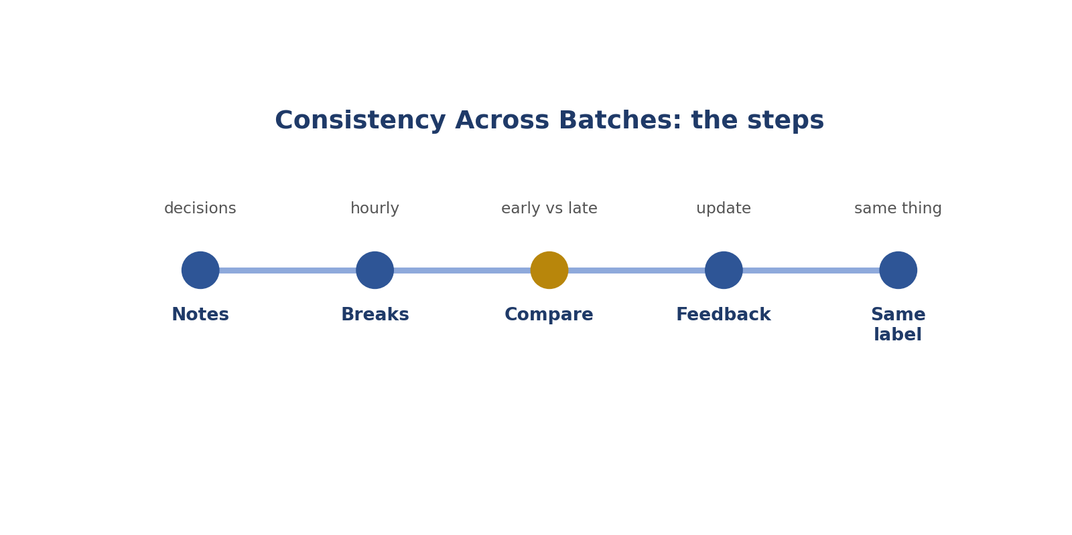
Consistency Across Batches: the steps.
Words to know
Term | What it means
Batch | A group of tasks done together.
Consistent | The same every time.
Drift | A slow change you don't notice.

● Where it fits in the job
Datasets mix thousands of labels. If they don't match, the AI gets confused.
In simple English: Mixed labels confuse the AI.
● Why it matters
Tiredness slowly changes how you label.
In simple English: Tiredness causes drift.
How to do it, step by step
Step 1 Keep notes of tricky decisions.
Simply: Write decisions down.
Step 2 Take short breaks.
Simply: Rest.
Step 3 Compare recent work with early work.
Simply: Compare.
Step 4 Update notes after feedback.
Simply: Learn and update.
Step 5 Use the same label for the same thing.
Simply: Same thing, same label.
Good versus bad
What good looks like | What bad looks like
Keeps a decisions file | Decides differently each time
Takes breaks | Works tired for hours
Checks early vs late work | Never checks

Worked examples
SCOOTER CONFUSION
The situation: Scooters labelled motorbike in the morning, bicycle in the afternoon.
What to do: Check the definition and fix the wrong ones.
Why: Same thing, different labels.
In simple English: Same thing, same label.
LOOSER BOXES
The situation: Boxes got looser after two hours.
What to do: Take a break and recheck.
Why: Tiredness made you less precise.
In simple English: Tired? Rest and recheck.
NOTES FILE
The situation: You decide scooters with pedals are bicycles. You write it down.
What to do: Use the same decision next time.
Why: Notes keep you steady.
In simple English: Write it down, do it the same.
NEW RULE
The situation: Feedback changes a rule.
What to do: Update your notes and ask about old tasks.
Why: Old and new work should match.
In simple English: Update and ask.
Common mistakes
Mistake | Why it's a problem
Deciding differently each time | Keep notes.
Working very tired | Take breaks.
Ignoring feedback | Update notes.
Changing standards to go faster | Never.

● How it's tested
Hidden test tasks check consistency.
In simple English: Hidden tasks check you.
How to practise
1. Label the same 10 pictures on two days and compare.
2. Keep a decisions file.
3. Check your first and last task each session.
Skill levels
Level | What it looks like
Beginner | Changes over time.
Developing | Mostly steady.
Strong | Steady from first to last.

● What it looks like on your CV
"Maintained consistent labelling quality across high-volume batches."
In simple English: Shows steady quality.
Quick check
Question: What is a batch?
Answer: A group of tasks done together.
Question: Name one habit that keeps you consistent.
Answer: A notes file, breaks, or comparing early and late work.
Practise this skill: Day 3 Task Bank, Chapter 7.

CHAPTER 12
Annotation Skill 8: Annotation Tool Shortcuts

THINK OF IT LIKE THIS
Shortcuts are like knowing the quick route to school. You arrive faster without skipping anything important.
In simple English: Faster, without skipping steps.
DEFINITION
Annotation tool shortcuts are keys and features, like number keys for labels, zoom and undo, that help you work faster without losing accuracy.

In simple English: Learn the keys that make the tool faster.
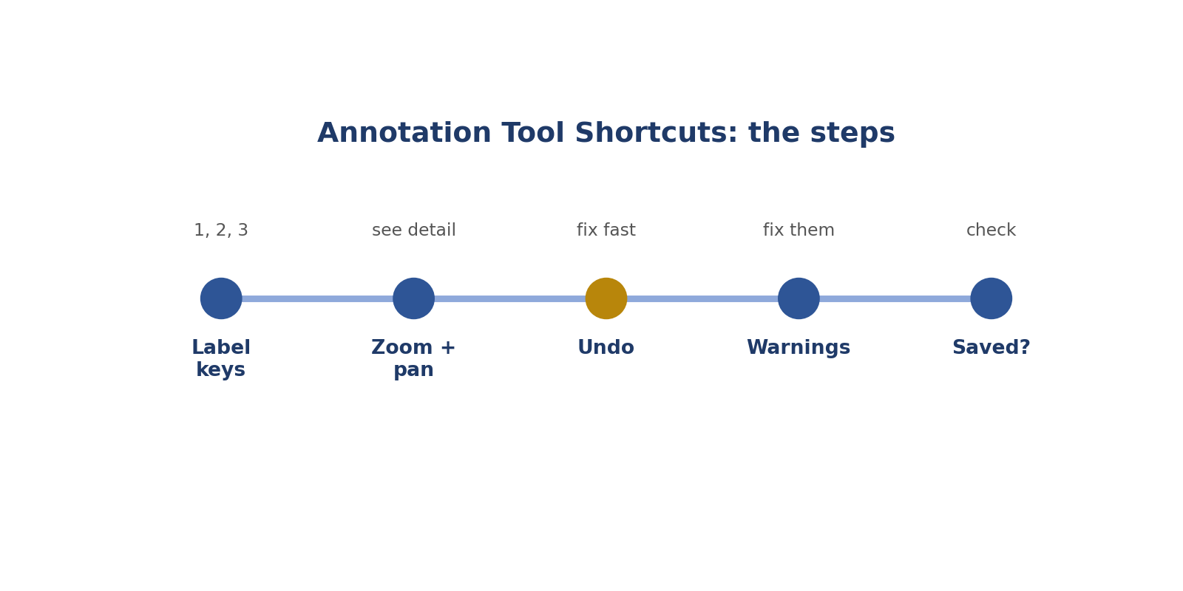
Annotation Tool Shortcuts: the steps.
Real-style picture for annotation tool shortcuts.
Words to know
Term | What it means
Shortcut | A key that does something quickly.
Zoom | Make the picture bigger on screen.
Undo | Reverse the last action.

● Where it fits in the job
All labelling happens inside a tool.
In simple English: The tool is your workplace.
● Why it matters
Slow tool use wastes time and causes wrong clicks.
In simple English: Slow clicking causes mistakes.
How to do it, step by step
Step 1 Read the tool's shortcut list on day one.
Simply: Learn the keys.
Step 2 Use number keys for labels.
Simply: Keys for labels.
Step 3 Use zoom and pan for detail.
Simply: Zoom and move.
Step 4 Use undo to fix mistakes.
Simply: Undo fast.
Step 5 Check every task saved.
Simply: Make sure it saved.
Good versus bad
What good looks like | What bad looks like
Uses keys | Clicks menus every time
Fixes warnings | Ignores warnings
Checks auto-labels | Trusts auto-labels

Worked examples
NUMBER KEYS
The situation: Press 1 for car, 2 for person.
What to do: Use keys instead of menus.
Why: Saves time on every label.
In simple English: Keys are faster.
WRONG POINT
The situation: You click a wrong polygon point.
What to do: Press undo.
Why: Quick fix.
In simple English: Undo fixes mistakes.
WARNING
The situation: The tool says "box outside image".
What to do: Fix the box.
Why: Warnings stop mistakes.
In simple English: Fix warnings.
AUTO-LABELS
The situation: The tool suggests boxes for you.
What to do: Check and fix each one.
Why: You're responsible for the final label.
In simple English: Check every suggestion.
Common mistakes
Mistake | Why it's a problem
Clicking menus for everything | Learn keys.
Ignoring warnings | Fix them.
Trusting auto-labels | Check them.
Not checking saves | Check.

● How it's tested
Many tests run inside the real tool.
In simple English: Tests use the real tool.
How to practise
1. Try CVAT or Label Studio (free tools).
2. Learn 5 shortcuts.
3. Time yourself with and without shortcuts.
Skill levels
Level | What it looks like
Beginner | Clicks menus.
Developing | Knows some keys.
Strong | Fast and accurate with the tool.

● What it looks like on your CV
"Worked efficiently in annotation platforms such as CVAT and Label Studio."
In simple English: Names tools you really used.
Quick check
Question: Why learn shortcuts?
Answer: To work faster without losing accuracy.
Question: The tool suggests boxes. What do you do?
Answer: Check and fix every one.
Practise this skill: Day 3 Task Bank, Chapter 8.

CHAPTER 13
Role 2: Computer Vision Annotation Specialist

DEFINITION
A Computer Vision Annotation Specialist draws exact labels on pictures (boxes, shapes and points) so AI can learn to find, outline and understand objects and people.

In simple English: You draw exact boxes, shapes and dots on pictures so AI can learn to see.
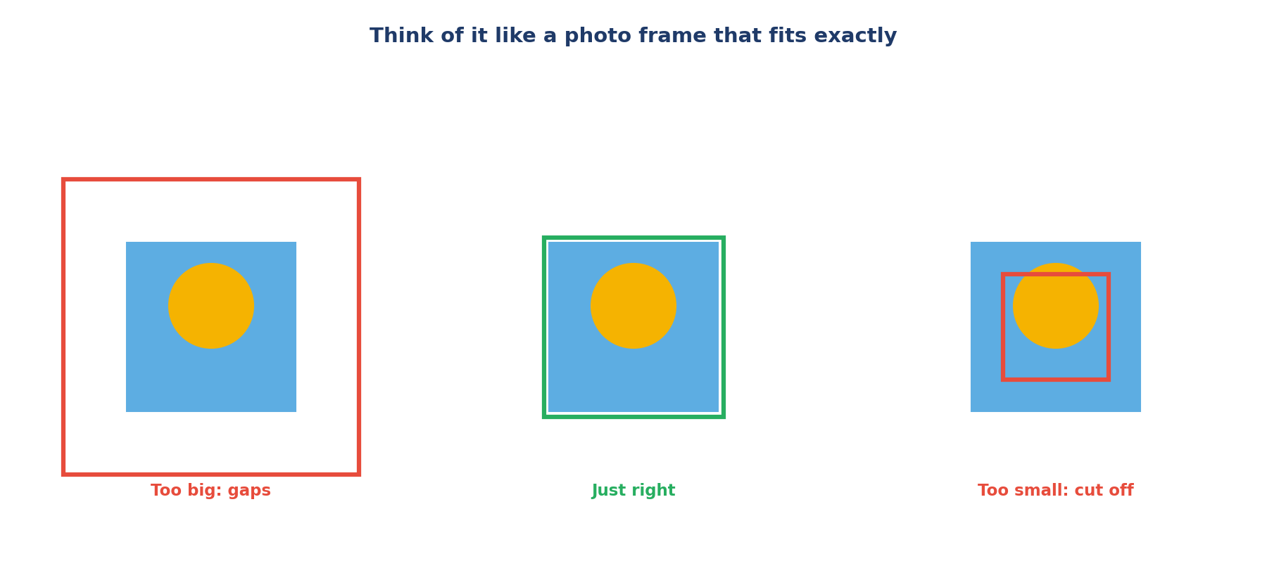
Like a photo frame that fits exactly.
Let's read this picture together
Step 1 Left: the frame is too big, with gaps around the picture. Wrong.
Simply: Too big.
Step 2 Middle: the frame fits exactly. Right.
Simply: Just right.
Step 3 Right: the frame is too small and cuts the picture. Wrong.
Simply: Too small.
The words explained
● What "computer vision" means
The part of AI that understands pictures and videos, like finding cars in a street photo.
In simple English: AI that sees.
● How it differs from Role 1
Role 1 uses many kinds of data. Role 2 focuses only on pictures, where being exact matters most.
In simple English: Only pictures, but more exact.
The main label types
Tight box (right) and loose box (wrong).
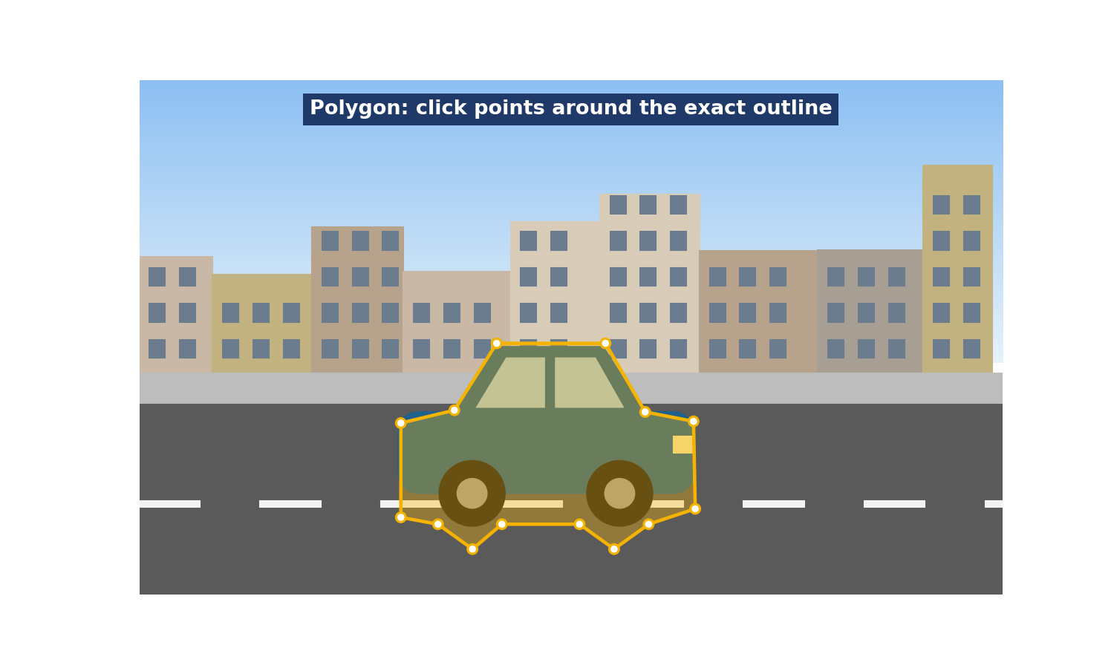
A polygon follows the exact shape.
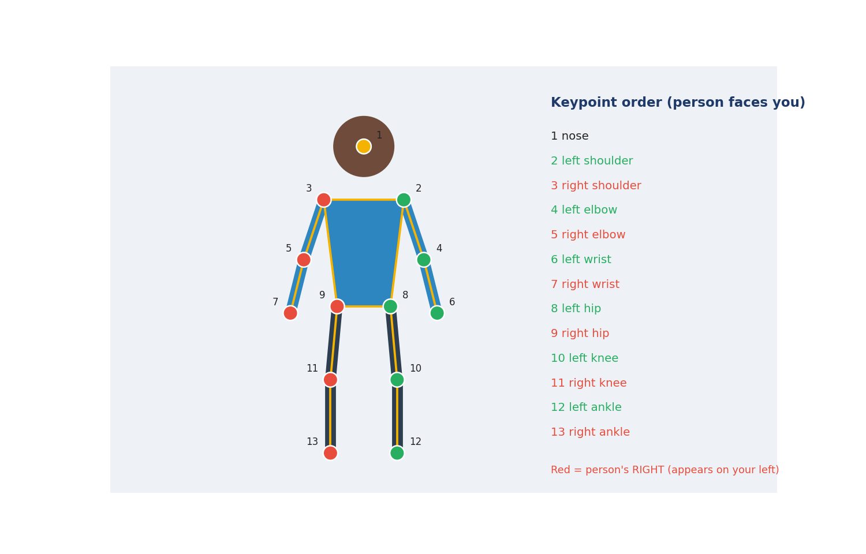
Keypoints in the right order.
Let's read the keypoints picture
Step 1 The person faces you.
Simply: Facing the camera.
Step 2 Red dots are the person's RIGHT side, which appears on YOUR left.
Simply: Their right is on your left.
Step 3 The list on the right shows the order: 1 nose, 2 left shoulder, and so on.
Simply: Follow the order.
● Where this work is used
Self-driving cars, traffic cameras, shop checkouts, farm drones and phone cameras.
In simple English: Cars, cameras and phones.
● Common job titles
Computer Vision Annotator, Image Annotation Specialist, Segmentation Annotator, Pose Annotator.
In simple English: Many names, same work.

CHAPTER 14
How the 8 Computer Vision Skills Work Together

Step | Skill | Simply
Mark where things are | 1. Bounding boxes | Tight frames
Mark exact shapes | 2. Polygons | Trace the shape
Mark body points | 3. Keypoints | Dots in order
Label the whole picture | 4. Classification | One name
Record hidden or cut-off | 5. Flags | Tick boxes
Skip tiny or hidden objects | 6. Thresholds | Size limits
Be exact | 7. Zoom | Zoom in
Check your work | 8. Self-review | Check before sending

CHAPTER 15
Computer Vision Skill 1: Bounding Boxes

THINK OF IT LIKE THIS
A bounding box is like a photo frame that fits the picture exactly: no big gaps around it, and nothing cut off.
In simple English: A frame that fits exactly.
DEFINITION
A bounding box is a tight rectangle drawn around an object, with its edges touching the object's outer edges on all four sides.

In simple English: Draw a close-fitting rectangle around each object.
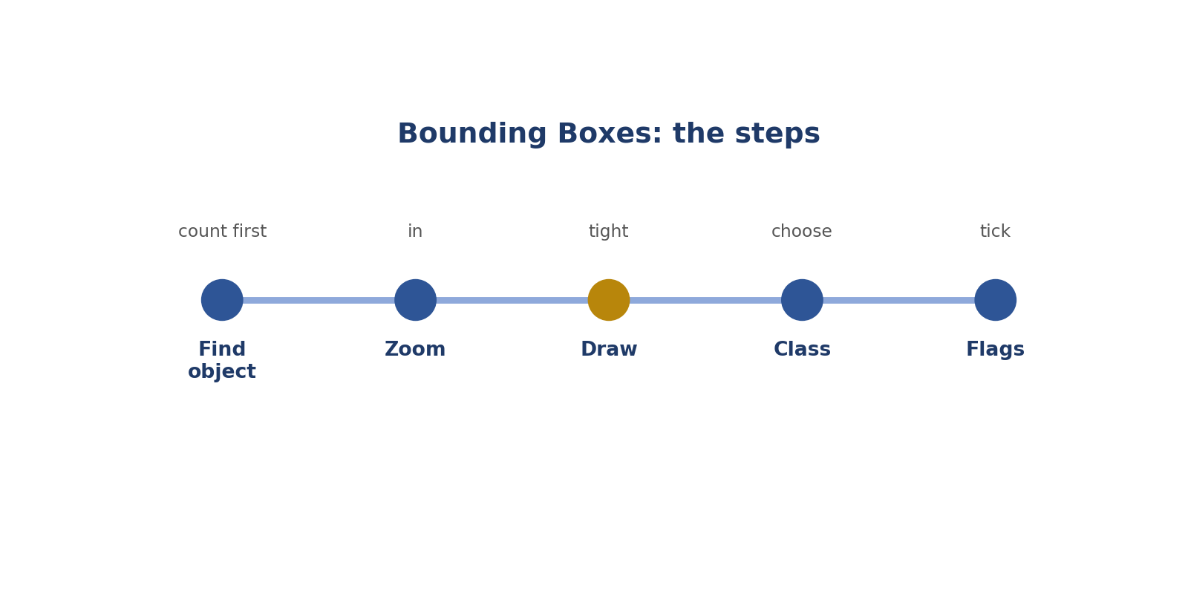
Bounding Boxes: the steps.
Real-style picture for bounding boxes.
Words to know
Term | What it means
Bounding box | A rectangle around an object.
Object detection | Teaching AI to find objects in pictures.
Tight | Touching the edges.

● Where it fits in the job
Boxes are the most common picture label.
In simple English: Boxes are used most.
● Why it matters
Loose or cut-off boxes teach the AI wrong sizes and positions.
In simple English: Bad boxes teach wrong sizes.
How to do it, step by step
Step 1 Count the objects to label.
Simply: Count first.
Step 2 Zoom in on one object.
Simply: Zoom in.
Step 3 Draw the box touching all four sides.
Simply: Touch all sides.
Step 4 Choose the class.
Simply: Name it.
Step 5 Tick any flags.
Simply: Tick flags.
Good versus bad
What good looks like | What bad looks like
Touches all four sides | Leaves big gaps
Includes mirrors | Cuts off thin parts
One box per object | One box around a group

Worked examples
TIGHT BOX
The situation: A box touches the car on every side.
What to do: Keep it.
Why: It's correct.
In simple English: Touching all sides is right.
GAP AT THE TOP
The situation: A box leaves space above a dog's head.
What to do: Pull the top edge down.
Why: Extra space is wrong.
In simple English: Remove gaps.
RAISED ARMS
The situation: A person raises their arms.
What to do: Include the hands in the box.
Why: The hands are part of the person.
In simple English: Include raised arms.
GROUP OF PEOPLE
The situation: One box around five people.
What to do: Draw five boxes.
Why: One object, one box.
In simple English: Each object gets its own box.
Common mistakes
Mistake | Why it's a problem
Loose edges | Zoom and tighten.
Cutting off parts | Include everything.
One box for many objects | One each.
Including shadows | Usually not allowed.

● How it's tested
Box accuracy is measured against reference boxes.
In simple English: Your boxes are measured.
How to practise
1. Draw boxes on 20 photos.
2. Zoom in and check each edge.
3. Compare with a friend.
Skill levels
Level | What it looks like
Beginner | Loose boxes.
Developing | Mostly tight.
Strong | Tight every time.

● What it looks like on your CV
"Drew precise bounding boxes for object detection datasets."
In simple English: Shows box skills.
Quick check
Question: What should box edges touch?
Answer: The object's outer edges on all four sides.
Question: Five people: how many boxes?
Answer: Five.
Practise this skill: Day 3 Task Bank, Chapter 9.

CHAPTER 16
Computer Vision Skill 2: Polygon Segmentation

THINK OF IT LIKE THIS
A polygon is like tracing a cartoon with dots and lines. Where the drawing curves, you need more dots to follow it.
In simple English: Trace the shape with dots.
DEFINITION
Polygon segmentation means clicking points around an object's exact outline, so the shape follows curves and thin parts closely.

In simple English: Click points around the exact shape.
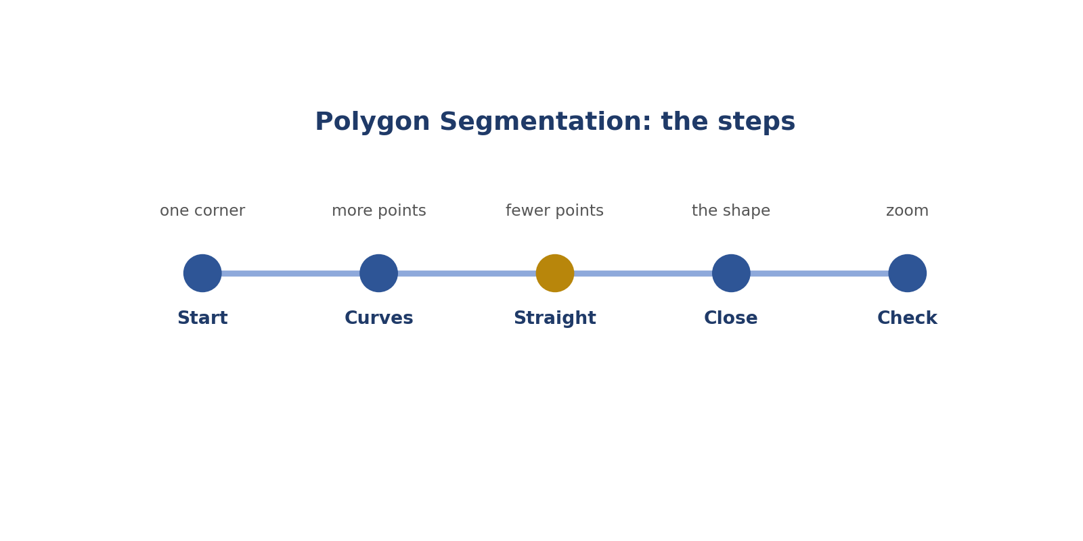
Polygon Segmentation: the steps.
Real-style picture for polygon segmentation.
Words to know
Term | What it means
Polygon | A shape made of connected points.
Segmentation | Separating an object's exact area from the background.
Point | A dot you click.

● Where it fits in the job
Some AI needs exact shapes, not rectangles.
In simple English: Exact shapes need polygons.
● Why it matters
Rough shapes teach the AI the wrong outline.
In simple English: Rough shapes teach wrong lessons.
How to do it, step by step
Step 1 Start at one corner.
Simply: Start somewhere clear.
Step 2 Add more points on curves.
Simply: Curves need more dots.
Step 3 Use fewer points on straight edges.
Simply: Straight needs few dots.
Step 4 Close the shape.
Simply: Join the last dot.
Step 5 Zoom and check every point.
Simply: Check it.
Good versus bad
What good looks like | What bad looks like
Many points on curves | Few points everywhere
Includes handles | Cuts off thin parts
No background inside | Includes background

Worked examples
CAR ROOF
The situation: A polygon cuts across a curved roof.
What to do: Add points along the curve.
Why: It skipped the curve.
In simple English: Follow the curve.
MUG HANDLE
The situation: A polygon leaves out the handle.
What to do: Include it.
Why: The handle is part of the mug.
In simple English: Include thin parts.
WALL INSIDE
The situation: A person polygon includes part of the wall.
What to do: Tighten it.
Why: Background doesn't belong.
In simple English: Leave out background.
ROUND BALL
The situation: Only 4 points around a ball.
What to do: Add many more.
Why: Round shapes need many points.
In simple English: Round needs many dots.
Common mistakes
Mistake | Why it's a problem
Too few points | Add more on curves.
Including background | Tighten it.
Missing thin parts | Include them.
Crossing lines | Go around in order.

● How it's tested
Polygons are compared with correct shapes.
In simple English: Shapes are checked.
How to practise
1. Trace 10 objects with curves.
2. Practise thin parts like handles.
3. Check with zoom.
Skill levels
Level | What it looks like
Beginner | Rough shapes.
Developing | Good on simple objects.
Strong | Accurate on complex objects.

● What it looks like on your CV
"Created polygon segmentation masks for vehicles and people."
In simple English: Shows shape skills.
Quick check
Question: Where do polygons need more points?
Answer: On curves and thin parts.
Question: Should a person polygon include the wall behind?
Answer: No.
Practise this skill: Day 3 Task Bank, Chapter 10.

CHAPTER 17
Computer Vision Skill 3: Keypoint Placement and Order

THINK OF IT LIKE THIS
Keypoints are like dot-to-dot puzzles. If you number the dots in the wrong order, the picture comes out twisted.
In simple English: Right dots, right order.
DEFINITION
Keypoint placement means putting dots on exact parts of a body or object, like joints, in the order the rules set, using the person's own left and right.

In simple English: Put dots on the right parts, in the right order.
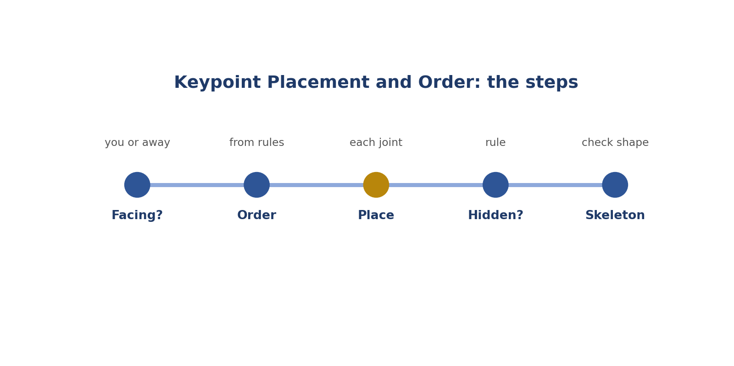
Keypoint Placement and Order: the steps.
Real-style picture for keypoint placement and order.
Words to know
Term | What it means
Keypoint | A dot on a body part, like an elbow.
Pose | How a body is positioned.
Skeleton | Lines joining the dots.

● Where it fits in the job
Pose AI learns body positions from keypoints.
In simple English: Pose AI needs exact dots.
● Why it matters
Swapping left and right makes the whole pose wrong.
In simple English: A swap ruins everything.
How to do it, step by step
Step 1 Check if the person faces you or away.
Simply: Which way are they facing?
Step 2 Follow the order in the rules.
Simply: Use the right order.
Step 3 Place each dot on the exact joint.
Simply: Put dots on joints.
Step 4 Follow the rule for hidden points.
Simply: Hidden? Follow the rule.
Step 5 Check the skeleton looks right.
Simply: Does it look right?
Good versus bad
What good looks like | What bad looks like
Uses the person's left and right | Uses your own left and right
Follows the order | Random order
Marks hidden points by the rule | Guesses hidden points

Worked examples
FACING YOU
The situation: A person faces you; their right hand is on your left.
What to do: Label it right wrist.
Why: Use the person's side.
In simple English: Their right is on your left.
FACING AWAY
The situation: A person faces away; their right hand is on your right.
What to do: Label it right wrist.
Why: Facing away, sides match yours.
In simple English: Facing away, sides match.
HIDDEN KNEE
The situation: A knee is hidden behind the other leg.
What to do: Follow the hidden-point rule.
Why: Don't guess.
In simple English: Hidden? Follow the rule.
TWISTED SKELETON
The situation: The skeleton looks twisted.
What to do: Check the order and sides.
Why: Something is swapped.
In simple English: Twisted means a swap.
Common mistakes
Mistake | Why it's a problem
Using your own left and right | Use theirs.
Wrong order | Follow the list.
Guessing hidden points | Use the rule.
Dots on the wrong part | Zoom in.

● How it's tested
Tests use people facing the camera.
In simple English: Tests use people facing you.
How to practise
1. Label 5 people facing you and 5 facing away.
2. Learn the dot order.
3. Check skeletons.
Skill levels
Level | What it looks like
Beginner | Swaps sides.
Developing | Mostly correct.
Strong | Always correct, including hidden points.

● What it looks like on your CV
"Placed ordered keypoints for human pose estimation."
In simple English: Shows pose skills.
Quick check
Question: A person faces you. Where is their right hand?
Answer: On your left.
Question: Why does order matter?
Answer: The AI reads the dots by position in the list.
Practise this skill: Day 3 Task Bank, Chapter 11.

CHAPTER 18
Computer Vision Skill 4: Image Classification

THINK OF IT LIKE THIS
Classification is like sorting photos into albums: beach, birthday, school. Each photo goes into one album.
In simple English: Put each picture in the right group.
DEFINITION
Image classification means giving a whole picture one label (or several, if allowed) from a fixed list, using the rules' definitions.

In simple English: Give the whole picture a label from the list.
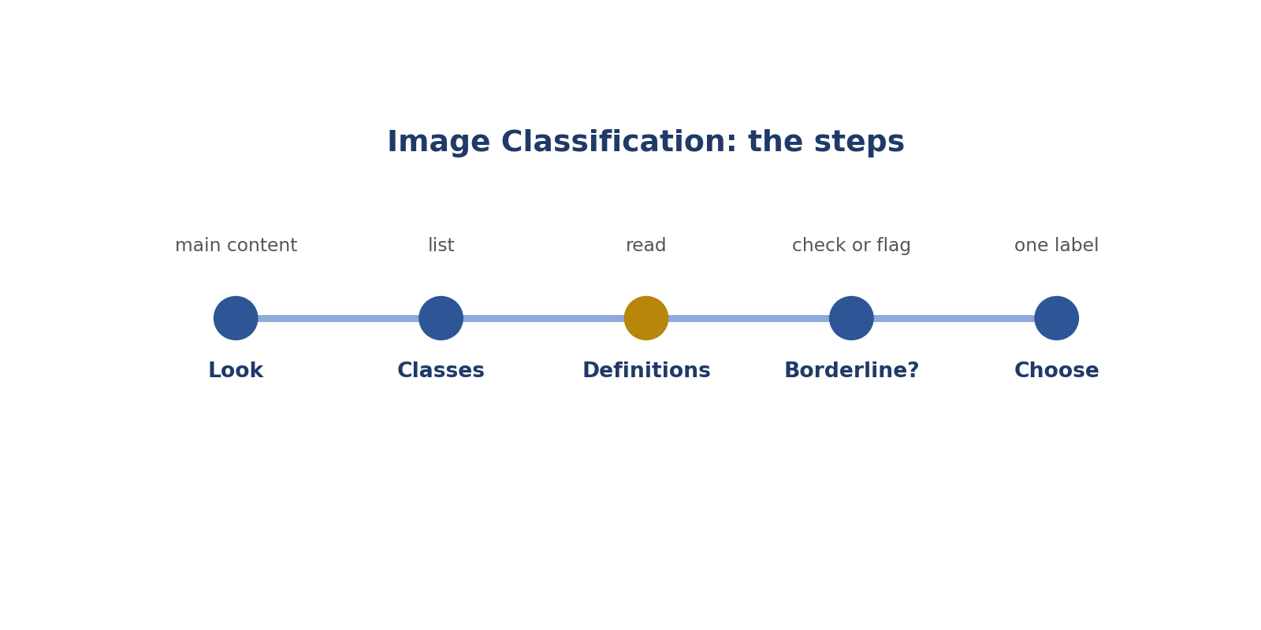
Image Classification: the steps.
Words to know
Term | What it means
Classification | Choosing one label for the whole picture.
Borderline | Between two groups.
Multi-label | When more than one label is allowed.

● Where it fits in the job
Classification is often the first task new labellers get.
In simple English: Often the first task.
● Why it matters
Fast tasks invite careless mistakes.
In simple English: Fast tasks cause mistakes.
How to do it, step by step
Step 1 Look at the main content.
Simply: What's the picture of?
Step 2 Check the class list.
Simply: What are the choices?
Step 3 Read definitions for close cases.
Simply: Read the meanings.
Step 4 Use "unclear" or flag if needed.
Simply: Unsure? Flag.
Step 5 Choose the label.
Simply: Pick it.
Good versus bad
What good looks like | What bad looks like
Labels the main content | Labels a tiny detail
Checks definitions | Guesses
Uses "unclear" when allowed | Forces a label

Worked examples
BEACH
The situation: Classes: indoor, outdoor. A beach photo.
What to do: Outdoor.
Why: Easy case.
In simple English: Beach is outdoor.
COVERED MARKET
The situation: Indoor or outdoor? A market stall open at the sides.
What to do: Check the definition or flag.
Why: It's borderline.
In simple English: Borderline? Check or flag.
RABBIT
The situation: Classes: cat, dog, other. A rabbit.
What to do: Other.
Why: Nothing else fits.
In simple English: Nothing fits? Other.
MULTI-LABEL
The situation: Tags allowed: cars, people, trees. A street with all three.
What to do: Tag all three.
Why: Multi-label means all that apply.
In simple English: Tag all that fit.
Common mistakes
Mistake | Why it's a problem
Labelling a small detail | Label the main content.
Guessing borderline cases | Check or flag.
Rushing | Slow down on hard ones.
Ignoring multi-label rules | Tag all that apply.

● How it's tested
Hidden test pictures check classification.
In simple English: Hidden pictures check you.
How to practise
1. Sort 30 photos into indoor or outdoor.
2. Note the borderline ones.
3. Explain each choice.
Skill levels
Level | What it looks like
Beginner | Guesses on hard pictures.
Developing | Right on clear pictures.
Strong | Right on hard pictures too.

● What it looks like on your CV
"Classified large image sets against defined category lists."
In simple English: Shows classification work.
Quick check
Question: What does classification mean?
Answer: Giving the whole picture a label.
Question: Nothing fits. What do you do?
Answer: Use other, unclear, or flag.
Practise this skill: Day 3 Task Bank, Chapter 12.

CHAPTER 19
Computer Vision Skill 5: Occluded and Truncated Flags

THINK OF IT LIKE THIS
Flags are like notes on a photo: "part of this person is hidden" or "this person is cut off". They tell the AI what it can't see.
In simple English: Notes about what's hidden.
DEFINITION
Occluded and truncated flags are tick boxes that record whether an object is partly hidden behind something or cut off by the picture's edge.

In simple English: Tick the right box for hidden or cut-off objects.
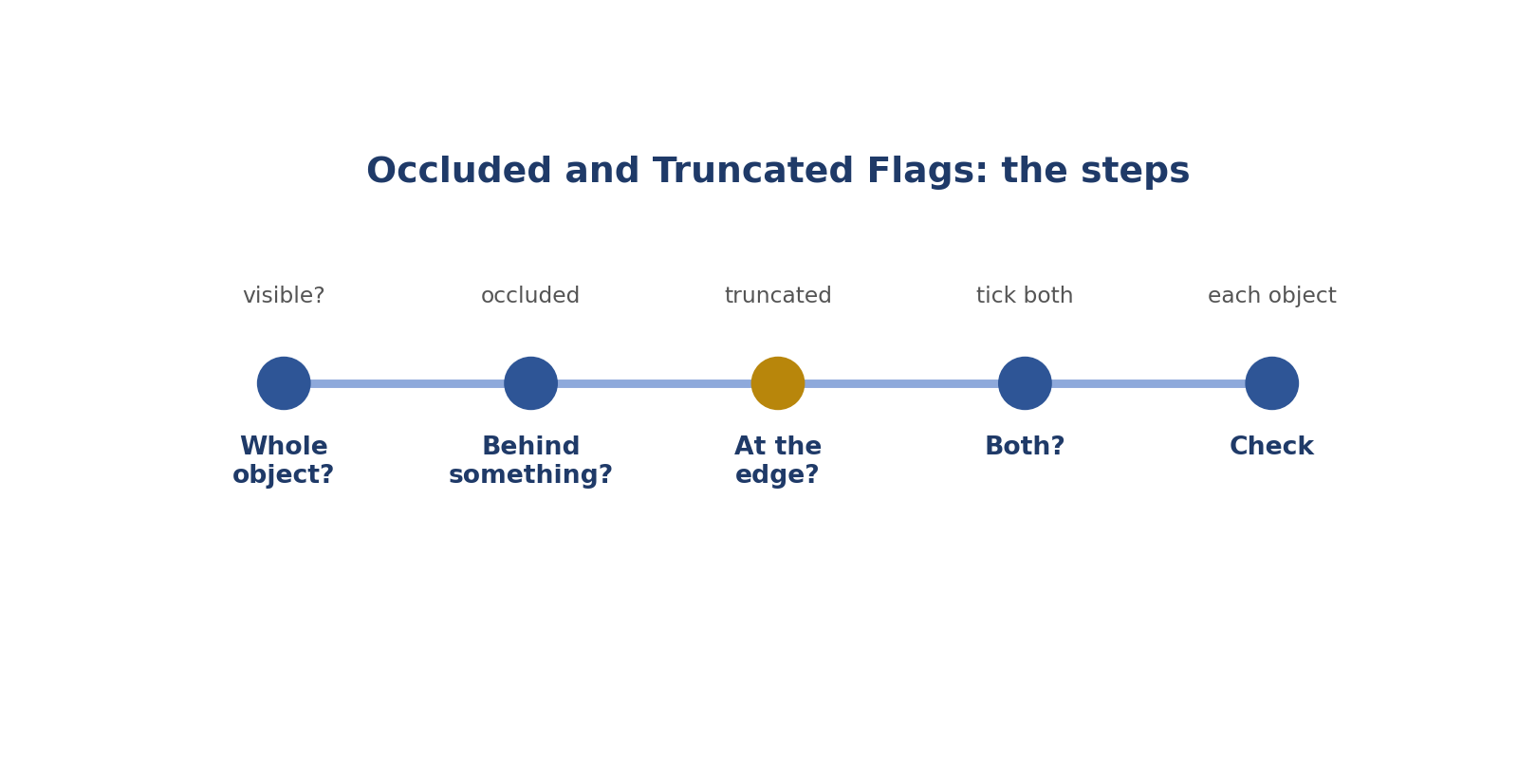
Occluded and Truncated Flags: the steps.
Real-style picture for occluded and truncated flags.
Words to know
Term | What it means
Flag (attribute) | An extra detail ticked for a label.
Occluded | Hidden behind something.
Truncated | Cut off by the edge.

● Where it fits in the job
Flags tell the AI how much of the object it sees.
In simple English: Flags tell the AI what's visible.
● Why it matters
Wrong flags confuse the AI about size and shape.
In simple English: Wrong flags confuse the AI.
How to do it, step by step
Step 1 Ask: can I see the whole object?
Simply: All visible?
Step 2 Hidden behind something? Tick occluded.
Simply: Behind: occluded.
Step 3 Cut by the edge? Tick truncated.
Simply: Edge: truncated.
Step 4 Both? Tick both.
Simply: Both.
Step 5 Check every object.
Simply: Check each one.
Good versus bad
What good looks like | What bad looks like
Checks each object | Ticks by habit
Ticks both when needed | Ticks only one
Knows the difference | Mixes them up

Worked examples
BEHIND A CAR
The situation: Only the top of a person shows behind a car.
What to do: Occluded.
Why: The car hides them.
In simple English: Behind: occluded.
TOP EDGE
The situation: A bus is cut off at the top.
What to do: Truncated.
Why: The edge cuts it.
In simple English: Any edge counts.
GLASS DOOR
The situation: A dog is fully visible through a glass door.
What to do: Usually not occluded; check the rules.
Why: Glass may not hide it.
In simple English: See-through may not hide.
SIGN HELD UP
The situation: A person holds a big sign in front of their body.
What to do: Occluded.
Why: The sign hides them.
In simple English: Things held can hide people.
Common mistakes
Mistake | Why it's a problem
Ticking by habit | Check each object.
Mixing up the flags | Behind vs edge.
Forgetting both | Tick both.
Forgetting flags entirely | Always check.

● How it's tested
Audits check flags on sampled objects.
In simple English: Flags are checked.
How to practise
1. Tick flags on 10 busy pictures.
2. Explain each flag aloud.
3. Compare with a friend.
Skill levels
Level | What it looks like
Beginner | Forgets flags.
Developing | Gets obvious ones.
Strong | Always correct.

● What it looks like on your CV
"Applied occlusion and truncation attributes accurately."
In simple English: Shows accuracy.
Quick check
Question: Can an object be both?
Answer: Yes.
Question: Does truncated mean small?
Answer: No. It means cut off by the edge.
Practise this skill: Day 3 Task Bank, Chapter 13.

CHAPTER 20
Computer Vision Skill 6: Size and Visibility Thresholds

THINK OF IT LIKE THIS
A threshold is like a height limit on a fun-fair ride. If you're tall enough, you ride. If not, you don't. No guessing.
In simple English: A clear yes-or-no limit.
DEFINITION
Size and visibility thresholds are rules about the smallest objects to label and how much must be visible, like "at least 20 pixels wide" or "at least half visible".

In simple English: Follow the rules about tiny or barely visible objects.
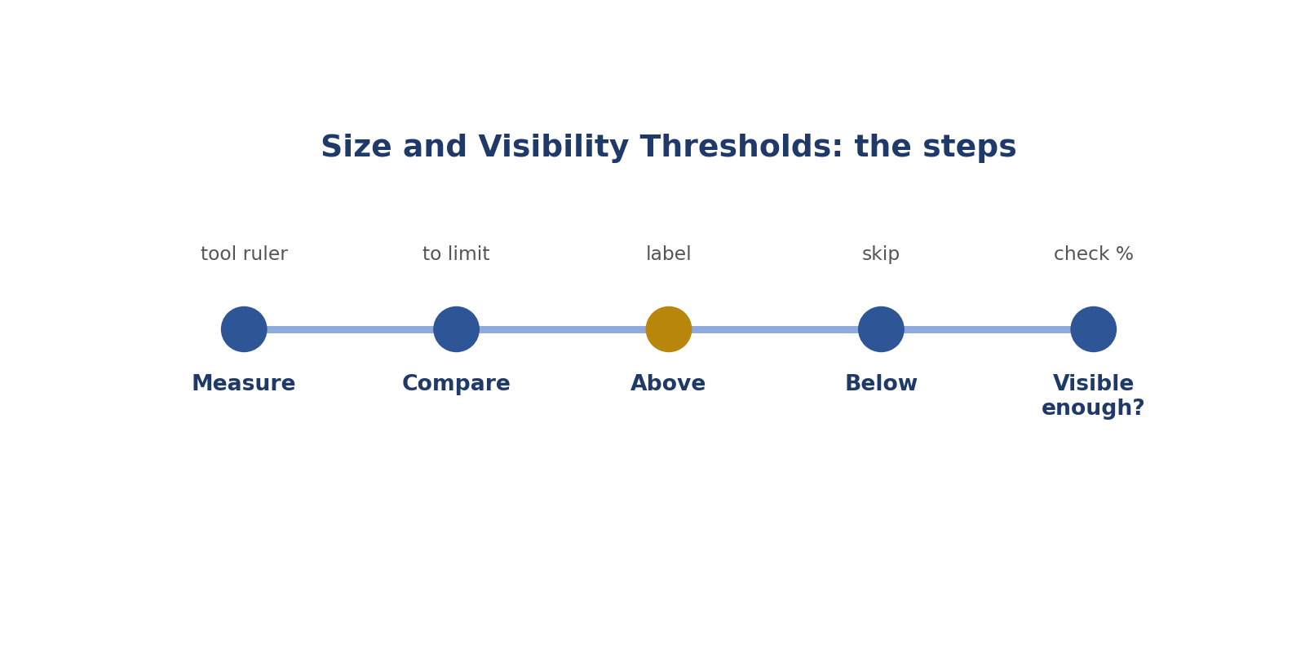
Size and Visibility Thresholds: the steps.
Words to know
Term | What it means
Threshold | A limit that decides yes or no.
Pixel | One tiny dot in a picture.
Visibility | How much of the object you can see.

● Where it fits in the job
Tiny or barely visible objects make messy data, so rules set limits.
In simple English: Limits keep data clean.
● Why it matters
Labelling too-small objects wastes time; skipping allowed ones loses data.
In simple English: Too many or too few both hurt.
How to do it, step by step
Step 1 Measure the object with the tool.
Simply: Measure it.
Step 2 Compare with the limit.
Simply: Compare.
Step 3 Above the limit: label it.
Simply: Big enough: label.
Step 4 Below: skip it.
Simply: Too small: skip.
Step 5 Check how much is visible.
Simply: Visible enough?
Good versus bad
What good looks like | What bad looks like
Measures | Guesses
Follows the limit | Labels everything
Knows "at least" includes the number | Gets the edge cases wrong

Worked examples
30 PIXELS
The situation: Limit 20. A car is 30.
What to do: Label it.
Why: Above the limit.
In simple English: Big enough: label.
12 PIXELS
The situation: Limit 20. A car is 12.
What to do: Skip it.
Why: Below the limit.
In simple English: Too small: skip.
EXACTLY 20
The situation: Limit "at least 20". A car is 20.
What to do: Label it.
Why: "At least" includes 20.
In simple English: At least includes the number.
40% VISIBLE
The situation: Rule: at least half visible. A car is 40% visible.
What to do: Skip it.
Why: Less than half.
In simple English: Not visible enough: skip.
Common mistakes
Mistake | Why it's a problem
Guessing sizes | Measure.
Labelling everything | Follow the limit.
Getting "at least" wrong | It includes the number.
Ignoring visibility rules | Check them.

● How it's tested
Tests place objects near the limit.
In simple English: Tests sit near the limit.
How to practise
1. Measure 20 small objects.
2. Practise with the limit rules.
3. Explain each yes or no.
Skill levels
Level | What it looks like
Beginner | Guesses.
Developing | Measures sometimes.
Strong | Always measures near the limit.

● What it looks like on your CV
"Applied size and visibility thresholds per project rules."
In simple English: Shows rule-following.
Quick check
Question: Limit 20 pixels; car is 22. Label?
Answer: Yes.
Question: Limit 20; car is 18. Label?
Answer: No.
Practise this skill: Day 3 Task Bank, Chapter 14.

CHAPTER 21
Computer Vision Skill 7: Zoom and Edge Precision

THINK OF IT LIKE THIS
Zooming is like using a magnifying glass to thread a needle. Without it, you keep missing the hole.
In simple English: Zoom in to be exact.
DEFINITION
Zoom and edge precision means zooming in to place edges and points exactly, especially on small objects and thin parts.

In simple English: Zoom in so your edges are exact.
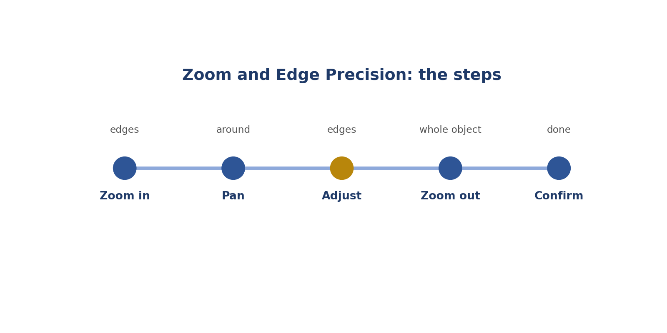
Zoom and Edge Precision: the steps.
Real-style picture for zoom and edge precision.
Words to know
Term | What it means
Zoom | Make the picture bigger on screen.
Pan | Move around a zoomed picture.
Thin part | A narrow part like a mirror or handle.

● Where it fits in the job
Small mistakes you can't see at normal size still matter to the AI.
In simple English: Tiny mistakes still matter.
● Why it matters
Not zooming is the main cause of loose edges.
In simple English: Not zooming causes loose edges.
How to do it, step by step
Step 1 Zoom in on the edges.
Simply: Zoom in.
Step 2 Pan around the object.
Simply: Move around.
Step 3 Fix each edge.
Simply: Adjust.
Step 4 Zoom out to check the whole object.
Simply: Zoom out to check.
Step 5 Confirm and move on.
Simply: Done.
Good versus bad
What good looks like | What bad looks like
Zooms on small objects | Never zooms
Checks thin parts | Misses mirrors and handles
Zooms out to check the whole | Only sees one corner

Worked examples
HANDLEBARS
The situation: A bicycle's handlebars are thin.
What to do: Zoom to place the edge.
Why: Thin parts decide the edge.
In simple English: Zoom on thin parts.
SMALL TRAFFIC LIGHT
The situation: A traffic light is 22 pixels.
What to do: Zoom to draw it exactly.
Why: Small objects need zoom.
In simple English: Zoom on small things.
TOO ZOOMED
The situation: You can't see the whole object.
What to do: Zoom out a little.
Why: You might miss parts.
In simple English: Not too close.
BLURRY EDGE
The situation: A car's edge blends into its shadow.
What to do: Place the edge on the clearest car pixels.
Why: Leave the shadow out.
In simple English: Pick the clearest edge.
Common mistakes
Mistake | Why it's a problem
Never zooming | Zoom on every small object.
Zooming too far | Zoom out to check.
Missing thin parts | Zoom on them.
Skipping the final check | Zoom out and confirm.

● How it's tested
Precision scores show if you zoom.
In simple English: Scores show if you zoom.
How to practise
1. Label 10 objects without and with zoom; compare.
2. Learn zoom keys.
3. Practise on thin parts.
Skill levels
Level | What it looks like
Beginner | Rarely zooms.
Developing | Zooms on hard objects.
Strong | Zooms by habit.

● What it looks like on your CV
"Maintained high edge precision on small and complex objects."
In simple English: Shows precision.
Quick check
Question: When is zoom most important?
Answer: On small objects and thin parts.
Question: What's panning?
Answer: Moving around a zoomed picture.
Practise this skill: Day 3 Task Bank, Chapter 15.

CHAPTER 22
Computer Vision Skill 8: Self-Review Before Submitting

THINK OF IT LIKE THIS
Self-review is like checking your bag before leaving home: keys, phone, wallet. A few seconds saves a big problem later.
In simple English: Check before you go.
DEFINITION
Self-review means a quick final check of every label before you submit: right type, right class, tight edges, correct flags, nothing missed.

In simple English: Check your work before you send it.
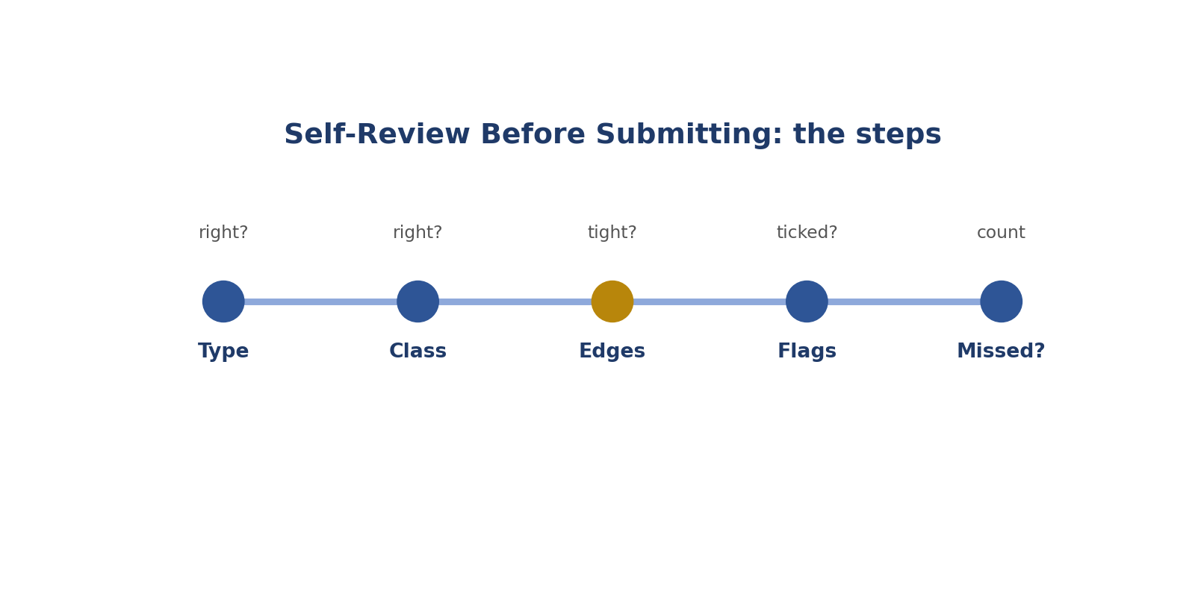
Self-Review Before Submitting: the steps.
Real-style picture for self-review before submitting.
Words to know
Term | What it means
Self-review | Checking your own work.
Submit | Send your finished work.
Rejection | When work is sent back as wrong.

● Where it fits in the job
A few seconds of checking prevents most rejected tasks.
In simple English: A quick check prevents rejections.
● Why it matters
Once you submit, mistakes count against you.
In simple English: Sent mistakes count.
How to do it, step by step
Step 1 Is the label type right?
Simply: Right type?
Step 2 Is the class right?
Simply: Right name?
Step 3 Are edges tight?
Simply: Tight?
Step 4 Are flags ticked?
Simply: Flags?
Step 5 Count objects: any missed?
Simply: Anything missed?
Good versus bad
What good looks like | What bad looks like
Checks every task | Submits straight away
Uses a short checklist | Checks randomly
Counts objects | Forgets small objects

Worked examples
MISSED CAR
The situation: 4 cars, 3 boxes.
What to do: Find and box the missing car.
Why: Counting found it.
In simple English: Count before submitting.
WRONG CLASS
The situation: Review finds a car labelled bus.
What to do: Fix it.
Why: Easy to fix now.
In simple English: Fix before sending.
MISSING HANDLE
The situation: A polygon cuts off a handle.
What to do: Add points.
Why: Caught before submitting.
In simple English: Check shapes.
VIDEO CHECK
The situation: A video segment ends late.
What to do: Fix the end frame.
Why: Times need checking too.
In simple English: Check times too.
Common mistakes
Mistake | Why it's a problem
Submitting without checking | Always check.
Skipping review when busy | Mistakes cost more later.
Long checklists | Keep 5 points.
Not counting objects | Count.

● How it's tested
Your quality score shows how well you review.
In simple English: Scores show your care.
How to practise
1. Write a 5-point checklist.
2. Use it for a whole day.
3. Track your rejections.
Skill levels
Level | What it looks like
Beginner | Never reviews.
Developing | Reviews sometimes.
Strong | Reviews every task.

● What it looks like on your CV
"Self-reviewed every task with a checklist, keeping a high audit pass rate."
In simple English: Shows care.
Quick check
Question: Name the 5 checks.
Answer: Type, class, edges, flags, missed objects.
Question: 4 cars, 3 boxes. What now?
Answer: Find and box the missing car.
Practise this skill: Day 3 Task Bank, Chapter 16.

CHAPTER 23
Comparing the Two Roles

 | Data Annotator | Computer Vision Specialist
In one line | Labels many kinds of data | Draws exact labels on pictures
Data | Pictures, video, sound, text | Pictures and video frames
Main labels | Classes, boxes, times, text tags | Boxes, polygons, keypoints, flags
Best for people who | Like variety | Like exact, careful drawing
Next step | QA reviewer | Segmentation or pose specialist

In simple English: Variety versus exactness.

CHAPTER 24
In-Class Activity (15 minutes)

1. Look at the labelling tool picture. How many objects are labelled? Which classes?
2. Look at the hidden and cut-off picture. Which object is occluded? Which is truncated?
3. In pairs, draw boxes on a printed street photo, then check each other's edges.
4. Look at the keypoints picture. Why is the person's right hand on your left?
In simple English: Use the pictures, then practise drawing and checking.

CHAPTER 25
Day 3 Assignment

Complete before the next class. Answers are in the separate Day 3 Assignment Answer Key.
Part A: Task Bank
Complete 5 tasks from any four Data Annotator chapters and 5 tasks from any four Computer Vision chapters.
Part B: Questions
1. What does "multimodal" mean? Name four kinds of data.
2. Explain the jar-label picture in three sentences.
3. Why must you read the whole rulebook first?
4. Match each task to a label type: road outline; elbows; indoor or outdoor; when someone speaks.
5. What is the difference between occluded and truncated?
6. What should a flag note include?
7. What does a tight box look like?
8. Where do polygons need more points?
9. A person faces you. Their right hand is on your left. Which label?
10. Limit 20 pixels; a car is 18. Label it?
11. Write a 5-point self-review checklist.
Part C: Practical
Install a free tool such as CVAT (Computer Vision Annotation Tool) or Label Studio. Label 10 street photos with boxes, including at least two occluded and two truncated objects. Bring a screenshot.

CHAPTER 26
Glossary

Term | What it means
Annotation | Labelling data.
Multimodal | Many kinds of data.
Computer vision | AI that understands pictures.
Guideline | The rulebook.
Exclusion | Something you must not label.
Label type | The kind of mark.
Class | The name of a thing.
Taxonomy | The full list of classes.
Bounding box | A tight rectangle.
Polygon | An exact traced shape.
Segmentation | Separating an object from the background.
Keypoint | A dot on a body part.
Pose | How a body is positioned.
Occluded | Hidden behind something.
Truncated | Cut off by the edge.
Edge case | A case the rules don't cover.
Threshold | A yes-or-no limit.
Pixel | One tiny dot in a picture.
Timestamp | A start or end time.
Self-review | Checking your own work.

CHAPTER 27
Day 3 Recap

☐ I know the 12 Day 3 words
☐ I can explain both Day 3 jobs
☐ I can read the tool, video, sound and text pictures
☐ I know occluded from truncated
☐ I can draw tight boxes and good polygons
☐ I know the person's left and right rule
☐ I have started the Task Bank, assignment and practical

