Day 3 Must-Know Notes
Data Annotator and Computer Vision Specialist, made simple
Everyday comparisons · Pictures · Steps · Do and don't · Examples · Cheat sheet · Quiz
CHAPTER 1
How to Use These Notes

These are the must-know notes for Day 3. Every skill has a short card in very simple English: an everyday comparison, what it means, a picture, the steps, do and don't, two examples, key words and a quick check. At the end there is a cheat sheet, a mistakes table and a 20-question quiz.
In simple English: Short cards, simple words, pictures and a quiz.

CHAPTER 2
The Big Idea

● What is annotation?
Adding labels to data so AI can learn. You tell the AI: this is a car, this is a person, this sound is a door.
In simple English: You teach AI by labelling.
Term | What it means
Annotation | Labelling data
Class | The name of a thing
Bounding box | A tight rectangle
Polygon | An exact shape
Occluded | Hidden behind something
Truncated | Cut off by the edge

CHAPTER 3
Role 1: Data Annotator

● In one sentence
You label pictures, videos, sounds and text by following the rules.
In simple English: Label many kinds of data.
● What you do
Read the rules, choose the label type and name, mark it exactly, tick flags, check, submit.
In simple English: Read, label, check, submit.
● Why it matters
The AI learns from your labels.
In simple English: Your labels teach the AI.
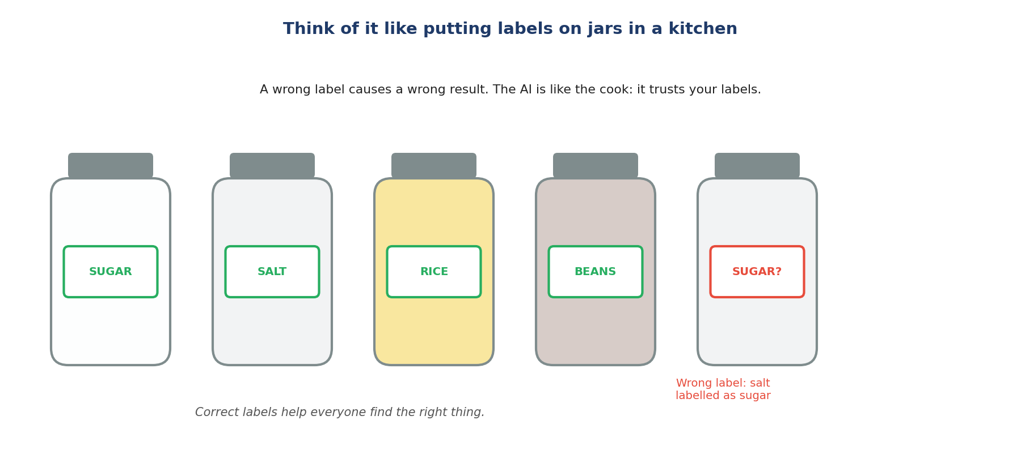
Like labelling jars.
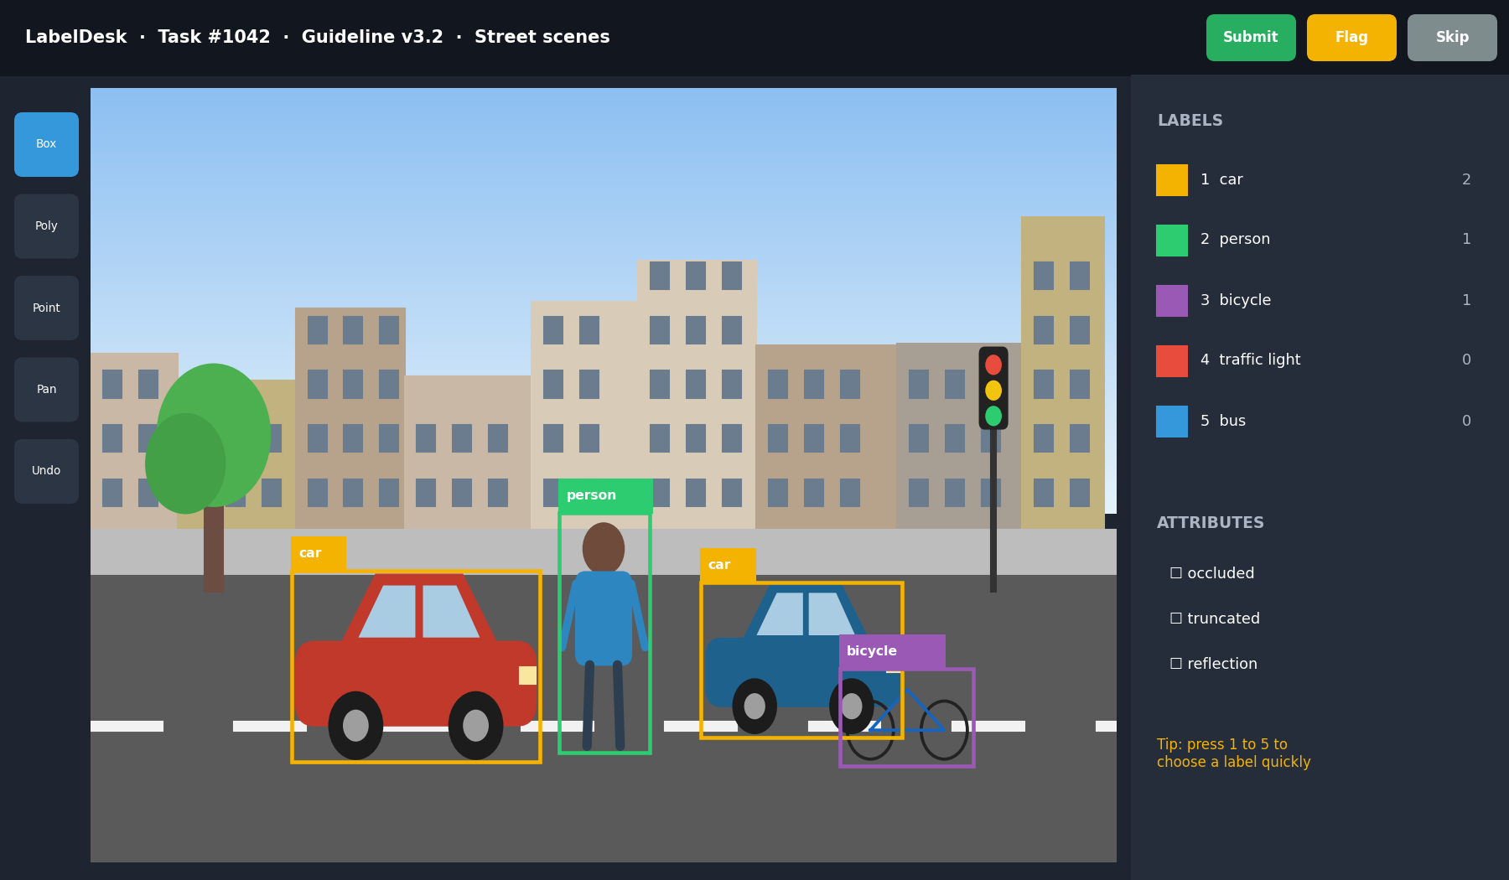
A labelling tool.
Must-know rules
1. Read the whole rulebook first.
2. Use the label type the rules ask for.
3. Choose names by the written meaning.
4. Hidden behind = occluded. Cut by the edge = truncated.
5. Not covered? Flag it.
6. Edges and times must be exact.
7. Same thing, same label, every time.
8. Learn the tool's keys.

CHAPTER 4
Annotation Skill 1: Reading Annotation Guidelines

THINK OF IT LIKE THIS
Reading the guideline is like reading the rules of a board game before playing. If you skip the rules, you might move pieces the wrong way the whole game.
In simple English: Read the rules before you play.
● What it means
Reading annotation guidelines means studying the project's rulebook from start to finish, including its rules, examples and "do not label" list, before you label anything.
In simple English: Read the whole rulebook before you start.
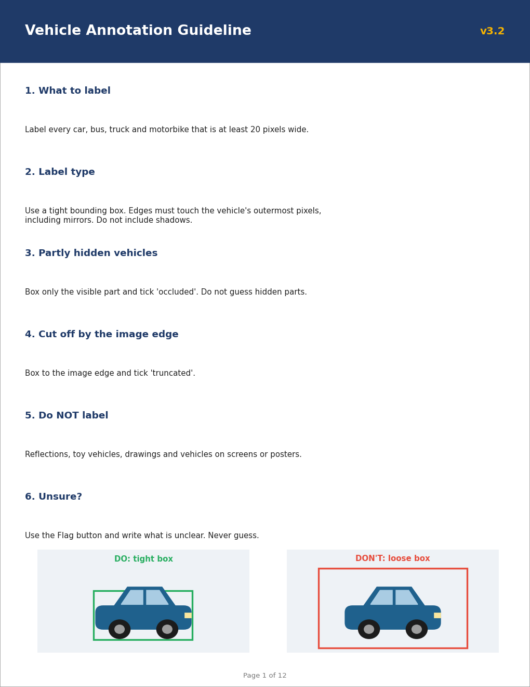
Picture: reading annotation guidelines.
The steps, simply
1. Read every page.
2. Know what's in and what's out.
3. Know the kind of label.
4. Study the examples.
5. Know when to flag.
Do | Don't
Reads every section | Reads only page 1
Checks updates | Uses old rules
Studies the examples | Skips the pictures

Two examples
THE "DO NOT LABEL" LIST
What happened: The rule says don't label reflections. A car shows in a shop window.
What to do: Don't label it.
In simple English: If the rules say no, don't label it.
MIRRORS COUNT
What happened: An example picture shows car boxes including side mirrors.
What to do: Include mirrors in your boxes.
In simple English: Follow the examples too.
Words to know
Term | What it means
Guideline | The project's rulebook.
Exclusion | Something you must NOT label.
Version | Which update of the rules you're using, like v3.2.

Quick check: What four things should you know after reading?
Answer: What to label, how, what not to label, and what to do when unsure.
Quick check: The rule says don't label reflections. Do you label a car in a mirror?
Answer: No.

CHAPTER 5
Annotation Skill 2: Choosing the Right Label Type

THINK OF IT LIKE THIS
Label types are like tools in a toolbox. A hammer is great for nails, but useless for screws. Each job needs the right tool.
In simple English: Use the right tool for the job.
● What it means
Choosing the right label type means using exactly the kind of mark the rules ask for: a class, a box, a polygon, keypoints, a timestamp or a text tag.
In simple English: Use the kind of label the rules ask for.
Picture: choosing the right label type.
The steps, simply
1. What's the goal?
2. What type do the rules say?
3. Whole thing: class.
4. Shape or position.
5. Time: timestamps.
Do | Don't
Checks the type every time | Uses boxes for everything
Matches type to the goal | Picks the fastest type
Asks if unsure | Guesses

Two examples
ROAD OUTLINE
What happened: "Draw the exact outline of each road."
What to do: Use a polygon.
In simple English: Exact shapes need polygons.
ELBOWS AND KNEES
What happened: "Mark each person's elbows and knees."
What to do: Use keypoints.
In simple English: Body parts need keypoints.
Words to know
Term | What it means
Label type | The kind of mark: class, box, polygon, keypoint, timestamp, tag.
Class | The name of what something is.
Timestamp | A start or end time in audio or video.

Quick check: Which type traces an exact outline?
Answer: Polygon.
Quick check: Which type marks when someone speaks?
Answer: Timestamps.

CHAPTER 6
Annotation Skill 3: Applying Class Definitions

THINK OF IT LIKE THIS
Class definitions are like a dictionary. People might call a minibus a "bus" or a "van", but the project's dictionary decides which word is correct.
In simple English: The rulebook's meaning decides.
● What it means
Applying class definitions means choosing each label by matching the item to the rulebook's written meaning of each class, not by everyday names or guesses.
In simple English: Choose labels by the written meaning.
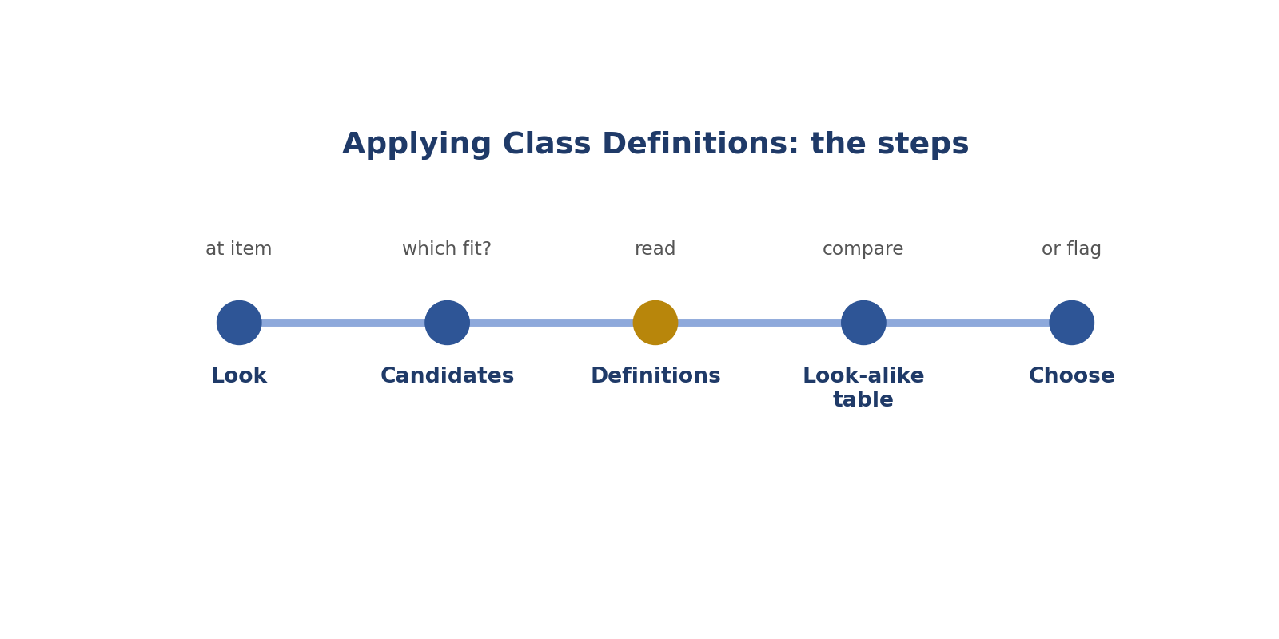
Steps: applying class definitions.
The steps, simply
1. Look closely.
2. Which could it be?
3. Read the meanings.
4. Compare similar ones.
5. Choose or ask.
Do | Don't
Uses written definitions | Uses everyday names
Compares look-alikes | Guesses between them
Uses "other" or flags when nothing fits | Forces a wrong class

Two examples
PICKUP TRUCK
What happened: Definition: a truck has a separate cargo area. A pickup has an open cargo bed.
What to do: Label it truck.
In simple English: The rulebook's meaning wins.
MINIBUS
What happened: Definition: bus = 15 or more passengers. A 12-seat minibus.
What to do: Not a bus; check if "van" fits.
In simple English: Use the numbers in the definition.
Words to know
Term | What it means
Definition | The written meaning of a class.
Taxonomy | The full list of classes.
Look-alike | Things that look very similar.

Quick check: What decides the class: everyday name or definition?
Answer: The definition.
Quick check: Nothing fits. What do you do?
Answer: Use "other" or flag it.

CHAPTER 7
Annotation Skill 4: Occlusion and Truncation Rules

THINK OF IT LIKE THIS
Imagine a friend standing behind a car: you can only see their head. That's occluded (hidden behind something). Now imagine a photo that cuts your friend in half at the edge: that's truncated (cut off).
In simple English: Hidden behind = occluded. Cut by the edge = truncated.
● What it means
Occlusion and truncation rules tell you how to label objects that are partly hidden behind something (occluded) or cut off by the edge of the picture or clip (truncated).
In simple English: Know what to do with hidden and cut-off objects.
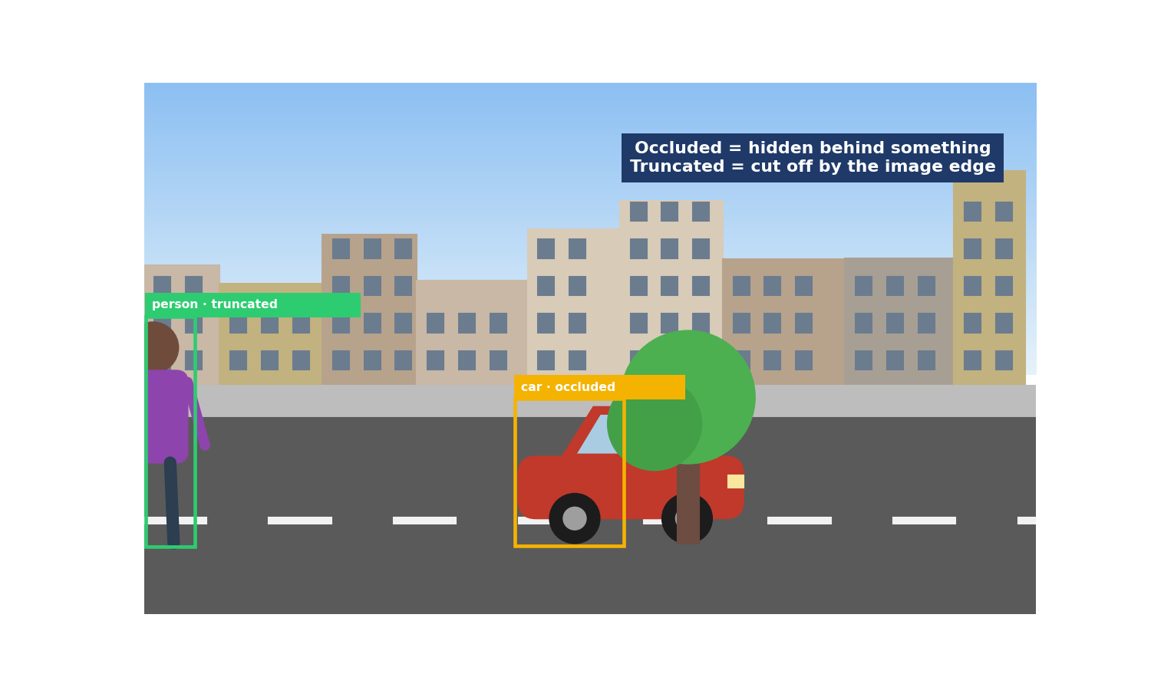
Picture: occlusion and truncation rules.
The steps, simply
1. See all? No flag.
2. Hidden behind: occluded.
3. Cut by edge: truncated.
4. Both can happen.
5. Label what you see.
Do | Don't
Labels the visible part | Draws the hidden part
Uses the right flag | Mixes up the flags
Checks every object | Ticks flags by habit

Two examples
CAR BEHIND A TREE
What happened: A car is half hidden by a tree.
What to do: Box the visible part, tick occluded.
In simple English: Behind something: occluded.
PERSON AT THE EDGE
What happened: A person is cut off by the left edge.
What to do: Box to the edge, tick truncated.
In simple English: Edge: truncated.
Words to know
Term | What it means
Occluded | Partly hidden behind something.
Truncated | Cut off by the edge of the picture.
Visible part | The part you can actually see.

Quick check: Hidden behind a tree: which flag?
Answer: Occluded.
Quick check: Cut off by the picture's edge: which flag?
Answer: Truncated.

CHAPTER 8
Annotation Skill 5: Flagging Edge Cases

THINK OF IT LIKE THIS
Flagging is like putting up your hand in class when you don't understand. One question helps the whole class get the same answer.
In simple English: Ask, don't guess.
● What it means
Flagging edge cases means marking tasks the rules don't clearly cover, with a short note saying what's unclear, instead of guessing.
In simple English: If the rules don't cover it, flag it.
Picture: flagging edge cases.
The steps, simply
1. Feel unsure? Stop.
2. Look in the rules.
3. Look in the FAQ.
4. Flag with a note.
5. Say what you did.
Do | Don't
Flags with a clear note | Guesses
Searches first | Flags everything
Says what was done | Writes "weird"

Two examples
CAR ON A TV
What happened: A car appears on a TV screen. No rule mentions screens.
What to do: Flag: "Car on a TV screen; no rule for screens; left unlabelled."
In simple English: Not covered? Flag it.
COVERED CASE
What happened: The rule clearly says to skip reflections.
What to do: Don't flag; follow the rule.
In simple English: Covered? Just follow the rule.
Words to know
Term | What it means
Edge case | A situation the rules don't clearly cover.
Flag | A button that asks a reviewer to look.
Note | A short message explaining why.

Quick check: What do you do before flagging?
Answer: Search the rulebook and FAQ.
Quick check: What two things go in a flag note?
Answer: What's unclear and what you did.

CHAPTER 9
Annotation Skill 6: Precision at Boundaries

THINK OF IT LIKE THIS
Precision is like colouring inside the lines. Going over the lines or leaving gaps makes the picture wrong.
In simple English: Stay exactly on the edges.
● What it means
Precision at boundaries means placing edges exactly where the rules say: tight boxes, accurate shape points, and exact start and end times in audio and video.
In simple English: Put edges and times in exactly the right place.
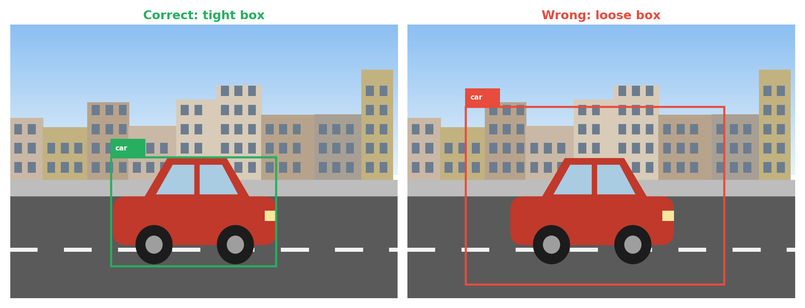
Picture: precision at boundaries.
The steps, simply
1. Zoom in.
2. Touch the edges.
3. Include thin parts.
4. Leave out shadows.
5. Find the exact time.
Do | Don't
Tight boxes | Boxes full of background
Includes mirrors and handles | Cuts off thin parts
Exact start and end times | Late or early times

Two examples
LOOSE BOX
What happened: A box has road all around the car.
What to do: Pull every edge in to touch the car.
In simple English: Touch the edges.
CUT-OFF MIRROR
What happened: A box cuts off the side mirror.
What to do: Move that edge out to include it.
In simple English: Include every part.
Words to know
Term | What it means
Boundary | The edge of an object, or the start and end of a sound.
Tight | Touching the edges, with no extra space.
Pixel | One tiny dot in a picture.

Quick check: What should a tight box touch?
Answer: The object's outer edges on every side.
Quick check: Should shadows be inside the box?
Answer: Usually no.

CHAPTER 10
Annotation Skill 7: Consistency Across Batches

THINK OF IT LIKE THIS
Consistency is like a baker making bread every day. Customers expect the same taste every time, not great on Monday and different on Friday.
In simple English: Same quality every time.
● What it means
Consistency across batches means labelling the same kind of item the same way every time, from the first task to the last, even when tired.
In simple English: Label the same things the same way, every time.
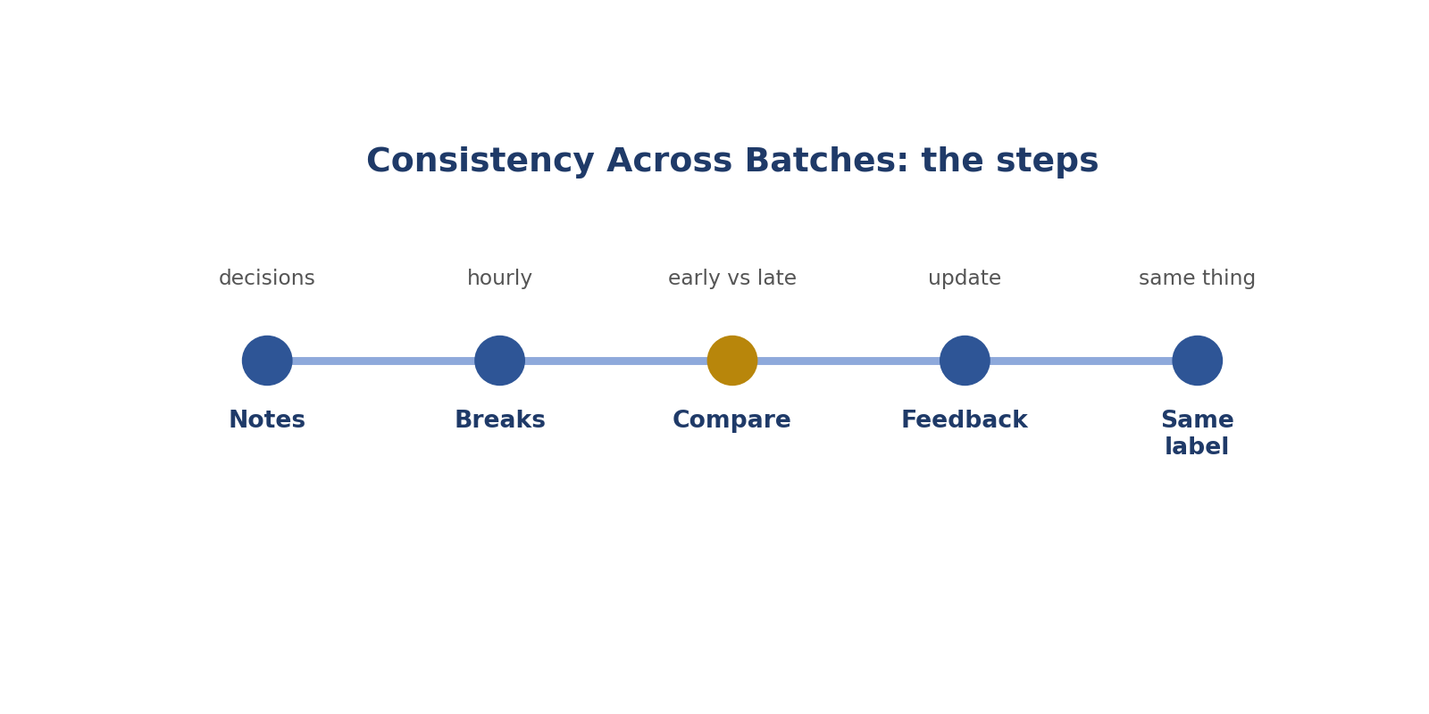
Steps: consistency across batches.
The steps, simply
1. Write decisions down.
2. Rest.
3. Compare.
4. Learn and update.
5. Same thing, same label.
Do | Don't
Keeps a decisions file | Decides differently each time
Takes breaks | Works tired for hours
Checks early vs late work | Never checks

Two examples
SCOOTER CONFUSION
What happened: Scooters labelled motorbike in the morning, bicycle in the afternoon.
What to do: Check the definition and fix the wrong ones.
In simple English: Same thing, same label.
LOOSER BOXES
What happened: Boxes got looser after two hours.
What to do: Take a break and recheck.
In simple English: Tired? Rest and recheck.
Words to know
Term | What it means
Batch | A group of tasks done together.
Consistent | The same every time.
Drift | A slow change you don't notice.

Quick check: What is a batch?
Answer: A group of tasks done together.
Quick check: Name one habit that keeps you consistent.
Answer: A notes file, breaks, or comparing early and late work.

CHAPTER 11
Annotation Skill 8: Annotation Tool Shortcuts

THINK OF IT LIKE THIS
Shortcuts are like knowing the quick route to school. You arrive faster without skipping anything important.
In simple English: Faster, without skipping steps.
● What it means
Annotation tool shortcuts are keys and features, like number keys for labels, zoom and undo, that help you work faster without losing accuracy.
In simple English: Learn the keys that make the tool faster.
Picture: annotation tool shortcuts.
The steps, simply
1. Learn the keys.
2. Keys for labels.
3. Zoom and move.
4. Undo fast.
5. Make sure it saved.
Do | Don't
Uses keys | Clicks menus every time
Fixes warnings | Ignores warnings
Checks auto-labels | Trusts auto-labels

Two examples
NUMBER KEYS
What happened: Press 1 for car, 2 for person.
What to do: Use keys instead of menus.
In simple English: Keys are faster.
WRONG POINT
What happened: You click a wrong polygon point.
What to do: Press undo.
In simple English: Undo fixes mistakes.
Words to know
Term | What it means
Shortcut | A key that does something quickly.
Zoom | Make the picture bigger on screen.
Undo | Reverse the last action.

Quick check: Why learn shortcuts?
Answer: To work faster without losing accuracy.
Quick check: The tool suggests boxes. What do you do?
Answer: Check and fix every one.

CHAPTER 12
Role 2: Computer Vision Specialist

● In one sentence
You draw exact boxes, shapes and dots on pictures.
In simple English: Exact labels on pictures.
● What you do
Count objects, zoom, draw tight, choose the name, tick flags, check.
In simple English: Count, zoom, draw, check.
● Where it's used
Self-driving cars, cameras and phones.
In simple English: Cars, cameras, phones.
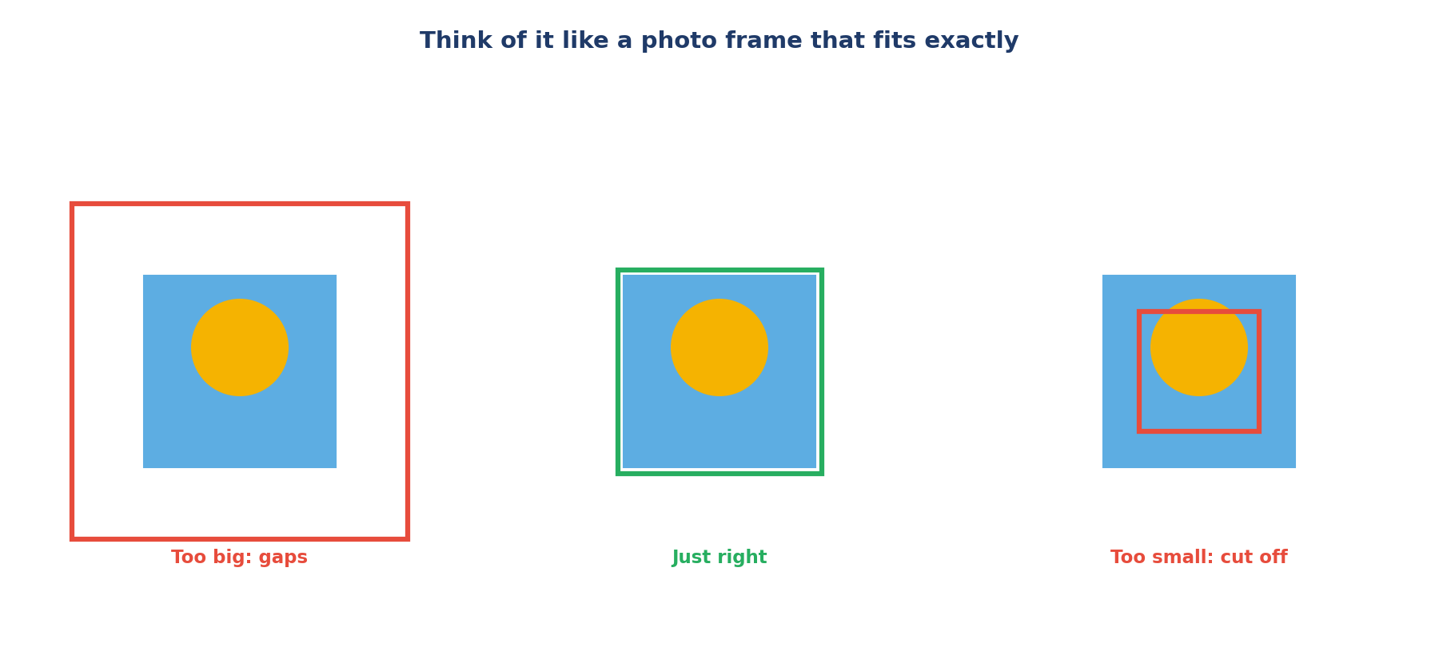
Like a photo frame that fits exactly.
Tight box (right), loose box (wrong).
Must-know rules
1. Boxes touch all four sides.
2. More polygon points on curves.
3. Use the person's own left and right.
4. One label for the whole picture in classification.
5. Tick occluded or truncated when needed.
6. Skip objects below the size limit.
7. Zoom in on small and thin parts.
8. Check before submitting.

CHAPTER 13
Computer Vision Skill 1: Bounding Boxes

THINK OF IT LIKE THIS
A bounding box is like a photo frame that fits the picture exactly: no big gaps around it, and nothing cut off.
In simple English: A frame that fits exactly.
● What it means
A bounding box is a tight rectangle drawn around an object, with its edges touching the object's outer edges on all four sides.
In simple English: Draw a close-fitting rectangle around each object.
Picture: bounding boxes.
The steps, simply
1. Count first.
2. Zoom in.
3. Touch all sides.
4. Name it.
5. Tick flags.
Do | Don't
Touches all four sides | Leaves big gaps
Includes mirrors | Cuts off thin parts
One box per object | One box around a group

Two examples
TIGHT BOX
What happened: A box touches the car on every side.
What to do: Keep it.
In simple English: Touching all sides is right.
GAP AT THE TOP
What happened: A box leaves space above a dog's head.
What to do: Pull the top edge down.
In simple English: Remove gaps.
Words to know
Term | What it means
Bounding box | A rectangle around an object.
Object detection | Teaching AI to find objects in pictures.
Tight | Touching the edges.

Quick check: What should box edges touch?
Answer: The object's outer edges on all four sides.
Quick check: Five people: how many boxes?
Answer: Five.

CHAPTER 14
Computer Vision Skill 2: Polygon Segmentation

THINK OF IT LIKE THIS
A polygon is like tracing a cartoon with dots and lines. Where the drawing curves, you need more dots to follow it.
In simple English: Trace the shape with dots.
● What it means
Polygon segmentation means clicking points around an object's exact outline, so the shape follows curves and thin parts closely.
In simple English: Click points around the exact shape.
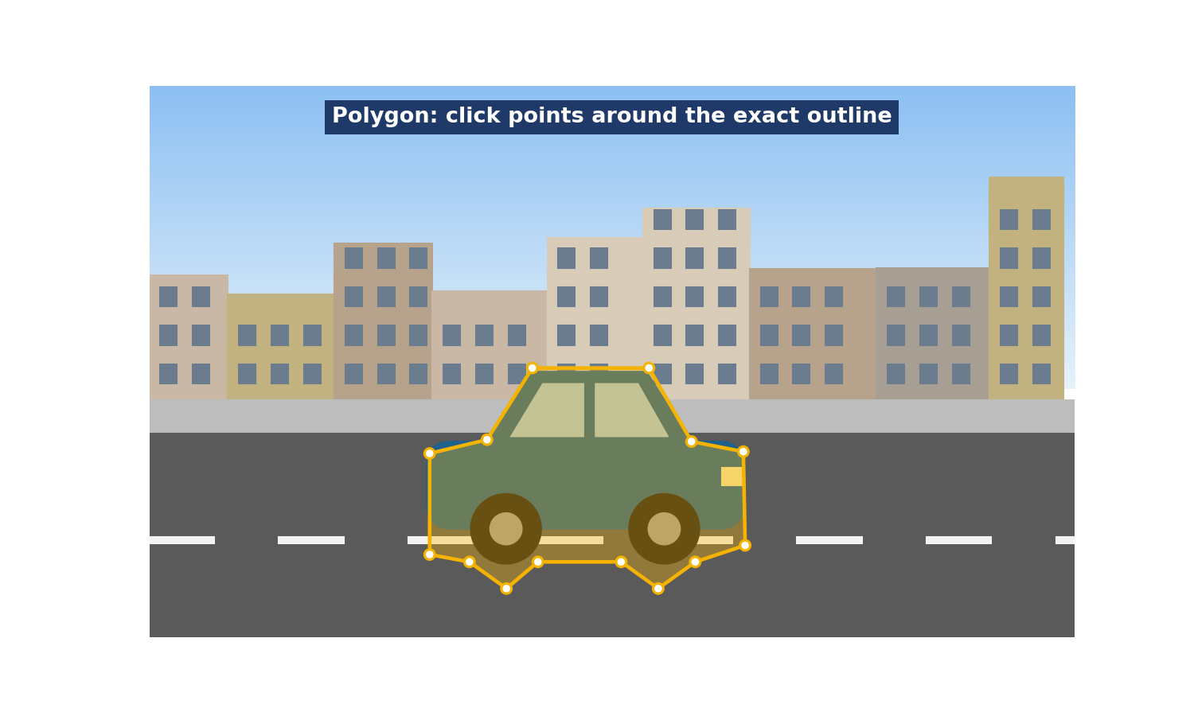
Picture: polygon segmentation.
The steps, simply
1. Start somewhere clear.
2. Curves need more dots.
3. Straight needs few dots.
4. Join the last dot.
5. Check it.
Do | Don't
Many points on curves | Few points everywhere
Includes handles | Cuts off thin parts
No background inside | Includes background

Two examples
CAR ROOF
What happened: A polygon cuts across a curved roof.
What to do: Add points along the curve.
In simple English: Follow the curve.
MUG HANDLE
What happened: A polygon leaves out the handle.
What to do: Include it.
In simple English: Include thin parts.
Words to know
Term | What it means
Polygon | A shape made of connected points.
Segmentation | Separating an object's exact area from the background.
Point | A dot you click.

Quick check: Where do polygons need more points?
Answer: On curves and thin parts.
Quick check: Should a person polygon include the wall behind?
Answer: No.

CHAPTER 15
Computer Vision Skill 3: Keypoint Placement and Order

THINK OF IT LIKE THIS
Keypoints are like dot-to-dot puzzles. If you number the dots in the wrong order, the picture comes out twisted.
In simple English: Right dots, right order.
● What it means
Keypoint placement means putting dots on exact parts of a body or object, like joints, in the order the rules set, using the person's own left and right.
In simple English: Put dots on the right parts, in the right order.
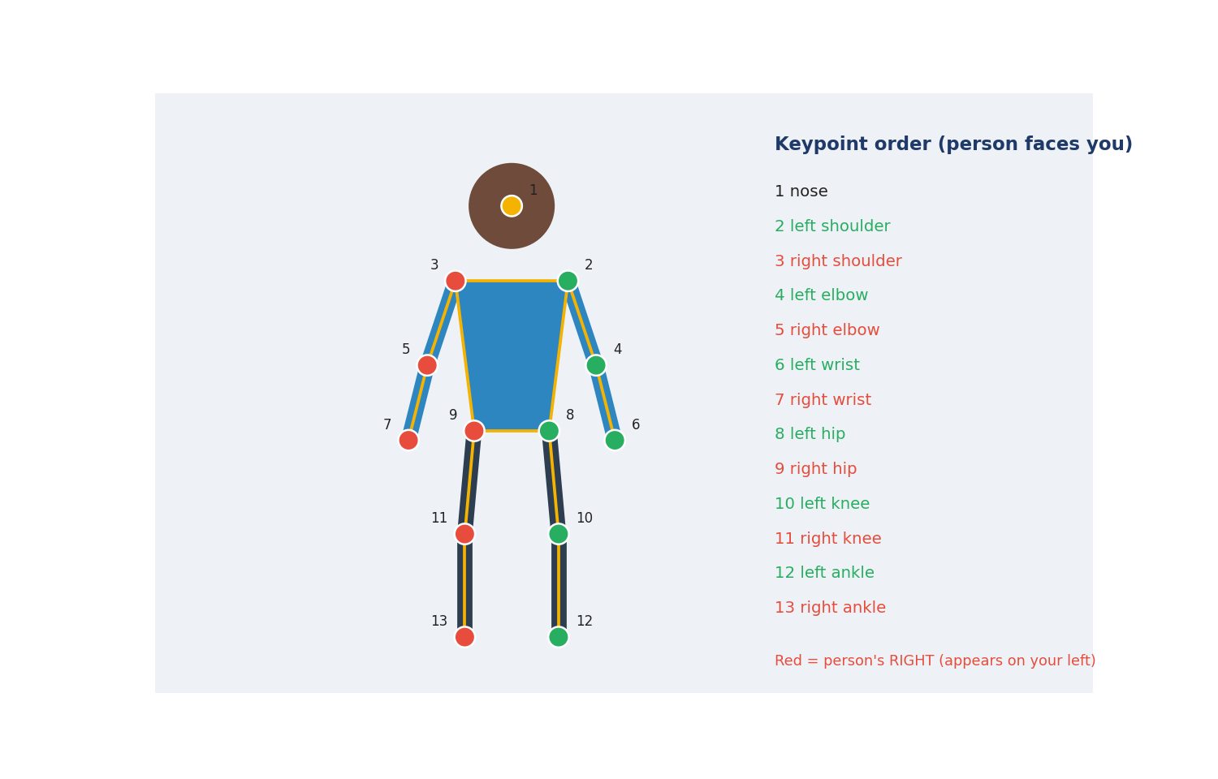
Picture: keypoint placement and order.
The steps, simply
1. Which way are they facing?
2. Use the right order.
3. Put dots on joints.
4. Hidden? Follow the rule.
5. Does it look right?
Do | Don't
Uses the person's left and right | Uses your own left and right
Follows the order | Random order
Marks hidden points by the rule | Guesses hidden points

Two examples
FACING YOU
What happened: A person faces you; their right hand is on your left.
What to do: Label it right wrist.
In simple English: Their right is on your left.
FACING AWAY
What happened: A person faces away; their right hand is on your right.
What to do: Label it right wrist.
In simple English: Facing away, sides match.
Words to know
Term | What it means
Keypoint | A dot on a body part, like an elbow.
Pose | How a body is positioned.
Skeleton | Lines joining the dots.

Quick check: A person faces you. Where is their right hand?
Answer: On your left.
Quick check: Why does order matter?
Answer: The AI reads the dots by position in the list.

CHAPTER 16
Computer Vision Skill 4: Image Classification

THINK OF IT LIKE THIS
Classification is like sorting photos into albums: beach, birthday, school. Each photo goes into one album.
In simple English: Put each picture in the right group.
● What it means
Image classification means giving a whole picture one label (or several, if allowed) from a fixed list, using the rules' definitions.
In simple English: Give the whole picture a label from the list.
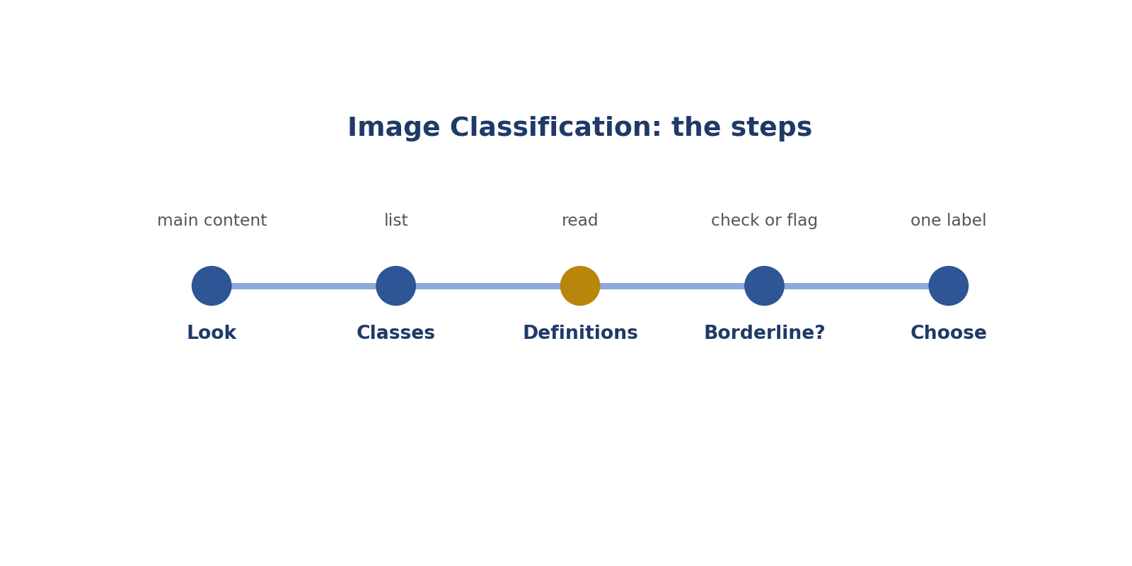
Steps: image classification.
The steps, simply
1. What's the picture of?
2. What are the choices?
3. Read the meanings.
4. Unsure? Flag.
5. Pick it.
Do | Don't
Labels the main content | Labels a tiny detail
Checks definitions | Guesses
Uses "unclear" when allowed | Forces a label

Two examples
BEACH
What happened: Classes: indoor, outdoor. A beach photo.
What to do: Outdoor.
In simple English: Beach is outdoor.
COVERED MARKET
What happened: Indoor or outdoor? A market stall open at the sides.
What to do: Check the definition or flag.
In simple English: Borderline? Check or flag.
Words to know
Term | What it means
Classification | Choosing one label for the whole picture.
Borderline | Between two groups.
Multi-label | When more than one label is allowed.

Quick check: What does classification mean?
Answer: Giving the whole picture a label.
Quick check: Nothing fits. What do you do?
Answer: Use other, unclear, or flag.

CHAPTER 17
Computer Vision Skill 5: Occluded and Truncated Flags

THINK OF IT LIKE THIS
Flags are like notes on a photo: "part of this person is hidden" or "this person is cut off". They tell the AI what it can't see.
In simple English: Notes about what's hidden.
● What it means
Occluded and truncated flags are tick boxes that record whether an object is partly hidden behind something or cut off by the picture's edge.
In simple English: Tick the right box for hidden or cut-off objects.
Picture: occluded and truncated flags.
The steps, simply
1. All visible?
2. Behind: occluded.
3. Edge: truncated.
4. Both.
5. Check each one.
Do | Don't
Checks each object | Ticks by habit
Ticks both when needed | Ticks only one
Knows the difference | Mixes them up

Two examples
BEHIND A CAR
What happened: Only the top of a person shows behind a car.
What to do: Occluded.
In simple English: Behind: occluded.
TOP EDGE
What happened: A bus is cut off at the top.
What to do: Truncated.
In simple English: Any edge counts.
Words to know
Term | What it means
Flag (attribute) | An extra detail ticked for a label.
Occluded | Hidden behind something.
Truncated | Cut off by the edge.

Quick check: Can an object be both?
Answer: Yes.
Quick check: Does truncated mean small?
Answer: No. It means cut off by the edge.

CHAPTER 18
Computer Vision Skill 6: Size and Visibility Thresholds

THINK OF IT LIKE THIS
A threshold is like a height limit on a fun-fair ride. If you're tall enough, you ride. If not, you don't. No guessing.
In simple English: A clear yes-or-no limit.
● What it means
Size and visibility thresholds are rules about the smallest objects to label and how much must be visible, like "at least 20 pixels wide" or "at least half visible".
In simple English: Follow the rules about tiny or barely visible objects.
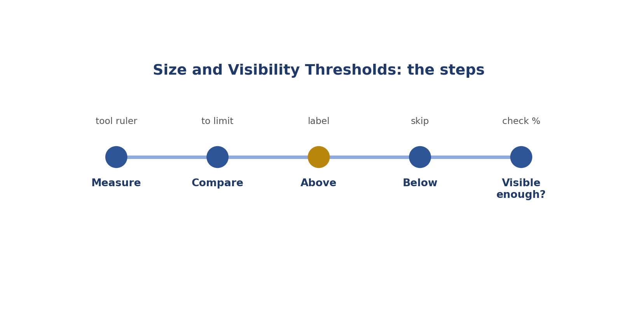
Steps: size and visibility thresholds.
The steps, simply
1. Measure it.
2. Compare.
3. Big enough: label.
4. Too small: skip.
5. Visible enough?
Do | Don't
Measures | Guesses
Follows the limit | Labels everything
Knows "at least" includes the number | Gets the edge cases wrong

Two examples
30 PIXELS
What happened: Limit 20. A car is 30.
What to do: Label it.
In simple English: Big enough: label.
12 PIXELS
What happened: Limit 20. A car is 12.
What to do: Skip it.
In simple English: Too small: skip.
Words to know
Term | What it means
Threshold | A limit that decides yes or no.
Pixel | One tiny dot in a picture.
Visibility | How much of the object you can see.

Quick check: Limit 20 pixels; car is 22. Label?
Answer: Yes.
Quick check: Limit 20; car is 18. Label?
Answer: No.

CHAPTER 19
Computer Vision Skill 7: Zoom and Edge Precision

THINK OF IT LIKE THIS
Zooming is like using a magnifying glass to thread a needle. Without it, you keep missing the hole.
In simple English: Zoom in to be exact.
● What it means
Zoom and edge precision means zooming in to place edges and points exactly, especially on small objects and thin parts.
In simple English: Zoom in so your edges are exact.
Picture: zoom and edge precision.
The steps, simply
1. Zoom in.
2. Move around.
3. Adjust.
4. Zoom out to check.
5. Done.
Do | Don't
Zooms on small objects | Never zooms
Checks thin parts | Misses mirrors and handles
Zooms out to check the whole | Only sees one corner

Two examples
HANDLEBARS
What happened: A bicycle's handlebars are thin.
What to do: Zoom to place the edge.
In simple English: Zoom on thin parts.
SMALL TRAFFIC LIGHT
What happened: A traffic light is 22 pixels.
What to do: Zoom to draw it exactly.
In simple English: Zoom on small things.
Words to know
Term | What it means
Zoom | Make the picture bigger on screen.
Pan | Move around a zoomed picture.
Thin part | A narrow part like a mirror or handle.

Quick check: When is zoom most important?
Answer: On small objects and thin parts.
Quick check: What's panning?
Answer: Moving around a zoomed picture.

CHAPTER 20
Computer Vision Skill 8: Self-Review Before Submitting

THINK OF IT LIKE THIS
Self-review is like checking your bag before leaving home: keys, phone, wallet. A few seconds saves a big problem later.
In simple English: Check before you go.
● What it means
Self-review means a quick final check of every label before you submit: right type, right class, tight edges, correct flags, nothing missed.
In simple English: Check your work before you send it.
Picture: self-review before submitting.
The steps, simply
1. Right type?
2. Right name?
3. Tight?
4. Flags?
5. Anything missed?
Do | Don't
Checks every task | Submits straight away
Uses a short checklist | Checks randomly
Counts objects | Forgets small objects

Two examples
MISSED CAR
What happened: 4 cars, 3 boxes.
What to do: Find and box the missing car.
In simple English: Count before submitting.
WRONG CLASS
What happened: Review finds a car labelled bus.
What to do: Fix it.
In simple English: Fix before sending.
Words to know
Term | What it means
Self-review | Checking your own work.
Submit | Send your finished work.
Rejection | When work is sent back as wrong.

Quick check: Name the 5 checks.
Answer: Type, class, edges, flags, missed objects.
Quick check: 4 cars, 3 boxes. What now?
Answer: Find and box the missing car.

CHAPTER 21
Cheat Sheet

Question | Answer
First step? | Read the whole rulebook
Exact outline? | Polygon
Body parts? | Keypoints
Whole picture? | Class
Sound or action times? | Timestamps
Hidden behind something? | Occluded
Cut off by the edge? | Truncated
Not covered by rules? | Flag it
Tight box? | Touches all sides
Person facing you: their right hand? | On your left
Below the size limit? | Skip it
"At least 20": is 20 OK? | Yes
Before submitting? | Type, class, edges, flags, missed objects
Free tools? | CVAT, Label Studio

CHAPTER 22
Mistakes to Avoid

Mistake | Do this instead
Starting without reading the rules | Read every page
Boxes when polygons are needed | Check the type
Everyday names for classes | Use definitions
Drawing hidden parts | Label what you see
Mixing up the flags | Behind vs edge
Guessing unclear items | Flag them
Loose boxes | Zoom and tighten
Cutting off mirrors | Include thin parts
Swapping left and right | Use the person's side
Labelling tiny objects | Follow the limit
Late start times | Step frame by frame
Submitting without checking | Use a checklist

CHAPTER 23
Practice Quiz

1. What does annotation mean?
2. What does multimodal mean?
3. Name the four kinds of data.
4. What's the first step on any project?
5. Which type traces an exact outline?
6. Which type marks elbows?
7. Which type labels the whole picture?
8. Car behind a tree: which flag?
9. Person cut off by the edge: which flag?
10. Can an object be both?
11. Rules don't cover it. What do you do?
12. What should a tight box touch?
13. Where do polygons need more points?
14. Person faces you: where is their right hand?
15. Limit 20; car is 18. Label it?
16. "At least 20": is 20 OK?
17. How do you find exact video start times?
18. Why keep a notes file?
19. Name two free tools.
20. Name the five self-review checks.

CHAPTER 24
Quiz Answers

1. Adding labels to data.
2. Many kinds of data.
3. Pictures, video, sound, text.
4. Read the whole rulebook.
5. Polygon.
6. Keypoints.
7. Classification.
8. Occluded.
9. Truncated.
10. Yes.
11. Flag it with a note.
12. The object's edges on all four sides.
13. On curves and thin parts.
14. On your left.
15. No.
16. Yes.
17. Step frame by frame.
18. To label the same things the same way.
19. CVAT and Label Studio.
20. Type, class, edges, flags, missed objects.

