Day 3 Task Bank
320 tasks: 20 for each of the 16 Day 3 skills, explained so anyone can understand
The situation · What is this asking? · Answer · Why, explained simply · Key word · In simple English
CHAPTER 1
How to Use This Task Bank

This task bank has 320 practice tasks: 20 for each of the 16 Day 3 skills. Chapters 1 to 8 are Data Annotator skills. Chapters 9 to 16 are Computer Vision skills. Each task is marked Easy, Medium or Hard.
In simple English: 320 tasks, 20 for every skill.
Part | What it tells you
The situation | The rule, picture or label you are looking at
What is this asking? | The question in plain, everyday words
Your task | Exactly what you must decide
Answer | The correct answer
Why (explained simply) | The reason, explained so anyone can follow
Key word | One important word and what it means
In simple English | The whole lesson in one short line

How to practise
1. Cover everything below "Your task".
2. Read the situation and the plain-words question.
3. Write your own answer.
4. Uncover and compare.
5. Read "Why" even if you were right.
6. Learn the key word.
A worked walk-through
EXAMPLE TASK · EASY
The situation: A photo shows a cat sitting fully inside a window frame. The task: draw a bounding box around the cat.
What is this asking? Where should the box edges go?
Your task: Describe the correct box.
Answer: Tight around the cat's outer edges (ears, tail, paws), not around the window frame.
Why (explained simply): The box is for the cat, not the window. Its edges should touch the cat on every side.
Key word: Bounding box = A tight rectangle around an object.
In simple English: Box the object, not what's around it.

CHAPTER 2
Annotation Skill 1: Reading Annotation Guidelines

THINK OF IT LIKE THIS
Reading the guideline is like reading the rules of a board game before playing. If you skip the rules, you might move pieces the wrong way the whole game.
In simple English: Read the rules before you play.
In simple English: Read the whole rulebook before you start.
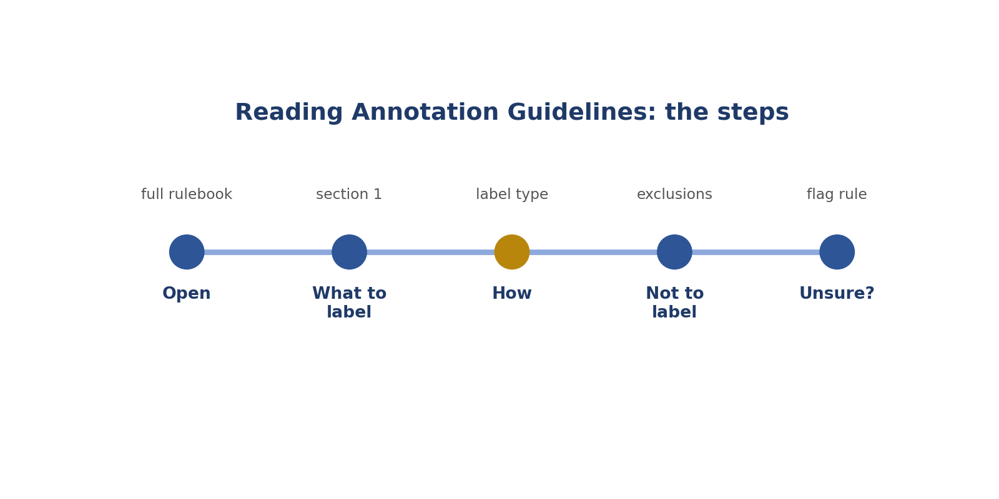
Reading Annotation Guidelines: the steps.
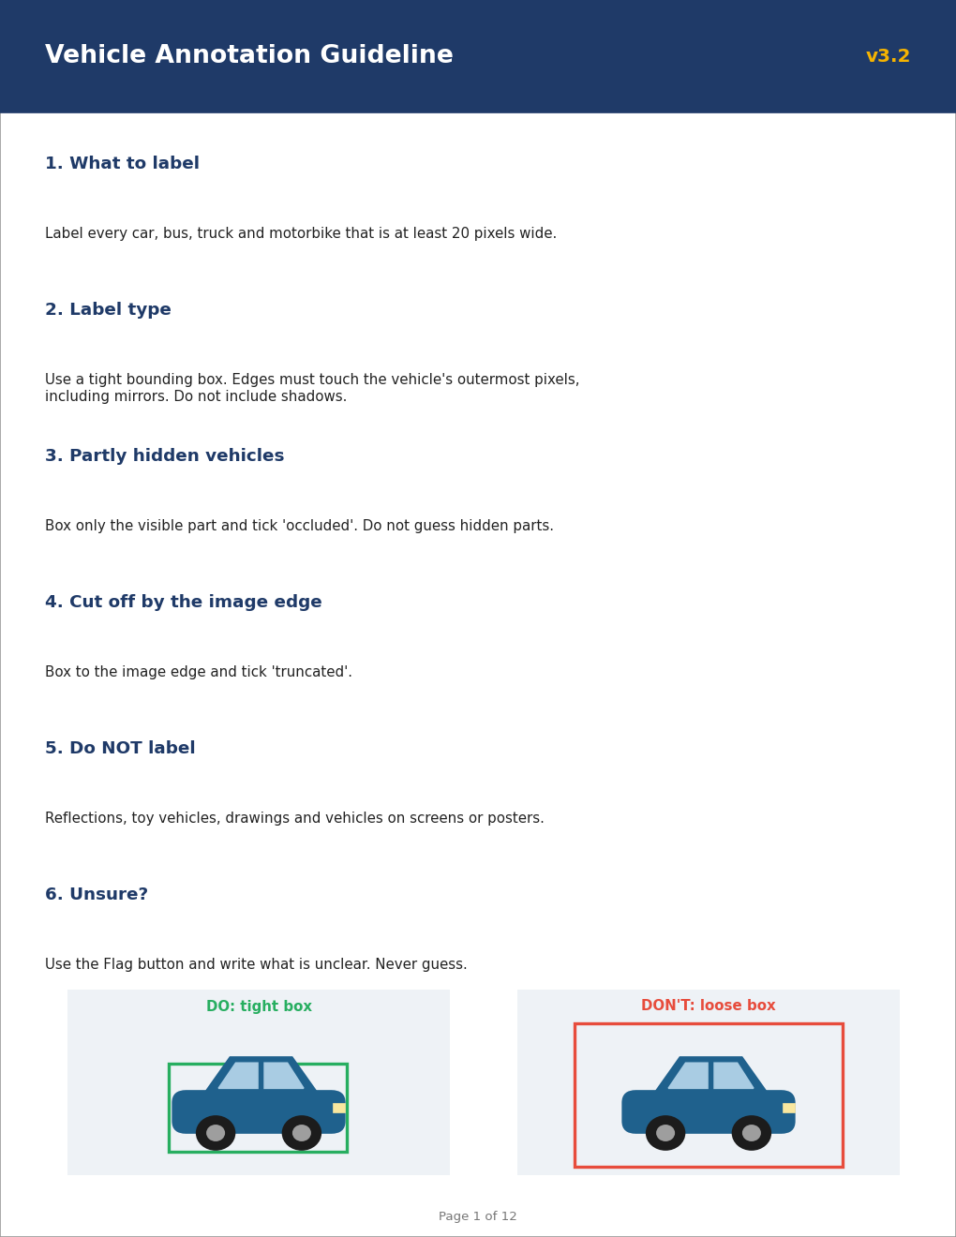
Picture: reading annotation guidelines.
How to answer these tasks
1. Read the whole guideline, page by page.
2. Find what to label and what NOT to label.
3. Find which label type to use.
4. Look at every example picture.
5. Find what to do when you're unsure.
TASK 1.1 · EASY
The situation: You are given a 12-page guideline and your first task.
What is this asking? What's the very first thing to do?
Your task: What should you do first?
Answer: Read the whole guideline, including examples and the "do not label" list.
Why (explained simply): Read the whole rulebook first, like reading game rules before playing.
Key word: Guideline = The project's rulebook.
In simple English: Read everything first.

TASK 1.2 · EASY
The situation: Guideline section 5 says: do not label reflections.
What is this asking? Should you label a car in a reflection?
Your task: A car appears in a shop window reflection. Label it?
Answer: No.
Why (explained simply): No. The rulebook says reflections are not labelled.
Key word: Reflection = An image seen in a mirror or window.
In simple English: Follow the "do not label" list.

TASK 1.3 · MEDIUM
The situation: The guideline was updated from v3.1 to v3.2 overnight.
What is this asking? The rules changed overnight. What first?
Your task: What should you do before continuing?
Answer: Read the change notes and any updated sections.
Why (explained simply): Read what changed before you carry on.
Key word: Version = Which update of the rules.
In simple English: Check updates first.

TASK 1.4 · EASY
The situation: Guideline: "Label vehicles at least 20 pixels wide."
What is this asking? Is 25 pixels big enough?
Your task: A motorbike is 25 pixels wide. Label it?
Answer: Yes; it's above the limit.
Why (explained simply): Yes. The rule says at least 20, and 25 is more.
Key word: Pixel = One tiny dot in a picture.
In simple English: Check the size rule.

TASK 1.5 · MEDIUM
The situation: A guideline example shows a car box including mirrors, but the text doesn't mention mirrors.
What is this asking? Should mirrors be inside the box?
Your task: Include mirrors?
Answer: Yes; examples show how the rule is applied.
Why (explained simply): Yes. The example shows mirrors included, and examples show how rules work.
Key word: Example = A picture showing the rule.
In simple English: Examples explain the rules.

TASK 1.6 · EASY
The situation: An audio guideline says: "Label laughter as 'non-speech'."
What is this asking? What label for laughing?
Your task: A clip has a speaker laughing. What label?
Answer: Non-speech.
Why (explained simply): Non-speech, because the audio rule says so.
Key word: Non-speech = Sounds that aren't words.
In simple English: Use the rule's label.

TASK 1.7 · MEDIUM
The situation: A text guideline says sarcasm counts as the real meaning.
What is this asking? Is "Great, another delay!" happy?
Your task: "Great, another delay!" Sentiment?
Answer: Negative.
Why (explained simply): No. It's sarcasm, so the real meaning is negative.
Key word: Sarcasm = Saying the opposite of what you mean.
In simple English: Follow the sarcasm rule.

TASK 1.8 · HARD
The situation: Two sections of a guideline seem to disagree.
What is this asking? Two rules disagree. What now?
Your task: What should you do?
Answer: Check for a priority note; if none, flag and ask before labelling similar items.
Why (explained simply): Look for a priority note; if none, flag it and ask.
Key word: Priority = Which rule wins.
In simple English: Ask when rules disagree.

TASK 1.9 · EASY
The situation: Where do you usually find "what not to label"?
What is this asking? Where is the "don't label" list?
Your task: Answer.
Answer: In a "do not label" or exclusions section.
Why (explained simply): In the exclusions section of the rulebook.
Key word: Exclusion = Something you must not label.
In simple English: Look for the exclusions list.

TASK 1.10 · MEDIUM
The situation: A video guideline says: "Start 'walking' at the first step."
What is this asking? When does "walking" start?
Your task: When does your segment start?
Answer: At the frame where the first step begins.
Why (explained simply): At the very first step, because that's what the rule says.
Key word: Segment = A marked piece of video.
In simple English: Follow the start rule exactly.

TASK 1.11 · EASY
The situation: You forgot the rule for blurry images.
What is this asking? Forgot a rule?
Your task: What should you do?
Answer: Look it up in the guideline instead of guessing.
Why (explained simply): Look it up. Don't guess.
Key word: Look up = Check in the rulebook.
In simple English: Check the rulebook, don't guess.

TASK 1.12 · MEDIUM
The situation: The guideline has an FAQ at the end.
What is this asking? Why read the FAQ?
Your task: Why read it?
Answer: It answers common edge cases other labellers asked about.
Why (explained simply): It answers tricky questions other people already asked.
Key word: FAQ = Common questions with answers.
In simple English: The FAQ answers common questions.

TASK 1.13 · HARD
The situation: A rule says "label all people", and an FAQ says "not people on posters".
What is this asking? Rule says all people; FAQ says not posters?
Your task: A poster shows a person. Label?
Answer: No; the FAQ clarifies the rule.
Why (explained simply): Don't label the poster person. The FAQ makes the rule clearer.
Key word: Clarify = Make clearer.
In simple English: FAQs can narrow rules.

TASK 1.14 · EASY
The situation: A guideline gives colour codes for classes.
What is this asking? Why use the colour codes?
Your task: Why follow them?
Answer: So reviewers and tools read your labels correctly.
Why (explained simply): So tools and reviewers read your labels correctly.
Key word: Colour code = A colour that means a class.
In simple English: Follow the tool's colour rules.

TASK 1.15 · MEDIUM
The situation: You summarise the guideline in a one-page notes file.
What is this asking? Why a one-page summary?
Your task: How does this help?
Answer: It keeps key rules in front of you while you work.
Why (explained simply): It keeps the key rules in front of you.
Key word: Summary = A short version.
In simple English: Keep a short summary nearby.

TASK 1.16 · EASY
The situation: A text guideline lists 6 intent classes.
What is this asking? Can you add a 7th class?
Your task: Can you invent a 7th?
Answer: No; use only the listed classes.
Why (explained simply): No. Use only the listed classes.
Key word: Class = The name of a thing.
In simple English: Use only listed classes.

TASK 1.17 · MEDIUM
The situation: A guideline says timestamps must include 0.2 seconds of silence before speech.
What is this asking? Where does the clip start?
Your task: Where does your clip start?
Answer: 0.2 seconds before the speech begins.
Why (explained simply): 0.2 seconds before the speech, because the rule asks for that much silence.
Key word: Padding = Extra time before or after.
In simple English: Include the required padding.

TASK 1.18 · HARD
The situation: You find a spelling mistake in the guideline that changes a class name.
What is this asking? A typo in the rulebook?
Your task: What should you do?
Answer: Report it through the project channel and use the intended class until confirmed.
Why (explained simply): Report it and use the meant class until confirmed.
Key word: Report = Tell someone officially.
In simple English: Report errors in the rules.

TASK 1.19 · EASY
The situation: A new project uses a different box rule from your last project.
What is this asking? Which project's rule?
Your task: Which rule do you use?
Answer: The new project's rule.
Why (explained simply): The new project's rule. Every project is different.
Key word: Project = One piece of work with its own rules.
In simple English: Each project has its own rules.

TASK 1.20 · MEDIUM
The situation: You finished reading the guideline but aren't sure about one rule.
What is this asking? Unsure about one rule?
Your task: What's the best next step?
Answer: Reread that section and its examples; if still unsure, ask before starting.
Why (explained simply): Reread it and its examples; if still unsure, ask before starting.
Key word: Ask = Get help.
In simple English: Clear up doubts before starting.

CHAPTER 3
Annotation Skill 2: Choosing the Right Label Type

THINK OF IT LIKE THIS
Label types are like tools in a toolbox. A hammer is great for nails, but useless for screws. Each job needs the right tool.
In simple English: Use the right tool for the job.
In simple English: Use the kind of label the rules ask for.
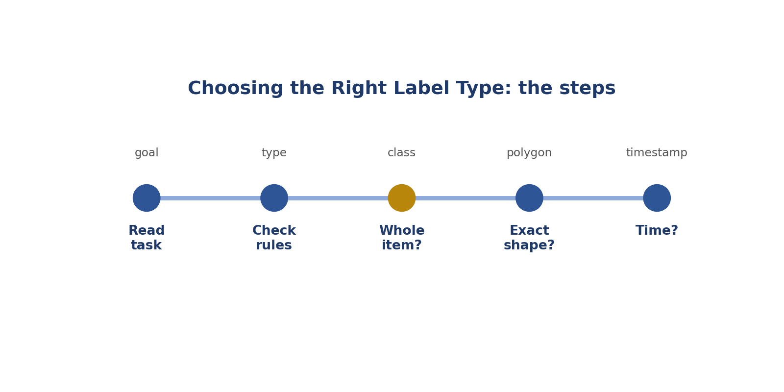
Choosing the Right Label Type: the steps.
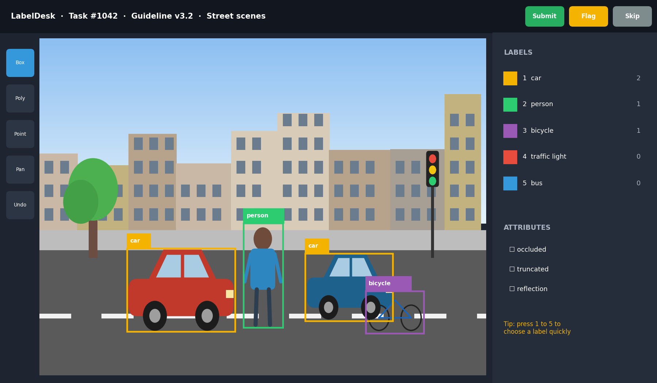
Picture: choosing the right label type.
How to answer these tasks
1. Read what the task wants the AI to learn.
2. Check the rulebook for the label type.
3. Whole picture or message? Use a class.
4. Exact shape? Use a polygon. Position? Use a box.
5. Sound or action over time? Use timestamps.
TASK 2.1 · EASY
The situation: Task: "Draw the exact outline of each road."
What is this asking? Which type for a road outline?
Your task: Which label type?
Answer: Polygon.
Why (explained simply): Polygon, because it follows the exact edge.
Key word: Polygon = A shape traced around the edge.
In simple English: Exact outlines need polygons.

TASK 2.2 · EASY
The situation: Task: "Mark each person's elbows and knees."
What is this asking? Which type for elbows and knees?
Your task: Which label type?
Answer: Keypoints.
Why (explained simply): Keypoints: dots on body parts.
Key word: Keypoint = A dot on a body part.
In simple English: Body parts need keypoints.

TASK 2.3 · EASY
The situation: Task: "Say whether each photo is indoor or outdoor."
What is this asking? Which type for indoor or outdoor?
Your task: Which label type?
Answer: Classification.
Why (explained simply): Classification: one label for the whole picture.
Key word: Classification = One label for the whole thing.
In simple English: One label per image is classification.

TASK 2.4 · EASY
The situation: Task: "Draw a rectangle around each dog."
What is this asking? Which type for a rectangle?
Your task: Which label type?
Answer: Bounding box.
Why (explained simply): Bounding box.
Key word: Bounding box = A rectangle around an object.
In simple English: Rectangles are boxes.

TASK 2.5 · MEDIUM
The situation: Task: "Mark when each speaker starts and stops talking."
What is this asking? Which type for when people speak?
Your task: Which label type?
Answer: Timestamp segments with speaker labels.
Why (explained simply): Timestamps with speaker names.
Key word: Timestamp = A start or end time.
In simple English: Sound needs start and end times.

TASK 2.6 · MEDIUM
The situation: Task: "Tag each customer message as question, complaint or request."
What is this asking? Which type for message types?
Your task: Which label type?
Answer: Text classification (intent tags).
Why (explained simply): Text classification tags.
Key word: Tag = A label on text.
In simple English: Messages get text tags.

TASK 2.7 · MEDIUM
The situation: A contributor draws boxes on a polygon task because it's faster.
What is this asking? Boxes on a polygon task?
Your task: What's wrong?
Answer: Wrong label type; the task needs polygons, so the work is unusable.
Why (explained simply): Wrong type. The work can't be used.
Key word: Label type = The kind of mark.
In simple English: Use the required type.

TASK 2.8 · HARD
The situation: A task asks for boxes and a colour attribute for each car.
What is this asking? Box plus colour?
Your task: What two things must you add?
Answer: A box and the colour attribute.
Why (explained simply): Draw the box AND add the colour detail.
Key word: Attribute = An extra detail about a label.
In simple English: Some tasks need extra details.

TASK 2.9 · EASY
The situation: Task: "Mark the start and end of each goal in a football video."
What is this asking? Which type for goals in a video?
Your task: Which label type?
Answer: Video timestamp segments.
Why (explained simply): Video time segments.
Key word: Segment = A marked piece of time.
In simple English: Actions in video get time segments.

TASK 2.10 · MEDIUM
The situation: Task: "Highlight names of people in each sentence."
What is this asking? Which type for names in a sentence?
Your task: Which label type?
Answer: Text span (entity) labels.
Why (explained simply): Text span labels.
Key word: Span = A group of words.
In simple English: Words in a sentence get span labels.

TASK 2.11 · EASY
The situation: Task: "Is this review positive, negative or neutral?"
What is this asking? Which type for review feelings?
Your task: Which label type?
Answer: Sentiment classification.
Why (explained simply): Sentiment classification.
Key word: Sentiment = How someone feels.
In simple English: Feelings get sentiment labels.

TASK 2.12 · MEDIUM
The situation: A project needs to know exactly which pixels are road.
What is this asking? Exact road pixels: box or polygon?
Your task: Box or polygon?
Answer: Polygon (segmentation).
Why (explained simply): Polygon.
Key word: Segmentation = Marking exact areas.
In simple English: Exact pixels need polygons.

TASK 2.13 · HARD
The situation: A task wants both a box around each person and keypoints for their joints.
What is this asking? Box and keypoints together?
Your task: How do you handle it?
Answer: Draw the box, then add keypoints inside it, both following the guideline.
Why (explained simply): Draw the box, then add the dots inside.
Key word: Combine = Use together.
In simple English: Some tasks combine types.

TASK 2.14 · EASY
The situation: Task: "Transcribe what the speaker says."
What is this asking? What kind of label is writing down speech?
Your task: What kind of label?
Answer: A text transcription.
Why (explained simply): A text transcription.
Key word: Transcription = Writing what someone says.
In simple English: Transcription is writing what's said.

TASK 2.15 · MEDIUM
The situation: Task: "Draw a line along each road lane marking."
What is this asking? Which type for lane markings?
Your task: Which label type?
Answer: A polyline (line annotation).
Why (explained simply): A line (polyline).
Key word: Polyline = A line made of points.
In simple English: Lanes use lines.

TASK 2.16 · EASY
The situation: Can you change the label type if you think another is better?
What is this asking? Can you change the type?
Your task: Answer.
Answer: No; use the type the guideline requires.
Why (explained simply): No. Use what the rules say.
Key word: Required = Must be used.
In simple English: Don't change the type.

TASK 2.17 · MEDIUM
The situation: Task: "Mark the moment a door opens in a video."
What is this asking? Which type for a door opening moment?
Your task: Which label type?
Answer: A timestamp (event) label.
Why (explained simply): A timestamp.
Key word: Event = Something that happens at a moment.
In simple English: Moments get timestamps.

TASK 2.18 · HARD
The situation: The guideline says "use boxes, but polygons for people".
What is this asking? Car and person, different rules?
Your task: An image has a car and a person. What types?
Answer: Box for the car, polygon for the person.
Why (explained simply): Box for the car, polygon for the person.
Key word: Rule = An instruction.
In simple English: Different objects can need different types.

TASK 2.19 · EASY
The situation: Task: "Pick the main emotion in this audio clip."
What is this asking? Which type for an emotion in audio?
Your task: Which label type?
Answer: Audio classification.
Why (explained simply): Audio classification.
Key word: Emotion = A feeling.
In simple English: A whole clip gets one class.

TASK 2.20 · MEDIUM
The situation: Why do different AI models need different label types?
What is this asking? Why different types?
Your task: Explain.
Answer: Each model learns a different skill: finding objects (boxes), exact shapes (polygons), poses (keypoints), timing (timestamps).
Why (explained simply): Each AI learns a different skill, so it needs a different kind of label.
Key word: Model = The AI program.
In simple English: Each AI skill needs its own label type.

CHAPTER 4
Annotation Skill 3: Applying Class Definitions

THINK OF IT LIKE THIS
Class definitions are like a dictionary. People might call a minibus a "bus" or a "van", but the project's dictionary decides which word is correct.
In simple English: The rulebook's meaning decides.
In simple English: Choose labels by the written meaning.
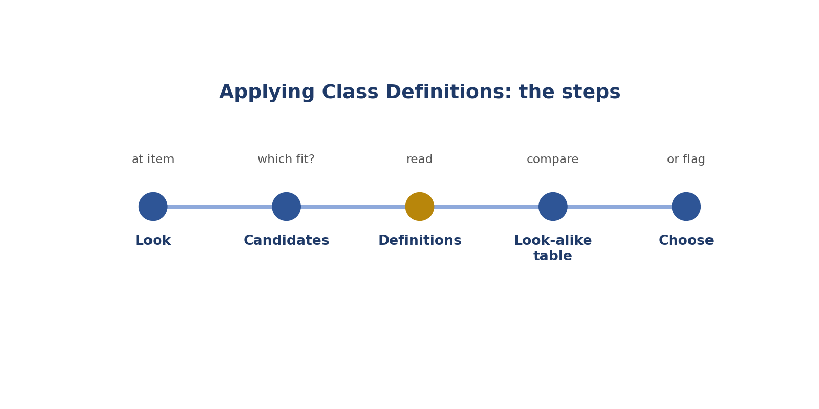
Applying Class Definitions: the steps.
How to answer these tasks
1. Look at the item carefully.
2. List the classes it might be.
3. Read each definition.
4. Compare look-alikes using a table.
5. Choose, or flag if none fits.
TASK 3.1 · EASY
The situation: Classes: cat, dog, other. Image shows a goat.
What is this asking? Goat, but only cat, dog, other?
Your task: Which class?
Answer: Other.
Why (explained simply): Other.
Key word: Other = The choice when nothing else fits.
In simple English: Use "other" when nothing fits.

TASK 3.2 · MEDIUM
The situation: Definition: "bus: vehicle for 15 or more passengers". Image shows a 12-seat minibus.
What is this asking? A 12-seat minibus is a bus?
Your task: Bus?
Answer: No; under 15 seats, so check whether another class like van fits.
Why (explained simply): No. The rule says 15 or more seats.
Key word: Definition = The written meaning.
In simple English: Use the number in the definition.

TASK 3.3 · EASY
The situation: Definition: "truck has a separate cargo area". Image shows a pickup.
What is this asking? Pickup truck: car or truck?
Your task: Which class?
Answer: Truck.
Why (explained simply): Truck, because it has a separate cargo bed.
Key word: Cargo = Things carried.
In simple English: The definition decides.

TASK 3.4 · MEDIUM
The situation: Text classes: Complaint = dissatisfaction with a product or service.
What is this asking? Is "sad it's raining" a complaint?
Your task: "I'm sad it's raining." Complaint?
Answer: No; not about a product or service.
Why (explained simply): No. It isn't about a product or service.
Key word: Complaint = Unhappy about a product or service.
In simple English: Check the whole definition.

TASK 3.5 · EASY
The situation: Audio classes: speech, music, noise.
What is this asking? A radio playing a song?
Your task: A radio playing a song. Which class?
Answer: Music.
Why (explained simply): Music.
Key word: Audio class = A type of sound.
In simple English: Match to the definition.

TASK 3.6 · MEDIUM
The situation: Classes: bicycle, motorbike. Image shows an electric bicycle with pedals.
What is this asking? Electric bicycle with pedals?
Your task: How do you decide?
Answer: Use the definitions; if pedals define bicycle, choose bicycle; if unclear, flag.
Why (explained simply): Use the definitions; if pedals mean bicycle, choose it; otherwise flag.
Key word: Look-alike = Things that look the same.
In simple English: Use definitions or flag.

TASK 3.7 · HARD
The situation: Two contributors label scooters differently.
What is this asking? Two people label scooters differently?
Your task: What's the likely cause?
Answer: An unclear definition; escalate for clarification.
Why (explained simply): The rule is probably unclear. Ask for it to be clarified.
Key word: Unclear = Not clear.
In simple English: Unclear definitions cause mixed labels.

TASK 3.8 · EASY
The situation: Why not use everyday names?
What is this asking? Why not everyday names?
Your task: Explain.
Answer: People use everyday names differently; definitions keep labels the same.
Why (explained simply): People use them differently. Definitions keep everyone the same.
Key word: Consistent = The same.
In simple English: Definitions keep everyone the same.

TASK 3.9 · MEDIUM
The situation: Class "person" includes "any real human". A mannequin in a shop.
What is this asking? Is a mannequin a person?
Your task: Person?
Answer: No; a mannequin isn't a real human.
Why (explained simply): No. It isn't a real human.
Key word: Mannequin = A model of a person in a shop.
In simple English: Read what the class includes.

TASK 3.10 · EASY
The situation: Sentiment: positive, neutral, negative. "The food was okay."
What is this asking? "The food was okay."?
Your task: Which class?
Answer: Neutral.
Why (explained simply): Neutral.
Key word: Neutral = Neither happy nor unhappy.
In simple English: Plain statements are often neutral.

TASK 3.11 · MEDIUM
The situation: Intent classes with rule: "Request beats Complaint". "This is broken, please fix it."
What is this asking? Complaint and request together?
Your task: Which class?
Answer: Request.
Why (explained simply): Request, because of the priority rule.
Key word: Priority rule = A rule for which wins.
In simple English: Use the priority rule.

TASK 3.12 · HARD
The situation: A class list has "traffic sign" but not "billboard". A billboard shows a speed limit ad.
What is this asking? Speed-limit advert billboard?
Your task: How do you decide?
Answer: It's an advert, not a real traffic sign; don't label it as a sign unless the guideline says otherwise; flag if unsure.
Why (explained simply): It's an advert, not a real sign; flag if unsure.
Key word: Billboard = A big advert board.
In simple English: Real signs only.

TASK 3.13 · EASY
The situation: Classes: tree, bush. A small tree in a pot.
What is this asking? Small tree in a pot?
Your task: How do you decide?
Answer: Check the definitions (for example height or trunk); flag if unclear.
Why (explained simply): Check the definitions; flag if unclear.
Key word: Definition = The written meaning.
In simple English: Check definitions.

TASK 3.14 · MEDIUM
The situation: Video actions: walking, running. A person jogs slowly.
What is this asking? Slow jogging: walking or running?
Your task: How do you decide?
Answer: Use the definitions (for example both feet leaving the ground means running).
Why (explained simply): Use the defined difference.
Key word: Action = Something someone does.
In simple English: Use the defined difference.

TASK 3.15 · EASY
The situation: Where do you find class definitions?
What is this asking? Where are definitions?
Your task: Answer.
Answer: In the guideline's class list or taxonomy section.
Why (explained simply): In the class list.
Key word: Class list = The list of names.
In simple English: Look in the class list.

TASK 3.16 · MEDIUM
The situation: A class has example images that don't match its written definition.
What is this asking? Example doesn't match the definition?
Your task: What should you do?
Answer: Follow the written definition and report the conflicting example.
Why (explained simply): Follow the written definition and report the example.
Key word: Conflict = Disagreement.
In simple English: Report conflicting examples.

TASK 3.17 · HARD
The situation: A text contains two topics equally.
What is this asking? Two equal topics, one label allowed?
Your task: Classes allow one label. What do you do?
Answer: Apply the tie-break rule; if none, choose the first-mentioned topic only if the guideline says so, otherwise flag.
Why (explained simply): Use the tie-break rule, or flag.
Key word: Tie-break = A rule for choosing.
In simple English: Use the tie-break rule or flag.

TASK 3.18 · EASY
The situation: Classes: car, truck, bus. A tractor.
What is this asking? A tractor?
Your task: Which class?
Answer: Check for an "other" class; if none, flag.
Why (explained simply): If there's no "other", flag it.
Key word: Flag = Ask for help.
In simple English: Flag if nothing fits.

TASK 3.19 · MEDIUM
The situation: Why make a table of look-alike classes?
What is this asking? Why a look-alike table?
Your task: Explain.
Answer: It shows the exact differences, so you choose correctly every time.
Why (explained simply): It shows exact differences.
Key word: Table = Rows and columns.
In simple English: A table helps with look-alikes.

TASK 3.20 · EASY
The situation: Class: "dog (real animals only)". A dog toy.
What is this asking? A dog toy?
Your task: Label as dog?
Answer: No.
Why (explained simply): Not a real dog.
Key word: Real = Not a toy or picture.
In simple English: Toys aren't real animals.

CHAPTER 5
Annotation Skill 4: Occlusion and Truncation Rules

THINK OF IT LIKE THIS
Imagine a friend standing behind a car: you can only see their head. That's occluded (hidden behind something). Now imagine a photo that cuts your friend in half at the edge: that's truncated (cut off).
In simple English: Hidden behind = occluded. Cut by the edge = truncated.
In simple English: Know what to do with hidden and cut-off objects.
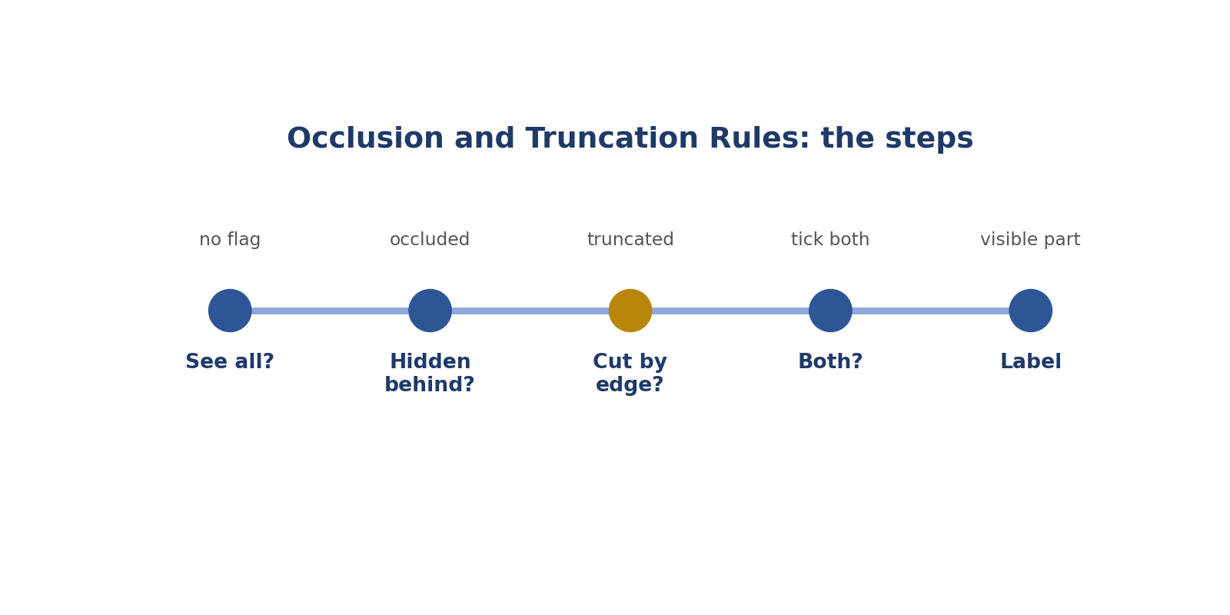
Occlusion and Truncation Rules: the steps.
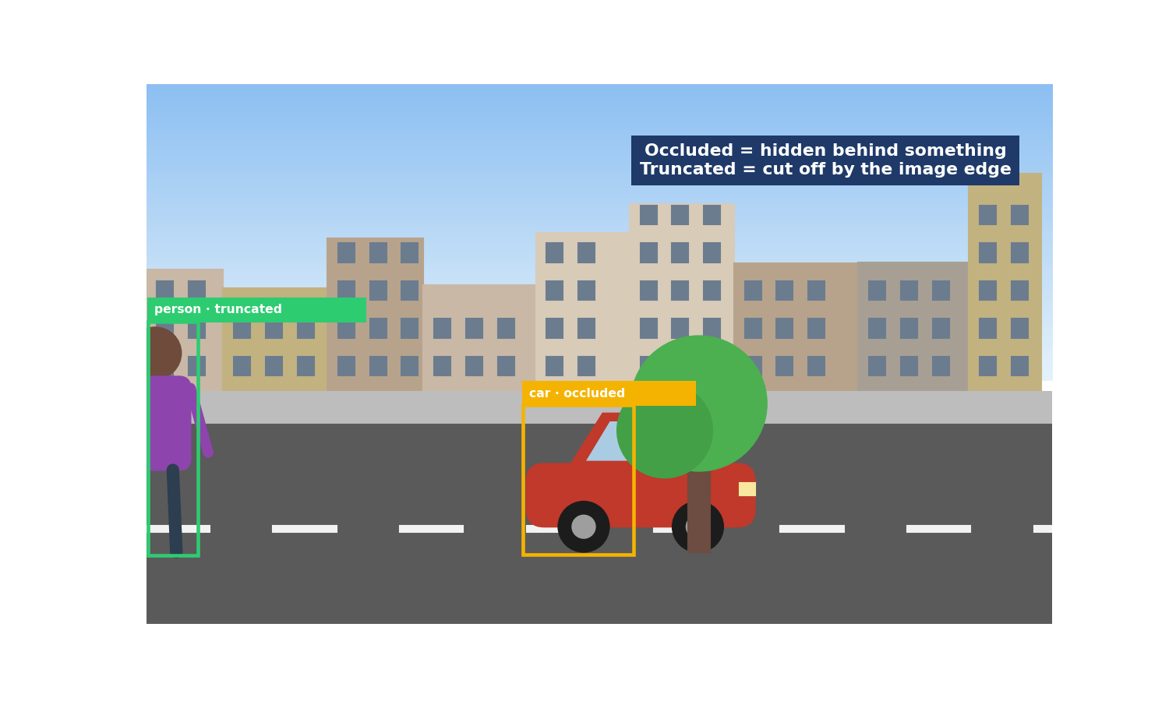
Picture: occlusion and truncation rules.
How to answer these tasks
1. Ask: can I see all of it?
2. Is part hidden behind something? Tick occluded.
3. Is part cut off by the edge? Tick truncated.
4. Both? Tick both.
5. Label only the visible part, unless told otherwise.
TASK 4.1 · EASY
The situation: A car is half hidden behind a bus.
What is this asking? Car half hidden by a bus?
Your task: Which flag?
Answer: Occluded.
Why (explained simply): Occluded.
Key word: Occluded = Hidden behind something.
In simple English: Hidden behind something = occluded.

TASK 4.2 · EASY
The situation: A person is cut off by the right edge of the image.
What is this asking? Person cut off at the edge?
Your task: Which flag?
Answer: Truncated.
Why (explained simply): Truncated.
Key word: Truncated = Cut off by the edge.
In simple English: Cut by the edge = truncated.

TASK 4.3 · MEDIUM
The situation: A dog behind a fence: you can see it through the gaps.
What is this asking? Dog behind a fence?
Your task: Occluded?
Answer: Yes; the fence hides parts of it.
Why (explained simply): Yes, occluded. The fence hides parts.
Key word: Fence = A barrier made of posts or wire.
In simple English: Partly hidden is occluded.

TASK 4.4 · EASY
The situation: Should you draw the hidden part of an occluded car?
What is this asking? Draw the hidden part?
Your task: Answer.
Answer: No, unless the guideline says to estimate it.
Why (explained simply): No, unless the rules say to.
Key word: Visible = Can be seen.
In simple English: Label only what you see.

TASK 4.5 · MEDIUM
The situation: In a video, a person walks behind a tree for 2 seconds.
What is this asking? Person hidden for 2 seconds in a video?
Your task: What do you do in those frames?
Answer: Follow the guideline: often mark as occluded or not visible, then continue the track when they reappear.
Why (explained simply): Follow the video rule: often mark as hidden, then continue.
Key word: Track = Following an object through a video.
In simple English: Follow the video rule for hidden moments.

TASK 4.6 · MEDIUM
The situation: In audio, two people speak at the same time.
What is this asking? Two voices at once?
Your task: How is this like occlusion?
Answer: One voice partly hides another; label both segments if overlaps are allowed.
Why (explained simply): One voice partly hides the other. Label both if allowed.
Key word: Overlap = When things happen at the same time.
In simple English: Overlapping sounds can both be labelled.

TASK 4.7 · HARD
The situation: A car is behind a tree and also cut off by the edge.
What is this asking? Behind a tree and cut off?
Your task: Which flags?
Answer: Both occluded and truncated.
Why (explained simply): Both flags.
Key word: Both = Two at once.
In simple English: Some objects need both.

TASK 4.8 · EASY
The situation: A person stands in front of a car.
What is this asking? Person in front of a car?
Your task: Which object is occluded?
Answer: The car.
Why (explained simply): The car is occluded.
Key word: In front = Closer to the camera.
In simple English: The object behind is occluded.

TASK 4.9 · MEDIUM
The situation: Only a car's side mirror is visible behind a wall.
What is this asking? Only a mirror visible?
Your task: Label it?
Answer: Check the minimum visibility rule; if too little is visible, skip or flag.
Why (explained simply): Check the visibility rule; skip or flag.
Key word: Minimum = The least allowed.
In simple English: Check the visibility rule.

TASK 4.10 · EASY
The situation: What does truncated mean?
What is this asking? What does truncated mean?
Your task: Define it.
Answer: Cut off by the edge of the image or frame.
Why (explained simply): Cut off by the edge.
Key word: Edge = The border of the picture.
In simple English: Cut off by the edge.

TASK 4.11 · MEDIUM
The situation: A video clip starts halfway through a person waving.
What is this asking? Clip starts mid-wave?
Your task: How does this relate to truncation?
Answer: The action is cut off at the start; label from the first frame and mark it truncated if the guideline has that option.
Why (explained simply): The action is cut off at the start.
Key word: Clip = A short piece of video.
In simple English: Actions can be cut off too.

TASK 4.12 · HARD
The situation: A reflection of a car hides part of a real car.
What is this asking? A reflection hides a real car?
Your task: What do you label?
Answer: The real car, as occluded; not the reflection.
Why (explained simply): Label the real car as occluded; not the reflection.
Key word: Reflection = A mirror image.
In simple English: Label real objects only.

TASK 4.13 · EASY
The situation: A cup is fully visible.
What is this asking? Fully visible cup?
Your task: Any flag?
Answer: No.
Why (explained simply): No flag.
Key word: Fully = Completely.
In simple English: Fully visible needs no flag.

TASK 4.14 · MEDIUM
The situation: A person is 90% hidden by a crowd.
What is this asking? 90% hidden?
Your task: What do you check?
Answer: The guideline's rule for heavily occluded objects.
Why (explained simply): Check the rule for heavily hidden objects.
Key word: Heavily = A lot.
In simple English: Check rules for very hidden objects.

TASK 4.15 · EASY
The situation: Why not guess hidden parts?
What is this asking? Why not guess hidden parts?
Your task: Explain.
Answer: It adds made-up information to the data.
Why (explained simply): It adds made-up information.
Key word: Guess = Decide without knowing.
In simple English: Guessing adds fake data.

TASK 4.16 · MEDIUM
The situation: A cyclist is cut off at the bottom of the image.
What is this asking? Cut off at the bottom?
Your task: Which flag?
Answer: Truncated.
Why (explained simply): Truncated.
Key word: Bottom = The lowest part.
In simple English: Bottom edge counts too.

TASK 4.17 · HARD
The situation: A text message is cut off mid-sentence (the rest is missing).
What is this asking? Message cut off mid-sentence?
Your task: How should you label it?
Answer: Label what's there if possible, and use a "truncated" or "incomplete" tag if the guideline has one; otherwise flag.
Why (explained simply): Use an "incomplete" tag if there is one, or flag.
Key word: Incomplete = Not finished.
In simple English: Cut-off text can be flagged too.

TASK 4.18 · EASY
The situation: A bus is partly behind a lamp post.
What is this asking? Bus behind a lamp post?
Your task: Which flag?
Answer: Occluded.
Why (explained simply): Occluded.
Key word: Lamp post = A pole holding a street light.
In simple English: Behind a post = occluded.

TASK 4.19 · MEDIUM
The situation: A person is in front of a window, and part of them is outside the image.
What is this asking? Outside the picture, not hidden by the window?
Your task: Which flag?
Answer: Truncated (the window doesn't hide them).
Why (explained simply): Truncated.
Key word: Outside = Not inside the picture.
In simple English: Check what's really hiding the object.

TASK 4.20 · EASY
The situation: Can an object be truncated at the top edge?
What is this asking? Top edge?
Your task: Answer.
Answer: Yes; any edge counts.
Why (explained simply): Yes, any edge counts.
Key word: Any = Every one.
In simple English: Any edge counts.

CHAPTER 6
Annotation Skill 5: Flagging Edge Cases

THINK OF IT LIKE THIS
Flagging is like putting up your hand in class when you don't understand. One question helps the whole class get the same answer.
In simple English: Ask, don't guess.
In simple English: If the rules don't cover it, flag it.
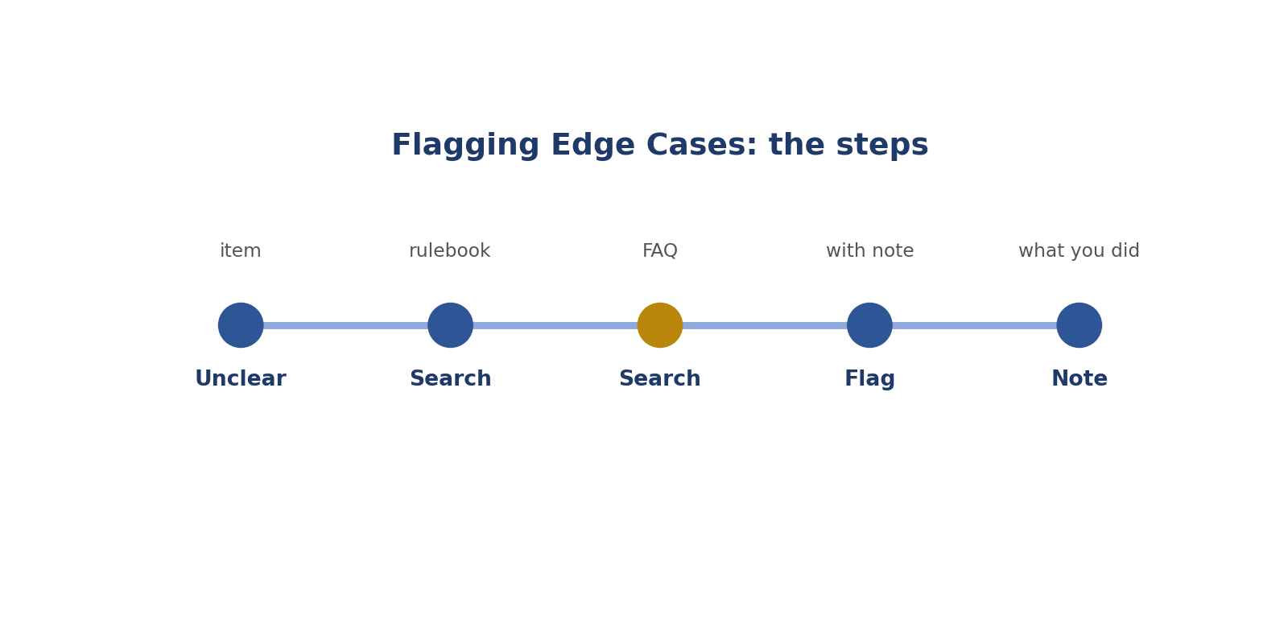
Flagging Edge Cases: the steps.
Picture: flagging edge cases.
How to answer these tasks
1. Notice when you're unsure.
2. Search the rulebook.
3. Search the FAQ.
4. If still unclear, press Flag and write a note.
5. Say what you did meanwhile.
TASK 5.1 · EASY
The situation: A car appears on a TV screen. The guideline doesn't mention screens.
What is this asking? Car on a TV, no rule?
Your task: What do you do?
Answer: Flag it with a note.
Why (explained simply): Flag it with a note. The rules don't say.
Key word: Edge case = A case the rules don't cover.
In simple English: Flag what the rules don't cover.

TASK 5.2 · MEDIUM
The situation: Write a flag note for a person in a painting, not covered by the rules.
What is this asking? Write a flag note for a painted person.
Your task: Write it.
Answer: "Person shown in a painting; guideline doesn't cover artworks. Left unlabelled pending guidance."
Why (explained simply): Say what's unclear and what you did: "Person in a painting; no rule; left unlabelled."
Key word: Note = A short message.
In simple English: Say what and why.

TASK 5.3 · EASY
The situation: A case is clearly covered by the guideline.
What is this asking? Flag a covered case?
Your task: Flag it?
Answer: No; apply the rule.
Why (explained simply): No. Just follow the rule.
Key word: Covered = Already in the rules.
In simple English: Don't flag covered cases.

TASK 5.4 · MEDIUM
The situation: An audio clip has a language you don't recognise.
What is this asking? Unknown language in audio?
Your task: What do you do?
Answer: Flag it if the guideline has no rule for unknown languages.
Why (explained simply): Flag it if there's no rule.
Key word: Language = The words people speak.
In simple English: Flag unknown situations.

TASK 5.5 · HARD
The situation: You flagged the same kind of case ten times this week.
What is this asking? Same flag 10 times?
Your task: What should you also do?
Answer: Suggest to the project team that a rule be added.
Why (explained simply): Suggest adding a rule.
Key word: Suggest = Offer an idea.
In simple English: Repeated flags need a rule.

TASK 5.6 · EASY
The situation: A text message contains only emojis.
What is this asking? Only emojis?
Your task: What do you do?
Answer: Check the guideline; if not covered, flag it.
Why (explained simply): Check the rules; if not covered, flag.
Key word: Emoji = A small picture like a smiley.
In simple English: Check, then flag.

TASK 5.7 · MEDIUM
The situation: A flag note says "weird".
What is this asking? Improve "weird".
Your task: Improve it.
Answer: "Image is upside down; guideline doesn't say whether to label rotated images."
Why (explained simply): Say exactly what's unclear, like "picture is upside down; no rule for rotated pictures".
Key word: Specific = Exact.
In simple English: Be specific.

TASK 5.8 · EASY
The situation: Why is flagging better than guessing?
What is this asking? Why flag, not guess?
Your task: Explain.
Answer: It creates one shared answer instead of hidden inconsistency.
Why (explained simply): So everyone gets one shared answer.
Key word: Shared = The same for everyone.
In simple English: One answer for everyone.

TASK 5.9 · MEDIUM
The situation: A video has a person in a costume that looks like an animal.
What is this asking? Person in an animal costume?
Your task: Person or animal?
Answer: A real person in costume is usually still a person; if the guideline doesn't cover costumes, flag.
Why (explained simply): Usually still a person; flag if not covered.
Key word: Costume = Clothes to look like something else.
In simple English: Costumes can be edge cases.

TASK 5.10 · EASY
The situation: Where is the flag button in most tools?
What is this asking? Where's the flag button?
Your task: Answer.
Answer: Near the submit button or in the task menu.
Why (explained simply): Near Submit or in the task menu.
Key word: Button = Something you click.
In simple English: Find the flag button early.

TASK 5.11 · MEDIUM
The situation: You flag a task and continue with the next.
What is this asking? What do you note after flagging?
Your task: What should you note?
Answer: What you did in the meantime (for example, left unlabelled).
Why (explained simply): What you did meanwhile, like "left unlabelled".
Key word: Meanwhile = While waiting.
In simple English: Say what you did.

TASK 5.12 · HARD
The situation: A reviewer says your flag was unnecessary.
What is this asking? Flag wasn't needed?
Your task: What should you learn?
Answer: Which rule covered it, and add it to your notes.
Why (explained simply): Learn which rule covered it and add it to your notes.
Key word: Learn = Find out.
In simple English: Learn which rule applied.

TASK 5.13 · EASY
The situation: A photo is completely black.
What is this asking? Completely black photo?
Your task: What do you do?
Answer: Use the "unusable" option or flag it.
Why (explained simply): Mark it unusable or flag it.
Key word: Unusable = Can't be used.
In simple English: Unusable images get flagged.

TASK 5.14 · MEDIUM
The situation: A sentence mixes English and Hausa.
What is this asking? English and Hausa mixed?
Your task: The guideline covers English only. What do you do?
Answer: Flag it unless the guideline covers mixed-language text.
Why (explained simply): Flag unless the rules cover mixed languages.
Key word: Mixed = Put together.
In simple English: Mixed language may need a flag.

TASK 5.15 · EASY
The situation: Should you flag everything to be safe?
What is this asking? Flag everything to be safe?
Your task: Answer.
Answer: No; over-flagging wastes reviewer time.
Why (explained simply): No. Too many flags waste time.
Key word: Over-flag = Flag too often.
In simple English: Only flag real edge cases.

TASK 5.16 · MEDIUM
The situation: An object is half car, half toy (a ride-on toy car).
What is this asking? Ride-on toy car?
Your task: What do you do?
Answer: Check the "toy" rule; if unclear, flag.
Why (explained simply): Check the toy rule; flag if unclear.
Key word: Toy = Something to play with.
In simple English: Check, then flag.

TASK 5.17 · HARD
The situation: A flagged case gets answered in the FAQ.
What is this asking? The FAQ answered your flag?
Your task: What should you do with similar tasks?
Answer: Apply the new answer consistently from now on.
Why (explained simply): Use that answer every time now.
Key word: Answer = The reply you got.
In simple English: Use new answers every time.

TASK 5.18 · EASY
The situation: A clip's audio is silent the whole time.
What is this asking? Silent audio?
Your task: What do you do?
Answer: Label as silence if that class exists; otherwise flag.
Why (explained simply): Use "silence" if it exists; otherwise flag.
Key word: Silence = No sound.
In simple English: Use the class or flag.

TASK 5.19 · MEDIUM
The situation: An image is a screenshot of a video game street.
What is this asking? Video game street?
Your task: Real scene?
Answer: Check whether game images count; flag if not covered.
Why (explained simply): Check if game pictures count; flag if unsure.
Key word: Screenshot = A picture of a screen.
In simple English: Game images can be edge cases.

TASK 5.20 · EASY
The situation: What two parts should every flag note include?
What is this asking? Two parts of a flag note?
Your task: Answer.
Answer: What's unclear and what you did in the meantime.
Why (explained simply): What's unclear, and what you did.
Key word: Flag note = The message with a flag.
In simple English: What's unclear and what you did.

CHAPTER 7
Annotation Skill 6: Precision at Boundaries

THINK OF IT LIKE THIS
Precision is like colouring inside the lines. Going over the lines or leaving gaps makes the picture wrong.
In simple English: Stay exactly on the edges.
In simple English: Put edges and times in exactly the right place.
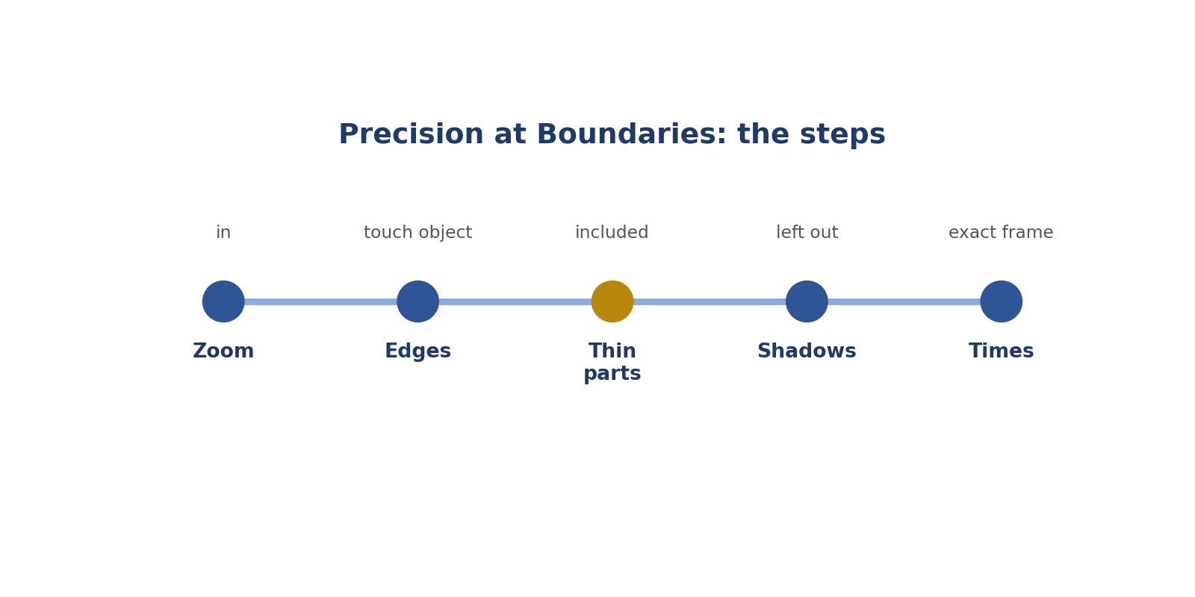
Precision at Boundaries: the steps.
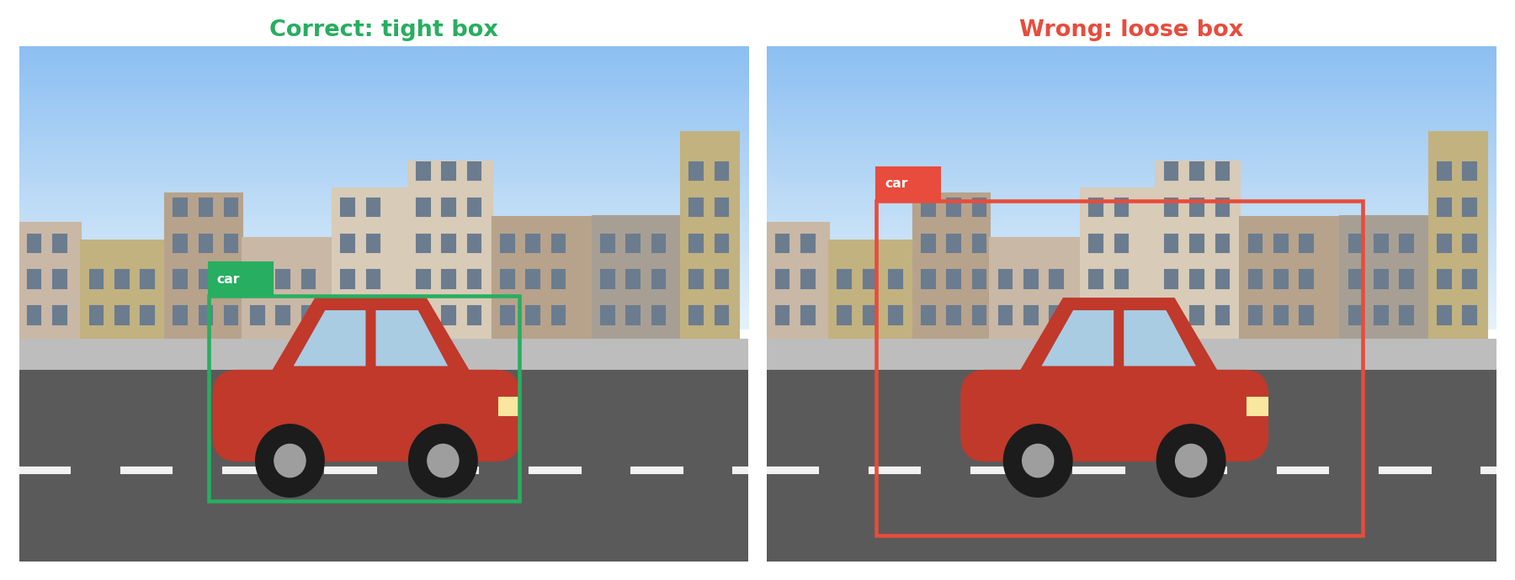
Picture: precision at boundaries.
How to answer these tasks
1. Zoom in on the object.
2. Make every edge touch the object.
3. Include thin parts like mirrors.
4. Leave out shadows, unless told otherwise.
5. For audio and video, step frame by frame at the start and end.
TASK 6.1 · EASY
The situation: A box has a gap of road on every side of a car.
What is this asking? Road all around the car?
Your task: What's wrong?
Answer: It's too loose.
Why (explained simply): The box is too loose.
Key word: Loose = Too much space.
In simple English: Boxes must be tight.

TASK 6.2 · EASY
The situation: A box cuts off a car's side mirror.
What is this asking? Mirror cut off?
Your task: What's wrong?
Answer: It's too tight on that side.
Why (explained simply): Too tight on that side.
Key word: Tight = Touching the edges.
In simple English: Include every part.

TASK 6.3 · MEDIUM
The situation: An audio segment starts 0.5 seconds after the speech begins.
What is this asking? Audio starts late?
Your task: What's wrong?
Answer: The start is late; move it to where speech begins (plus any required padding).
Why (explained simply): Move the start to where speech begins.
Key word: Start time = When something begins.
In simple English: Start times must be exact.

TASK 6.4 · MEDIUM
The situation: A video action segment ends 1 second after the action stops.
What is this asking? Video ends late?
Your task: What's wrong?
Answer: The end is late; end at the last frame of the action.
Why (explained simply): End at the last frame of the action.
Key word: Frame = One picture in a video.
In simple English: End times must be exact.

TASK 6.5 · EASY
The situation: A polygon skips the car's roof curve.
What is this asking? Polygon skips the roof curve?
Your task: What's wrong?
Answer: It cuts the corner; add points along the curve.
Why (explained simply): Add points along the curve.
Key word: Curve = A bending line.
In simple English: Follow the curve.

TASK 6.6 · HARD
The situation: A box includes the car's shadow. The guideline excludes shadows.
What is this asking? Box includes the shadow?
Your task: What's wrong?
Answer: The box is too big on the shadow side.
Why (explained simply): Move the edge to the car body.
Key word: Shadow = A dark shape made by blocking light.
In simple English: Shadows aren't part of the object.

TASK 6.7 · EASY
The situation: What does "tight" mean for a box?
What is this asking? What does tight mean?
Your task: Define it.
Answer: Edges touch the object's outermost visible pixels.
Why (explained simply): Edges touch the object's outer pixels.
Key word: Pixel = One tiny dot.
In simple English: Touching the edges.

TASK 6.8 · MEDIUM
The situation: A text span label includes the space after a name.
What is this asking? Extra space in a text span?
Your task: Is this a precision issue?
Answer: Yes; spans should cover only the name's characters.
Why (explained simply): Yes, a precision issue: mark only the name.
Key word: Span = A group of words.
In simple English: Text spans must be exact too.

TASK 6.9 · EASY
The situation: How do you place precise edges?
What is this asking? One habit for precise edges?
Your task: Name one habit.
Answer: Zoom in.
Why (explained simply): Zoom in.
Key word: Zoom = Make the picture bigger.
In simple English: Zoom in.

TASK 6.10 · MEDIUM
The situation: In video, how do you find the exact start frame?
What is this asking? Exact start frame?
Your task: Answer.
Answer: Step frame by frame around the start.
Why (explained simply): Step frame by frame.
Key word: Step = Move one at a time.
In simple English: Step frame by frame.

TASK 6.11 · HARD
The situation: A person holds a bag. The guideline includes carried items.
What is this asking? Bag included?
Your task: Where does the box edge go?
Answer: Out to include the bag's edge.
Why (explained simply): Yes, if the rules include carried items.
Key word: Carried item = Something being held.
In simple English: Carried items can be included.

TASK 6.12 · EASY
The situation: A keypoint is placed on the forearm instead of the wrist.
What is this asking? Point on the forearm, not the wrist?
Your task: What's wrong?
Answer: Wrong position; move it to the wrist.
Why (explained simply): Move it to the wrist.
Key word: Wrist = Where the hand meets the arm.
In simple English: Points go on the exact part.

TASK 6.13 · MEDIUM
The situation: An audio clip includes a cough in the middle of a speech segment.
What is this asking? A cough in speech?
Your task: Should the speech segment end?
Answer: Follow the guideline: some keep short coughs inside speech; others split. Check.
Why (explained simply): Check the rule for short sounds.
Key word: Cough = A short sound from the throat.
In simple English: Check how to handle short sounds.

TASK 6.14 · EASY
The situation: Why do loose edges matter?
What is this asking? Why do loose edges matter?
Your task: Explain.
Answer: The AI learns wrong sizes and positions.
Why (explained simply): The AI learns wrong sizes.
Key word: Size = How big something is.
In simple English: The AI copies your edges.

TASK 6.15 · MEDIUM
The situation: A polygon includes a bit of the road under the car.
What is this asking? Road inside the car polygon?
Your task: What's wrong?
Answer: It includes background; tighten the lower edge.
Why (explained simply): Tighten the bottom edge.
Key word: Background = What's behind the object.
In simple English: Leave out background.

TASK 6.16 · HARD
The situation: Two objects touch each other.
What is this asking? Two touching objects?
Your task: How do you draw boxes?
Answer: Each box tight around its own object; boxes may overlap.
Why (explained simply): One tight box each; they can overlap.
Key word: Overlap = Covering part of each other.
In simple English: Each object gets its own tight box.

TASK 6.17 · EASY
The situation: What causes most loose boxes?
What is this asking? Main cause of loose boxes?
Your task: Answer.
Answer: Not zooming in and rushing.
Why (explained simply): Not zooming and rushing.
Key word: Rushing = Going too fast.
In simple English: Zoom and slow down.

TASK 6.18 · MEDIUM
The situation: A timestamp for a door slam covers 3 seconds; the slam lasts half a second.
What is this asking? 3 seconds for a short slam?
Your task: What's wrong?
Answer: Too long; mark only the half-second sound (plus padding if required).
Why (explained simply): Too long. Mark only the slam.
Key word: Duration = How long something lasts.
In simple English: Mark only the sound.

TASK 6.19 · EASY
The situation: A box around a person misses their raised hand.
What is this asking? Missed raised hand?
Your task: What's wrong?
Answer: Too tight at the top; include the hand.
Why (explained simply): Include it.
Key word: Raised = Lifted up.
In simple English: Include raised arms.

TASK 6.20 · MEDIUM
The situation: How do audits measure precision?
What is this asking? How is precision checked?
Your task: Answer.
Answer: By comparing your edges or times with reference labels.
Why (explained simply): By comparing your edges with correct ones.
Key word: Reference = The correct example.
In simple English: Your edges are compared.

CHAPTER 8
Annotation Skill 7: Consistency Across Batches

THINK OF IT LIKE THIS
Consistency is like a baker making bread every day. Customers expect the same taste every time, not great on Monday and different on Friday.
In simple English: Same quality every time.
In simple English: Label the same things the same way, every time.
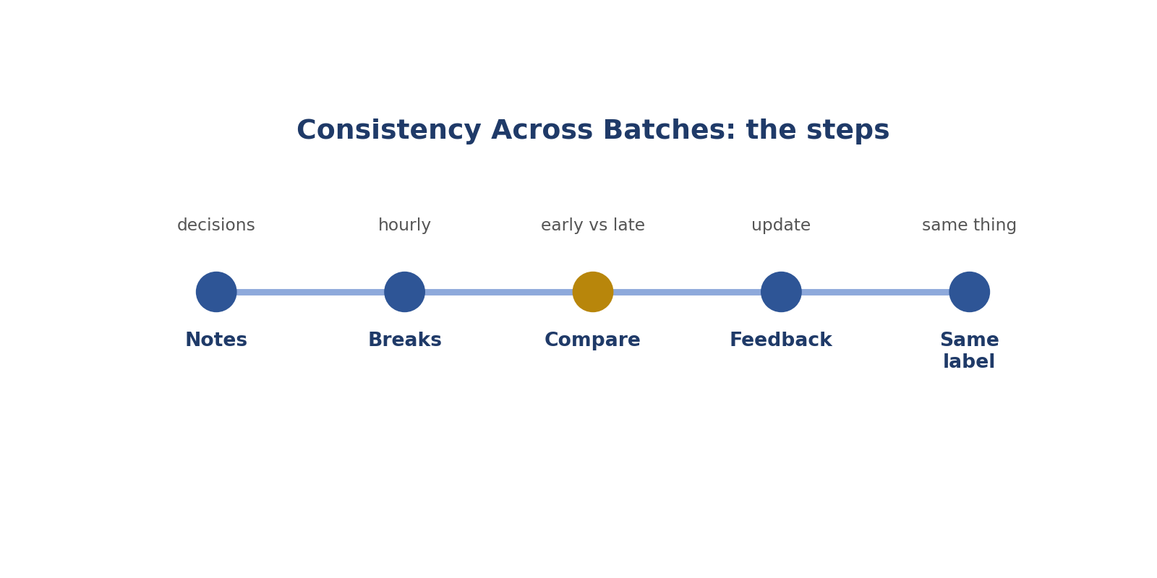
Consistency Across Batches: the steps.
How to answer these tasks
1. Keep notes of tricky decisions.
2. Take short breaks.
3. Compare recent work with early work.
4. Update notes after feedback.
5. Use the same label for the same thing.
TASK 7.1 · EASY
The situation: You labelled scooters as "motorbike" this morning and "bicycle" this afternoon.
What is this asking? Scooters labelled two ways?
Your task: What's the problem?
Answer: Inconsistency; check the definition and fix the wrong ones.
Why (explained simply): Inconsistent. Fix with the definition.
Key word: Inconsistent = Not the same.
In simple English: Same thing, same label.

TASK 7.2 · MEDIUM
The situation: Your boxes are looser after two hours.
What is this asking? Looser after two hours?
Your task: What should you do?
Answer: Take a break and recheck recent tasks.
Why (explained simply): Take a break and recheck.
Key word: Break = A short rest.
In simple English: Rest and recheck.

TASK 7.3 · EASY
The situation: How can a notes file help consistency?
What is this asking? Why a notes file?
Your task: Answer.
Answer: It records your decisions so you repeat them.
Why (explained simply): It records decisions so you repeat them.
Key word: Decision = A choice you made.
In simple English: Notes keep decisions the same.

TASK 7.4 · MEDIUM
The situation: You receive feedback that changes a rule.
What is this asking? A rule changed?
Your task: What about tasks you did before?
Answer: Apply the new rule from now on, and ask whether past tasks need fixing.
Why (explained simply): Use it now and ask about old tasks.
Key word: Old tasks = Work already done.
In simple English: Ask about old tasks.

TASK 7.5 · EASY
The situation: Why does consistency matter to AI?
What is this asking? Why does consistency matter?
Your task: Explain.
Answer: Mixed labels confuse what the AI learns.
Why (explained simply): Mixed labels confuse the AI.
Key word: Confuse = Make unclear.
In simple English: Mixed labels confuse the AI.

TASK 7.6 · MEDIUM
The situation: You notice you label "neutral" more often late at night.
What is this asking? More "neutral" late at night?
Your task: What might be happening?
Answer: Tired drift; take breaks and recheck.
Why (explained simply): Tired drift. Rest and recheck.
Key word: Drift = Slowly changing.
In simple English: Watch for tired patterns.

TASK 7.7 · HARD
The situation: Two batches look slightly different (daytime vs night images).
What is this asking? Day and night pictures?
Your task: How do you keep consistent?
Answer: Apply the same rules; check the guideline for night-specific rules.
Why (explained simply): Same rules for both; check for night rules.
Key word: Same rules = No change.
In simple English: Same rules for all images.

TASK 7.8 · EASY
The situation: A golden task shows you labelled differently from the reference.
What is this asking? Golden task missed?
Your task: What should you do?
Answer: Learn the correct rule and update your notes.
Why (explained simply): Learn the right rule and update notes.
Key word: Golden task = A hidden test.
In simple English: Learn from hidden tests.

TASK 7.9 · MEDIUM
The situation: You re-label 10 images from yesterday and get 3 different results.
What is this asking? 3 different answers on re-labelling?
Your task: What does it show?
Answer: Your standard isn't steady; review the rules for those cases.
Why (explained simply): You're not consistent yet.
Key word: Re-label = Label again.
In simple English: Test yourself by re-labelling.

TASK 7.10 · EASY
The situation: Should you change your standard to finish faster?
What is this asking? Change standards to go faster?
Your task: Answer.
Answer: No.
Why (explained simply): No.
Key word: Standard = The level of quality.
In simple English: Never change standards to go faster.

TASK 7.11 · MEDIUM
The situation: In audio, you started including 0.2s padding halfway through a batch.
What is this asking? Added padding halfway through?
Your task: What should you do?
Answer: Go back and apply the rule to earlier tasks if allowed, or tell the team.
Why (explained simply): Fix earlier tasks if allowed, or tell the team.
Key word: Padding = Extra time added.
In simple English: Fix inconsistent work.

TASK 7.12 · HARD
The situation: A batch has many edge cases, and you decided each differently.
What is this asking? Many edge cases decided differently?
Your task: What should you do?
Answer: Flag the pattern and ask for one rule; then relabel consistently.
Why (explained simply): Flag the pattern and ask for one rule.
Key word: Pattern = Something that repeats.
In simple English: One rule for similar cases.

TASK 7.13 · EASY
The situation: What helps keep the same standard all day?
What is this asking? One habit for steady work?
Your task: Name one.
Answer: Regular short breaks.
Why (explained simply): Regular short breaks.
Key word: Habit = Something you do often.
In simple English: Breaks help.

TASK 7.14 · MEDIUM
The situation: Your first and last boxes in a session differ in tightness.
What is this asking? First and last boxes differ?
Your task: How do you check this?
Answer: Compare an early and a recent task side by side.
Why (explained simply): Compare them side by side.
Key word: Compare = Look at differences.
In simple English: Compare early and late work.

TASK 7.15 · EASY
The situation: A class name changed in the tool.
What is this asking? Class name changed?
Your task: What should you check?
Answer: That you use the new name consistently.
Why (explained simply): Use the new name every time.
Key word: Rename = Change the name.
In simple English: Update your habits.

TASK 7.16 · MEDIUM
The situation: Two team members label the same case differently.
What is this asking? Two people label differently?
Your task: What should happen?
Answer: Ask for a clear rule so everyone matches.
Why (explained simply): Ask for a clear rule.
Key word: Clear = Easy to understand.
In simple English: Teams need one rule.

TASK 7.17 · HARD
The situation: Your consistency drops on Mondays.
What is this asking? Worse on Mondays?
Your task: What might cause it?
Answer: New batches or rule changes at the start of the week; reread notes before starting.
Why (explained simply): New batches or rule changes. Reread notes first.
Key word: Monday = The start of the week.
In simple English: Refresh rules at the start.

TASK 7.18 · EASY
The situation: Consistent but wrong: is that good?
What is this asking? Consistent but wrong?
Your task: Answer.
Answer: No; you must be consistent and correct.
Why (explained simply): Not good. Be right AND consistent.
Key word: Correct = Right.
In simple English: Right and steady.

TASK 7.19 · MEDIUM
The situation: You keep a list of tricky examples with the right answers.
What is this asking? List of tricky examples?
Your task: How does this help?
Answer: You can match new tricky cases to them.
Why (explained simply): Match new tricky cases to it.
Key word: Tricky = Hard to decide.
In simple English: Use your examples list.

TASK 7.20 · EASY
The situation: What is a batch?
What is this asking? What is a batch?
Your task: Define it.
Answer: A group of tasks done together.
Why (explained simply): A group of tasks done together.
Key word: Batch = A group of tasks.
In simple English: A group of tasks.

CHAPTER 9
Annotation Skill 8: Annotation Tool Shortcuts

THINK OF IT LIKE THIS
Shortcuts are like knowing the quick route to school. You arrive faster without skipping anything important.
In simple English: Faster, without skipping steps.
In simple English: Learn the keys that make the tool faster.
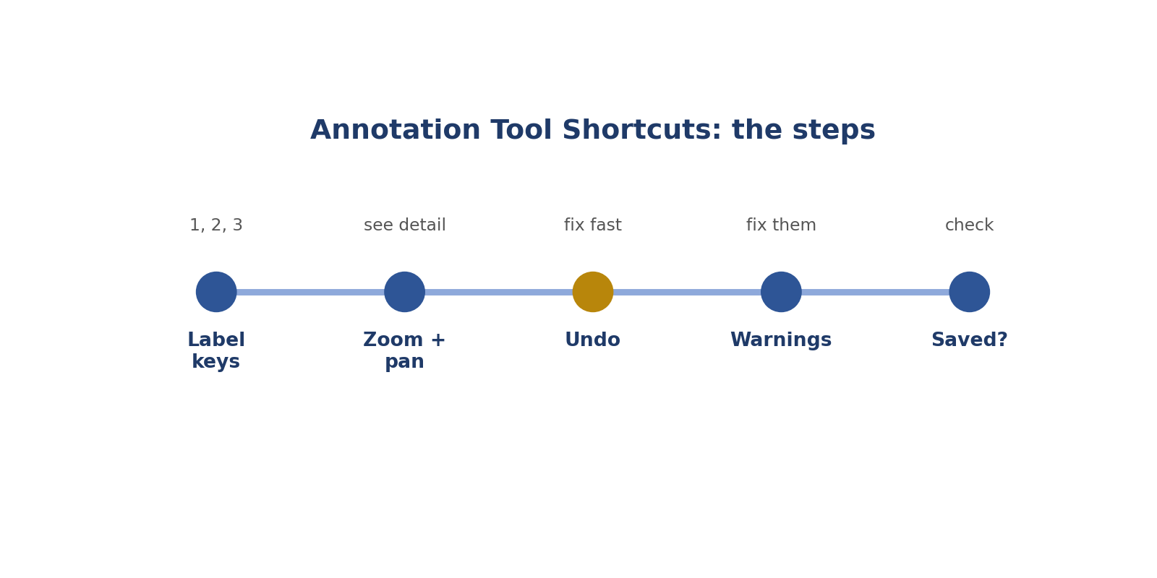
Annotation Tool Shortcuts: the steps.
Picture: annotation tool shortcuts.
How to answer these tasks
1. Read the tool's shortcut list on day one.
2. Use number keys for labels.
3. Use zoom and pan for detail.
4. Use undo to fix mistakes.
5. Check every task saved.
TASK 8.1 · EASY
The situation: The tool lets you press 1 for "car".
What is this asking? Why press 1 for car?
Your task: Why use it?
Answer: It's faster than clicking the menu.
Why (explained simply): Faster than clicking the menu.
Key word: Shortcut = A quick key.
In simple English: Keys are faster.

TASK 8.2 · EASY
The situation: You made a wrong point.
What is this asking? Wrong point?
Your task: Which shortcut helps?
Answer: Undo (often Ctrl+Z).
Why (explained simply): Undo.
Key word: Undo = Reverse the last action.
In simple English: Undo fixes mistakes fast.

TASK 8.3 · MEDIUM
The situation: You can't see a small object clearly.
What is this asking? Can't see a small object?
Your task: Which tool features help?
Answer: Zoom and pan.
Why (explained simply): Zoom and pan.
Key word: Pan = Move around a zoomed picture.
In simple English: Zoom and move around.

TASK 8.4 · EASY
The situation: Where do you find a tool's shortcuts?
What is this asking? Where are shortcuts?
Your task: Answer.
Answer: In the help page or shortcut list.
Why (explained simply): In the help page.
Key word: Help page = Instructions in the tool.
In simple English: Check the help page.

TASK 8.5 · MEDIUM
The situation: A tool warns: "Box outside image."
What is this asking? "Box outside image" warning?
Your task: What should you do?
Answer: Fix the box; don't ignore warnings.
Why (explained simply): Fix the box.
Key word: Warning = A message that something is wrong.
In simple English: Fix warnings.

TASK 8.6 · EASY
The situation: Should you learn shortcuts before paid work?
What is this asking? Learn shortcuts first?
Your task: Answer.
Answer: Yes, if practice tasks are available.
Why (explained simply): Yes, if practice is available.
Key word: Practice = Doing it to learn.
In simple English: Practise first.

TASK 8.7 · MEDIUM
The situation: You keep assigning the wrong label with number keys.
What is this asking? Wrong labels with number keys?
Your task: What's the fix?
Answer: Slow down and check the label list before submitting.
Why (explained simply): Slow down and check the label list.
Key word: Check = Make sure.
In simple English: Speed must not cause mistakes.

TASK 8.8 · HARD
The situation: Shortcuts differ between two tools you use.
What is this asking? Two tools, different keys?
Your task: How do you avoid errors?
Answer: Keep a short shortcut list for each tool beside you.
Why (explained simply): Keep a list for each tool.
Key word: List = Things written one under another.
In simple English: Keep a list for each tool.

TASK 8.9 · EASY
The situation: What does "submit" do?
What is this asking? What does submit do?
Your task: Answer.
Answer: Sends your finished task for review.
Why (explained simply): Sends your finished task.
Key word: Submit = Send.
In simple English: Submit sends your work.

TASK 8.10 · MEDIUM
The situation: In audio tools, what helps find exact start times?
What is this asking? Exact audio start times?
Your task: Answer.
Answer: Zooming into the waveform and playing short sections.
Why (explained simply): Zoom into the sound wave.
Key word: Waveform = The picture of a sound.
In simple English: Zoom into the waveform.

TASK 8.11 · EASY
The situation: Name two free tools to practise with.
What is this asking? Two free tools?
Your task: Answer.
Answer: CVAT (Computer Vision Annotation Tool) and Label Studio.
Why (explained simply): CVAT and Label Studio.
Key word: CVAT = Computer Vision Annotation Tool.
In simple English: Free tools exist.

TASK 8.12 · MEDIUM
The situation: A video tool can copy a box to the next frame.
What is this asking? Copy a box to the next frame?
Your task: Why use it?
Answer: It saves time; then adjust the box to the new position.
Why (explained simply): Saves time; then move it to fit.
Key word: Copy = Make the same again.
In simple English: Copy, then adjust.

TASK 8.13 · HARD
The situation: Auto-labelling suggests boxes for you.
What is this asking? Auto-labels?
Your task: How should you treat them?
Answer: Check and correct every suggestion; the final label is your responsibility.
Why (explained simply): Check and fix every one.
Key word: Auto-label = A label made by the tool.
In simple English: Check every auto-label.

TASK 8.14 · EASY
The situation: Your work didn't save.
What is this asking? Work didn't save?
Your task: What habit prevents this?
Answer: Check the saved or submitted status before moving on.
Why (explained simply): Check the saved status before moving on.
Key word: Saved = Kept safely.
In simple English: Check it saved.

TASK 8.15 · MEDIUM
The situation: The tool has a "hide other labels" button.
What is this asking? Hide other labels?
Your task: When is it useful?
Answer: When many boxes overlap and you need to see one clearly.
Why (explained simply): Useful when many boxes overlap.
Key word: Hide = Make invisible.
In simple English: Hide others to see clearly.

TASK 8.16 · EASY
The situation: Can shortcuts replace care?
What is this asking? Can shortcuts replace care?
Your task: Answer.
Answer: No; they save time, not checks.
Why (explained simply): No.
Key word: Care = Paying close attention.
In simple English: Shortcuts save time, not care.

TASK 8.17 · MEDIUM
The situation: You use a mouse with no scroll wheel.
What is this asking? No scroll wheel?
Your task: What problem might you have?
Answer: Zooming is harder; use keyboard zoom or a better mouse.
Why (explained simply): Zooming is harder; use keys or a better mouse.
Key word: Mouse = The device you click with.
In simple English: Good equipment helps.

TASK 8.18 · HARD
The situation: A new tool update moved the label list.
What is this asking? Tool update moved things?
Your task: What should you do?
Answer: Re-check the layout before continuing to avoid wrong clicks.
Why (explained simply): Check the layout before continuing.
Key word: Layout = Where things are.
In simple English: Recheck after updates.

TASK 8.19 · EASY
The situation: What is panning?
What is this asking? What is panning?
Your task: Define it.
Answer: Moving around a zoomed-in image.
Why (explained simply): Moving around a zoomed picture.
Key word: Panning = Moving the view.
In simple English: Moving around the picture.

TASK 8.20 · MEDIUM
The situation: You finish tasks fast but accuracy drops.
What is this asking? Fast but less accurate?
Your task: What should you do?
Answer: Slow down and add a quick review before submitting.
Why (explained simply): Slow down and review before submitting.
Key word: Accuracy = Being correct.
In simple English: Accuracy comes first.

CHAPTER 10
Computer Vision Skill 1: Bounding Boxes

THINK OF IT LIKE THIS
A bounding box is like a photo frame that fits the picture exactly: no big gaps around it, and nothing cut off.
In simple English: A frame that fits exactly.
In simple English: Draw a close-fitting rectangle around each object.
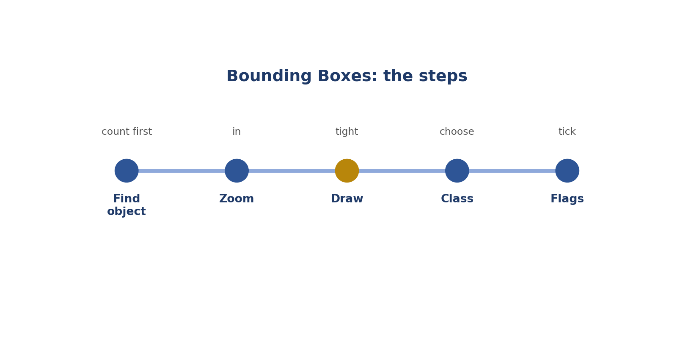
Bounding Boxes: the steps.
Picture: bounding boxes.
How to answer these tasks
1. Count the objects to label.
2. Zoom in on one object.
3. Draw the box touching all four sides.
4. Choose the class.
5. Tick any flags.
TASK 9.1 · EASY
The situation: A box around a car touches all four edges of the car.
What is this asking? Is a box touching all four sides right?
Your task: Correct?
Answer: Yes; it's tight.
Why (explained simply): Yes, that's a tight box.
Key word: Tight = Touching the edges.
In simple English: Touching all sides is correct.

TASK 9.2 · EASY
The situation: A box around a dog leaves space above its head.
What is this asking? Space above the dog's head?
Your task: What's wrong?
Answer: Too loose at the top.
Why (explained simply): Too loose at the top. Pull it down.
Key word: Loose = Too much space.
In simple English: Remove extra space.

TASK 9.3 · MEDIUM
The situation: A box around a bicycle cuts off the back wheel.
What is this asking? Back wheel cut off?
Your task: What's wrong?
Answer: Too tight; include the whole wheel.
Why (explained simply): Too tight. Include the whole wheel.
Key word: Cut off = Not included.
In simple English: Include every part.

TASK 9.4 · EASY
The situation: Two cars overlap. Can their boxes overlap?
What is this asking? Can boxes overlap?
Your task: Answer.
Answer: Yes; each car gets its own box.
Why (explained simply): Yes. Each car gets its own box.
Key word: Overlap = Cover part of each other.
In simple English: Boxes can overlap.

TASK 9.5 · MEDIUM
The situation: A car's shadow extends to the right. The guideline excludes shadows.
What is this asking? Where does the edge go with a shadow?
Your task: Where does the right edge go?
Answer: At the car's body, not the shadow.
Why (explained simply): At the car, not the shadow.
Key word: Shadow = A dark shape from blocked light.
In simple English: Leave out shadows.

TASK 9.6 · EASY
The situation: How many boxes for three people?
What is this asking? Three people, how many boxes?
Your task: Answer.
Answer: Three, one per person.
Why (explained simply): Three.
Key word: One each = A separate one for every object.
In simple English: One box per object.

TASK 9.7 · MEDIUM
The situation: A person raises their arms above their head.
What is this asking? Raised arms?
Your task: Where is the top edge?
Answer: At the top of the hands.
Why (explained simply): The top edge goes at the top of the hands.
Key word: Raised = Lifted up.
In simple English: Include raised arms.

TASK 9.8 · HARD
The situation: A truck has a long trailer attached.
What is this asking? Truck with a trailer?
Your task: One box or two?
Answer: Follow the guideline: some count the trailer as part of the truck; others label it separately.
Why (explained simply): Follow the rule: one box or separate boxes.
Key word: Trailer = A part pulled behind a truck.
In simple English: Check how the rules treat attachments.

TASK 9.9 · EASY
The situation: A box includes lots of road.
What is this asking? Lots of road in the box?
Your task: What's this called?
Answer: A loose box.
Why (explained simply): A loose box.
Key word: Background = What's behind the object.
In simple English: Too much background = loose.

TASK 9.10 · MEDIUM
The situation: A box is drawn around a group of 5 people.
What is this asking? One box around 5 people?
Your task: What's wrong?
Answer: Each person needs their own box, unless a "group" class exists.
Why (explained simply): Each person needs their own box.
Key word: Group = Many together.
In simple English: One object, one box.

TASK 9.11 · EASY
The situation: Should box edges go through the object?
What is this asking? Should edges cut through the object?
Your task: Answer.
Answer: No; they should touch its outer edges.
Why (explained simply): No. They should touch its outside.
Key word: Outside = The outer edge.
In simple English: Edges touch, not cut.

TASK 9.12 · MEDIUM
The situation: A car's open door sticks out.
What is this asking? Open door?
Your task: Include it?
Answer: Usually yes, as part of the car; check the guideline.
Why (explained simply): Usually yes; check the rules.
Key word: Door = The part that opens.
In simple English: Open doors are usually part of the car.

TASK 9.13 · HARD
The situation: A motorbike with a rider.
What is this asking? Rider on a motorbike?
Your task: How many boxes?
Answer: Usually two (rider and motorbike), unless the guideline says to label them together.
Why (explained simply): Usually two boxes, unless the rules say one.
Key word: Rider = The person riding.
In simple English: Check the rider rule.

TASK 9.14 · EASY
The situation: What does a box tell the AI?
What is this asking? What does a box tell the AI?
Your task: Answer.
Answer: Where the object is and roughly how big it is.
Why (explained simply): Where the object is and how big.
Key word: Position = Where something is.
In simple English: Where and how big.

TASK 9.15 · MEDIUM
The situation: You drew a box but chose the wrong class.
What is this asking? Wrong class on a good box?
Your task: What should you do?
Answer: Change the class before submitting.
Why (explained simply): Fix the class before submitting.
Key word: Class = The name of a thing.
In simple English: Check the class too.

TASK 9.16 · EASY
The situation: A box around a sign includes its pole.
What is this asking? Sign with its pole?
Your task: Is that right?
Answer: Check the guideline; many label only the sign face.
Why (explained simply): Check the rules; often just the sign.
Key word: Pole = A long stick holding something up.
In simple English: Check what counts.

TASK 9.17 · MEDIUM
The situation: A box's corner goes slightly outside the image.
What is this asking? Corner outside the picture?
Your task: What should you do?
Answer: Keep the box inside the image; tools often warn you.
Why (explained simply): Keep the box inside the picture.
Key word: Inside = Within the edges.
In simple English: Stay inside the image.

TASK 9.18 · HARD
The situation: A distant car is 19 pixels wide; the limit is 20.
What is this asking? 19 pixels, limit 20?
Your task: Draw a box?
Answer: No; it's below the limit.
Why (explained simply): No box. Too small.
Key word: Limit = The smallest allowed.
In simple English: Follow size limits.

TASK 9.19 · EASY
The situation: What should you do before drawing boxes on a busy image?
What is this asking? Busy picture: first step?
Your task: Answer.
Answer: Count the objects to label.
Why (explained simply): Count the objects.
Key word: Count = Find how many.
In simple English: Count first.

TASK 9.20 · MEDIUM
The situation: A box is perfect but on the wrong object.
What is this asking? Perfect box, wrong object?
Your task: What kind of error?
Answer: A placement error; move it to the right object.
Why (explained simply): A placement error. Move it.
Key word: Placement = Where you put something.
In simple English: Right box, right object.

CHAPTER 11
Computer Vision Skill 2: Polygon Segmentation

THINK OF IT LIKE THIS
A polygon is like tracing a cartoon with dots and lines. Where the drawing curves, you need more dots to follow it.
In simple English: Trace the shape with dots.
In simple English: Click points around the exact shape.
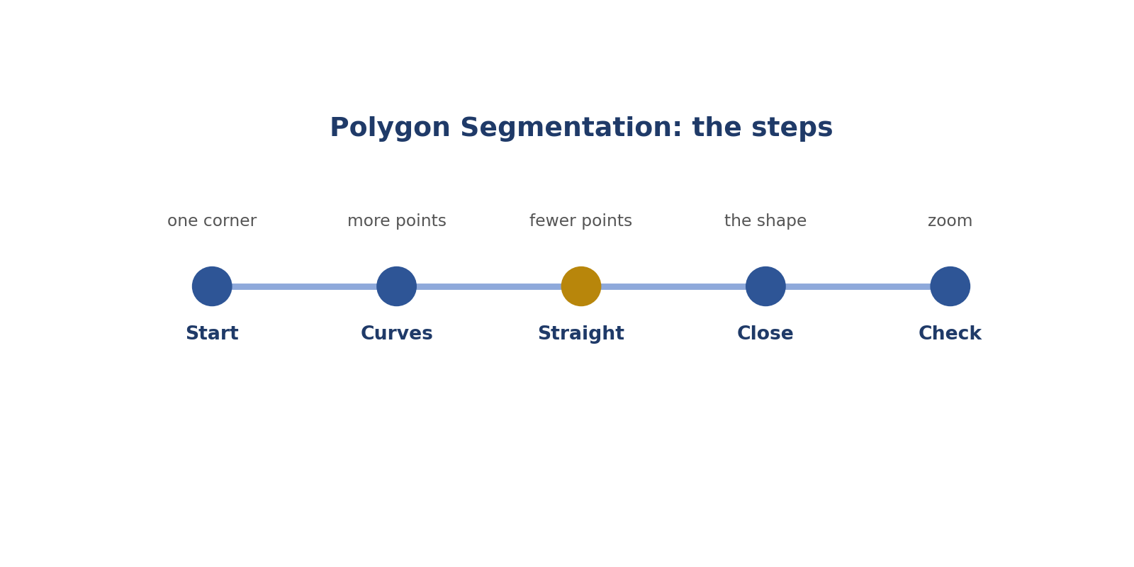
Polygon Segmentation: the steps.
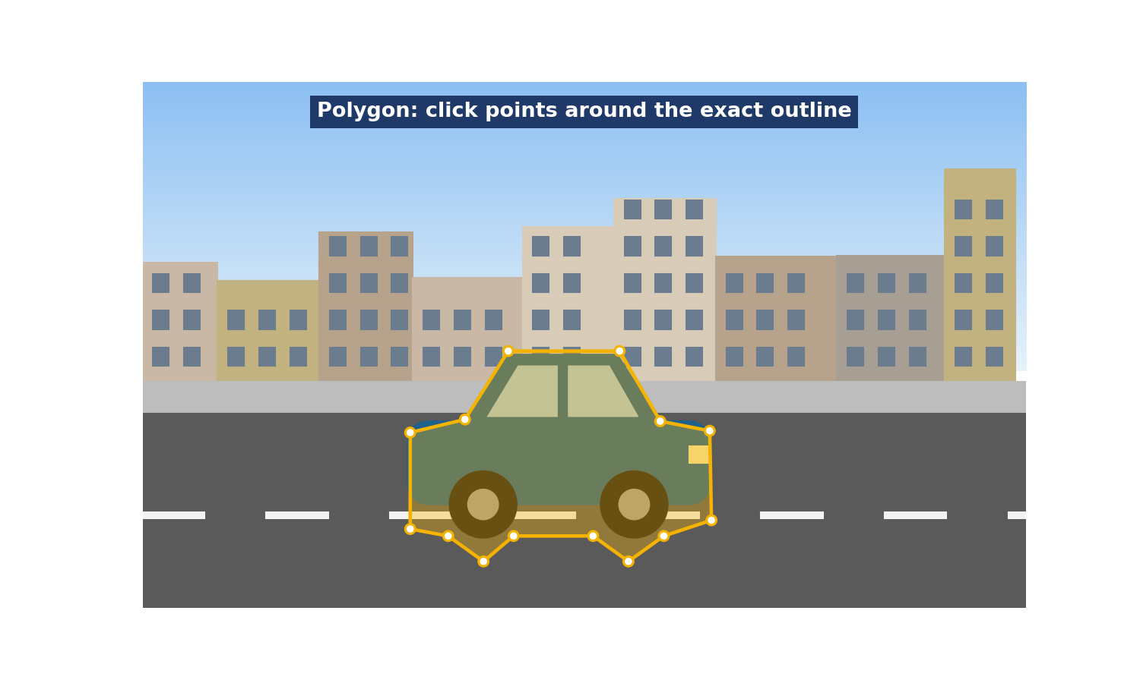
Picture: polygon segmentation.
How to answer these tasks
1. Start at one corner.
2. Add more points on curves.
3. Use fewer points on straight edges.
4. Close the shape.
5. Zoom and check every point.
TASK 10.1 · EASY
The situation: A polygon skips the curved roof of a car.
What is this asking? Polygon skips the curve?
Your task: What's wrong?
Answer: It cuts the corner; add points along the curve.
Why (explained simply): Add points along the curve.
Key word: Curve = A bending line.
In simple English: Follow curves with more points.

TASK 10.2 · EASY
The situation: How many points does a flat edge need?
What is this asking? Points on a flat edge?
Your task: Answer.
Answer: Only a few; more points are needed on curves.
Why (explained simply): Only a few.
Key word: Flat = Straight.
In simple English: Few on straight, more on curves.

TASK 10.3 · MEDIUM
The situation: A polygon around a mug leaves out the handle.
What is this asking? Mug handle left out?
Your task: What's wrong?
Answer: The handle is part of the mug; include it.
Why (explained simply): Include it; it's part of the mug.
Key word: Handle = The part you hold.
In simple English: Include thin parts.

TASK 10.4 · MEDIUM
The situation: A polygon around a person includes part of the wall behind them.
What is this asking? Wall inside a person polygon?
Your task: What's wrong?
Answer: It includes background; tighten it.
Why (explained simply): Tighten it; leave out the wall.
Key word: Background = What's behind.
In simple English: Leave out background.

TASK 10.5 · EASY
The situation: When do you use polygons instead of boxes?
What is this asking? When to use polygons?
Your task: Answer.
Answer: When the exact shape is needed.
Why (explained simply): When the exact shape is needed.
Key word: Exact = Precisely right.
In simple English: Exact shapes need polygons.

TASK 10.6 · HARD
The situation: A tree has many gaps between leaves.
What is this asking? Tree with gaps?
Your task: How detailed should the polygon be?
Answer: Follow the guideline's detail level; many allow a simpler outline around the canopy.
Why (explained simply): Follow the detail level the rules ask for.
Key word: Detail = How exact.
In simple English: Follow the detail level asked for.

TASK 10.7 · EASY
The situation: A polygon's points cross over each other.
What is this asking? Points cross over?
Your task: Is that a problem?
Answer: Yes; points should go in order around the edge without crossing.
Why (explained simply): Yes, a problem. Go around in order.
Key word: Order = One after another.
In simple English: Go around in order.

TASK 10.8 · MEDIUM
The situation: A car is half hidden behind a pole.
What is this asking? Car behind a pole?
Your task: Polygon around what?
Answer: Only the visible parts (unless the guideline says otherwise).
Why (explained simply): Only the visible parts.
Key word: Visible = Can be seen.
In simple English: Visible parts only.

TASK 10.9 · EASY
The situation: What is segmentation?
What is this asking? What is segmentation?
Your task: Define it.
Answer: Separating an object's exact area from the background.
Why (explained simply): Separating an object's exact area from the background.
Key word: Segmentation = Separating exact areas.
In simple English: Separate the object from the background.

TASK 10.10 · MEDIUM
The situation: Road markings sit on the road polygon.
What is this asking? Road markings in "road"?
Your task: Include them in "road"?
Answer: Usually yes, if the guideline treats markings as part of the road; check.
Why (explained simply): Usually yes; check the rules.
Key word: Marking = Painted lines.
In simple English: Check what the class includes.

TASK 10.11 · HARD
The situation: Two people overlap: one in front of the other.
What is this asking? Two people overlap?
Your task: How do the polygons meet?
Answer: The front person gets their full visible shape; the back person's polygon stops where the front person begins.
Why (explained simply): The front person gets the full shape; the back one stops at the front person.
Key word: Front = Closer to the camera.
In simple English: Front objects get full shape.

TASK 10.12 · EASY
The situation: A polygon has only 4 points around a round ball.
What is this asking? 4 points around a ball?
Your task: Is it good enough?
Answer: No; a round object needs many points.
Why (explained simply): No. Round needs many points.
Key word: Round = Shaped like a circle.
In simple English: Round objects need many points.

TASK 10.13 · MEDIUM
The situation: The tool has an "auto-snap" to edges.
What is this asking? Auto-snap?
Your task: What should you do?
Answer: Check each snapped point; fix any mistakes.
Why (explained simply): Check every snapped point.
Key word: Auto-snap = The tool moving points for you.
In simple English: Check auto help.

TASK 10.14 · EASY
The situation: Should polygons include shadows?
What is this asking? Shadows in polygons?
Your task: Answer.
Answer: Usually no, unless the guideline says so.
Why (explained simply): Usually no.
Key word: Exclude = Leave out.
In simple English: Usually leave out shadows.

TASK 10.15 · MEDIUM
The situation: A bicycle has thin spokes and gaps.
What is this asking? Bicycle spokes?
Your task: How detailed?
Answer: Follow the guideline; often trace the outline and exclude big gaps only if asked.
Why (explained simply): Follow the detail rule.
Key word: Spoke = A thin bar in a wheel.
In simple English: Follow the detail rule.

TASK 10.16 · HARD
The situation: A polygon for "sky" touches the edges of the image.
What is this asking? Sky touching the edges?
Your task: Is that allowed?
Answer: Yes; background areas often reach the image edges.
Why (explained simply): Yes, that's fine.
Key word: Edge = The border of the picture.
In simple English: Background can touch the edges.

TASK 10.17 · EASY
The situation: What should you do after closing a polygon?
What is this asking? After closing a polygon?
Your task: Answer.
Answer: Zoom in and check every point.
Why (explained simply): Zoom in and check every point.
Key word: Check = Make sure.
In simple English: Check every point.

TASK 10.18 · MEDIUM
The situation: A person holds an umbrella.
What is this asking? Person with an umbrella?
Your task: Include the umbrella in the person polygon?
Answer: Follow the guideline on carried items.
Why (explained simply): Follow the carried-item rule.
Key word: Umbrella = A cover against rain.
In simple English: Check the carried-item rule.

TASK 10.19 · EASY
The situation: Can you edit a polygon after drawing it?
What is this asking? Can you edit a polygon?
Your task: Answer.
Answer: Yes; most tools let you move or add points.
Why (explained simply): Yes, move or add points.
Key word: Edit = Change.
In simple English: You can fix points.

TASK 10.20 · MEDIUM
The situation: Why might a polygon score low in an audit?
What is this asking? Why a low score?
Your task: Answer.
Answer: Too few points, missing parts or included background.
Why (explained simply): Too few points, missing parts, or background inside.
Key word: Audit = A check.
In simple English: Missing parts or extra background.

CHAPTER 12
Computer Vision Skill 3: Keypoint Placement and Order

THINK OF IT LIKE THIS
Keypoints are like dot-to-dot puzzles. If you number the dots in the wrong order, the picture comes out twisted.
In simple English: Right dots, right order.
In simple English: Put dots on the right parts, in the right order.
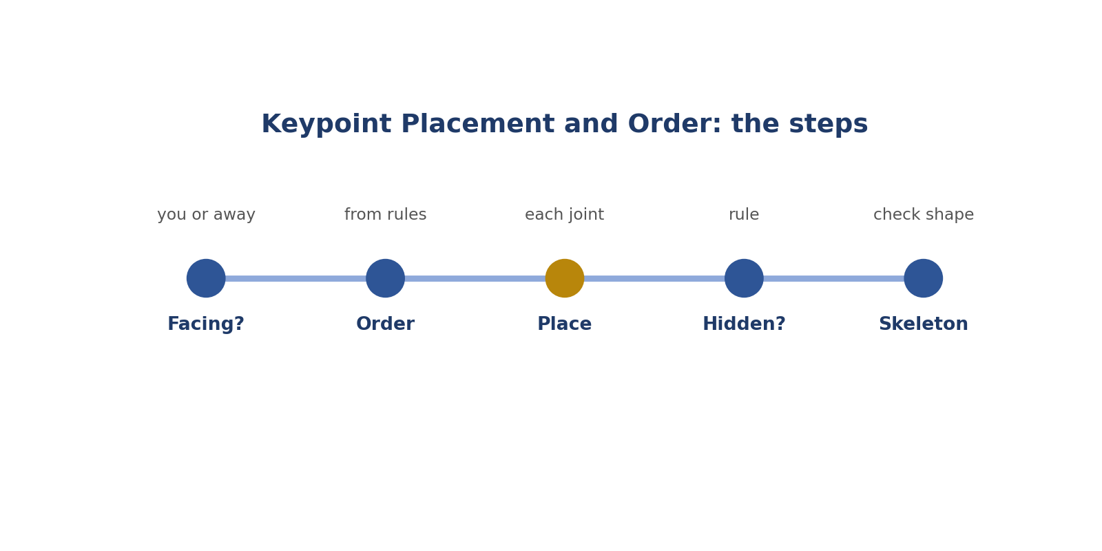
Keypoint Placement and Order: the steps.
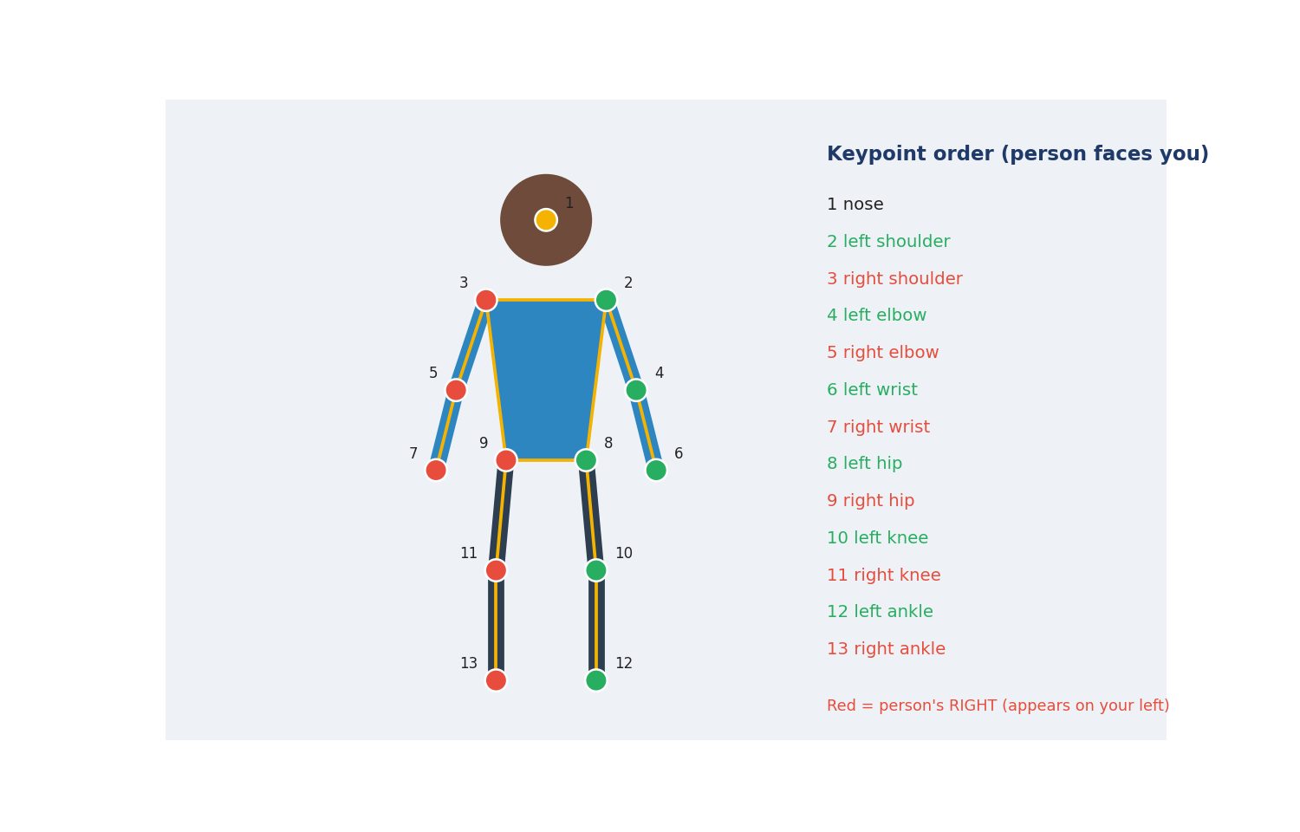
Picture: keypoint placement and order.
How to answer these tasks
1. Check if the person faces you or away.
2. Follow the order in the rules.
3. Place each dot on the exact joint.
4. Follow the rule for hidden points.
5. Check the skeleton looks right.
TASK 11.1 · EASY
The situation: A person faces you. Their right hand is on your left.
What is this asking? Facing you, right hand on your left?
Your task: Which label?
Answer: Right wrist (or right hand).
Why (explained simply): Right wrist. Use their side.
Key word: Facing = Looking toward you.
In simple English: Use the person's side.

TASK 11.2 · EASY
The situation: A person faces away from you. Their right hand is on your right.
What is this asking? Facing away, right hand on your right?
Your task: Which label?
Answer: Right wrist.
Why (explained simply): Right wrist. Sides match yours.
Key word: Facing away = Back toward you.
In simple English: Facing away, sides match yours.

TASK 11.3 · MEDIUM
The situation: The guideline order starts with the nose. You started with the left shoulder.
What is this asking? Started with the shoulder, not the nose?
Your task: What's wrong?
Answer: Wrong order; follow the set order.
Why (explained simply): Wrong order. Follow the list.
Key word: Order = The set sequence.
In simple English: Follow the order.

TASK 11.4 · MEDIUM
The situation: A person's left knee is hidden behind the other leg.
What is this asking? Knee hidden?
Your task: What do you do?
Answer: Follow the rule for hidden keypoints (often mark "not visible").
Why (explained simply): Follow the hidden-point rule.
Key word: Hidden = Can't be seen.
In simple English: Follow the hidden-point rule.

TASK 11.5 · EASY
The situation: A keypoint is on the forearm instead of the elbow.
What is this asking? Dot on the forearm, not the elbow?
Your task: What's wrong?
Answer: Wrong position.
Why (explained simply): Wrong place. Move it.
Key word: Elbow = The middle joint of the arm.
In simple English: Put points on the exact joint.

TASK 11.6 · HARD
The situation: A person is lying down sideways.
What is this asking? Lying down sideways?
Your task: How do you decide left and right?
Answer: Still use the person's own left and right.
Why (explained simply): Still use their own left and right.
Key word: Sideways = On their side.
In simple English: Their left is always their left.

TASK 11.7 · EASY
The situation: What is a pose?
What is this asking? What is a pose?
Your task: Define it.
Answer: The position of a person's body.
Why (explained simply): How a body is positioned.
Key word: Pose = Body position.
In simple English: How a body is positioned.

TASK 11.8 · MEDIUM
The situation: You swapped left and right for every point on a person.
What is this asking? Swapped every left and right?
Your task: What's the impact?
Answer: The whole pose is wrong.
Why (explained simply): The whole pose is wrong.
Key word: Swap = Exchange places.
In simple English: A swap ruins the pose.

TASK 11.9 · EASY
The situation: How many keypoints on a person in the lecture example?
What is this asking? How many points in the example?
Your task: Answer.
Answer: 13.
Why (explained simply): 13.
Key word: Keypoint = A dot on a body part.
In simple English: The example uses 13.

TASK 11.10 · MEDIUM
The situation: A car keypoint task marks wheel centres.
What is this asking? Wheel centre points?
Your task: Where does the point go?
Answer: At the centre of each wheel.
Why (explained simply): Put them in the middle of each wheel.
Key word: Centre = The middle.
In simple English: Centre of the wheel.

TASK 11.11 · HARD
The situation: A person's arm is outside the image.
What is this asking? Arm outside the picture?
Your task: What about the wrist point?
Answer: Follow the rule for truncated keypoints, usually marked as not visible or not labelled.
Why (explained simply): Follow the rule for cut-off points.
Key word: Cut off = Not in the picture.
In simple English: Follow the rule for cut-off points.

TASK 11.12 · EASY
The situation: Why does order matter?
What is this asking? Why does order matter?
Your task: Explain.
Answer: The AI reads points by position in the list; wrong order means wrong body parts.
Why (explained simply): The AI reads dots by their place in the list.
Key word: List = Things in a set order.
In simple English: Order tells the AI which part is which.

TASK 11.13 · MEDIUM
The situation: A mannequin's pose in a shop.
What is this asking? A mannequin?
Your task: Label keypoints?
Answer: Only if the guideline includes mannequins; usually only real people.
Why (explained simply): Usually only real people.
Key word: Real = Not a model.
In simple English: Real people only, usually.

TASK 11.14 · EASY
The situation: What colour showed the person's right side in the lecture?
What is this asking? Which colour was the person's right?
Your task: Answer.
Answer: Red.
Why (explained simply): Red.
Key word: Right side = The person's own right.
In simple English: Red for right in the example.

TASK 11.15 · MEDIUM
The situation: Two people overlap. Their wrists are close.
What is this asking? Two people close together?
Your task: How do you avoid mixing them up?
Answer: Label one person fully, then the other, checking each point belongs to the right person.
Why (explained simply): Finish one person, then the other.
Key word: Separate = One at a time.
In simple English: One person at a time.

TASK 11.16 · HARD
The situation: A person's face is turned away, so the nose isn't visible.
What is this asking? Nose not visible?
Your task: What do you do?
Answer: Mark the nose as not visible, if that option exists.
Why (explained simply): Mark it not visible.
Key word: Not visible = Can't be seen.
In simple English: Mark hidden points.

TASK 11.17 · EASY
The situation: Should you guess where a hidden point is?
What is this asking? Guess hidden points?
Your task: Answer.
Answer: Only if the guideline says to estimate.
Why (explained simply): Only if the rules say so.
Key word: Guess = Decide without seeing.
In simple English: Don't guess unless told.

TASK 11.18 · MEDIUM
The situation: A person is sitting.
What is this asking? Sitting person?
Your task: Do hip and knee points still apply?
Answer: Yes; place them on the joints as they appear.
Why (explained simply): Same points, wherever the joints are.
Key word: Sitting = On a chair.
In simple English: Same points, any pose.

TASK 11.19 · EASY
The situation: What's a skeleton in keypoint tools?
What is this asking? What's a skeleton?
Your task: Answer.
Answer: Lines joining the keypoints to show the body shape.
Why (explained simply): Lines joining the dots.
Key word: Skeleton = A stick figure.
In simple English: Lines joining points.

TASK 11.20 · MEDIUM
The situation: You finish a person and the skeleton looks twisted.
What is this asking? Twisted skeleton?
Your task: What might be wrong?
Answer: Points are in the wrong order or left and right are swapped.
Why (explained simply): Wrong order or swapped sides.
Key word: Twisted = Bent the wrong way.
In simple English: Twisted skeleton means wrong order or sides.

CHAPTER 13
Computer Vision Skill 4: Image Classification

THINK OF IT LIKE THIS
Classification is like sorting photos into albums: beach, birthday, school. Each photo goes into one album.
In simple English: Put each picture in the right group.
In simple English: Give the whole picture a label from the list.
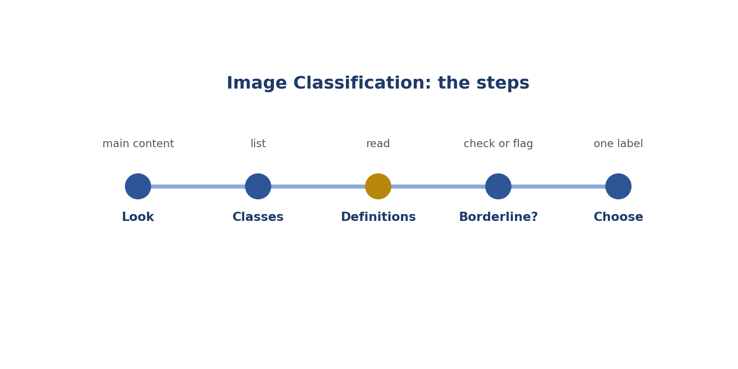
Image Classification: the steps.
How to answer these tasks
1. Look at the main content.
2. Check the class list.
3. Read definitions for close cases.
4. Use "unclear" or flag if needed.
5. Choose the label.
TASK 12.1 · EASY
The situation: Classes: indoor, outdoor. A photo of a beach.
What is this asking? Beach photo?
Your task: Which class?
Answer: Outdoor.
Why (explained simply): Outdoor.
Key word: Outdoor = Outside.
In simple English: Easy cases first.

TASK 12.2 · EASY
The situation: Classes: day, night. A photo with dark sky and street lights on.
What is this asking? Dark sky, street lights on?
Your task: Which class?
Answer: Night.
Why (explained simply): Night.
Key word: Night = When it's dark.
In simple English: Look at the main clue.

TASK 12.3 · MEDIUM
The situation: Classes: indoor, outdoor. A covered market open at the sides.
What is this asking? Covered market open at the sides?
Your task: What do you do?
Answer: Check the definition; if not covered, flag.
Why (explained simply): Check the definition or flag.
Key word: Borderline = Between two choices.
In simple English: Borderline: check or flag.

TASK 12.4 · EASY
The situation: Classes: cat, dog, other. A photo of a rabbit.
What is this asking? A rabbit?
Your task: Which class?
Answer: Other.
Why (explained simply): Other.
Key word: Other = When nothing fits.
In simple English: Nothing fits: other.

TASK 12.5 · MEDIUM
The situation: Classes: food, not food. A photo of a menu.
What is this asking? A menu photo: food?
Your task: Which class?
Answer: Usually not food (it's text about food); check definitions.
Why (explained simply): Usually not food; check the definitions.
Key word: Menu = A list of food in a restaurant.
In simple English: Pictures of words aren't the thing.

TASK 12.6 · HARD
The situation: A photo shows a cat and a dog equally.
What is this asking? Cat and dog equally?
Your task: Single-label task. What do you do?
Answer: Use the guideline's rule for multiple subjects (for example a "multiple" class); otherwise flag.
Why (explained simply): Use the multiple-subjects rule or flag.
Key word: Single-label = Only one label allowed.
In simple English: Use the multiple-subjects rule.

TASK 12.7 · EASY
The situation: Should you label the tiniest detail or the main content?
What is this asking? Tiny detail or main content?
Your task: Answer.
Answer: The main content, unless told otherwise.
Why (explained simply): The main content.
Key word: Main = Most important.
In simple English: Label the main thing.

TASK 12.8 · MEDIUM
The situation: Classes: clean, damaged (for car photos). A car with a small scratch.
What is this asking? Small scratch: clean or damaged?
Your task: Which class?
Answer: Check the definition of damaged; if any scratch counts, damaged.
Why (explained simply): Check the definition of damaged.
Key word: Damaged = Broken or scratched.
In simple English: Definitions decide small cases.

TASK 12.9 · EASY
The situation: A photo is completely blurry.
What is this asking? Very blurry?
Your task: What do you do?
Answer: Choose "unusable" if available, or flag.
Why (explained simply): Unusable or flag.
Key word: Blurry = Not clear.
In simple English: Unusable if you can't tell.

TASK 12.10 · MEDIUM
The situation: Classes: urban, rural. A small town street.
What is this asking? Small town: urban or rural?
Your task: How do you decide?
Answer: Use the definitions (for example buildings and roads); flag if unclear.
Why (explained simply): Use the definitions; flag if unclear.
Key word: Urban = City-like.
In simple English: Check definitions.

TASK 12.11 · HARD
The situation: A multi-label task allows several tags. A street photo has cars, people and trees.
What is this asking? Multi-label street?
Your task: What do you tag?
Answer: All tags that apply: cars, people and trees.
Why (explained simply): Tag everything that's there.
Key word: Multi-label = More than one label allowed.
In simple English: Multi-label means tag all that apply.

TASK 12.12 · EASY
The situation: A photo of a painting of a dog. Class: dog (real animals).
What is this asking? A painting of a dog?
Your task: Which class?
Answer: Not dog; use other or the rule for artworks.
Why (explained simply): Not a real dog.
Key word: Painting = A picture made with paint.
In simple English: Paintings aren't real animals.

TASK 12.13 · MEDIUM
The situation: You classify 500 images quickly.
What is this asking? 500 photos fast?
Your task: What risk?
Answer: Careless mistakes; keep checking borderline images.
Why (explained simply): Risk of careless mistakes.
Key word: Careless = Not paying attention.
In simple English: Speed causes mistakes.

TASK 12.14 · EASY
The situation: What does "classification" mean?
What is this asking? What is classification?
Your task: Define it.
Answer: Giving a whole image a label.
Why (explained simply): Giving a whole picture a label.
Key word: Classification = Sorting into groups.
In simple English: One label for the whole picture.

TASK 12.15 · MEDIUM
The situation: Classes: happy, sad, neutral (faces). A slight smile.
What is this asking? Slight smile?
Your task: How do you decide?
Answer: Use the guideline's definitions and examples.
Why (explained simply): Use the definitions and examples.
Key word: Expression = A look on someone's face.
In simple English: Use the examples.

TASK 12.16 · HARD
The situation: The image is upside down.
What is this asking? Upside down?
Your task: Still classify?
Answer: Usually yes if the content is clear, unless the guideline says to flag rotated images.
Why (explained simply): Usually still classify; check the rules.
Key word: Rotated = Turned around.
In simple English: Check rotation rules.

TASK 12.17 · EASY
The situation: Classes: vehicle, animal, person. A horse pulling a cart with a person.
What is this asking? Horse, cart and person?
Your task: Single label. What do you do?
Answer: Use the main-subject rule or flag.
Why (explained simply): Use the main-subject rule or flag.
Key word: Main subject = The most important thing.
In simple English: Pick the main subject by the rule.

TASK 12.18 · MEDIUM
The situation: Your classification speed is high but golden tasks show errors.
What is this asking? Fast but missing golden tasks?
Your task: What should you do?
Answer: Slow down on borderline cases.
Why (explained simply): Slow down on hard ones.
Key word: Golden task = A hidden test.
In simple English: Slow down on hard ones.

TASK 12.19 · EASY
The situation: A photo of a sunset on a beach. Classes: day, night, dusk.
What is this asking? Sunset: day, night or dusk?
Your task: Which class?
Answer: Dusk (if defined).
Why (explained simply): Dusk, if it's a class.
Key word: Dusk = Evening, as it gets dark.
In simple English: Use the closest defined class.

TASK 12.20 · MEDIUM
The situation: Why use "unclear" instead of guessing?
What is this asking? Why "unclear", not a guess?
Your task: Explain.
Answer: A wrong guess teaches the AI something false.
Why (explained simply): A wrong guess teaches the AI something false.
Key word: Unclear = Not sure.
In simple English: Guesses teach wrong things.

CHAPTER 14
Computer Vision Skill 5: Occluded and Truncated Flags

THINK OF IT LIKE THIS
Flags are like notes on a photo: "part of this person is hidden" or "this person is cut off". They tell the AI what it can't see.
In simple English: Notes about what's hidden.
In simple English: Tick the right box for hidden or cut-off objects.
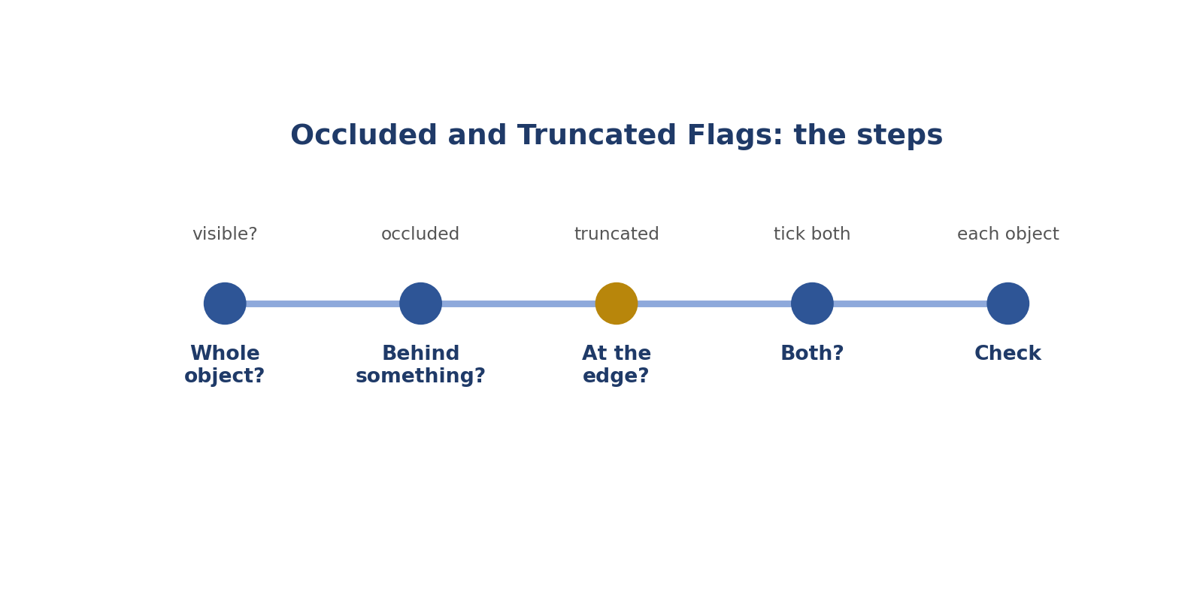
Occluded and Truncated Flags: the steps.
Picture: occluded and truncated flags.
How to answer these tasks
1. Ask: can I see the whole object?
2. Hidden behind something? Tick occluded.
3. Cut by the edge? Tick truncated.
4. Both? Tick both.
5. Check every object.
TASK 13.1 · EASY
The situation: A person is behind a car, only the top half visible.
What is this asking? Only the top half behind a car?
Your task: Which flag?
Answer: Occluded.
Why (explained simply): Occluded.
Key word: Occluded = Hidden behind something.
In simple English: Hidden behind = occluded.

TASK 13.2 · EASY
The situation: A bus is cut off by the top edge.
What is this asking? Bus cut off at the top?
Your task: Which flag?
Answer: Truncated.
Why (explained simply): Truncated.
Key word: Truncated = Cut off by the edge.
In simple English: Cut by edge = truncated.

TASK 13.3 · MEDIUM
The situation: A car behind a pole and cut off by the edge.
What is this asking? Behind a pole and at the edge?
Your task: Which flags?
Answer: Both.
Why (explained simply): Both flags.
Key word: Both = Two at once.
In simple English: Both can apply.

TASK 13.4 · EASY
The situation: A fully visible bicycle.
What is this asking? Fully visible bicycle?
Your task: Any flags?
Answer: None.
Why (explained simply): No flags.
Key word: Fully visible = All of it can be seen.
In simple English: Visible = no flag.

TASK 13.5 · MEDIUM
The situation: A dog behind a glass door, fully visible through the glass.
What is this asking? Dog behind clear glass?
Your task: Occluded?
Answer: Usually no, if the glass doesn't hide it; check the guideline.
Why (explained simply): Usually not occluded; check the rules.
Key word: Glass = Clear material you can see through.
In simple English: See-through may not hide.

TASK 13.6 · HARD
The situation: A person is partly hidden by another person's arm.
What is this asking? Hidden by someone's arm?
Your task: Occluded?
Answer: Yes; any object can occlude.
Why (explained simply): Yes, occluded.
Key word: Arm = The part from shoulder to hand.
In simple English: People can hide people.

TASK 13.7 · EASY
The situation: Why tick flags?
What is this asking? Why tick flags?
Your task: Explain.
Answer: They tell the AI how much of the object is visible.
Why (explained simply): They tell the AI how much it can see.
Key word: Attribute = An extra detail.
In simple English: Flags explain visibility.

TASK 13.8 · MEDIUM
The situation: You ticked occluded on every object by habit.
What is this asking? Occluded on everything?
Your task: What's wrong?
Answer: Many objects aren't occluded; flags must be checked for each.
Why (explained simply): Wrong. Check each object.
Key word: Habit = Something done without thinking.
In simple English: Check each object.

TASK 13.9 · EASY
The situation: A car's front is cut off by the left edge.
What is this asking? Front cut off on the left?
Your task: Which flag?
Answer: Truncated.
Why (explained simply): Truncated.
Key word: Left edge = The left border.
In simple English: Left edge counts.

TASK 13.10 · MEDIUM
The situation: Leaves partly cover a traffic sign.
What is this asking? Leaves cover a sign?
Your task: Which flag?
Answer: Occluded.
Why (explained simply): Occluded.
Key word: Leaves = Parts of a tree.
In simple English: Leaves can hide objects.

TASK 13.11 · HARD
The situation: A person stands in a doorway, partly hidden by the door frame.
What is this asking? Partly hidden by a door frame?
Your task: Which flag?
Answer: Occluded.
Why (explained simply): Occluded.
Key word: Door frame = The edges around a door.
In simple English: Frames can hide objects.

TASK 13.12 · EASY
The situation: Can flags be changed after drawing?
What is this asking? Can you change flags?
Your task: Answer.
Answer: Yes, before submitting.
Why (explained simply): Yes, before submitting.
Key word: Change = Make different.
In simple English: Fix before submitting.

TASK 13.13 · MEDIUM
The situation: In a video, a car becomes occluded in frame 20.
What is this asking? Car hidden from frame 20?
Your task: What do you do?
Answer: Tick occluded from frame 20 on, as the tool allows.
Why (explained simply): Tick occluded from frame 20 on.
Key word: Frame = One picture in a video.
In simple English: Flags can change over time.

TASK 13.14 · EASY
The situation: Does truncated mean small?
What is this asking? Does truncated mean small?
Your task: Answer.
Answer: No; it means cut off by the edge.
Why (explained simply): No. It means cut by the edge.
Key word: Small = Little.
In simple English: Truncated isn't small.

TASK 13.15 · MEDIUM
The situation: A person is 95% hidden.
What is this asking? 95% hidden?
Your task: What do you check?
Answer: The minimum visibility rule; you may skip.
Why (explained simply): Check the visibility limit.
Key word: Visibility = How much can be seen.
In simple English: Check the visibility limit.

TASK 13.16 · HARD
The situation: A reflection covers part of a real car.
What is this asking? Reflection covers a real car?
Your task: Flag?
Answer: Occluded, if the reflection hides part of the car.
Why (explained simply): Occluded, for the real car.
Key word: Reflection = A mirror image.
In simple English: Reflections can hide things.

TASK 13.17 · EASY
The situation: What colour is the person box in the lecture occlusion image?
What is this asking? What colour was the person box?
Your task: Answer.
Answer: Green (person, truncated).
Why (explained simply): Green.
Key word: Colour = Like red, green or blue.
In simple English: Green in the example.

TASK 13.18 · MEDIUM
The situation: Can an image-edge truncation happen at the bottom?
What is this asking? Bottom edge?
Your task: Answer.
Answer: Yes.
Why (explained simply): Yes, truncated.
Key word: Bottom = The lowest part.
In simple English: Any edge.

TASK 13.19 · EASY
The situation: What's the first question to ask for flags?
What is this asking? First question for flags?
Your task: Answer.
Answer: Can I see the whole object?
Why (explained simply): Can I see the whole object?
Key word: Whole = All of it.
In simple English: Can I see all of it?

TASK 13.20 · MEDIUM
The situation: A person holds a large sign in front of their body.
What is this asking? Big sign held in front?
Your task: Which flag?
Answer: Occluded.
Why (explained simply): Occluded.
Key word: Held = Carried in the hands.
In simple English: Carried items can hide the body.

CHAPTER 15
Computer Vision Skill 6: Size and Visibility Thresholds

THINK OF IT LIKE THIS
A threshold is like a height limit on a fun-fair ride. If you're tall enough, you ride. If not, you don't. No guessing.
In simple English: A clear yes-or-no limit.
In simple English: Follow the rules about tiny or barely visible objects.
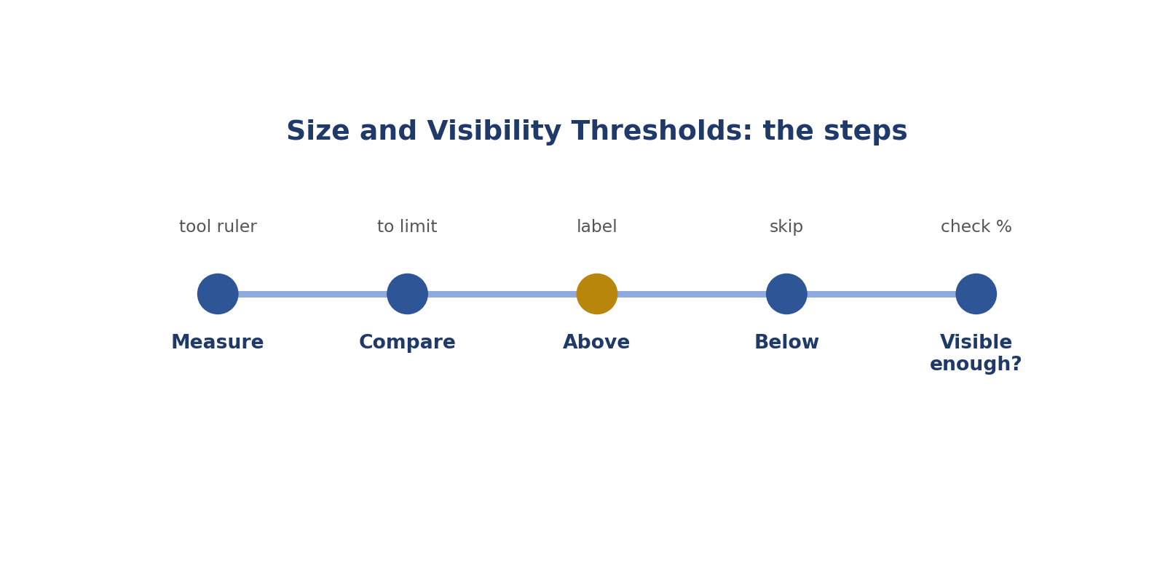
Size and Visibility Thresholds: the steps.
How to answer these tasks
1. Measure the object with the tool.
2. Compare with the limit.
3. Above the limit: label it.
4. Below: skip it.
5. Check how much is visible.
TASK 14.1 · EASY
The situation: Rule: label objects at least 20 px wide. A car is 30 px.
What is this asking? 30 pixels, limit 20?
Your task: Label?
Answer: Yes.
Why (explained simply): Label it.
Key word: Above = More than.
In simple English: Above the limit.

TASK 14.2 · EASY
The situation: Same rule. A car is 12 px.
What is this asking? 12 pixels?
Your task: Label?
Answer: No.
Why (explained simply): Skip it.
Key word: Below = Less than.
In simple English: Below the limit.

TASK 14.3 · MEDIUM
The situation: Rule: label if at least half visible. A car is 40% visible.
What is this asking? 40% visible, half needed?
Your task: Label?
Answer: No.
Why (explained simply): Skip it.
Key word: Half = 50%.
In simple English: Below half = skip.

TASK 14.4 · MEDIUM
The situation: How do you check pixel width?
What is this asking? How do you measure?
Your task: Answer.
Answer: Use the tool's size display or ruler.
Why (explained simply): Use the tool's size display.
Key word: Measure = Find the size.
In simple English: Use the tool to measure.

TASK 14.5 · EASY
The situation: Why have size limits?
What is this asking? Why size limits?
Your task: Explain.
Answer: Tiny objects create noisy data.
Why (explained simply): Tiny objects make messy data.
Key word: Messy = Confusing.
In simple English: Tiny things add noise.

TASK 14.6 · HARD
The situation: An object is exactly 20 px and the rule says "at least 20".
What is this asking? Exactly 20, "at least 20"?
Your task: Label?
Answer: Yes; "at least" includes 20.
Why (explained simply): Label it. "At least" includes 20.
Key word: At least = That number or more.
In simple English: "At least" includes the number.

TASK 14.7 · EASY
The situation: Should you label tiny objects to be thorough?
What is this asking? Label tiny things to be thorough?
Your task: Answer.
Answer: No; follow the limit.
Why (explained simply): No. Follow the limit.
Key word: Thorough = Very complete.
In simple English: Thorough means following rules.

TASK 14.8 · MEDIUM
The situation: A person is far away but 25 px tall and 8 px wide.
What is this asking? 8 wide when 10 is needed?
Your task: Rule: at least 10 px wide. Label?
Answer: No, if the rule uses width.
Why (explained simply): No, if the rule uses width.
Key word: Width = How wide.
In simple English: Check which measure the rule uses.

TASK 14.9 · EASY
The situation: What does "visibility" mean?
What is this asking? What is visibility?
Your task: Define it.
Answer: How much of an object can be seen.
Why (explained simply): How much can be seen.
Key word: Visibility = How much shows.
In simple English: How much you can see.

TASK 14.10 · MEDIUM
The situation: Rule: skip objects less than 25% visible. A dog is 30% visible.
What is this asking? 30% visible, 25% needed?
Your task: Label?
Answer: Yes.
Why (explained simply): Label it.
Key word: Percent = Out of 100.
In simple English: Above the limit.

TASK 14.11 · HARD
The situation: Size limits differ for cars (20 px) and people (10 px).
What is this asking? Different limits for people and cars?
Your task: A 15 px person and a 15 px car. Label which?
Answer: The person only.
Why (explained simply): Label the 15-pixel person, not the 15-pixel car.
Key word: Class limit = A limit for one class.
In simple English: Different classes can have different limits.

TASK 14.12 · EASY
The situation: Where do you find size limits?
What is this asking? Where are size limits?
Your task: Answer.
Answer: In the guideline's "what to label" section.
Why (explained simply): In the "what to label" section.
Key word: Section = A part of a document.
In simple English: In the rules.

TASK 14.13 · MEDIUM
The situation: You're unsure if an object is 19 or 21 px.
What is this asking? 19 or 21?
Your task: What should you do?
Answer: Zoom and measure carefully.
Why (explained simply): Zoom and measure.
Key word: Unsure = Not certain.
In simple English: Measure, don't guess.

TASK 14.14 · EASY
The situation: A threshold is a...
What is this asking? A threshold is...?
Your task: Complete the sentence.
Answer: Limit that decides whether to label.
Why (explained simply): A limit that decides yes or no.
Key word: Threshold = A yes-or-no limit.
In simple English: A yes-or-no limit.

TASK 14.15 · MEDIUM
The situation: Video: a car shrinks below the limit as it drives away.
What is this asking? Car shrinks in a video?
Your task: What do you do?
Answer: Stop labelling it when it falls below the limit, as the guideline says.
Why (explained simply): Stop labelling below the limit.
Key word: Shrink = Get smaller.
In simple English: Stop when too small.

TASK 14.16 · HARD
The situation: A rule says skip if less than 50% visible, and occluded flags are required above that.
What is this asking? 60% visible?
Your task: A car is 60% visible. What do you do?
Answer: Label it and tick occluded.
Why (explained simply): Label it and tick occluded.
Key word: Occluded = Hidden behind.
In simple English: Label and flag.

TASK 14.17 · EASY
The situation: Why not guess sizes?
What is this asking? Why not guess?
Your task: Explain.
Answer: Guesses near the limit are often wrong.
Why (explained simply): Guesses near the limit are often wrong.
Key word: Guess = Decide without checking.
In simple English: Guessing near limits fails.

TASK 14.18 · MEDIUM
The situation: A guideline changes the size limit from 20 to 15 px.
What is this asking? Limit lowered to 15?
Your task: What changes?
Answer: More small objects must now be labelled.
Why (explained simply): More small things get labelled.
Key word: Change = Make different.
In simple English: New limits change what you label.

TASK 14.19 · EASY
The situation: A 5 px speck might be a bird.
What is this asking? 5-pixel speck?
Your task: Label?
Answer: No, if below the limit.
Why (explained simply): Skip it.
Key word: Speck = A tiny dot.
In simple English: Tiny specks are skipped.

TASK 14.20 · MEDIUM
The situation: Tests often place objects near the limit. Why?
What is this asking? Why test near the limit?
Your task: Explain.
Answer: To see whether you measure carefully.
Why (explained simply): To see if you measure.
Key word: Test = A check.
In simple English: Tests check careful measuring.

CHAPTER 16
Computer Vision Skill 7: Zoom and Edge Precision

THINK OF IT LIKE THIS
Zooming is like using a magnifying glass to thread a needle. Without it, you keep missing the hole.
In simple English: Zoom in to be exact.
In simple English: Zoom in so your edges are exact.
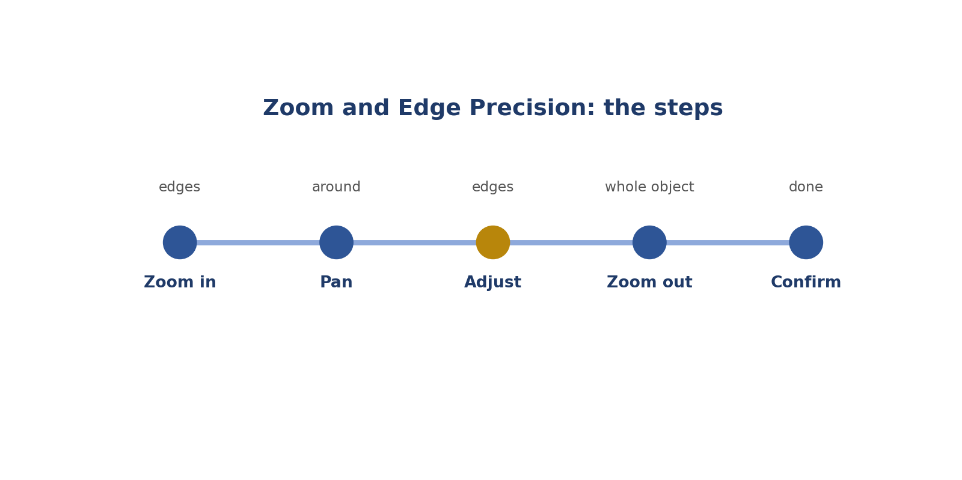
Zoom and Edge Precision: the steps.
Picture: zoom and edge precision.
How to answer these tasks
1. Zoom in on the edges.
2. Pan around the object.
3. Fix each edge.
4. Zoom out to check the whole object.
5. Confirm and move on.
TASK 15.1 · EASY
The situation: Should you zoom in on small objects?
What is this asking? Zoom on small objects?
Your task: Answer.
Answer: Yes.
Why (explained simply): Yes.
Key word: Zoom = Make bigger.
In simple English: Zoom on small things.

TASK 15.2 · EASY
The situation: What does panning do?
What is this asking? What's panning?
Your task: Answer.
Answer: Moves around a zoomed image.
Why (explained simply): Moving around a zoomed picture.
Key word: Pan = Move the view.
In simple English: Move around the picture.

TASK 15.3 · MEDIUM
The situation: You labelled 20 boxes without zooming; many are loose.
What is this asking? 20 loose boxes?
Your task: What should you do?
Answer: Zoom in and fix each edge.
Why (explained simply): Zoom in and fix each one.
Key word: Fix = Correct.
In simple English: Zoom and fix.

TASK 15.4 · MEDIUM
The situation: Zoomed so far you can't see the whole object.
What is this asking? Too zoomed?
Your task: What's the problem?
Answer: You may miss parts; zoom out enough to see the whole object while checking edges.
Why (explained simply): Zoom out to see the whole object.
Key word: Whole = All of it.
In simple English: Not too close.

TASK 15.5 · EASY
The situation: What are thin parts?
What is this asking? Two thin parts?
Your task: Give two examples.
Answer: Side mirrors, handlebars, antennas, straps.
Why (explained simply): Mirrors and handlebars.
Key word: Thin part = A narrow part.
In simple English: Mirrors and handlebars.

TASK 15.6 · HARD
The situation: A blurry edge where the car meets its shadow.
What is this asking? Blurry edge near a shadow?
Your task: Where does the edge go?
Answer: Where the car's body appears to end, based on the clearest pixels; don't include shadow.
Why (explained simply): Use the clearest car pixels.
Key word: Blurry = Not sharp.
In simple English: Pick the clearest edge.

TASK 15.7 · EASY
The situation: Why does zoom help keypoints?
What is this asking? Why zoom for keypoints?
Your task: Answer.
Answer: It shows the exact joint location.
Why (explained simply): It shows the exact joint.
Key word: Joint = Where bones meet.
In simple English: It shows the exact spot.

TASK 15.8 · MEDIUM
The situation: A tool zooms with the mouse wheel.
What is this asking? Mouse-wheel zoom?
Your task: What might speed you up?
Answer: Learning keyboard zoom shortcuts too.
Why (explained simply): Learn zoom keys too.
Key word: Key = A button on the keyboard.
In simple English: Learn zoom keys.

TASK 15.9 · EASY
The situation: When is zoom less necessary?
What is this asking? When is zoom less needed?
Your task: Answer.
Answer: For large, clear objects with sharp edges.
Why (explained simply): Big, clear objects.
Key word: Clear = Easy to see.
In simple English: Big clear objects need less zoom.

TASK 15.10 · MEDIUM
The situation: You zoom but still see pixelated edges.
What is this asking? Still pixelated?
Your task: What do you do?
Answer: Place the edge at the boundary pixels of the object as best you can.
Why (explained simply): Use the best edge pixels you can.
Key word: Pixelated = Showing tiny squares.
In simple English: Use the best boundary pixels.

TASK 15.11 · HARD
The situation: Audits show your boxes are 5% too big on average.
What is this asking? Boxes 5% too big?
Your task: What habit to change?
Answer: Zoom in on every edge and pull edges inward to touch the object.
Why (explained simply): Zoom and pull edges in.
Key word: Too big = Larger than needed.
In simple English: Pull edges in.

TASK 15.12 · EASY
The situation: Zooming slows me down. Should I skip it?
What is this asking? Skip zoom to save time?
Your task: Answer.
Answer: No; precision matters more than a few seconds.
Why (explained simply): No. Exactness matters more.
Key word: Exact = Precisely right.
In simple English: Precision first.

TASK 15.13 · MEDIUM
The situation: In video, what's the equivalent of zooming?
What is this asking? Zoom in video?
Your task: Answer.
Answer: Stepping frame by frame at action boundaries.
Why (explained simply): Go frame by frame.
Key word: Frame by frame = One picture at a time.
In simple English: Frame by frame.

TASK 15.14 · EASY
The situation: Audio equivalent of zooming?
What is this asking? Zoom in audio?
Your task: Answer.
Answer: Zooming into the waveform timeline.
Why (explained simply): Zoom into the sound wave.
Key word: Waveform = The picture of a sound.
In simple English: Zoom the waveform.

TASK 15.15 · MEDIUM
The situation: A tiny traffic light is 22 px.
What is this asking? Tiny traffic light?
Your task: What's the challenge?
Answer: Placing precise edges; zoom in.
Why (explained simply): Zoom for exact edges.
Key word: Tiny = Very small.
In simple English: Zoom on small objects.

TASK 15.16 · HARD
The situation: Two objects touch; the boundary is unclear.
What is this asking? Two touching objects?
Your task: How do you place edges?
Answer: Zoom in, find the clearest dividing line and place each box to its own side.
Why (explained simply): Zoom and find the dividing line.
Key word: Dividing line = Where one ends and the other starts.
In simple English: Find the dividing line.

TASK 15.17 · EASY
The situation: Name one sign you need to zoom more.
What is this asking? Sign you need more zoom?
Your task: Answer.
Answer: Reviewers say your edges are loose.
Why (explained simply): Loose-edge feedback.
Key word: Feedback = Comments to help you.
In simple English: Loose edge feedback.

TASK 15.18 · MEDIUM
The situation: You zoom, fix, then forget to zoom back out to check the whole box.
What is this asking? Forgot to zoom out?
Your task: What might you miss?
Answer: Parts of the object on other sides.
Why (explained simply): You may miss other parts.
Key word: Miss = Not notice.
In simple English: Check the whole object too.

TASK 15.19 · EASY
The situation: Does zoom change the image?
What is this asking? Does zoom change the picture?
Your task: Answer.
Answer: No; it only changes your view.
Why (explained simply): No, only your view.
Key word: View = What you see.
In simple English: Zoom only changes your view.

TASK 15.20 · MEDIUM
The situation: Why do thin parts matter for boxes?
What is this asking? Why do thin parts matter?
Your task: Answer.
Answer: They sit at the object's outer edge, so they decide where the box ends.
Why (explained simply): They're at the outer edge.
Key word: Outer edge = The outside border.
In simple English: Thin parts set the edge.

CHAPTER 17
Computer Vision Skill 8: Self-Review Before Submitting

THINK OF IT LIKE THIS
Self-review is like checking your bag before leaving home: keys, phone, wallet. A few seconds saves a big problem later.
In simple English: Check before you go.
In simple English: Check your work before you send it.
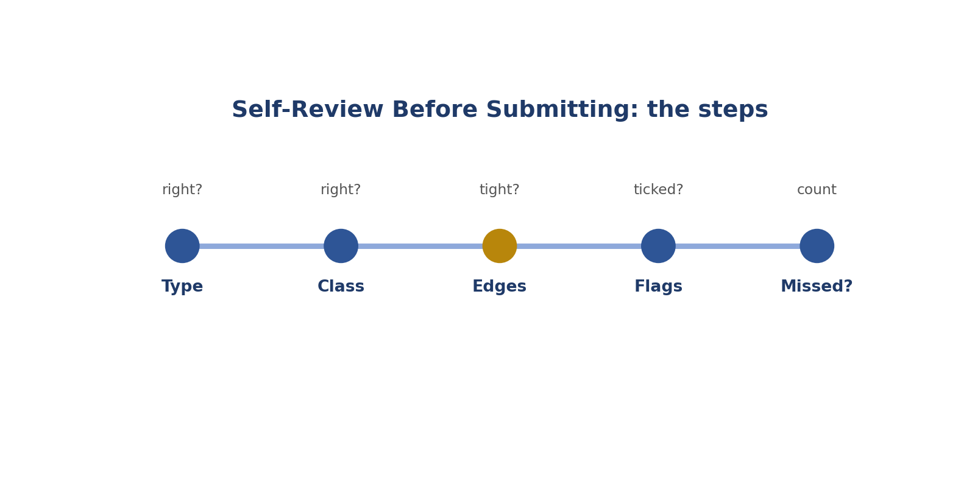
Self-Review Before Submitting: the steps.
Picture: self-review before submitting.
How to answer these tasks
1. Is the label type right?
2. Is the class right?
3. Are edges tight?
4. Are flags ticked?
5. Count objects: any missed?
TASK 16.1 · EASY
The situation: You're about to submit. What three things do you check?
What is this asking? Three things to check?
Your task: Answer.
Answer: Label type, class and tight edges (also flags and missed objects).
Why (explained simply): Type, class and tight edges.
Key word: Check = Make sure.
In simple English: Type, class, edges.

TASK 16.2 · EASY
The situation: You count 5 people but drew 4 boxes.
What is this asking? 5 people, 4 boxes?
Your task: What do you do?
Answer: Find and label the missed person.
Why (explained simply): Find and box the missing one.
Key word: Missing = Not there.
In simple English: Count before submitting.

TASK 16.3 · MEDIUM
The situation: A self-review finds a box with the wrong class.
What is this asking? Wrong class found?
Your task: What do you do?
Answer: Fix the class, then continue the review.
Why (explained simply): Fix it.
Key word: Class = The name.
In simple English: Fix and keep checking.

TASK 16.4 · MEDIUM
The situation: You're busy and want to skip review.
What is this asking? Skip review when busy?
Your task: What's the risk?
Answer: Mistakes count against your quality score.
Why (explained simply): Mistakes will count against you.
Key word: Risk = Chance of something bad.
In simple English: Skipping review costs you.

TASK 16.5 · EASY
The situation: Why use a checklist?
What is this asking? Why a checklist?
Your task: Explain.
Answer: So you check the same things every time.
Why (explained simply): The same checks every time.
Key word: Checklist = A list to tick.
In simple English: Checklists keep checks the same.

TASK 16.6 · HARD
The situation: Your self-review keeps missing the same error.
What is this asking? Keep missing the same error?
Your task: What should you do?
Answer: Add that error to your checklist.
Why (explained simply): Add it to your checklist.
Key word: Add = Put in.
In simple English: Add repeat errors to your list.

TASK 16.7 · EASY
The situation: How long should a review take?
What is this asking? How long to review?
Your task: Answer.
Answer: A few seconds to a minute, depending on the task.
Why (explained simply): Seconds to a minute.
Key word: Quick = Fast.
In simple English: Seconds, not hours.

TASK 16.8 · MEDIUM
The situation: In video, what do you check before submitting?
What is this asking? Video check?
Your task: Answer.
Answer: Start and end frames, labels, and that tracks don't jump between objects.
Why (explained simply): Start and end frames, labels, and tracks.
Key word: Track = Following an object.
In simple English: Check times and tracks.

TASK 16.9 · EASY
The situation: Should you check flags in review?
What is this asking? Check flags?
Your task: Answer.
Answer: Yes.
Why (explained simply): Yes.
Key word: Flag = A tick box.
In simple English: Check flags too.

TASK 16.10 · MEDIUM
The situation: Review shows a polygon cuts off a handle.
What is this asking? Handle cut off?
Your task: What do you do?
Answer: Add points to include the handle.
Why (explained simply): Add points.
Key word: Points = Dots on a shape.
In simple English: Fix the shape.

TASK 16.11 · HARD
The situation: You find an edge case during review.
What is this asking? Edge case during review?
Your task: What do you do?
Answer: Flag it before submitting.
Why (explained simply): Flag it before submitting.
Key word: Edge case = A case not covered.
In simple English: Flag during review if needed.

TASK 16.12 · EASY
The situation: Name one sign that review helps you.
What is this asking? Sign review helps?
Your task: Answer.
Answer: Fewer rejected tasks.
Why (explained simply): Fewer rejected tasks.
Key word: Rejected = Sent back as wrong.
In simple English: Fewer rejections.

TASK 16.13 · MEDIUM
The situation: Audio review: what do you listen for?
What is this asking? Audio check?
Your task: Answer.
Answer: That segments start and end at the right times and labels match the sounds.
Why (explained simply): Start and end times, and the labels.
Key word: Time = When something happens.
In simple English: Check times and labels.

TASK 16.14 · EASY
The situation: Text review: what do you check?
What is this asking? Text check?
Your task: Answer.
Answer: That the label matches the definition and the whole text was read.
Why (explained simply): Label matches the meaning.
Key word: Meaning = What something says.
In simple English: Label matches meaning.

TASK 16.15 · MEDIUM
The situation: You review by glancing at the whole image only.
What is this asking? Only a quick glance?
Your task: What might you miss?
Answer: Loose edges and small missed objects; zoom during review.
Why (explained simply): Loose edges and small objects get missed.
Key word: Glance = A quick look.
In simple English: Zoom during review too.

TASK 16.16 · HARD
The situation: A reviewer says your self-review is too slow.
What is this asking? Review too slow?
Your task: How do you balance?
Answer: Keep a short, focused checklist of the most common errors.
Why (explained simply): Use a short, focused checklist.
Key word: Focused = On the important things.
In simple English: Short, focused checklist.

TASK 16.17 · EASY
The situation: What happens after you submit?
What is this asking? After submitting?
Your task: Answer.
Answer: Your work may be sampled and reviewed.
Why (explained simply): Your work may be checked.
Key word: Sample = A part that gets checked.
In simple English: Your work may be checked.

TASK 16.18 · MEDIUM
The situation: Your checklist has 20 items.
What is this asking? 20-item checklist?
Your task: Is that good?
Answer: Probably too long; keep the five most important.
Why (explained simply): Too long. Keep the top 5.
Key word: Long = Too many.
In simple English: Keep it short.

TASK 16.19 · EASY
The situation: Should you review easy tasks?
What is this asking? Review easy tasks?
Your task: Answer.
Answer: Yes, briefly; easy tasks can hide mistakes.
Why (explained simply): Yes, quickly.
Key word: Easy = Simple.
In simple English: Review all tasks.

TASK 16.20 · MEDIUM
The situation: Write a five-point self-review checklist for boxes.
What is this asking? 5 checks for boxes?
Your task: Write it.
Answer: Right type; right class; tight on all sides; flags ticked; no objects missed.
Why (explained simply): Type, class, tight, flags, nothing missed.
Key word: Self-review = Checking your own work.
In simple English: Five quick checks.

