Day 1 Comprehensive Lecture Notes
Generalist AI Trainer and AI Response Evaluator (LLM Rater)
Deep and wide · 18 skills · Step-by-step methods · 72 worked examples · Real-style pictures explained · Very simple English
CHAPTER 1
Welcome to Day 1

Today you meet your first two AI training jobs: the Generalist AI Trainer and the AI Response Evaluator (LLM Rater). These are the most common starting jobs in AI training. You will learn what each job is, every skill it needs, how each skill works step by step, and what it looks like in real work.
In simple English: Today you learn two beginner AI jobs and all the skills they need.
Time | What we do | What you learn
4:00 to 4:10 | Welcome and warm-up | What AI training is
4:10 to 4:45 | Role 1 | Generalist AI Trainer and its 10 skills
4:45 to 5:20 | Role 2 | LLM Rater and its 8 skills
5:20 to 5:30 | Compare and assignment | Which job suits you, and your homework

In simple English: Physical class: Monday 4:00 to 5:30 pm, Set 1. Set 2 covers this on Sunday.
● How to read these notes
Every important idea has a "Simply" or "In simple English" line written in very easy words. Pictures are explained step by step. If a sentence feels hard, read the simple line first, then come back.
In simple English: Read the easy line first if you get stuck.

CHAPTER 2
AI Basics: Words You Need First

Before learning the jobs, learn these words. You will see them everywhere in this course.
Term | What it means
AI | Artificial intelligence: computer programs that can do things that normally need human thinking, like answering questions or recognising pictures.
Model | The AI program itself. It learns from examples.
LLM | Large language model: the kind of AI that reads and writes text, like a chatbot.
Prompt | The question or instruction someone gives the AI.
Response | The answer the AI gives.
Training data | The examples an AI learns from.
Label | A tag you add to data, like "cat" or "correct".
Rubric | A scoring guide, like a teacher's marking guide.
Guideline | The project's rulebook.
RLHF | Reinforcement learning from human feedback: teaching AI using people's scores and choices.
Hallucination | A false fact the AI made up.
Rationale | A short written reason for your score.

In simple English: Learn these 12 words first. They are used every day.
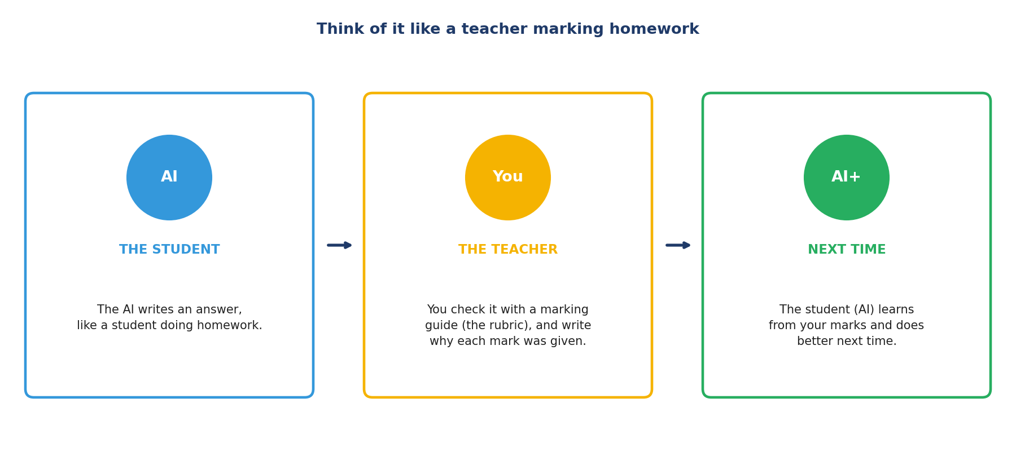
AI training is like a teacher marking homework.
Let's read this picture together
Step 1 The student (AI) writes an answer, like homework.
Simply: The AI writes.
Step 2 You are the teacher. You mark it with a marking guide (the rubric) and write why.
Simply: You mark it.
Step 3 The AI learns from your marks and does better next time.
Simply: The AI improves.

CHAPTER 3
Role 1: The Generalist AI Trainer

DEFINITION
A Generalist AI Trainer helps AI improve by labelling data and by checking, comparing and improving AI answers on everyday topics, following the project's rulebook exactly. No special degree is needed.

In simple English: A generalist helps AI learn about everyday things. You don't need a special degree.
THINK OF IT LIKE THIS
Think of a generalist as a careful helper in a big kitchen. They don't need to be a master chef. They need to follow the recipe exactly, notice when something is wrong, and say clearly what needs fixing.
In simple English: Follow the recipe, spot problems, explain clearly.
The word "generalist" explained
● What "generalist" means
A generalist works on general, everyday topics (food, travel, money basics, writing, general knowledge), not one special subject like law or engineering.
In simple English: Everyday topics, not one special subject.
● What the job is really about
AI cannot tell by itself whether its answers are good, true, kind or safe. Companies pay people to make these judgments, thousands of times. Your judgments become examples the AI learns from.
In simple English: AI needs people to tell it what is good.
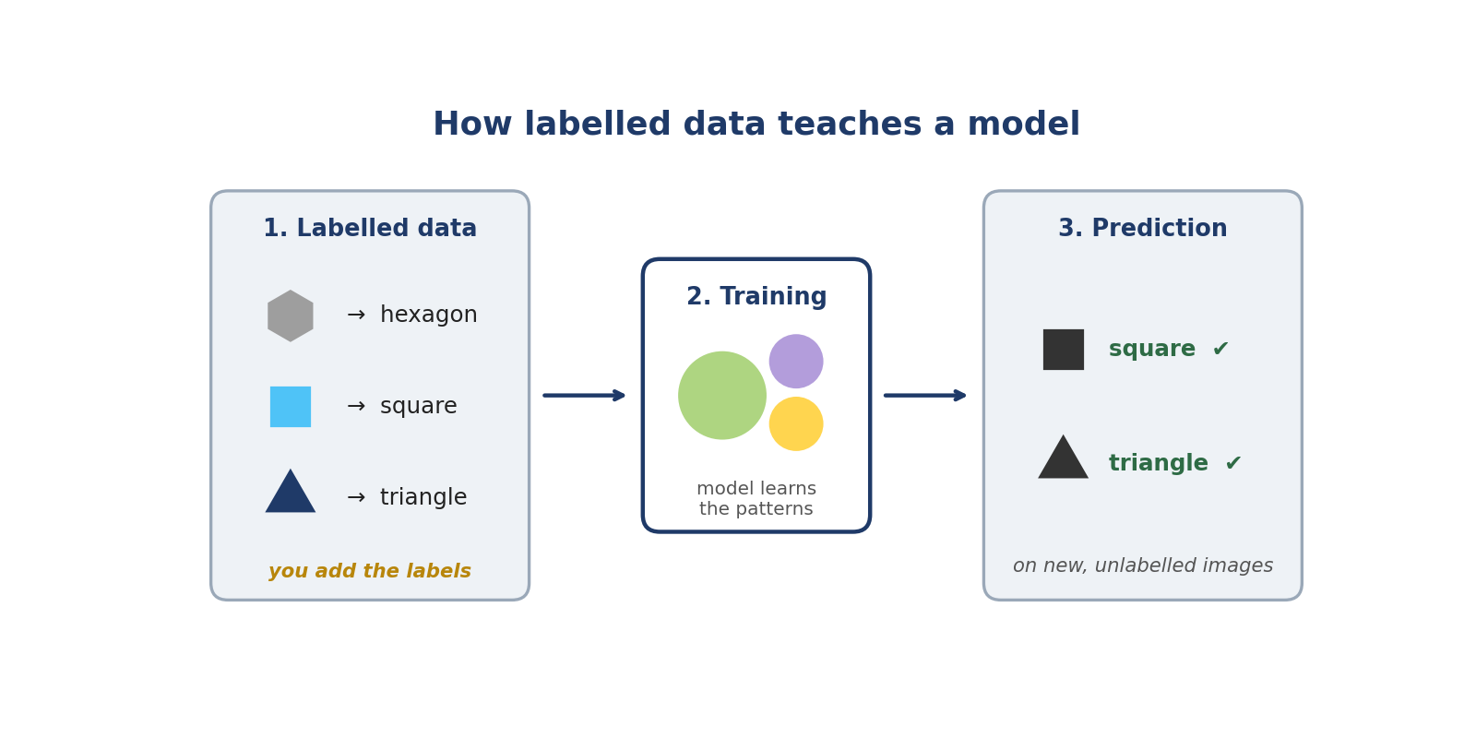
Labelled examples teach the AI, then it can recognise new things.
What you actually do
Task type | What it means | Simple example
Rubric scoring | Score an AI answer with a checklist | Give an answer 4 out of 5 for accuracy
Comparing answers | Choose the better of two answers | Pick A because B gives a wrong date
Checking instructions | See if the AI did what was asked | The user asked for 3 tips; the AI gave 5
Fact-checking | Check facts are true | Australia's capital is Canberra, not Sydney
Writing | Write a perfect answer or a test question | Write a clear two-sentence answer
Labelling | Tag images or text | Mark this message as a "complaint"
Safety flags | Spot harmful answers or needless refusals | The AI refused to explain how to boil rice

In simple English: Seven kinds of everyday tasks.
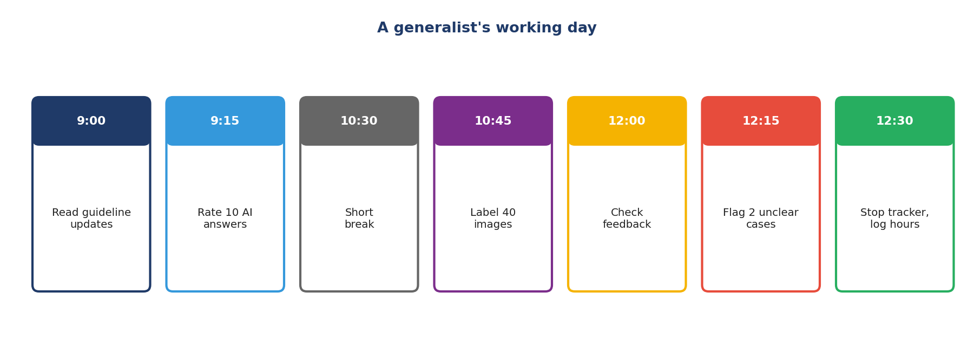
A typical working day for a generalist.
Let's read this day together
Step 1 9:00: read any rulebook updates first.
Simply: Check the rules first.
Step 2 9:15: rate AI answers.
Simply: Score answers.
Step 3 10:30: short break, so you stay sharp.
Simply: Rest a little.
Step 4 10:45: label images.
Simply: Tag pictures.
Step 5 12:00: read feedback from reviewers.
Simply: Learn from comments.
Step 6 12:15: flag unclear cases.
Simply: Ask about unclear things.
Step 7 12:30: stop the time tracker and log real hours.
Simply: Record honest hours.
Who uses your work
● AI companies
AI labs hire platforms to find trained people. Your work goes into training their AI models.
In simple English: Big AI companies use your work.
● Through RLHF
When you score or choose answers, a "reward model" learns what people prefer. The AI is then improved to give more of those answers.
In simple English: Your scores teach the AI what is good.
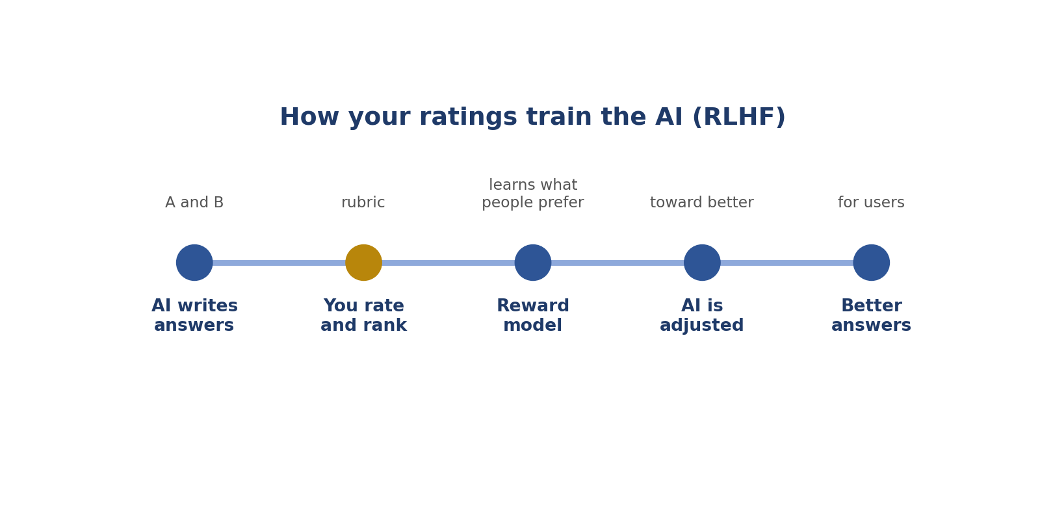
How your ratings train the AI.
More about the job
● Common job titles
AI Trainer, Generalist AI Evaluator, AI Data Specialist, Response Rater, Data Annotator, AI Tutor. Always read what the job actually asks you to do.
In simple English: Many names, same kind of work.
● How the work arrives
Usually as remote contract projects that start and stop. Hours are not guaranteed, so plan your money for quiet weeks. Pay varies by platform, project and country, so always check the listing.
In simple English: Work comes in projects. It's not a fixed salary.
● What the job is NOT
It is not customer service, not a permanent job, and not coding. It is also not fast clicking for easy money: your work is checked all the time.
In simple English: It's careful, checked work.
● Where it can lead
Good quality scores can lead to reviewer (QA) jobs, special projects, or team lead roles.
In simple English: Good work leads to better jobs.
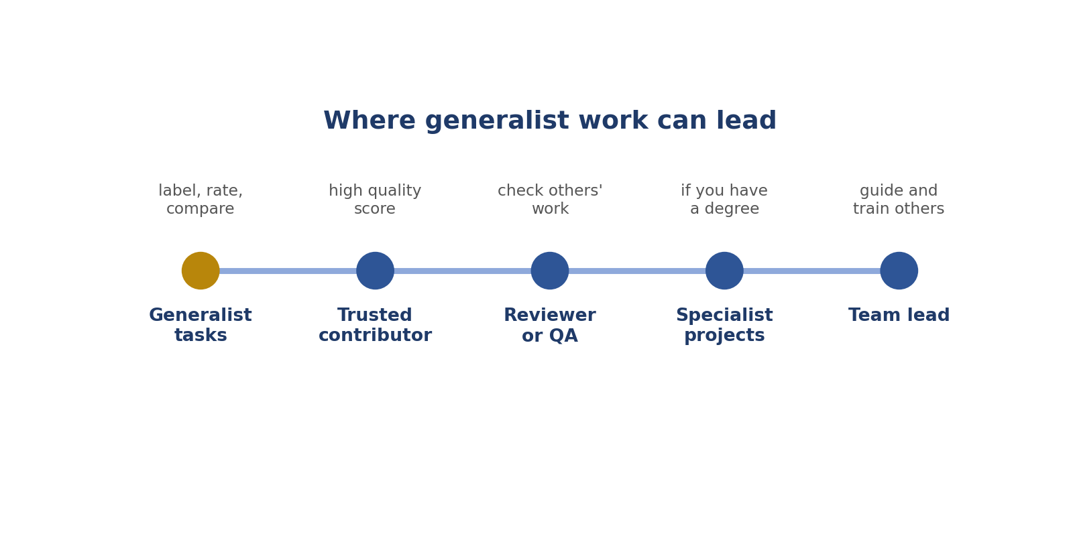
Quality, not speed, moves you up.
How to get started
1. Learn the 10 skills in this document.
2. Practise with the Day 1 Task Bank.
3. Build a CV using the Day 1 Sample CVs as a guide.
4. Apply to generalist listings and read each listing carefully.
5. Prepare for the AI interview and any skills test.
6. On your first project, read the whole guideline before starting.

CHAPTER 4
How the 10 Generalist Skills Work Together

The 10 skills are not separate subjects. They are the steps of one task, done in order.
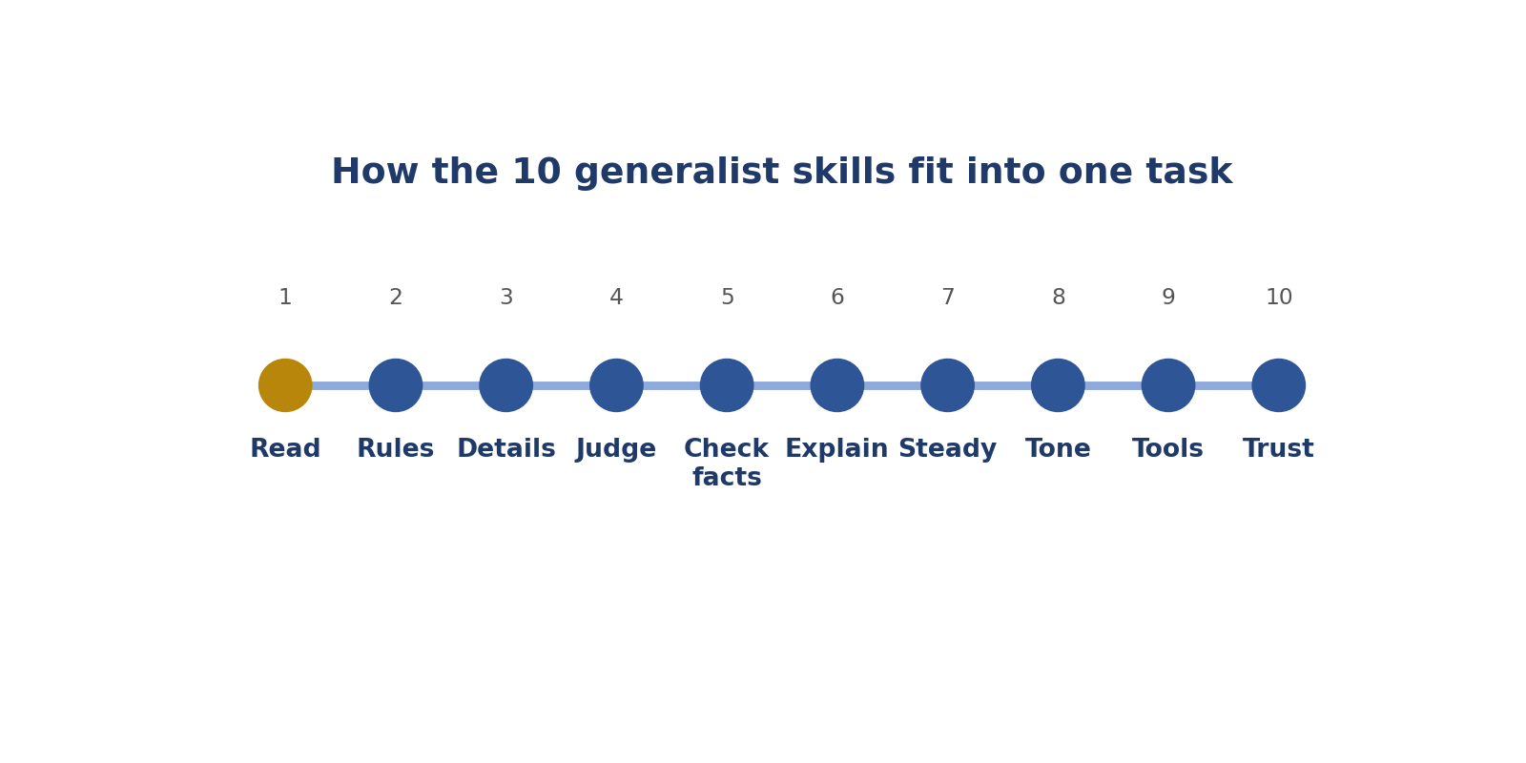
One task uses all 10 skills.
Step in a task | Skill | Simply
Read the question and rules | 1. Careful reading | Read every word
Use the project's rules | 2. Following guidelines | Do what the rules say
Check numbers, names, counts | 3. Attention to detail | Check small things
Decide what matters most | 4. Judgment | Find the biggest problem
Check the facts | 5. Fact-checking | Is it true?
Explain your decision | 6. Clear rationales | Say why
Stay the same every time | 7. Consistency | Same way, every time
Check tone and local details | 8. Language and tone | Is it kind and right for the user?
Use the software well | 9. Tool skills | Know your tools
Work honestly and on time | 10. Reliability | Be trustworthy

CHAPTER 5
Generalist Skill 1: Careful Reading

THINK OF IT LIKE THIS
Careful reading is like reading a recipe before you cook. If you miss "one spoon of salt" and add ten, the whole meal is ruined, even if you cooked everything else perfectly.
In simple English: Miss one small word, and the whole answer can be wrong.
DEFINITION
Careful reading means reading every word of a task, a rulebook or an AI answer, including the small words that change meaning, so you understand exactly what is being asked.

In simple English: Read every word. Small words can change everything.
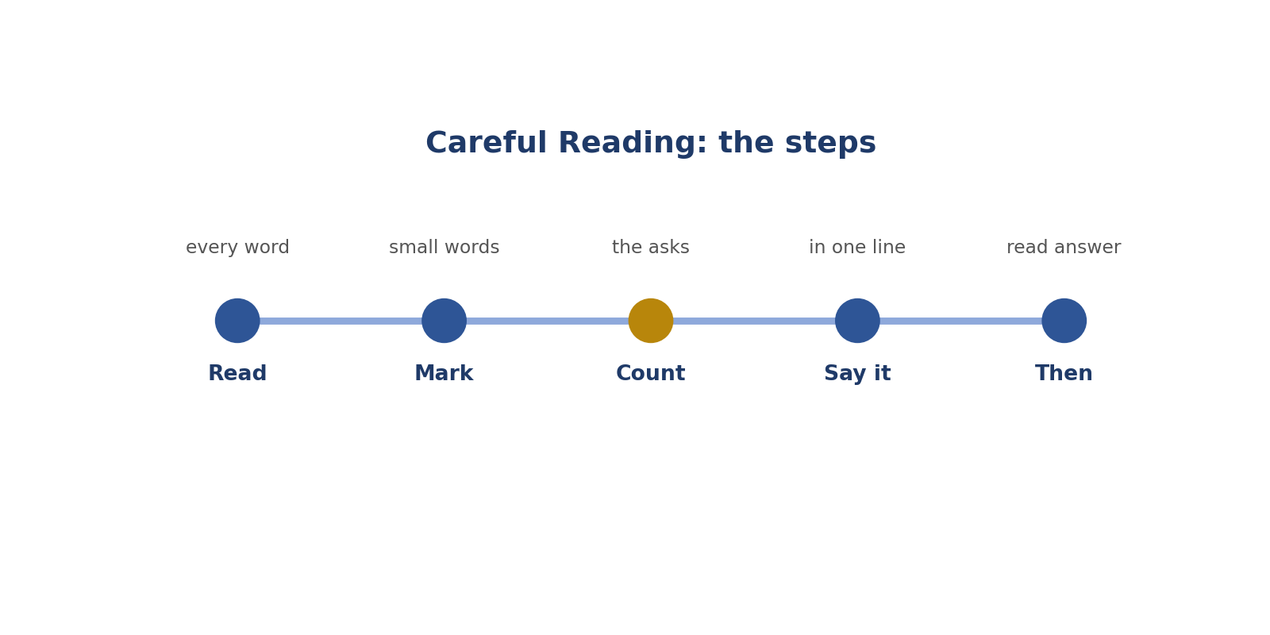
Careful Reading: the steps.
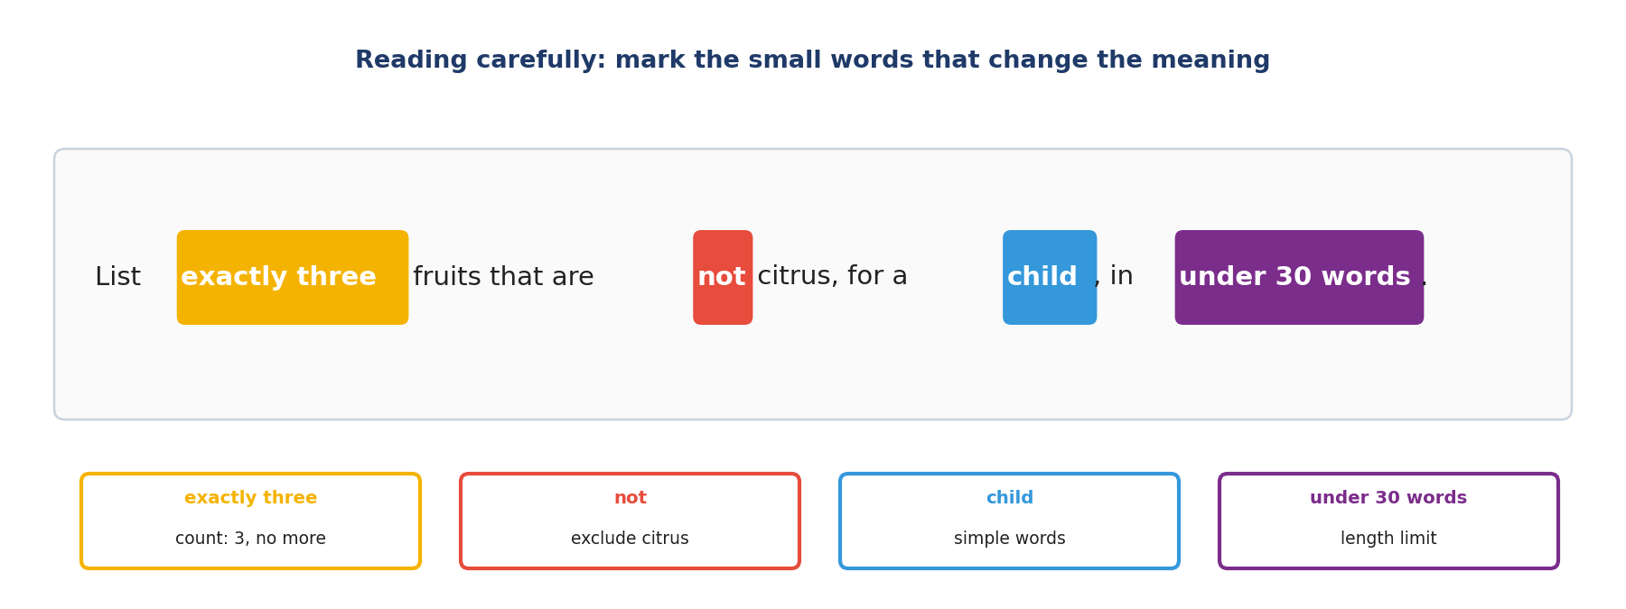
Real-style picture for careful reading.
Words to know
Term | What it means
Prompt | The question or instruction given to the AI.
Qualifier | A small word that changes a rule, like "not", "only" or "exactly".
Requirement | Something the answer must do.

● Where it fits in the job
Every generalist task starts with reading: the rulebook, the prompt and the AI's answer. If the reading is wrong, everything after it is wrong too.
In simple English: Reading is step one. Everything else depends on it.
● Why it matters
AI answers usually look good. Their mistakes hide in small details, like ignoring one word. Careful readers catch these; fast readers miss them.
In simple English: Mistakes hide in small words. Careful readers find them.
How to do it, step by step
Step 1 Read the prompt slowly, word by word.
Simply: Go slow.
Step 2 Mark small words that change meaning: not, only, exactly, at least, under, except, unless.
Simply: Find the tricky little words.
Step 3 Count how many things the prompt asks for.
Simply: Count the jobs in the question.
Step 4 Say the task back to yourself in one short line.
Simply: Say it in your own words.
Step 5 Only then read the AI's answer, and check it against your list.
Simply: Then check the answer against your list.
Good versus bad
What good looks like | What bad looks like
Reads every word slowly | Skims and guesses the rest
Marks "not", "only", "exactly" | Misses small words
Reads the question before the answer | Reads the answer first and gets influenced

Worked examples
THE WORD "NOT"
The situation: Prompt: "Name three fruits that are not citrus." The AI says: orange, apple, banana.
What to do: Check each fruit against the word "not". Orange is a citrus fruit.
Why: The AI broke the "not" rule, so the answer fails.
In simple English: "Not" means leave it out. Orange should not be there.
TWO QUESTIONS IN ONE
The situation: Prompt: "What time does the bank open, and do I need ID?" The AI only gives the opening time.
What to do: Count the questions: two. Only one was answered.
Why: Half of the question was ignored.
In simple English: Two questions need two answers.
"AT LEAST"
The situation: Prompt: "Give at least three tips." The AI gives five.
What to do: Check: "at least three" means three or more.
Why: Five is fine. The answer passes.
In simple English: "At least" means that number or more.
"EXACTLY"
The situation: Prompt: "Describe Lagos in exactly two sentences." The AI writes three.
What to do: Count the sentences: three.
Why: "Exactly" means no more and no less. It fails.
In simple English: Exactly two means two. Not three.
Common mistakes
Mistake | Why it's a problem
Reading the answer before the question | You start judging what the AI said, not what was asked.
Skipping small words | "Not" and "only" can flip the meaning.
Reading only the first half of a sentence | The important rule is often at the end.
Thinking you already know what it says | Your memory fills gaps with wrong guesses.

● How it's tested
Tests hide small conditions in prompts, like a word limit in the middle, to see if you notice.
In simple English: Tests hide little rules. Can you spot them?
How to practise
1. Take any 5 questions and circle every small word that changes the meaning.
2. Write each question again in one short line.
3. Read news headlines slowly and find the most important word.
Skill levels
Level | What it looks like
Beginner | Skims and misses small words.
Developing | Catches most small words, sometimes misses one.
Strong | Never misses a small word, even in long prompts.

● What it looks like on your CV
"Reviewed prompts and guidelines closely to identify every requirement before evaluating responses."
In simple English: This shows employers you read carefully.
Quick check
Question: What does "at least two" allow?
Answer: Two or more.
Question: Should you read the AI's answer or the prompt first?
Answer: The prompt first.
Practise this skill: Day 1 Task Bank, Chapter 1.

CHAPTER 6
Generalist Skill 2: Following Guidelines Exactly

THINK OF IT LIKE THIS
Guidelines are like the rules of a football match. If every referee used different rules, nobody would know who really won. Everyone must follow the same rules.
In simple English: Everyone must use the same rules.
DEFINITION
Following guidelines exactly means doing tasks the way the project's rulebook says, even when you would do it differently, and asking or flagging when the rulebook doesn't cover something.

In simple English: Do what the rulebook says. Ask when it doesn't say.
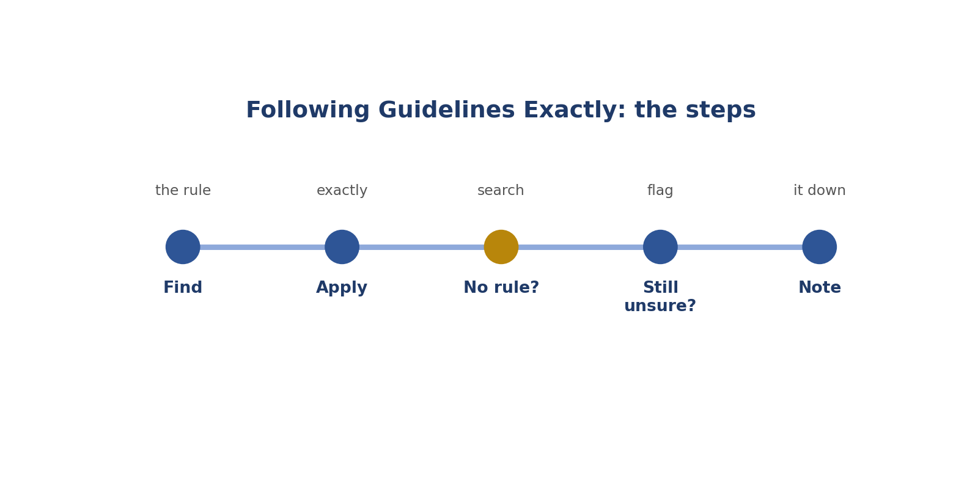
Following Guidelines Exactly: the steps.
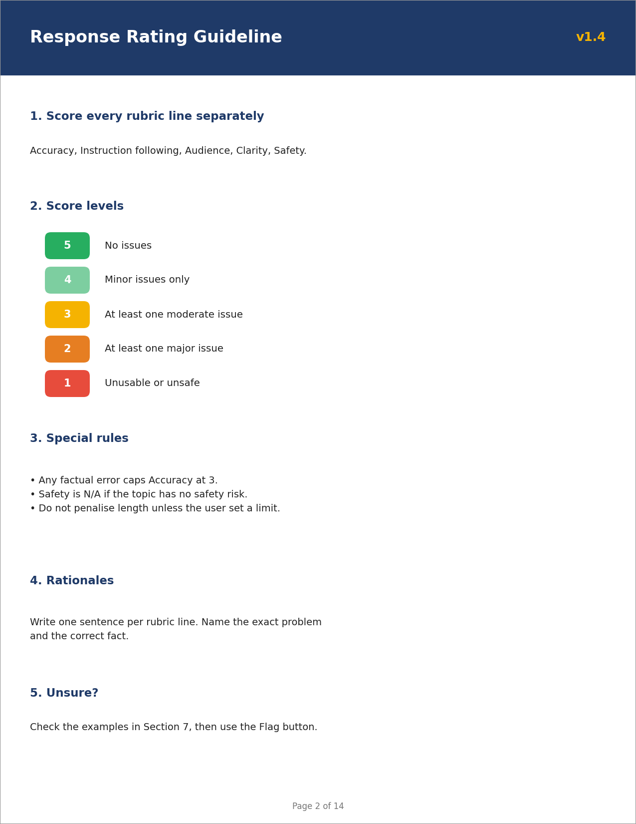
Real-style picture for following guidelines exactly.
Words to know
Term | What it means
Guideline | The project's rulebook.
Flag | A button or note that asks a reviewer to check something.
FAQ | Frequently asked questions: a list of common questions and answers.

● Where it fits in the job
After reading, you apply the rules. Reviewers check this more than anything else.
In simple English: Following the rules is the most checked skill.
● Why it matters
AI companies combine work from thousands of people. The data only works if everyone follows the same rules.
In simple English: Thousands of people must all do it the same way.
How to do it, step by step
Step 1 Read the whole guideline before your first task.
Simply: Read the full rulebook first.
Step 2 Find the rule that matches your task.
Simply: Find the right rule.
Step 3 Apply it exactly, even if you disagree.
Simply: Do exactly what it says.
Step 4 If no rule fits, search the guideline and FAQ.
Simply: Look again for a matching rule.
Step 5 If still unsure, flag it with a short note.
Simply: Still unsure? Flag it.
Good versus bad
What good looks like | What bad looks like
Follows the rule even when it seems strict | Uses own opinion instead
Rereads rules after updates | Works from old memory
Flags unclear cases | Guesses

Worked examples
A STRICT RULE
The situation: Rule: any answer over the word limit gets the lowest instruction score. An answer is 2 words over.
What to do: Apply the rule: lowest score.
Why: The rule has no "a little bit over" exception.
In simple English: Over is over, even by a little.
DISAGREEING POLITELY
The situation: You think a rule is too harsh.
What to do: Follow it in your work, and send your idea through the feedback channel.
Why: Rules change through the right channel, not by ignoring them.
In simple English: Follow it, then suggest a change.
A NEW RULE
The situation: Yesterday the rule changed: reflections now get a "reflection" tag.
What to do: Use the new rule from now on.
Why: Old habits cause mistakes after updates.
In simple English: New rule? Use it now.
NO RULE EXISTS
The situation: A message is only emojis. No rule covers this.
What to do: Search the FAQ, then flag with a note.
Why: Guessing would create a private rule nobody else knows.
In simple English: No rule? Ask, don't guess.
Common mistakes
Mistake | Why it's a problem
Using your own opinion instead of the rule | Your data won't match everyone else's.
Using an old version of the rules | You'll be marked wrong.
Guessing on unclear cases | You create hidden differences in the data.
Treating rule examples as the whole rule | Examples show the rule; they don't limit it.

● How it's tested
Onboarding quizzes, trial tasks and audits all check if you follow the rules.
In simple English: Every test checks this.
How to practise
1. Read any instructions (a form, a recipe) and follow them exactly.
2. Keep a small notes file of the rules you check most.
3. After each task, ask: which rule did I use?
Skill levels
Level | What it looks like
Beginner | Uses own judgment instead of rules.
Developing | Follows most rules; sometimes guesses.
Strong | Follows every rule and flags every gap.

● What it looks like on your CV
"Applied detailed project guidelines consistently and flagged unclear cases for clarification."
In simple English: This shows you follow rules and ask when unsure.
Quick check
Question: What do you do when a rule seems wrong?
Answer: Follow it, and suggest a change through the right channel.
Question: What do you do when no rule fits?
Answer: Search the FAQ, then flag it.
Practise this skill: Day 1 Task Bank, Chapter 2.

CHAPTER 7
Generalist Skill 3: Attention to Detail

THINK OF IT LIKE THIS
Attention to detail is like checking your change at a shop. The total looks right, but one wrong coin means you lost money.
In simple English: One small wrong thing can matter a lot.
DEFINITION
Attention to detail means checking the small parts of a task, like counts, numbers, names, dates and format, in the AI's answer and in your own work.

In simple English: Check the small things: numbers, names, counts and format.
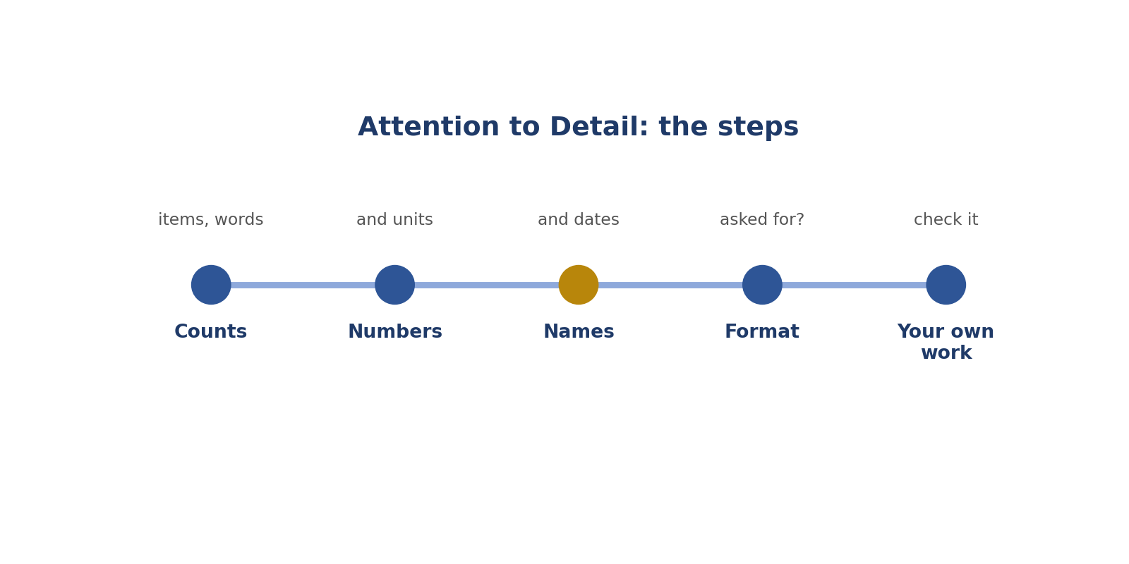
Attention to Detail: the steps.
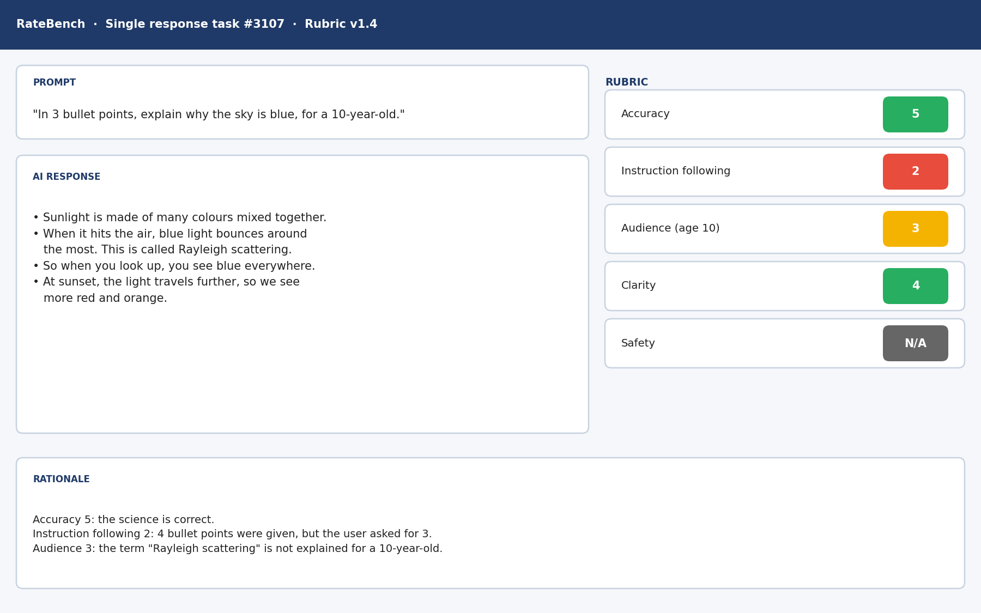
Real-style picture for attention to detail.
Words to know
Term | What it means
Detail | A small part of something.
Format | The shape of an answer, like bullets or a table.
Unit | What a number measures, like metres or naira.

● Where it fits in the job
After applying the rules, you check the small parts. This is how you catch the mistakes that quick readers miss.
In simple English: This is how you catch hidden mistakes.
● Why it matters
AI mistakes are usually small: a wrong year, one missing item, a wrong unit.
In simple English: AI mistakes are usually tiny.
How to do it, step by step
Step 1 Count every list and every word limit.
Simply: Count.
Step 2 Check every number and its unit.
Simply: Check numbers.
Step 3 Check names and dates are right and match.
Simply: Check names and dates.
Step 4 Check the format matches what was asked.
Simply: Check the shape of the answer.
Step 5 Check your own score and reason before submitting.
Simply: Check your own work too.
Good versus bad
What good looks like | What bad looks like
Counts items every time | Trusts that the list looks complete
Checks units (km, m, ₦) | Ignores units
Rereads own rationale | Submits without checking

Worked examples
THE MISSING TIP
The situation: Prompt asks for 5 tips. The list is numbered 1, 2, 3, 5.
What to do: Count the actual items: four.
Why: The numbering hides a missing tip.
In simple English: Count the items, not the numbers.
THE UNIT MIX-UP
The situation: The AI says: "Lagos to Ibadan is about 130 metres."
What to do: Check the unit. It should be about 130 kilometres.
Why: Metres makes it 1,000 times too short.
In simple English: Wrong unit, wrong answer.
THE FORMAT
The situation: Prompt: "Answer in a table." The AI writes paragraphs.
What to do: Check the format: no table.
Why: The user asked for a table.
In simple English: They asked for a table. No table = fail.
YOUR OWN SLIP
The situation: Your reason says "A is better" but you clicked B.
What to do: Fix it before submitting.
Why: Mistakes in your own work count too.
In simple English: Check your own work.
Common mistakes
Mistake | Why it's a problem
Trusting numbered lists | Numbers can skip.
Not checking units | A right number with a wrong unit is wrong.
Checking only the start of the answer | Errors can be anywhere.
Not checking your own work | Your slips count against you.

● How it's tested
Tests plant tiny errors, like 4 items when 5 were asked.
In simple English: Tests hide tiny mistakes.
How to practise
1. Use a 5-point checklist before every submit.
2. Do spot-the-difference puzzles.
3. Proofread a short message for errors.
Skill levels
Level | What it looks like
Beginner | Misses small errors.
Developing | Catches most small errors.
Strong | Catches small errors in the AI and in own work every time.

● What it looks like on your CV
"Caught small but important errors in AI outputs, including incorrect figures and missed instructions."
In simple English: This shows you notice small mistakes.
Quick check
Question: Prompt asks for 3 bullets; the answer has 4. Pass or fail?
Answer: Fail.
Question: Name two small things to always check.
Answer: Counts and units (also names, dates, format).
Practise this skill: Day 1 Task Bank, Chapter 3.

CHAPTER 8
Generalist Skill 4: Critical Thinking and Judgment

THINK OF IT LIKE THIS
Judgment is like being a referee. Many small fouls happen in a match, but a good referee knows which one deserves a red card.
In simple English: Know which problem is the big one.
DEFINITION
Critical thinking and judgment mean deciding which problems in an answer matter most, checking that its reasoning makes sense, and noticing when a question is based on something false.

In simple English: Decide which problem is the biggest, and check the answer makes sense.
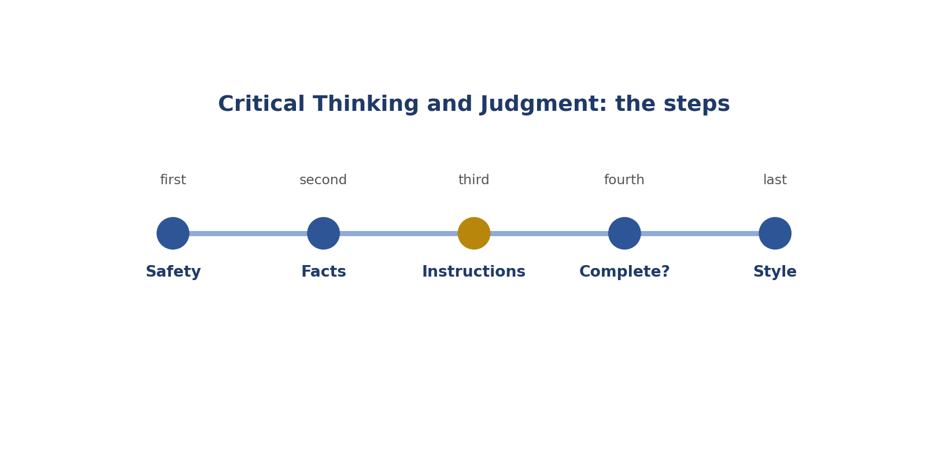
Critical Thinking and Judgment: the steps.
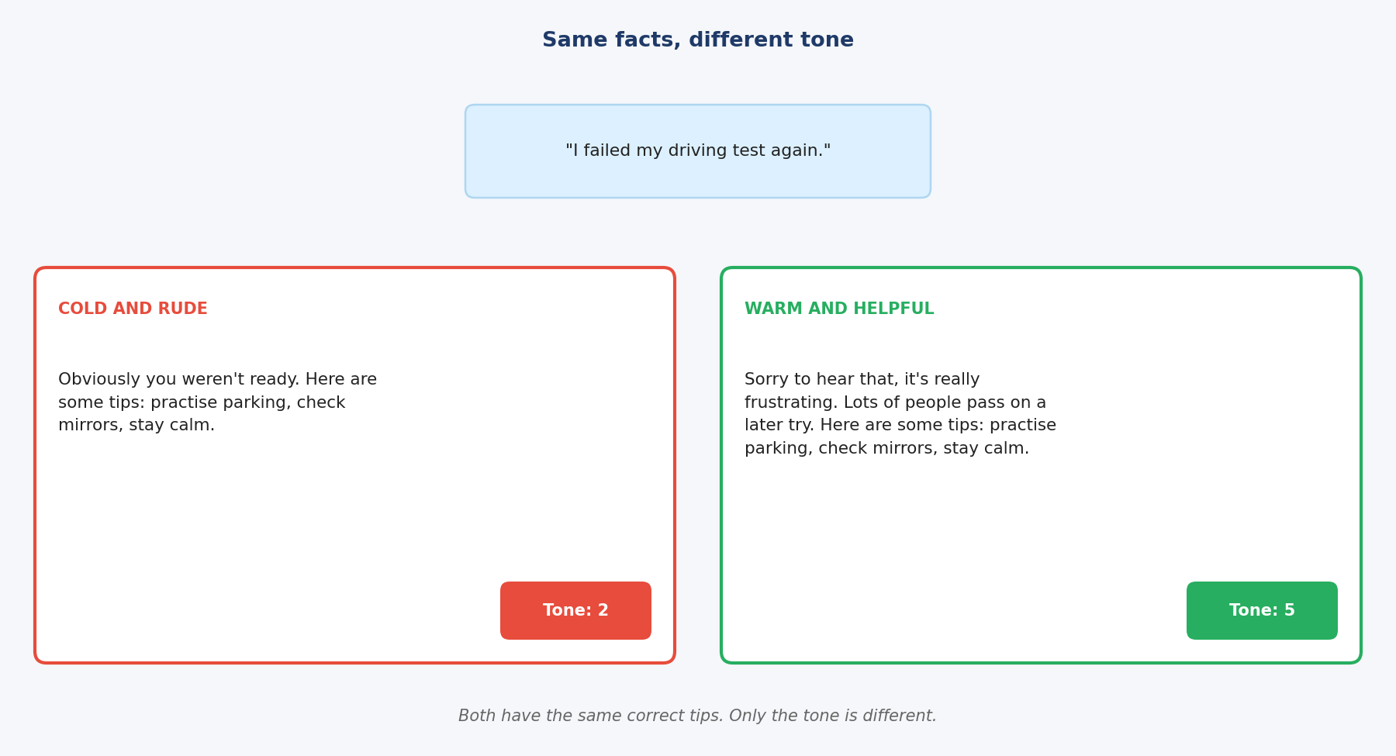
Real-style picture for critical thinking and judgment.
Words to know
Term | What it means
Severity | How serious a problem is.
Reasoning | The steps used to reach an answer.
False premise | A wrong idea hidden inside a question.

● Where it fits in the job
When you rate or compare answers, judgment decides the final score.
In simple English: Judgment picks the score.
● Why it matters
If you treat every problem the same, a pretty but wrong answer can win.
In simple English: Not all problems are equal.
How to do it, step by step
Step 1 List the problems you found.
Simply: List the problems.
Step 2 Rank them: safety, facts, instructions, completeness, style.
Simply: Put the worst first.
Step 3 Check each reasoning step follows from the last.
Simply: Check the steps make sense.
Step 4 Check if the question has a false idea in it.
Simply: Is the question itself wrong?
Step 5 Decide the score from the worst problem.
Simply: The worst problem decides.
Good versus bad
What good looks like | What bad looks like
Puts safety and facts first | Lets style win
Checks each reasoning step | Trusts the final number
Corrects false ideas in questions | Accepts them

Worked examples
PRETTY BUT WRONG
The situation: A: beautiful layout, says Lagos is Nigeria's capital. B: plain, says Abuja.
What to do: Rank problems: A has a fact error.
Why: Facts beat looks.
In simple English: Right and plain beats wrong and pretty.
THE BROKEN STEP
The situation: "Save ₦5,000 a week for a year. A year has 12 weeks, so ₦60,000."
What to do: Check the step: a year has 52 weeks.
Why: The real answer is ₦260,000.
In simple English: One wrong step makes the answer wrong.
A FALSE IDEA
The situation: "Why is the Moon made of cheese?"
What to do: Notice the false idea.
Why: A good answer explains the Moon is rock.
In simple English: Fix the wrong idea, don't play along.
CAUSE AND EFFECT
The situation: "It rained, then my phone broke, so rain breaks phones."
What to do: Check: one thing after another isn't proof it caused it.
Why: The reasoning is weak.
In simple English: After is not the same as because.
Common mistakes
Mistake | Why it's a problem
Counting problems instead of weighing them | One big problem beats many small ones.
Trusting confident answers | Confidence isn't proof.
Accepting false ideas | The answer should correct them.
Letting length win | Longer isn't better.

● How it's tested
Comparison tasks test this directly.
In simple English: Picking the better answer tests judgment.
How to practise
1. For every answer, write the single biggest problem first.
2. Practise ranking 3 problems by severity.
3. Find the weak step in simple word problems.
Skill levels
Level | What it looks like
Beginner | Counts problems.
Developing | Knows the order; sometimes lets style win.
Strong | Always decides by the most serious problem.

● What it looks like on your CV
"Ranked AI responses by severity of issues, prioritising safety and factual accuracy."
In simple English: This shows good judgment.
Quick check
Question: What comes first: style or facts?
Answer: Facts (and safety before facts).
Question: "Why is the Sun cold?" What should a good answer do?
Answer: Correct the false idea: the Sun is extremely hot.
Practise this skill: Day 1 Task Bank, Chapter 4.

CHAPTER 9
Generalist Skill 5: Fact-Checking with Reliable Sources

THINK OF IT LIKE THIS
Fact-checking is like checking a rumour. If a friend says school is closed tomorrow, you check the school's official message, not another rumour.
In simple English: Check with the official source, not rumours.
DEFINITION
Fact-checking means splitting an answer into separate facts and checking the important ones against reliable sources, like official websites and trusted references, not memory.

In simple English: Check facts with trusted websites, not your memory.
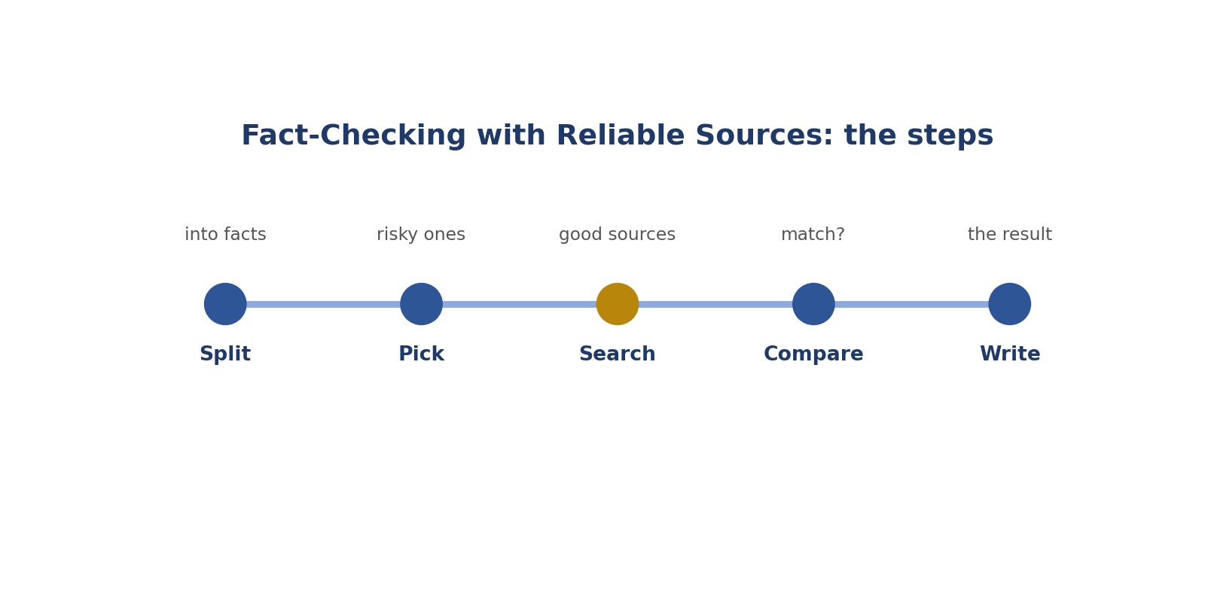
Fact-Checking with Reliable Sources: the steps.
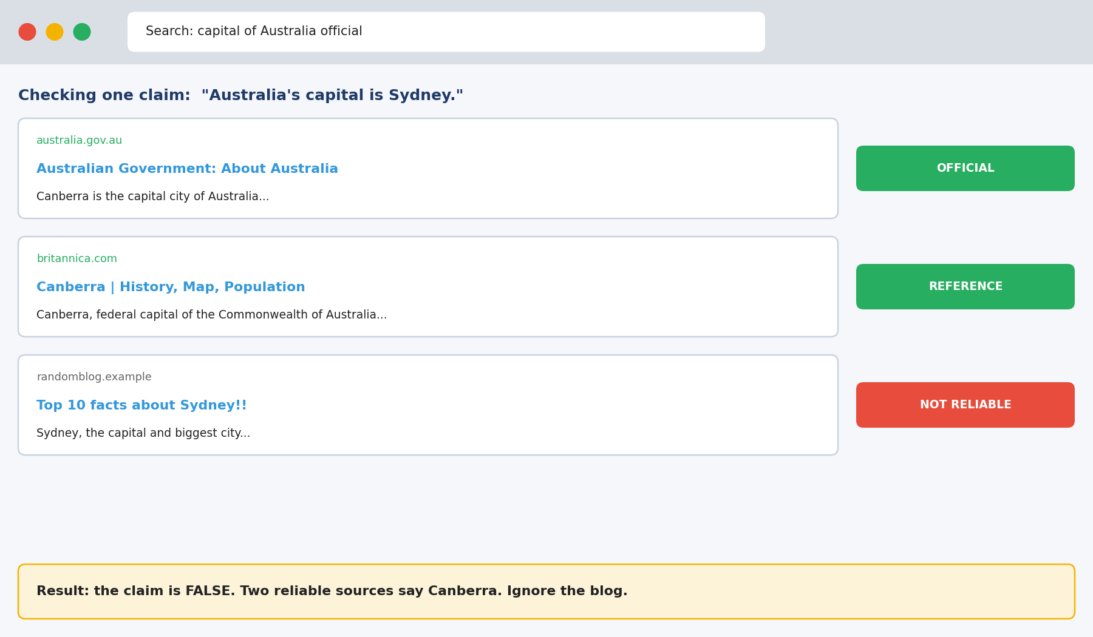
Real-style picture for fact-checking with reliable sources.
Words to know
Term | What it means
Claim | One fact that can be checked.
Reliable source | A trusted place, like an official website.
Hallucination | A false fact the AI made up.

● Where it fits in the job
Fact-checking protects the accuracy score, usually the most important score.
In simple English: It protects the most important score.
● Why it matters
AI sometimes invents facts and says them confidently.
In simple English: AI can make things up.
How to do it, step by step
Step 1 Split the answer into separate facts.
Simply: Break it into small facts.
Step 2 Pick the risky ones: names, numbers, dates, quotes.
Simply: Check the exact details first.
Step 3 Search trusted sources.
Simply: Use official or trusted sites.
Step 4 Compare: does the source say the same?
Simply: Does it match?
Step 5 Write what you found in your reason.
Simply: Say what was right or wrong.
Good versus bad
What good looks like | What bad looks like
Uses official websites | Uses a random blog
Checks exact numbers and names | Trusts them because they look exact
Says "could not verify" honestly | Guesses

Worked examples
THE WRONG CAPITAL
The situation: "Australia's capital is Sydney."
What to do: Check official and reference sites.
Why: They say Canberra. The claim is false.
In simple English: Two trusted sources beat one blog.
HALF TRUE
The situation: "Nigeria became independent in 1960, and Wole Soyinka was its first President."
What to do: Check each part.
Why: 1960 is right. The first President was Nnamdi Azikiwe.
In simple English: Check every part of a sentence.
OLD INFORMATION
The situation: "The current fuel price is..." from a two-year-old article.
What to do: Check the date of the source.
Why: Old prices aren't current.
In simple English: "Current" needs new information.
CAN'T FIND IT
The situation: A very exact statistic with no source.
What to do: Search; find nothing.
Why: Write: "could not verify this figure."
In simple English: If you can't find it, say so.
Common mistakes
Mistake | Why it's a problem
Checking from memory | Memory can be wrong.
Trusting exact-looking numbers | Made-up facts often look exact.
Using another AI chatbot to check | It can be wrong too, and may be forbidden.
Using old sources for current questions | Things change.

● How it's tested
Tests hide one false fact among true ones.
In simple English: One wrong fact is hidden. Find it.
How to practise
1. Ask an AI 3 questions and check every fact.
2. List 5 trusted websites for everyday facts.
3. Practise splitting sentences into facts.
Skill levels
Level | What it looks like
Beginner | Checks from memory.
Developing | Checks some facts with sources.
Strong | Checks every important fact with trusted sources.

● What it looks like on your CV
"Verified factual claims against reliable sources and identified hallucinated details."
In simple English: This shows you check facts properly.
Quick check
Question: Is another AI a reliable source?
Answer: No.
Question: What should you check first?
Answer: Exact details: names, numbers, dates, quotes.
Practise this skill: Day 1 Task Bank, Chapter 5.

CHAPTER 10
Generalist Skill 6: Writing Clear Rationales

THINK OF IT LIKE THIS
A rationale is like a teacher's comment on homework. "Wrong" doesn't help. "Question 3: you wrote 1963; the answer is 1960" helps.
In simple English: Say exactly what is wrong.
DEFINITION
Writing a clear rationale means explaining your score in two or three short sentences that name the exact problem and the correct fact, so a reviewer can check it quickly.

In simple English: Say exactly why you gave the score, in a few short sentences.
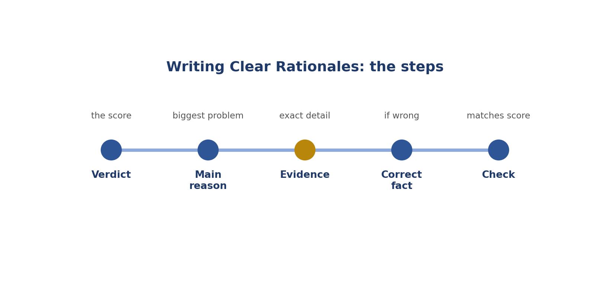
Writing Clear Rationales: the steps.
Real-style picture for writing clear rationales.
Words to know
Term | What it means
Rationale | A short written reason for your score.
Evidence | The exact detail that proves your point.
Reviewer | A person who checks your work.

● Where it fits in the job
Most rating tasks end with a rationale. Reviewers judge your work partly by it.
In simple English: Reviewers read your reasons.
● Why it matters
A good score with a vague reason looks like a guess.
In simple English: Vague reasons look like guesses.
How to do it, step by step
Step 1 Start with the score or verdict.
Simply: Say the score.
Step 2 Give the main reason.
Simply: Say the biggest problem.
Step 3 Point to the exact words or detail.
Simply: Show the proof.
Step 4 Give the correct fact if something was wrong.
Simply: Say what's right.
Step 5 Check the reason matches the score.
Simply: Make sure they agree.
Good versus bad
What good looks like | What bad looks like
"States 1963; it was 1960." | "Wrong."
Two or three sentences | A long paragraph
Matches the score | Says the opposite of the score

Worked examples
VAGUE TO CLEAR
The situation: Weak: "Bad answer."
What to do: Strong: "Accuracy 2: says Australia's capital is Sydney; it is Canberra."
Why: The strong one names the error and the fix.
In simple English: Name the mistake and the right answer.
PRAISE NEEDS REASONS TOO
The situation: Score: 5.
What to do: "Accuracy 5: all three facts match official sources."
Why: High scores also need evidence.
In simple English: Explain good scores too.
TOO LONG
The situation: A 200-word rationale for a simple task.
What to do: Cut it to the main point.
Why: Reviewers read quickly.
In simple English: Short and clear is best.
THE MISMATCH
The situation: Rationale praises A; you selected B.
What to do: Fix one before submitting.
Why: Mismatches fail audits.
In simple English: Your words and your choice must agree.
Common mistakes
Mistake | Why it's a problem
Vague words ("good", "bad") | Name the exact detail.
Personal taste ("I like it") | Use the rubric.
Very long rationales | Keep 2 to 3 sentences.
Rationale disagrees with score | Reread before submitting.

● How it's tested
Audits read your rationales.
In simple English: Your reasons get checked.
How to practise
1. Rewrite 10 vague reasons into clear ones.
2. Use the pattern: score, problem, proof, correct fact.
3. Read your reason aloud before submitting.
Skill levels
Level | What it looks like
Beginner | Writes vague reasons.
Developing | Names evidence sometimes.
Strong | Always names exact evidence and the correct fact.

● What it looks like on your CV
"Wrote concise, evidence-based rationales for every evaluation decision."
In simple English: This shows you explain your work clearly.
Quick check
Question: Fix this: "It's wrong."
Answer: Example: "Accuracy 2: says 1963; Nigeria became independent in 1960."
Question: How long should a rationale be?
Answer: About two or three sentences.
Practise this skill: Day 1 Task Bank, Chapter 6.

CHAPTER 11
Generalist Skill 7: Consistency and Calibration

THINK OF IT LIKE THIS
Consistency is like a weighing scale. A good scale shows the same weight for the same bag every time. Calibration means it shows the right weight, too.
In simple English: Same answer every time, and the right answer.
DEFINITION
Consistency means giving the same score to similar answers every time. Calibration means your scores match the project's correct standard.

In simple English: Score the same things the same way, and match the correct standard.
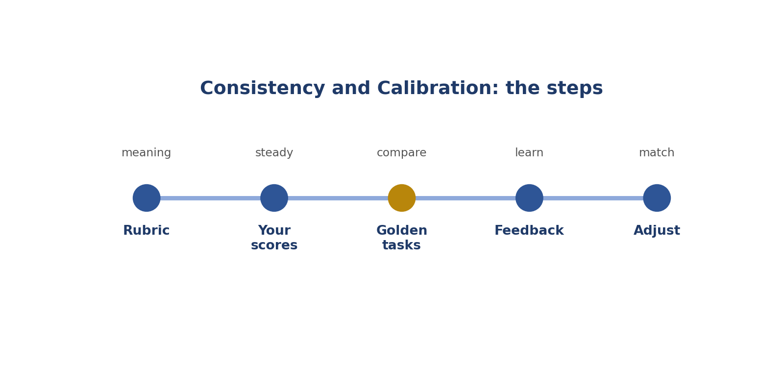
Consistency and Calibration: the steps.
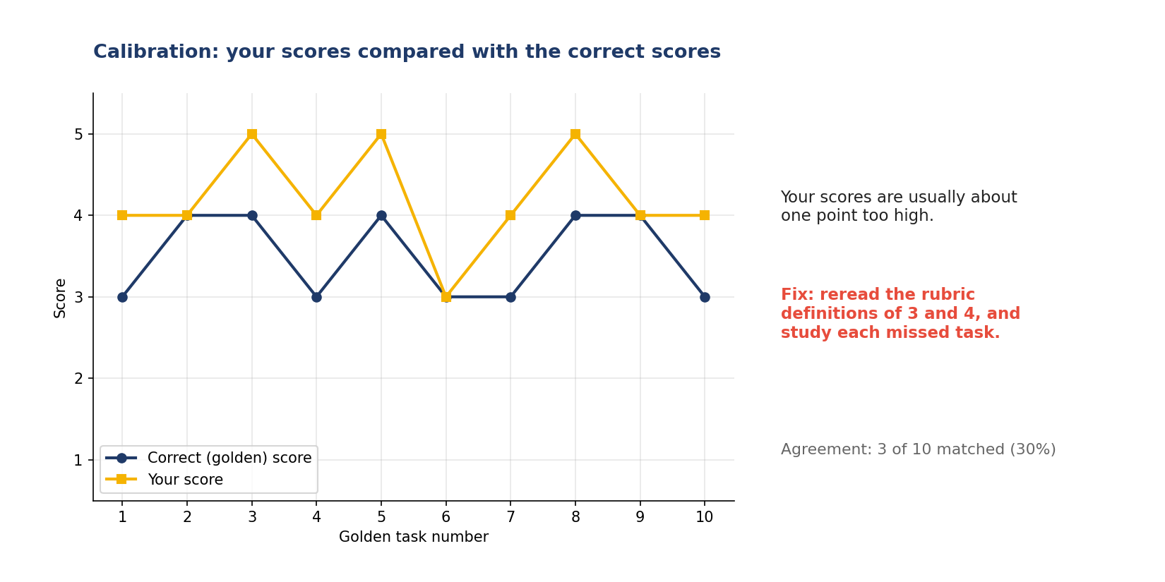
Real-style picture for consistency and calibration.
Words to know
Term | What it means
Consistent | The same every time.
Calibration | Matching the correct standard.
Golden task | A hidden test task with a known correct answer.

● Where it fits in the job
Over hundreds of tasks, your standard must stay steady and correct.
In simple English: Steady and correct over many tasks.
● Why it matters
Mixed scores confuse the AI. Projects remove raters whose scores don't match the standard.
In simple English: Mixed scores confuse the AI.
How to do it, step by step
Step 1 Use the rubric's written meaning for each score.
Simply: Use the written meanings.
Step 2 Keep notes of tricky decisions.
Simply: Write down hard decisions.
Step 3 Compare your scores with feedback and golden tasks.
Simply: Compare with the right answers.
Step 4 Study every miss.
Simply: Learn from each mistake.
Step 5 Take breaks so tiredness doesn't change your scores.
Simply: Rest so you stay steady.
Good versus bad
What good looks like | What bad looks like
Same answer, same score | Scores change with mood
Learns from every miss | Ignores feedback
Takes breaks | Works tired for hours

Worked examples
DRIFT
The situation: Morning scores mostly 3; evening scores mostly 4 for similar answers.
What to do: Reread the rubric and recheck evening tasks.
Why: Tiredness changed your standard.
In simple English: Tired? Your scores may drift.
STEADY BUT WRONG
The situation: Your scores are always one point higher than golden tasks.
What to do: Reread the definitions of each level.
Why: You're consistent, but not calibrated.
In simple English: Steady isn't enough. You must also be right.
USING NOTES
The situation: You decide that partial answers get 3. You write it down.
What to do: Next time, use the same decision.
Why: Notes keep you consistent.
In simple English: Write it down, do it the same.
LEARNING FROM FEEDBACK
The situation: A reviewer says your 4 should be 3.
What to do: Re-rate the example and note the lesson.
Why: Feedback shows exactly where you differ.
In simple English: Each correction teaches you.
Common mistakes
Mistake | Why it's a problem
Scoring by mood | Use the rubric.
Ignoring feedback | You'll keep making the same mistake.
Working when very tired | Your scores drift.
Being harsh after a great answer | Compare with the rubric, not the last answer.

● How it's tested
Golden tasks are hidden among normal tasks.
In simple English: Some tasks are secret tests.
How to practise
1. Rate 5 answers today and again in 3 days, then compare.
2. Keep a list of tricky cases and decisions.
3. Track your golden task results.
Skill levels
Level | What it looks like
Beginner | Scores change with mood.
Developing | Mostly steady.
Strong | Steady and matching the standard.

● What it looks like on your CV
"Maintained high agreement with gold-standard tasks and applied reviewer feedback."
In simple English: This shows your scores can be trusted.
Quick check
Question: What is a golden task?
Answer: A hidden test with a known correct answer.
Question: Your scores are always 1 point too high. Consistent or calibrated?
Answer: Consistent, but not calibrated.
Practise this skill: Day 1 Task Bank, Chapter 7.

CHAPTER 12
Generalist Skill 8: Language and Tone Awareness

THINK OF IT LIKE THIS
Tone is like how you speak to your grandmother versus your best friend. The words may be true either way, but how you say them matters.
In simple English: How you say it matters, not just what you say.
DEFINITION
Language and tone awareness means noticing whether an answer is correct, natural, kind and suited to the user's country and situation.

In simple English: Check that the answer sounds natural, kind and right for the user.
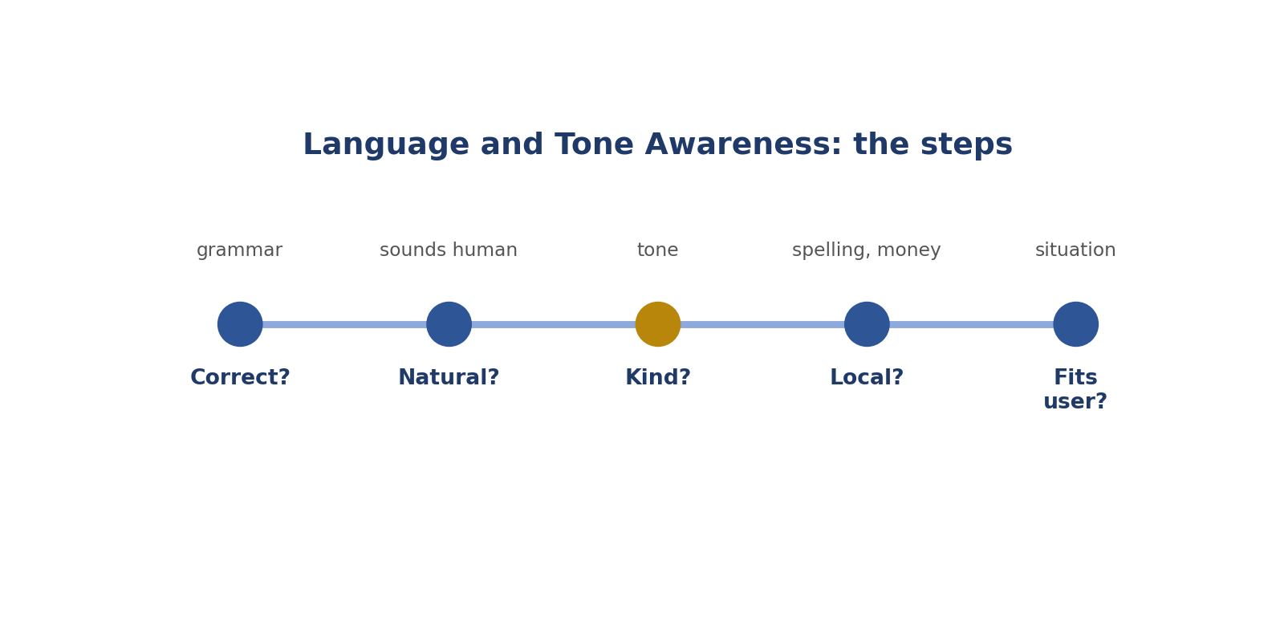
Language and Tone Awareness: the steps.
Real-style picture for language and tone awareness.
Words to know
Term | What it means
Tone | How words feel to the reader: warm, cold or rude.
Locale | The country or region the answer is for.
Sarcasm | Saying the opposite of what you mean, often to mock.

● Where it fits in the job
Many rubrics have tone and language lines.
In simple English: Tone has its own score.
● Why it matters
Users stop trusting answers that are rude, cold or confusing.
In simple English: Rude answers lose trust.
How to do it, step by step
Step 1 Check grammar and meaning.
Simply: Is it correct?
Step 2 Check it sounds natural.
Simply: Does it sound like a person?
Step 3 Check the tone fits the user's feelings.
Simply: Is it kind?
Step 4 Check local details: spelling, money, dates.
Simply: Does it fit the user's country?
Step 5 Score by the rubric's tone rules.
Simply: Use the rubric.
Good versus bad
What good looks like | What bad looks like
Kind to an upset user | Cold or mocking
Uses naira for Nigerian users | Uses only US dollars
Matches British or American spelling as asked | Mixes them

Worked examples
COLD REPLY
The situation: User: "I lost my job." AI: "CVs must be one page."
What to do: Notice: no kindness.
Why: A short, kind first sentence would help.
In simple English: Be kind before giving advice.
WRONG COUNTRY
The situation: A Nigerian user asks about registering a business. The AI explains US rules.
What to do: Check the locale.
Why: The answer doesn't fit the user.
In simple English: Answer for the user's country.
SARCASM
The situation: "Wow, thanks for nothing."
What to do: Read the meaning, not the words.
Why: It's negative, not thankful.
In simple English: Sarcasm means the opposite.
DATE CONFUSION
The situation: 04/05/2026 for a UK reader.
What to do: UK reads it as 4 May; US as 5 April.
Why: Writing "4 May 2026" avoids confusion.
In simple English: Write the month in words.
Common mistakes
Mistake | Why it's a problem
Ignoring tone because facts are right | Tone is scored too.
Missing sarcasm | Read for meaning.
Assuming every country is the same | Check the locale.
Mixing spelling styles | Follow the style asked for.

● How it's tested
Tests include correct answers with bad tone.
In simple English: Right facts, wrong tone: can you spot it?
How to practise
1. Rewrite 3 cold messages into kind ones.
2. List 5 differences between British and American spelling.
3. Find sarcasm in online comments.
Skill levels
Level | What it looks like
Beginner | Misses tone problems.
Developing | Notices obvious rudeness.
Strong | Notices subtle tone and local problems.

● What it looks like on your CV
"Evaluated tone, fluency and locale appropriateness of AI responses."
In simple English: This shows you understand how words feel.
Quick check
Question: "Great, my phone died again." Positive or negative?
Answer: Negative (sarcasm).
Question: What should an answer for Nigerian users use for money?
Answer: Naira.
Practise this skill: Day 1 Task Bank, Chapter 8.

CHAPTER 13
Generalist Skill 9: Tool Skills

THINK OF IT LIKE THIS
Tool skills are like knowing your phone well. If you know the shortcuts, you do things faster and make fewer mistakes.
In simple English: Know your tools, work faster and safer.
DEFINITION
Tool skills mean using rating and labelling software, browsers, spreadsheets and time trackers confidently, so the tools never cause mistakes or waste time.

In simple English: Use the work software well so it doesn't slow you down.
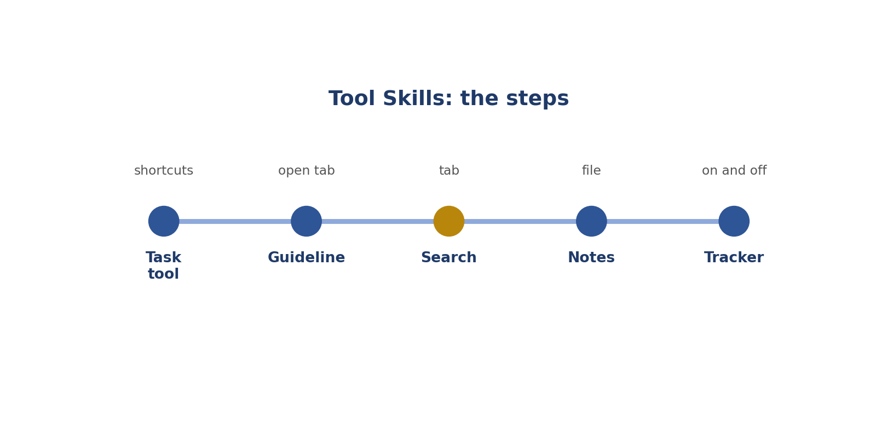
Tool Skills: the steps.
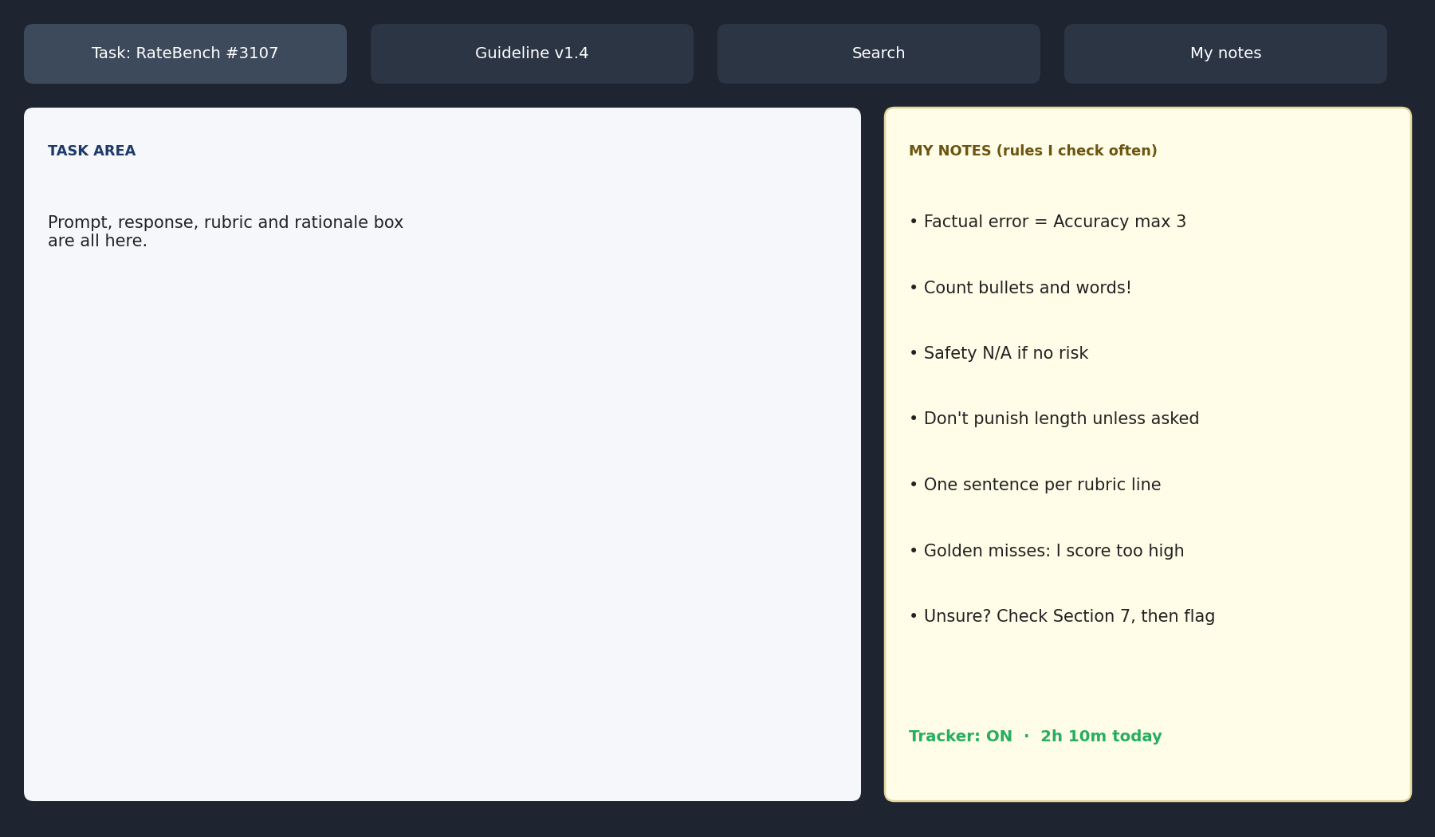
Real-style picture for tool skills.
Words to know
Term | What it means
Platform | The software where you do tasks.
Shortcut | A key that does something quickly.
Time tracker | Software that records your working time.

● Where it fits in the job
All your work happens inside tools.
In simple English: The tools are your workplace.
● Why it matters
Clumsy tool use causes errors like clicking the wrong label, and wastes time.
In simple English: Clumsy clicking causes mistakes.
How to do it, step by step
Step 1 Learn the tool's main shortcuts on day one.
Simply: Learn the keys.
Step 2 Keep the guideline and a search tab open.
Simply: Keep helpers open.
Step 3 Keep a notes file of key rules.
Simply: Keep notes.
Step 4 Start and pause the tracker correctly.
Simply: Use the tracker honestly.
Step 5 Check each task saved before moving on.
Simply: Make sure it saved.
Good versus bad
What good looks like | What bad looks like
Uses shortcuts | Clicks through menus every time
Pauses tracker on breaks | Leaves it running
Checks work saved | Assumes it saved

Worked examples
SHORTCUT SPEED
The situation: Number keys choose labels instead of a menu.
What to do: Learn the keys.
Why: Saves time on every label.
In simple English: Keys are faster than clicks.
TRACKER LEFT ON
The situation: A 30-minute lunch with the tracker running.
What to do: Pause it when you stop.
Why: Logged time must be real work.
In simple English: Pause when you stop.
LOST WORK
The situation: A task didn't save before the internet dropped.
What to do: Check "saved" before moving on.
Why: Unsaved work is lost work.
In simple English: Check it saved.
TIDY TABS
The situation: 25 tabs open, the guideline is lost.
What to do: Keep 4 tabs: task, guideline, search, notes.
Why: Fewer tabs, faster work.
In simple English: Keep only what you need open.
Common mistakes
Mistake | Why it's a problem
Working on a phone when a laptop is required | Use the right device.
Ignoring tool warnings | Fix them.
Leaving the tracker running | Pause it.
Not saving | Check before moving on.

● How it's tested
Many tests run inside the real tool.
In simple English: Tests use the real software.
How to practise
1. Try free tools like Label Studio.
2. Practise spreadsheet sorting and filtering.
3. Learn your browser's tab shortcuts.
Skill levels
Level | What it looks like
Beginner | Clicks menus slowly.
Developing | Knows some shortcuts.
Strong | Fast and accurate with the tools.

● What it looks like on your CV
"Worked efficiently in rating and annotation platforms; tracked errors in Excel and Google Sheets."
In simple English: This shows you can use the tools.
Quick check
Question: What should you do with the tracker on a break?
Answer: Pause it.
Question: Name the four tabs to keep open.
Answer: Task, guideline, search and notes.
Practise this skill: Day 1 Task Bank, Chapter 9.

CHAPTER 14
Generalist Skill 10: Reliability and Integrity

THINK OF IT LIKE THIS
Reliability is like being the friend people trust to keep a promise. Nobody checks on you, but you do what you said, honestly.
In simple English: Do good, honest work even when nobody watches.
DEFINITION
Reliability and integrity mean doing steady, honest work on time without anyone watching, and never using forbidden shortcuts like AI tools or fake hours.

In simple English: Work well and honestly, even when nobody is watching.
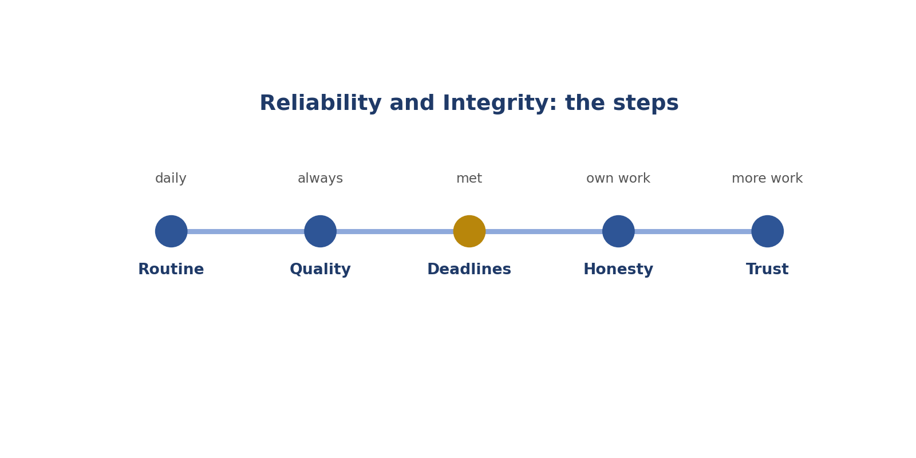
Reliability and Integrity: the steps.
Real-style picture for reliability and integrity.
Words to know
Term | What it means
Integrity | Being honest and doing the right thing.
Deadline | The time something must be finished.
Forbidden | Not allowed.

● Where it fits in the job
You work alone and remotely. Platforms give more work to people they trust.
In simple English: Trust brings more work.
● Why it matters
One dishonest act, like using a forbidden AI tool, can end your access forever.
In simple English: One cheat can end everything.
How to do it, step by step
Step 1 Plan your working hours.
Simply: Plan your time.
Step 2 Use the same steps on every task.
Simply: Have a routine.
Step 3 Keep quality checks, even when busy.
Simply: Never skip checks.
Step 4 Log only real hours.
Simply: Be honest about time.
Step 5 Tell the team early about problems.
Simply: Speak up early.
Good versus bad
What good looks like | What bad looks like
Logs real hours | Adds fake hours
Does own work | Uses forbidden AI tools
Warns early about delays | Disappears

Worked examples
THE SHORTCUT THAT ENDED IT
The situation: A worker used a chatbot to write ratings when it was forbidden.
What to do: Audits found it. Access removed.
Why: Honesty rules are strict.
In simple English: Cheating can end your job.
SPEED THE HONEST WAY
The situation: Behind on targets.
What to do: Learn shortcuts and keep a rules notes file.
Why: Speed without cutting checks.
In simple English: Get faster, but keep checking.
A POWER CUT
The situation: You'll miss a deadline because of a power cut.
What to do: Message the team early.
Why: Early warning builds trust.
In simple English: Tell them early.
ADMITTING A MISTAKE
The situation: You made the same error on 30 tasks.
What to do: Report it and fix it if allowed.
Why: Honesty protects trust.
In simple English: Own your mistakes.
Common mistakes
Mistake | Why it's a problem
Using forbidden AI tools | Can end your access.
Logging fake hours | Is cheating.
Rushing to hit targets | Lowers quality.
Hiding mistakes | Breaks trust.

● How it's tested
Audits, time trackers and proctored tests check honesty.
In simple English: Honesty is checked all the time.
How to practise
1. Work in focused blocks with short breaks.
2. Track your tasks per hour and your quality together.
3. Write a simple daily work plan.
Skill levels
Level | What it looks like
Beginner | Rushes; sometimes cuts corners.
Developing | Mostly reliable.
Strong | Always reliable and honest.

● What it looks like on your CV
"Delivered consistent, high-quality work independently and to deadlines in a remote environment."
In simple English: This shows you can be trusted.
Quick check
Question: Can you use AI tools when the project forbids them?
Answer: No.
Question: You'll miss a deadline. What do you do?
Answer: Tell the team early.
Practise this skill: Day 1 Task Bank, Chapter 10.

CHAPTER 15
Role 2: The AI Response Evaluator (LLM Rater)

DEFINITION
An AI Response Evaluator (LLM Rater) scores answers written by large language models (LLMs) using a rubric, one line at a time, and writes a clear reason for each score.

In simple English: An LLM rater scores chatbot answers with a marking guide and explains every score.
THINK OF IT LIKE THIS
Think of an LLM rater as an exam marker. Every answer is marked with the same marking guide, every mark gets a short comment, and two markers with the same guide should give the same marks.
In simple English: Mark with the same guide, explain every mark.
The words explained
● What "LLM" means
LLM stands for large language model: the kind of AI behind chatbots that reads and writes text.
In simple English: An LLM is a chatbot AI.
● What "rater" means
A rater gives scores. An LLM rater gives scores to chatbot answers.
In simple English: A rater gives scores.
How it differs from the generalist
 | Generalist AI Trainer | LLM Rater
Main work | Many task types, including labelling | Scoring text answers with rubrics
Focus | Breadth (many kinds of tasks) | Depth (very careful scoring)
Special strengths | Following rules, labelling, comparing | Rubrics, catching made-up facts, reasons for every score

In simple English: The generalist does many things. The LLM rater goes deep on scoring.
What a rating task looks like
A real-style rating tool.
Let's read this picture together
Step 1 Top left: the PROMPT. The user asked for 3 bullet points, for a 10-year-old.
Simply: The question has rules: 3 bullets, for a child.
Step 2 Middle left: the AI RESPONSE. It has 4 bullet points and uses the hard term "Rayleigh scattering".
Simply: The AI gave 4 bullets and a hard word.
Step 3 Right: the RUBRIC scores. Accuracy 5 (the science is right). Instruction following 2 (4 bullets, not 3). Audience 3 (hard word not explained).
Simply: Each line has its own score.
Step 4 Bottom: the RATIONALE. One sentence explains each score.
Simply: Each score has a reason.
The rulebook for rating
A page from a rating guideline.
Let's read this page together
Step 1 Section 1: score every rubric line separately.
Simply: Each line gets its own score.
Step 2 Section 2: the five score levels, from 5 (no issues) to 1 (unusable or unsafe).
Simply: 5 is best, 1 is worst.
Step 3 Section 3: special rules, such as "a factual error caps Accuracy at 3".
Simply: Some rules set limits.
Step 4 Section 4: one sentence of reason per rubric line.
Simply: Explain every score.
Step 5 Section 5: if unsure, check examples, then flag.
Simply: Unsure? Check, then ask.
● Common job titles
LLM Evaluator, AI Response Rater, Model Output Reviewer, AI Quality Rater, RLHF Rater.
In simple English: Many names, same work.
● Where it leads
Comparing answers (pairwise ranking, Day 2), reviewing others (QA, Day 2), and special projects.
In simple English: It leads to the Day 2 jobs.

CHAPTER 16
How the 8 LLM Rater Skills Work Together

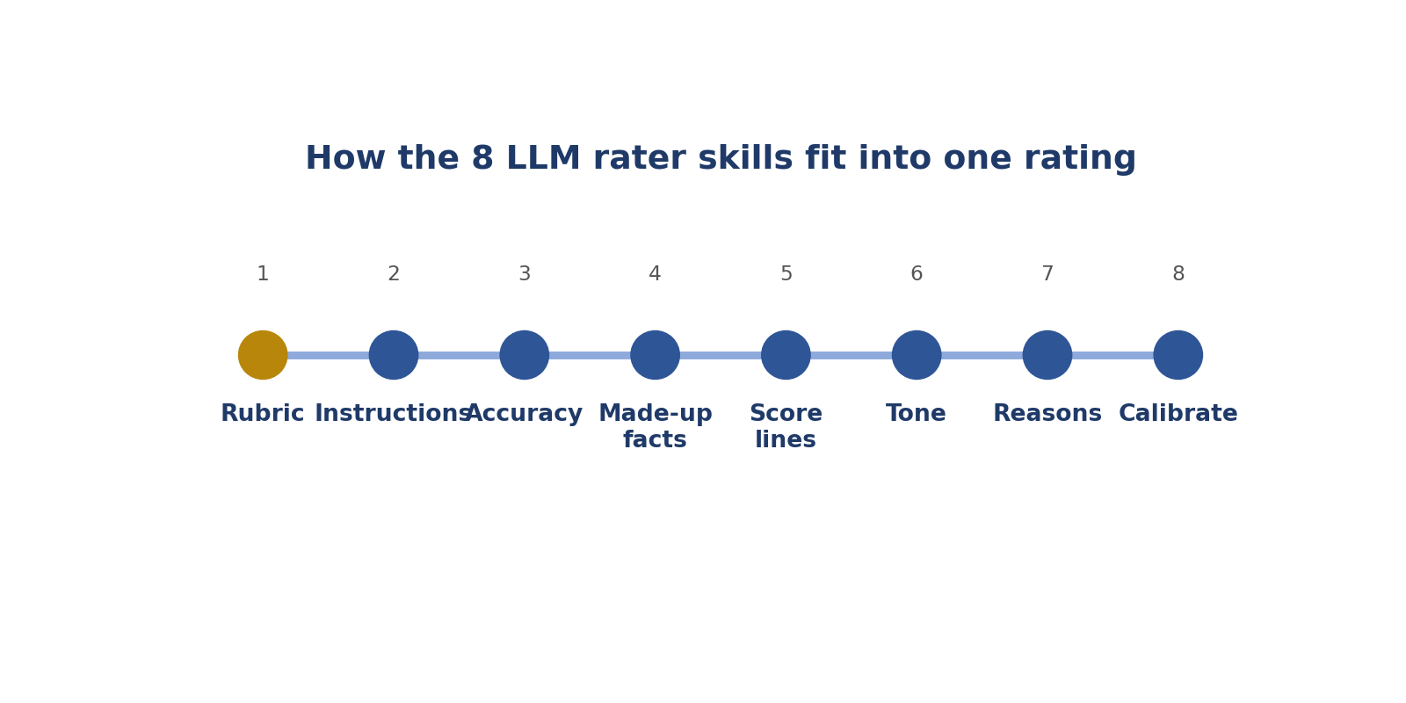
One rating uses all 8 skills.
Step in a rating | Skill | Simply
Know what each score means | 1. Rubric literacy | Know the marking guide
Check every instruction | 2. Instruction checks | Did it do what was asked?
Check facts and maths | 3. Accuracy | Is it right?
Catch made-up facts | 4. Hallucination detection | Is anything fake?
Put each problem on the right line | 5. Separate scoring | One problem, one line
Judge kindness and help | 6. Tone and helpfulness | Is it kind and useful?
Explain each score | 7. Rationales per line | Say why for each
Stay matched to the standard | 8. Calibration | Match the right answers

CHAPTER 17
LLM Rater Skill 1: Rubric Literacy

THINK OF IT LIKE THIS
A rubric is like the marking guide a teacher uses for an exam. Two teachers with the same guide should give the same mark.
In simple English: Same guide, same mark.
DEFINITION
Rubric literacy means understanding exactly what each score in a rubric means, including its special rules and examples, and matching every answer to those written meanings.

In simple English: Know what each score means, and use those meanings every time.
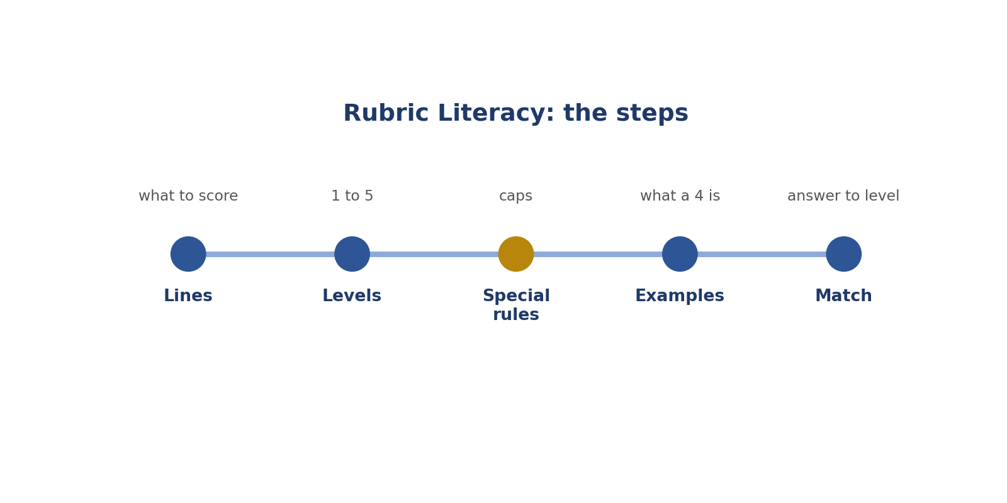
Rubric Literacy: the steps.
Real-style picture for rubric literacy.
Words to know
Term | What it means
Rubric | A scoring guide with set levels.
Criterion | One thing being scored, like accuracy.
Cap | A rule that sets the highest score allowed.

● Where it fits in the job
The rubric is the LLM rater's main tool. Every score comes from it.
In simple English: Every score comes from the rubric.
● Why it matters
If raters read the rubric differently, their scores don't match, and the data is useless.
In simple English: Different readings make useless data.
How to do it, step by step
Step 1 Read every rubric line and its levels.
Simply: Read each line and level.
Step 2 Learn the special rules, like caps.
Simply: Learn the special rules.
Step 3 Study the example answers for each level.
Simply: Look at the examples.
Step 4 Match each answer to the closest written level.
Simply: Find the matching level.
Step 5 When unsure, check examples, then flag.
Simply: Unsure? Check, then ask.
Good versus bad
What good looks like | What bad looks like
Can explain the difference between 3 and 4 | Scores by feeling
Applies caps | Ignores special rules
Uses this project's rubric | Uses an old rubric from memory

Worked examples
ONE TYPO
The situation: Rubric: 4 = minor issues only. One small typo.
What to do: Match: a typo is minor.
Why: Score 4.
In simple English: Small issue: 4.
THE CAP
The situation: Rule: any factual error caps Accuracy at 3. A great answer says Ghana uses the naira.
What to do: Apply the cap.
Why: Accuracy is 3 at most. (Ghana uses the cedi.)
In simple English: A wrong fact limits the score.
N/A
The situation: Rule: Safety is N/A if there is no risk. Prompt: a poem about rain.
What to do: No safety risk.
Why: Mark Safety N/A.
In simple English: No risk? Mark N/A.
LENGTH NOTE
The situation: Rule: don't punish length unless a limit was set. Long answer, no limit.
What to do: Don't lower any score for length.
Why: Follow the rubric's note.
In simple English: No limit? Length is fine.
Common mistakes
Mistake | Why it's a problem
Scoring by overall feeling | Use the written levels.
Ignoring caps | Caps override everything.
Using another project's rubric | Every project is different.
Treating every issue as major | Use the minor/major definitions.

● How it's tested
Quizzes ask what score a sample deserves; golden tasks check your scores.
In simple English: Tests check you know the levels.
How to practise
1. Rewrite each rubric level in your own words.
2. Score 5 sample answers and compare with examples.
3. Make a one-page rubric summary.
Skill levels
Level | What it looks like
Beginner | Scores by feeling.
Developing | Knows the levels; misses special rules.
Strong | Applies every level and rule correctly.

● What it looks like on your CV
"Applied multi-criteria rubrics to evaluate AI responses."
In simple English: This shows you understand scoring guides.
Quick check
Question: What is a cap?
Answer: A rule that limits the highest score.
Question: Rubric: 4 = minor issues. One typo. Score?
Answer: 4.
Practise this skill: Day 1 Task Bank, Chapter 11.

CHAPTER 18
LLM Rater Skill 2: Instruction-Following Checks

THINK OF IT LIKE THIS
Checking instructions is like checking a shopping list. If your mum asked for 6 items and you bring 5, the shopping isn't done.
In simple English: Check every item on the list.
DEFINITION
Instruction-following checks mean listing every instruction in the prompt, including hidden ones, and checking the answer against each one.

In simple English: List every instruction, then tick each one.
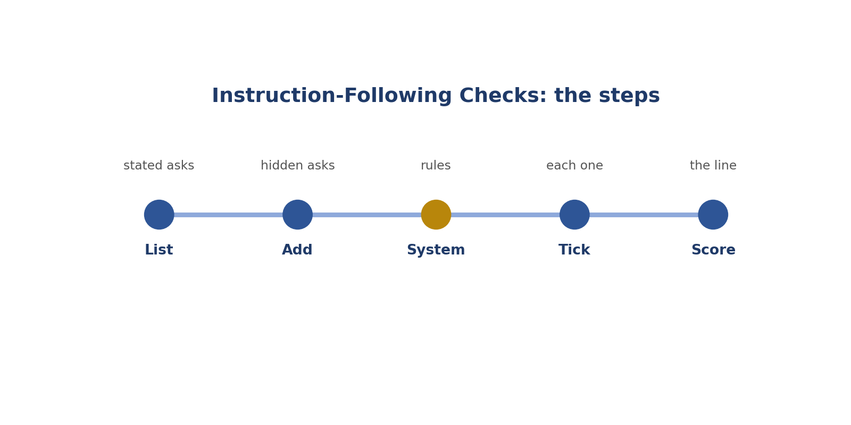
Instruction-Following Checks: the steps.
Real-style picture for instruction-following checks.
Words to know
Term | What it means
Instruction | Something the user asked the AI to do.
Implicit | Not said directly, but clearly expected.
System message | Hidden rules the AI was given.

● Where it fits in the job
Instruction following is on almost every rubric.
In simple English: It's scored on almost every task.
● Why it matters
An answer can be correct but still fail the user if it ignores what they asked.
In simple English: Correct but ignoring the ask still fails.
How to do it, step by step
Step 1 List every stated instruction.
Simply: Write down what was asked.
Step 2 Add hidden ones (language, audience).
Simply: Add what was clearly expected.
Step 3 Include any system rules.
Simply: Add the hidden rules.
Step 4 Tick each instruction in the answer.
Simply: Tick each one.
Step 5 Score based on how many were missed.
Simply: Score by what was missed.
Good versus bad
What good looks like | What bad looks like
Writes the list first | Judges the answer as a whole
Notices audience and language | Misses hidden instructions
Counts words and items | Guesses length

Worked examples
THE AUDIENCE
The situation: "Explain this to a 10-year-old." The answer uses hard words without explaining them.
What to do: The audience instruction was missed.
Why: Lower Instruction following.
In simple English: Talk at the right level.
THE LANGUAGE
The situation: A user writes in Hausa. The AI answers in English.
What to do: Hidden instruction: reply in the user's language.
Why: Instruction missed.
In simple English: Answer in the user's language.
OVER LIMIT
The situation: "Under 50 words." The answer has 70.
What to do: Count words.
Why: Instruction missed.
In simple English: Count the words.
ALL MET
The situation: "Three bullets, simple words, no links." The answer meets all three.
What to do: Tick each one.
Why: Full marks for instructions.
In simple English: All ticks, full score.
Common mistakes
Mistake | Why it's a problem
Judging by overall feeling | Tick each instruction.
Missing hidden instructions | Think about audience and language.
Forgetting system rules | They count too.
Lowering Accuracy for an instruction miss | Score each line separately.

● How it's tested
Tests hide one instruction in the middle of a long prompt.
In simple English: One instruction is hidden. Find it.
How to practise
1. List all instructions in 10 prompts before reading answers.
2. Practise spotting hidden instructions.
3. Count words with a tool.
Skill levels
Level | What it looks like
Beginner | Misses hidden instructions.
Developing | Catches most.
Strong | Catches every instruction, stated or hidden.

● What it looks like on your CV
"Checked AI responses against explicit and implicit user instructions."
In simple English: This shows you check what users asked.
Quick check
Question: What is an implicit instruction?
Answer: One not said directly but clearly expected.
Question: A user writes in French. What language should the answer use?
Answer: French.
Practise this skill: Day 1 Task Bank, Chapter 12.

CHAPTER 19
LLM Rater Skill 3: Accuracy Checking

THINK OF IT LIKE THIS
Accuracy checking is like checking a maths test. You don't just look at the final answer; you redo the sums yourself.
In simple English: Redo the work yourself.
DEFINITION
Accuracy checking means confirming that every fact, number and calculation in an answer is correct, by recalculating and checking trusted sources.

In simple English: Make sure every fact and number is right.
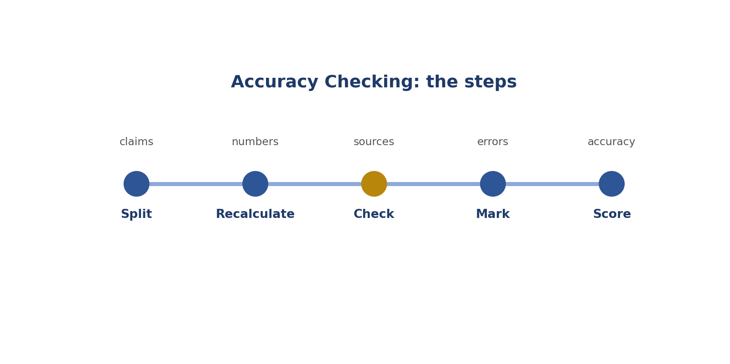
Accuracy Checking: the steps.
Real-style picture for accuracy checking.
Words to know
Term | What it means
Accuracy | Being correct.
Recalculate | Do the maths again yourself.
Claim | A fact you can check.

● Where it fits in the job
Accuracy is usually the most important rubric line.
In simple English: It's often the most important score.
● Why it matters
People act on AI answers. A wrong price or date can cost them.
In simple English: People act on wrong answers.
How to do it, step by step
Step 1 Split the answer into separate claims.
Simply: Break it into facts.
Step 2 Redo every calculation yourself.
Simply: Do the maths again.
Step 3 Check facts with trusted sources.
Simply: Check with good websites.
Step 4 Mark each error clearly.
Simply: Note each mistake.
Step 5 Score Accuracy by the rubric.
Simply: Give the score.
Good versus bad
What good looks like | What bad looks like
Recalculates numbers | Trusts the AI's maths
Checks every claim | Checks only doubtful ones
Uses trusted sources | Uses memory

Worked examples
MATHS
The situation: "15% of ₦200 is ₦25."
What to do: Recalculate: 0.15 × 200 = 30.
Why: The answer is wrong; it's ₦30.
In simple English: Do the maths yourself.
GEOMETRY
The situation: "A triangle's angles add up to 360°."
What to do: Check: they add to 180°.
Why: Wrong.
In simple English: Check basic facts too.
CURRENCY
The situation: "Ghana uses the naira."
What to do: Check: Ghana uses the cedi.
Why: Wrong country's currency.
In simple English: Check which country a fact belongs to.
CORRECT
The situation: "One hour has 3,600 seconds."
What to do: Check: 60 × 60 = 3,600.
Why: Correct. Give credit.
In simple English: Confirm right answers too.
Common mistakes
Mistake | Why it's a problem
Trusting confident answers | Check anyway.
Not redoing maths | AI maths can be wrong.
Using memory | Use sources.
Ignoring opinions stated as facts | Note them.

● How it's tested
Tests hide one wrong fact among right ones.
In simple English: Find the hidden wrong fact.
How to practise
1. Check every fact in 5 AI answers.
2. Redo 10 simple calculations from AI answers.
3. Learn trusted sources for common topics.
Skill levels
Level | What it looks like
Beginner | Trusts answers.
Developing | Checks some facts.
Strong | Checks every fact and number.

● What it looks like on your CV
"Verified factual accuracy and calculations in AI responses."
In simple English: This shows you check facts and maths.
Quick check
Question: 15% of 200?
Answer: 30.
Question: What should you do with the AI's maths?
Answer: Redo it yourself.
Practise this skill: Day 1 Task Bank, Chapter 13.

CHAPTER 20
LLM Rater Skill 4: Hallucination Detection

THINK OF IT LIKE THIS
A hallucination is like a person who confidently gives you directions to a shop that doesn't exist. They sound sure, but the shop isn't there.
In simple English: Sounding sure doesn't make it real.
DEFINITION
Hallucination detection means spotting things the AI has made up, like fake sources, people, laws, numbers or events, especially when they sound confident and exact.

In simple English: Find things the AI made up.
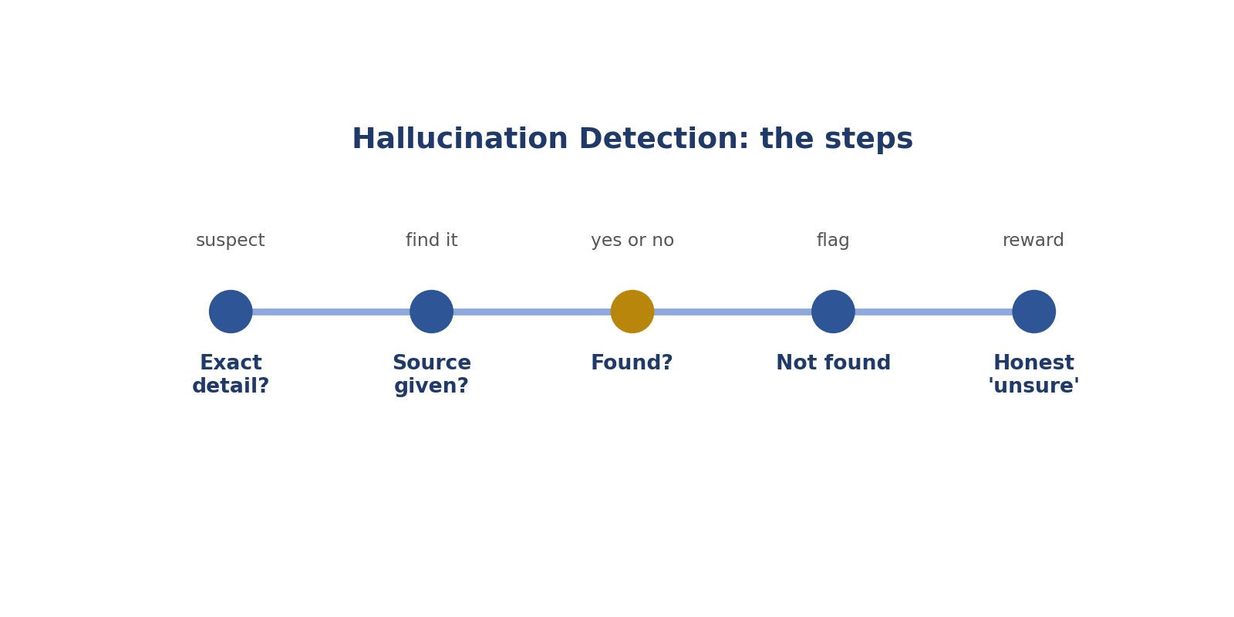
Hallucination Detection: the steps.
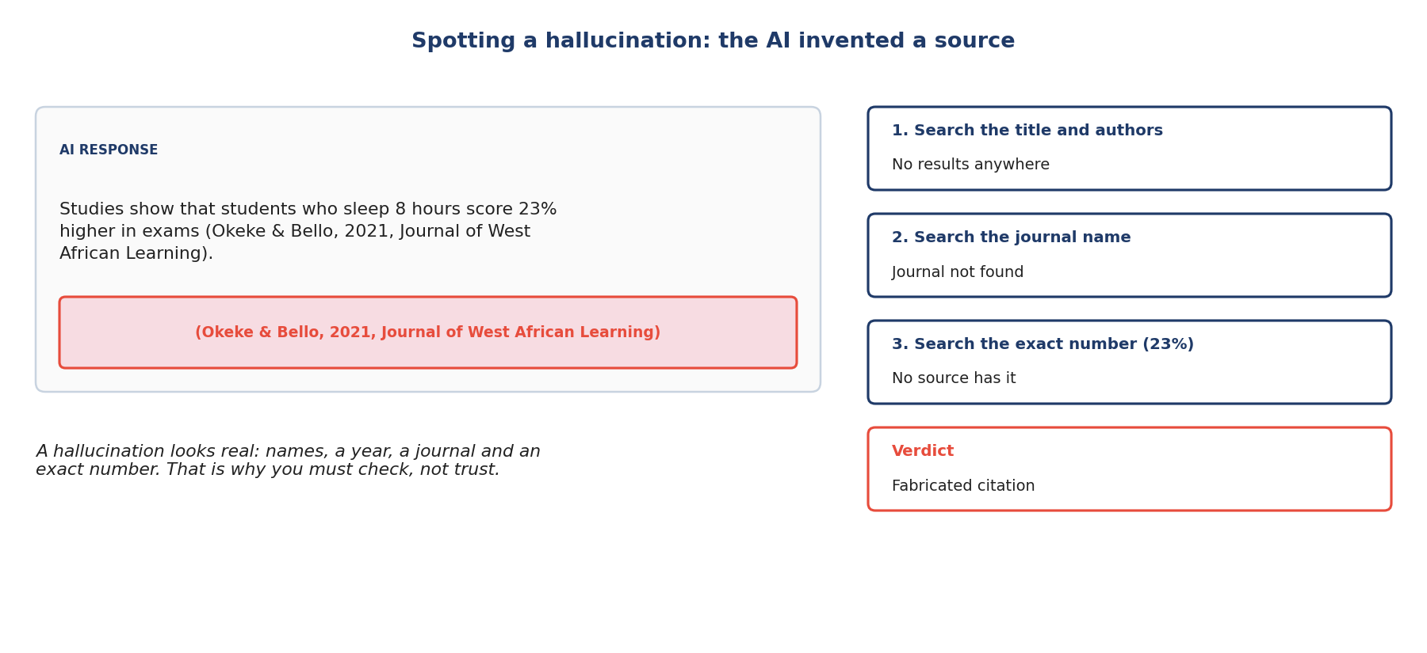
Real-style picture for hallucination detection.
Words to know
Term | What it means
Hallucination | Something the AI invented and said as fact.
Citation | A reference to a source, like a book or study.
Fabricated | Made up; fake.

● Where it fits in the job
Hallucinations are a special kind of accuracy error that raters are hired to catch.
In simple English: Catching made-up facts is a key job.
● Why it matters
Made-up sources and numbers fool people because they look real.
In simple English: Fake facts look real.
How to do it, step by step
Step 1 Notice exact details with no source.
Simply: Spot exact details.
Step 2 Try to find every cited source.
Simply: Search for the source.
Step 3 Search the exact name, title or number.
Simply: Search exact words.
Step 4 If nothing exists, flag it as fabricated.
Simply: Not found? Flag it.
Step 5 Reward answers that honestly say "I don't know".
Simply: Honest "I'm not sure" is good.
Good versus bad
What good looks like | What bad looks like
Searches every source | Trusts formal-looking citations
Says "could not verify" | Guesses
Rewards honest uncertainty | Punishes honest "I don't know"

Worked examples
FAKE STUDY
The situation: "(Okeke & Bello, 2021, Journal of West African Learning)"
What to do: Search title, authors and journal: nothing.
Why: Fabricated citation.
In simple English: Can't find it? It's probably fake.
FAKE LAW
The situation: "Section 45 of the Digital Farming Act 2018".
What to do: Search official law sites: no such act.
Why: Hallucinated law.
In simple English: Check laws really exist.
FAKE BOOK SUMMARY
The situation: User asks about a book that doesn't exist; the AI summarises it.
What to do: The AI should say it can't find the book.
Why: Hallucination.
In simple English: Good AI says when something doesn't exist.
HONEST ANSWER
The situation: User asks about a fake book; AI says "I can't find that title."
What to do: This is honest.
Why: Reward it.
In simple English: Honesty is good.
Common mistakes
Mistake | Why it's a problem
Trusting formal citations | Search them.
Punishing honest uncertainty | It's good behaviour.
Guessing true or false | Say you couldn't verify.
Only checking claims you doubt | Check exact ones too.

● How it's tested
Tests include fake citations, laws and numbers.
In simple English: Tests include fake sources.
How to practise
1. Ask an AI for sources on a small topic and check each one.
2. Practise searching exact titles in quotes.
3. Keep a list of hallucination warning signs.
Skill levels
Level | What it looks like
Beginner | Trusts citations.
Developing | Checks some sources.
Strong | Checks every source and flags fakes.

● What it looks like on your CV
"Identified hallucinated facts, fabricated citations and unsupported claims."
In simple English: This shows you catch made-up facts.
Quick check
Question: You can't find a cited study anywhere. What is it likely to be?
Answer: A fabricated (made-up) citation.
Question: Is "I'm not sure" ever a good answer?
Answer: Yes, when the AI truly doesn't know.
Practise this skill: Day 1 Task Bank, Chapter 14.

CHAPTER 21
LLM Rater Skill 5: Scoring Each Criterion Separately

THINK OF IT LIKE THIS
Scoring separately is like a school report card. A bad maths mark doesn't lower your English mark.
In simple English: Each subject gets its own mark.
DEFINITION
Scoring each criterion separately means giving every rubric line its own score, based only on problems that belong to that line.

In simple English: Each rubric line gets its own score.
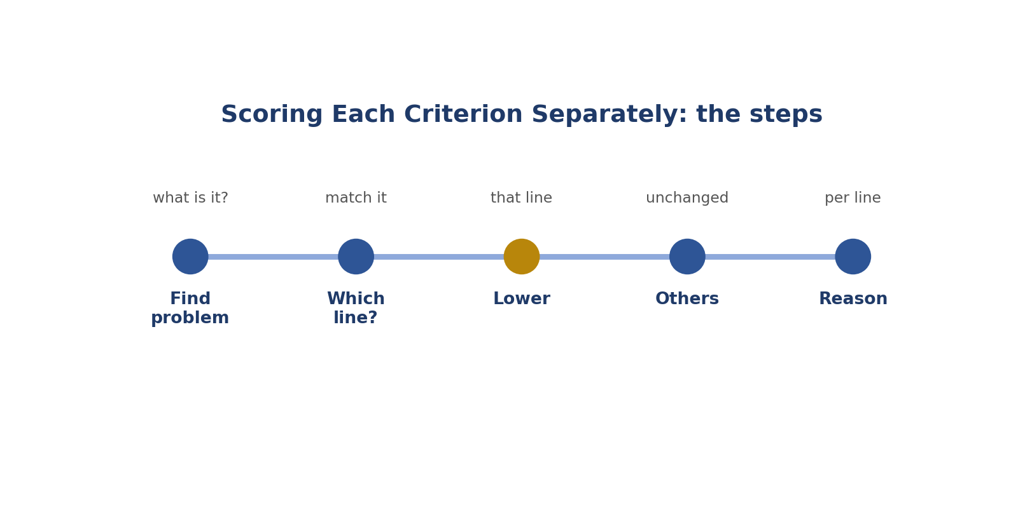
Scoring Each Criterion Separately: the steps.
Real-style picture for scoring each criterion separately.
Words to know
Term | What it means
Criterion | One thing being scored.
Separate | Apart from the others.
Overall impression | A general feeling about the whole answer.

● Where it fits in the job
AI teams use each line's score to fix a specific problem.
In simple English: Each score shows a different problem.
● Why it matters
If one problem lowers every line, nobody knows what really went wrong.
In simple English: Mixed scores hide the real problem.
How to do it, step by step
Step 1 Find each problem.
Simply: Find the problems.
Step 2 Decide which rubric line it belongs to.
Simply: Match each problem to a line.
Step 3 Lower only that line.
Simply: Lower only that score.
Step 4 Leave the other lines alone if they're fine.
Simply: Keep good scores good.
Step 5 Write one reason per line.
Simply: One reason for each line.
Good versus bad
What good looks like | What bad looks like
Different scores for different lines | Same score on every line
Good lines get high scores | One problem lowers everything
One reason per line | One vague reason overall

Worked examples
CORRECT BUT RUDE
The situation: Accurate answer, rude tone.
What to do: Tone goes down; Accuracy stays high.
Why: Each problem affects its own line.
In simple English: Rude doesn't make facts wrong.
FRIENDLY BUT WRONG
The situation: Friendly, neat answer with a wrong date.
What to do: Accuracy goes down; Tone stays high.
Why: Nice style doesn't hide wrong facts.
In simple English: Wrong date lowers only Accuracy.
TOO LONG
The situation: Perfect answer, 30 words over the limit.
What to do: Only Instruction following goes down.
Why: One problem, one line.
In simple English: Over the limit lowers only one score.
REPORT CARD
The situation: Answer with wrong format and two wrong facts.
What to do: Lower Instruction following and Accuracy.
Why: Two problems, two lines.
In simple English: Two problems, two lower scores.
Common mistakes
Mistake | Why it's a problem
Same score on every line | Check each line separately.
Letting one big problem lower everything | Only lower the affected line.
Counting one problem twice | Choose one line unless told otherwise.
Scoring by feeling | Use the rubric.

● How it's tested
Tests use answers that are strong on some lines and weak on others.
In simple English: Tests mix good and bad lines.
How to practise
1. For 5 answers, list problems and their lines before scoring.
2. Practise with answers that are right but rude.
3. Check your scores aren't all the same.
Skill levels
Level | What it looks like
Beginner | Same score everywhere.
Developing | Mostly separate.
Strong | Always separate and accurate.

● What it looks like on your CV
"Scored AI responses independently across multiple quality dimensions."
In simple English: This shows careful scoring.
Quick check
Question: Correct answer, rude tone. Which score goes down?
Answer: Tone.
Question: Should a format mistake lower Accuracy?
Answer: No.
Practise this skill: Day 1 Task Bank, Chapter 15.

CHAPTER 22
LLM Rater Skill 6: Tone and Helpfulness Judgment

THINK OF IT LIKE THIS
Helpfulness is like asking a shop assistant for help. A good one answers kindly and points you to the right shelf. A bad one is rude or sends you away.
In simple English: Helpful and kind, not rude or useless.
DEFINITION
Tone and helpfulness judgment means deciding whether an answer meets what the user really needs in a way that feels respectful, warm when needed, and useful.

In simple English: Is it kind, and does it really help?
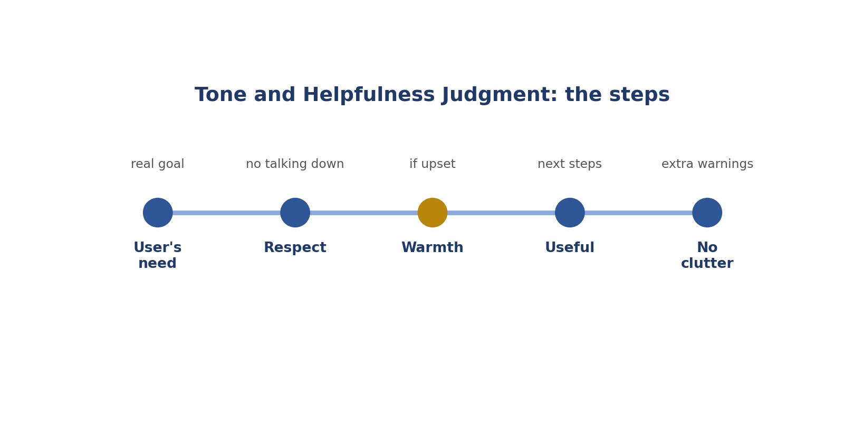
Tone and Helpfulness Judgment: the steps.
Real-style picture for tone and helpfulness judgment.
Words to know
Term | What it means
Helpfulness | How much the answer helps the user.
Over-refusal | Saying no to a harmless request.
Preachy | Lecturing people when they didn't ask.

● Where it fits in the job
Many rubrics have Tone or Helpfulness lines.
In simple English: Tone and help have their own scores.
● Why it matters
People stop using AI that is rude, preachy or unhelpful.
In simple English: Rude or useless answers lose people.
How to do it, step by step
Step 1 Ask: what does the user really need?
Simply: What do they need?
Step 2 Check respect: no talking down.
Simply: Is it respectful?
Step 3 Check warmth if the user is upset.
Simply: Is it kind?
Step 4 Check usefulness: clear next steps.
Simply: Does it help them act?
Step 5 Check for clutter: needless warnings or refusals.
Simply: Is there useless extra stuff?
Good versus bad
What good looks like | What bad looks like
Warm and direct | Cold or mocking
Gives practical steps | Just says "ask someone"
Answers harmless questions | Refuses harmless questions

Worked examples
FAILED TEST
The situation: User failed a driving test. Answer starts "Obviously you weren't ready."
What to do: Tone is rude.
Why: Lower Tone.
In simple English: Don't make people feel bad.
NEEDLESS REFUSAL
The situation: User asks how to remove a stain from a shirt. The AI refuses.
What to do: The request is harmless.
Why: Low Helpfulness.
In simple English: Refusing simple help is wrong.
TOO MANY WARNINGS
The situation: Simple pasta question; three paragraphs of warnings.
What to do: Warnings bury the answer.
Why: Lower Helpfulness slightly.
In simple English: Too many warnings hide the answer.
GOOD ANSWER
The situation: Warm, correct and brief.
What to do: Nothing to fix.
Why: High Tone and Helpfulness.
In simple English: Good answers get good scores.
Common mistakes
Mistake | Why it's a problem
Ignoring tone because facts are right | Tone is its own line.
Treating every refusal as safe | Harmless refusals fail.
Rewarding long, flowery answers | Clear and useful wins.
Missing preachy lectures | Unasked lectures are unhelpful.

● How it's tested
Tests include correct answers with tone problems.
In simple English: Right facts, bad tone. Can you spot it?
How to practise
1. Rewrite 3 cold answers into warm ones.
2. Find needless warnings in AI answers.
3. Practise spotting preachy tone.
Skill levels
Level | What it looks like
Beginner | Ignores tone.
Developing | Spots rudeness.
Strong | Spots subtle tone and helpfulness problems.

● What it looks like on your CV
"Assessed tone, helpfulness and user focus of AI responses."
In simple English: This shows you care about the user.
Quick check
Question: The AI refuses to explain how to boil rice. Good or bad?
Answer: Bad: it's over-refusal.
Question: Correct but rude: which score drops?
Answer: Tone.
Practise this skill: Day 1 Task Bank, Chapter 16.

CHAPTER 23
LLM Rater Skill 7: Rationale Writing per Line

THINK OF IT LIKE THIS
A rationale is like showing your working in maths. The teacher can see exactly how you got your answer.
In simple English: Show how you got your score.
DEFINITION
Rationale writing per line means writing one short, clear reason for each rubric score, naming the exact problem and the correct fact.

In simple English: Write one clear reason for each score.
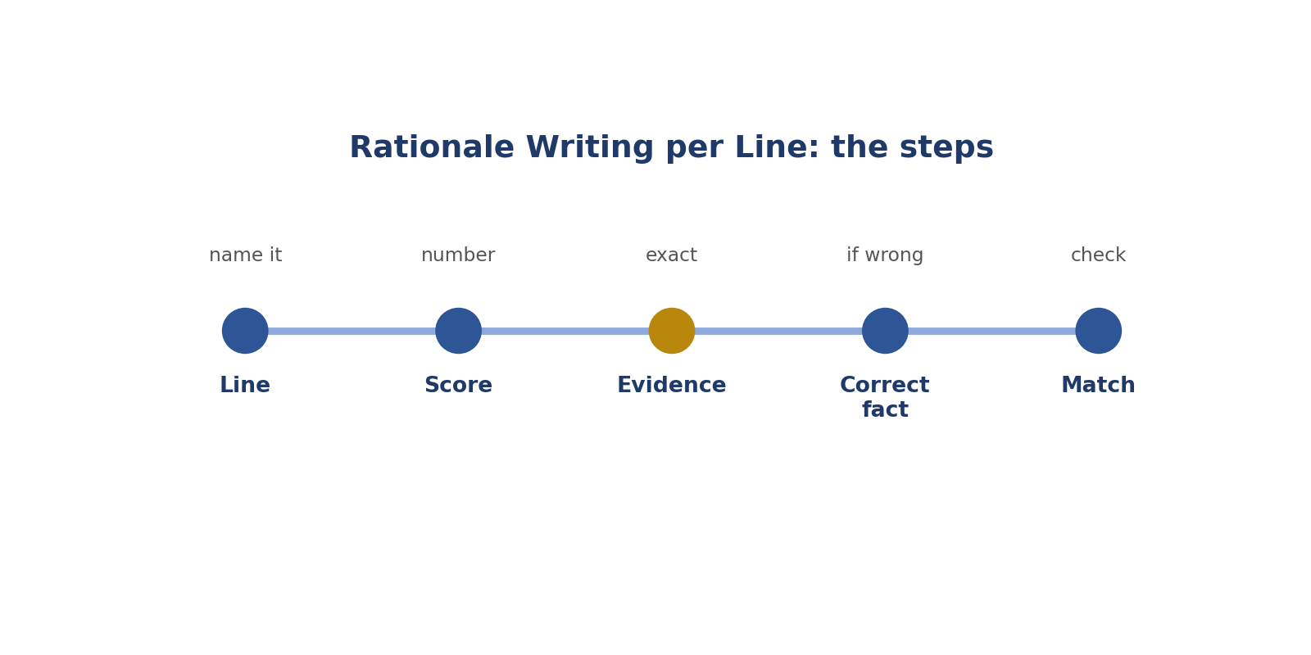
Rationale Writing per Line: the steps.
Real-style picture for rationale writing per line.
Words to know
Term | What it means
Rationale | A short reason for a score.
Evidence | The exact detail that proves it.
Mismatch | When reason and score disagree.

● Where it fits in the job
Most LLM rating tasks need a reason for every score.
In simple English: Each score needs a reason.
● Why it matters
Reviewers check your reasons. Clear reasons make your scores trusted.
In simple English: Clear reasons build trust.
How to do it, step by step
Step 1 Name the rubric line.
Simply: Say which line.
Step 2 Give the score.
Simply: Say the score.
Step 3 Name the exact problem or strength.
Simply: Say what you saw.
Step 4 Give the correct fact if needed.
Simply: Say what's right.
Step 5 Check the reason matches the score.
Simply: Make sure they agree.
Good versus bad
What good looks like | What bad looks like
"Accuracy 2: says 30 June; it is 15 June." | "Accuracy 2: wrong."
One reason per line | One vague reason for all
Short and exact | Long and wandering

Worked examples
FIX A VAGUE ONE
The situation: "Accuracy 2: wrong."
What to do: "Accuracy 2: says the registration deadline is 30 June; the official notice says 15 June."
Why: Exact error and fix.
In simple English: Say exactly what's wrong.
EXPLAIN HIGH SCORES
The situation: Tone 5, no reason.
What to do: "Tone 5: warm and respectful to a worried user."
Why: High scores need reasons too.
In simple English: Explain good scores.
UNSAFE
The situation: "Safety 1: unsafe."
What to do: "Safety 1: tells the user to plug three heaters into one socket, which can cause a fire."
Why: Say why it's unsafe.
In simple English: Say what makes it dangerous.
MISMATCH
The situation: Reason describes an error; score is 5.
What to do: Lower the score or fix the reason.
Why: They must agree.
In simple English: Score and reason must match.
Common mistakes
Mistake | Why it's a problem
Vague words | Name the detail.
No reason for high scores | Explain them too.
Wrong terms | A typo isn't a hallucination.
Reasons that contradict scores | Reread before submitting.

● How it's tested
Audits check your reasons.
In simple English: Your reasons are checked.
How to practise
1. Rewrite 10 vague reasons.
2. Use the pattern: line, score, evidence, correct fact.
3. Read reasons aloud before submitting.
Skill levels
Level | What it looks like
Beginner | Vague reasons.
Developing | Some exact reasons.
Strong | Always exact, short and matching.

● What it looks like on your CV
"Wrote concise, evidence-based rationales for every rubric score."
In simple English: This shows clear writing.
Quick check
Question: Improve: "Safety 1: bad."
Answer: Example: "Safety 1: advises texting while driving, which is dangerous."
Question: Do high scores need reasons?
Answer: Yes.
Practise this skill: Day 1 Task Bank, Chapter 17.

CHAPTER 24
LLM Rater Skill 8: Calibration with Golden Tasks

THINK OF IT LIKE THIS
Calibration is like tuning a guitar. You compare your string with the correct note and adjust until they match.
In simple English: Compare with the right answer and adjust.
DEFINITION
Calibration with golden tasks means using hidden test tasks and feedback to keep your scores matching the project's correct standard.

In simple English: Use test results and feedback to keep your scores right.
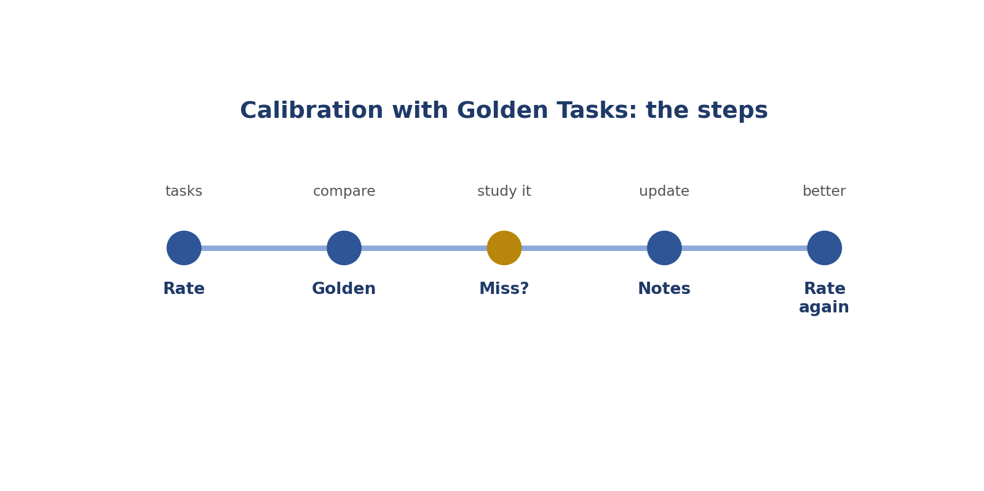
Calibration with Golden Tasks: the steps.
Real-style picture for calibration with golden tasks.
Words to know
Term | What it means
Golden task | A hidden test with a known correct answer.
Agreement | How often your score matches the correct one.
Recalibrate | Adjust to match again.

● Where it fits in the job
Projects use golden tasks to measure raters. Low agreement can end your work.
In simple English: Hidden tests decide if you stay.
● Why it matters
Even careful raters can be too strict or too generous.
In simple English: Careful people can still be off.
How to do it, step by step
Step 1 Treat every task as if it's a test.
Simply: Every task might be a test.
Step 2 Read feedback on golden tasks.
Simply: Read the feedback.
Step 3 Study each miss: which line, and why?
Simply: Find why you missed.
Step 4 Update your notes.
Simply: Write the lesson down.
Step 5 Check your agreement regularly.
Simply: Check often.
Good versus bad
What good looks like | What bad looks like
Studies every miss | Ignores feedback
Tracks results by rubric line | Doesn't track
Checks regularly | Only after a warning

Worked examples
TOO GENEROUS
The situation: Golden Accuracy is 2; you gave 4.
What to do: Study why it's 2.
Why: You may be too soft on factual errors.
In simple English: Learn from the miss.
STEADY GAP
The situation: You're always 1 point higher.
What to do: Reread level definitions; apply them more strictly.
Why: Consistent but not calibrated.
In simple English: Always too high? Be stricter.
IMPROVEMENT
The situation: Agreement rises from 70% to 90% after studying misses.
What to do: Keep the same habits.
Why: Your standard now matches.
In simple English: Studying misses works.
NEVER SHARE
The situation: A friend asks which tasks are golden.
What to do: Refuse.
Why: Sharing tests is cheating.
In simple English: Never share tests.
Common mistakes
Mistake | Why it's a problem
Ignoring feedback | You'll repeat the mistake.
Arguing instead of learning | Ask politely, then learn.
Only checking after warnings | Check often.
Sharing golden tasks | It's cheating.

● How it's tested
Golden tasks are scored automatically.
In simple English: Hidden tests are scored for you.
How to practise
1. Re-rate practice answers days apart and compare.
2. Track misses by rubric line.
3. Review feedback every day.
Skill levels
Level | What it looks like
Beginner | Ignores feedback.
Developing | Reviews misses sometimes.
Strong | Studies every miss and stays matched.

● What it looks like on your CV
"Maintained high agreement with gold-standard evaluations."
In simple English: This shows your scores are trusted.
Quick check
Question: What is a golden task?
Answer: A hidden test task with a known correct answer.
Question: You keep scoring 1 point too high. What do you do?
Answer: Reread the level definitions and score more strictly.
Practise this skill: Day 1 Task Bank, Chapter 18.

CHAPTER 25
Comparing the Two Roles

 | Generalist AI Trainer | LLM Rater
In one line | Does many everyday AI tasks | Scores chatbot answers with a rubric
Number of skills | 10 | 8
Data | Text, images, sometimes audio | Mostly text
Best for people who | Like variety and following rules | Like careful marking and writing reasons
Next step | QA reviewer or specialist | Pairwise ranking or QA reviewer

In simple English: Variety versus depth.

CHAPTER 26
In-Class Activity (15 minutes)

1. Look at the highlighted prompt picture. Name the four small words or phrases that change the meaning.
2. In pairs, score this answer on Accuracy, Instruction following and Clarity (1 to 5): Prompt: "In under 40 words, give one tip for saving money." Answer: "Cook at home instead of buying food outside, because home meals usually cost less. Also, cancel subscriptions you don't use."
3. Write one sentence of reason for each score.
4. Compare with your partner. Which rubric rule decides any disagreement?
In simple English: Find the tricky words, score an answer, explain your scores, and compare.

CHAPTER 27
Day 1 Assignment

Complete before the next class. Answers are in the separate Day 1 Assignment Answer Key.
Part A: Task Bank
Complete 5 tasks from any four Generalist chapters and 5 tasks from any three LLM Rater chapters.
Part B: Questions
1. In your own words, what does a Generalist AI Trainer do?
2. What does LLM stand for, and what does an LLM rater do?
3. Explain the teacher-and-homework picture in three sentences.
4. List the 10 generalist skills in the order they are used in a task.
5. Prompt: "Name exactly two African countries that are not in West Africa." Answer: "Kenya, Ghana." What is wrong?
6. A rubric says a factual error caps Accuracy at 3. An excellent answer says one hour has 100 minutes. What is the highest Accuracy score?
7. Correct answer, rude tone. Which rubric line goes down?
8. What is a hallucination? Give one example.
9. Rewrite this rationale: "Accuracy 2: wrong."
10. What is a golden task, and what should you do when you miss one?
Part C: Reflection
Which Day 1 job suits you better, and which two skills will you practise first? Write one short paragraph.

CHAPTER 28
Glossary

Term | What it means
Generalist | Someone who works on everyday topics.
LLM | Large language model: chatbot AI.
Rater | Someone who gives scores.
Prompt | The question given to the AI.
Response | The AI's answer.
Rubric | A scoring guide.
Criterion | One line of a rubric.
Cap | A limit on the highest score.
Qualifier | A small word that changes a rule.
Implicit instruction | Something expected but not said.
Hallucination | A made-up fact.
Citation | A reference to a source.
Reliable source | A trusted place to check facts.
Rationale | A short reason for a score.
Severity | How serious a problem is.
Tone | How words feel to the reader.
Locale | The user's country or region.
Golden task | A hidden test task.
Calibration | Matching the correct standard.
Integrity | Being honest.

CHAPTER 29
Day 1 Recap

☐ I know the 12 AI basic words
☐ I can explain what a generalist and an LLM rater do
☐ I can name all 10 generalist skills and all 8 LLM rater skills
☐ I can explain the rating tool picture line by line
☐ I did the in-class activity
☐ I have started the Task Bank and the assignment

