Hyderabad Annual Tree Survey Report

Ram Dayal Vaishnav

2024-09-03

## Hyderabad Annual Tree Survey Report

With rapid urbanization transforming Indian cities, understanding and preserving urban biodiversity is crucial. The Hyderabad Annual Tree Survey leverages citizen science to document and conserve the city’s flora and fauna.

Methodologically, the survey employed a custom web app and iNaturalist for data collection. Volunteers, organized into teams, surveyed both avenue and non-avenue locations, recording detailed information on tree species, diameter, and related observations, alongside animal counts and activities.

A pilot survey refined these methods, leading to a comprehensive survey of over 750 trees and 120 species across Hyderabad. This initiative provides essential insights into species distribution and the impacts of urbanization on biodiversity, guiding future conservation efforts.

## Data Analysis

### Tree Species and Observations

The survey covered over 750 trees, identifying 120 species. Key findings include:

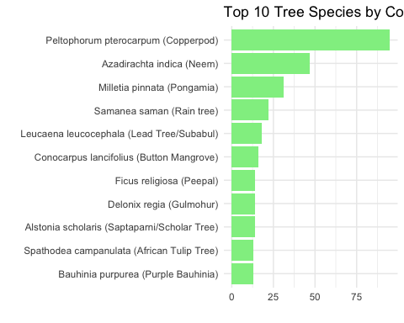

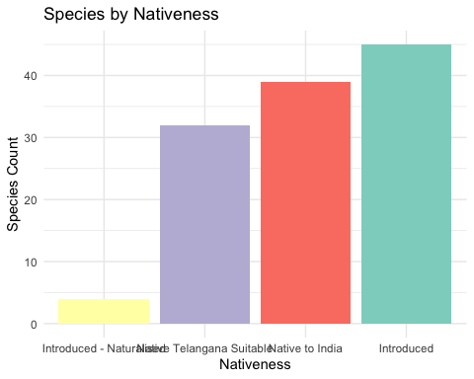

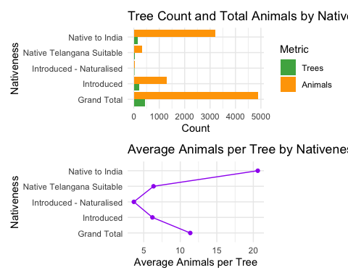

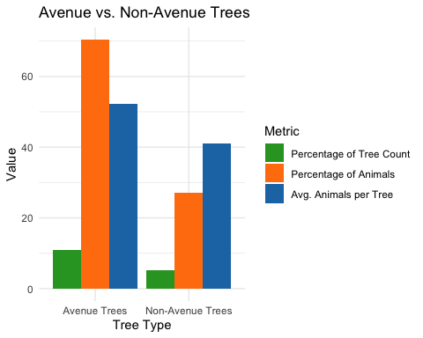

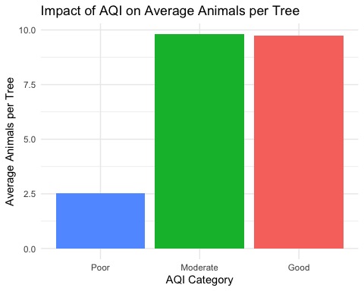

## Recommendations

1. **Prioritize Native Species:** Native Indian trees support significantly more biodiversity compared to introduced species.
2. **Enhance Urban Green Spaces:** Avenue trees play a crucial role in supporting urban wildlife.
3. **Improve Air Quality:** Higher air quality correlates with greater biodiversity.

## Conclusion

The Hyderabad Annual Tree Survey underscores the value of citizen science in urban biodiversity research. Future surveys should address vehicle density, human activity, and seasonal variations to further understand urban ecosystems.

**References:** - HAT Survey iNaturalist Project