**Advance Computer Architecture CS570**

**Homework 0**

**Chips:**

A chip is a complex device that forms the brains of every computing device. While chips look flat, they are three-dimensional structures and may include as many as 30 layers of complex circuitry.

**Gordon Moore:**The number of transistors incorporated in a chip will approximately double every 24 months."—Gordon Moore, Intel co-founder

* His revised law was a bit pessimistic; over roughly 40 years from 1961, the number of transistors doubled approximately every 18 months.
* Starting around 2010, however, Moore’s Law began to break down and many today are asking if our age of unprecedented growth is coming to an end.

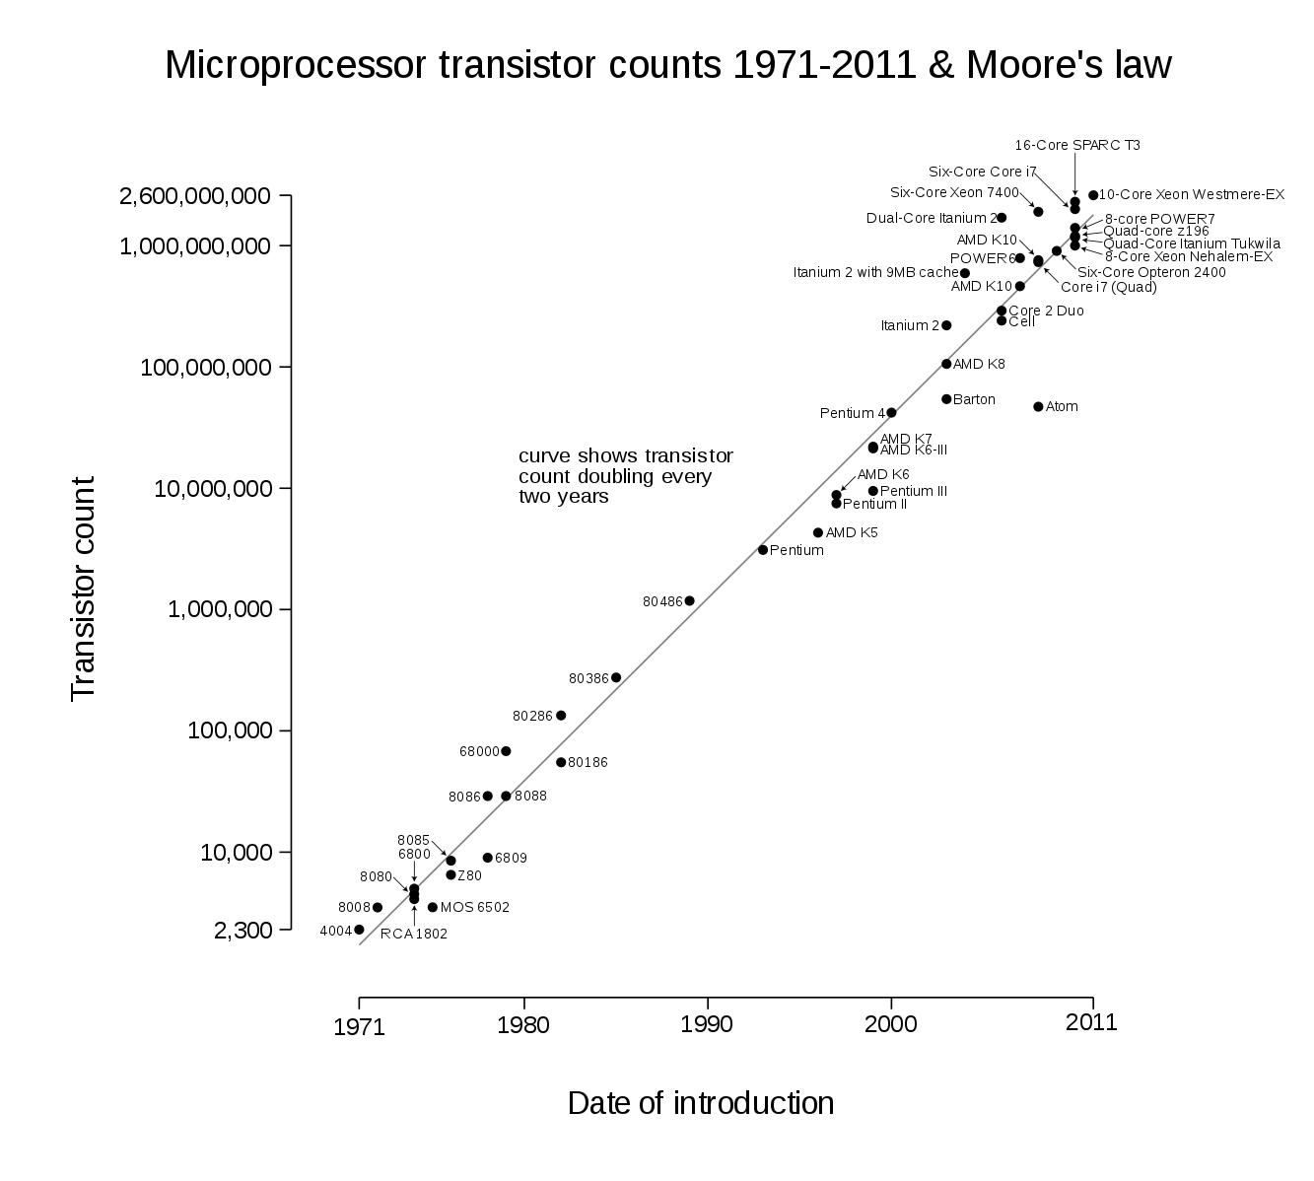

**FIG.1 MICROPROCESSOR TRANSISTOR COUNTS 1971-2011**

**FIG.2 THE NUMBER OF TRANSISTORS ON INTEGRATED CIRCUIT CHIPS (2010 – 2018)**

**Comparison between fig1 and fig2 statistics before 2010 and after 2010:**

The breakdown of Dennard scaling prompted a greater focus on multicore processors, but the gains offered by switching to more cores are lower than the gains that would be achieved had Dennard scaling continued. In another departure from Dennard scaling, Intel microprocessors adopted a non-planar tri-gate Finfet at 22 nm in 2012 that is faster and consumes less power than a conventional planar transistor. The rate of performance improvement for single-core microprocessors has slowed significantly. Single-core performance was improving by 52% per year in 1986–2003 and 23% per year in 2003–2011, but slowed to just seven percent per year in 2011–2018.

**Recommonded Survey Paper describing the changing of chip design and new challenges of chip design**

**TRENDS AND CHALLENGE ON SYSTEM-ON-A-CHIP DESIGNS:**

YEN-KUANG CHEN Intel Corporation, Santa Clara, CA 95052,

USA S. Y. KUNG Princeton University, Princeton, NJ 08544, USA.

Link: <http://www.oocities.org/ykchen913/publications/TrendSoC.pdf>

**Summary points for recommending this paper**:

* The success of system-on-a-chip (SoC) hinges upon a well-concerted integrated approach from multiple disciplines, such as device, design, and application.
* change is largely due to the advances in device technology, which enable us to put billions of transistors on a chip for almost unlimited processing capability.
* In the past 40 years, we have been able to put about a million times more transistors onto a chip (keeping pace with Moore’s Law [55, 56, 73]). The first microprocessor had a couple of thousand transistors with functionalities limited to basic logic/arithmetic processing. In contrast, a modern SoC can have billions of transistors, supporting a wide range of functions (processors/ controllers, application-specific modules, data storage, and mixed-signal circuits). Thanks to ever increasing large-scale integration, SoC is able to meet the increasing computational demand by new applications.
* Prevailing System Design Approach, Modern System Design Trends
* With greater device integration, SoC designs can implement high-performance and inexpensive systems for many killer applications. However, system designs have also become more complex. This paper surveyed the emerging issues, modern design trends, and future system design challenges for SoC research and design. It goes without saying that more research efforts are still required to create innovative solutions. The SoC architecture must consider overall system performance, flexibility, and scalability, power/thermal management, system partition (among digital, analog, on-chip, or off-chip), architecture partition (between hardware and software), algorithm developments for emerging applications, and so on.