### Scope

This project is the UI layer of the cost analysis application of the CliniCast Oncology solution. The goal of this application is to present cost analysis data on different populations, patient cohorts and individual patients.

There will be 2 phases for this UI project:

1. Complete all the html/CSS/javascript design, user experience and functionality based on a set of data files.
2. Have the UI make ajax call to the server for the data (instead of reading from the data files)

We should consider using [AngularJS](http://angularjs.org/) for this project.

### Phase 1

We already have a very good starting point as we have a demo that has a lot of the features done (particular on how to display data). We need to refine the reporting page with more structure and add logic to read and manage the raw data better.

**3 Dimensions**

This cost analysis reporting page has 3 dimensions:

**A. Population Selected**

There are 3 types of population choices that users can select from:

(i) *Population*: Facility & Cancer

Facility: All Hospital, Hospital 1, Hospital 2

Cancer: All Cancer, Breast Cancer, Lung Cancer

(ii) *Patient CoHorts*: Age, Gender, Race, Cancer Site, & Cancer Stage

Age: Range (0-116)

Gender: Any, Male, Female

Race: Any, White, Black, Asian, Others

Cancer Site: Any, Breast, Lung

Cancer Stage: Any, I, II, III, IV

(iii) *Individual Patient*: Name

Name: <Text Field>

***Note:*** All the potential values should not be hard-coded, but driven by data

**B. Cost Attribution**

There is a hierarchy of cost units:

Cost Home >> Cost Category >> Cost Department >> Cost Sub-Department

There is a master list of Cost Categories (not hard-coded, but driven by data). For each cost category, there is a list of Cost Departments. For each Cost Department, there is a list of Cost Sub-Departments.

We should use ***breadcrumb*** to both display and control the selection.

**C. Contex**t (Cost / Income)

First, we are talking about Cost or Income. All functionality are the same, but we need to be able to jump between Cost and Income, while remembering the selections on the other 2 dimensions.

**Page Structure and Elements**

**Pie Chart**

* It shows up on the page unless a Cost Sub-Department is selected, because Cost Sub-Department does not have another level of breakdown

**Breakdown Table**

* It shows up on the page unless a Cost Sub-Department is selected in the *Cost Attribution* dimension , because Cost Sub-Department does not have another level of breakdown

**Highest Patient Table**

* It shows up on the page unless an individual patient is select in the *Population* dimension
* ***column:***Patient Name, Age, Gender, Race, Cancer, Stage, Cost / Net Income

**Mockups**

***mockup 1:*** Individual Patient at Cost Home (the highest level of the Cost Attribute dimension)

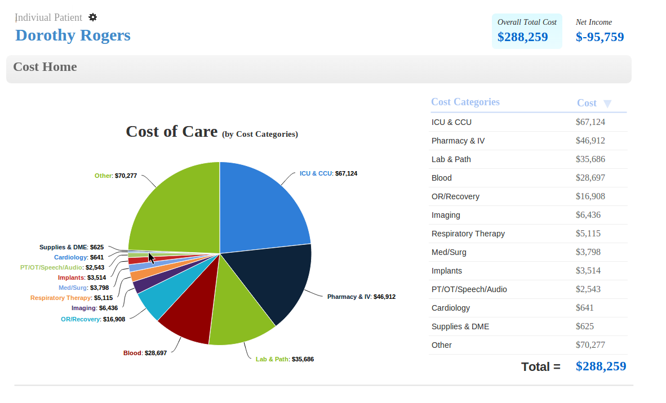

***mockup 2a:*** Population selected with a selected Cost Category

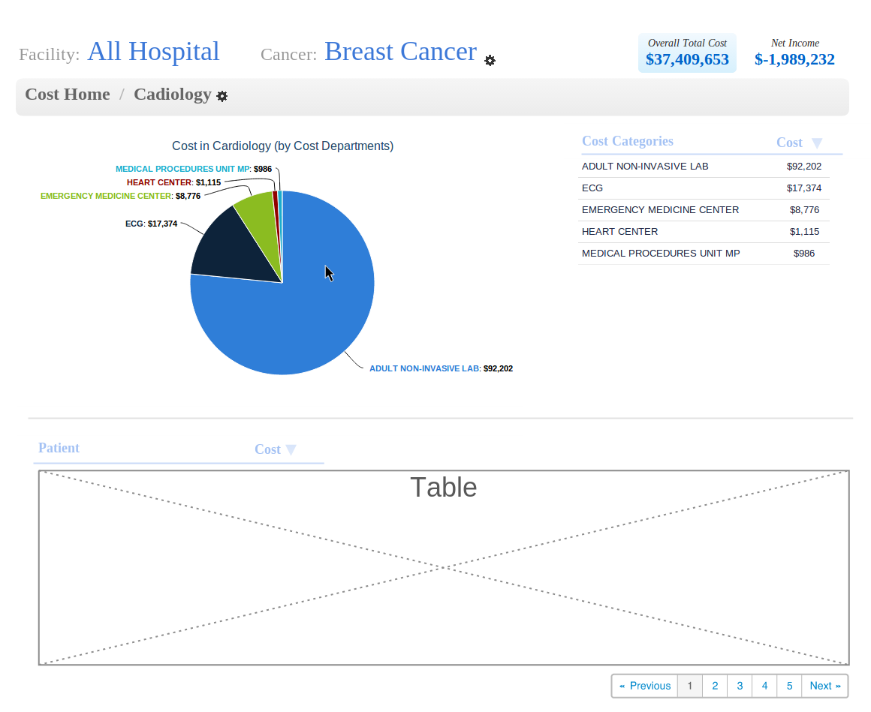

***mockup 2b:*** Select another cost category on the breadcrumb menu

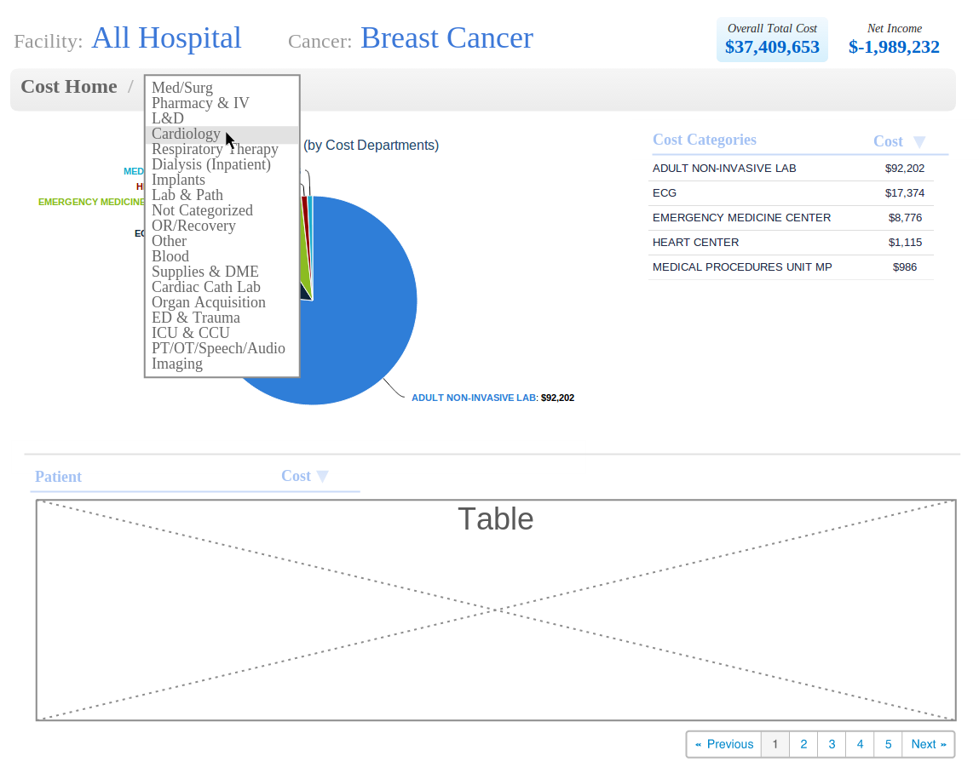

***NOTE:***  *In mockup 3, Krates made a mistake here. For Cost Department, there should be pie chart and Cost Sub-Department table. Only if Cost Sub-Department is selected, we will have only the patient table on the page.*

***mockup 3a:*** Patient Cohort selected with a select Cost Department

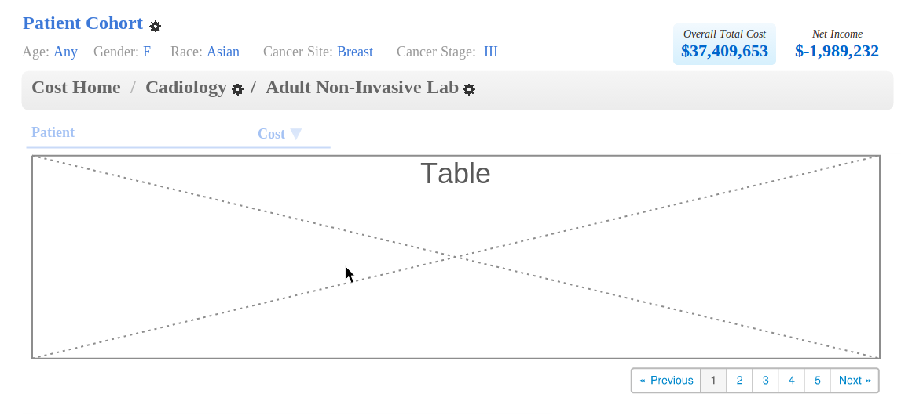

***mockup 3b:*** Select another cost category on the breadcrumb menu

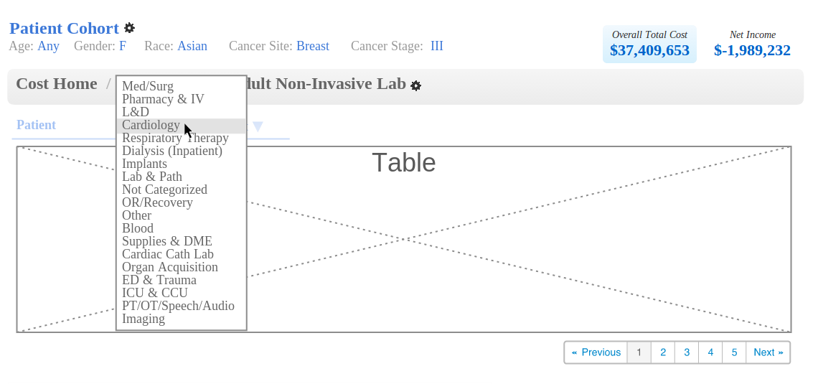

***mockup 2c:*** Select another cost department on the breadcrumb menu

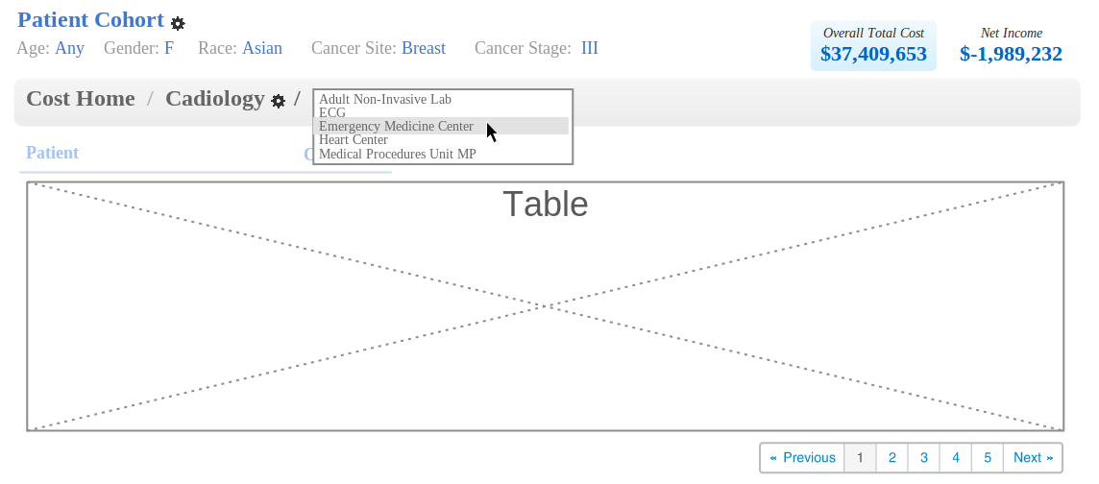

**User Experience**

**UE1.** When click on any patient on the patient table, user will be brought to the individual patient page with the same selection on the other 2 dimensions

**UE2.** When click on the pie chart or any entry on the cost breakdown table, user will be brought to the corresponding Cost Category, Department or Sub-Department page with the same selection on the other 2 dimensions

**UE3.** When click on the Cost Home of the BreadCrumb menu, user will be brought the top level of the Cost Attribution (with list of Cost Categories) with the same selection on the other 2 dimensions.

**UE4.** When click any time on the BreadCrumb menu, a dropdown selection of alternative Cost Category, Department or Sub-Department will be show. When selected on of them, user will be brought to that new selection with the same on the other 2 dimension.

**UE5.** When click on “setup” icon on the Population, Individual Patient or Patient Cohort, a dialog will be show to the user to select the population dimension.

**UE6.** The Cost and Net Income total remains the way to switch between Cost and Net Income dimension. It’s important that we support Cost only mode (without Net Income).



**Coding Standard**

**No Script in HTML**

This project is to be added to our software product, not just a demo. I want to keep a high standard. Let’s keep the code well structured. Let’s not put random javascript in the HTML. No quick fix.

**Modula**

For Phase 1, this frontend tool will be extracting data from a set of data files. But in phase 2, it should pull this same data from the server via ajax calls. Therefore, it is important the keep the javascript code and logic clean and organized. The logic to extract data should be separated from the logic to compute and display. It would make it easier to swap in the Ajax-to-server layer in phase 2.

**Data Source**

This section describe the structure of this data. All data are in JSON format

**MetaData**

**support_income_context**: 0/1

**choices_facility**: List of Strings [“All Hospital”, …]

**choices_cancer**: List of Strings [“All Cancer”, …]

**choices_gender**: List of Strings [“Any”, “Female” …]

**choices_race**: List of Strings [“Any”, “White” …]

**choices_stage**: List of Strings [“Any”, “I” …]

**cost_structure**: Dictionary of Dictionary of List of Strings

{“ICU & CCU”:{“N/S ICUB”: [“ICU 1:2”,.. ], “N/S FLOOR”: [“Isolation”, ..], ...}, ...}

Cost Category - keys for the 1st level dictionary

Cost Department - keys for the 2nd level dictionary

Cost Sub-Department - list of Strings

**Data Pull**

**Parameters**

context (cost / income)

population_type (population/cohort/individual)

population_facility

population_cancer

cohort_age_max

cohort_age_min

cohort_gender

cohort_race

cohort_cancer

cohort_stage

patient_name_search

cost_category

cost_department

cost_subdepartment

**Calls** (with result structure)

**Total**

{“Cost”: <cost>, “Income”: <net income>}

**Cost Breakdown**

{<next-level-key-1> : <cost>, <next-level-key-2> : <cost>, ….}

**Patient Costs**

{{“name”: <name>, “Cost”: <cost>, “Age”: <age>,....}, {..},….}

**Income Breakdown**

{<next-level-key-1> : <income>, <next-level-key-2> : <income>, ….}

**Patient Incomes**

{{“name”: <name>, “Income”: <income>, “Age”: <age>,....}, {..},….}