Name of Student:

Instructor’s Name:

Institutional Affiliation:

Course Title:

Assignment Due Date

**Mars colonization**

Over the last 60 years, humanity explored the lower Earth's trajectory and lunar flights. Currently, state institutions like Roscommon and NASA have connections to space and business entities, such as Space X challenging their limits and goals for Mars missions1. It lasted three days to hit the moon by the Apollo mission's crew just 380 thousand kilometers away. However, the present system would take about seven months to fly 55 million kilometers to Mars, only if the planets converge to shorten the trip. A compelling Mars mission might be perhaps the most significant success in the history of human civilization. After decades of study on spaceflight, one key issue persists: is it feasible to take astronauts to Mars and retrieve them in a safe state?

A trip to Mars faces significant problems in physiology and psychology2. The body has developed in a 1G atmosphere on Earth. Our structural mobility muscles, spine and balance mechanism, and cardiovascular system are optimized to thrive and efficient operation on Earth. While in orbit, the body will start to adjust to new gravity to a condition who’s physical and physiological capacities are more than necessity1. These modifications have been witnessed on missions to the International Space Station. However, it's a whole new story on a possible 2-year flight to Mars, thrice the moon trip duration, stronger radiation, and more adverse conditions. 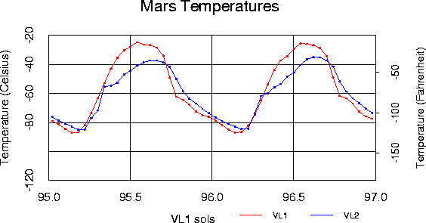

Figure 1. The diurnal cycle of Mars atmospheric temperature

Once beyond the Earth's gravitational and magnetic protection fields, cosmic rays and microgravity become significant concerns3. Microgravity permits fluids build-up in the brain that trigger vision problems. Explorers who travel around interplanetary space are constantly battered with high-energy protons which buzz through a spacecraft's metal base. Scientists may not be well conversant with how dangerous these radiations are, although laboratory studies indicate that they might increase the likelihood of diseases such as cancer of astronauts.

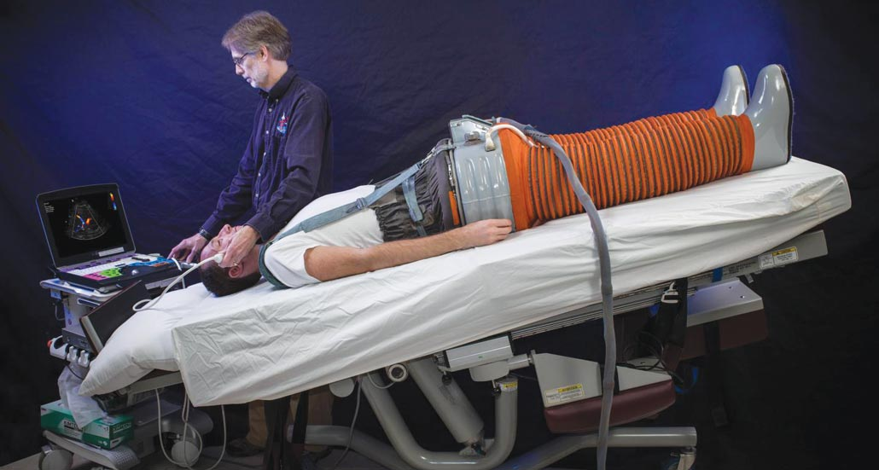

Figure 2. The lower body negative pressure or LBNP, by utilizing vacuum pressure, the suit limits the effects of gravity to pull the body of a human to the feet.

Naturally, the body develops strong muscle fibers for waking while opposing gravity and preventing us from falling. In the space, the musculature of the size and intensity we know is excessive, such that the body starts to lose it1. Similarly, bones are shaped by the Earth's atmospheric conditions to withstand reaction forces when we undertake our daily activities. Gravity exhibits no ground response forces and an apparent absence of measures for about 22 hours a day. Damage to a trabecular bone in the pelvic bone and leg bones in the pelvis would probably deteriorate in such a way that it is challenging to heal during a Mars trip. This may make astronauts fragile and susceptible to fractures on their return to Earth.

The mission's duration brings its risks. "If you're thinking about traveling to Mars, the moon has become like a hiking trip," says Erik Antonsen, a physicist, and NASA's aerospace engineer. Taking away the psychological and social challenges that might emerge among the inhabitants stranded in a mobile interplanetary unit, three years promises far more time and potential than a day-long Apollo mission to get ill or wounded1. Although Mars is approximately 600 times further than the moon is from the Earth. Also, light-speed transmissions from Mars will take over 20 minutes.

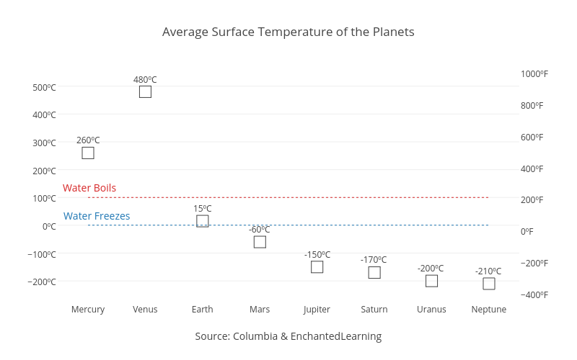

Fig. 3. Planet temperatures

ur bodies use the heart and the lungs as a driver to propel everything we do. Bodies take oxygen used to make triphosphate adenosine or energy carriers contained in the cells of all living beings; the primary energy currency that enables anything from digesting, brain function, and movement. On Earth, the core fights against gravity endlessly. When someone faints, we lay flat so that this gravitational force removes tension from the body. This tension is absent in a vacuum since we have no weight (which is a product of mass and gravity, the latter of which is missing). In the next few days, blood and other liquids move into the head, creating the "puffy mask," which is often seen in astronauts. For a few weeks, the body adapts to decrease blood flow in the body. Moving muscles are less involved, so energy and oxygen requirements are fallen, and because demand for oxygen supply is reduced, the vessels of distribution are reduced (the blood).

The psychiatric difficulty is as profound as neurological. On a nine-month trip, astronauts are sent in a slim, finite-resourced spacecraft isolated from artificial extremes by only a few millimeters of aluminum. The SOS will not be recorded for more than 30 minutes if anything goes wrong on the Red planet’s surface. The psychological effects of these obstacles cannot be overlooked and are arguably as significant as the space travel influence on the body's entire physiology3.

We must do better to identify countermeasures for specific decreases. This may include conventional exercise-related countermeasures, medicines, or even new health technology such as gene therapy (which, at most, we know, delays the pace of decline). To be accurate, we first need to understand the processes through which we lose muscle in space. Model species including C elegant may be used to research muscle failure recently to the International Space Station1. We might transmit these microscopic roundworms and Mars for many generations to see how these elemental creatures respond in space over a long period. Other interstellar species candidates involve eight-legged parasitic organisms known in extreme surroundings worldwide and known for their resistance. This species tolerates high temperatures and even boiling pressures. If these bodies cannot withstand a round trip to Mars, people have little hope.

The human body is suitable for space-fly despite extended and is no longer consistent with existence in a 1G setting. This poses significant obstacles for the upcoming Mars return mission. Spaceflight is an accelerated aging model. After 18 months in space travel, if we sent a 40-year-old astronaut to Mars, he might return with the physiology of an 80-year-old3. We are aware from International Space Station flights that any of these losses may be recovered, so you can travel about and practice successfully within six months in the space and atmosphere. What if the astronaut stays in the spacecraft suggested for the Mars launch by NASA Orion? This is the size of a car—how long would one live, eat, and sleep?

The Dutch space exploration corporation Mars One has found one possible alternative. A one-way mission mitigates some of the spaceflight deconditioning issues. You absolutely cannot return to Earth whether you are used to a world of little gravity or slightly lower gravity (1/3G on Mars). But what is this a solution? Not to return?

The survival of every population is decided by the reproductive and sustainability of the ecosystem. Will our genus survive on Mars?3 Can embryonic growth be feasible on Mars, and would it be acceptable to pursue it anyway? Simulated microgravity research has demonstrated that fertilization can occur in microgravity. However, birth rates are adversely influenced since placental cells do not properly mature. It is necessary to remember that the results of space radiation are not simulated in these studies. Radiation (of adequate dose) can destroy embryos, but significant malformations are rare in surviving offspring. The anticipated consequences of spatial radiation may involve an elevated risk of cancer or cognitive performance. There has been a little study in spatial mammalian reproduction, but we must investigate this field if colonization of Mars is to become a possibility.

Researchers believe that a steady high pressure behind the eyes is the fault of vision issues, such as far sight, which affect around half the astronauts in orbit. Weightlessness often confuses the vestibular gravitational organs in the inner ear, which play a role in motor control and balance. On his return to Earth, he notes, "I could walk normally and very quickly by the end of the day, but it took me a few days to start walking around a corner."

A spacecraft should be equipped with artificial gravity devices to ensure explorers can walk straight forward to see what they are doing on Mars. A lower body negative pressure or LBNP chamber is one of these devices. The system places vacuum pressure on the lower half of the body when a human is screened down.

More than 0.2 million applicants for a one-way mission to Mars with Mars One were present in 20133. The goal is to establish the first Mars settlement by 2031. We are experiencing a phase of the second space race, and one where there are more than two participants in the game.

In making the first Mars missions, everyone will likely perish. Despite these risks, the US, China, Russia, and other countries have all expressed their desire to send humans to Mars. In the 2030s, NASA is gunning for a Mars flight1. Because of this time limit, researchers are designing a series of medical instruments and medicines to travel to Mars. The products on this packaging list are also relatively ineffective and sometimes very unproven in the very early stages of production. Universal walls are a vague thought. However, researchers are developing artificial gravity masks, radiation-proofing medicines, and miniature medical devices that scientists expect will be ready for the first time in a decade for secure and stable travelers on Mars.

# References

1. Buckey Jr JC. Preparing for Mars: the physiologic and medical challenges. European journal of medical research. 1999 Sep 1;4(9):353-6.
2. Strollo F, Vernikos J. Aging-like metabolic and adrenal changes in microgravity: State of the art in preparation for Mars. Neuroscience & Biobehavioral Reviews. 2021 Mar 20.
3. Swaminathan A, Malhotra V. A case study on the advancements in Mars colonization. InAIP Conference Proceedings 2021 May 13 (Vol. 2341, No. 1, p. 030019). AIP Publishing LLC.