Contents
1. Getting Started with OPENJDK 13 for Windows 2
1.1 Download OPENJDK with the Zip Bundle 2
1.2 Installing OPENJDK with the Zip Bundle 2
2 JMeter Setup 5.2 4
2.1 Download JMeter 4
2.2 Run JMeter 5
3 Apache JMeter 6
4 What can I do with it? 6

Getting Started with OPENJDK 13 for Windows
OpenJDK (Open Java Development Kit) is a free and open-source implementation of the Java Platform, Standard Edition (Java SE)

Download OPENJDK with the Zip Bundle
To manually install OpenJDK 8 for Windows using the ZIP bundle:
- Download the Zip bundle of OpenJDK 13 for Windows from following path: https://jdk.java.net/13/
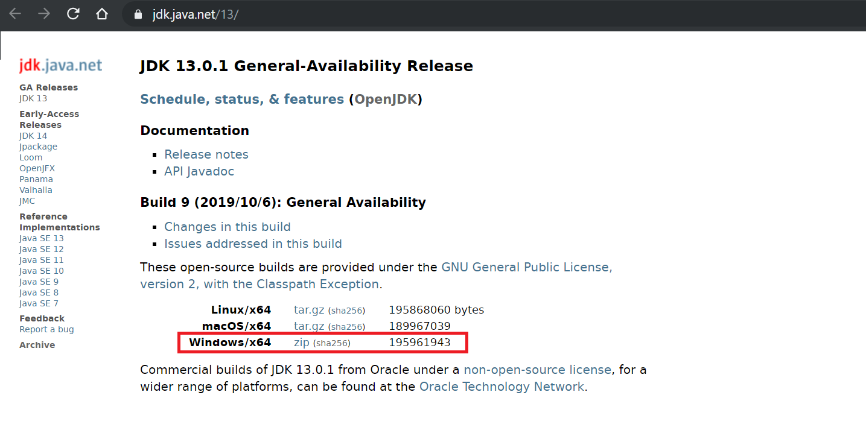

Installing OPENJDK with the Zip Bundle

- Extract the contents of the Zip bundle to a directory of your choice
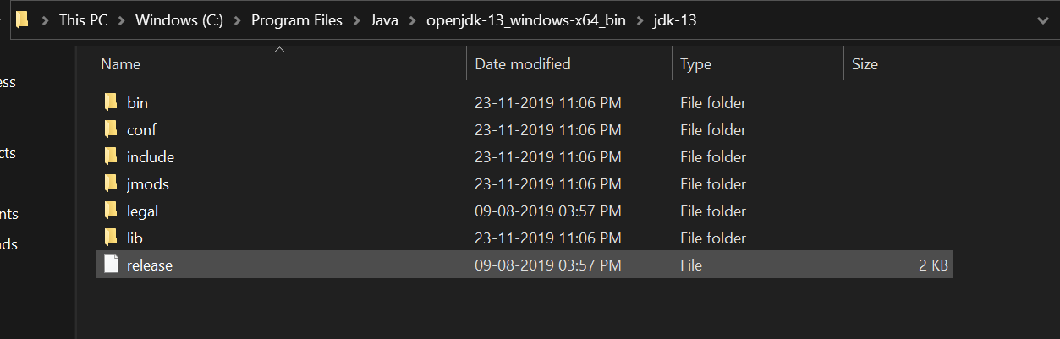

- The %JAVA_HOME% system variable must also be set to use some developer tools. Set the %JAVA_HOME% system variable as follows:
Right click This PC-> Open Properties-> Click on Advance System Settings - Click System Variables-> Create New System Variables
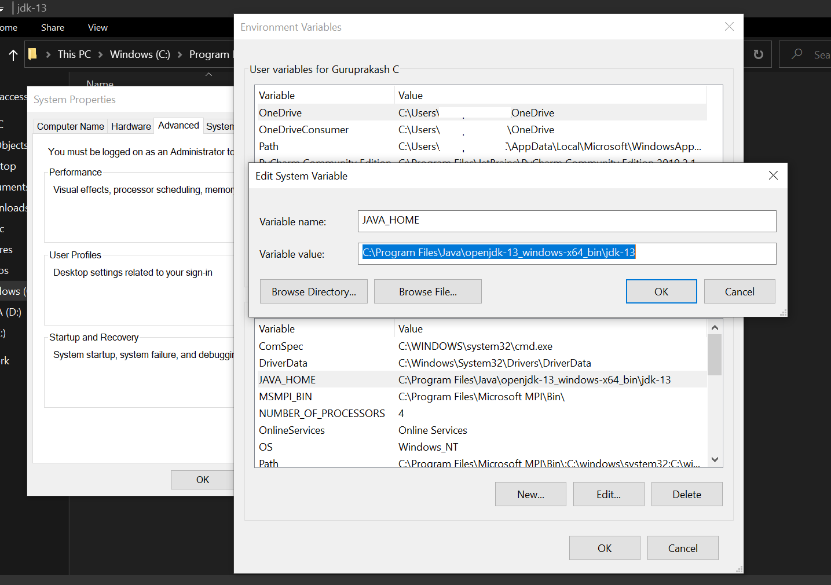
- Add the bin directory contained in your OpenJDK 13 for Windows installation path to the %PATH% system variable: 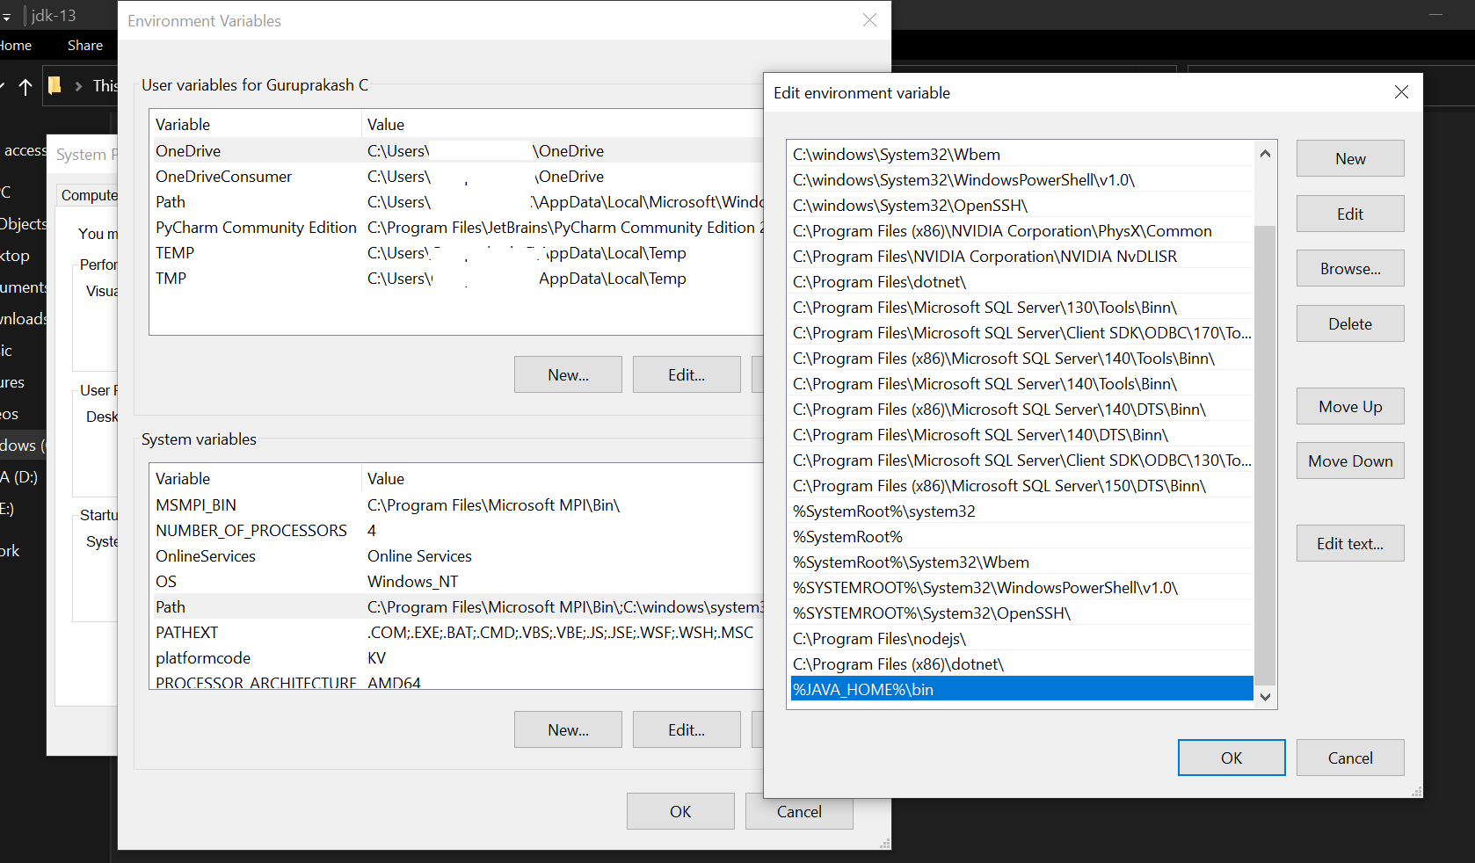
- Make sure the OpenJDK 13 configured using below instruction
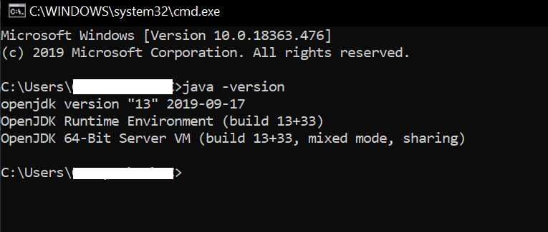

JMeter Setup 5.2

Download JMeter
Download JMeter from following path: https://jmeter.apache.org/download_jmeter.cgi
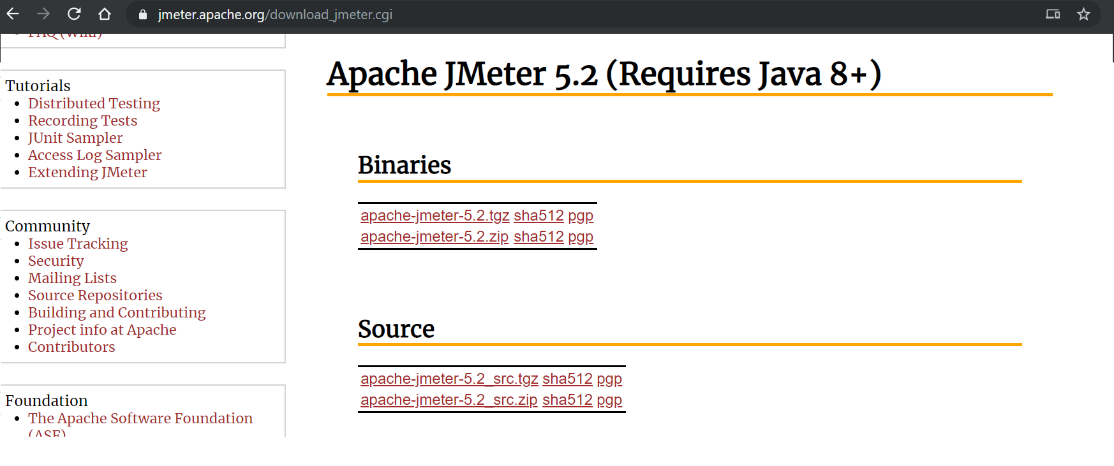

Run JMeter
The screenshot below shows what JMeter’s bin/ folder contains. It’s a bunch of configuration and executable files.
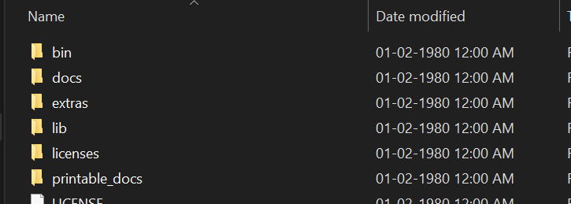

to run JMeter:
Browse to bin/ folder by double-clicking on it, double-click on jmeter.bat to run it or run by command prompt
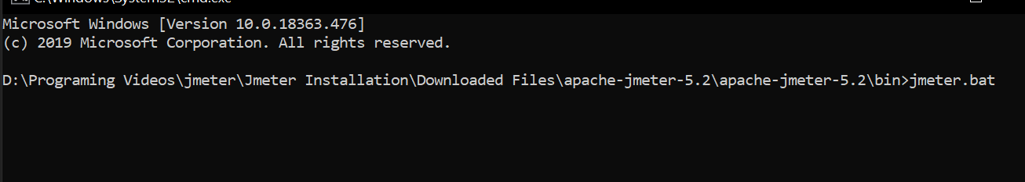
It should open both a command-line terminal and JMeter’s UI
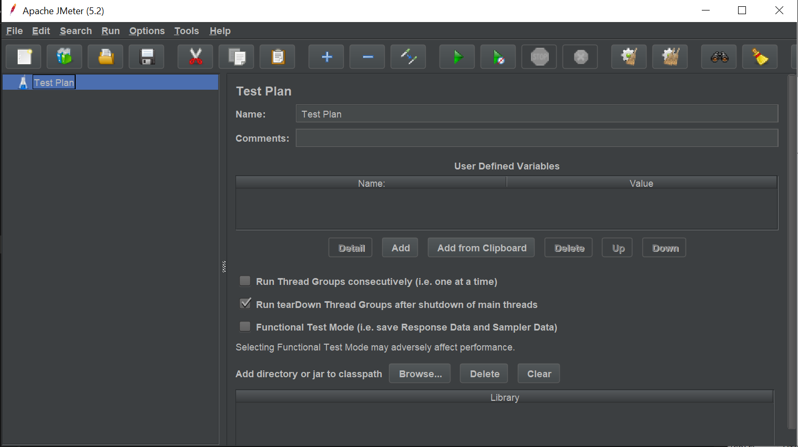

Apache JMeter
The Apache JMeter™ application is open source software, a 100% pure Java application designed to load test functional behaviour and measure performance. It was originally designed for testing Web Applications but has since expanded to other test functions.

What can I do with it?
Apache JMeter may be used to test performance both on static and dynamic resources, Web dynamic applications. It can be used to simulate a heavy load on a server, group of servers, network or object to test its strength or to analyse overall performance under different load types.
Apache JMeter features include:
Ability to load and performance test many different applications/server/protocol types:
- Web - HTTP, HTTPS (Java, NodeJS, PHP, ASP.NET, …)
- SOAP / REST Webservices
- FTP
- Database via JDBC
- LDAP
- Message-oriented middleware (MOM) via JMS
- Mail - SMTP(S), POP3(S) and IMAP(S)
- Native commands or shell scripts
- TCP
- Java Objects
Full featured Test IDE that allows fast Test Plan recording (from Browsers or native applications), building and debugging.
Complete portability and 100% Java purity.
Full multi-threading framework allows concurrent sampling by many threads and simultaneous sampling of different functions by separate thread groups.
Highly Extensible core:
- Pluggable Samplers allow unlimited testing capabilities.
- Scriptable Samplers (JSR223-compatible languages like Groovy and BeanShell)
- Several load statistics may be chosen with pluggable timers.
- Data analysis and visualization plugins allow great extensibility as well as personalization.
- Functions can be used to provide dynamic input to a test or provide data manipulation.
- Easy Continuous Integration through 3rd party Open Source libraries for Maven, Gradle and Jenkins.

How to Create a First JMeter Test
Step 1: Start JMeter (bin\JMeter.bat)
Step 2:

