**Why String is Immutable or Final in Java**<https://www.baeldung.com/java-string-immutable> Good link

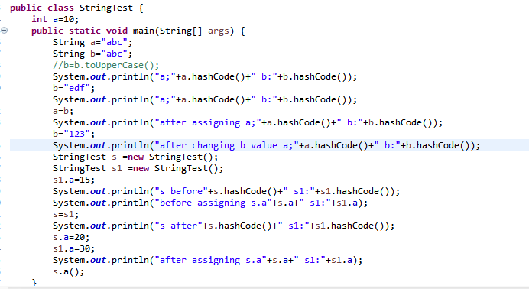

Because java uses the concept of string literal. Suppose there are 5 reference variables, all referes to one object "sachin". If one reference variable changes the value of the object, it will be affected to all the reference variables. That is why string objects are immutable in java.

But for string literals if all pointing to one reference in string pool if one value is changed it will point to that value and all others point to the same old value and it will not point to the new value. As below if we create a String with new object also it will work same as literals

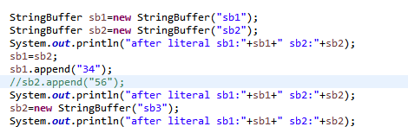

**How can we check if two *Strings* are anagrams in Java?**

An anagram is a word formed by rearranging the letters of another given word, for example, “car” and “arc”.

To begin, we first check whether both the *Strings* are of equal length or not.

Then we [convert them to *char[]* array, sort them, and then check for equality](https://www.baeldung.com/java-sort-string-alphabetically).

