ClientFlow — Project Overview
1. Project Title
ClientFlow: Client Project and Issue Management System
2. Problem Statement
Software development teams often use different tools, spreadsheets, emails, and messaging applications to manage client projects and track tasks. This can lead to scattered project information, unclear task ownership, missed deadlines, and difficulty monitoring project progress.
Project managers may find it difficult to identify overdue tasks, developers may lack clarity about priorities, and clients may not have sufficient visibility into the status of their projects.
Therefore, a centralized system is needed to organize project information, manage tasks and bugs, improve collaboration, and provide clear visibility into project progress.
3. Proposed Solution
ClientFlow is a web-based project management application that enables software teams to manage client projects, assign tasks, report bugs, collaborate through comments, and monitor project progress from one platform.
The application will provide role-based access control, task status tracking, project dashboards, and activity history. A REST API built with Node.js and Express.js will handle application requests, while PostgreSQL will store project and task information.
4. Project Objective
The main objective is to develop a secure, maintainable, and user-friendly project management system that improves task organization, collaboration, accountability, and project progress tracking.

5. Stakeholders
The primary stakeholders of ClientFlow are:
1. Administrator
Responsible for managing user accounts, maintaining appropriate access permissions, and overseeing the platform.
2. Project Manager
Responsible for creating projects, managing project members, assigning tasks, prioritizing work, and monitoring deadlines and project progress.
3. Developer
Responsible for viewing assigned tasks, updating task statuses, reporting bugs, and collaborating with team members through comments.
4. Client
Responsible for reviewing authorized project information, monitoring progress, and viewing relevant task updates.
5. Development Team
Responsible for developing, testing, deploying, and maintaining the ClientFlow application.
6. User Roles and Responsibilities
User Role | Responsibilities
Administrator | Manage user accounts and platform-level permissions
Project Manager | Create projects, manage members, assign tasks, and monitor progress
Developer | Work on assigned tasks, update statuses, and report bugs
Client | View authorized project progress and relevant updates
Access permissions will be enforced by the backend. Users must not be able to access projects or perform actions beyond their assigned permissions.

7. Functional Requirements
7.1 User Authentication
FR-01: The system shall allow new users to register using their name, email address, and password.
FR-02: The system shall authenticate registered users using valid login credentials.
FR-03: The system shall allow authenticated users to access protected application features.
FR-04: The system shall prevent unauthenticated users from accessing protected resources.
7.2 Project Management
FR-05: The system shall allow authorized project managers to create projects.
FR-06: The system shall allow authorized users to view projects they are permitted to access.
FR-07: The system shall allow authorized project managers to update project details and manage project membership.
FR-08: The system shall allow authorized project managers to archive projects that are no longer active.
7.3 Task and Bug Management
FR-09: The system shall allow authorized users to create tasks within a project.
FR-10: The system shall allow authorized users to assign tasks to eligible project members.
FR-11: The system shall allow users with appropriate permissions to update task details and status.
FR-12: The system shall support task priorities, due dates, and task types such as task and bug.
FR-13: The system shall allow authorized users to search, filter, and paginate task lists.
7.4 Collaboration and Activity Tracking
FR-14: The system shall allow authorized project members to add comments to tasks.
FR-15: The system shall maintain an activity history for important task changes.
FR-16: The system shall display task comments and relevant activity history to authorized users.
7.5 Dashboard and Reporting
FR-17: The system shall display project task counts by status.
FR-18: The system shall identify overdue tasks based on their due dates and completion status.
FR-19: The system shall calculate project completion percentages using the defined task completion rules.
7.6 Access Control
FR-20: The system shall enforce role-based and project-level permissions on protected operations.
FR-21: The system shall prevent users from viewing or modifying projects and tasks for which they lack permission.

Initial technology stack
Layer | Technology | Purpose
Frontend | React + TypeScript + Vite | User interface
Backend | Node.js + Express | REST API and business logic
Database | PostgreSQL | Persistent relational data
Database access | Prisma ORM | Queries, migrations, and schema management
Authentication | JWT + password hashing | Login and protected routes
Validation | Zod | Validate API input
Testing | Vitest/Jest, Supertest, React Testing Library | Backend and frontend tests
API documentation | Swagger / OpenAPI | Document and explore endpoints
Version control | Git + GitHub | Branches, commits, collaboration
Deployment | Docker + a cloud host | Reproducible deployment

System architecture
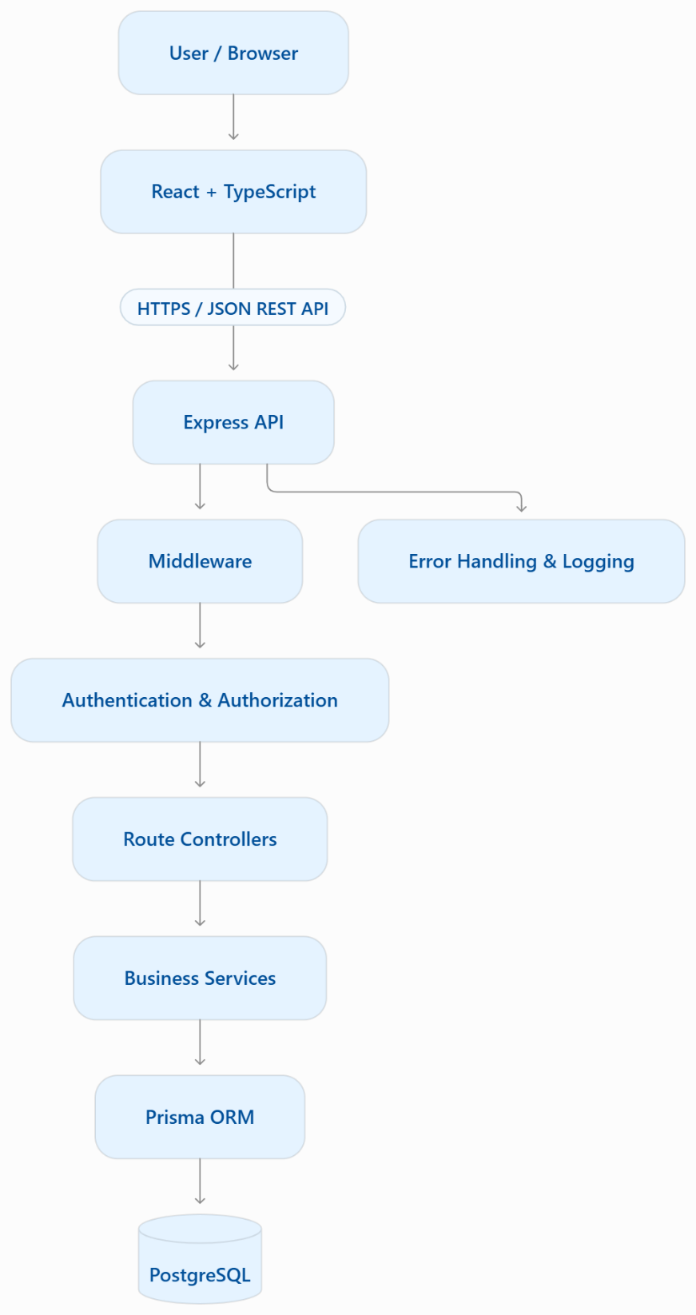

How a request travels through the application
Imagine a project manager creates a new task.
- The user fills out a form in React.
- React sends a POST /api/v1/projects/:projectId/tasks request.
- Express receives the request.
- Authentication middleware verifies the user.
- Authorization checks that the user can create tasks in that project.
- Zod validates the submitted data.
- The service applies business rules and Prisma writes to PostgreSQL.
- Express returns a JSON response with an appropriate HTTP status code.
- React updates the task list and displays success or an error.

Database architecture
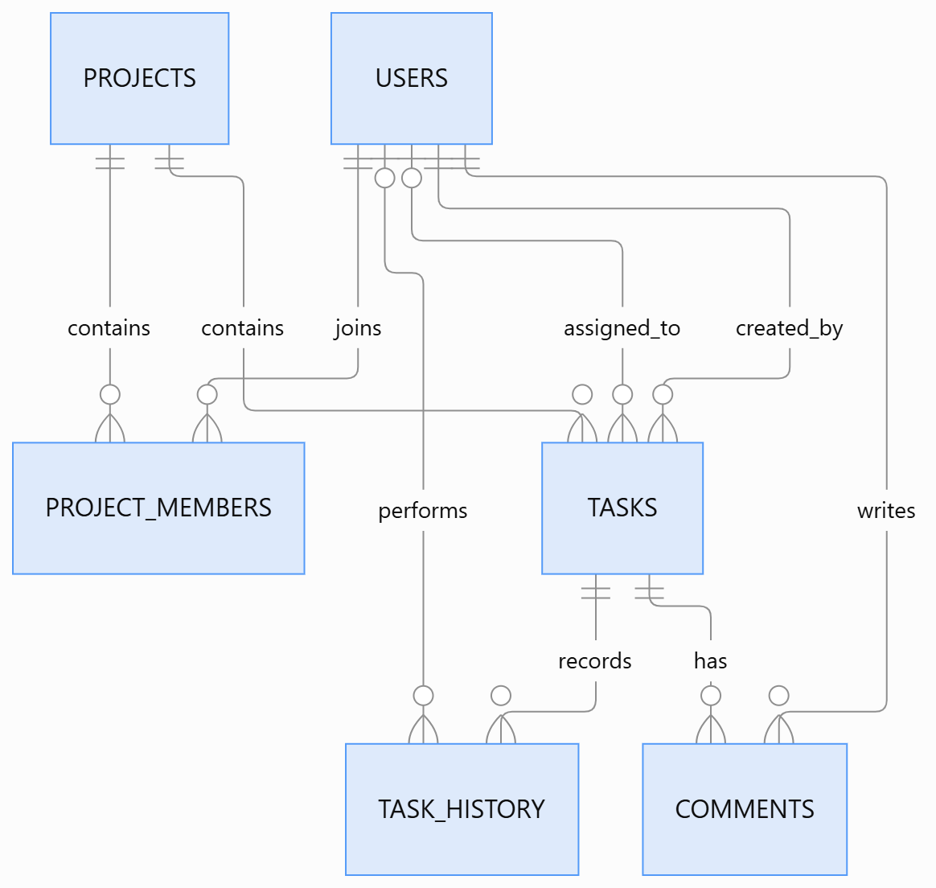

Table | Purpose
users | User accounts, email, hashed password, account status
projects | Project name, description, owner, dates
project_members | Users associated with projects and their project-specific roles
tasks | Task or bug details, status, priority, assignee, creator, due date
comments | Discussion on individual tasks
task_history | Audit trail of task status and field changes

REST API design
Method | Endpoint | Purpose
POST | /api/v1/auth/register | Register a user
POST | /api/v1/auth/login | Authenticate a user
GET | /api/v1/auth/me | Get the current user
GET, POST | /api/v1/projects | List or create projects
GET, PATCH, DELETE | /api/v1/projects/:projectId | Read, update, or archive a project
GET, POST | /api/v1/projects/:projectId/tasks | List or create tasks
GET, PATCH, DELETE | /api/v1/tasks/:taskId | Read, update, or delete a task
GET, POST | /api/v1/tasks/:taskId/comments | Read or add comments
GET | /api/v1/projects/:projectId/activity | Read project activity

Git and GitHub workflow
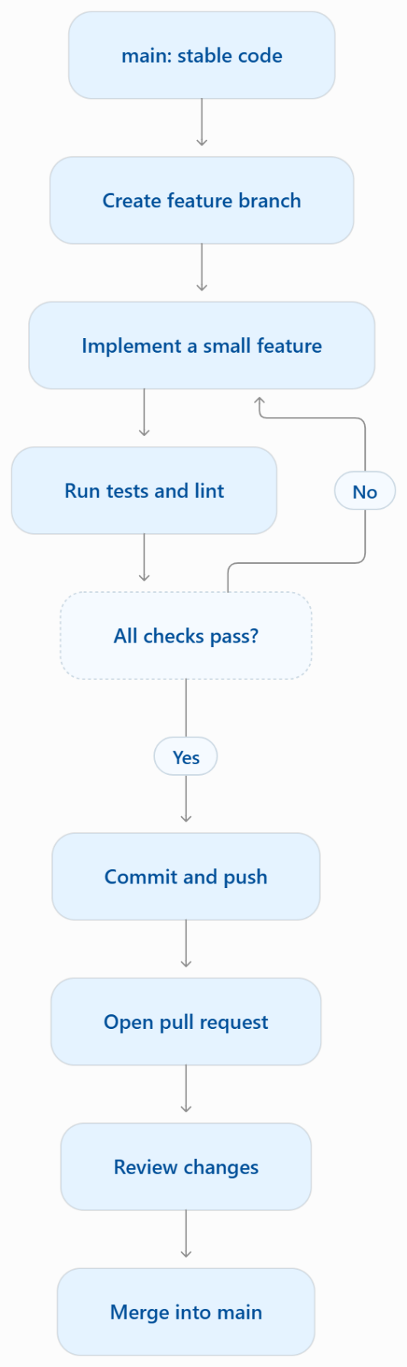

Deployment architecture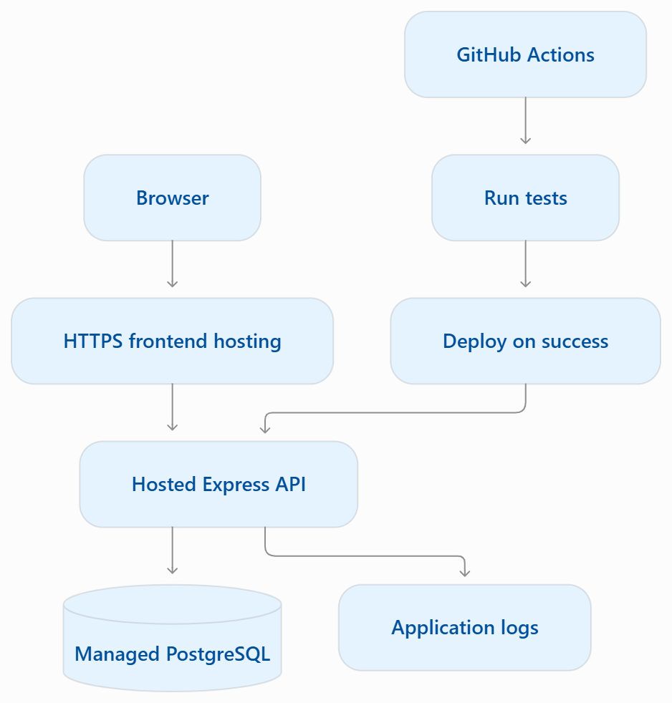

Backend Application Architecture
Architecture Decision: Separate application configuration from server startup.
Files Created:
- app.js — Configures the Express application, middleware, and API routes.
- server.js — Starts the HTTP server and listens on the configured port.
Design Rationale:
This separation improves maintainability, supports automated testing, and keeps application configuration independent of server startup.
Technology: Node.js, Express.js, JavaScript ES Modules.
Validation: The /api/v1/health endpoint returns HTTP 200 with a JSON response confirming that the ClientFlow API is running.

Modular API Routing
Objective: Separate API route definitions from Express application configuration.
Implementation:
- Created src/routes/health.routes.js.
- Defined the health-check endpoint using Express Router.
- Imported the route module into app.js.
- Registered the router under /api/v1.
API Endpoint: GET /api/v1/health
Expected Status: HTTP 200 OK.
Design Benefit: Modular routing improves maintainability and makes it easier to add authentication, project management, tasks, comments, and other API modules independently.

Centralized Error Handling
Objective: Provide consistent and safe error responses across the ClientFlow API.
Implementation:
- Created src/middleware/error.middleware.js.
- Implemented a 404 handler for unmatched routes.
- Implemented centralized Express error-handling middleware.
- Registered middleware after the API routes.
Expected Behavior:
- Valid health request: HTTP 200.
- Unknown route: HTTP 404.
- Unhandled application error: HTTP 500 with a generic client-facing message.
Design Benefit: Centralized error handling reduces duplicated error-response logic and avoids exposing internal server details to API clients.
Security Note: Detailed errors should be logged securely on the server when production logging is introduced.

Request Validation
Objective: Validate incoming API request bodies before processing them.
Technology: Zod.
Implementation:
- Installed the Zod validation library.
- Created reusable request-body validation middleware.
- Defined a schema for a temporary validation endpoint.
- Registered the route under the /api/v1 prefix.
Expected Behavior:
- Valid request: HTTP 200.
- Invalid request: HTTP 400 with field-level validation errors.
Design Benefit: Reusable schema-based validation improves API reliability and reduces duplicated validation logic.
Note: The validation endpoint is temporary and will be removed or replaced when actual feature routes are implemented.

Database Integration and User Authentication
Status: Implemented — initial registration and authenticated user retrieval tested successfully.
3.1 Technology Stack
- Node.js with Express.js
- JavaScript ES Modules
- PostgreSQL database
- Prisma ORM
- Zod for request validation
- bcryptjs for password hashing
- JSON Web Tokens (JWT) for authentication
3.2 Database Setup
- Created the clientflow_db PostgreSQL database.
- Configured Prisma to connect to PostgreSQL using the DATABASE_URL environment variable.
- Created the User model with the following fields:
  - id
  - name
  - email
  - passwordHash
  - role
  - isActive
  - createdAt
  - updatedAt
- Configured a unique constraint on the email field.
- Validated the Prisma schema and confirmed the database schema was up to date.
3.3 User Registration API
Endpoint: POST /api/v1/auth/register
Implemented functionality:
- Validates name, email and password using Zod.
- Normalizes email addresses.
- Hashes passwords using bcryptjs before database storage.
- Prevents duplicate email registration.
- Returns the newly created user's public details without exposing the password hash.
Test result: Registration succeeded and returned the new user's ID, name, email, role and creation timestamp.
3.4 User Login API
Endpoint: POST /api/v1/auth/login
Implemented functionality:
- Looks up the user by email.
- Verifies the submitted password against the stored password hash.
- Rejects invalid credentials and inactive accounts.
- Generates a JWT token after successful authentication.
- Sets the token expiration to one hour.
3.5 Protected User Profile API
Endpoint: GET /api/v1/auth/me
Implemented functionality:
- Requires a valid JWT in the Authorization: Bearer <token> header.
- Verifies the token and identifies the authenticated user.
- Retrieves the user's public profile from PostgreSQL.
- Returns user details without exposing the password hash.
Test result: The endpoint returned the authenticated user's profile successfully.
3.6 Validation and Error Handling
- Added reusable Zod request-validation middleware.
- Added centralized handling for unmatched routes and application errors.
- Added authentication middleware for protected endpoints.
- Implemented appropriate HTTP responses for invalid credentials, duplicate accounts and missing authentication tokens.
3.7 API Route Structure
- GET /api/v1/health — health check
- POST /api/v1/validate-example — validation demonstration
- GET /api/v1/users — list users
- POST /api/v1/auth/register — register a user
- POST /api/v1/auth/login — authenticate a user
- GET /api/v1/auth/me — retrieve the authenticated user's profile
3.8 Security Tests Pending
- Access /api/v1/auth/me without a token — expect HTTP 401.
- Login with an incorrect password — expect HTTP 401.
- Register an existing email address — expect HTTP 409.
3.9 Next Development Milestone
Implement Project Management CRUD APIs, including project creation, listing, retrieval, updates and deletion. Associate projects with users and enforce authentication and ownership checks.
Development principle: Keep credentials in environment variables, never commit .env to Git, and never store plain-text passwords.

