Git Notes

Command: git status

gives status of the git repository.

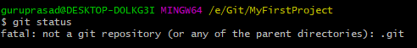
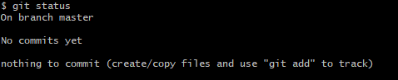

Command: git init

Initialize a git repository in a path. It creates a .git folder.

Don't intialize a repo inside a repo. Tracking a repo get difficult(Top-down approach)

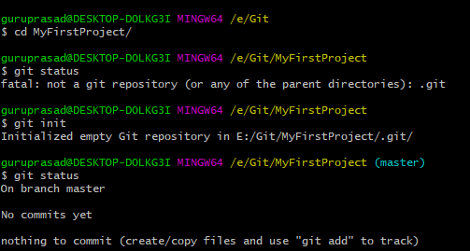
Command: git add

This command will add the files from working directory to staging area.
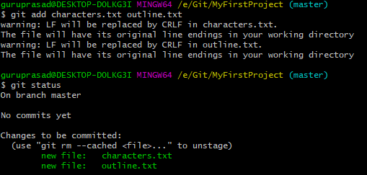

Explanation:

Working directory: Present working area where we do the change.
Staging area:
Repository:

Add some file and enter command to see untracked status: git status

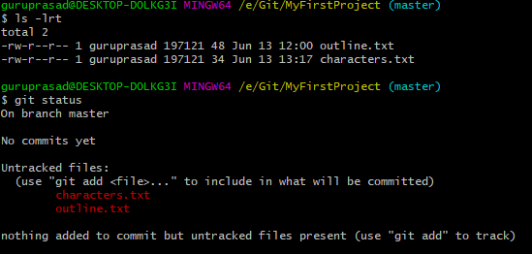

Once “git add filename: is entered it will update this in staging area

Command : git commit -m “some meaningful message”

This will update the changes from staging to repository.

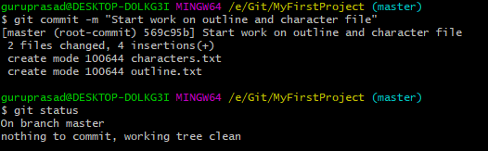

Extra tips:

Add chapter1.txt file and modify characters.txt and see git status

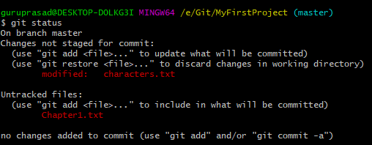

Command: git log

Provide commit information of the present repository

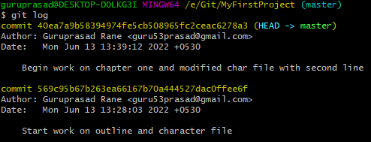

Extra Tips: 1.Commits should be atomic in nature.
- Commit messages should be resent tense and imperative approach
- Setting visual studio code for editing purpose in git command: git config --global core.editor "code –wait"
- git see log in one line: git log –oneline

Command: git commit –amend

This command will redo previous commit changes like commit message or forgotten to add files during staging.
This command will only work for previous commit.

Extra tip: .gitignore is a file in the root directory of the repository to ignore certain files by the git. Use cases can be os files, passwords or keys, etc.

GIT Branching

Branching is a strategy of having to develop different versions of project at same time.

Master branch vs Main branch difference:
Master: Git
Main: Github

Head : A kind of pointer/reference which will point to last commit of present branch.

Command: git branch

View your current branches. Symbol “ * ” will tell you which branch you are currently on

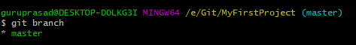

Command: git branch <branchname>

Create a new branch with name as specified in branchname.
Head will still be in present branch when we create a new branch

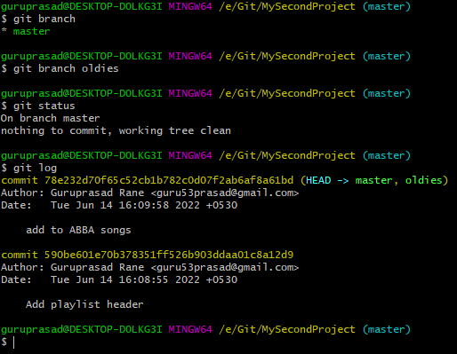

Command: git switch <branchname>

Used to switch to other branch.

Useful tips:
Head will point to specified branch on git switch command.
if we commit to new branch then the head will reference to new branch commit message/id and the old branch will still point to old commit message.
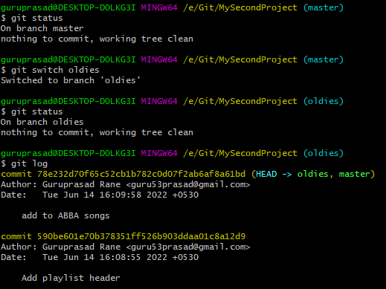

Command: git checkout <branch-name>

Can be used to switch branch.

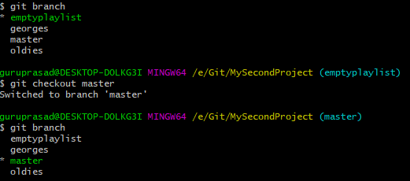

Additional tips:

Command : git switch -c <branch-name>
or Command git checkout -b <branch-name>
Creates a new branch and switches to that branch

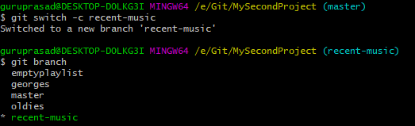

Switching to a new branch without saving the current branch is not allowed when there is a conflict(same file changes). Either we need to commit it or stash the branch.
Dig depicts file which is in conflict.

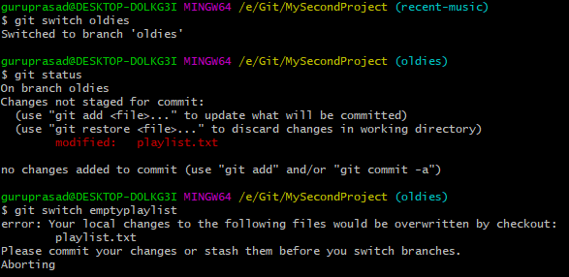

Dig depicts a new file created which is not in conflict and hence switching happens even when branch commit or stash is not done.

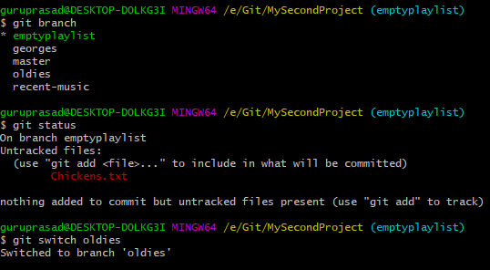

Command: git branch -d <branch-name>

Delete a branch with that name

Extra tip: Git will not allow us to delete the branch if we are in that branch.
Git will not allow us to delete the branch if the deleting branch is not merged
However we can forcefully delete a branch by using -D option.

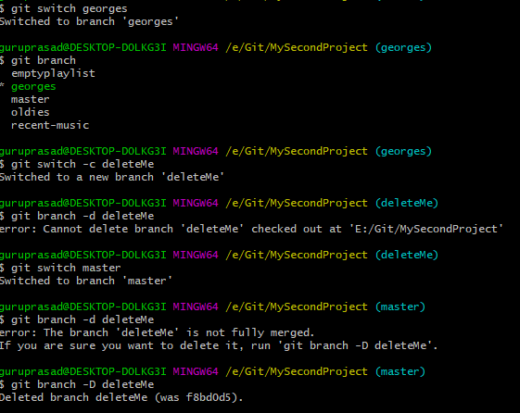

Command: git branch -M <branch-name>

Extra tip:
Used to rename a branch from existing branchname.
Should be in that branch to rename the branch.

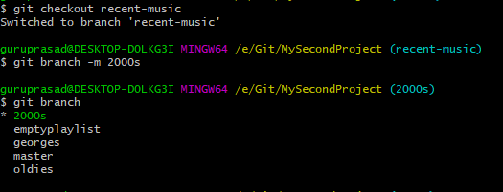

GIT Merging

Command: git merge <branchname>

Merging is joining 2 branches.

fast forward merge: its a type of merging where the master branch has no commit.
Dig depicts oldies branch been merged to master.

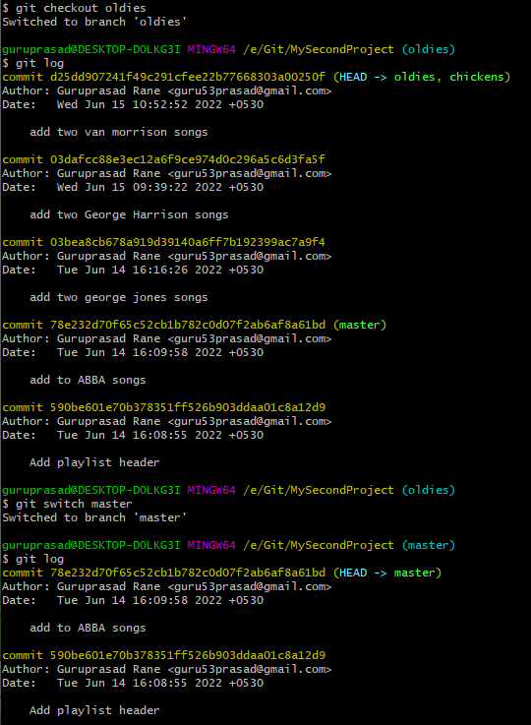

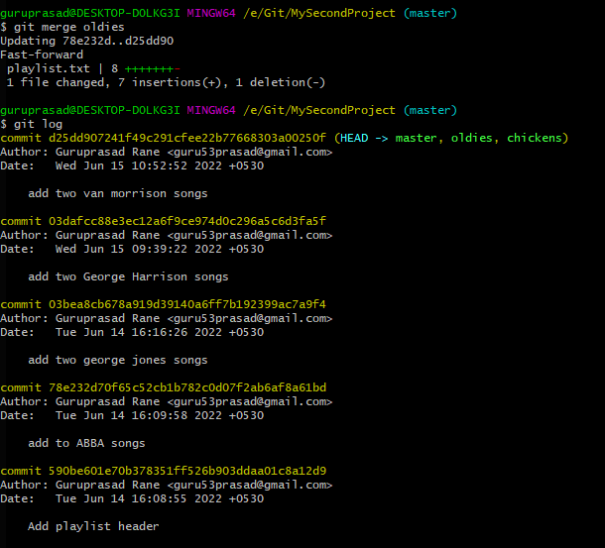

Extra tip: Command git branch -v
will give extra info like commit hashes and last commit message

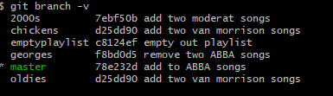

Commit can have 2 parents.

Merge commit without conflict.

Git will do it automatically.
Eg: merging when new file is created
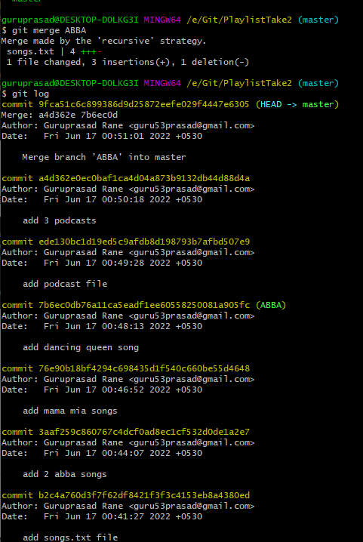

Merge with conflict.

Eg: delete a file
change in same line in a file

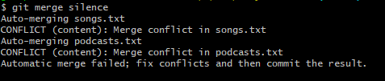

GIT Differnce

Used to view changes between commits, branches,files our working dir and more.

Command: git diff

Without options it will compare non staged and working directory comparisons.

Command: git diff HEAD

Will compare files between last HEAD and unstaged or staged .

Command: git diff –staged
Command: git diff –cached

Command: git diff branchename1 branchname2

Command: git diff commitid1 commitid2

