Document OCR Extractor (PAN/GST/Bank)

Problem Statement
Vendor onboarding in ERP systems requires extracting KYC information from documents such as PAN cards, GST certificates, and bank proofs. Manual data entry is slow, error-prone, and difficult to scale. The objective of this project is to build an automated Python-based document extraction system that converts unstructured scanned documents into structured, validated JSON suitable for ERP vendor master creation.

Architecture / Flow
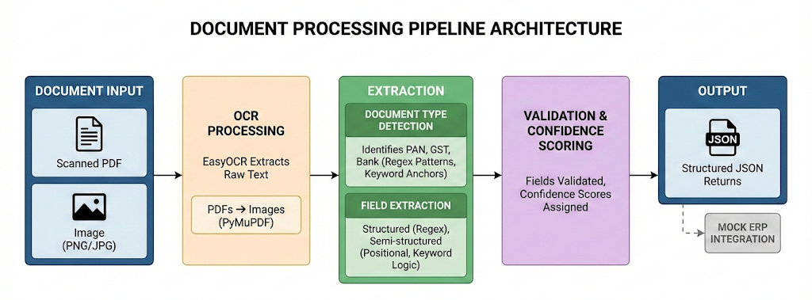

Tools & Libraries
- Python 3.10 and above
- EasyOCR – OCR engine
- PyMuPDF – PDF processing
- OpenCV – Image preprocessing
- Regex – Pattern-based extraction
- spaCy – Named Entity Recognition
- FastAPI – REST API framework
- Pydantic – Data validation
- pytest – Unit testing

Key Logic Explanation
- Input documents (PDF or images) are pre-processed and processed using EasyOCR to extract text.
- Document type (PAN, GST, or Bank) is automatically detected using keywords and identifier patterns such as PAN, GSTIN, and IFSC formats.
- Structured fields (PAN, GSTIN, IFSC, account number) are extracted using strict regex validation, while names and addresses use anchor-based positional logic.
- OCR noise is handled using character-repair rules and fuzzy keyword matching to improve extraction robustness.
- For multi-page documents, fields are consolidated using highest-confidence selection, and each field is assigned a confidence score for extraction.

