Outputs:

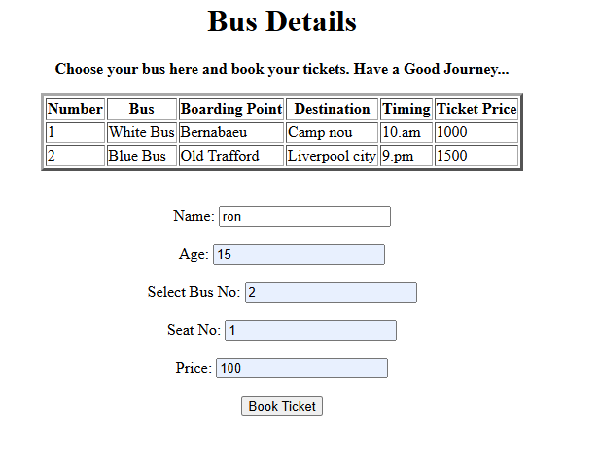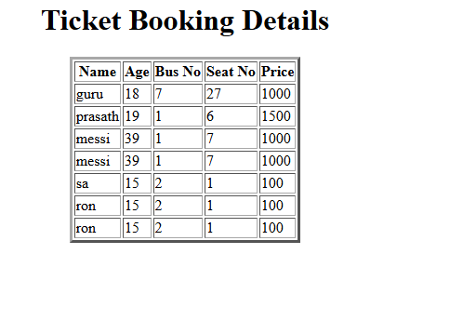
Bus.html:
<!DOCTYPE html>
<html>
<head>
<title>Bus Ticket Booking System</title>
</head>
<body>
<h1 align="center">Bus Details</h1>
<center>
<p><b>Choose your bus here and book your tickets. Have a Good Journey...</b></p>
</center>
<table border="3" align="center">
<tr>
<th>Number</th>
<th>Bus</th>
<th>Boarding Point</th>
<th>Destination</th>
<th>Timing</th>
<th>Ticket Price</th>
</tr>
<tr>
<td>1</td>
<td>White Bus</td>
<td>Bernabaeu</td>
<td>Camp nou</td>
<td>10.am</td>
<td>1000</td>
</tr>
<tr>
<td>2</td>
<td>Blue Bus</td>
<td>Old Trafford</td>
<td>Liverpool city</td>
<td>9.pm</td>
<td>1500</td>
</tr>
</table>
<br><br>
<center>
<form action="BusServlet" method="post">

<label>Name:</label>
<input type="text" name="name" required>
<br><br>
<label>Age:</label>
<input type="text" name="age" required>
<br><br>
<label>Select Bus No:</label>
<input type="text" name="busno" required>
<br><br>
<label>Seat No:</label>
<input type="text" name="seatno" required>
<br><br>
<label>Price:</label>
<input type="text" name="price" required>
<br><br>
<input type="submit" value="Book Ticket">
</form>
</center>
</body>
</html>

Servlet:
package ticketbooking;
import java.io.IOException;
import java.io.PrintWriter;
import java.sql.Connection;
import java.sql.DriverManager;
import java.sql.PreparedStatement;
import java.sql.ResultSet;
import java.sql.Statement;
import javax.servlet.ServletException;
import javax.servlet.annotation.WebServlet;
import javax.servlet.http.HttpServlet;
import javax.servlet.http.HttpServletRequest;
import javax.servlet.http.HttpServletResponse;

@WebServlet("/BusServlet")
public class BusServlet extends HttpServlet {
protected void doPost(HttpServletRequest request,
HttpServletResponse response)
throws ServletException, IOException {

response.setContentType("text/html");
PrintWriter out = response.getWriter();
String name = request.getParameter("name");
int age = Integer.parseInt(request.getParameter("age"));
int busno = Integer.parseInt(request.getParameter("busno"));
int seatno = Integer.parseInt(request.getParameter("seatno"));
int price = Integer.parseInt(request.getParameter("price"));
try {
Class.forName("com.mysql.cj.jdbc.Driver");
Connection con = DriverManager.getConnection(
"jdbc:mysql://localhost:3306/ticketdb",
"root",
"mysql"
);
String sql = "INSERT INTO tickets(name, age, busno, seatno, price) "
+ "VALUES (?, ?, ?, ?, ?)";
PreparedStatement ps = con.prepareStatement(sql);
ps.setString(1, name);
ps.setInt(2, age);
ps.setInt(3, busno);
ps.setInt(4, seatno);
ps.setInt(5, price);
ps.executeUpdate();
out.println("<html>");
out.println("<head>");
out.println("<title>Ticket Details</title>");
out.println("</head>");
out.println("<body>");
out.println("<h1 align='center'>Ticket Booking Details</h1>");
out.println("<table border='3' align='center'>");
out.println("<tr>");
out.println("<th>Name</th>");
out.println("<th>Age</th>");
out.println("<th>Bus No</th>");
out.println("<th>Seat No</th>");
out.println("<th>Price</th>");
out.println("</tr>");
Statement st = con.createStatement();
ResultSet rs = st.executeQuery(
"SELECT * FROM tickets"
);

while (rs.next()) {
out.println("<tr>");
out.println("<td>"
+ rs.getString("name")
+ "</td>");
out.println("<td>"
+ rs.getInt("age")
+ "</td>");
out.println("<td>"
+ rs.getInt("busno")
+ "</td>");
out.println("<td>"
+ rs.getInt("seatno")
+ "</td>");
out.println("<td>"
+ rs.getInt("price")
+ "</td>");
out.println("</tr>");
}
out.println("</table>");
out.println("</body>");
out.println("</html>");
rs.close();
st.close();
ps.close();
con.close();
} catch (Exception e) {
out.println("<h2>Error: " + e.getMessage() + "</h2>");
}
}
}
databse:
mysql> use ticketdb;
Database changed
mysql> create table tickets(id int auto_increment primary,key,name varchar(50),age int,busno int,seatno int,price int);
ERROR 1064 (42000): You have an error in your SQL syntax; check the manual that corresponds to your MySQL server version for the right syntax to use near ',key,name varchar(50),age int,busno int,seatno int,price int)' at line 1
mysql> create table tickets(id int auto_increment primary key,name varchar(50),age int,busno int,seatno int,price int);
Query OK, 0 rows affected (0.04 sec)

mysql> select * from tickets;
+----+------+------+-------+--------+-------+
| id | name | age | busno | seatno | price |
+----+------+------+-------+--------+-------+
| 1 | guru | 18 | 7 | 27 | 1000 |
+----+------+------+-------+--------+-------+
1 row in set (0.00 sec)

mysql> select * from tickets;
+----+---------+------+-------+--------+-------+
| id | name | age | busno | seatno | price |
+----+---------+------+-------+--------+-------+
| 1 | guru | 18 | 7 | 27 | 1000 |
| 2 | prasath | 19 | 1 | 6 | 1500 |
+----+---------+------+-------+--------+-------+
2 rows in set (0.00 sec)

mysql> select * from tickets;
+----+---------+------+-------+--------+-------+
| id | name | age | busno | seatno | price |
+----+---------+------+-------+--------+-------+
| 1 | guru | 18 | 7 | 27 | 1000 |
| 2 | prasath | 19 | 1 | 6 | 1500 |
| 3 | messi | 39 | 1 | 7 | 1000 |
+----+---------+------+-------+--------+-------+
3 rows in set (0.00 sec)

mysql> select * from tickets;
+----+---------+------+-------+--------+-------+
| id | name | age | busno | seatno | price |
+----+---------+------+-------+--------+-------+
| 1 | guru | 18 | 7 | 27 | 1000 |
| 2 | prasath | 19 | 1 | 6 | 1500 |
| 3 | messi | 39 | 1 | 7 | 1000 |
| 4 | messi | 39 | 1 | 7 | 1000 |
| 5 | sa | 15 | 2 | 1 | 100 |
+----+---------+------+-------+--------+-------+
5 rows in set (0.00 sec)

