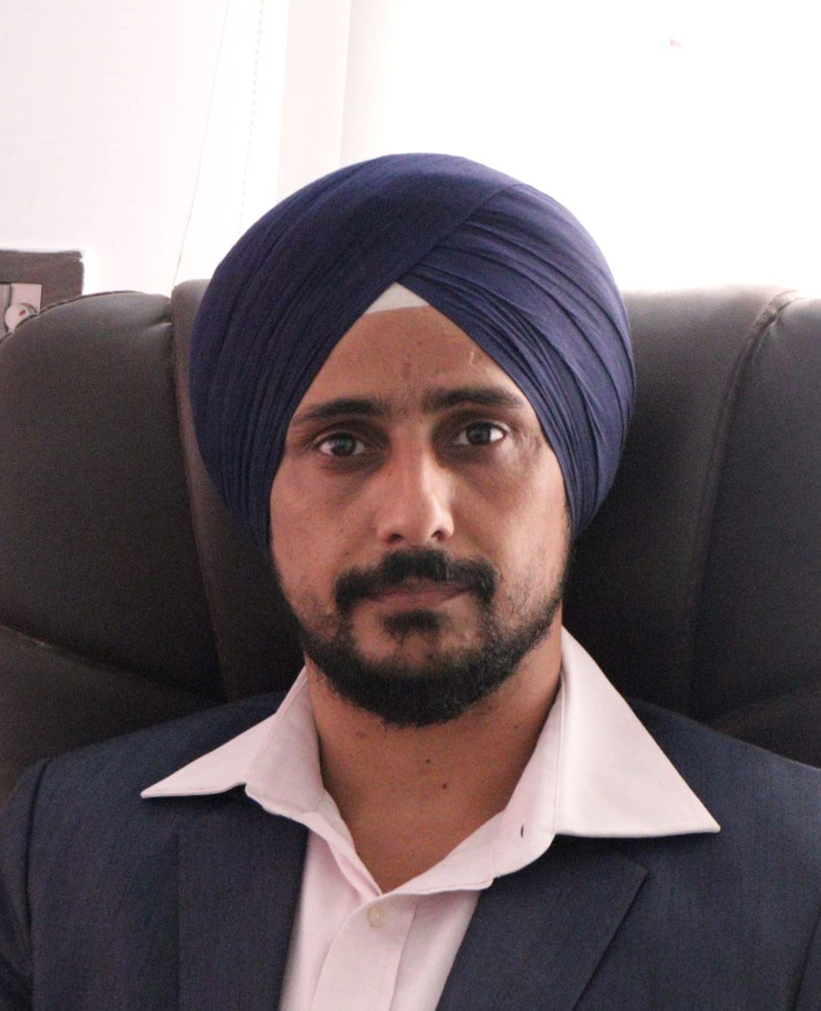
GURUPREETH SINGH

Professor | Corporate Trainer | AI & Data Science Mentor
Bangalore, Karnataka, India
Aspen Garden Apartment, Flat No. 6B, T-Dasarahalli, Hesaraghatta Road, Bangalore
+91 9538596766 | igurupreeth@gmail.com

ACADEMIC & PROFESSIONAL SUMMARY
Highly accomplished Professor-Level Technical Trainer, Corporate Instructor, and Software Engineering Mentor with 14+ years of combined teaching, academic mentoring, and industry experience in the domains of:
- Computer Science Engineering
- Artificial Intelligence & Machine Learning
- Data Science & Predictive Analytics
- Software Engineering & Full-Stack Development
- Automation Testing & Quality Engineering
Proven expertise in delivering high-impact academic instruction, designing modern engineering curricula, conducting corporate upskilling programs, mentoring large student cohorts, and guiding real-world software & AI projects aligned with industry standards.
Currently pursuing M.Tech in Artificial Intelligence & Machine Learning from PES University, with strong interest in research-driven teaching and next-generation AI education.

EDUCATIONAL QUALIFICATIONS

Master of Technology (M.Tech) – Artificial Intelligence & Machine Learning (Pursuing)
PES University, Bangalore (Koramangala Campus)

Bachelor of Engineering – Industrial Engineering & Management
M.S. Ramaiah Institute of Technology, Bangalore
Year of Passing: 2008

PRIMARY TEACHING & SPECIALIZATION AREAS

Core Computer Science Domains
- Computer Science Engineering Fundamentals
- Software Engineering Principles & SDLC
- Object-Oriented Programming & System Design
- Data Structures & Algorithmic Thinking

Artificial Intelligence & Data Science Expertise
- Machine Learning Foundations & Applications
- Supervised & Unsupervised Learning Models
- Deep Learning & Neural Networks (Keras/TensorFlow)
- Data Science Workflow: Data → Features → Model → Deployment

Modern Software Development
- Full-Stack Engineering using MERN Stack
- Flask/Django-Based AI Web Applications
- REST API Development & Integration

Software Testing & Automation Engineering
- Selenium Automation Framework Design
- TestNG, PyTest, API Testing (REST Assured)
- Database Validation & QA Engineering Best Practices

CORE COMPETENCIES

Teaching, Training & Academic Mentoring
- Corporate Training in Java, Python, AI/ML, Data Science
- Classroom + Laboratory Instruction (Theory + Practical)
- Curriculum Development, Assessments & Evaluation Design
- Internship Training & Final-Year Project Mentoring
- Industry-Aligned Hands-on Learning Methodologies

Technical Competencies
Programming Languages
Java | Python | C | C++ | JavaScript | React | R-language | Nodejs
Web & Full-Stack Development
MERN Stack | Flask Framework | HTML | CSS | Bootstrap | jQuery | WordPress
Databases & Data Management
MySQL | PostgreSQL | Oracle | SQLite | MongoDB
Testing & Automation Tools
Selenium (Java/Python) | TestNG | PyTest | Postman
Development & Productivity Tools
Android Studio | API Tools | LMS Platforms | Deployment Basics

PROFESSIONAL EXPERIENCE (14+ Years)

Corporate Trainer & Technical Mentor

ECODERS Pvt Ltd, Bangalore
(2017 – Present)
- Deliver advanced training programs in:
Computer Science, Java, Python, MERN Stack, AI/ML, Data Science, Automation Testing, API Testing
- Develop structured roadmaps, lab manuals, assignments, and skill-based assessments.
- Mentor students on academic and industry-driven software & AI projects.
- Build internal platforms using:
MERN Stack, Flask/Django, WordPress Applications
- Trained and guided 200+ students and professionals in career-oriented technical domains.

Corporate Trainer – Java | Selenium | API Testing

Skillmine Technology (8 Months)
- Conducted training sessions in:
Java, Selenium Automation, REST Assured, DB Testing
- Delivered corporate upskilling programs in Python & PyTest frameworks.

Sub-Teacher / Technical Instructor

Surana College, Peenya (1 Year)
- Handled Computer Science laboratory instruction and theory lectures.
- Taught:
Java Programming, Python Fundamentals, Android Development
- Conducted practical lab sessions for undergraduate learners.

Digital Marketing Manager

Sandhu Herbals (2014 – 2017)
- Managed SEO, SEM, Social Media Marketing initiatives.
- Maintained and enhanced WordPress-based e-commerce systems.

Corporate Trainer – Software Technologies

Netcraft (2011 – 2013)
- Delivered training in:
Java, Python, Web Development, Testing, DBMS, Data Science Foundations
- Built strong foundations for students transitioning into IT careers.

Software Automation Engineer

Neutrix Pvt Ltd (2008 – 2010)
- Worked on enterprise CRM automation projects using Java + Selenium.
- Performed test case design, execution, defect reporting, and DB validation.
- Supported quality engineering processes across SDLC.

PROJECTS HANDLED & SYSTEMS MENTORED
- ServiceNow – CRM Domain Application
- Sandhu Herbals – E-Commerce Platform
- Bonmillette – E-Commerce Platform
- JSAF – E-Commerce Application
- Clap Collaboration – Training Project
- Sanashwa – Product Website
- Conducted Corporate Training Programs for 200+ Students

ACADEMIC IMPACT & TRAINING CONTRIBUTIONS
- Designed modern job-ready training programs in AI/ML & Software Engineering
- Mentored multiple internship cohorts and final-year engineering projects
- Delivered hands-on labs in automation, full-stack, and AI application development
- Strong expertise in bridging the gap between academic curriculum and industry needs

ADDITIONAL PROFESSIONAL STRENGTHS
- Excellent communication, presentation, and mentoring skills
- Highly interactive and student-centric teaching approach
- Ability to simplify complex AI/ML and software engineering concepts
- Strong classroom and lab management experience
- Proven mentorship for learners from both IT and non-IT backgrounds

DECLARATION
I hereby declare that all the information provided above is true and accurate to the best of my knowledge and belief.

GURUPREETH SINGH
9538596766
igurupreeth@gmail.com

