Document Release Status

|  |  |
| --- | --- |
| Release Date | Version |

2017-11-24 1.2

**Communication between APA and EPS For CHB**



|  |  |  |  |  |  |
| --- | --- | --- | --- | --- | --- |
|  |  | Document Name  **Communication between APA and EPS For CHB** | | | |
|  |  |
|  |  |  |  |  |  |
|  | | Document Type |  |  |  |
| Owner Domain: Document Prefix | | |  |
| Document No | Revision | Volume No | Page No |
|  | **1.2** |  | **1 (14)** |

Document Release Status

|  |  |  |  |  |  |  |  |  |  |  |  |  |  |
| --- | --- | --- | --- | --- | --- | --- | --- | --- | --- | --- | --- | --- | --- |
|  |  |  |  |  |  | Release Date | | |  | Version | | |  |
|  |  |  |  |  |  | 2017-11-24 | | |  | 1.2 |  |  |  |
|  | **Revision history** | | |  |  |  |  |  |  |  |  |  |  |
|  |  |  |  |  |  |  |  |  |  | |  |  |  |
|  | **Previous** |  | **Current** |  | **Version Description** |  |  | **Responsible** | **Date** | |  |  |  |
|  | **Version** |  | **Version** |  |  |  |  |  |  |  |  |  |  |
|  |  |  |  |  |  |  |  |  |  | |  |  |  |
|  | N/A |  | V1.0 | 1.0 | |  |  |  | 2017-11-17 | |  |  |  |
|  |  |  |  |  |  |  |  |  |  |  |  |  |  |
|  |  |  |  |  | 1、更新 Checksum 算法 |  |  |  |  |  |  |  |  |
|  | V1.1 |  | V1.2 |  | 2、删除 SAS1 相关部分 |  |  | XYP | 2017-11-24 | |  |  |  |
|  |  |  | 3、EPS 状态转换 C4 增加条件“APA_WorkSts=Active” |  |  |  |  |  |
|  |  |  |  |  |  |  |  |  |  |  |  |  |
|  |  |  |  |  | 4、增加“APA 与 EPS 的信号交互示意图” |  |  |  |  |  |  |  |  |
|  |  |  |  |  |  |  |  |  |  |  |  |  |  |

**Change log**

|  |  |  |
| --- | --- | --- |
| **Release** | **Section** | **Change Description** |
|  |  |  |
|  |  |  |

|  |  |  |  |  |  |
| --- | --- | --- | --- | --- | --- |
|  |  | Document Name  **Communication between APA and EPS For CHB** | | | |
|  |  |
|  |  |  |  |  |  |
|  | | Document Type |  |  |  |
| Owner Domain: Document Prefix | | |  |
| Document No | Revision | Volume No | Page No |
|  | **1.2** |  | **2 (14)** |

Document Release Status

|  |  |
| --- | --- |
| Release Date | Version |

2017-11-24 1.2

Contents

1. 介绍..................................................................................4

1.1 文档范围............................................................................4

1.2 参考文档............................................................................4

1.3 缩写词..............................................................................4

1. APA发送CAN消息到EPS.................................................................5

2.1 APA发送CAN消息....................................................................5

2.2 信号描述............................................................................6

2.2.1 ROLLINGCOUNTER_APA1.......................................................................6

2.2.2 CHECKSUM_APA1......................................................................7

2.2.3 APA_REQCOMTROLEPS........................................................................ 7

2.2.4 APA_REQCOMTROLEPSVALID.............................................................7

2.2.5 APA_REQEPSTARGETAMGLE..............................................................7

3 APA从EPS接收CAN消息...............................................................8

3.1 APA接收CAN消息....................................................................8

3.2 信号描述............................................................................9

3.2.1 EPS1消息..........................................................................9

3.2.1.1 RollingCounter_EPS1..............................................................9

3.2.1.2 CheckSum_EPS1....................................................................9

3.1.2.3 EPS_InterferDect.................................................................9

3.1.2.4 EPS_InterferDectValid............................................................9

3.1.2.5 EPS_AvailSts....................................................................10

3.1.2.5.1 EPS_AvailSts=“Permanently failed” ..........................................10

3.1.2.5.2 EPS_AvailSts=“Temporary inhibit” ...........................................10

3.1.2.5.3 EPS_AvailSts=“Available for control” .......................................10

3.1.2.5.4 EPS_AvailSts=“Active” ......................................................11

3.1.2.5.5 EPS状态转换..................................................................11

3.1.2.5.5 EPS状态......................................................................11

|  |  |  |  |  |  |
| --- | --- | --- | --- | --- | --- |
|  |  | Document Name  **Communication between APA and EPS For CHB** | | | |
|  |  |
|  |  |  |  |  |  |
|  | | Document Type |  |  |  |
| Owner Domain: Document Prefix | | |  |
| Document No | Revision | Volume No | Page No |
|  | **1.2** |  | **3 (14)** |

Document Release Status

|  |  |
| --- | --- |
| Release Date | Version |

2017-11-24 1.2

1. **介绍**

**1.1** **文档范围**

这文档定义了 APA 与 EPS 的通讯，适用于 GWM-CHB041 项目

**1.2** **参考文档**

Table 1.2.1 列出了参考文档.

**Table 1.2.1**:参考

|  |  |  |  |  |  |  |  |  |  |  |
| --- | --- | --- | --- | --- | --- | --- | --- | --- | --- | --- |
| **Reference** |  |  | **Source** |  | **Title** |  | **Version or date** | **Document** |  |  |
| **Num** |  |  |  |  |  |  |  | **Number** |  |  |
|  |  |  |  |  |  |  |  |  |  |  |
| 1 |  |  | GWM |  | GWMLAN00-11-01 RollCnt and Chksum Req Spec.doc |  | v1.0 2017-11-01 | GWMLAN00- | |  |
|  |  |  |  | 11-01 |  |  |
|  |  |  |  |  |  |  |  |  |  |
|  |  |  |  |  |  |  |  |  |  |  |
|  |  |  |  |  |  |  |  |  |  |  |
|  |  |  |  |  |  |  |  |  |  |  |

**1.3** **缩写词**

.表 1.3.1 列出的参考词

**Table 1.3.1:** 缩写词

|  |  |
| --- | --- |
| **Acronyms** | **Description** |
|  |  |
|  |  |
|  |  |
|  |  |

|  |  |  |  |  |  |
| --- | --- | --- | --- | --- | --- |
|  |  | Document Name  **Communication between APA and EPS For CHB** | | | |
|  |  |
|  |  |  |  |  |  |
|  | | Document Type |  |  |  |
| Owner Domain: Document Prefix | | |  |
| Document No | Revision | Volume No | Page No |
|  | **1.2** |  | **4 (14)** |

Document Release Status

|  |  |
| --- | --- |
| Release Date | Version |

2017-11-24 1.2

**2** **APA 发送 CAN 消息到 EPS**

**2.1** **APA 发送 CAN 消息**

* 2.1.1 列出了 APA 发送的 CAN 消息.
* 2.1.2 是 APA1 的消息规范.
* 2.1.1 APA 发送 CAN 消息

|  |  |  |  |  |  |  |  |  |  |  |  |  |  |  |  |  |  |  |  |  |  |  |  |  |  |
| --- | --- | --- | --- | --- | --- | --- | --- | --- | --- | --- | --- | --- | --- | --- | --- | --- | --- | --- | --- | --- | --- | --- | --- | --- | --- |
|  |  | **Message** |  |  | **Signal Name** |  |  | **Factor** | |  |  |  | **Value** | | |  |  | **Value** | |  |  | **Length** |  |  |  |
|  |  | **Name** |  |  |  |  |  |  |  |  |  | **Type** | |  |  | **(Bit)** |  |  |  |
|  |  |  |  |  |  |  |  |  |  |  |  |  |  |  |  |  |  |  |  |  |  |
|  |  |  |  |  | CheckSum_APA1 | | 1 | |  |  | 0~255 | |  |  |  |  |  | Unsigned | | | 8 | |  |  |  |
|  |  |  |  |  |  | |  | |  |  |  | |  |  |  |  |  |  | | |  | |  |  |  |
|  |  |  |  |  | APA_InfoDisplayReq | | 1 | |  |  | 0~255 | |  |  |  |  |  | Unsigned | | | 8 | |  |  |  |
|  |  |  |  |  |  | |  | |  |  |  | |  |  |  |  |  |  | | |  | |  |  |  |
|  |  |  |  |  | APA_SysSoundIndication | | 1 | |  |  | 0~15 | |  |  |  |  |  | Unsigned | | | 4 | |  |  |  |
|  |  |  |  |  |  |  |  |  |  |  |  |  |  |  |  |  |  |  |  |  |  |  |  |  |  |
|  |  |  |  |  |  |  |  |  |  |  |  | 0: Disable |  |  |  |  |  |  |  |  |  |  |  |  |  |
|  |  |  |  |  | APA_WorkSts | | 1 | |  |  |  | 1: Enable |  |  |  |  |  | Unsigned | | | 2 | |  |  |  |
|  |  |  |  |  |  |  |  | 2: Active |  |  |  |  |  |  |  |  |
|  |  |  |  |  |  |  |  |  |  |  |  |  |  |  |  |  |  |  |  |  |  |  |  |  |
|  |  |  |  |  |  |  |  |  |  |  |  | 3: Failed |  |  |  |  |  |  |  |  |  |  |  |  |  |
|  |  |  |  |  |  | |  | |  |  |  | |  |  |  |  |  |  | | |  | |  |  |  |
|  |  |  |  |  | APA_SysSoundFreq | | 1 | |  |  | 0~3 | |  |  |  |  |  | Unsigned | | | 2 | |  |  |  |
|  |  | APA_1 |  |  |  |  |  |  |  |  |  |  |  |  |  |  |  |  |  |  |  |  |  |  |  |
|  |  |  |  | APA_ReqEPSTargetAngle | |  | 0.1deg | | |  | -3276.8 ~ 3276.7 deg | | | |  |  | Signed | | | 16 | |  |  |  |
|  |  |  |  |  |  |  |  |  |  |  |  |
|  |  |  |  |  |  | |  | |  |  |  | |  |  |  |  |  |  | | |  | |  |  |  |
|  |  |  |  |  | APA_ParkBarPercent | | % | |  |  | 0 - 100% | |  |  |  |  |  | Unsigned | | | 7 | |  |  |  |
|  |  |  |  |  |  |  |  |  |  |  |  |  | | | |  |  |  |  |  |  |  |  |  |  |
|  |  |  |  |  | APA_ParkBarFillDirection | | 1 | |  |  |  | 0:From top to bottom | | | |  |  | Unsigned | | | 1 | |  |  |  |
|  |  |  |  |  |  |  |  | 1:From bottom to top | | | |  |  |  |  |  |
|  |  |  |  |  |  |  |  |  |  |  |  |  |  |  |  |  |  |  |  |  |  |
|  |  |  |  |  |  |  |  |  |  |  |  |  |  |  |  |  |  |  |  |  |  |  |  |  |  |
|  |  |  |  |  | APA_ReqControlEPSValid | | 1 | |  |  |  | 0: Invalid |  |  |  |  |  | Unsigned | | | 1 | |  |  |  |
|  |  |  |  |  |  |  |  | 1: Valid |  |  |  |  |  |  |  |  |
|  |  |  |  |  |  |  |  |  |  |  |  |  |  |  |  |  |  |  |  |  |  |  |  |  |
|  |  |  |  |  |  |  |  |  |  |  |  |  | | | |  |  |  |  |  |  |  |  |  |  |
|  |  |  |  |  | APA_ReqControlEPS | | 1 | |  |  |  | 0: No request on EPS control | | | |  |  | Unsigned | | | 1 | |  |  |  |
|  |  |  |  |  |  |  |  | 1: Request on EPS control | | | |  |  |  |  |  |
|  |  |  |  |  |  |  |  |  |  |  |  |  |  |  |  |  |  |  |  |  |  |
|  |  |  |  |  |  | |  | |  |  |  | |  |  |  |  |  |  | | |  | |  |  |  |
|  |  |  |  |  | RollingCounter_APA1 | | 1 | |  |  | 0~15 | |  |  |  |  |  | Unsigned | | | 4 | |  |  |  |
|  |  |  |  |  |  |  |  |  |  |  |  |  |  |  |  |  |  |  |  |  |  |  |  |  |  |

|  |  |  |  |  |  |
| --- | --- | --- | --- | --- | --- |
|  |  | Document Name  **Communication between APA and EPS For CHB** | | | |
|  |  |
|  |  |  |  |  |  |
|  | | Document Type |  |  |  |
| Owner Domain: Document Prefix | | |  |
| Document No | Revision | Volume No | Page No |
|  | **1.2** |  | **5 (14)** |

Document Release Status

|  |  |
| --- | --- |
| Release Date | Version |

2017-11-24 1.2

* 2.1.2 APA1 发送 CAN 消息 Layout

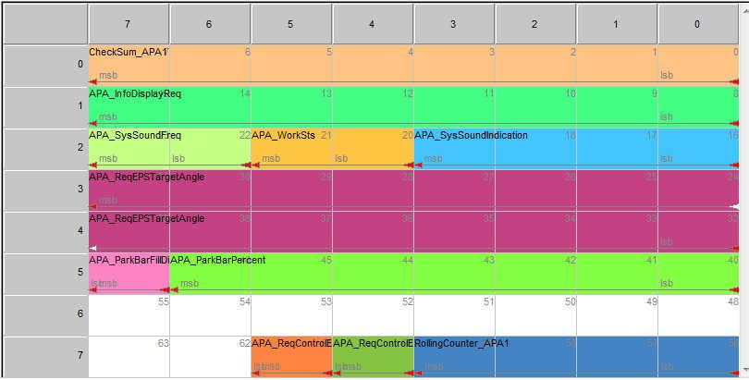

**2.2** **信号描述**

**2.2.1** **RollingCounter_APA1**

此信号用来指示 APA1 信息的发送序列。APA1 消息每 20ms 发送一次，相应的 RollingCounter_APA1 信号将从 0 到 15 开始累加，计满后又从 0 开始，此信号的的数据长度是 4bits。请参考如下图片 2.2.1。

|  |  |  |  |  |  |  |
| --- | --- | --- | --- | --- | --- | --- |
| RollingCounter_ |  | RollingCounter_ |  | RollingCounter_ |  | RollingCounter_ |
| APA1=0 |  | APA1= 1 |  | APA1 = 15 |  | APA1 = 0 |
| **APA_1** |  | **APA_1** |  | **APA_1** |  | **APA_1** |
|  |  |  |  |  |  |  |

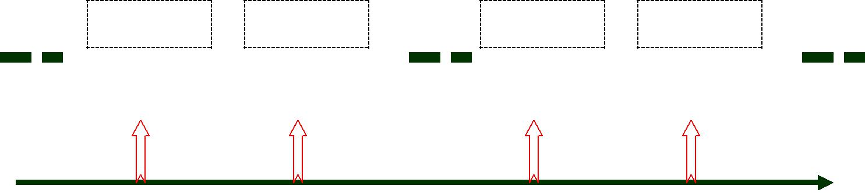

20 ms 20 ms 20 ms 20 ms Time / ms

* 2.2.1 APA_Roll_Count 的发送时序

|  |  |  |  |  |  |
| --- | --- | --- | --- | --- | --- |
|  |  | Document Name  **Communication between APA and EPS For CHB** | | | |
|  |  |
|  |  |  |  |  |  |
|  | | Document Type |  |  |  |
| Owner Domain: Document Prefix | | |  |
| Document No | Revision | Volume No | Page No |
|  | **1.2** |  | **6 (14)** |

Document Release Status

|  |  |
| --- | --- |
| Release Date | Version |

2017-11-24 1.2

**2.2.2** **CheckSum_APA1**

此信号是 APA1 消息的 Checksum，数据长度是 8bits。信号的发送周期是 20ms。

Checksum 的算法按照 GWM 协议，计算如下：

CheckSum_APA1 = Inverse { (APA_WorkSts + APA_ReqEPSTargetAngle

* APA_ReqControlEPSValid + APA_ReqControlEPS
* RollingCounter_APA1) mod 28}；

**2.2.3** **APA_ReqControlEPS**

* APA 需要控制方向盘时，该信号被使用。如果 APA_ReqControlEPS 信号被置为 1 并且

APA_ReqControlEPSValid 设为有效且 EPS 为可获得，EPS 状态将变为激活状态。

**2.2.4** **APA_ReqControlEPSValid**

这信号用来指示 APA_ReqControlEPS 是否有效。如果 APA_ReqControlEPSValid 被置为无效，EPS 将忽略请求激活信号，且如果 EPS 在 APA 的控制下时，将退出激活状态。

**2.2.5** **APA_ReqEPSTargetAngle**

如果 EPS 在 APA 的控制下，此信号用来指示目标转角。如果 EPS 是在激活状态且在当前转角和目标转角之间的△值是在一个极限值 MAX_ALLOW_CONTROL_STEP (ex: 100deg)之内的话，EPS 将转动方向盘到目标转

角。如果 APA_ReqEPSTargetAngle 的值是负的，则方向盘将向右转。如果 APA_ReqEPSTargetAngle 的值是正的，则方向盘将向左转。

|  |  |  |  |  |  |
| --- | --- | --- | --- | --- | --- |
|  |  | Document Name  **Communication between APA and EPS For CHB** | | | |
|  |  |
|  |  |  |  |  |  |
|  | | Document Type |  |  |  |
| Owner Domain: Document Prefix | | |  |
| Document No | Revision | Volume No | Page No |
|  | **1.2** |  | **7 (14)** |

Document Release Status

|  |  |
| --- | --- |
| Release Date | Version |

2017-11-24 1.2

**3** **APA 从 EPS 接收 CAN 消息**

**3.1** **APA 接收 CAN 消息**

* 3.1.1 列出了 APA 接收的 CAN 消息.

表 3.1.1 APA 接收 CAN 消息

|  |  |  |  |  |  |  |  |  |  |  |  |  |  |  |  |  |  |  |
| --- | --- | --- | --- | --- | --- | --- | --- | --- | --- | --- | --- | --- | --- | --- | --- | --- | --- | --- |
|  | **Message** |  |  | **Signal Name** |  |  | **Factor** |  |  | **Value** |  |  | **Value** |  |  | **Length** |  |  |
|  | **Name** |  |  |  |  |  |  |  |  | **Type** |  |  | **(Bit)** |  |  |
|  |  |  |  |  |  |  |  |  |  |  |  |  |  |  |  |
|  |  |  |  | CheckSum_EPS1 | | 1 | |  |  | Nmin = 0, Nmax = 255 | |  | Unsigned | | 8 | |  |  |
|  |  |  |  |  |  |  |  |  |  |  | |  |  |  |  |  |  |  |
|  |  |  |  | EPS_InterferDect | | 1 | |  |  | 0: False | |  | Unsigned | | 1 | |  |  |
|  |  |  |  |  |  | 1: True | |  |  |  |
|  |  |  |  |  |  |  |  |  |  |  |  |  |  |  |  |  |
|  |  |  |  |  |  |  |  |  |  |  | |  |  |  |  |  |  |  |
|  |  |  |  | EPS_InterferDectValid | | 1 | |  |  | 0: Invalid | |  | Unsigned | | 1 | |  |  |
|  |  |  |  |  |  | 1: Valid | |  |  |  |
|  | EPS1 | |  |  |  |  |  |  |  |  |  |  |  |  |  |  |
|  |  |  |  |  |  |  |  |  |  |  |  |  |  |  |  |  |
|  |  |  |  |  |  |  |  | 0: Temporary inhibit | |  |  |  |  |  |  |  |
|  |  |  |  |  |  |  |  |  |  |  |  |  |  |  |  |  |
|  |  |  |  | EPS_AvailSts | | 1 | |  |  | 1: Available for control | |  | Unsigned | | 2 | |  |  |
|  |  |  |  |  |  | 2: Active | |  |  |  |
|  |  |  |  |  |  |  |  |  |  |  |  |  |  |  |  |  |
|  |  |  |  |  |  |  |  |  |  | 3: Permanently failed | |  |  |  |  |  |  |  |
|  |  |  |  | RollingCounter_EPS1 | | 1 | |  |  | Nmin = 0, Nmax = 15 | |  | Unsigned | | 4 | |  |  |
|  |  |  |  |  |  |  |  |  |  |  |  |  |  |  |  |  |  |  |

* 3.1.2 EPS1 的 CAN 消息规范
* 3.1.2 EPS1 消息规范

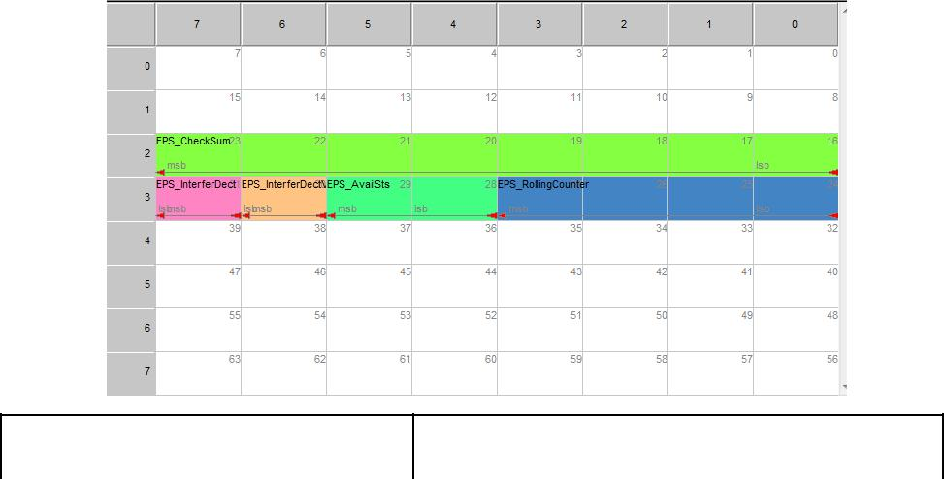

|  |  |  |  |  |  |
| --- | --- | --- | --- | --- | --- |
|  |  | Document Name  **Communication between APA and EPS For CHB** | | | |
|  |  |
|  |  |  |  |  |  |
|  | | Document Type |  |  |  |
| Owner Domain: Document Prefix | | |  |
| Document No | Revision | Volume No | Page No |
|  | **1.2** |  | **8 (14)** |

Document Release Status

|  |  |
| --- | --- |
| Release Date | Version |

2017-11-24 1.2

**3.2** **信号描述**

**3.2.1** **EPS1 消息**

**3.2.1.1** **RollingCounter_EPS1**

此信号用来指示 EPS1 信息的发送序列。EPS1 消息每 20ms 发送一次，相应的 RollingCounter_EPS1 信号将从 0 到 15 开始累加，计满后又从 0 开始，此信号的的数据长度是 4bits。请参考如下图片 3.2.1.1

|  |  |  |  |  |  |  |
| --- | --- | --- | --- | --- | --- | --- |
| RollingCounter |  | RollingCounter |  | RollingCounter |  | RollingCounter |
| _EPS1 = 0 |  | _EPS1 = 1 |  | _EPS1 = 15 |  | _EPS1 = 0 |
| **EPS1** |  | **EPS1** |  | **EPS1** |  | **EPS1** |
|  |  |  |  |  |  |  |

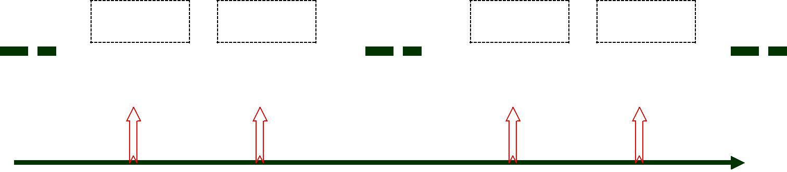

20 ms 20 ms 20 ms 20 ms Time / ms

Picture 3.2.1.1 Transmition of EPS_MSG_Counter

**3.2.1.2** **CheckSum_EPS1**

此信号是 EPS1 消息的 Checksum，数据长度是 8bits。信号的发送周期是 20ms。Checksum 的计算算法如下:

Checksum 的算法按照 GWM 协议，计算如下：

CheckSum_EPS1 = Inverse { (EPS_InterferDect + EPS_InterferDectValid

+ EPS_AvailSts+ RollingCounter_EPS1) mod 28}；

**3.2.1.3** **EPS_InterferDect**

当方向盘被 APA 控制时，EPS 是在激活状态，此信号用来检查是否驾驶员已试图控制方向盘。如果驾驶员设法控制方向盘，EPS1 将 EPS_InterferDect 置为 1 且发送 Temporary inhibit 状态。此检测算法取决于 EPS 供应商。但检测的算法要足够的强大，以避免误检测。软件的判断条件是驾驶员施加的扭矩和持续的时间，这些条件应该通过各种驾驶条件的测试而适当地设定的。当驾驶员没有控制方向盘时，EPS 不应该报出 EPS_InterferDect 置为 1。同样的当驾驶员设法控制方向盘时，EPS 不应把 EPS_InterferDect 置为 0。EPS 供应商判定和测试驾驶员干涉方向盘的标准，应得到 APA 供应商的确认。

**3.2.1.4** **EPS_InterferDectValid**

|  |  |  |  |  |  |  |
| --- | --- | --- | --- | --- | --- | --- |
|  |  | Document Name  **Communication between APA and EPS For CHB** | | | | |
|  |  |
|  |  |  | |  |  |  |
|  | | Document Type | |  |  |  |
| Owner Domain: Document Prefix | | | |  |
| Document No | Revision | | Volume No | Page No |
|  | **1.2** | |  | **9 (14)** |

Document Release Status

|  |  |
| --- | --- |
| Release Date | Version |

2017-11-24 1.2

此信号用来确认 EPS_InterferDect 信号是否有效。如果 EPS_InterferDect 信号时有效的，

EPS_InterferDectValid 信号应被设为有效；如果 EPS_InterferDect 为无效的，EPS_InterferDectValid 信号应被设为

无效。也就是说，如果 EPS 判定内部失败或者不符合检测驾驶员干预方向盘的条件，EPS 应设

EPS_InterferDectValid 的信号为无效。且如果 EPS 能正确地检测到方向盘受干预，EPS 应设

EPS_InterferDectValid 信号为有效。对于有效或无效的条件是由 EPS 供应商判定的。但所有的这些判定条件 EPS

供应商应告知 APA 供应商为了能再次确认，。

**3.2.1.5** **EPS_AvailSts**

EPS 将发送以下状态信号到 APA:

0: Temporary inhibit

1: Available for control

2: Active

3: Permanently failed

**3.2.1.5.1** **EPS_AvailSts = “Permanently failed”**

如果 EPS 是由于一个永久的失败而难以获得的，EPS 应发送“EPS_AvailSts = Failed”，永久失败：在那当前的上电周期（ignition cycle）里面，失败恢复是不可能的。以下列出了引起永久失败的可能性

硬件失败；

EPS 和 APA 的 CAN 通讯超时；

EPS 和 APA 的 CAN 通讯无效。

**3.2.1.5.2** **EPS_AvailSts = “Temporary inhibit”**

在由某个状态转换到” Temporary inhibited” 之后，那 EPS 将发送“EPS_AvailSts = Temporary inhibit”。在同一个上电周期里面，如果某种事件或失败的恢复是可能的，这种状态将被触及

以下列出了，在同一个上电周期里面，某些事件或暂时失败是可能被恢复的：

驾驶员干预；

驾驶速度超出了也许范围内；

CAN 通讯超时；

CAN 通讯信号无效。

|  |  |  |  |  |  |
| --- | --- | --- | --- | --- | --- |
| **3.2.1.5.3** | **EPS_AvailSts = “Available for control”** |  |  |  |  |

|  |  |  |  |  |  |
| --- | --- | --- | --- | --- | --- |
|  |  | Document Name  **Communication between APA and EPS For CHB** | | | |
|  |  |
|  |  |  |  |  |  |
|  | | Document Type |  |  |  |
| Owner Domain: Document Prefix | | |  |
| Document No | Revision | Volume No | Page No |
|  | **1.2** |  | **10 (14)** |

Document Release Status

|  |  |
| --- | --- |
| Release Date | Version |

2017-11-24 1.2

在某个状态转换为“Available for Control”之后，EPS 将发送“EPS_AvailSts = Available for control”。

**3.2.1.5.4** **EPS_AvailSts = “Active”**

在某个状态转换为“Active”之后，EPS 将发送“EPS_AvailSts= Active” 。在激活状态时， EPS 是处于 APA 的控制之下。

**3.2.1.5.5** **EPS 状态转换**

The EPS shall adhere to the following state flow control logic 那 EPS 应遵循以下状态的流程控制逻辑。

**3.2.1.5.6** **EPS 状态**

EPS 状态被定义如下:

“Permanently Failed” 状态

“Temporary Inhibited” 状态

“Available for Control” 状态 “Active” 状态

**3.2.1.5.6.1** **EPS 状态转换**

以下图 3.2.5.5.1 显示了 EPS 状态转换图表.

|  |  |  |  |  |  |
| --- | --- | --- | --- | --- | --- |
|  |  | Document Name  **Communication between APA and EPS For CHB** | | | |
|  |  |
|  |  |  |  |  |  |
|  | | Document Type |  |  |  |
| Owner Domain: Document Prefix | | |  |
| Document No | Revision | Volume No | Page No |
|  | **1.2** |  | **11 (14)** |

Document Release Status

|  |  |
| --- | --- |
| Release Date | Version |

2017-11-24 1.2

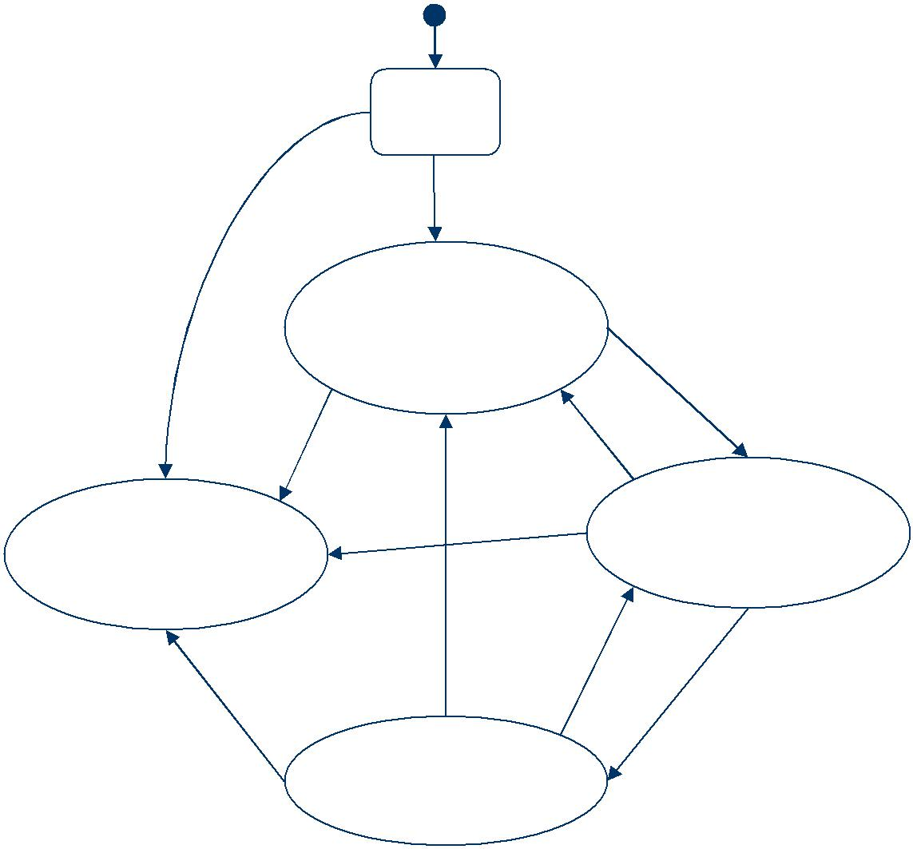

|  |  |  |  |  |
| --- | --- | --- | --- | --- |
|  | Power |  |  |  |
|  | Up Init |  |  |  |
| Init | Init OK |  |  |  |
| NOK |  |  |  |  |
|  | **Temporary** |  |  |  |
|  | **Inhibited** |  |  |  |
|  |  |  | C2 |  |
|  | C1 | C3 |  |  |
|  |  |  |  |
| **Permanently** |  | C1 | **Available for** |  |
|  | **Control** |  |
| **Failed** |  |  |  |
|  |  |  |  |
|  | C6 | C5 | C4 |  |
|  |  |  |
| C1 |  |  |  |  |

**Active**

* 3.2.5.5.1 EPS 状态转换图表

1. **C1**

任意的永久失败条件被符合时。

1. **C2**

车辆速度小于或等于限定速度（ex. <= 10km/h）且无从 APA 收到激活请求。

**3.** **C3**

车辆速度大于限定速度(ex. > 10km/h)或 EPS 辅助级别比较低。

|  |  |  |  |  |  |
| --- | --- | --- | --- | --- | --- |
|  |  | Document Name  **Communication between APA and EPS For CHB** | | | |
|  |  |
|  |  |  |  |  |  |
|  | | Document Type |  |  |  |
| Owner Domain: Document Prefix | | |  |
| Document No | Revision | Volume No | Page No |
|  | **1.2** |  | **12 (14)** |

Document Release Status

|  |  |
| --- | --- |
| Release Date | Version |

2017-11-24 1.2

**4.** **C4**

APA_WorkSts =2(Active)；EPS 既不是“永久失败”和“临时禁止状态”；车辆是固定的(车辆速度等于 0 在一定的车辆停滞时间（ex.1s）)且挡位被放置到 R 挡的在某段持续时间内（ex.500ms）且在 APA 请求控制 EPS 之后（APA1:APA_ReqControlEPS=1）

**5.** **C5**

APA 请求控制 EPS 无效（APA1: APA_ReqControlEPS=0）

1. **C6**

驾驶员干涉方向盘或暂时失败被检测或车辆速度大于限定值。

**3.2.1.5.6.2** **APA 与 EPS 的信号交互示意图**

|  |  |  |  |  |  |
| --- | --- | --- | --- | --- | --- |
|  |  | Document Name  **Communication between APA and EPS For CHB** | | | |
|  |  |
|  |  |  |  |  |  |
|  | | Document Type |  |  |  |
| Owner Domain: Document Prefix | | |  |
| Document No | Revision | Volume No | Page No |
|  | **1.2** |  | **13 (14)** |

Document Release Status

|  |  |
| --- | --- |
| Release Date | Version |

2017-11-24 1.2

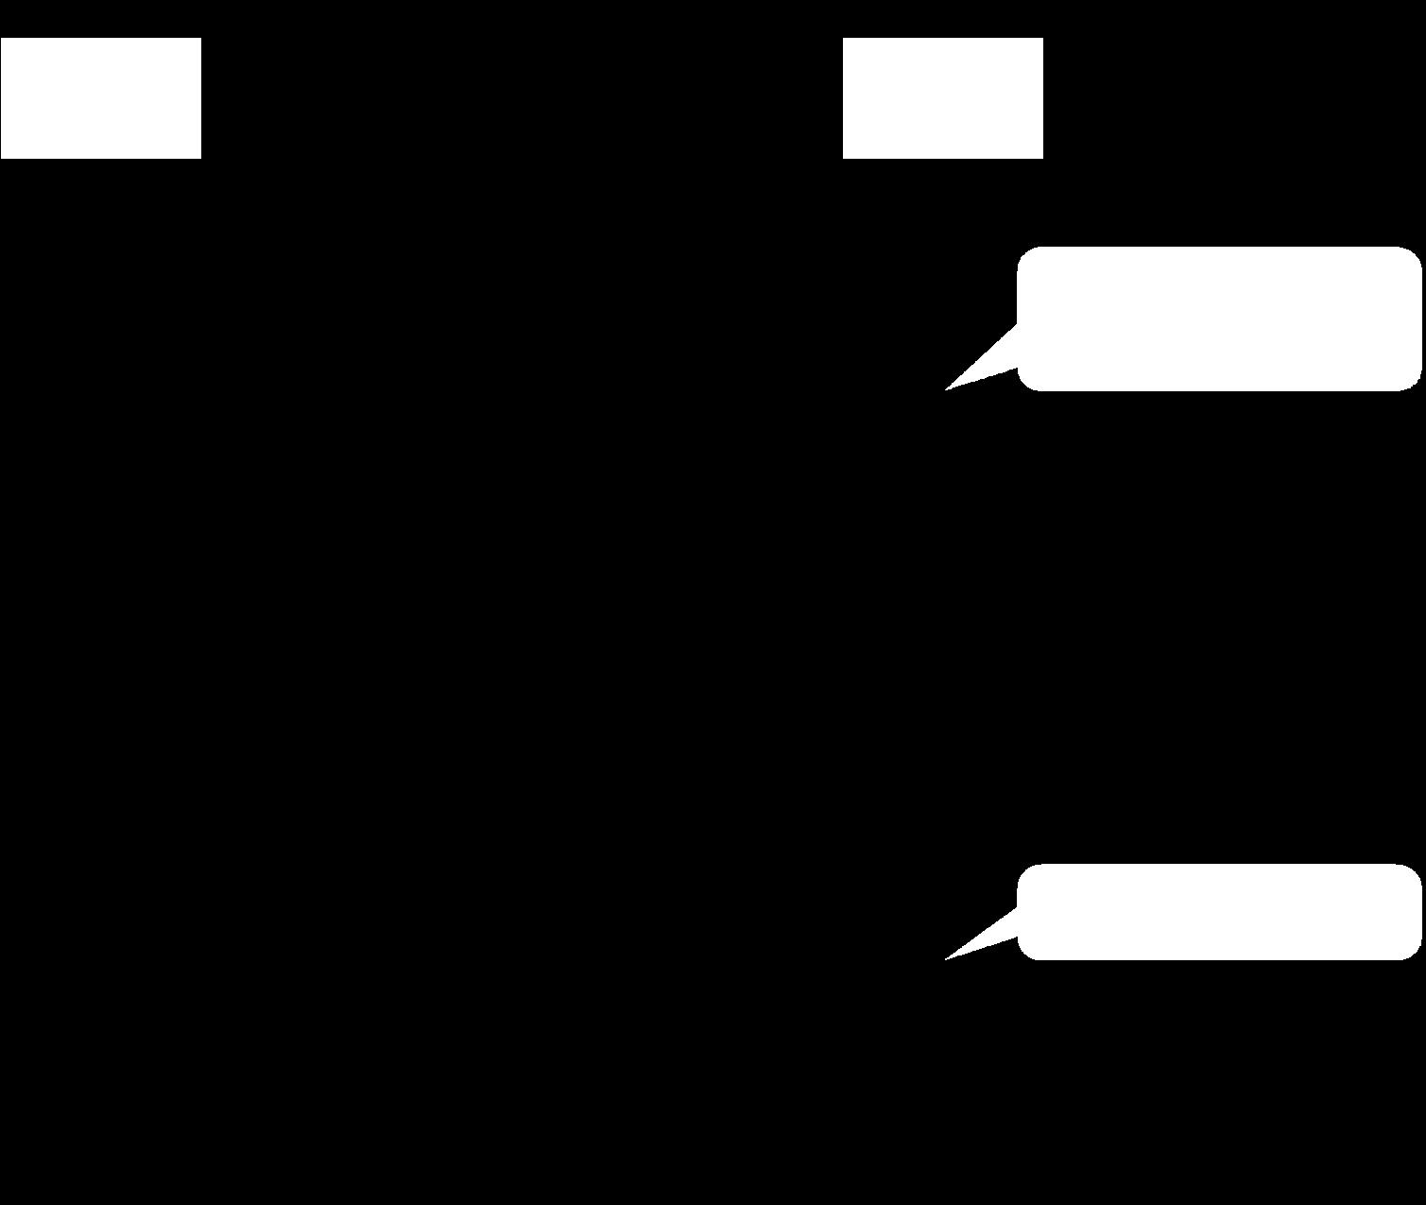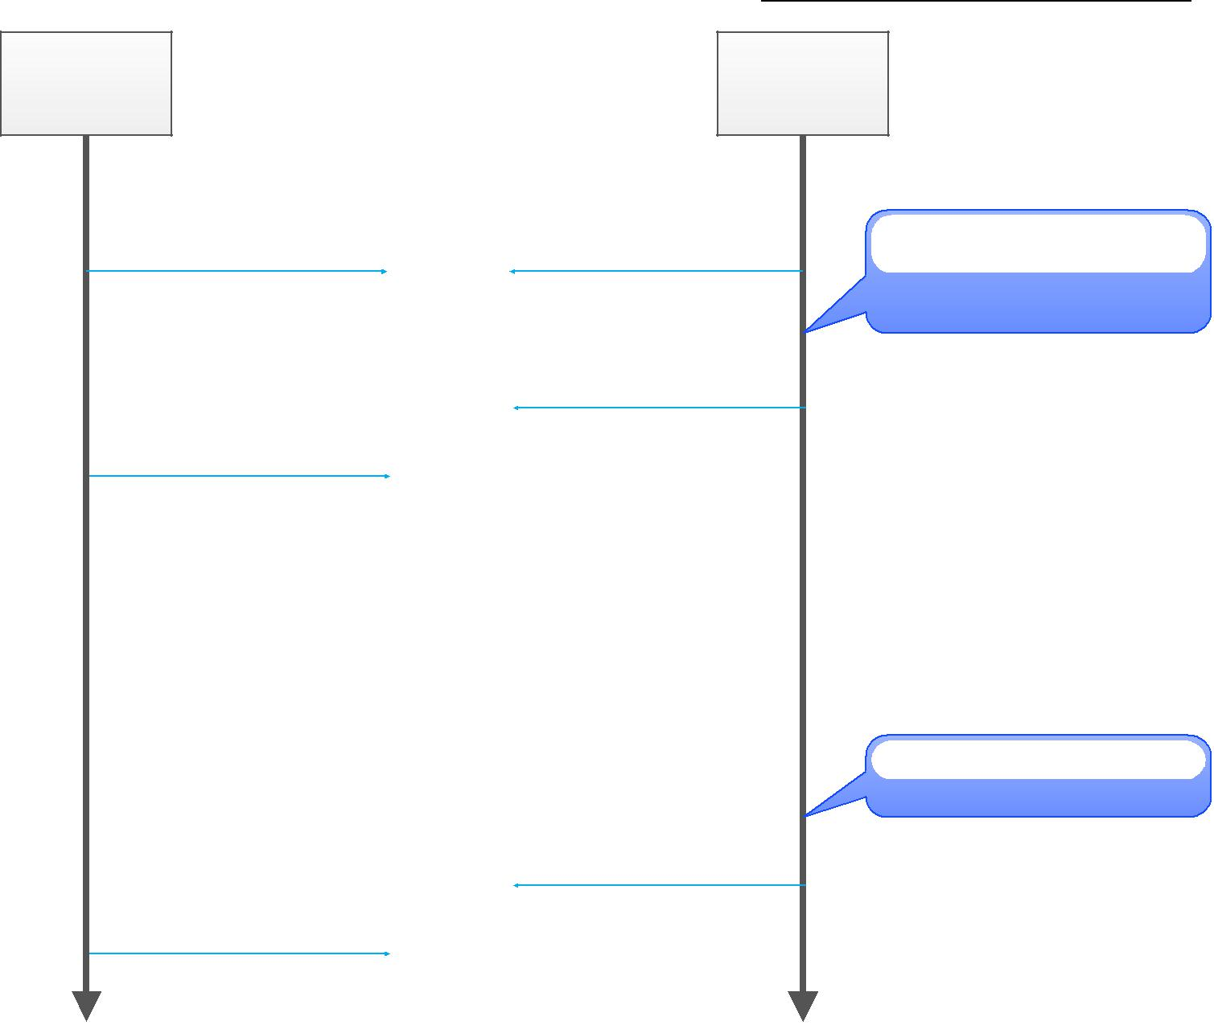

EPS

EPS_AvailSts = Available

EPS_AvailSts = Active

EPS_AvailSts = Available

APA

APA_WorkSts = Active

APA_ReqControlEPSValid = Valid APA_ReqControlEPS = 0

APA_ReqControlEPS = 1



APA_WorkSts = Enable APA_ReqControlEPS = 0

条件满足

（比如找到车位；停车；挂R档）

泊车完成

|  |  |  |  |  |  |
| --- | --- | --- | --- | --- | --- |
|  |  | Document Name  **Communication between APA and EPS For CHB** | | | |
|  |  |
|  |  |  |  |  |  |
|  | | Document Type |  |  |  |
| Owner Domain: Document Prefix | | |  |
| Document No | Revision | Volume No | Page No |
|  | **1.2** |  | **14 (14)** |