Word jam

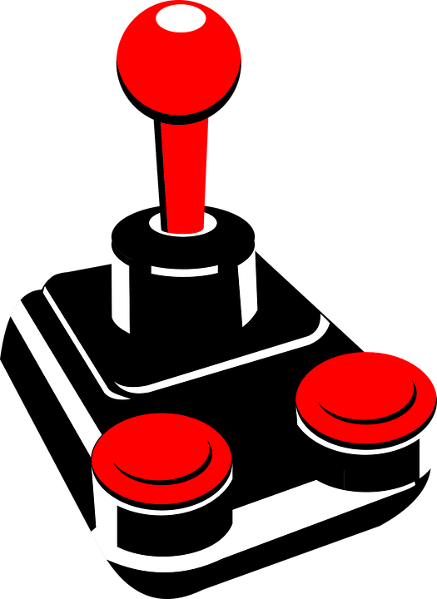

Controls:

* Joystick to move the laser and on screen cursor
* Joystick click on a word to grab and release it (to change its position)
* Green button to add a random word
* Red button to delete the word that is currently being grabbed by the cursor