

Of

RSA247

|  |  |
| --- | --- |
| **Version:** | 1.5 |
| **Last Updated:** | 22-Jun-16 |
| **Author:** | Vamsi Adarsh |
| **Designation:** | Product Owner |

Document Information and Approvals

Revision History

| Version | Date | Comment | Author | Reference # |
| --- | --- | --- | --- | --- |
| 0.1 | 24-Nov-15 | Initial draft version of FRD document | Adarsh |  |
| 0.2 | 1-Dec-15 | Reviewed & Updated version | Jitendra |  |
| 0.3 | 23-Mar-16 | After discussion update | Adarsh |  |
| 0.4 | 31-Mar-16 | Discussion , Aditya, Anand, Adarsh | Adarsh |  |
| 0.5 | 5-Apr-16 | Discussion Aditya, Anand, Jitendra, Adarsh | Adarsh |  |
| 0.6 | 15-Apr-16 | Discussion Aditya, Jitendra, Adarsh | Adarsh |  |
| 1.0 | 15-Apr-16 | Approved by Jitendra | Adarsh |  |
| 1.1 | 19-Apr-16 | Customer App FRD first cut | Adarsh |  |
| 1.3 | 29-Apr-16 | Customer App FRD | Adarsh |  |
| 1.4 | 04-May-16 | Customer App FRD after 1st meeting | Adarsh |  |

**Review Log Service Partner App**

| Version | Date | Requirement ID | Update | Approved By |
| --- | --- | --- | --- | --- |
| 0.3 | 23-Mar-16 | SP.1.1 | Document Upload with scan and browse options | Anand Rahul |
| 0.3 | 23-Mar-16 | SP.1.1 | Map view for pre populating the service provider details | Disapproved by Anand Rahul and Removed |
| 0.3 | 23-Mar-16 | SP.1.1 | Drop down for role of the user in the organization | Anand Rahul |
| 0.3 | 23-Mar-16 | SP.1.2 | List of documents should be shown in the document upload page | Anand Rahul |
| 0.3 | 23-Mar-16 | SP.1.1 | A message of business approval has to be sent to the app and also an SMS | Anand Rahul |
| 0.3 | 23-Mar-16 | SP.1.1 | Agreement can be accepted with a button, no need for a sign. | Anand Rahul |
| 0.3 | 23-Mar-16 | SP.1.7 | Accepting button will prompt to declare an ETA | Anand Rahul |
| 0.3 | 23-Mar-16 | SP.1.10 | Service provider will add description of the issue in a field after reaching the service location | Anand Rahul |
| 0.3 | 23-Mar-16 | SP.1.10 | The service provider can raise a tow request if he cannot service the vehicle at that location. | Anand Rahul |
| 0.3 | 23-Mar-16 | SP.1.12 | Spares and other items are not mentioned in the in the invoice. | Anand Rahul |
| 0.4 | 31-Mar-16 | SP.1.7 | Issues page will be the main screen. | Anand Rahul |
| 0.4 | 31-Mar-16 | SP.1.5 | Issues Shortcut in the Dashboard screen will have a number badge that shows the count of open notifications | Anand Rahul |
| 0.4 | 31-Mar-16 | SP.1.7 | Once a user accepts a request, he should not receive any notifications until he completes the service request | Anand Rahul |
| 0.5 | 5-Apr-16 | SP.1.15 | Rate card added in the profile menu | Anand Rahul |
| 0.5 | 5-Apr-16 |  | Superficial changes - colors, buttons and removal of map in end service screen | Anand Rahul |
| 0.6 | 15-Apr-16 | SP.1.1 | Removed no. of emp field, removed read agreement button, add image preview of id proof | Jitendra |
| 0.6 | 15-Apr-16 | SP.1.7 | Added starting now and 5 min and 10 mins | Jitendra |
| 0.6 | 15-Apr-16 | SP.1.9 | Removed the navigate button, retaining only Start button | Jitendra |
| 0.6 | 15-Apr-16 | SP.1.14 | Remove notification settings | Jitendra |
| 1.0 | 15-Apr-16 | Section 3.2 | Approved | Jitendra |
| 1.2 | 27-Apr-16 | SP.1.1 | Remove the Agent Login for sales executives | Anand Rahul |

**Review Log Customer App**

| Version | Date | Requirement ID | Update | Approved By |
| --- | --- | --- | --- | --- |
| 1.3 | 29-Apr-16 | CU.0.12 | Added Network Connectivity Not available |  |
| 1.4 | 04-may-16 | CU.0.2 | Driver’s License compulsory as ID Proof |  |
| 1.4 | 04-may-16 | CU.0.4 | Input Vehicle details changed to selecting brands and model pictures |  |
|  |  |  |  |  |

Document Reviewers/Approvers/Contributors

The following table identifies the individuals responsible for approving, contributing or reviewing this document.

| Name | Designation | Reviewer/  Approver/ Contributor | Approval Date |
| --- | --- | --- | --- |
| Rahul Anand | Managing Partner- RSA247 | Approver |  |
| Jitendra Tripathi | Director- Projects- UCS | Reviewer |  |
| Adarsh | Operational Manager- RSA247 | Reviewer |  |
|  |  |  |  |
|  |  |  |  |
|  |  |  |  |

Table of Contents

1. Introduction 5

1.1 Purpose 5

1.2 Business Context 5

1.3 Project Objectives 5

1.4 Scope 5

1.4.1 In Scope 5

1.4.2 Out of Scope 6

2. Assumptions/Constraints/Risks 6

2.1 Assumptions 6

2.2 Constraints 7

2.3 Risks 7

3. Functional & Non-functional Requirements 7

3.1 Functional Requirements for Customer App 7

3.1.1 Download & Install 7

3.1.2 App Sharing 8

3.1.3 Login and Signup 8

3.2 Service Partner App functionalities 11

3.2.1 Download & Install 11

3.2.2 Registration 11

3.2.3 Approval 13

3.2.4 Rate Card 14

3.2.5 Notifications for Service 14

3.2.6 Dashboard 16

3.2.7 Service Request Broadcasting 17

3.2.8 Accepting a Request 17

3.2.9 Service Request Items 18

3.2.10 Servicing Pre-requisites 19

3.2.11 Invoice 20

3.2.12 Payment Process 21

3.2.13 Persistent Notification 21

3.2.14 Profile Menu 22

3.2.15 Premium Service Provider 22

3.3 Admin App Functionalities 23

3.3.1 23

3.3.2 …n 23

3.4 Non Functional Features 24

4. Use Cases 24

4.1 Use Case Actors 24

4.2 Use Case Diagrams and Actor Hierarchy 24

4.3 Use Case Descriptions 25

5. Solution Landscape 27

5.1 System Vision 27

5.1.1 Data Sources 28

5.1.2 Integration 29

5.1.3 Data Storage 29

5.1.4 Analytics 29

5.1.5 Presentation & Report generation 29

5.2 Technical Framework 29

5.2.1 Data Flow Diagram 1- Complete System 29

5.2.2 Data Flow Diagram 2- Data Entry System 32

5.2.3 Data Flow Diagram 3 - ETL Processes 32

5.2.4 Data Flow Diagram 4 - Reporting Systems 32

5.2.5 Data Flow Diagram …n - 32

5.3 UI – Visual Design 32

6. Reference Documents 33

7. Annexures 33

7.1 Annexure A – Terms & Conditions 33

7.2 Annexure B – Additional Screenshots 33

# Introduction

## Purpose

This document contains products requirements at detailed level. To identify all the possible use cases of the application for all the screens.

## Business Context

RSA 247’s mail aim is to bring the customers in distress while on road and the service providers nearby on the same platform for a better road experience for the customer. At the same time we are a platform for the service provider to actively and instantly connect with the customer and grow their business and reach of customers. The promise of availability at any time and place is RSA’s major offering for the customers and the opportunity to increase the business for the service provider..

The apps are part of the business context of the RSA. Created for the usage of the service providers who would work along with RSA and also the customers that request for services. There is an admin app as well that would control both the apps from backend. There are three parties involved in each transaction, they are RSA support, Customer and the Service Provider. Each entity has an app to work with namely Admin app, Customer App and Service Provider App respectively.

## Project Objectives

The Project outcome is to create all the apps mentioned in the Business Context with a clear functionalities from various stakeholders. To create all three apps that will have a clear communication among them so that each works exactly the way they are supposed to.

## Scope

The project scope ends at the successful UAT. The tasks include App development, testing, UAT and adoption. App development will follow the order of Service Provider app followed by customer app and the admin app being developed in parallel.The service provider and customer apps would be native apps developed for android platform while the admin app would be a web app meant for the server.

### In Scope

The Service Partner App shall have these basic functionalities

1. Location Capture of the Service Provider
2. Fetch the customer’s location
3. View the issue of the customer
4. Accept or reject the request
5. Provide updates to the customer about ETA
6. Contact support for confirmation and closure
7. Create billing info along with an SMS
8. Android development
9. Web app development for admin app
10. UAT

### Out of Scope

The features of a bit complexity like reassignment, additional items in billing, employee Owner relations and views are out of scope for this project.

iOS and Windows development for service providers and customer apps are out of scope for this project.

# Assumptions/Constraints/Risks

## Assumptions

The following table identifies conditions that the project assumes already exists or are outside of the project teams area of responsibility that are Medium to the success of the project

| S No. | Description | Comments |
| --- | --- | --- |
|  | All our service partners have an Android device |  |
|  | SMS and Internet connectivity are not interdependent |  |
|  |  |  |
|  |  |  |
|  |  |  |
|  |  |  |
|  |  |  |
|  |  |  |
|  |  |  |
|  |  |  |

## Constraints

The level of smartphone usage could be a constraint, as the low end Android smartphones though affordable are not good performers and this results in a low level of adoption.

May be an observational study can tell us how many of them have an android phone(Average numbers)

## Risks

Apart from major competitors.

# Functional & Non-functional Requirements

## Customer App Functional Requirements

### Phase 1

### App Size

|  |  |  |  |
| --- | --- | --- | --- |
| **Requirement**  **ID** | **Req. Description** | **Priority** | **Comments** |
|  | * The App size would be around 15 – 25 MB and would require move to SD card option and also a file to store local data in the phone memory. |  |  |

### Download & Install

|  |  |  |  |
| --- | --- | --- | --- |
| **Requirement**  **ID** | **Req. Description** | **Priority** | **Comments** |
|  | * Available for free on the Google Play Store. * Needs Google Analytics Integration * Permissions need to be provided on first use (6.0 and above) |  |  |

### Authenticationte,

|  |  |  |  |
| --- | --- | --- | --- |
| **Requirement**  **ID** | **Req. Description** | **Priority** | **Comments** |
|  | * Mobile OTP is used as first level of authentication * Driver’s License requested as identity proof and proof that the person can drive legally. * A verification/confirmation call is initiated every time a service is requested |  |  |

### Registration

|  |  |  |  |
| --- | --- | --- | --- |
| **Requirement**  **ID** | **Req. Description** | **Priority** | **Comments** |
|  | * The user registration will have fields to capture data such as mobile number, email id, id proof and city. * It will also capture essential details such as blood group, Age, allergies if any, Current Medication (chronic), other surgeries and conditions present. |  |  |

### Packages & Pricing

|  |  |  |  |
| --- | --- | --- | --- |
| **Requirement**  **ID** | **Req. Description** | **Priority** | **Comments** |
|  | * There is only one flat pricing. * The user can access the website for purchasing the premium version. * Each person is treated as a unique member who can purchase a RSA cover. |  |  |

### Community

|  |  |  |  |
| --- | --- | --- | --- |
| **Requirement**  **ID** | **Req. Description** | **Priority** | **Comments** |
|  | * Every first time user is prompted to join the community by accepting the terms and conditions. * An opt out option is provided, using which one can exit the community at any point of time. * Once joined, the user can help other members and also request help when needed. |  |  |

### Emergency Contact

|  |  |  |  |
| --- | --- | --- | --- |
| **Requirement**  **ID** | **Req. Description** | **Priority** | **Comments** |
|  | * The user can input two mobile numbers as emergency contacts who will be notified in the case of an emergency such as an accident. |  |  |

### Emergency Services

|  |  |  |  |
| --- | --- | --- | --- |
| **Requirement**  **ID** | **Req. Description** | **Priority** | **Comments** |
|  | * The app would firstly ask the user if it is an medical emergency, if it is an ambulance is requested immediately without asking anymore questions * Once an ambulance is arranged, the user will be called by the RSA 247 support to arrange other requirements of service provider or towing. * An option to intimate police option is also included in the same screen. |  |  |

### Request Community

|  |  |  |  |
| --- | --- | --- | --- |
| **Requirement**  **ID** | **Req. Description** | **Priority** | **Comments** |
|  | * A user can request for a community request or request for a service provider * A Community request would be for simple requirements like Water, Tools and First Aid and these will be explicitly mentioned and the user can only choose one or more of them. * A comment section is also provided to request for something specific. * Rules should be set for usage of language, contacting fellow members, to mark the help complete and moved away from the location (to ensure the safety of the member who came for help) to curb misuse. * A service request that is broadcasted should have a range not more than 15 KM. * A community request can be accepted by multiple people, but restricted to a max limit of 3 members. |  |  |

### Request A Service Engineer

|  |  |  |  |
| --- | --- | --- | --- |
| **Requirement**  **ID** | **Req. Description** | **Priority** | **Comments** |
|  | * The User can request for a service engineer to come to his location for an onsite solution. * User can select from a list of services to intimate the service provider. * If the user is unsure about the problem, he can choose any of the problem and the service engineer will update the issue detail at the time of the visit. * The User can click on the picture of the service provider for better viewing * Night Stay | High |  |

### Internet Connectivity Not Available

|  |  |  |  |
| --- | --- | --- | --- |
| **Requirement**  **ID** | **Req. Description** | **Priority** | **Comments** |
|  | * Each time the RSA 247 app is opened, it should check for connectivity and if the internet connectivity is not available * The App should ask for a send SMS confirmation as the connectivity is not available. * The app should capture the location from GPS and send an SMS to be interpreted by the server * Then this location and other details should be put into a service request and broadcasted to service providers according to the algorithm. | High |  |

### Milestone Notifications

|  |  |  |  |
| --- | --- | --- | --- |
| **Requirement**  **ID** | **Req. Description** | **Priority** | **Comments** |
|  | * The User shall get notification each time the status of the service request changes  1. Service Request Accepted by a Service Provider 2. Service Engineer Left the location 3. Service Engineer Reached 4. Invoice Created 5. Service Complete 6. Rating & Feedback  * A click on these notifications will open the page of service request with details and the status of request mentioned at the top. | High |  |

### Invoice & Payment

|  |  |  |  |
| --- | --- | --- | --- |
| **Requirement**  **ID** | **Req. Description** | **Priority** | **Comments** |
|  | * The User will get an invoice for the services rendered, it will contain the service providers name and details. * Once the issue is closed an instant SMS and mail are triggered to the customer’s mail id. | High |  |

### SMS & Mail Trigger points

|  |  |  |  |
| --- | --- | --- | --- |
| **Requirement**  **ID** | **Req. Description** | **Priority** | **Comments** |
|  | * The SMS and mails are triggered at these stages in the service request lifecycle  1. When the service request is raised by the customer, an SMS and mail are triggered with the details 2. When the service request is accepted by a service provider, an SMS and mail are triggered in the same conversation 3. When an Invoice is generated, invoice is attached in the mail, SMS will have the amount of the Invoice. | High |  |

### SMS & Mail Templates

|  |  |  |  |
| --- | --- | --- | --- |
| **Requirement**  **ID** | **Req. Description** | **Priority** | **Comments** |
|  | * The SMS will look like - Hi, Mr/Ms XXXXXXXX, your invoice for the amount Rs. XXXX for (service) XXXX with the provider XXXXXXXX has been generated and sent to your mail id. * Mail will have the above information along with promotional content and an attached document of the invoice in pdf format. | High |  |

### Phase 2

### Family Members

|  |  |  |  |
| --- | --- | --- | --- |
| **Requirement**  **ID** | **Req. Description** | **Priority** | **Comments** |
|  | * The user can type in the details and add another member by tapping on the Add Family Member * The person to add other family members becomes the master of the group, and only he/she can add or remove family members. * The added family members are slaves to the master and cannot add or remove any more family members. |  |  |

### Vehicle Details

|  |  |  |  |
| --- | --- | --- | --- |
| **Requirement**  **ID** | **Req. Description** | **Priority** | **Comments** |
|  | * A user can add up to 3 vehicles that he own and any additional vehicle to be added after will be for a premium. * The details of the vehicle are autofilled as the user types in each field. * The year of manufacture would be a dropdown. * The user will also have an option to select 2-wheeler brands and 4 wheeler brands. |  |  |

### Member Badges

|  |  |  |  |
| --- | --- | --- | --- |
| **Requirement**  **ID** | **Req. Description** | **Priority** | **Comments** |
|  | * Each time a member accepts a community request, and completes it he gets a score and based on that score his profile has a badge. These badges show how helpful that member is and these badge details can be shared on the social media. * Each badge has sublevels in them too, to go to the next badge one has to complete these sublevels * For example the first badge could be FirstTimer, level 1 to 10 * Then the badge changes after 10 time to Good Samiritan level 1 to 10 each time a person levels up, he can share it on social media. * This needs social media integration, designing badges, a counter for the number of times requests accepted and completed. |  | Gamification of helping others.  This could be the USP of our app community point of view. |

### Profile Menu

|  |  |  |  |
| --- | --- | --- | --- |
| **Requirement**  **ID** | **Req. Description** | **Priority** | **Comments** |
|  | * The user can go to any of the screens,  1. Edit his personal and family details, 2. Add a new vehicle 3. Contact support from the profile menu. 4. View his current badge and share it on the social media and invite other friends 5. Share the app through Bluetooth, or send download link through Whatsapp and Facebook or SMS 6. Can send feedback and rate the app on the play store. |  |  |

## Service Partner App functionalities

### Download & Install

|  |  |  |  |
| --- | --- | --- | --- |
| **Requirement**  **ID** | **Name / Description** | **Priority** | **Comments** |
|  | * A free Google Play Store app for better reach to users * App size should be on the lower side * A move to sd card would be required in case the app size exceeds 10 MB * On installation terms and conditions of usage have to be accepted, Annexure A for detailed T&C |  |  |

### Registration

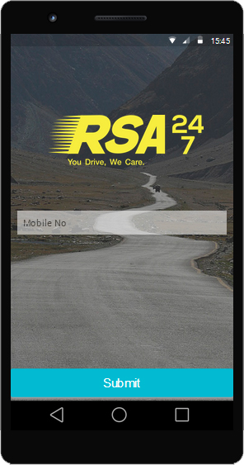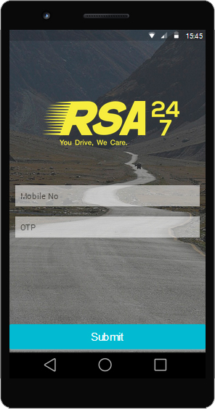

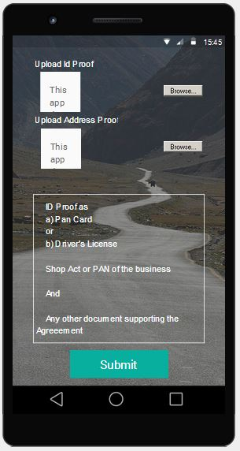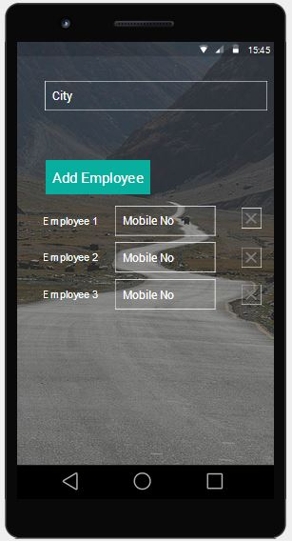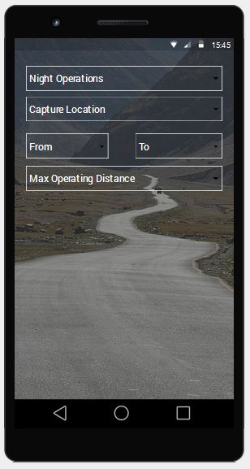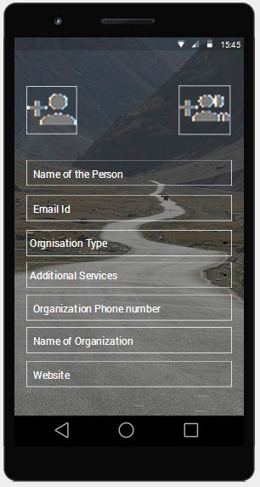

|  |  |  |  |
| --- | --- | --- | --- |
| **Requirement**  **ID** | **Name / Description** | **Priority** | **Comments** |
|  | * There won’t be any bifurcation for owner and employee in the app login page. * OTP will be used to authenticate the device for a new registration. * After this step the service provider will get an option to select the role he works for, for e.g. Owner, Technician, Mechanic, consultant. * Once the owner registers (after the OTP step) he will add the employees by providing the name and mobile numbers, these numbers will be registered and linked with the organization, they will also receive an SMS containing the download link. * Registration process starts with entering the details of the Organization and himself, the list includes  1. Type of Organization 2. Additional Services 3. Name of Organization 4. Phone number (landline) of organization 5. Website 6. Name of the Person 7. Mobile Number of the person 8. Email id 9. Location (Lat Long) 10. Photos of Business location, Person 11. Org work timings 12. Organization city of operation 13. Max Distance the organization can operate 14. Interest in night operations  * Adding employees along with name and mobile number.  1. Later these mobile numbers are used to group the statistics of the organization like rating, earnings, requests serviced, requests accepted, rejected. |  |  |

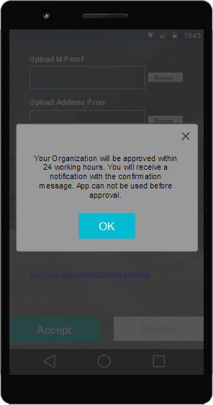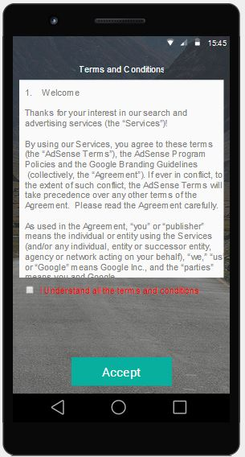

### Approval

|  |  |  |  |
| --- | --- | --- | --- |
| **Requirement**  **ID** | **Name / Description** | **Priority** | **Comments** |
|  | * Once a registration request is raised by an organization, the organization will receive a call from RSA executive to confirm and review the details. * Then an executivecan visit the business location to approve that the business exists * The list of the documents accepted have to be mentioned in this page. * Collect Identity proofs like  1. PAN card, Driver License, Shop Act or Address Proof  * Explain the terms of joining RSA,  1. the legalities, 2. How revenue is generated to the service provider 3. The standard rate card and how it works 4. Get the agreement signed.  * Once the agreement is signed it is digitized and uploaded. * The user himself can either upload an already clicked picture or click a picture right from the application. * The admin can view these digital copies later on if required. * The user/Service Partner can use the app only once the business is approved. The user will get an SMS and a notification, that the business is approved and he can use the app. |  |  |

### Rate Card

|  |  |  |  |
| --- | --- | --- | --- |
| **Requirement**  **ID** | **Name / Description** | **Priority** | **Comments** |
|  | * The list of predefined services will have a standard rate card that shall be followed in calculating the cost of service.  1. The rate card will not have exact values, instead it will have the units that have to be used to achieve the final cost of the service. 2. All these calculations are done in the customer app depending on the city and distance which is sent to the service provider along with request.  * There would be a basic convenience charge for each visit of the service engineer that is applicable even if any actual service is provided. * The rate card details come to app from the backend. |  |  |

### Notifications for Service

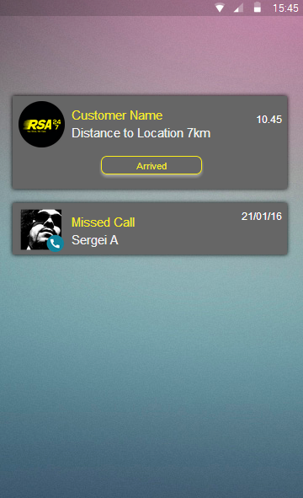

|  |  |  |  |
| --- | --- | --- | --- |
| **Requirement**  **ID** | **Name / Description** | **Priority** | **Comments** |
|  | * Receive Notifications for service requests from customer app in the notification bar with a notification tone   1. View the details of the service request   2. If there are permissions that block a certain app to use the notification bar, they have to be disabled either automatically by the app or guiding the user to unblock the permissions   3. The notification are of following types. Notification for request from a nearby customer. Notification for each stage of the transit( started, reached, distance to customer, service complete, amount paid) has to be sent from the service provider app to the customer app.   4. The status of the request can be changed by the service engineer right in the persistent notification without opening the app. |  |  |

### Dashboard

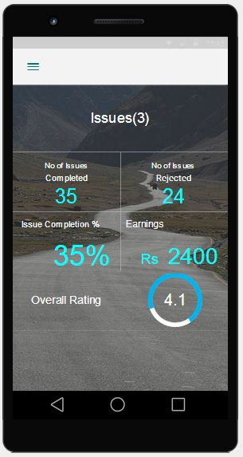

|  |  |  |  |
| --- | --- | --- | --- |
| **Requirement**  **ID** | **Name / Description** | **Priority** | **Comments** |
|  | * To view statistics about the service requests that were received and serviced * The dashboard contains a shortcut to the issues screen which will also contain a badge that displays the number of unseen service request notifications. * Dashboard is different for the owner and employee, the owner would view the overall stats of rating, service requests completed, earnings while the employee can only see his individual stats,   1. Rating of the service provider by the customer, the avg of all the individual ratings from each service requests.   2. No. of requests completed till date   3. No. of requests rejected till date (rejected midway after the service provider has accepted it.)   4. % completed, ratio of no of requests completed and no of requests sent. (Feasibility check required) current implementation uses no. of requests accepted as denominator.   5. Earnings in total for owner.   6. Issues shortcut is also provided at the bottom of the dashboard containing a number badge which displays the count of open notifications - The list of notifications received and list of accepted notifications. |  |  |

### Service Request Broadcasting

|  |  |  |  |
| --- | --- | --- | --- |
| **Requirement**  **ID** | **Name / Description** | **Priority** | **Comments** |
|  | * The service requesting is broadcasted using the following logic  1. For a given radius, the service request is broadcasted to the premium service providers, if no response is received, it is broadcasted to the highly rated non-premium service providers 2. If still no response is received the low rated non-premium service providers will get the notification. 3. If still no response is received the above process is repeated after increasing the radius to the next range value. 4. Initial range is 3KM, incremental radius is 2km for each iteration. |  |  |

### Accepting a Request

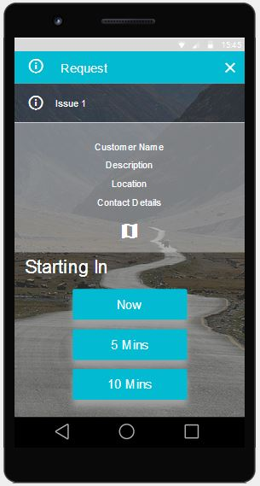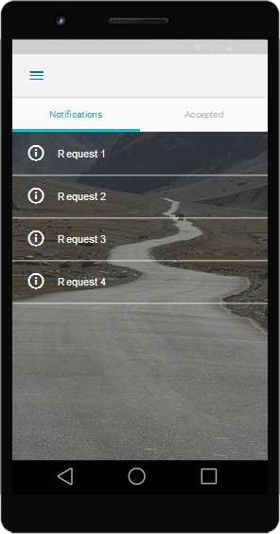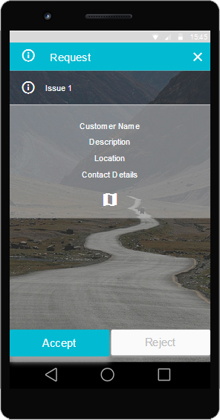

|  |  |  |  |
| --- | --- | --- | --- |
| **Requirement**  **ID** | **Name / Description** | **Priority** | **Comments** |
|  | * Accepting a request is First Come First Serve  1. This is the first screen the user sees on opening the app. 2. Any employee or owner can accept a request. 3. Once a request is accepted, it expires at all other users. 4. In case of a simultaneous click a user with higher rating will be given preference. 5. The accept button will have three options in which the user is asked for the expected time to provide the service, Accept immediately, Accept in 15 minutes, Accept in 30 minutes. 6. On accepting the request the details of the user are sent to the customer. 7. Once the user accepts a service request he would not be able to receive any more notifications until he finishes the current one. 8. The issue page will have a Not Interested button instead of the Reject button. |  |  |

### Service Request Items

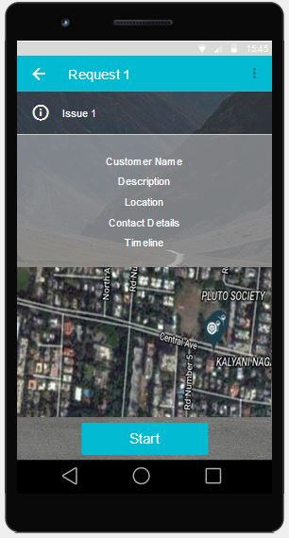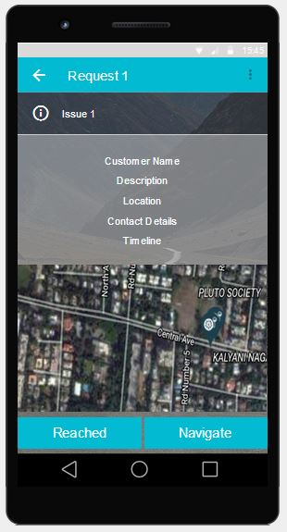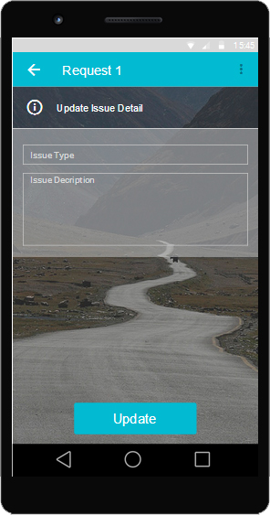

|  |  |  |  |
| --- | --- | --- | --- |
| **Requirement**  **ID** | **Name / Description** | **Priority** | **Comments** |
|  | * The service request will have all the following details  1. The request will have the time stamp when it was raised. 2. The issue type mentioned by the customer 3. Issue detail written by the customer. 4. The distance between Service Provider and Customer 5. The route map to the location 6. Mobile number of the customer 7. Accept button |  |  |

### Navigation

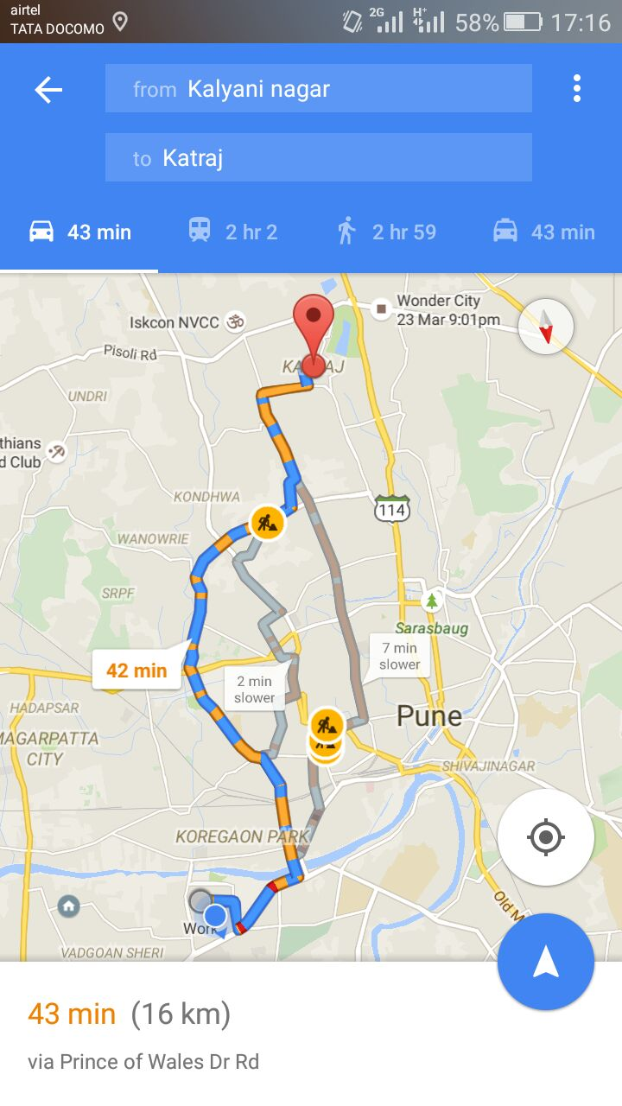

|  |  |  |  |
| --- | --- | --- | --- |
| **Requirement**  **ID** | **Name / Description** | **Priority** | **Comments** |
|  | * Once the service request is accepted, the service engineer can access the route map in the app which would route the user to the customer’s location. * On pressing back on the map view page, the user will come back to the issue page. * The button would read Start Work instead od Doable. |  |  |

### Servicing Pre-requisites

|  |  |  |  |
| --- | --- | --- | --- |
| **Requirement**  **ID** | **Name / Description** | **Priority** | **Comments** |
|  | * The service request screen will have option for the service partner to enter the details of the issue, once he has reached the service location. * If the service partner cannot service the vehicle at that location, the service partner can either create a towing request after confirming with the customer or call RSA support for the same and closing the current service request. * The service provider on reaching the location  1. Should confirm the issue 2. Ask for more symptoms 3. Explain the problem to the customer 4. Explain the cost with breakup 5. Explain additional costs if any 6. Take an Oral confirmation 7. Inform the RSA support 8. Start and Complete the task 9. Get paid 10. Inform RSA Support 11. Close issue |  |  |

### Payment Process

|  |  |  |  |
| --- | --- | --- | --- |
| **Requirement**  **ID** | **Name / Description** | **Priority** | **Comments** |
|  | * Payment process  1. The user/customer defines the issue in the beginning of the service request, which reflects in the app. Any free/promotional service applies to only this part. 2. Any additional service checkups, spare parts not mentioned/ unrelated in the beginning of the service is chargeable as per the pricing specified by the service provider on location. |  |  |

### Invoice

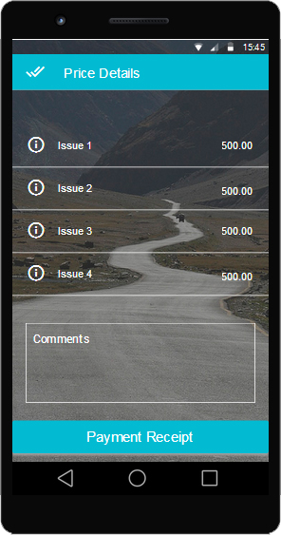

|  |  |  |  |
| --- | --- | --- | --- |
| **Requirement**  **ID** | **Name / Description** | **Priority** | **Comments** |
|  | * To get an invoice on the name of the service provider organization, the name mentioned in the Organization name would be used to provide * Service items mentioned in the invoice will be populated from the details furnished by the service provider after reaching the service location, and only these items will be mentioned in the invoice. Any additional items like spares are not included.   1. Itemized billing for all service items   2. SMS and mail intimation for all service requests that are completed.   3. Closure of the process after the payment is done. |  |  |

### Persistent Notification



|  |  |  |  |
| --- | --- | --- | --- |
| **Requirement**  **ID** | **Name / Description** | **Priority** | **Comments** |
|  | * Persistent Notification from App   1. A notification that stays even after the app is open   2. Notification with milestone buttons like accept, started, reached etc |  |  |

### Profile Menu

|  |  |  |  |
| --- | --- | --- | --- |
| **Requirement**  **ID** | **Name / Description** | **Priority** | **Comments** |
|  | * The service partner should be able to update the details of the organization  1. A menu option to edit the profile 2. Contact support for any clarification(could be cost addition) 3. It will also have a detailed list of earnings of all the employees – only for an owner profile |  |  |

### Premium Service Provider

|  |  |  |  |
| --- | --- | --- | --- |
| **Requirement**  **ID** | **Name / Description** | **Priority** | **Comments** |
|  | * Go Premium  1. Option to request the premium service in the app which can be managed and approved in the backend depending on the location and rating etc. |  | Needed in later versions. |

### SMS & Mail Trigger Points

|  |  |  |  |
| --- | --- | --- | --- |
| **Requirement**  **ID** | **Name / Description** | **Priority** | **Comments** |
|  | * The SMS and mails are triggered at these stages in the service request lifecycle  1. When the service request is raised by the customer, an SMS and mail are triggered with the details 2. When the service request is accepted by a service provider, an SMS and mail are triggered in the same conversation 3. When an Invoice is generated, invoice is attached in the mail, SMS will have the amount of the Invoice. |  |  |

### SMS & Mail Template

|  |  |  |  |
| --- | --- | --- | --- |
| **Requirement**  **ID** | **Name / Description** | **Priority** | **Comments** |
|  | * The SMS will look like - Hi, Mr/Ms XXXXXXXX, your invoice for the amount Rs. XXXX for standard services XXXX with the customer XXXXXXXX has been generated and sent to your mail id. * Mail will have the above information along with promotional content and an attached document of the invoice in pdf format. |  |  |

### APK for Sales Executives

|  |  |  |  |
| --- | --- | --- | --- |
| **Requirement**  **ID** | **Name / Description** | **Priority** | **Comments** |
|  | * There would be an apk for internal use by the sales executives. * Using this apk the sales executives would approve the business of the service provider, when they visit the business location * This specific apk would have a mobile pin login to identify the sales executive, it would have 2 additional screens  1. First screen would be to choose the business to |  |  |

## Admin App Functionalities

### App Type

|  |  |  |  |
| --- | --- | --- | --- |
| **Requirement**  **ID** | **Name / Description** | **Priority** | **Comments** |
|  | * The app would be a web app to be used in laptops and personal computers. |  |  |

### Login Credentials

|  |  |  |  |
| --- | --- | --- | --- |
| **Requirement**  **ID** | **Name / Description** | **Priority** | **Comments** |
|  | * The web app will have login page * Credentials are unique for each user * These credentials leave a note of the user and timestamp each time the user interrupts the process |  |  |

### Onboarding Data

|  |  |  |  |
| --- | --- | --- | --- |
| **Requirement**  **ID** | **Name / Description** | **Priority** | **Comments** |
|  | * User can edit, delete and view the onboarding data * Create backups of the date * Mark a data as obsolete or needs updation * Add comments to the data point for better recognition * Create a map view of the data * View the images of organization (not the service engineer) |  |  |

### Service Provider App Registration

|  |  |  |  |
| --- | --- | --- | --- |
| **Requirement**  **ID** | **Name / Description** | **Priority** | **Comments** |
|  | * The user can view the yet to be approved data points of Service Provider App * He can approve the data after a check on the pictures, ID proofs, employee images, agreement etc * He can access the contact details of the service provider and place calls and send SMS * Add comments to the data point. |  |  |

### Service Provider App Approved Data

|  |  |  |  |
| --- | --- | --- | --- |
| **Requirement**  **ID** | **Name / Description** | **Priority** | **Comments** |
|  | * The user can assign service requests to service providers manually in case of the failure of the algorithm * If a service provider rejects a request the user can re-start the algorithm to find another service provider * He can access contact details for calling the service provider * He can make the service providers premium providers, * Remove premium status of a service provider * Blacklist a service provider with reason * Whitelist a service provider |  |  |

### Customer App Registration Data

|  |  |  |  |
| --- | --- | --- | --- |
| **Requirement**  **ID** | **Name / Description** | **Priority** | **Comments** |
|  | * Customer data verification of Driver’s license * Update contact and other details |  |  |

### Customer App Approved Data

|  |  |  |  |
| --- | --- | --- | --- |
| **Requirement**  **ID** | **Name / Description** | **Priority** | **Comments** |
|  | * Access contact details for a call during a service request * Update feedback for a service provider in case if the customer gives a low rating or a comment. * Upgrade the plan of the user during a campaign or as astandalone upgrade. (with and without payment) |  |  |

### Call Notes

|  |  |  |  |
| --- | --- | --- | --- |
| **Requirement**  **ID** | **Name / Description** | **Priority** | **Comments** |
|  | * The user can add notes about conversations he has had with service provider and the customer against each service request. |  |  |

### Payments & Subscriptions

|  |  |  |  |
| --- | --- | --- | --- |
| **Requirement**  **ID** | **Name / Description** | **Priority** | **Comments** |
|  | * The user can track the payments made by customer to RSA 247 and to the service providers with unique transaction ids and other details |  |  |

### Promotions

|  |  |  |  |
| --- | --- | --- | --- |
| **Requirement**  **ID** | **Name / Description** | **Priority** | **Comments** |
|  | * The user can provide promotional coupons, offers for grievances and community members from admin console. |  |  |

### SMS Triggering

|  |  |  |  |
| --- | --- | --- | --- |
| **Requirement**  **ID** | **Name / Description** | **Priority** | **Comments** |
|  | * To trigger reminder SMS, promotional SMS * To send SMS for onboarded service partners |  |  |

### Issue View

|  |  |  |  |
| --- | --- | --- | --- |
| **Requirement**  **ID** | **Name / Description** | **Priority** | **Comments** |
|  | * The data that is visible to Admin should always be in relation to an issue. * These issues can be categorized into 5 types as  1. Service Provider Approval 2. Service Request 3. Community Request 4. Customer Approval 5. Customer Feedback for a service and help 6. Customer Feedback on RSA (app, website, Service, Grievance etc  * The Admin should not have access to information that is not related to an issue. |  |  |

### Advanced Search

|  |  |  |  |
| --- | --- | --- | --- |
| **Requirement**  **ID** | **Name / Description** | **Priority** | **Comments** |
|  | * The Admin should be able to search using mobile numbers, free text * Use combination of search parameters to narrow down search results * Use filters for search and issue results like city, Approved, not subscribed, not a community member etc |  |  |

### Reports

|  |  |  |  |
| --- | --- | --- | --- |
| **Requirement**  **ID** | **Name / Description** | **Priority** | **Comments** |
|  | * To generate reports periodically for business insights. * For adhoc queries for live analysis and decision making. |  |  |

## Non Functional Features

*<Specify non-functional requirements such as system performance, minimum memory requirement, minimum number of usersetF.>*

# Use Cases

*<Use cases provide specific examples of how users will interact with the system to meet a specific goal>*

## Use Case Actors

*<Use case actors are logical entities which are aggregated from the various ways users will interact with functionality of the system>*

## Use Case Diagrams and Actor Hierarchy

*<A graphical representation of how various use cases apply to system actors>*

*<Sample Diagram shown below>*

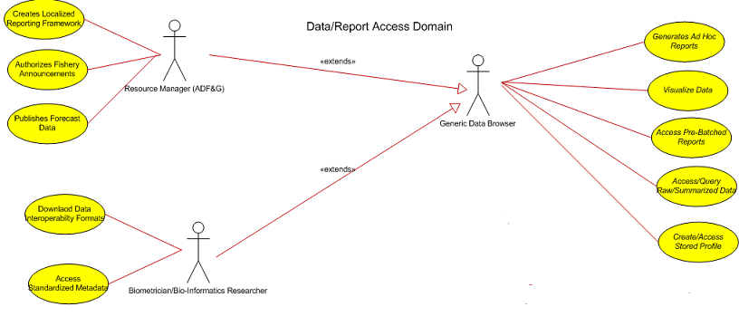

## Use Case Descriptions

|  |  |
| --- | --- |
| **Use Case ID:** | 1 |
| **Use Case Name:** |  |
| **Use Case Description:** |  |
| **Primary Actor:** |  |
| **Basic Flows:** |  |
| **Alternate Flows:** |  |

|  |  |
| --- | --- |
| **Use Case ID:** | 2 |
| **Use Case Name:** |  |
| **Use Case Description:** |  |
| **Primary Actor:** |  |
| **Basic Flows:** |  |
| **Alternate Flows:** |  |

|  |  |
| --- | --- |
| **Use Case ID:** | …n |
| **Use Case Name:** |  |
| **Use Case Description:** |  |
| **Primary Actor:** |  |
| **Basic Flows:** |  |
| **Alternate Flows:** |  |

# Solution Landscape

*<This section describes preferred solution architecture, platform, tools & technologiesetF.>*

**NOTE-** This section does not define the Final Architecture of the system whereas it defines Bird eye view of the system. The detailed system’s architecture should be covered in Project’s Design Documents (High Level Design (HLD) & Low Level Design Documents (LLD)).

## System Vision

*<Sample Diagram shown below>*

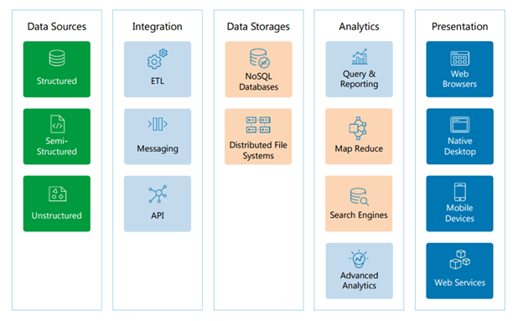

### Data Sources

*<Section contains description about Data Sources. If required, create sub sections to provide sufficient details>*

### Integration

*<Section contains description about Integration. If required, create sub sections to provide sufficient details>*

### Data Storage

*<Section contains description about Data Storage. If required, create sub sections to provide sufficient details>*

### Analytics

*<Section contains description about Analytics. If required, create sub sections to provide sufficient details>*

### Presentation &Report generation

*<Section contains description about Presentation & Report Generation module. If required, create sub sections to provide sufficient details>*

## Technical Framework

*<This section provides a map for application development. This section relies heavily upon the use of data flow diagrams (DFDs). These diagrams detail the flow of information in and out of data sources, data processing steps and interaction with external entities.>*

### Data Flow Diagram 1- Complete System

*<This section contains data flow diagram displays to show the logical flow of overall system.>*

*<Sample Diagram shown below>*

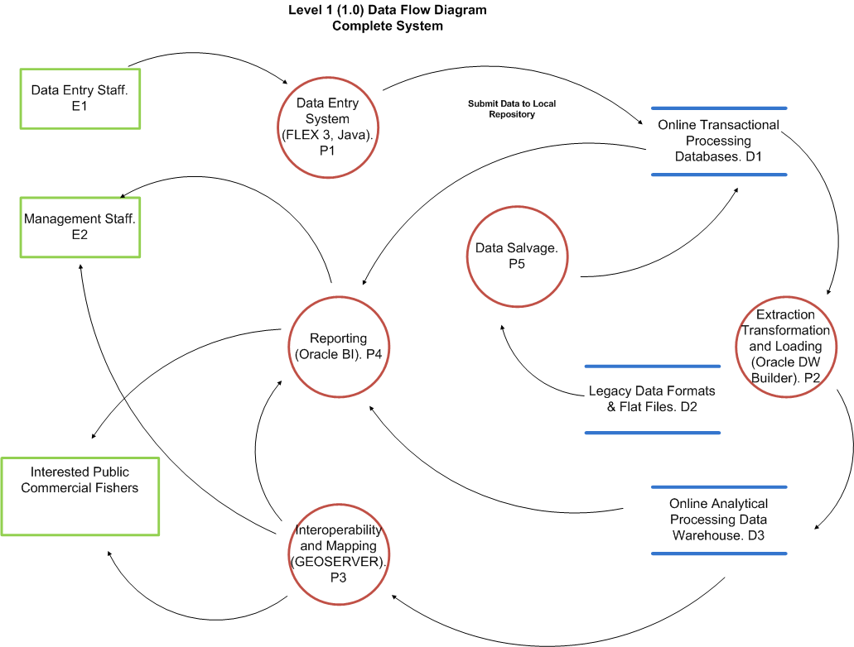

### Data Flow Diagram 2- Data Entry System

### Data Flow Diagram 3 - ETL Processes

### Data Flow Diagram 4 - Reporting Systems

### Data Flow Diagram …n -

## UI – Visual Design

*<Specify any UI design OR Mock up screen>*

# Reference Documents

*<Specify all referenced documents which are used OR referred to write FRD document>*

|  |  |  |
| --- | --- | --- |
| S No. | Document | Attachment |
|  |  |  |
|  |  |  |
|  |  |  |
|  |  |  |
|  |  |  |
|  |  |  |

# Annexures

## Annexure A – Terms & Conditions

## Annexure B – Additional Screenshots

|  |  |  |
| --- | --- | --- |
|  |  |  |
|  |  |  |
|  |  |  |
|  |  |  |
|  |  |  |
|  |  |  |