**Guru sai charan.D**

**231901037**

**Ex. No.: 9**

**Date: 02-04-2025**

**DEADLOCK AVOIDANCE**

**Aim:** To find out a safe sequence using Banker’s algorithm for deadlock avoidance.

**Algorithm:**

1. Initialize work=available and finish[i]=false for all values of i

2. Find an i such that both: finish[i]=false and Needi<= work

3. If no such i exists go to step 6

4. Compute work=work+allocationi

5. Assign finish[i] to true and go to step 2

6. If finish[i]==true for all i, then print safe sequence

7. Else print there is no safe sequence

**Program Code:**

#include <stdio.h>

#include <stdbool.h>

#define P 5 // Number of processes

#define R 3 // Number of resources

void findSafeSequence(int processes[], int available[], int max[][R], int allocation[][R]) {

int need[P][R];

bool finish[P] = {false};

int safeSequence[P];

int work[R];

// Calculate Need Matrix

for (int i = 0; i < P; i++) {

for (int j = 0; j < R; j++) {

need[i][j] = max[i][j] - allocation[i][j];

}

}

// Initialize work as available resources

for (int i = 0; i < R; i++) {

work[i] = available[i];

}

int count = 0;

while (count < P) {

bool found = false;

for (int i = 0; i < P; i++) {

if (!finish[i]) {

int j;

for (j = 0; j < R; j++) {

if (need[i][j] > work[j]) {

break;

}

}

if (j == R) { // If all needs are met

for (int k = 0; k < R; k++) {

work[k] += allocation[i][k];

}

safeSequence[count++] = processes[i];

finish[i] = true;

found = true;

}

}

}

if (!found) {

printf("No safe sequence exists\n");

return;

}

}

// Print Safe Sequence

printf("The SAFE Sequence is: ");

for (int i = 0; i < P; i++) {

printf("P%d", safeSequence[i]);

if (i < P - 1) printf(" -> ");

}

printf("\n");

}

int main() {

int processes[P];

int available[R];

int max[P][R];

int allocation[P][R];

// Get user input

printf("Enter process IDs: ");

for (int i = 0; i < P; i++) {

scanf("%d", &processes[i]);

}

printf("Enter available resources: ");

for (int i = 0; i < R; i++) {

scanf("%d", &available[i]);

}

printf("Enter max resource matrix: \n");

for (int i = 0; i < P; i++) {

for (int j = 0; j < R; j++) {

scanf("%d", &max[i][j]);

}

}

printf("Enter allocation matrix: \n");

for (int i = 0; i < P; i++) {

for (int j = 0; j < R; j++) {

scanf("%d", &allocation[i][j]);

}

}

findSafeSequence(processes, available, max, allocation);

return 0;

}

**OUTPUT:**

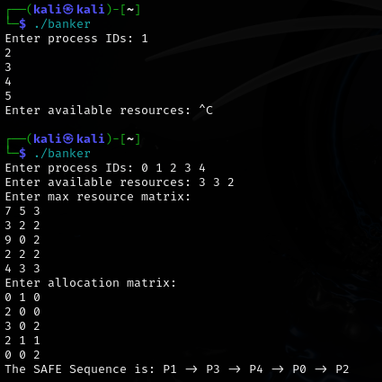

**RESULT:**

Hence,safe sequence using Banker’s algorithm for deadlock avoidance has been executed