**Guru sai charan.D 231901501**

**EXERCISE 4**

**Analyze the Malicious Network Traffic using Wireshark**

**AIM**:

To analyze malicious network traffic using Wireshark to detect unauthorized access, malware communication, and suspicious activities.



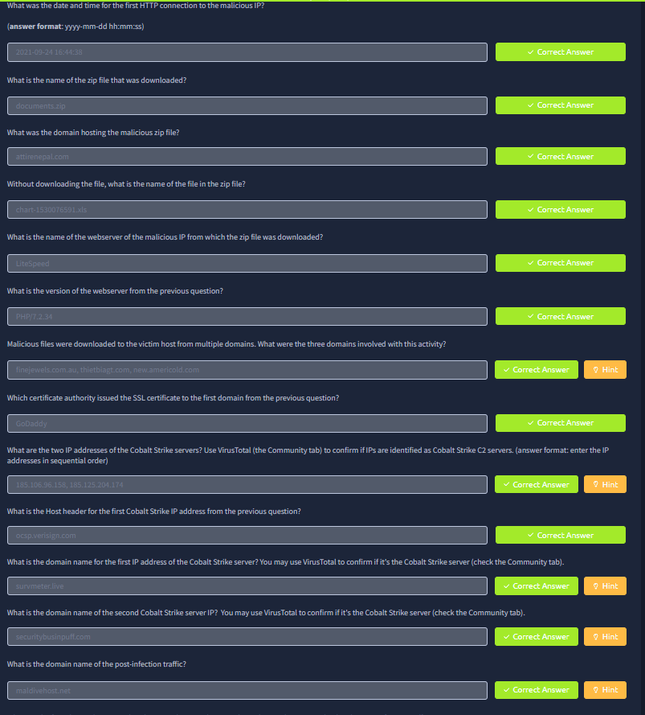

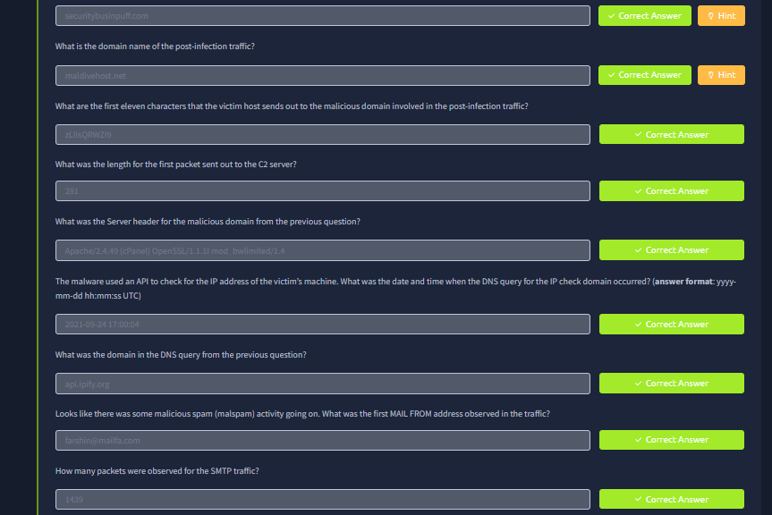

**RESULT**:

Malicious network traffic was identified and analyzed using Wireshark, revealing unauthorized access attempts and suspicious DNS queries, with mitigation measures recommended.