**Guru sai charan.D 231901037**

**EXERCISE 5A**

**Stack based buffer overflow attacks**

**AIM**:

To explore and analyze CVE-2019-18634, a buffer overflow vulnerability in the Unix Sudo program, and understand its exploitation and mitigation.



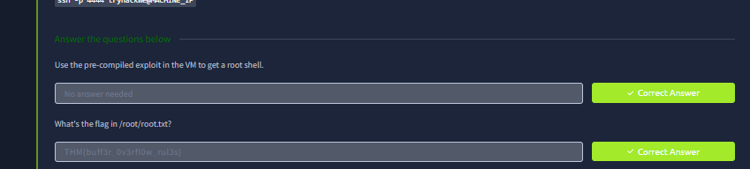

**RESULT**:

The vulnerability was successfully analyzed, demonstrating potential privilege escalation. Mitigation measures, including updating Sudo to version 1.8.31 or later, were recommended to prevent exploitation.