<https://www.youtube.com/watch?v=aeoGGabJhAQ>

<https://www.youtube.com/watch?v=FjSCdXd04Cs>

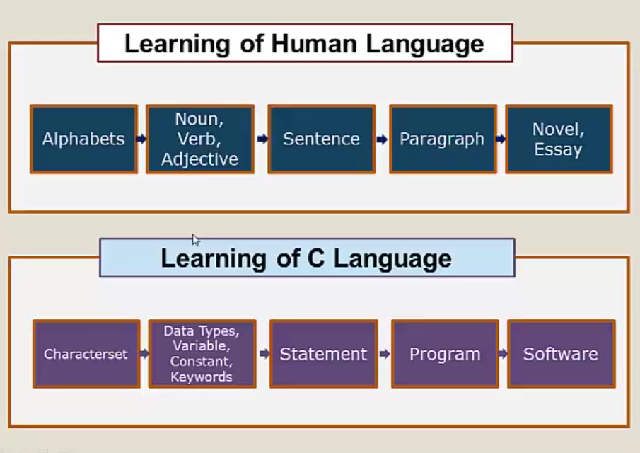

<https://www.youtube.com/watch?v=gp3hG9UFFk4>

It defines a type of storage place like a box. An int can store small numbers and a float is a different type of box where can store high level of decimal precision. A string is a storage area, too.

Do you agree that a name and a birth date are fundamentally different things? That’s why they should be treated differently. That’s what data types do, they give you (and the compiler/interpreter) a way to make sure that only things that are supposed to be in a variable will in fact get into a variable”.

Every species on earth can be compared as a data type. Every data type has different properties. Like hippos are fat while humans are slim.

