**GIT**

GIT is a distributed version control system

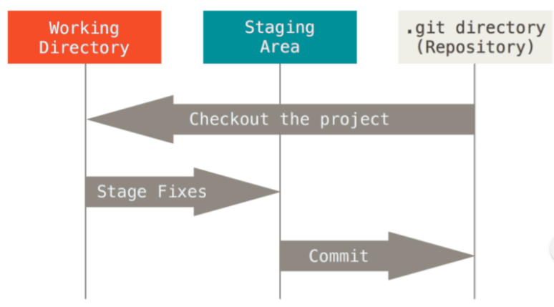

Git - -version

Git config - -global user.name “Guru Sarath”

Git config - -global user.email “guru@gmail.com”

Git config - - list <- list all the config

**Create a local repo to track**

Git init

**To see the status**

Git status

**Git ignore file ( .gitignore )**

touch .gitignore

**Adding files to the staging area**

Git add -A <- Add all the files to the staging area

Git add filename <- Add a single file to the staging area

**Remove files from the staging area**

Git reset <- Remove everything from staging area

**Commit**

Git commit -m “Your message about the commit”

**Log**

Git log

**Diff**

Git diff <- Show the changes

**Using a remote repo**

**Clone**

Git clone <url> <where to clone>

Viewing information

Git remote -v

Git branch -a

**Pushing changes**

Git pull origin master <- Get the new changes by others

Git push origin master

**BRANCHES**

Git branch <- List all the branches

Git branch <NameOfBranch> <- Create a new branch

Git checkout <NameOfBranch> <- Switch to another branch