**Learning Swing**

import javax.swing.*;

Swing

1. Container
   1. Top Level Containers (Does not inherit JComponent)
      1. JFrame
      2. JWindow
      3. JDialog
      4. JApplet
   2. Other Containers (Inherits JComponent)
      1. JPanel
2. Component

Top level container panes contain

* JRootPane
  + Glass pane – Transparent instance of JPanel, sits above all, manages mouse clicks
  + Content pane – Opaque instance of JPanel; Pane to which you will add visible components .

By default content pane associated with a JFrame user a border layout.

* + Layered pane – Instance of JLayeredPane; Allows you to give depth; Holds content pane, menu bar (optional)

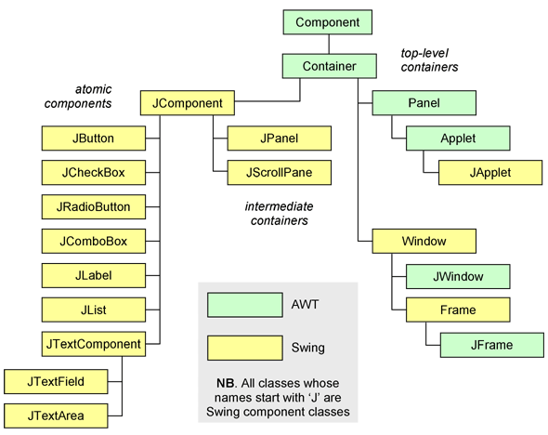

Simple Swing program

package learning_swing;

import java.awt.Toolkit;

import javax.swing.*;

/**

*

* @author GuruSarath

*/

public class MainWindow implements GLOBAL_CONSTANTS{

private JFrame MainApplicationWindow;

private Toolkit k = Toolkit.getDefaultToolkit();

MainWindow()

{

MainApplicationWindow = new JFrame();

setWindowProperties(MainApplicationWindow, MAIN_WINDOW_TITLE, k.getScreenSize().height / 2, k.getScreenSize().width / 2);

craftTheMainWindow();

MainApplicationWindow.setVisible(true);

}

private boolean setWindowProperties(JFrame window, String title, int height, int width)

{

// Center positon of the screen (Monitor)

int window_posX = (k.getScreenSize().width / 2) - (width/2);

int window_posY = (k.getScreenSize().height / 2) - (height/2);

window.setTitle(title);

window.setSize(width, height);

window.setDefaultCloseOperation(JFrame.EXIT_ON_CLOSE);

window.setLocation(window_posX, window_posY);

return true;

}

private boolean craftTheMainWindow()

{

return true;

}

}

Event Handling –

Event source -> generates event object -> sends to all registered listener objects

Listener object -> Instance of listerner class -> Listener calss implements a listener interface

Listener object performs actions (Calls methods of listener interface) based on the received event object.

Event Listener

Event Source

Listener Interface

Event Listner

Listener Interface

**EVENT Handling Summary table**

| **Event** | **Fired by** | **Listener interface** | **Handler methods** |
| --- | --- | --- | --- |
| java.awt.event.ComponentEvent | All components | ComponentListener | componentResized()  componentMoved()  componentShown()  componentHidden() |
| java.awt.event.FocusEvent | All components | FocusListener | focusGained()  focusLost() |
| java.awt.event.KeyEvent | All components | KeyListener | keyTyped()  keyPressed()  keyReleased() |
| java.awt.event.MouseEvent | All components | MouseListener | mouseClicked()  mousePressed()  mouseReleased()  mouseEntered()  mouseExited() |
|  |  | MouseMotionListener | mouseDragged()  mouseMoved() |
| java.awt.event.ContainerEvent | All containers | ContainerListener | componentAdded()  componentRemoved() |

| **Event** | **Fired by** | **Listener interface** | **Handler method** |
| --- | --- | --- | --- |
| java.awt.event.ActionEvent | JButton  JCheckBoxMenuItem  JComboBox  JFileChooser  JList  JRadioButtonMenuItem  JTextField  JToggleButton | ActionListener | actionPerformed() |
| java.awt.event.AdjustmentEvent | JScrollBar | Adjustment-Listener | adjustmentValue-Changed() |
| javax.swing.event.CaretEvent | JTextComponent | CaretListener | caretUpdate() |
| javax.swing.event.HyperlinkEvent | JEditorPane  JTextPane | Hyperlink-Listener | hyperlinkUpdate() |
| java.awt.event.InternalFrameEvent | JInternalFrame | InternalFrame-Listener | internalFrame-Activated()  internalFrame-Closed()  internalFrame-Closing()  internalFrame-Deactivated()  internalFrame-Deiconified()  internalFrame-Iconified()  internalFrame-Opened() |
| java.awt.event.ItemEvent | JCheckBoxMenuItem  JComboBox  JRadioButtonMenuItem  JToggleButton | ItemListener | itemStateChanged() |
| javax.swing.event.ListDataEvent | ListModel | ListDataListener | contentsChanged()  intervalAdded()  intervalRemoved() |
| javax.swing.event.ListSelectionEvent | JList  ListSelectionModel | ListSelection-Listener | valueChanged() |
| javax.swing.event.MenuEvent | JMenu | MenuListener | menuCanceled()  menuDeselected()  menuSelected() |
| javax.swing.event.PopupMenuEvent | JPopupMenu | PopupMenu-Listener | popupMenuCanceled()  popupMenuWill-BecomeInvisible()  popupMenuWill-BecomeVisible() |
| javax.swing.event.MenuKeyEvent | JMenuItem | MenuKeyListener | menuKeyPressed()  menuKeyReleased()  menuKeyTyped() |
| javax.swing.event.MenuDragMouseEvent | JMenuItem | MenuDragMouse-Listener | menuDragMouse-Dragged()  menuDragMouse-Entered()  menuDragMouse-Exited()  menuDragMouse-Released() |
| javax.swing.event.TableColumnModelEvent | TableColumnModel [[a](https://www.safaribooksonline.com/library/view/learning-java-4th/9781449372477/ch16s03.html#ftn.id946438)] | TableColumn-ModelListener | columnAdded()  columnMargin-Changed()  columnMoved()  columnRemoved()  columnSelection-Changed() |
| javax.swing.event.TableModelEvent | TableModel | TableModel-Listener | tableChanged() |
| javax.swing.event.TreeExpansionEvent | Jtree | TreeExpansion-Listener | treeCollapsed()  treeExpanded() |
| javax.swing.event.TreeModelEvent | TreeModel | TreeModel-Listener | treeNodesChanged()  treeNodesInserted()  treeNodesRemoved()  treeStructure-Changed() |
| javax.swing.event.TreeSelectionEvent | JTree  TreeSelectionModel | TreeSelection-Listener | valueChanged() |
| javax.swing.event.UndoableEditEvent | javax.swing.text.Document | UndoableEdit-Listener | undoableEdit-Happened() |
| java.awt.event.WindowEvent | JDialog  JFrame  JWindow | WindowListener | windowOpened()  windowClosing()  windowClosed()  windowIconified()  windowDeiconified()  windowActivated()  windowDeactivated() |
| [[a](https://www.safaribooksonline.com/library/view/learning-java-4th/9781449372477/ch16s03.html#id946438)]The TableColumnModel class breaks with convention in the names of the methods that add listeners. They are addColumnModelListener() and removeColumnModelListener(). | | | |

**Layouts**

* [BorderLayout](https://docs.oracle.com/javase/tutorial/uiswing/layout/visual.html#border)
* [BoxLayout](https://docs.oracle.com/javase/tutorial/uiswing/layout/visual.html#box)
* [CardLayout](https://docs.oracle.com/javase/tutorial/uiswing/layout/visual.html#card)
* [FlowLayout](https://docs.oracle.com/javase/tutorial/uiswing/layout/visual.html#flow)
* [GridBagLayout](https://docs.oracle.com/javase/tutorial/uiswing/layout/visual.html#gridbag)
* [GridLayout](https://docs.oracle.com/javase/tutorial/uiswing/layout/visual.html#grid)
* [GroupLayout](https://docs.oracle.com/javase/tutorial/uiswing/layout/visual.html#group)
* [SpringLayout](https://docs.oracle.com/javase/tutorial/uiswing/layout/visual.html#spring)