**Work Breakdown**

Guru is responsible for creating the android application and database. Saqib is responsible for integrating all hardware components together and Abhay is responsible for creating GUI for our interactive touch screen and linking it with database.

**Application and Work Breakdown:**

Below is the basic layout of how our app is going to look and the functionality it is going to have:

1. 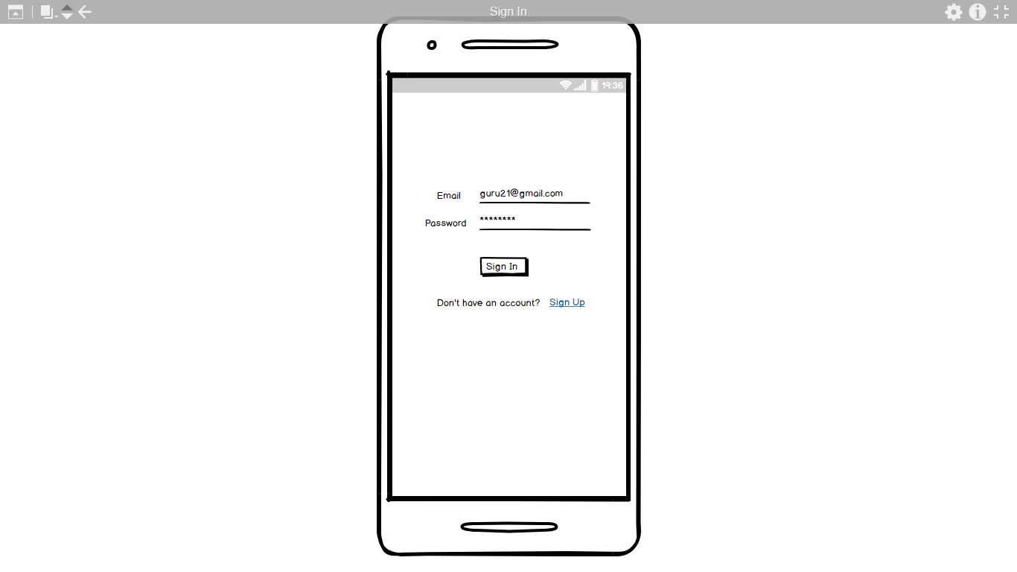

This is the first page that appears when a user opens the app and it will allow user to Sign In into the app. New users will have to Sign Up first in order to log in to the app. Input fields on this page will have validation on them in order to make sure the user enters the data in the right format. After successful sign in, the user will be directed to the shopping cart page.

1. 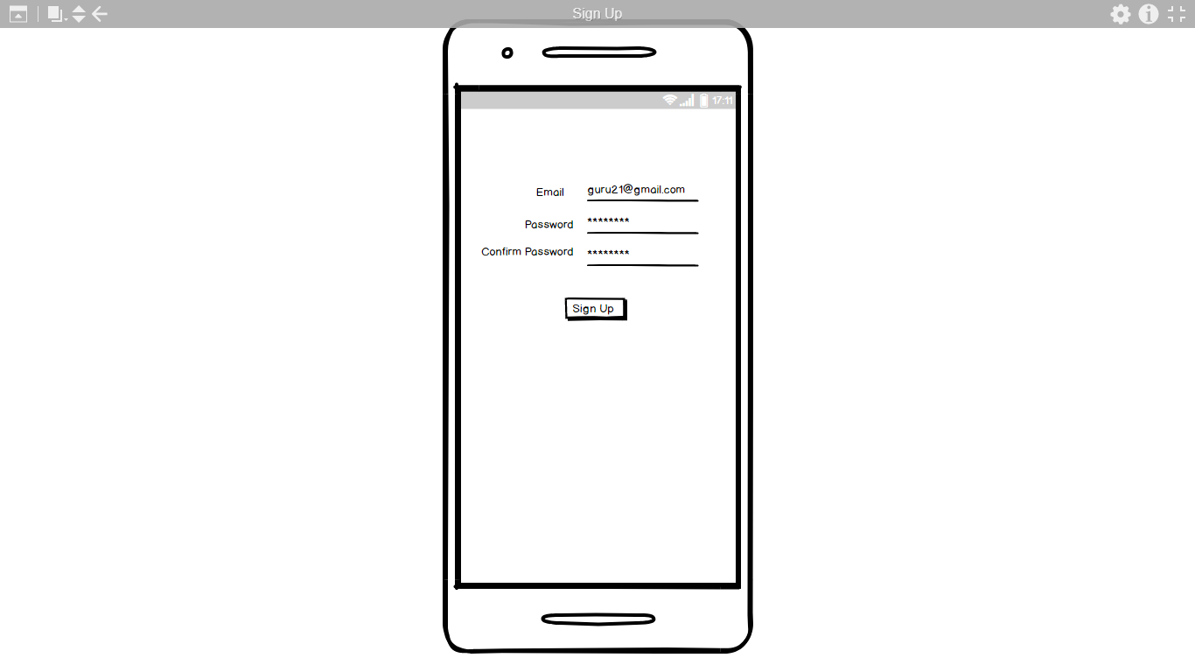

Sign Up page will allow first time users to Sign Up. After successfully signing up, the users will be redirected to the Sign In page, where they have to sign in to be able to see their shopping cart.

1. 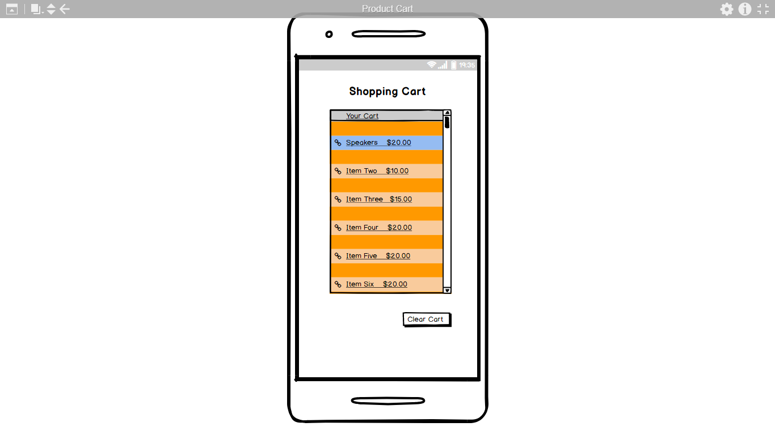

This is the page where users can see their shopping cart. This page is linked with real time database on the Firebase. Users can add items to the shopping cart from the interactive touch screen (part of hardware component), in order to see them on the app. Since our interactive touch screen will also be linked with the Firebase, any changes made to the shopping cart there will be reflected immediately on the Android app. From within the app, the users will have the option to clear their cart and they can also see product details by clicking on the item.

1. 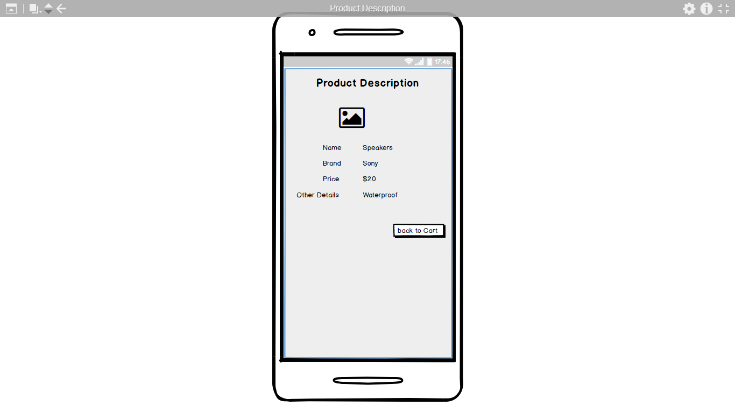

The users will be directed to this page if they want to see the details of an item in their shopping cart. The page will have some details and a picture of the item. The user can return to cart by clicking on the "back to cart" button.

**Database and Work Breakdown:**

Firebase database will store the items and their information. Interactive touch screen and the Android app will communicate with this real time database to add items to the cart and to display item description.

Below is the rough draft of how our current database on the Firebase. We might change or modify it later according to our needs:

{

"Items" : {

"Samsung Galaxy S8" : {

"Brand" : "Samsung",

"Name" : "Samsung Galaxy S8",

"Price" : "$1000",

"Waterproof" : "Yes"

},

"iPhone X" : {

"Brand" : "Apple",

"Name" : "iPhoneX",

"Price" : "$1000",

"Waterproof" : "Yes"

}

}

}