Introduction

This project is all about the automation of MCQ (Multi Choice Question) exams like entrance examinations for CAT, JEE, GATE etc and the campus placement tests. The on line test project or the Exam builder is made for the Engineering Colleges and various Institutes that deal with these examinations. The objective of the software is to provide a platform for students to prepare well for the exams and the result of that exam is a matter of pressing buttons. The environment used here are PHP, MySQL, HTML, JavaScript Apache or IIS.
The program is designed to work in LAN of any organization/Institution. The platforms are such that it solves the purpose of portability (if used with any latest internet browsers). Teachers are provided with an account (username and password) to access to the software. They have the privilege to create Question Banks for different Subjects, to create a question paper automatically or manually from any question banks and view the results as well as to edit the question banks. The students can access to the system (by the student ID and Name) to the question papers that are allowed and appear to the exam. The administrator will have all the authority to design the system, user and subject managements.

Features
- The administrator will be having the overall command and authority thus providing more security issues.
- Every teacher will be entering questions to the question bank using online HTML based advanced text-editor (helps typing mathematical expressions). The editing of questions is possible.
- Both randomization and manual methods will be provided for creating question paper with in no time.
- Examinations will be of MCQ type (5 choices), time bounded.
- Options will be there for negative marking at the time of creating question paper.
- Automatic save and exit on time completion.
- Option for saving will be there for Students.
- Provides the best interface for the students to interact.
- Many tests can be carried simultaneously.
- The question order will be different for students sitting side by side.
- Supports multiple correct answers.
- Supports images to be there in the question paper.
- With out the permission of teachers the student can not access to question paper.
- A candidate can appear an exam only Once.
- Result can be viewed for a single student for multiple exams that solve for analysis.
- Platform independency, data backup and recovery of system makes it different.
- Care is taken that whenever Exam Builder encounters any invalid data then it complains about it ensuring less error from the user side.

Reasons for choice of platforms
As already mentioned the platforms used are the following
PHP: A server side scripting language.
MySQL: A back end database server.
HTML: Environment of interaction for students.
JavaScript: client side scripting language.
Apache or IIS to be used as server software.
It can be run with any latest internet browser like Microsoft Internet Explorer, Mozilla etc. The operating system should be installed with PHP and MySQL.
PHP
It is very fast in operation in comparison to CGI in perl, ASP, JSP.
It runs on virtually every platform.
It can be embedded within HTML.
It’s free and an open source by GPL (general public license).
It costs you nothing.
Best when used with MySQL.

MySQL
MySQL is the most popular open source database server in existence.
It is fast in operation with speed comparable to that of Oracle’s.
It’s a very stable database.
Uses low system requirements.
It supports ANSI SQL.
Security is the key feature of it.
MySQL is distributed under the terms of the GNU General Public License (GPL) created by the Free Software Foundation (FSF).
So it’s free.

HTML and JavaScript
Probably the best environment that offers the platform independency yet supports all the requirements.

Apache
The world’s most reliable web server works both in Linux and windows.
Security is one of the specialities of it.
The most powerful software is also free.

Internet Information Services (IIS)
In windows platform the most popular web server.

Finally I must say that these are very recent area of development of portable web applications which makes better connectivity across the LAN as well as the internet. It’s one of the best ways when users are many and connectivity matters in the organizations. If we talk about the cost then the whole system can be obtained by setting up a LAMP setup (Linux, Apache, MySQL and PHP) absolutely free of cost.

Problem Definition
The existing procedures carried out by the organizations for the aptitude test, reasoning tests or the any MCQ type of exams are lack in efficiency if we consider the time invested on making the question paper and calculation of the results. These paper works are tedious for both the student and the evaluators for the practice tests. In fact for the practice session of the students they need the result of the exam to be out as soon as possible. It will help the students to prepare well and know how far they are from their aim. To solve the problem the some people introduced the ORS (optical response sheet). Means to answer the questions a student has to bubble or darken by pencil at right place in the sheet which will be evaluated by a scanner (IIT screening and GATE exams for example). This method, of course a little improved then the previous one but still lack in the efforts of man power. There are chances for technical or human error. To over come these difficulties many companies introduced the on line test, even some tests carried out over internet. These digital systems are very efficient and the results are out at the willingness of the exam coordinator within no time. The major software and IT industries follow the method of the online test to recruit their employees. It is a matter of one day or even less to select the number of the candidates they want.
So here I have made one attempt to provide an On Line Test platform by introducing the Exam Builder. It is useful exclusively for the engineering colleges to train their students for the campus placements.

Chapter II
System Design

Methodology
In on line test program, the basic problem is to prepare the questions on line and a few of them (those selected) have to be answered by the students. Then the answer sheet should be evaluated and the software has to provide the results accurately and quickly. The software should provide a friendly front end GUI to make the question banks and for the overall administration. The next step is to store the required data in a database (back end). When required we can view as well as edit the data stored in the database.
One of the important things is that without permission, the student should not access into system or in other words the software should be secure. I have used the PHP sessions concept for the user authentication. If the user is unauthorized the script is such programmed that it will redirect to the log in prompt till it gets authorized by proper username and password.

Database Design
The proper design of the database and the tables make the software efficient. Let’s talk from the ground level. The software uses a database named exam and we have given the privileges on it to a username called universal. There is a table called info containing the metadata of the database exam or the system information. It tells about all the tables and what they do. There is one table called the user table which contains the username and password of all the persons who have access to the system. The next is pques which corresponds to the properties of the question papers like if there is negative marking or not, how many questions are there from which question bank the question paper belong to, any special instructions and so on. There is a table called result which stores the marks of the students and when required we will fetch data from it. There is a special table called running which says about how many exams are currently carried out.
The most important of all is the subject tables, i.e. where the questions are stored. The internal table structure is very simple. It has got 10 fields. They are question ID, the question itself, the five options, the correct choice (may be more than one), submitted by and any explanation for it which will be helpful for the teachers to understand. It is the administrator who can create as many subjects as he wishes. The structure for all the subjects will be as described above. For the internal database design details see Appendix I.

Hardware Requirements
As the software is to be used in the LAN of an organization so it has to be loaded on a server. The power of the server affects the number of users.
The server configurations are described below.
CPU: Pentium 4, 2 GHz or above
RAM: 512 MB or above
Hard disk: 40 GB or above
Networking: 100 Mbps
The client machine configuration
CPU: Celeron or above (compatible with internet browsers) supporting network.

Software Requirements
For Server configurations
Operating system: Linux or windows (Linux preferred)
Server Software: Apache or Microsoft Internet Information Services
Back end Scripting: PHP installed with server
Database Server Software: MySQL
Libraries that contain the function to communicate MySQL database from PHP.
Latest version of internet browser like Mozilla Fire fox or Internet Explorer
For client side the internet browser should be latest and it supports networking.

System Back Ups
There different methods to back up the data explained in database backup section.
Testing and Development
The software is tested under different operating system and different browsers. The operating systems used for testing are Fedora Core Linux 1, Red Hat Linux 9, Windows XP and Windows 98. The browsers considered here are Mozilla Fire fox, Microsoft internet explorer 5.5 & 6 and the default browser of Fedora Core 1 from Mozilla. It is strongly recommended to use the latest browsers in order to use all the advanced features.
The database server i.e. MySQL version is 3.23 and the server side script PHP version is 4.3.3. However it is expected that it should work properly with the higher versions of PHP and MySQL. Well the most important is the server application. Exam Builder has passed the test successfully with Apache 1.x under Linux and in windows it worked with Apache 2.x. The software is also tested with Microsoft IIS 5. For development purpose there is excellent software called phpdev423. It includes apache, MySQL and PHP and the best tool for beginners to develop the powerful web applications. To add to it I have user another free software PHP designer 2005. This is a powerful IDE exclusively made for writing PHP scripts. In Linux I have used the VI editor to edit my PHP scripts. For administration purpose of the MySQL database server MySQL administration commands can be used. But there is another alternative i.e. to use phpMyAdmin. It is totally written in PHP and offers the GUI administration for the MySQL database and user managements.
I recommend using this software under the LAMP configuration and obtaining the whole system free of cost. It provides better security, stability and maintenance. LAMP is trusted by millions of server over the world for its exclusivity.

System study and analysis
Study of the existing system
The tests that are carried out during the campus placement or during the practice tests are as follows. The examples suitable are the aptitude tests, reasoning and the technical question papers based on C skill tests. The examiner creates a question paper according to the correct format. Then the question paper is processed and made suitable no of copies to distribute to the students. After the examination the teachers evaluate the answer sheets and sort it to produce the ranking of the students.

Drawbacks in the existing system
If we consider the time factor then the present system is very inefficient. It takes much time to evaluate the answer sheets and more to it sorting the whole thing is a tedious job for the teachers. If we need the results with in one hour means it’s a challenging job for teachers to produce the results accurately. If the students are more then it is impossible to get the results in one day. In the campus placement test the students have to wait for minimum of one to two hours to get the results. So we need a fully computerized process to execute these works. Every body is aware of the efficiency and accuracy of the computerized works if programmed well. We know that for fast operation and huge transactions; banks, payroll system, ticket booking etc are equipped with sophisticated computerized methods.
So I have made a computerized system “Exam Builder” to make the whole thing digitalized.

Cost and Benefit of employing a digital system
The existing system is full of manual and paper works. Huge numbers of answer sheets are used and after the first use these papers become useless or can’t be used next time. If these types of examinations are carried out frequently then within no time answer sheets produce a junk for the institute. Hard work of the evaluators is required to produce the results. There are chances of erroneous output.
In an organization like the engineering colleges there are already huge numbers of computers used in LAN. So the requirement is to make suitable software which can be used in LAN for the MCQ tests. The institutes also do not lack in knowledgeable persons with adequate computer knowledge to use the software after a few hours of training in order to familiarize with it. The large number of the paper works and the hard work of the examiners are avoided. Once the question bank is ready it’s a matter of decision to make a question paper and expose it to the students. It makes the students very happy to get the results as soon as they appeared the test. It is helpful for the students to know how far they are from their goal. Allows the students to analyze their improvements. One also can think of the time saved. Only the input to the system is to prepare the question banks.

So the key points of making computerized are:
- Avoid large amount of paper works.
- The paper cost is saved.
- Less time to get the result accurately.
- Making question papers are very easy once the question bank is set.
- Easy to analyze and create reposts.

Pre Development process
It is most important for the designer of the system to know the exact format. A detailed study of the current process is required. For gathering the information interview with the teachers and students is done. Information regarding the on line test are gathered like the GRE, Java tests etc. After that a format is created and now ready to implement.

The data flow diagrams (DFD)
DFDs are easier to understand by technical and non-technical audiences. DFDs can provide a high level system overview, complete with boundaries and connections to other systems. DFDs can provide a detailed representation of system components.

Exam Builder
Server
(Database)
MySQL
PHP
Administrator
Teachers
Students
(0 Level DFD)

We can very well understand from the above figure that the whole system is a two tier system (the client and server model). From the next figure we can know how Exam Builder works in a LAN. The central server can be accessed by a teacher, root user and the students.
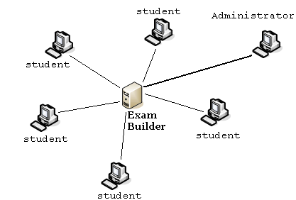

The figure tells that we have to install the software in one system (Exam Builder Server). If it can be accessed anywhere in the LAN then the software can be controlled and operated by both the students and the teachers who in fact create the question papers. For remote administration the root user can also use Exam Builder from a system connected in LAN.
Installation & User Manual

Installation of Exam Builder
Well it’s not a binary program or an application software which can be installed by double clicking the setup.exe or install script in the prompt. Rather we are trying to configure the server for Exam Builder which is a sequential process and needs the successes of the previous process. Let me describe in high level manner. I will assume that the server is properly configured with the server software, PHP and the database engine. For more information about the server configurations refer Appendix II. You can make a quick test on it. Just fire the web browser and navigate to http://localhost/ and you know what is the SERVER ROOT directory. Create a file named testcfg.php and use your favorite editor to write the following code in it and save in the SERVER ROOT.

// File to test the PHP and MySQL configurations.
<?
phpinfo();
?>

Run the script by visiting the link http://localhost/testcfg.php. If the output is colorful and satisfying then most of the work is done here (See fig 1). You need to edit the php.ini file located in windows ROOT directory (usually C:\WINDOWS) to enable the sessions in PHP which is a primary requirement for Exam Builder to carry out the user authentication issues. In php.ini file ensure that following line is present and undocumented. Ensure that tmp directory is present in C drive.
session.save_path = c:/tmp
However in Linux you can skip this step as the sessions and are activated already. PHP is ready for Exam Builder.
Now it’s time to configure MySQL. MySQL ships with a blank password for the root MySQL user. As soon as you have successfully installed MySQL - you need to set a root password and harden MySQL to prevent anonymous user to access to the database application. Ensure that MySQL service is running.

For Windows

shell> mysql -u root
mysql> SET PASSWORD FOR 'root'@'localhost' = PASSWORD('your_password');
mysql> SET PASSWORD FOR 'root'@'%' = PASSWORD('your_password');

To assign passwords to the root accounts using mysqladmin, execute the following commands
shell> mysqladmin -u root password "your_password"
shell> mysqladmin -u root -h host_name password "your_password"

To assign passwords to the anonymous accounts, you can use

mysql> SET PASSWORD FOR ''@'localhost' = PASSWORD('your_password');
mysql> SET PASSWORD FOR ''@'%' = PASSWORD('your_password');

If you are interested to prevent the access of the anonymous users use the following statements:
mysql> DELETE FROM mysql.user WHERE User = '';
mysql> FLUSH PRIVILEGES;

Puzzled!!! No worry MySQL is not that much difficult there are the commands you require only once. But this makes your MySQL server damn secure that it’s almost impossible to tinker with it.

Another alternative is to install phpMyAdmin and in the GUI we can set the proper privileges. Both the ways provide the same results. Now you can log into MySQL as root by issuing the following command.
shell> mysql –u root –p
You will be asked for the password and then if everything goes right you can see the MySQL prompt. MySQL is ready for Exam Builder.

At this point the backend is ready. We need to setup the front end and create the required databases and tables. Copy the exam directory to the SERVER ROOT directory. The open web browser and navigate to
http://localhost/exam/admin/make.php
You will be prompted with administrator log in page. Log in as the root account just you have created with MySQL. If every things are set up properly then the required database and the table are created in MySQL. Log in to your MySQL as root in prompt and check that a database named exam is created.
Congratulations! The configuration for Exam Builder is completed successfully.

User Manual
This user manual describes how Exam Builder can be used. Extreme care is taken to make the GUI very user friendly. A person who frequently surfs internet (basically checking mails and knows a little bit how to open an account in free mail services like yahoo or hotmail and account management) will surely find Exam Builder very easy to use. Here the role and function of users, administrator and students who uses Exam Builder are discussed.
A normal user has the following privileges.
- Change the password of his/her account.
- Add questions to the subjects (Question Banks) given by administrator.
- See the questions present in the question banks.
- Edit the questions present in the question banks.
- Create a question paper for Examination (automatically or manually).
- See the questions in the question paper (Teacher and student view).
- Start any examination.
- Stop any examination that has already been started.
- Browse for the results (By question paper code or student ID)
- Can upload images that may be used in questions.
- Able to use advanced editor.
The students have the following usability.
- Log in to Exam Builder by issuing name and student ID.
- If any question papers are allowed then only the student can access to the questions and attend the exam.
- Attempt the questions, Save and Submit the paper (if time period of that exam exceeds then automatically the form will be submitted).
- A student can attempt to a particular exam only once. After submission it can’t be edited.

Role of the administrator
The root (means root of MySQL database server) enjoys the maximum privileges. Only he can do all kind of management and manipulation. The root privileges are discussed next.
- Design, delete and manage the whole system.
- Can the inter design of the database.
- Add new users to the system.
- See the users of the system.
- Delete users.
- Reset the password of any user if the user forgets it.
- Change the password of the administrator itself (internally change the password of MySQL database server).
- Create new subjects or Question Banks.
- See what the present subjects are.
- Delete any subjects.
- See all the question of a question bank.
- Delete any question from the question bank (avoid it).
- Can see the teacher/student view of any question paper.
- Delete any question paper.
- Delete results for a particular exam.
The other things that the administrator can’t do using Exam Builder GUI are discussed here. Regularly he should check the system for any repetition of questions in the same question bank; this is not a technical problem with the script or the database rather more than one teachers (in fact who are the users of Exam Builder) can submit the same question. And this should be avoided. Database back up is another most important issue. The administrator should back up the MySQL data files in order to recover to the system quickly.

Input and Output

In this chapter we will discuss the input and output of Exam Builder. Here I present the screen shots from the beginning. I will discuss all the functions of Exam Builder and explain the pictures.

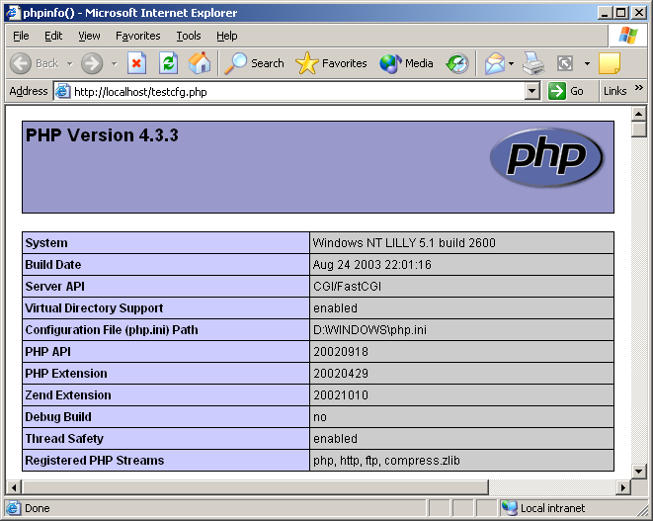
(Fig 1: Confirming the PHP Installation)

Description: This page shows that PHP is properly installed and the test page gives the details of the system.

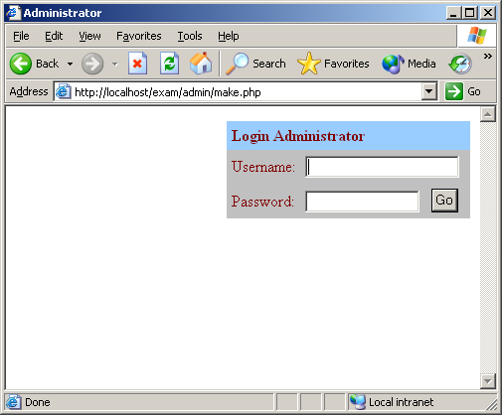
(Fig 2: Login page of make script)

Description: In order to install Exam Builder the execution of this page is a must and here the MySQL administrator user (root) can only execute it with MySQL database server password. It initializes the database and the users.
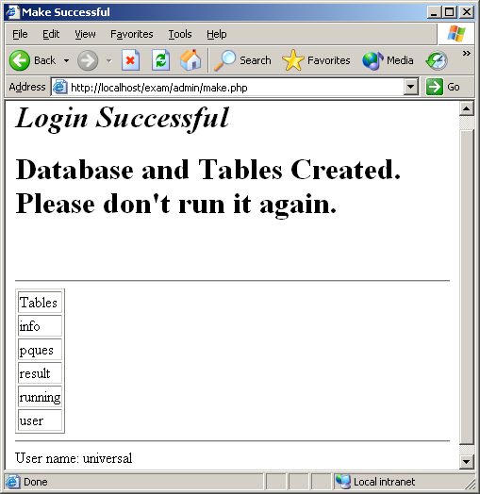
(Fig 3: Output of the make script)

Description: The output when make.php is run for the fresh installation. Note that the output may be different if we back up our data as the database is already there so this script results an error message but initializes the users and Exam Builder will work fine with the old database.
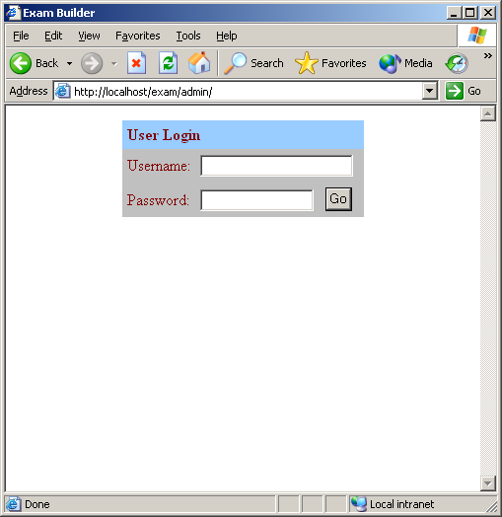
(Fig 4: Teacher/User login page)

Description: The user or the teacher’s login page. Any teacher can be logged in using his/her username and password.

Administrator Pages

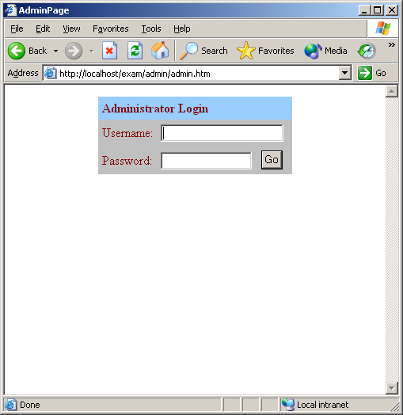
(Fig 5: Administrator login page)

Description: The administrator or root user’s login page. Root (root) user can be logged in using the MySQL database server root and password as username and password.

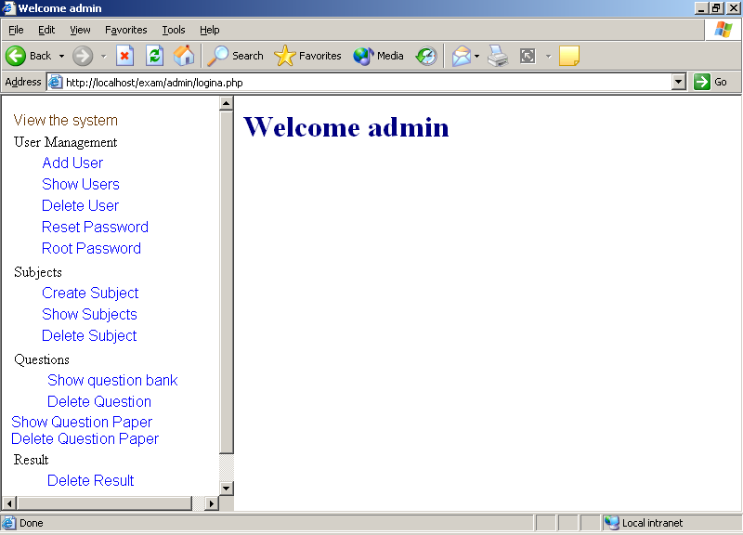
(Fig 6: Administrator page)

Description: The administrator or root user’s page. Root (root) user can control the operation of Exam Builder through this page.

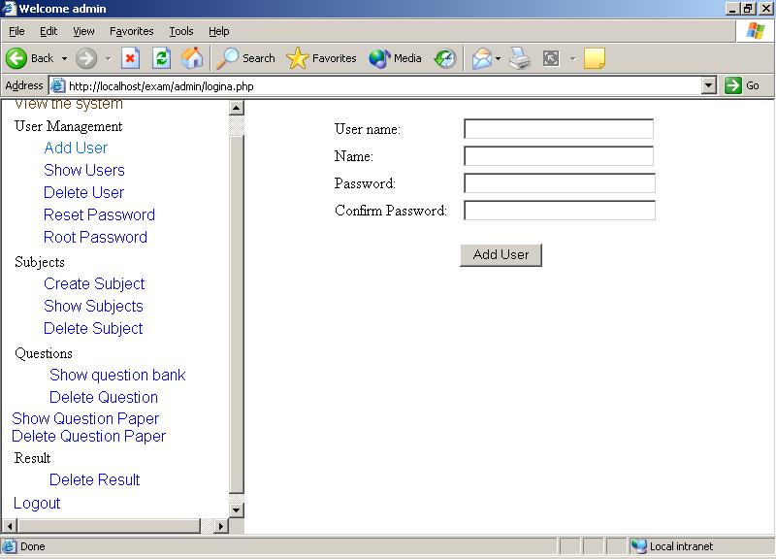
(Fig 7: Add User page)

Description: This page allows the administrator to add new users to the system.

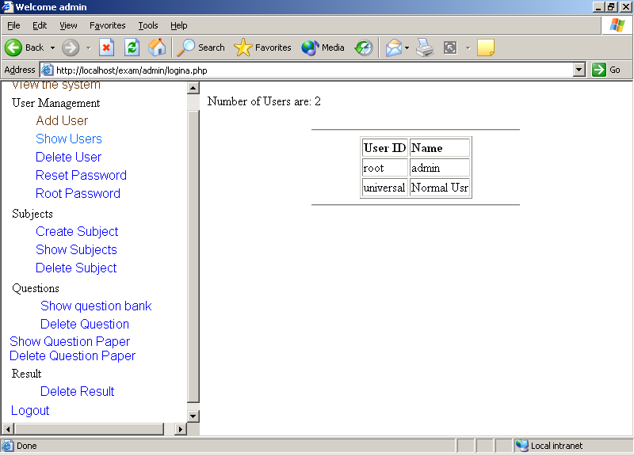
(Fig 8: Show Users page)

Description: This page allows the administrator to see the users of Exam Builder.

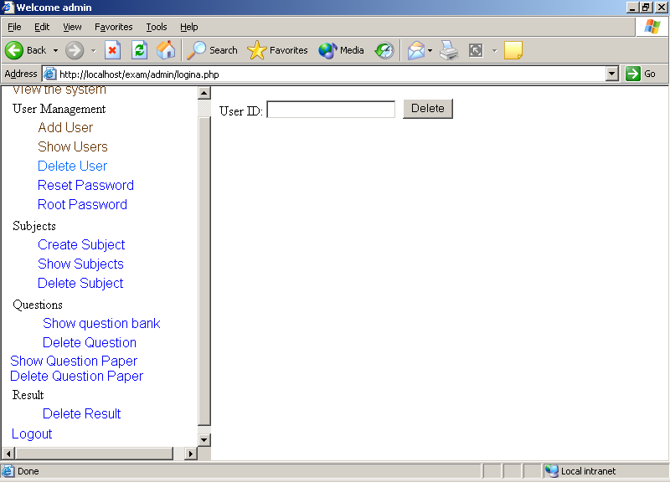
(Fig 9: The root can delete the user)

Description: This page allows the administrator to delete the users by giving the username.

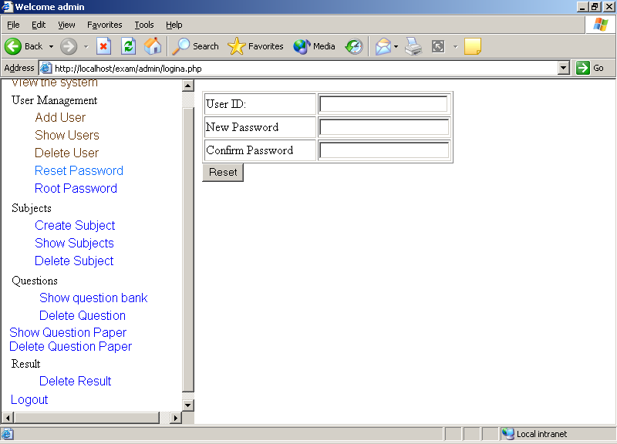
(Fig 10: Reset password of Users)

Description: The administrator can reset the password of any user.

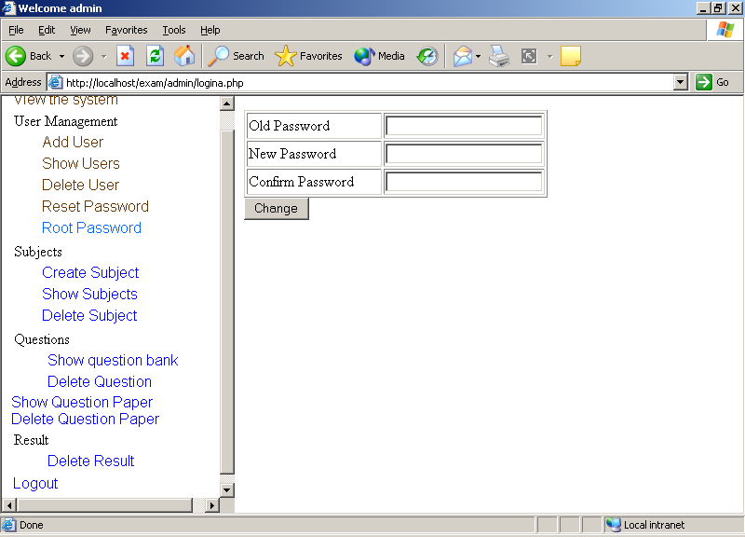
(Fig 11: Change root (administrator) password)

Description: The administrator can even change the root password (MySQL server’s root user) by this page.

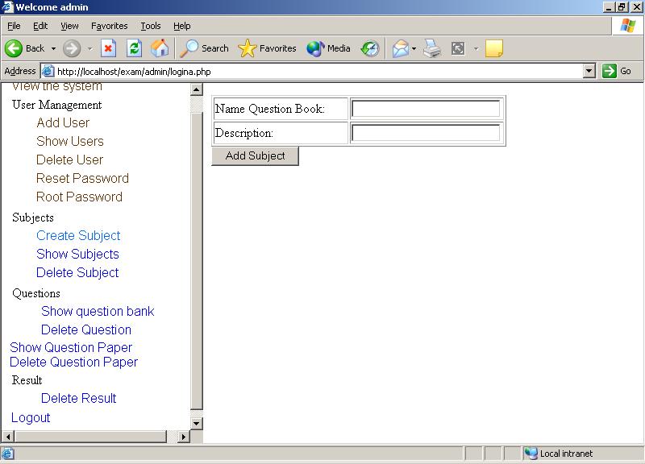
(Fig 12: Create question bank or Subject)

Description: The administrator can create new subject for the question banks of different subject. For example all C questions will be in the subject “CP” and all database questions will be in “DATA1”. Means categorizing the questions.
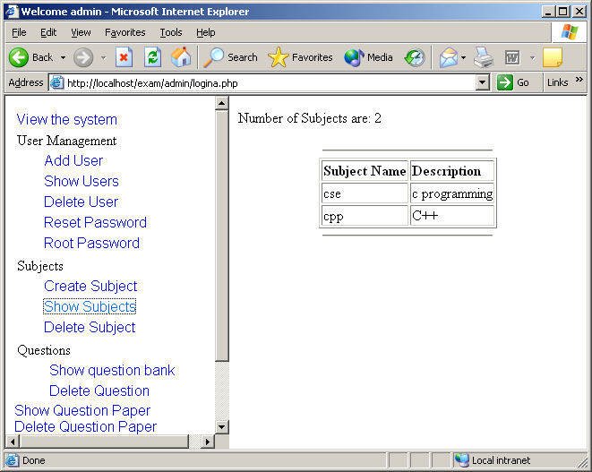
(Fig 13: Show subjects page)

Description: Only the administrator can see how many subjects are there in Exam Builder.
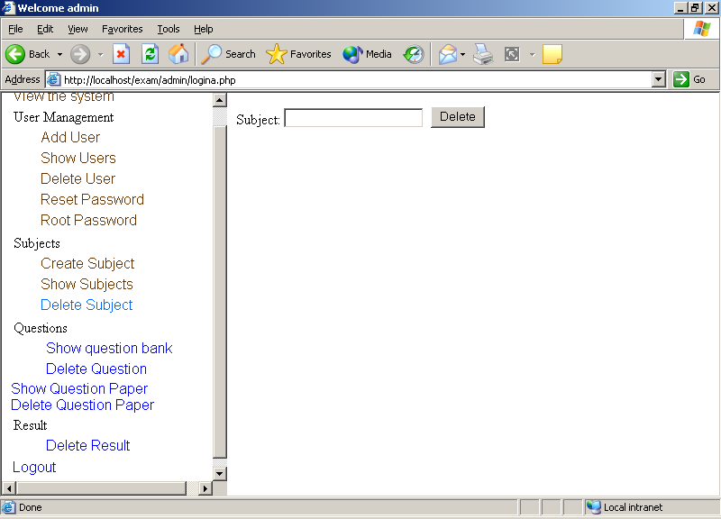
(Fig 14: Delete subjects page)

Description: This page allows the administrator to delete the subjects from Exam Builder. Care should be taken because Exam Builder never asks for confirmation.
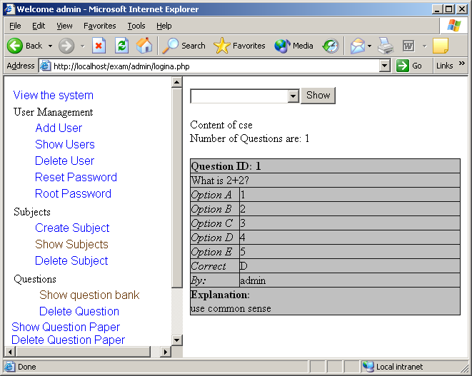
(Fig 15: Show the questions from a question bank)

Description: The administrator can see all the questions present in any question bank.
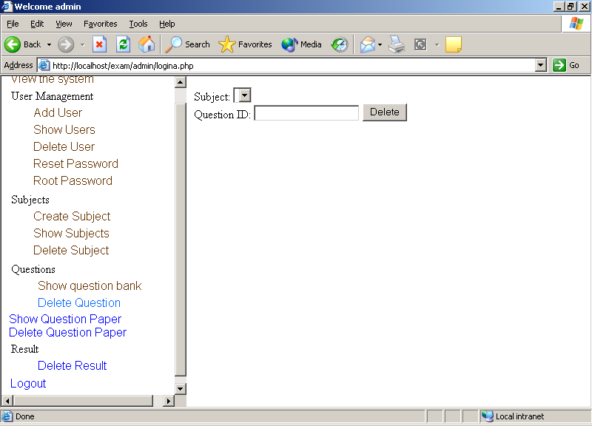
(Fig 16: Delete any question from a question bank)

Description: This page allows the administrator to delete a question from any question bank of Exam Builder. Care should be taken because Exam Builder never asks for confirmation.

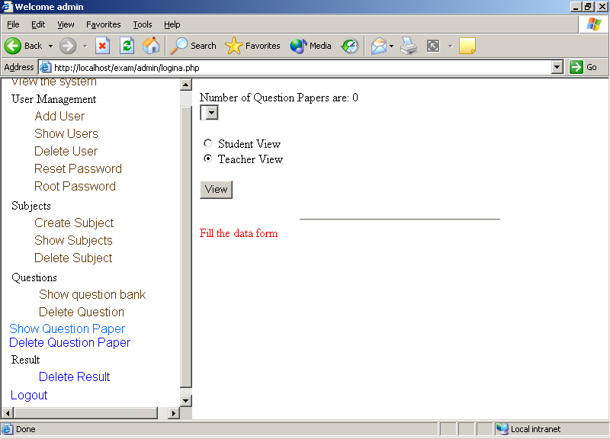
(Fig 17: See the question paper in student/teachers view)

Description: The administrator can see the questions in any question paper. There are two views one for the teachers; questions as well as answers will be displayed. Another for students means question will be displayed with the options only.

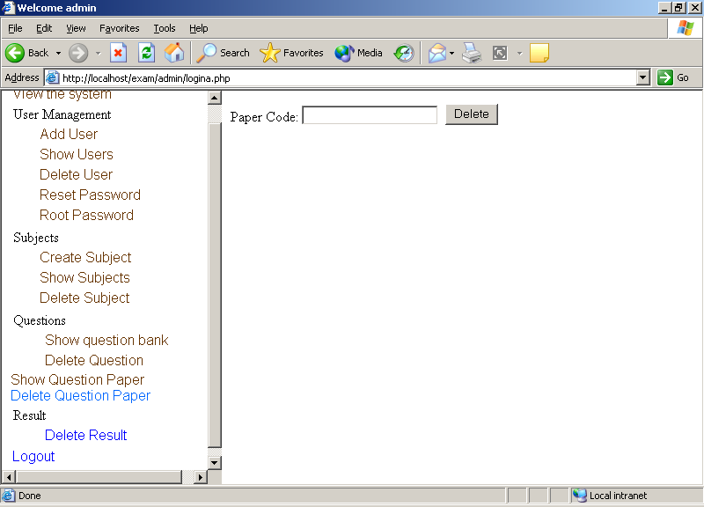
(Fig 18: Delete any question paper from a question bank)

Description: This page allows the administrator to delete a question paper from Exam Builder. Care should be taken because Exam Builder never asks for confirmation.

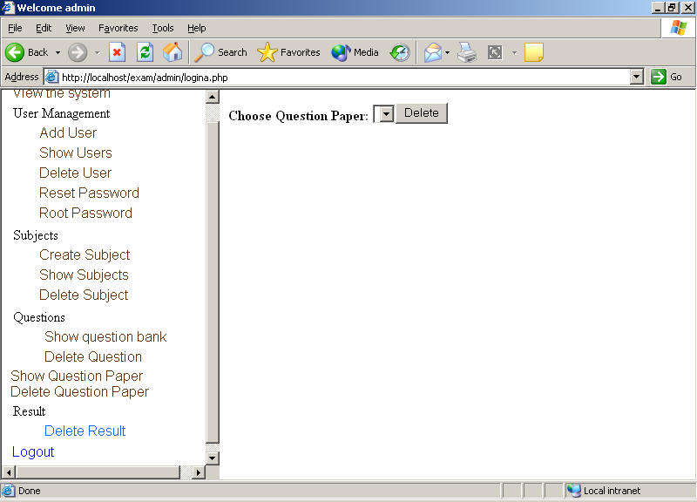
(Fig 19: Delete results)

Description: The administrator can delete the results of an exam through this page.

User/Teacher Pages

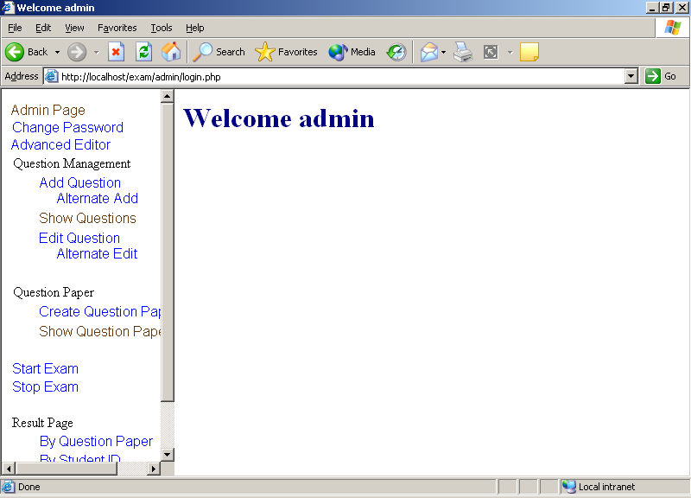
(Fig 20: Welcome page for user)

Description: The user starts from here. It shows “Welcome admin” as we have logged in using the root account. Yes the root can log in as a user but the converse is not true.

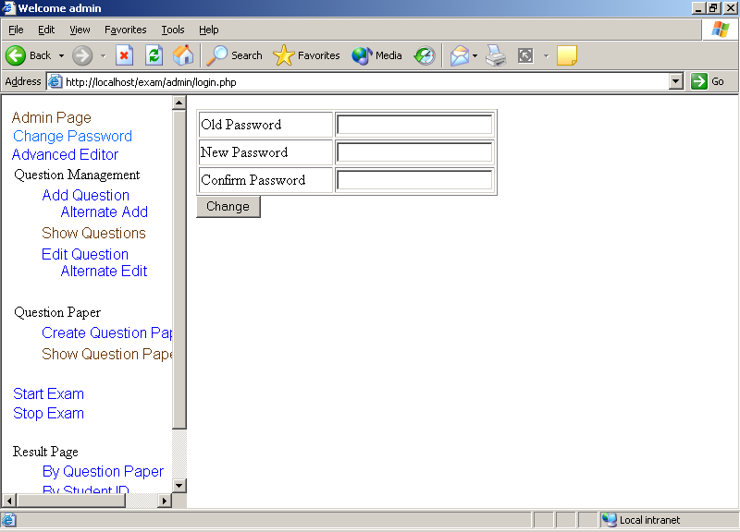
(Fig 21: change password for user)

Description: The user is allowed to change his/her password.

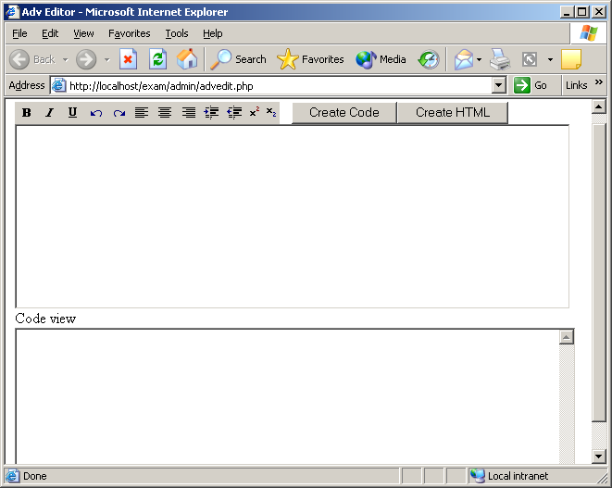
(Fig 22: Advanced Editor)

Description: The user is can type any type of formatted text here. Also the editor supports pictures. We have to give the HTML path to the picture.

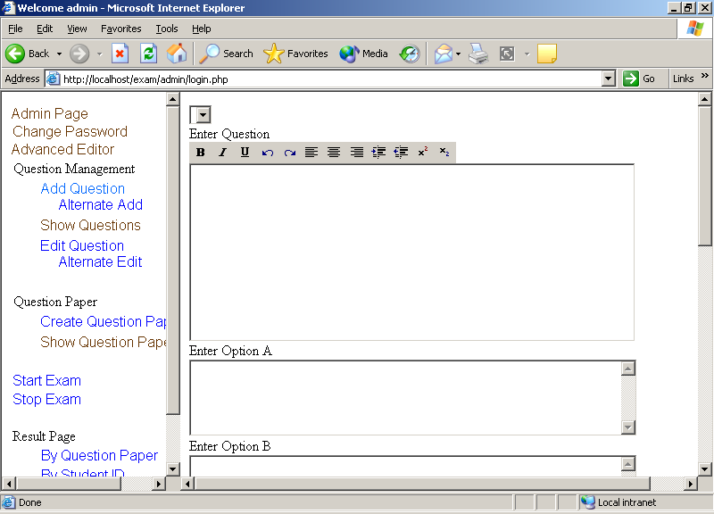
(Fig 23: Add questions page)

Description: The user can add as many as questions to a question bank. Here the user can use the text formatting in the question.
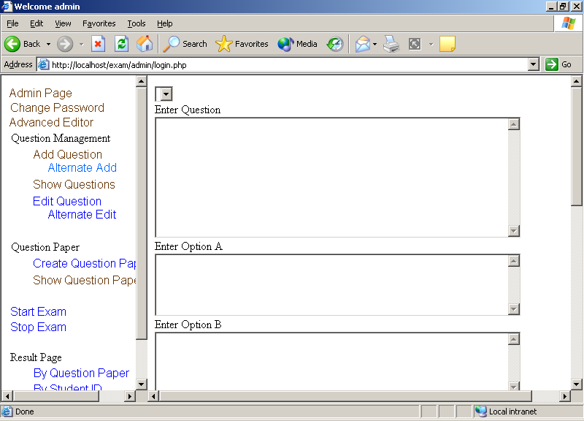
(Fig 24: Alternative Add questions page)

Description: The user can add as many as questions to a question bank. Here the user can not use the text formatting in the question. This is made because the questions can still be added from clients not having a suitable browser.
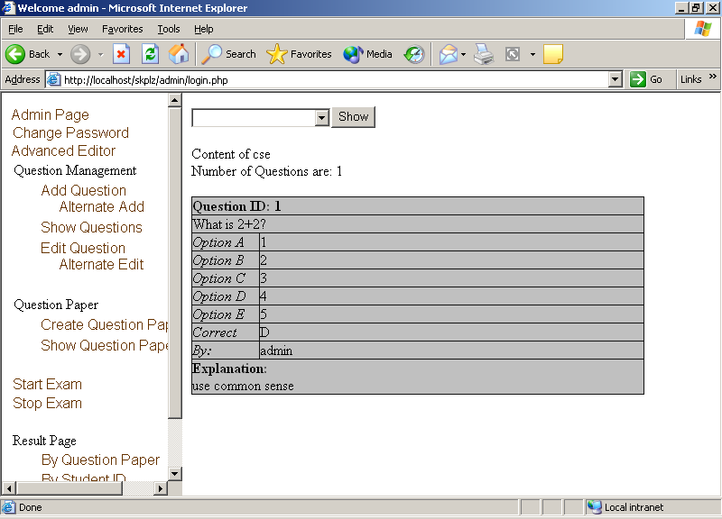
(Fig 25: See the questions)

Description: The user can see the questions present in the question banks.
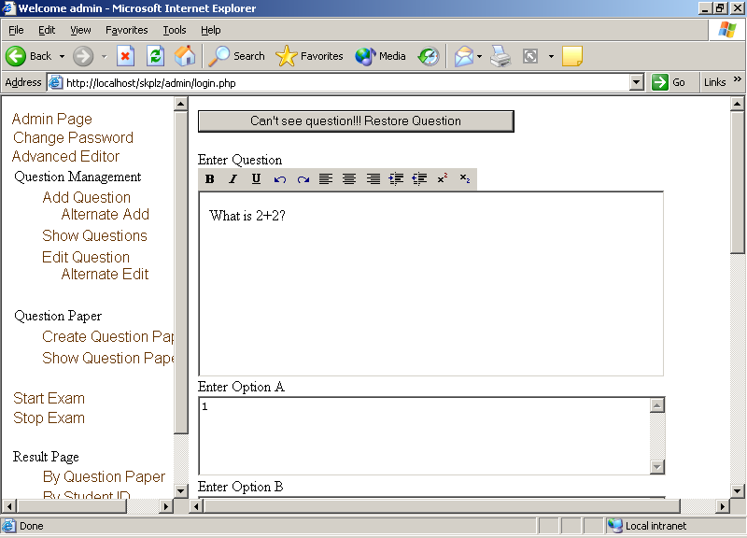
(Fig 26: Edit questions page)

Description: The user can edit the questions present in the question banks.
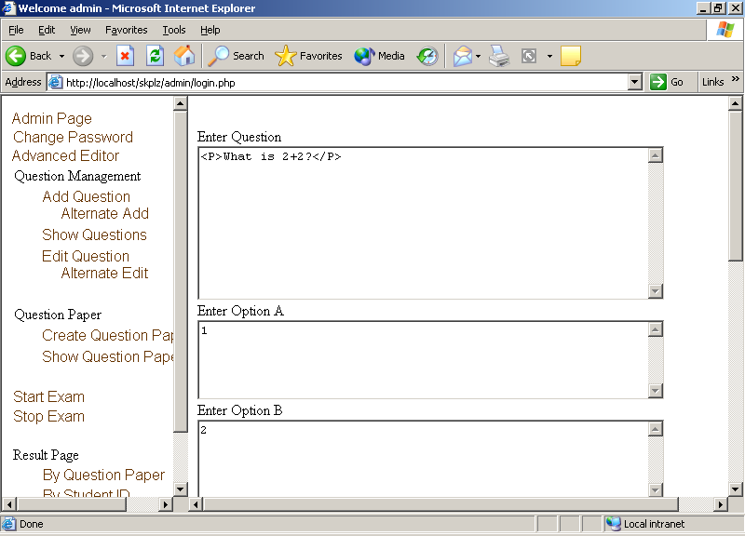
(Fig 27: Alternative Edit questions page)

Description: The user can edit the questions present in the question banks in HTML mode.
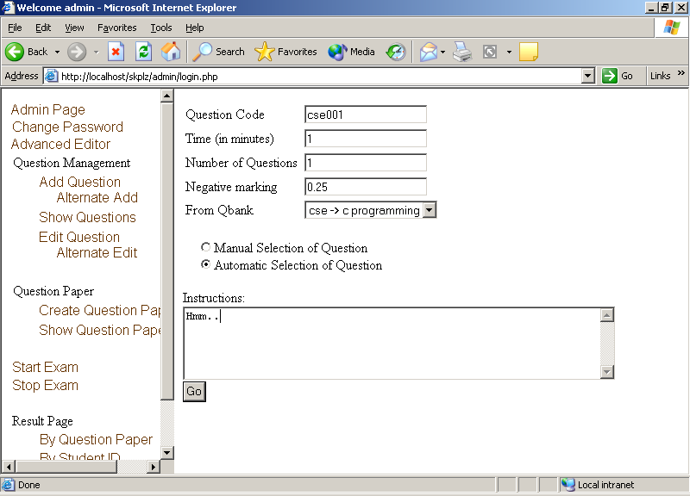
(Fig 28: Create question paper page)

Description: A question paper can be created by any user. He has to fill up the above details and according to the mode the question paper will be created.
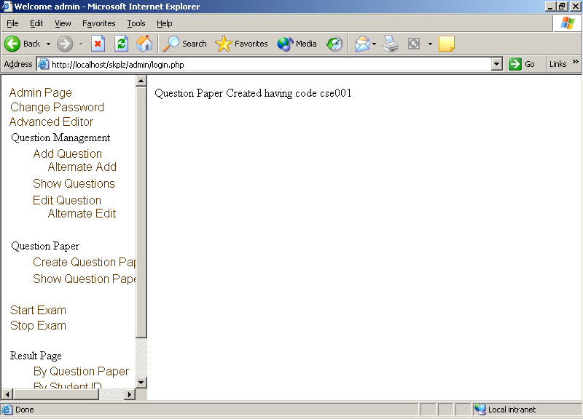
(Fig 29: Message on completion of question paper creation)

Description: If automatic option is selected then question paper is created immediately and the message is displayed, in case of any error the proper error message is displayed.
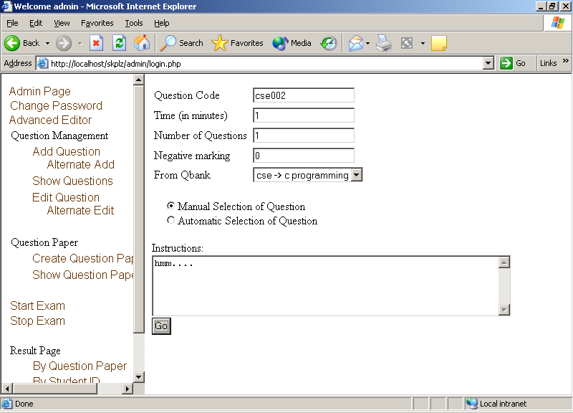
(Fig 30: Manual mode of question paper creation)

Description: In this option all questions in the question bank is displayed and the user has to select proper number of questions.
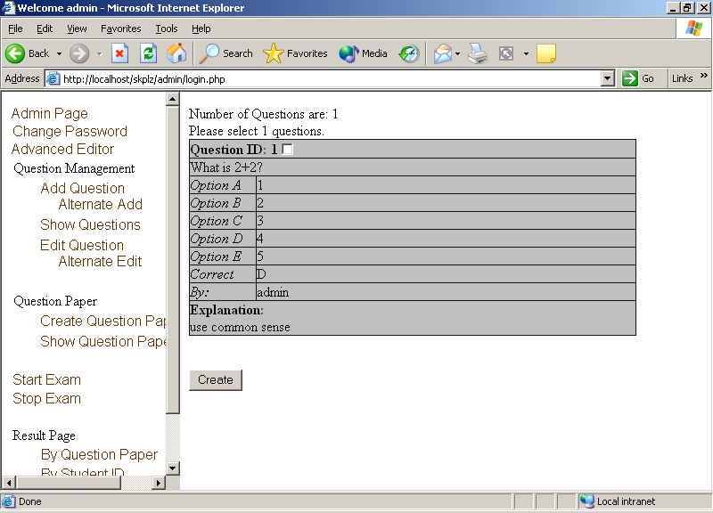
(Fig 31: Manual mode of question paper creation contd.)

Description: When the user selects the proper number of questions and presses the create button the question paper is created and a proper message is displayed.
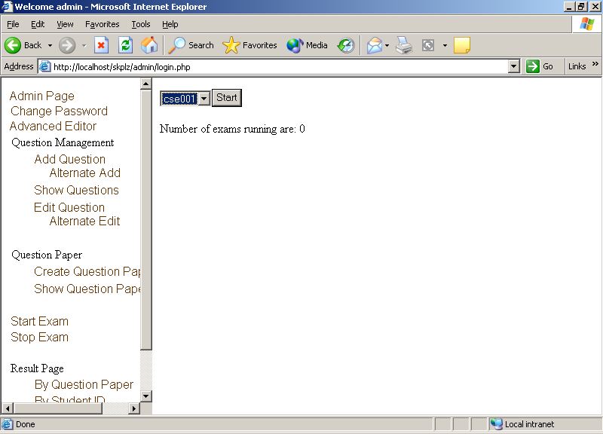
(Fig 32: Start of Examination)

Description: In order to add more security any exam has to be started and then only it can be accessed by the students.
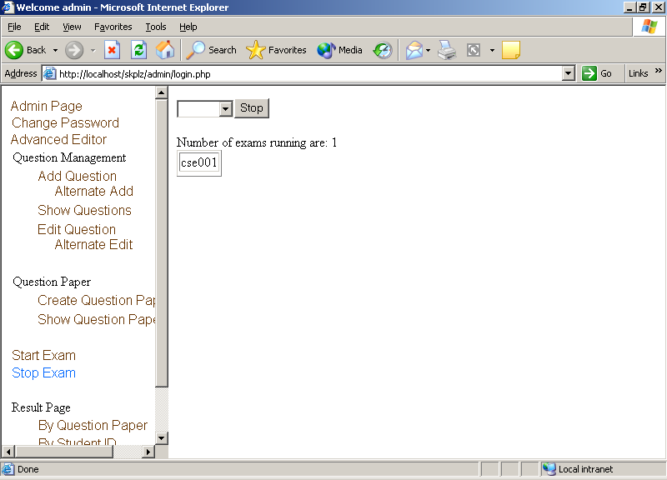
(Fig 33: Stop of examination)

Description: Similarly when the examination is stopped the students can’t access to the examination.

Let’s go to the student’s page and then we will discuss the results pages.
Student Page

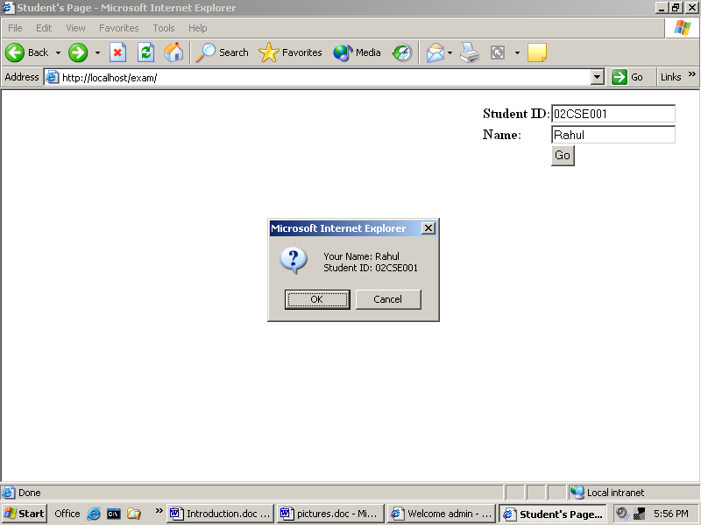
(Fig 34: Student’s details entry page)

Description: The student enters his/her details and Exam Builder asks for the confirmation. If pressed OK then the student can go to the next page.
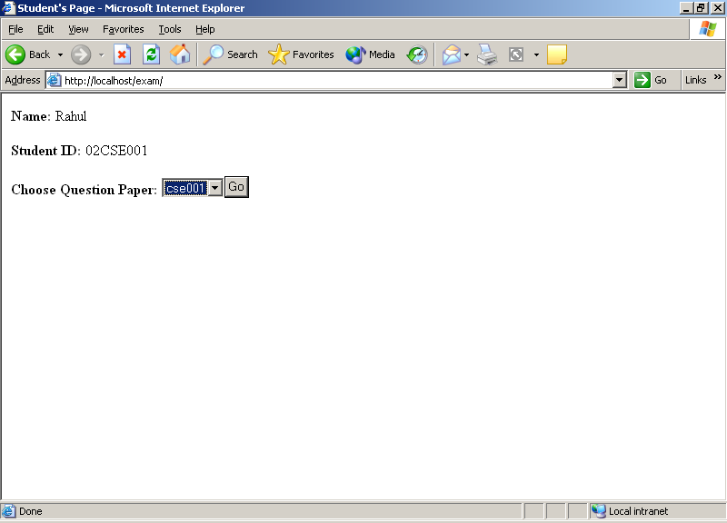
(Fig 35: Question paper selection page)

Description: The student selects the proper question paper. S/he can only select the question paper if it is started by any teacher.
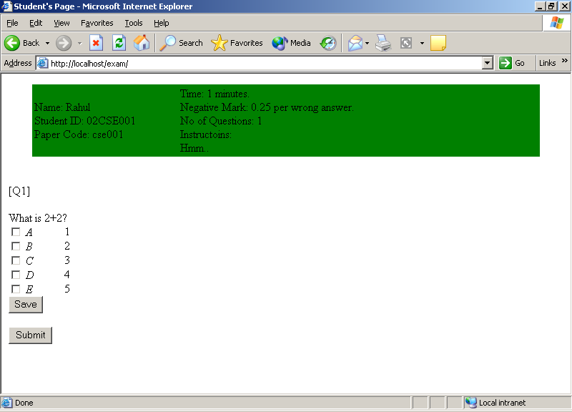
(Fig 36: The answer page)

Description: Here the student answers the questions. After completion of the answer page the student presses the submit button.
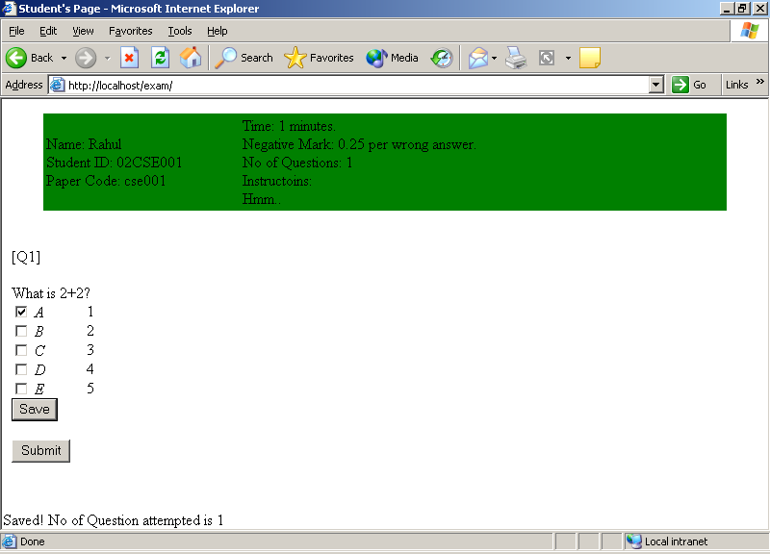
(Fig 37: Saving of current status)

Description: If the student wants to save the current position then proper message is displayed.
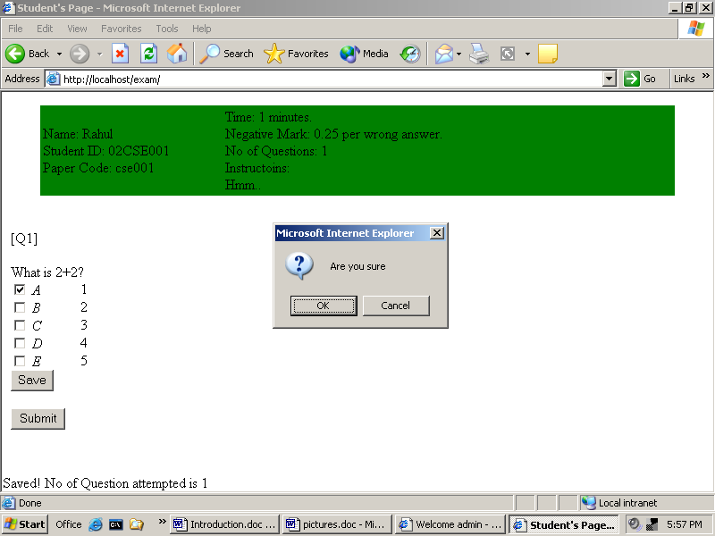
(Fig 38: Last Confirmation from the student)

Description: When the student wants to submit Exam Builder asks the confirmation for the last time.
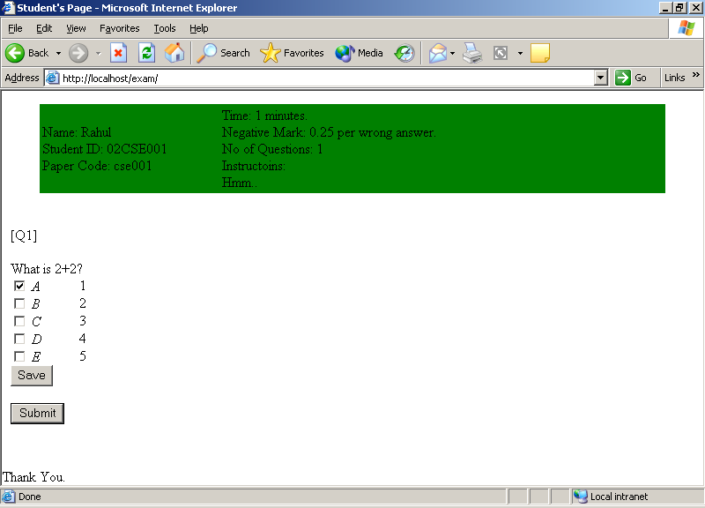
(Fig 39: Thank you page)

Description: Exam Builder thanks the students when they confirm their data. It shows that the answer sheet is properly processed and saved in results.
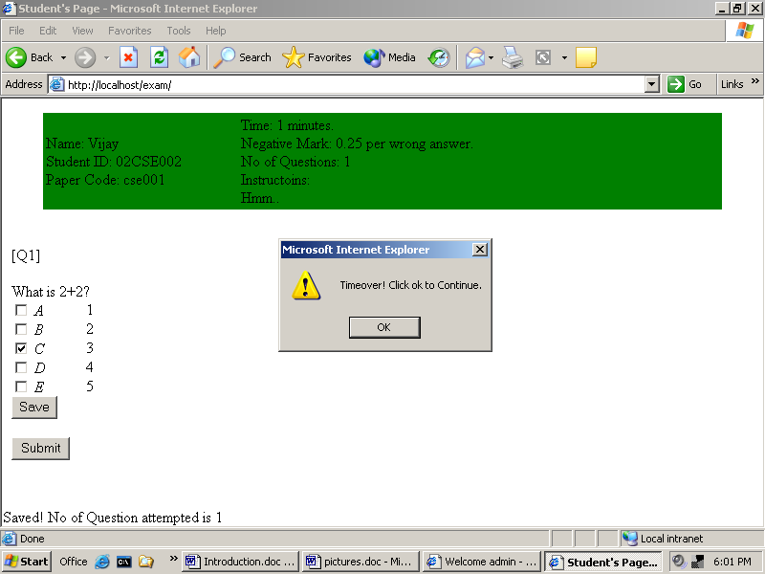
(Fig 40: Time over status)

Description: When time is over, Exam Builder gives a message and the student has to accept it by pressing the OK button and the result is calculated up to that time.
Coming back to the teachers page

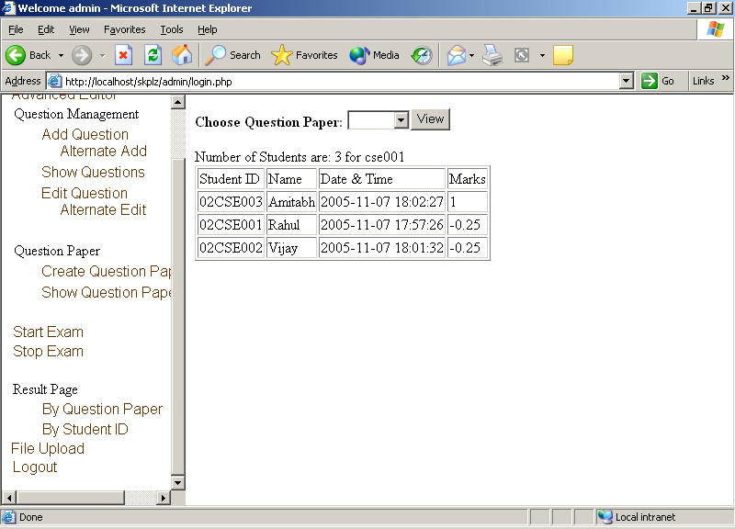
(Fig 41: results by examination code)

Description: Exam Builder displays the result in proper manner (highest marks – highest rank) by question paper code.
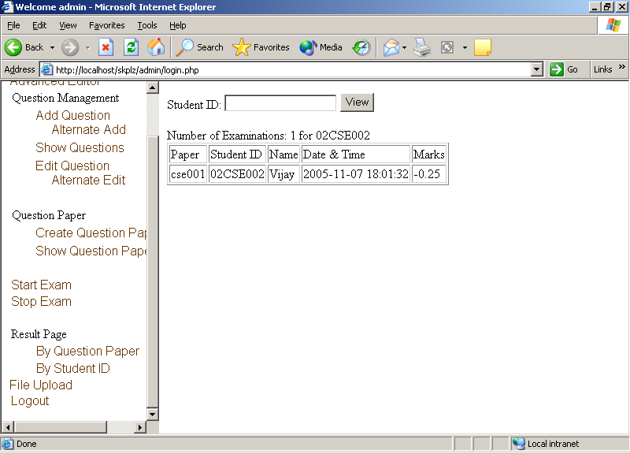
(Fig 42: results by student ID)

Description: Some times the teacher is interested to know the improvements of a single student. The teacher can give the student ID and all the examination given by that particular student will be displayed.

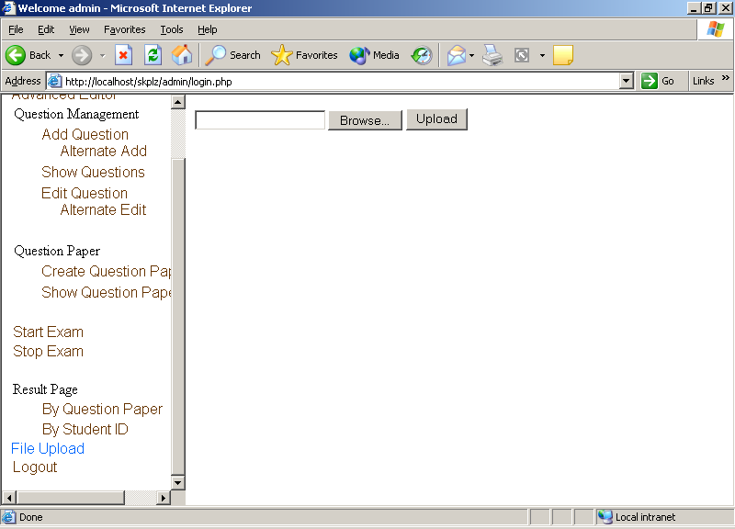
(Fig 43: The file upload page)

Description: In order to support photos and figures we need to upload the photo/figure to the server. Care should be taken while giving the address of the photo in Add question pages. The file is stored in the photos directory.

System Maintenance

The administrator is responsible for the maintenance of Exam Builder. The main tasks that are involved are user management, system back ups, optimizing the data stored in the MySQL database server.

User management
The administrator (root user) can add as many users to the system. Some users may forget their passwords or some are inactive users. The administrator should continuously monitor overall activities and he should take actions accordingly. If the user forgets the password then the root user should reset the password for the user. Inactive users should be deleted soon. Care should b taken such that no user unknowingly harms the data stored.

Database back ups
The data should be kept safely with in regular interval of time. While system restore, the saved data has to be recovered so that the system becomes as before with in no time. The PHP codes are simply ASCII files, and they never get updated. But the photos directory is continuously updated if questions with figures are added in the question banks. This directory has to be backed up.
We have used the database name “exam” for Exam Builder. So we need to back up this database only. There are many processes to back up the data from MySQL server. We can even copy the directory “exam” situated in D:\mysql\data (D drive is that drive where MySQL is stored) or we can search the MySQL server’s data directory and we can take a back up of the “exam” directory from the data directory. But it is recommended to back up the data using MySQL commands.

shell> mysqldump --opt db_name > backup-file.sql

shell> mysql db_name < backup-file.sql

The administrator may have to use the root account for the bake up of the database. The whole syntax is as follows.

mysqldump --user=accountname --password=password
databasename > backup.sql

The above command is for backing up the data. Now the data is stored in the file backup.sql.

mysql -u accountname -p databasename < backup.sql

MySQL database back up and recovery needs expertise with MySQL. The root user should be enough skillful to deal with errors generated at the time of back up and recovery process.

Where do you go from here?

This chapter explains how the software can be improved further. In order to fill the maximum needs of the teachers and the administrator we need some more flexibility for Exam Builder. Suppose for example if the teacher wants a question paper containing questions of different subjects and different types (say true/false) of questions. Then we need to develop it further. So some ways to improve the software are as follows.

- Transferring of questions from one question bank to other.
- Should generate reports for statistical analysis
- Should support questions from different subject simultaneously
- Animations and graphical environment should be employed
- Database back up and recovery should be done graphically

So these are some points to improve Exam Builder further.

Internal description of Database and Tables.
As already said the database used is exam. There are some tables automatically created when the make.php is executed. The tables are info, pques, result, running, and user. For each table the purpose and each field descriptions are discussed below. Let’s begin from the beginning i.e. logging into MySQL.
To log in to MySQL as root issue the following command.
D:\mysql\bin>mysql -u root -p
Enter password: ********
Welcome to the MySQL monitor. Commands end with ; or \g.
Your MySQL connection id is 2 to server version: 3.23.56-nt

Type 'help;' or '\h' for help. Type '\c' to clear the buffer.

mysql>

Here D:\mysql\> is my MySQL installation directory. And bin is the subdirectory where MySQL binary files are located. When the command is used MySQL will ask for the password. If it’s correct then MySQL allows to access to the database server. Now we got our MySQL prompt and from Here the operation begins. Follow the command instructions given below.
To select exam database use
mysql> use exam;
Database changed
mysql>

Now the database is selected. Let’s see the tables.
mysql> show tables;
+----------------+
| Tables_in_exam |
+----------------+
| info |
| pques |
| result |
| running |
| user |
+----------------+
5 rows in set (0.00 sec)

mysql>

Table name: info
Purpose: Stores all information about all the tables in the database exam. We can say it as The metadata (data about the data) of exam. Any tables created during the GUI the table information will be appended to here. For example if one subject named “sample” is created then the information added to info are tname will be sample, ttype will be subject and tinfo will be the description about the subject.
Structure:
mysql> desc info;
+-------+-------------+------+-----+---------+-------+
| Field | Type | Null | Key | Default | Extra |
+-------+-------------+------+-----+---------+-------+
| tname | varchar(30) | | PRI | | |
| tinfo | varchar(50) | | | | |
| ttype | varchar(30) | | | | |
+-------+-------------+------+-----+---------+-------+
3 rows in set (0.01 sec)

mysql>

About fields:
tname Table name
tinfo Table information or description
ttype Table type
subject for Question banks
ques for Question Papers.

SQL command:
create table info (
tname varchar(30) NOT NULL,
tinfo varchar(50) NOT NULL,
ttype varchar(30) NOT NULL,
primary key(tname)
);

Table name: pques
Purpose: It stores the properties of the question papers like the number of questions, negative marking, time of the examination etc.
Structure:
mysql> desc pques;
+-------+-------------+------+-----+---------+-------+
| Field | Type | Null | Key | Default | Extra |
+-------+-------------+------+-----+---------+-------+
| qcode | varchar(30) | | PRI | | |
| sub | varchar(30) | | | | |
| qneg | float | | | 0 | |
| qtime | int(4) | | | 0 | |
| qnos | int(4) | | | 0 | |
| qinst | text | YES | | NULL | |
+-------+-------------+------+-----+---------+-------+
6 rows in set (0.02 sec)

mysql>

About fields:
qcode question paper code (e.g. CSE005)
sub question paper corresponding to the subject
qneg Negative marking (0 is default)
qtime Time of the question paper
qnos No of questions in the question paper
qinst Instruction about the question paper
SQL command:
create table pques (
qcode varchar(30) NOT NULL,
sub varchar(30) NOT NULL,
qneg float NOT NULL,
qtime int(4) NOT NULL,
qnos int(4) NOT NULL,
qinst text,
primary key(qcode)
);

Table name: result
Purpose: Table for recording to the marks of the students. Care is taken that no single student can appear more than once to a single question paper or exam.
Structure:
mysql> desc result;
+-------+-------------+------+-----+---------+-------+
| Field | Type | Null | Key | Default | Extra |
+-------+-------------+------+-----+---------+-------+
| qcode | varchar(30) | | PRI | | |
| sid | varchar(10) | | PRI | | |
| sname | varchar(50) | YES | | NULL | |
| marks | float | YES | | NULL | |
| time | datetime | YES | | NULL | |
| sta | int(2) | | | 0 | |
+-------+-------------+------+-----+---------+-------+
6 rows in set (0.02 sec)

mysql>
About fields:
qcode Name of the question paper or code
sid student ID
sname Student Name
marks Marks
time time of submission
sta Status (used for checking the intermediate stage)
SQL Command:
create table result (
qcode varchar(30) NOT NULL,
sid varchar(10) NOT NULL,
sname varchar(50),
marks float,
time datetime,
sta int(2) NOT NULL,
primary key(qcode,sid)
);

Table name: running
Purpose: To know which are the examinations currently running. When any exam is started its value is stored in this table and when stopped its value is deleted from this table. If the name of the exam to be carried out is not in this table then the students can not access to that exam.
Structure:
mysql> desc running;
+-------+-------------+------+-----+---------+-------+
| Field | Type | Null | Key | Default | Extra |
+-------+-------------+------+-----+---------+-------+
| qcode | varchar(30) | | PRI | | |
+-------+-------------+------+-----+---------+-------+
1 row in set (0.00 sec)

mysql>

About fields:
qcode name of the question paper.

SQL command:
create table running (
qcode varchar(30) NOT NULL,
primary key(qcode)
);

Table name: user
Purpose: Maintains the username and password record. The password field is encrypted here means if the password is forgotten then not even administrator can retrieve the old password. But if password is forgotten then the administrator can reset the password for the user.
Structure:
mysql> desc user;
+----------+-------------+------+-----+---------+-------+
| Field | Type | Null | Key | Default | Extra |
+----------+-------------+------+-----+---------+-------+
| uname | varchar(30) | | PRI | | |
| fname | varchar(50) | | | | |
| password | varchar(20) | | | | |
+----------+-------------+------+-----+---------+-------+
3 rows in set (0.00 sec)

mysql>

About fields:
uname username (must be unique for each user)
fname Full Name of the user
password password for the user
SQL command:
create table user (
uname varchar(30) NOT NULL,
fname varchar(50) NOT NULL,
password varchar(20) NOT NULL,
primary key(uname)
);

These above described tables are all automatically created. Let’s have a look about the question bank. Let create a subject table as root. After adding a subject “CSE” and description “Computer Science”, check the content of the table info.
mysql> select * from info;
+---------+------------------------------+---------+
| tname | tinfo | ttype |
+---------+------------------------------+---------+
| info | System information | admin |
| user | User information | admin |
| pques | Question Format & Properties | admin |
| result | Results Table | admin |
| running | Running Examinations | admin |
| CSE | Computer Science | subject |
+---------+------------------------------+---------+
6 rows in set (0.00 sec)

mysql>

You can see that CSE is appended in the last.
Table name: CSE
Purpose: A question bank for Computer Science (say C programming)
Structure:
mysql> desc CSE;
+-------+-------------+------+-----+---------+----------------+
| Field | Type | Null | Key | Default | Extra |
+-------+-------------+------+-----+---------+----------------+
| qid | int(4) | | PRI | NULL | auto_increment |
| ques | text | | | | |
| opa | text | | | | |
| opb | text | | | | |
| opc | text | | | | |
| opd | text | | | | |
| ope | text | | | | |
| corr | varchar(8) | | | | |
| susr | varchar(50) | | | | |
| expl | text | YES | | NULL | |
+-------+-------------+------+-----+---------+----------------+
10 rows in set (0.00 sec)
About fields:
qid Question ID
ques The question itself
opa Option A
opb Option B
opc Option C
opd Option D
ope Option E
corr Correct answer
susr Submitted by user
expl Explanation

SQL command:
create table CSE (
qid int(4) NOT NULL AUTO_INCREMENT,
ques text NOT NULL,
opa text NOT NULL,
opb text NOT NULL,
opc text NOT NULL,
opd text NOT NULL,
ope text NOT NULL,
corr varchar(8) NOT NULL,
susr varchar(50) NOT NULL,
expl text,
primary key(qid)
);
This is all about the question bank. Now we will see when one question paper is created then what’s the structure of the table created. Let’s create a question paper called sample from it.
Table name: sample
Purpose: It’s the name of a question paper. It contains only the question IDs. We can get from which question bank the question paper belong to and we can select that much of questions which are present in the question paper table.
Structure:
mysql> desc sample;
+-------+--------+------+-----+---------+-------+
| Field | Type | Null | Key | Default | Extra |
+-------+--------+------+-----+---------+-------+
| qid | int(4) | | PRI | 0 | |
+-------+--------+------+-----+---------+-------+
1 row in set (0.00 sec)

About fields:
qid Question ID

SQL command:

create table sample (
qid int(4) NOT NULL,
primary key(qid)
);

Now if we see the pques table we can know about the question paper.
mysql> select * from pques;
+--------+-----+------+-------+------+-------+
| qcode | sub | qneg | qtime | qnos | qinst |
+--------+-----+------+-------+------+-------+
| sample | CSE | 0 | 1 | 1 | |
+--------+-----+------+-------+------+-------+
1 row in set (0.00 sec)

It shows that there is one question paper configured. The name of the question paper is sample having 1 number of questions and one minute time. The question paper is from the question paper bank CSE.
I here conclude the internals of the back end database.

Setting up server for Exam Builder
There are several methods to set up the server for Exam Builder. A detailed description requires many pages of explanation. Hence we will consider the easiest method and discuss it in brief. The reader is encouraged to have a look at the reference section to find out more about how to set up a server running apache/IIS with database engine MySQL and scripting language PHP. As these are all open sources (except IIS) we can compile MySQL and PHP from the source code also but I feel unless you want to make your hands dirty go for the direct installations in windows and red hat package manager (rpm) in UNIX like operating systems.

For windows installations
We will discuss how to install IIS/Apache, MySQL, and PHP. I have tested in different versions of windows like windows 98, 2000, 2000 advanced server and XP. I used apache as my server software in windows 98 and IIS for the rest. However installing apache for all windows operating systems is similar.

Installing Internet Information Services (IIS)
IIS is shipped with windows XP, 2000 and 2000 advanced server. Install it from the operating system CD and confirm that http://localhost gives you fruitful results.

Installing Apache
Get the latest binary installation package of APACHE HTTP SERVER from www.apache.org and install it. Install apache as a service so that it runs each time the system boots up. Read the apache installation notes for it. In order to run PHP with apache we need to edit httpd.conf file. I used PHP to work as CGI application. There are specific tags we need to add to httpd.conf. Please read apache documentation in order to work apache with PHP. Make sure that apache is running and now check http://localhost. You should to be able to see that apache home page in your web browser. You can skip this step if you plan to run server in IIS.

Installing PHP
For installing PHP I used the zipped distribution. Download PHP and MySQL from the respective web sites and make sure that they agree with each other. I used PHP 4.3.3 and MySQL 3.23. Unzip the php-4.3.3-Win32.zip to c:\php and make sure that c:\php\php.exe exists. For windows 2000 or higher go to control panel, Administrative Tools, Internet Information Services. Double click web sites and right click default web site then go to properties, Home directory and click configuration.
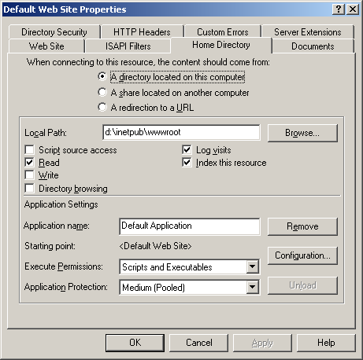
Click on configuration and click add. Give the path to php.exe and then write extension as .php and click OK.
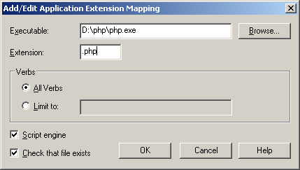
Then you can see that PHP is added in the list, click OK.
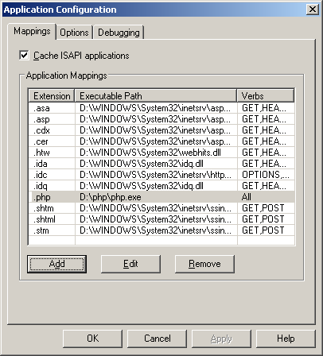
Now open php.ini-recommended in notepad. Make sure that this line is present and undocumented cgi.force_redirect = 0. In order to enable sessions make sure that this tag is present session.save_path = c:/tmp. Now create a folder or directory named tmp in C drive. That’s all for PHP.
Installing MySQL
It’s the easiest process in windows. Just run the setup and follow the instructions.

For Linux installations
In Linux (fedora and red hat), usually apache (httpd), PHP and MySQL comes pre-installed. The server configuration is called LAMP installation and needs a little bit of skills in Linux to tune and work for PHP/MySQL. I skip this process as it is a lengthy one but it is readily available in the manual pages of PHP and MySQL websites. I recommend the reader to see the documentation in the respective web sites or in the reference sections for resources.
Lastly I encourage the user/reader to set up the LAMP installation. I have developed Exam Builder in windows environment but tested in Linux (Fedora Core 1 and 4). One should know how good Linux performs as a server. It’s really secure and fast.

Abbreviations

ASP | Active Server Pages
CAT | Common Admission Test
CGI | Common Gateway Interface
CPU | Central Processing Unit
FSF | Free Software Foundation
GB | Giga Byte
GHz | Giga Hertz
GNU | GNU is Not Unix
GPL | General Public License
GUI | Graphical User Interface
HTML | Hyper-Text Mark up Language
ID | Identity
IIS | Internet Information Service
IIT | Indian Institute of Technology
IT | Information Technology
JEE | Joint Entrance Examination
JSP | Java Server Pages
LAN | Local Area Network
MB | Megabyte
Mbps | Mega bits per second
MCQ | Multi Choice Questions
PHP | PHP Hypertext Processing
SQL | Structured Query Language

