Amplifiers

An **amplifier** is **an electronic device that increases the voltage, current, or power of a signal**. Amplifiers are used in wireless communications and broadcasting, and in audio equipment of all kinds. Many different types of amplifier are found in electronic circuits.

The main types of amplifier are.

##### **A.C. Coupled Amplifiers**

In A.C. coupled amplifiers, stages are coupled together in such a way that D.C. levels are isolated and only the A.C. components of a signal are transferred from stage to stage.

##### **D.C. Coupled Amplifiers**

In **D.C.**(or direct) coupled amplifiers, stages are coupled together in such a way that stages are not isolated to **D.C.**potentials. Both **A.C**. and **D.C.**signal components are transferred from stage to stage.

##### **Large-signal amplifiers**

Large-signal amplifiers are designed to provide an appreciable voltage and/or current levels (typically from 1 V to 100 V or more).

##### **Small-signal amplifiers**

Small-signal amplifiers are designed to provide a low-level signals (normally less than 1 V and often smaller). Small-signal amplifiers have to be specially designed to reduce the effects of noise.

##### **Audio frequency amplifiers**

Audio frequency amplifiers operate in the band of frequencies that is normally associated with audio signals (e.g. 20 Hz to 20 kHz).

##### **Wideband amplifiers**

Wideband amplifiers are capable of amplifying a very wide range of frequencies, typically from a few tens of hertz to several megahertz.

##### **Low-noise amplifiers**

Low-noise amplifiers are designed so that they contribute negligible noise (signal disturbance) to the signal being amplified. These amplifiers are usually designed for use with very small signal levels (usually less than 10 mV or so).

**Radio frequency amplifiers**

Radio frequency amplifiers operate in the band of frequencies that is normally associated with radio signals (e.g. from 100 kHz to over 1 GHz). Note that it is desirable for amplifiers of this type to be frequency selective and thus their frequency response may be restricted to a relatively narrow band of frequencies.

**Gain**

The important parameter of an amplifier is the amount of amplification or gain that it provides. Gain is simply the ratio of output voltage to input voltage, output current to input current, or output power to input power. These three ratios give, respectively, the voltage gain, current gain and power gain.

Thus:

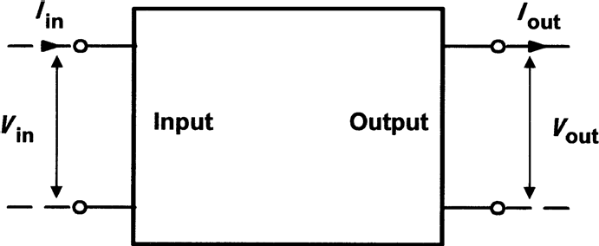

Voltage gain, Av= Vout / Vin

Current gain, Ai = Iout / Iin

Power gain, Ap = Pout / Pin

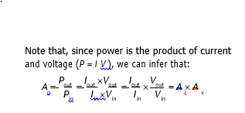

### **Input and output resistance**

**Input resistance** is the ratio of input voltage to input current and it is expressed in ohms.

The input of an amplifier is normally purely resistive (i.e. any reactive component is negligible) in the middle of its working frequency range (i.e. the **mid-band**). In some cases, the reactance of the input may become appreciable (e.g. if a large value of stray capacitance appears in parallel with the input resistance). In such cases we would refer to **input impedance** rather than input resistance.

**Output resistance** is the ratio of open-circuit output voltage to short-circuit output current and is measured in ohms. Note that this resistance is internal to the amplifier and should not be

confused with the resistance of a load connected externally.

As with input resistance, the output of an amplifier is normally purely resistive and we

can safely ignore any reactive component. If this is not the case, we would once again need to refer to **output impedance** rather than output resistance.

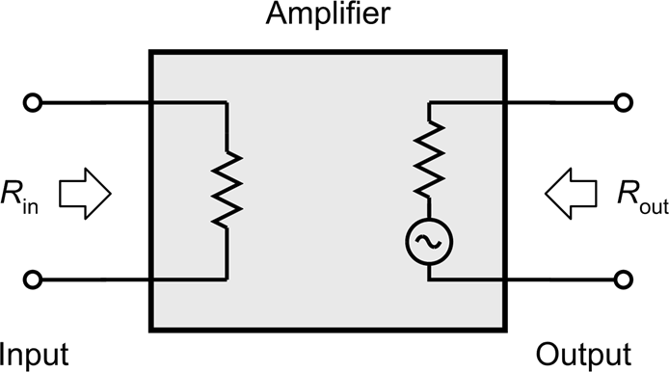 Fig. shows how the input and output resistances are ‘seen’ looking into the input and output terminals, respectively.

**Frequency response:**

* The frequency response characteristics for various types of amplifier are shown in Fig. 7.9. Note that, for response curves of this type, frequency is almost invariably plotted on a **logarithmic scale**.
* The frequency response of an amplifier is usually specified in terms of the upper and lower **cut-off frequencies** of the amplifier. These frequencies are those at which the output power has dropped to 50% (otherwise known as the **3 dB points**) or where the voltage gain has dropped to 70.7% of its mid-band value.
* Figs 7.10 and 7.11, respectively, show how the bandwidth can be expressed in terms of either power or voltage (the cut-off frequencies, *f*1 and *f*2, and bandwidth are identical).

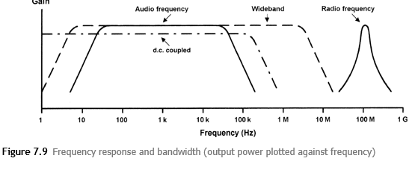

|  |  |
| --- | --- |
|  |  |

**Bandwidth**

* The bandwidth of an amplifier is usually taken as the difference between the upper and lower cut-off frequencies (i.e. f2 and f1 in Figs 7.10 and 7.11).
* The bandwidth of an amplifier must be sufficient to accommodate the range of frequencies present within the signals that it is to be presented with.

**Phase shift**

* Phase shift is the phase angle between the input and output signal voltages measured in degrees
* Conventional single-stage transistor amplifiers provide phase shifts of either 180° or 360°.

**Negative feedback**

* Advantages of negative feedback:

1. To precisely control the gain.
2. Reduce distortion and
3. Improve bandwidth

* The gain can be reduced to a manageable value by feeding back a small proportion of the output.
* The amount of feedback determines the overall (or closed-loop) gain.
* Because this form of feedback has the effect of reducing the overall gain of the circuit, this form of feedback is known as negative feedback.
* An alternative form of feedback, where the output is fed back in such a way as to reinforce the input (rather than to subtract from it) is known as positive feedback. This form of feedback is used in oscillator circuits
* Fig. 7.13 shows the block diagram of an amplifier stage with negative feedback applied. In this circuit, the proportion of the output voltage fed back to the input is given by β and the overall voltage gain will be given by:

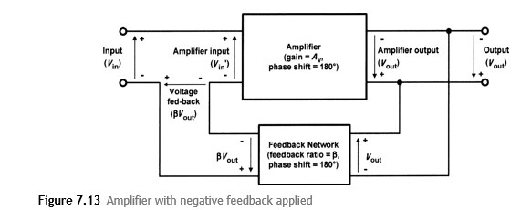





Rearranging the e





