**Assignment-1**

Thota GuruTheja Reddy

19BCD7034

I. General Hardware Database:

Sales Person(SalesPersonNumber, SalesPersonName, CommPercentage, YearHire, OfficeNumber)

Customer (CustomerNumber, CustomerName, SalesPersonNumber, HeadQuarterCity)

Customer Employee (CustomerNumber, EmployeeNumber, EmployeeName, Title)

Product (ProductNumber, ProductName, UnitPrice)

Sales (SalesPersonNumber, ProductNumber, Quantity)

Office (OfficeNumber, Telephone, Size)

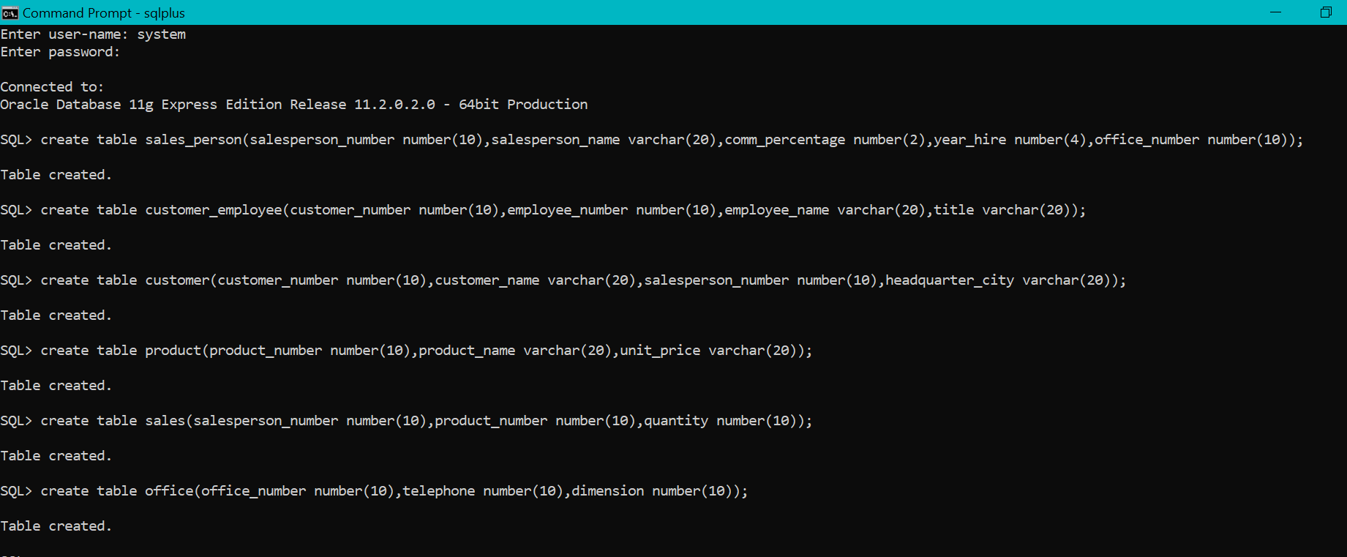

Inserting sales person details

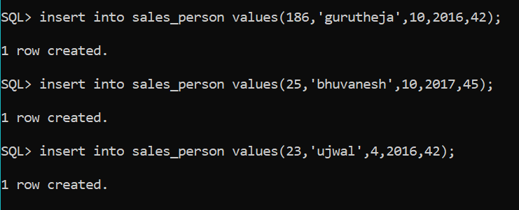

1.Find the commission percentage and year of hire of salesperson number 186.

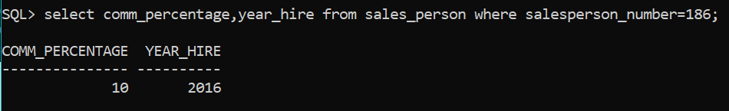

2.List the salesperson numbers and salesperson names of those salespersons who have a commission percentage of 10.

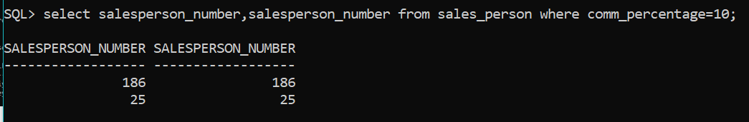

3.List the salesperson number and salesperson name of all of the salespersons.

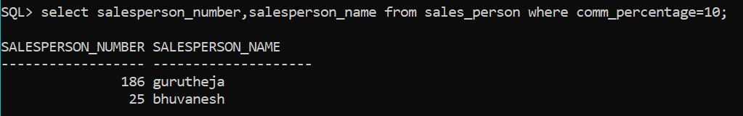

4.List the salesperson numbers, salesperson names, and commission percentages of the salespersons whose commission percentage is less than 12.

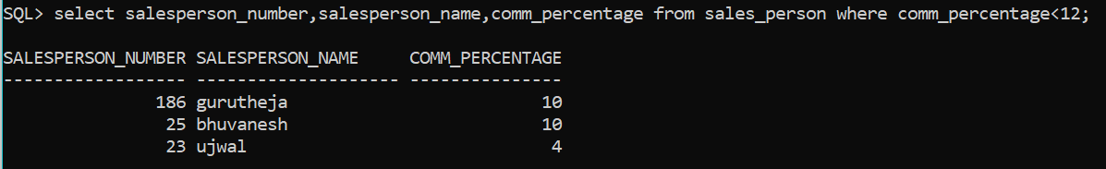

Inserting customer details

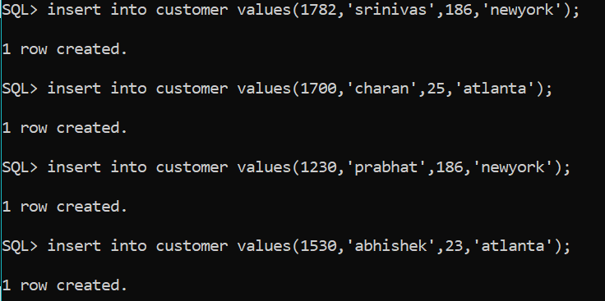

5.List the customer numbers and headquarters cities of the customers that have a customer number of at least 1700.

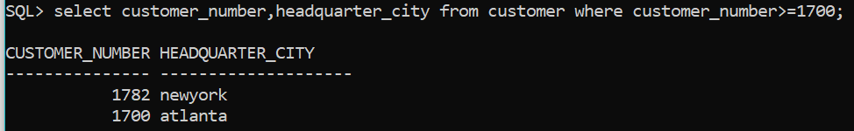

6.List the customer numbers, customer names, and headquarters cities of the customers that are headquartered in New York and that have a customer number higher than 1500.



7.‘List the customer numbers, customer names, and headquarterscities of the customers that are headquartered in New York or that have a customer number higher than 1500.

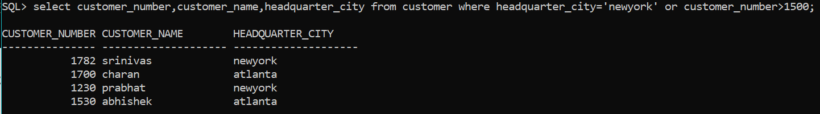

8.List the customer numbers, customer names, and headquarters cities of the customers that are headquartered in New York or that satisfy the two conditions of having a customer number higher than 1500 and being headquartered in Atlanta.

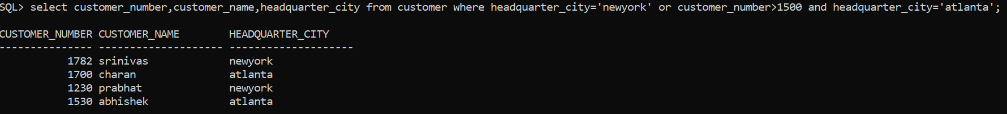

9.Which cities serve as headquarters cities for General Hardware customers?

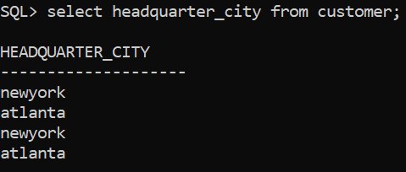

10.Find the customer numbers, customer names, and headquarters cities of those customers with customer numbers greater than 1000. List the results in alphabetic order by headquarters cities.

