**Assignment-4**

**Thota GuruTheja Reddy**

**19BCD7034**

**L57&L58**

**TABLE CREATION:**



**INSERTION OF DATA**

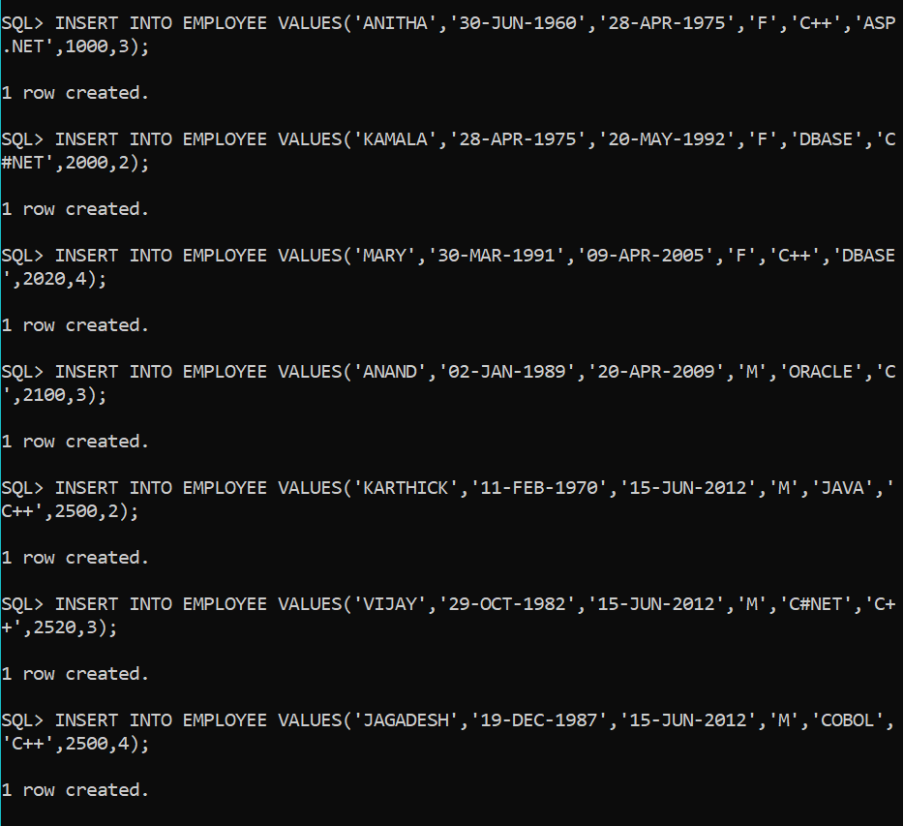

1.

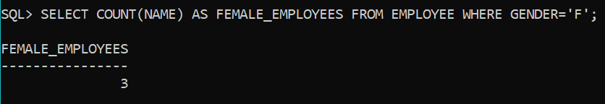

2.

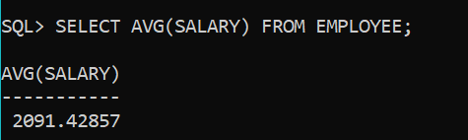

3.

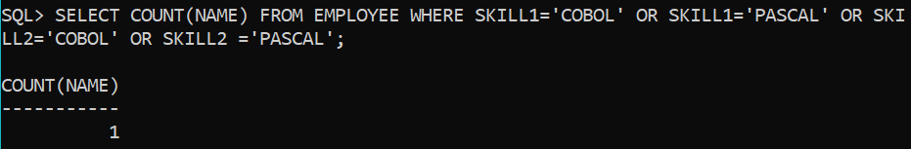

**4.**

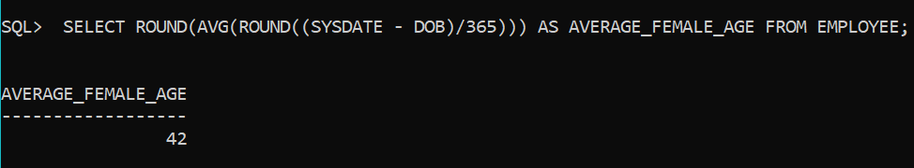

5.

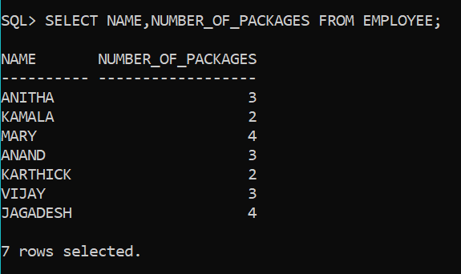

6. AND 7.

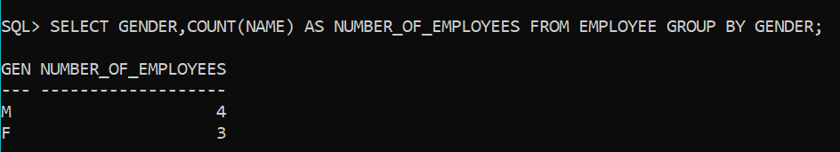



8. AND 9.

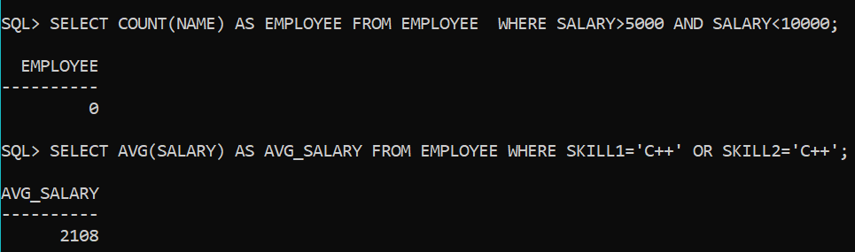

10. AND 11.

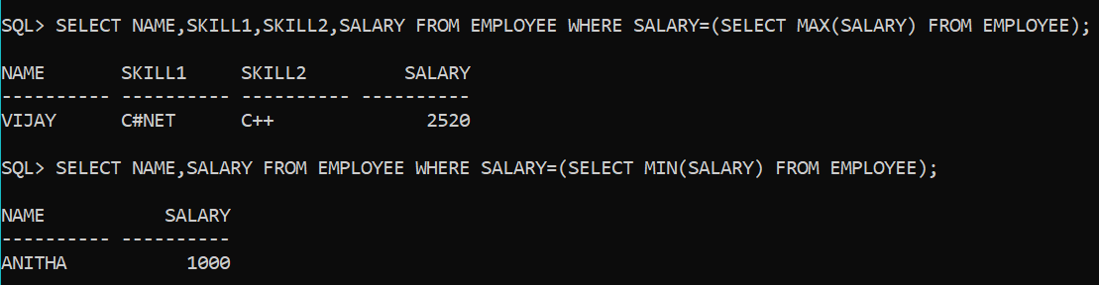

12.

