**Assignment-7**

**Thota GuruTheja Reddy**

**19BCD7034**

**L57 & L58**

**Creating table:**

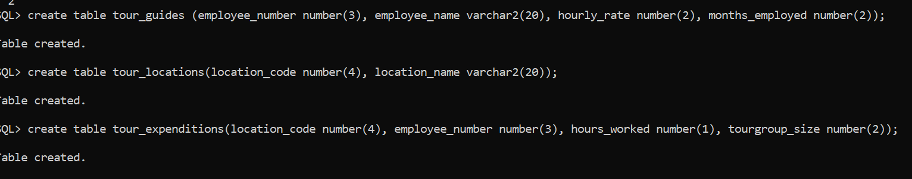

**Inserting values:**

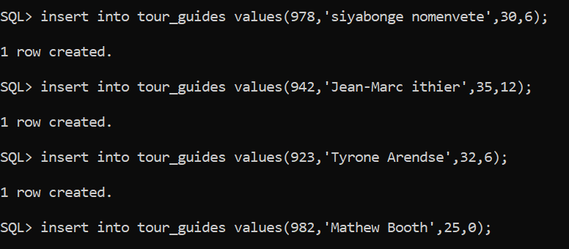

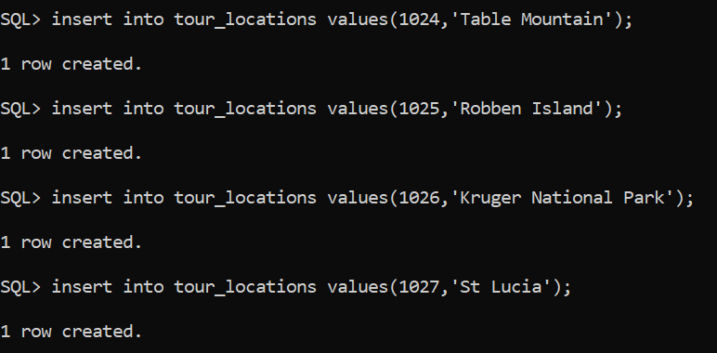

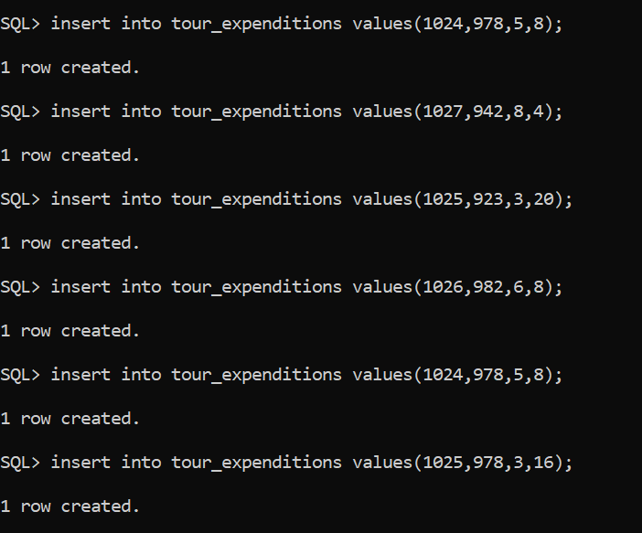

1) Display the employee names with their respective tour locations.

2) Display the employee_numbers who had a trip to Table Mountain

3) Display all the employees name regardless of whether they have undertaken a trip or not? (use left outer join)

4) How do we return the employee numbers, names and locations of all guides, including those who have not yet given a trip

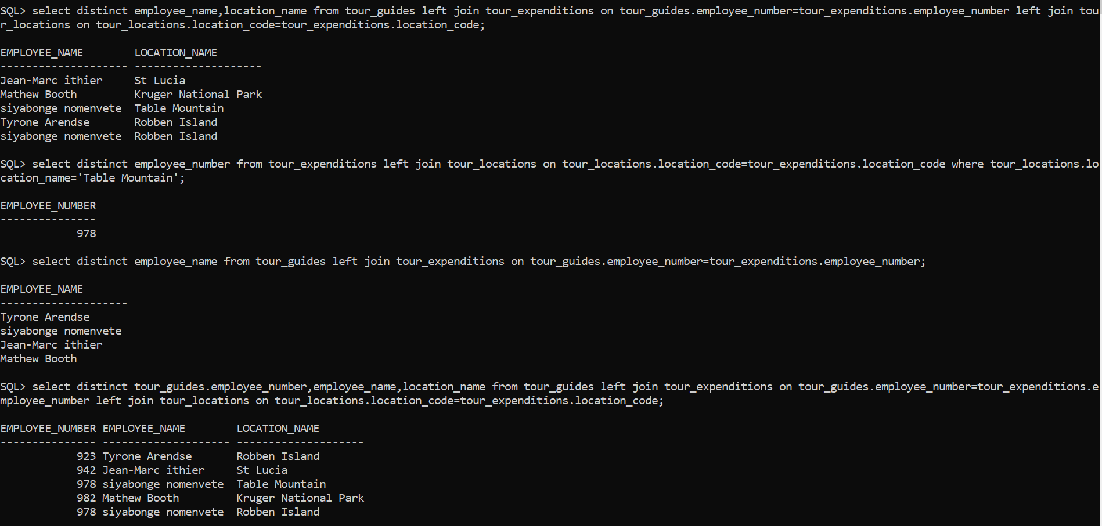

5) Display all employees who've worked with a tour group of more than 10 people



6) Find the names of all the employees who have the same hourly rate as Siyabonge Nomvete.(self join)

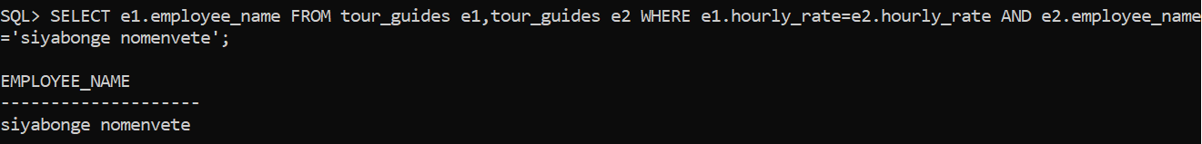

7) Display the employee name and employee number who have worked for more than 3 hours.

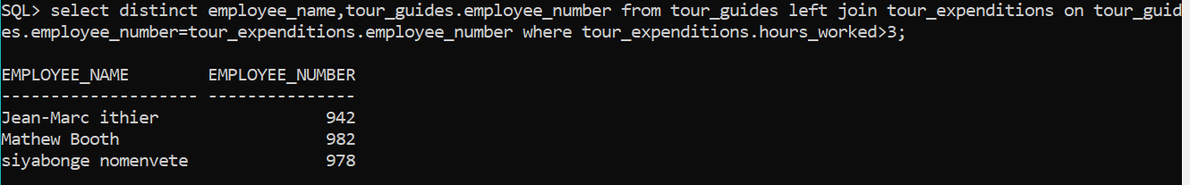

8) Display the total information of the tour guides along with their hourly rate in asc order

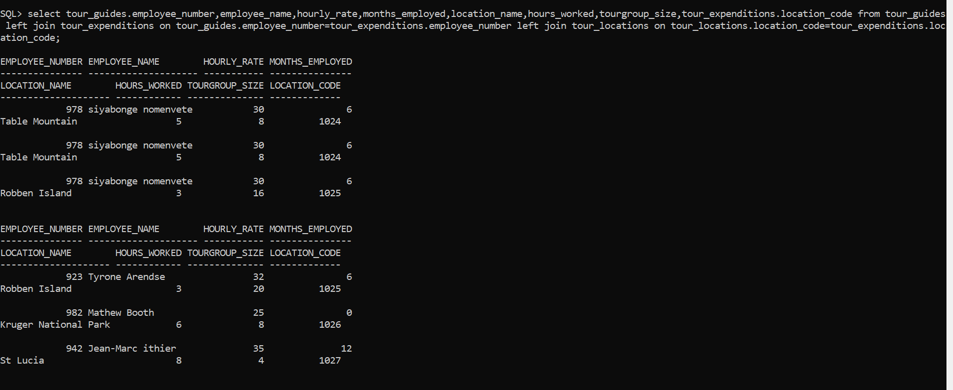

9) Display the tour location in which tour group have visited more than once.

