**Assignment-8**

**Thota GuruTheja reddy**

**19BCD7034**

1) Write PL/SQL code to find Largest of three numbers.

Declare

Var1 integer;

Var2 integer;

Var3 integer;

Begin

Var1:=&var1;

Var2:=&var2;

Var3:=&var3;

if(Var1>Var2 and Var1>Var3)

then

dbms_output.put_line('Largest number is ' || Var1);

elsif(Var2>Var1 and Var2>Var3)

then

dbms_output.put_line('Largest number is ' || Var2);

else

dbms_output.put_line('Largest number is ' || Var3);

end if;

end;

/

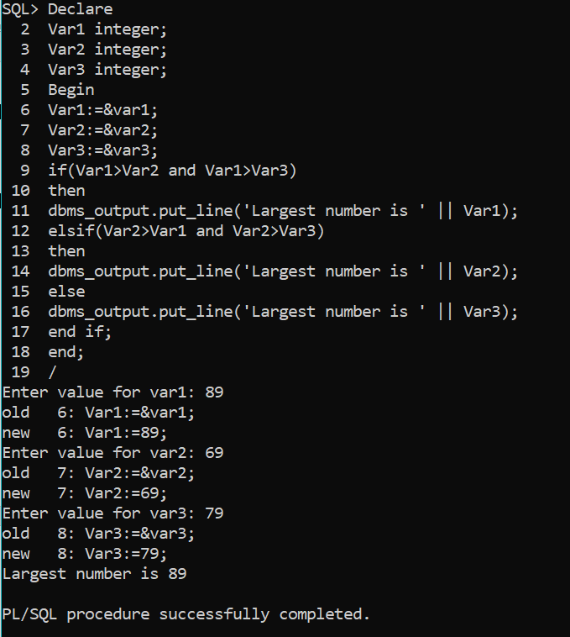

2) Write PL/SQL code to find Factorial of a given number

declare

factorial number :=1;

num number:= &num;

begin

while num > 0

loop

factorial:=num*factorial;

num:=num-1;

end loop;

dbms_output.put_line('Factorial of given number is ' || factorial);

end;

/

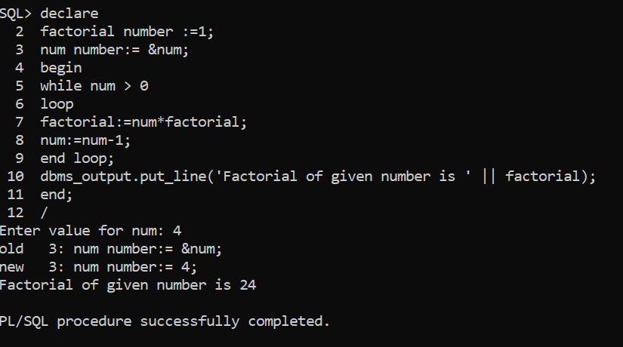

3) Write PL/SQL code to Read number and prints its Multiplication Table

declare

num number;

temp number:=1;

result number;

begin

num :=&num;

while temp <= 10

loop

result := num*temp;

dbms_output.put_line(num || ' x ' || temp || ' = ' || result);

temp:=temp+1;

end loop;

end;

/

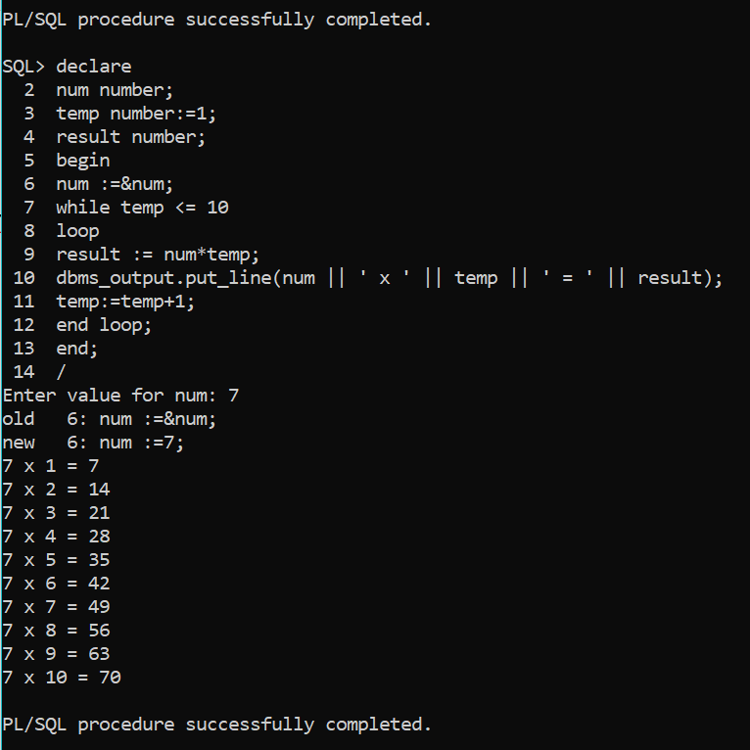

4) Write PL/SQL code to find given number is Prime or not​

declare

num number:=&num;

i number:=1;

c number:=0;

begin

for i in 1..num

loop

if((mod(num,i))=0)

then

c:=c+1;

end if;

end loop;

if(c>2)

then

dbms_output.put_line(num||' not a prime');

else

dbms_output.put_line(num||' is prime');

end if;

end;

/

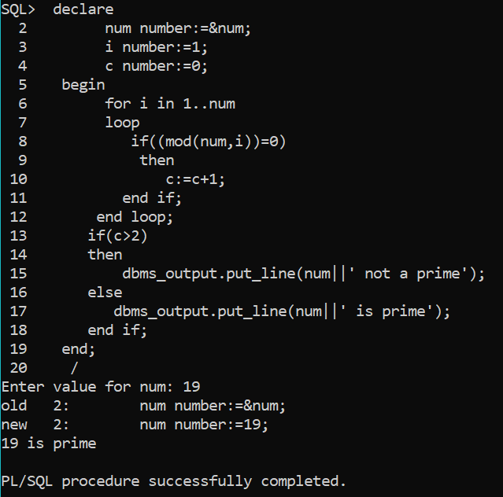

5) Write PL/SQL code to accept the text and reverse the text and test whether the given character is Palandrome or not.

declare

text1 varchar(30);

text2 varchar(30);

len number;

i number;

begin

text1:= &text1;

len:=length(text1);

for i in reverse 1..len

loop

text2:=text2 || substr(text1,i,1);

end loop;

if text1=text2

then

dbms_output.put_line(text1||' is a palindrome');

else

dbms_output.put_line(text1||' is not a palindrome');

end if;

end;

/

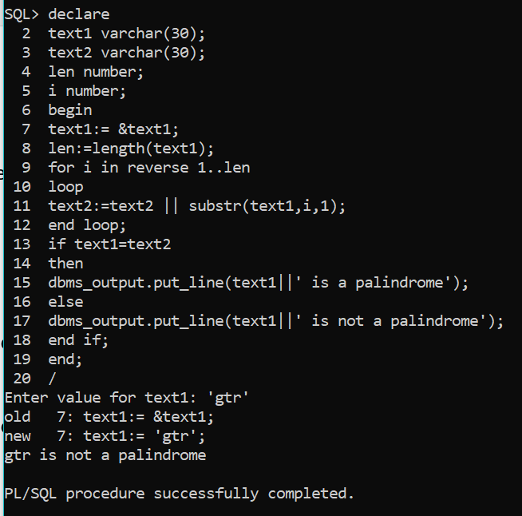

6) Write PL/SQL code to find Reverse of a given number.​

declare

num NUMBER;

rev NUMBER;

begin

num:=&num;

rev:=0;

while num>0

loop

rev:=(rev*10) + mod(num,10);

num:=floor(num/10);

end loop;

dbms_output.put_line('Reverse of the number is: ' || rev);

END;

/

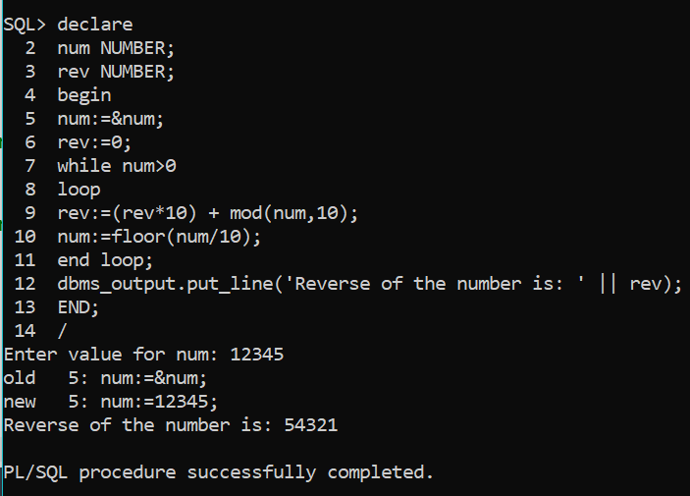

7) Write PL/SQL code to generate Fibonacci series for given number.​

declare

first number := 0;

second number := 1;

temp number;

n number :=&n;

i number;

begin

dbms_output.put_line('Series:');

dbms_output.put_line(first);

dbms_output.put_line(second);

for i in 2..n

loop

temp:=first+second;

first := second;

second := temp;

dbms_output.put_line(temp);

end loop;

end;

/

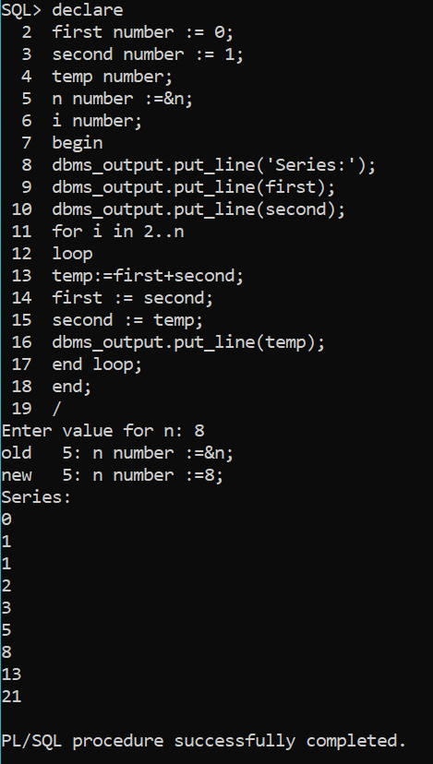

8) Write PL/SQL code to print the numbers in this form ​

          1 ​

          1 2 ​

          1 2 3​

declare

i number;

j number;

begin

for i in 1..3

loop

for j in 1..i

loop

dbms_output.put(to_char(j) ||' ');

end loop;

dbms_output.new_line;

end loop;

end;

/

