2. Write a program to create a class and create 5 objects using array of objects.

Read the input from the user, calculate percentage of marks and display the

student details.

Class: Student

Instance variables: name, regno, dept, year, addr, m1,m2,m3,

percentage(m2+m3+m1/3)

method:

getdetail()

display()

Ans: import java.util.Scanner;

class Student{

String name,regno,dept,address;

int m1,m2,m3,year;

double percentage;

void getDetails()

{

Scanner sc=new Scanner(System.in);

System.out.println("Enter Details of student");

System.out.println("Enter name");

name=sc.nextLine();

System.out.println("Enter registration number");

regno=sc.nextLine();

System.out.println("Enter Department");

dept=sc.nextLine();

System.out.println("Enter address");

address=sc.nextLine();

System.out.println("Enter Year");

year=sc.nextInt();

System.out.println("Marks in subject 1");

m1=sc.nextInt();

System.out.println("Marks in subject 2");

m2=sc.nextInt();

System.out.println("Marks in subject 3");

m3=sc.nextInt();

percentage=(m1+m2+m3)/3;

}

void display()

{

System.out.println("\n Details of the student are: \n Name of the Student is "+name+"\n Registration number of Student is "+regno+"\n Department of Student is "+dept+"\n year "+year+"\n Address of Student "+address+"\n Marks of the Student are "+m1+","+m2+","+m3+"\n Percentage of Student is " +percentage);

}

}

class Main {

public static void main (String[] args) {

Student s[]=new Student[5];

for(int i=0;i<5;i++)

{

s[i]=new Student();

}

for(int j=0;j<5;j++)

{

s[j].getDetails();

}

for(int k=0;k<5;k++)

{

s[k].display();

}

}

OUTPUT:

}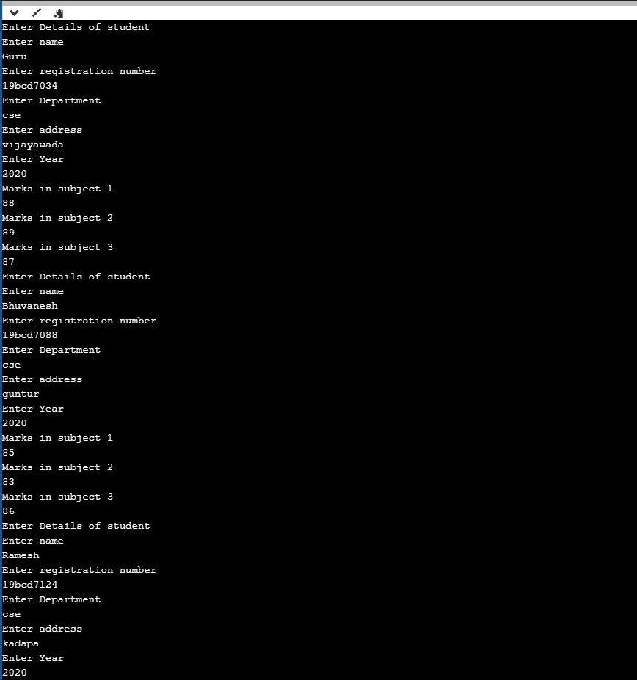

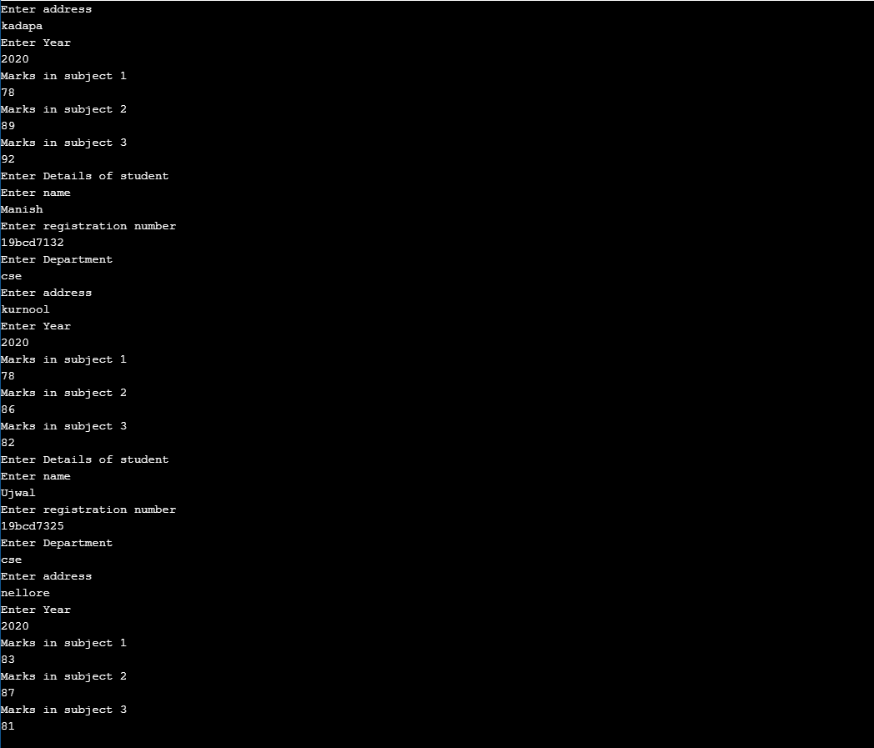

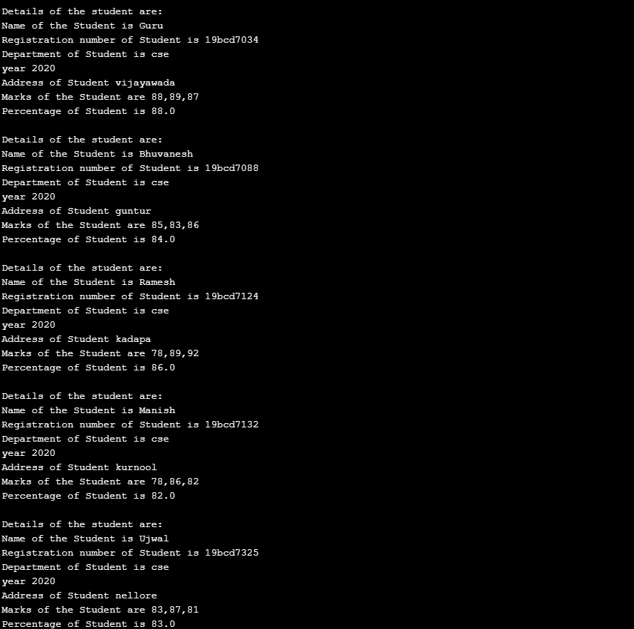

3.Mr.Arun gives k integer numbers as key to open a secret locker. The locker will

open only when the sum of all keys in alternative index is a palindrome otherwise

not. Write a java program to implement it and display whether locker opened or

not.

Ans: import java.util.Scanner;

public class Main {

public static void main(String []args)

{

Scanner sc= new Scanner(System.in);

int sum= 0;

int j= 0;

int k= sc.nextInt();

int a[]= new int[k];

for(int i=0;i<k;i++)

{

a[i]=sc.nextInt();

}

while(j<k)

{

sum=sum+a[j];

j=j+2;

}

int temp= sum;

int n= temp;

int r;

sum=0;

while(n>0){

r=n%10;

sum=(sum\*10)+r;

n=n/10;

}

if(temp==sum)

System.out.println("palindrome number \n Door opened");

else

System.out.println("not palindrome \n Door not opened");

}

}

OUTPUT:

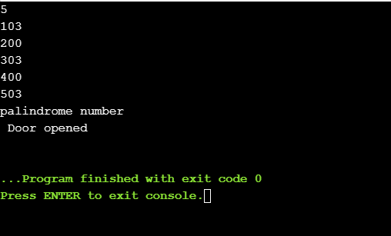

1. write a program to read n strings and sort in ascending order.

Ans: import java.util.Scanner;

public class Main

{

public static void main(String[] args)

{

int n;

String temp;

Scanner s = new Scanner(System.in);

System.out.print("Number of strings =");

n = s.nextInt();

String strings[] = new String[n];

Scanner gc = new Scanner(System.in);

System.out.println("Enter Strings");

for(int i = 0; i < n; i++)

{

strings[i] = gc.nextLine();

}

for (int i = 0; i < n; i++)

{

for (int j = i + 1; j < n; j++)

{

if (strings[i].compareTo(strings[j])>0)

{

temp = strings[i];

strings[i] = strings[j];

strings[j] = temp;

}

}

}

System.out.print("Strings in ascending order are: ");

for (int i = 0; i < n - 1; i++)

{

System.out.print(strings[i] + ",");

}

System.out.print(strings[n - 1]);

}

}

OUTPUT:

