Name: Thota Gurutheja Reddy

Reg No: 19BCD7034

Lab 12

1. Create your own menu and display it using javaFX

Ans:

import javafx.application.Application;

import javafx.scene.Group;

import javafx.scene.Scene;

import javafx.scene.control.Menu;

import javafx.scene.control.MenuBar;

import javafx.scene.control.MenuItem;

import javafx.scene.paint.Color;

import javafx.stage.Stage;

public class MenuBar_1 extends Application {

public void start(Stage stage) {

Menu fileMenu = new Menu("Documents");

MenuItem item1 = new MenuItem("Office Documents");

MenuItem item2 = new MenuItem("personal Documents");

fileMenu.getItems().addAll(item1, item2);

MenuBar menuBar = new MenuBar(fileMenu);

menuBar.setTranslateX(200);

menuBar.setTranslateY(20);

Group root = new Group(menuBar);

Scene scene = new Scene(root, 595, 200, Color.BEIGE);

stage.setTitle("Menu");

stage.setScene(scene);

stage.show();

}

public static void main(String args[]){

launch(args);

}

}

Output:

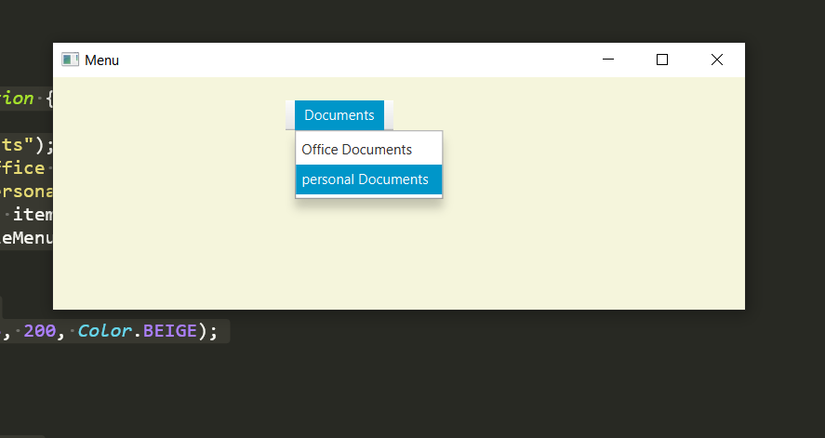

2. Create the tree below using javaFX

Ans: import javafx.application.Application;

import javafx.geometry.Insets;

import javafx.scene.Group;

import javafx.scene.Scene;

import javafx.scene.control.TreeItem;

import javafx.scene.control.TreeView;

import javafx.scene.layout.VBox;

import javafx.scene.paint.Color;

import javafx.stage.Stage;

public class Tree extends Application {

public void start(Stage stage) {

TreeItem root1 = new TreeItem("Sales Department");

TreeItem item1 = new TreeItem("Ethan Williams");

TreeItem item2 = new TreeItem("Michael Brown");

TreeItem item3 = new TreeItem("Anna Balck");

root1.getChildren().addAll(item1, item2, item3);

TreeItem root2 = new TreeItem("IT Support");

TreeItem item4 = new TreeItem("Mike Graham");

TreeItem item5 = new TreeItem("Judy Mayer");

TreeItem item6 = new TreeItem("Grefory Smith");

root2.getChildren().addAll(item4, item5, item6);

TreeItem root3 = new TreeItem("Accounts Department");

TreeItem item7 = new TreeItem("Jacob Smith");

TreeItem item8 = new TreeItem("Isabella Jhonson");

TreeItem item9 = new TreeItem("Jhonson");

root3.getChildren().addAll(item7, item8, item9);

TreeItem<String> base = new TreeItem<String>("MyCompany Human Resources");

base.setExpanded(true);

base.getChildren().addAll(root1, root2, root3);

TreeView view = new TreeView(base);

view.setPrefHeight(300);

VBox pane = new VBox(10);

pane.setPadding(new Insets(5, 5, 5, 50));

pane.getChildren().addAll(view);

Group node = new Group(pane);

Scene scene = new Scene(node, 595, 320, Color.BEIGE);

stage.setTitle("Tree");

stage.setScene(scene);

stage.show();

}

public static void main(String args[]){

launch(args);

}

}

