Thota GuruTheja Reddy

19BCD7034

Lab-2

1.

import java.util.Scanner;

class Circle{

double radius;

double pi = 3.14;

Circle(double r){

this.radius = r;

}

public double getArea(){

return (pi*radius*radius);

}

public double getCircumference(){

return (2*pi*radius);

}

void displayArea()

{

System.out.println("Area of the circle is: "+getArea());

}

void displayCircumference()

{

System.out.println("Circumference of the circle is: "+getCircumference());

}

}

public class Main

{

public static void main(String[] args) {

Scanner sc = new Scanner(System.in);

System.out.println("Enter radius of the circle");

double r = sc.nextDouble();

Circle obj = new Circle(r);

obj.getArea();

obj.getCircumference();

obj.displayArea();

obj.displayCircumference();

}

}

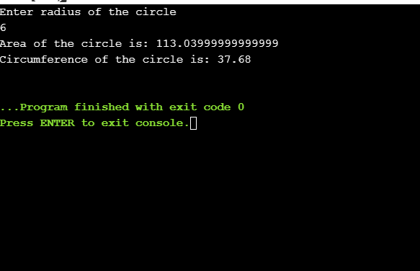

2. import java.util.Scanner;

class Student{

String name,address;

static int regno;

final String dept="CSE";

int sub_mark1,sub_mark2,sub_mark3;

int elec1,elec2,elec3;

int num_of_subs;

char grade;

Student(int sub_mark1,int sub_mark2,int sub_mark3,int elec1,int elec2,int elec3){

num_of_subs= 6;

this.sub_mark1=sub_mark1;

this.sub_mark2=sub_mark2;

this.sub_mark3=sub_mark3;

this.elec1=elec1;

this.elec2=elec2;

this.elec3=elec3;

}

Student(int sub_mark1,int sub_mark2,int sub_mark3,int elec1,int elec2){

num_of_subs= 5;

this.sub_mark1=sub_mark1;

this.sub_mark2=sub_mark2;

this.sub_mark3=sub_mark3;

this.elec1=elec1;

this.elec2=elec2;

}

int getTotal(){

int total = sub_mark1+sub_mark2+sub_mark3+elec1+elec2+elec3;

return total;

}

double getAverage(int total){

double avg =total/num_of_subs;

return avg;

}

char getGrade(double avg){

if (avg<50){

grade='F';

}else if(avg>=50 && avg<60){

grade='E';

}else if(avg>=60 && avg<70){

grade='D';

}else if(avg>=70 && avg<80){

grade='C';

}else if(avg>=80 && avg<90){

grade='B';

}else if(avg>=90 && avg<95){

grade='A';

}else {

grade='S';

}

return grade;

}

void display(){

System.out.println("Details of the student are:\nName: "+name+"\nRegistration number: "+regno+"\nDepartment: "+dept+"\nAddress: "+address+"\nGrade of the student is "+grade );

}

}

public class Main{

public static void main (String[] args) {

int sub_mark1,sub_mark2,sub_mark3;

int elec1,elec2,elec3;

String name,address;

int regno;

String dept;

Student s[]=new Student[3];

Scanner sc=new Scanner(System.in);

for(int i=0;i<3;i++){

if(i>0){

sc.nextLine();

}

System.out.println("Is there 3 electives yes or no ");

String o=sc.nextLine();

System.out.println("Enter Name");

name=sc.nextLine();

System.out.println("Enter registration number");

regno=sc.nextInt();

sc.nextLine();

System.out.println("Enter address");

address=sc.nextLine();

System.out.println("Enter sub_mark1");

sub_mark1=sc.nextInt();

System.out.println("Enter sub_mark2");

sub_mark2=sc.nextInt();

System.out.println("Enter sub_mark3");

sub_mark3=sc.nextInt();

System.out.println("Enter elec1");

elec1=sc.nextInt();

System.out.println("Enter elec2");

elec2=sc.nextInt();

if (o.equals("no")){

s[i] = new Student(sub_mark1,sub_mark2,sub_mark3,elec1,elec2);

int n = s[i].getTotal();

double g = s[i].getAverage(n);

char grade = s[i].getGrade(g);

s[i].name=name;

s[i].regno=regno;

s[i].address=address;

}

else {

System.out.println("Enter elec3");

elec3=sc.nextInt();

s[i] = new Student(sub_mark1,sub_mark2,sub_mark3,elec1,elec2,elec3);

int n = s[i].getTotal();

double g = s[i].getAverage(n);

char grade = s[i].getGrade(g);

s[i].name=name;

s[i].regno=regno;

s[i].address=address;

}

}

for(int j=0;j<3;j++){

s[j].display();

}

}

}

