1.

import java.util.Scanner;

class Rectangle{

int length;

int breadth;

public Rectangle(int length,int breadth){

this.length=length;

this.breadth=breadth;

}

}

class Box extends Rectangle{

int height;

Box(int length,int breadth, int h){

super(length,breadth);

height=h;

}

int volume(){

return length*breadth*height;

}

}

class Main{

public static void main(String[]args){

Scanner sc= new Scanner(System.in);

System.out.println("Enter Length: ");

int l = sc.nextInt();

System.out.println("Enter Breadth: ");

int b = sc.nextInt();

System.out.println("Enter Height: ");

int h = sc.nextInt();

Box obj= new Box(l,b,h);

System.out.println("Therefore the volume is: "+obj.volume());

}

}

Output:

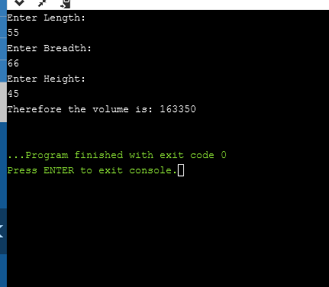

2.

import java.util.Scanner;

class Student {

private String name;

private String email;

private char gender;

public Student(String name, String email, char gender) {

this.name = name;

this.email = email;

this.gender = gender;

}

public String getName() {

return name;

}

public char getGender() {

return gender;

}

public String getEmail() {

return email;

}

public void setEmail(String email) {

this.email = email;

}

public String toString() {

return( "Details of the student are:\nName: "+name+"\nGender: "+gender+"\nDepartment: "+dept+"\nEmail: "+name+"@"+email);

}

}

class Department extends Student{

String dept;

Department(String name, String email, char gender, String str){

super(name,email,gender);

dept=str;

}

public String getDepartment(){

return dept;

}

}

public class Main{

public static void main(String[]args){

Scanner sc=new Scanner(System.in);

System.out.println("Enter name of the student ");

String n = sc.nextLine();

System.out.println("Enter email");

String e = sc.nextLine();

System.out.println("Enter gender");

char g = sc.next().charAt(0);

sc.nextLine();

System.out.println("Enter Department ");

String d= sc.nextLine();

Department stu=new Department(n,e,g,d);

System.out.println(stu);

}

}

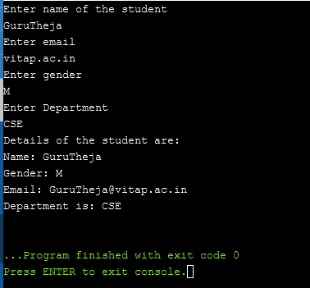

3.

import java.util.Scanner;

class Department{

String department_name,hod_name;

int total_students,no_of_sections;

public Department(String department_name, String hod_name, int total_students, int no_of_sections){

this.department_name=department_name;

this.hod_name=hod_name;

this.total_students=total_students;

this.no_of_sections=no_of_sections;

}

void showDepartmentDetails(){

System.out.println("Department_name: "+department_name);

System.out.println("Hod_name: "+hod_name);

System.out.println("Total_students: "+total_students);

System.out.println("No_of_sections: "+no_of_sections);

}

}

class StaffMember extends Department implements Publication {

String staff_name,staff_qualification,designation,experience;

int staff_id;

public StaffMember(String department_name, String hod_name, int total_students, int no_of_sections,String staff_name,int staff_id,String staff_qualification,String designation,String experience){

super(department_name,hod_name,total_students,no_of_sections);

this.staff_name=staff_name;

this.staff_id=staff_id;

this.staff_qualification=staff_qualification;

this.designation=designation;

this.experience=experience;

}

void showStaffDetails(){

System.out.println("Staff Name: "+staff_name);

System.out.println("Staff_id "+staff_id);

System.out.println("Staff_qualification: "+staff_qualification);

System.out.println("Designation: "+designation);

System.out.println("Experience: "+experience);

}

public void show_publication_detail()

{

System.out.println("Number of journal count"+journalcount);

System.out.println("Number of projectcount"+projectcount);

System.out.println("Number of patterncount"+patterncount);

}

}

interface Publication{

int journalcount=5;

int projectcount=6;

int patterncount=7;

void show_publication_detail();

}

public class Main{

public static void main(String[]args){

String d,h,sn,sq,des,e;

int t,ns,si ;

Scanner sc=new Scanner(System.in);

System.out.println("Enter number of staff members: ");

int n=sc.nextInt();

StaffMember obj[]= new StaffMember[n];

for(int i=0;i<n;i++){

System.out.println("Enter Department details ");

d=sc.nextLine();

h=sc.nextLine();

sc.nextLine();

t=sc.nextInt();

ns=sc.nextInt();

System.out.println("Enter Staff Details");

sn=sc.nextLine();

sc.nextLine();

si=sc.nextInt();

sc.nextLine();

sq=sc.nextLine();

des=sc.nextLine();

e=sc.nextLine();

obj[i]=new StaffMember(d,h,t,ns,sn,si,sq,des,e);

}

for(int j=0;j<n;j++){

obj[j].showDepartmentDetails();

obj[j].showStaffDetails();

}

}

}

