**THOTA GURUTHEJA REDDY**

**19BCD7034**

**LAB_4**

1. Create a class 'Degree' having a method 'getDegree' that prints "I got a degree". It has two subclasses namely 'Undergraduate' and 'Postgraduate' each having a method with the same name that prints "I am an Undergraduate" and "I am a Postgraduate" respectively. Call the method by creating an object of each class and print the student details (name, regno, degree, years) by creating a method “display” in class Degree

Ans.)

import java.util.Scanner;

class Degree{

public void getDegree(){

System.out.println("I got a Degree");

}

String name, regno, degree;

int years;

void display(String name,String regno,String degree, int years){

this.name=name;

this.regno=regno;

this.degree=degree;

this.years=years;

System.out.println("Name of the Student: "+name+"\nRegistration number is: "+regno+"\nDegree: "+degree+"\nYears: "+years);

}

}

class Undergraduate extends Degree{

public void getDegree(){

System.out.println("I am an Undergraduate");

}

}

class Postgraduate extends Degree{

public void getDegree(){

System.out.println("I am an Postgraduate");

}

}

public class Main{

public static void main(String[]args){

Undergraduate a = new Undergraduate();

Postgraduate b = new Postgraduate();

Scanner sc=new Scanner(System.in);

System.out.println("Enter name of the student");

String n = sc.nextLine();

System.out.println("Enter Registration number");

String r = sc.nextLine();

System.out.println("Enter type of Degree");

String d = sc.nextLine();

System.out.println("Enter years");

int y = sc.nextInt();

if(d.equals("Undergraduate")){

a.display(n,r,d,y);

a.getDegree();

}

else if (d.equals("Postgraduate")){

b.display(n,r,d,y);

b.getDegree();

}

else {

System.out.println("Invalid input");

}

}

}

Output:

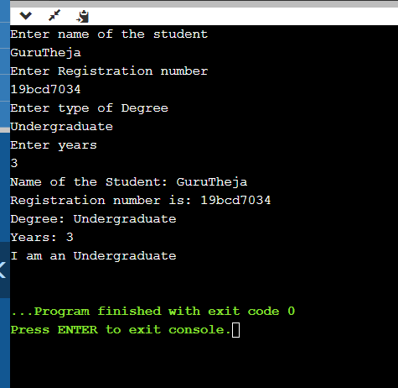

2. Create a class Shapes with a method “calculatearea()” to find the area of a circle (πr2), square(a2), rectangle(w X h) and triangle(1/2 b h) using the same method name “calculatearea” in each class. Declare the input for calculation in class as private (r,a,w,h,b).

Ans.)

import java.util.Scanner;

class Shapes{

private double r,w;

private int a,h,b;

double pi=3.14;

void calculateArea(double r){

this.r=r;

double area = pi*r*r;

System.out.println("Area of circle is: "+area);

}

void calculateArea(int a){

this.a=a;

double area = a*a;

System.out.println("Area of square is: "+area);

}

void calculateArea(double w,int h){

this.w=w;

this.h=h;

double area = w*h;

System.out.println("Area of rectangle is: "+area);

}

void calculateArea(int b, int h){

this.b=b;

this.h=h;

double area = 0.5*b*h;

System.out.println("Area of triangle is: "+area);

}

}

class Main{

public static void main(String[]args){

Scanner sc =new Scanner(System.in);

System.out.println("Enter radius: ");

double r= sc.nextDouble();

System.out.println("Enter height: ");

int h= sc.nextInt();

System.out.println("Enter width: ");

double w= sc.nextDouble();

System.out.println("Enter length: ");

int a= sc.nextInt();

System.out.println("Enter base length: ");

int b= sc.nextInt();

Shapes obj=new Shapes();

obj.calculateArea(r);

obj.calculateArea(a);

obj.calculateArea(w,h);

obj.calculateArea(b,h);

}

}

Output: 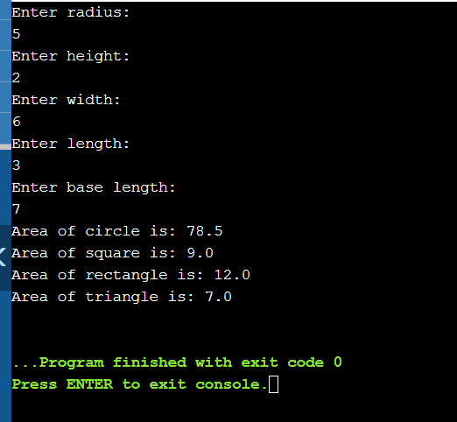

3. Create a class to perform addition of different data types (int, double, string) using the concept of polymorphism.

int add(int,int)

add(int, double)

add(double,int)

add(double,double)

add(String,String)

add(int [])

Ans.)

import java.util.Scanner;

class addition {

void add(int a,int b)

{

int c=a+b;

System.out.println("Sum of numbers is "+ c);

}

void add(int a,double b)

{

double c=a+b;

System.out.println("Sum of numbers is "+ c);

}

void add(double a,int b)

{

double c=a+b;

System.out.println("Sum of numbers is "+c);

}

void add(double a,double b)

{

double c=a+b;

System.out.println("Sum of numbers is "+c);

}

void add(String a,String b)

{

String c=a+b;

System.out.println("Sum of strings is "+c);

}

void add(int a[])

{

int c=0;

for (int i=0;i<a.length;i++)

{

c=c+a[i];

}

System.out.println("Sum of numbers in array is "+ c);

}

}

class Main {

public static void main(String[] args) {

addition a1=new addition();

Scanner sc=new Scanner(System.in);

System.out.println("Enter integer");

int n= sc.nextInt();

System.out.println("Enter double");

double d=sc.nextDouble();

sc.nextLine();

System.out.println("Enter String");

String str=sc.nextLine();

System.out.println("Enter number of elements in array");

int e=sc.nextInt();

int a[]= new int[e];

for (int i=0;i<e;i++){

a[i]=sc.nextInt();

}

a1.add(n,n);

a1.add(n,d);

a1.add(d,n);

a1.add(d,d);

a1.add(str,str);

a1.add(a);

}

}

Output:

